BSc in Software Development Year 4

Mobile Applications Development 3

Project Part 1 – Design Document

Gary Mannion

**Research on game types:**

Looked through all the types of game to consider and concluded that the 2D platform style would be the best choice for me. Although I would have a big interest in shooter games such as Call of Duty as an example he FPS style of game didn’t appeal to me, the styles I looked at were all 3D based games and just didn’t interest me. As for a puzzle game I never had any interest in playing them, the likes of Tetris or a simple game of chess never got my attention and never seen how people could play it for hours on end. My main reason for choosing the 2D platform game style would be that was a big fan of the old super Mario games and I see this style always being associated with gaming, so I would like to design and create my own version of this game. It will be different but based on the same platform. It also helps that I had a design in my mind based on this platform already.

**Software:**

For this game I will be using both Visual Studio and Unity for designing and creating it. I will be using Visual Studio Community 2017, I am choosing to use this software as I have previous experience in the past using it to create UWP such as a weather app for example. Visual Studio also works very well with Unity so it will make the design process much simpler.

I will also be using Unity. Unity is a cross-platform game engine that can be used on multiple different devices. It can be used to make 2D and 3D games as well as simulations that can be used on desktops, laptops, game consoles, smart TVs and Smartphones. I have little to zero experience of using Unity but I hope by following some tutorials and researching problems I encounter that I will come out of this project with a good understanding of the Unity world.

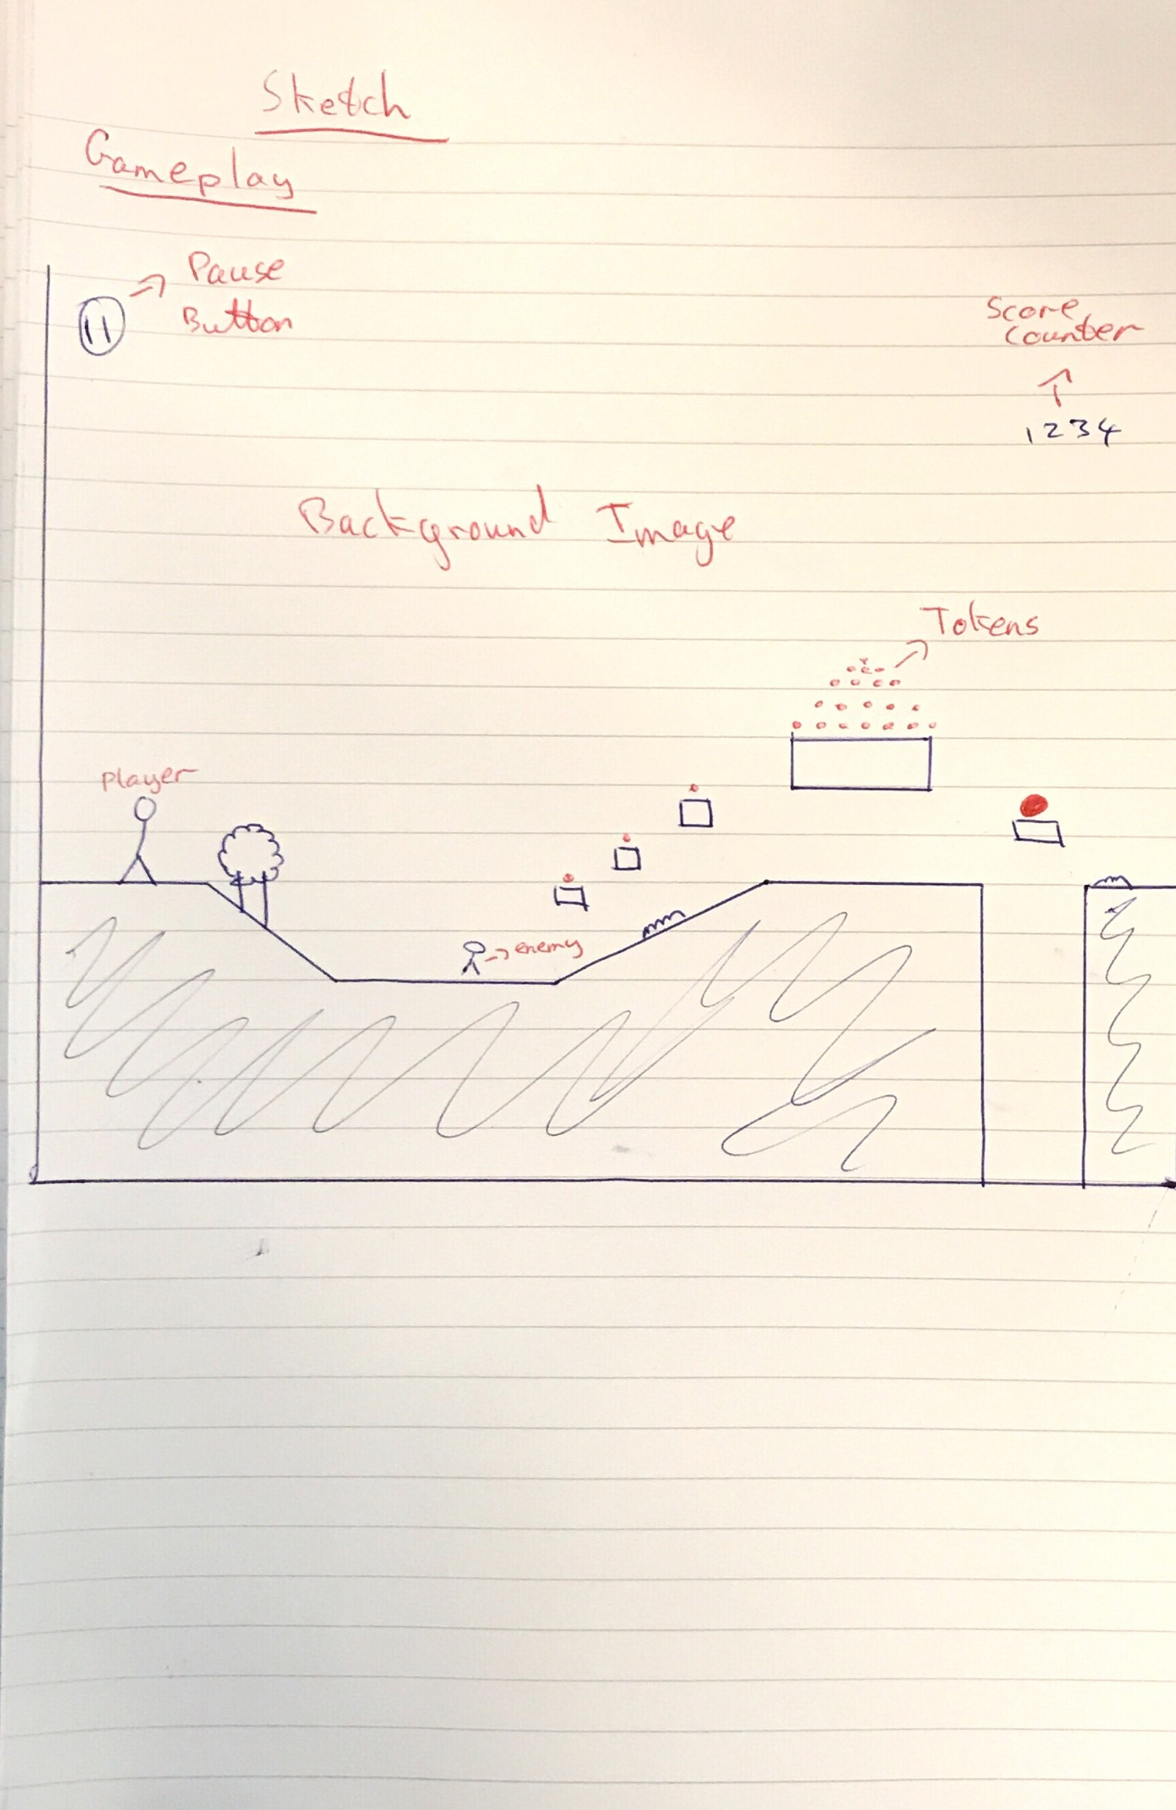**Sketch Design:**

**Gameplay:**

The gameplay will be as described in the sketches. The player will begin at the start of the scene and try to navigate their way through the game. The score will be kept track of on the top right-hand corner and each user will be given 3 lives to reach the end and get a high score. Checkpoints will be added so if the user does lose a life they don’t have to start at the beginning again. The main aim of the game will be to have the highest score at the end of the game by collecting as many tokens as the user can. The player will have to jump to avoid enemies or they can destroy them by jumping on top of them resulting in some extra points, jump onto certain objects to reach a higher level where tokens can be collected and also avoiding drops that could kill the player by jumping over them, this would become more difficult as the game was to speed up.

**Control Mechanism:**

The game will be controlled by using the arrow keys or alternatively by using the WASD keys for player movement. The space bar will also be used as a control to make the player jump on the spot and while moving. These controls are the most obvious choice to use as it is universally known to use these controls in a platform style game so seemed the most logical to choose so everyone would know straight away how to play the game.

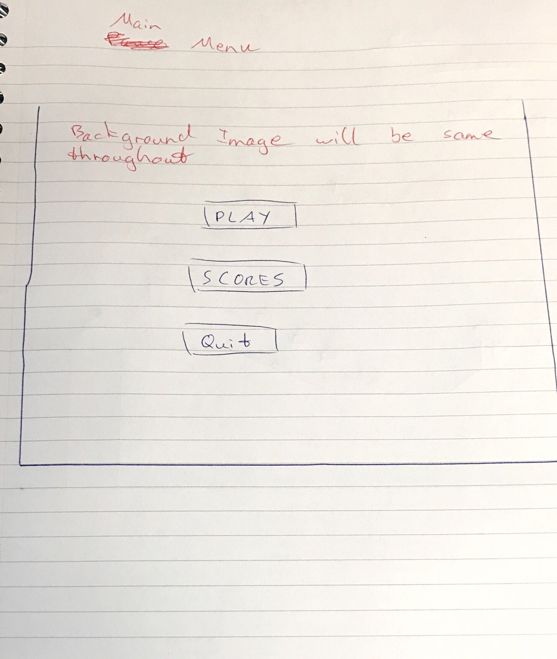**Menu:**

The player will be met by a menu when entering the game, when pressing the PLAY button they will be jumped into the game will the character moving on the spot ready to move it is then up to the user to move the character using the controls.

There will also be a button to enter the scores which will hold the highest scores recorded in the game. This will be in a new menu style area.

The last button will be an option to quit out of the game or close the application.

My design choice for this comes from researching numerous games on the app store and simply concluding that this style was most suited to my game and it is a very simplistic style that any user can recognise straight away. My choice of menu headings is simplistic so that the user can simply enter the game straight away, have a look to see what the highest score is and if they can beat it, and simply end the game if they don’t want to play anymore.

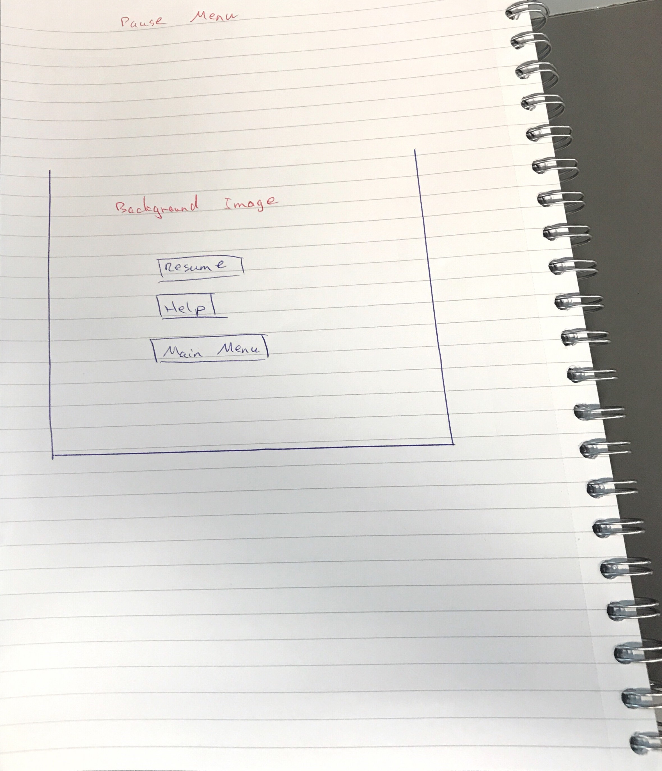**Pause menu:**

In the gameplay itself I will have a pause menu where the user can pause the game if they wish and an option to return to the main menu which would result in any scores being erased. A help option will also be available to the user if they are having difficulty understanding the game.

**Difficulty:**

To make the game become more difficult for a user I will increase the speed the character will travel at making it harder to avoid obstacles and collect tokens. Along with this, I will make it harder to collect tokens along the way by putting them in awkward places to jump to or placing obstacles around them. I can also make enemy targets more mobile and become harder to eliminate.

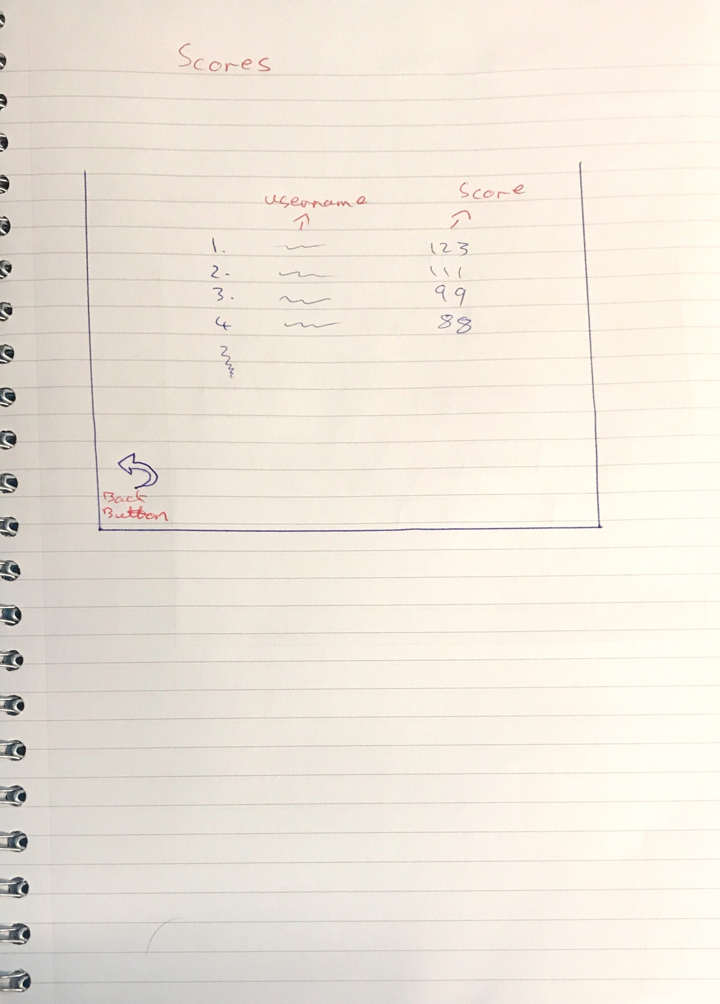**Score Screen:**

A simple screen that will show you which user has the highest score and what the highest score. It will have a back button to bring you back to the main menu. The score will be tracked using dreamlo in the unity asset store. The user will have to input a username after the game has ended and a score is recorded, when pressing the enter button when inputting the username the score will be updated to the list and be visible in the scores screen.

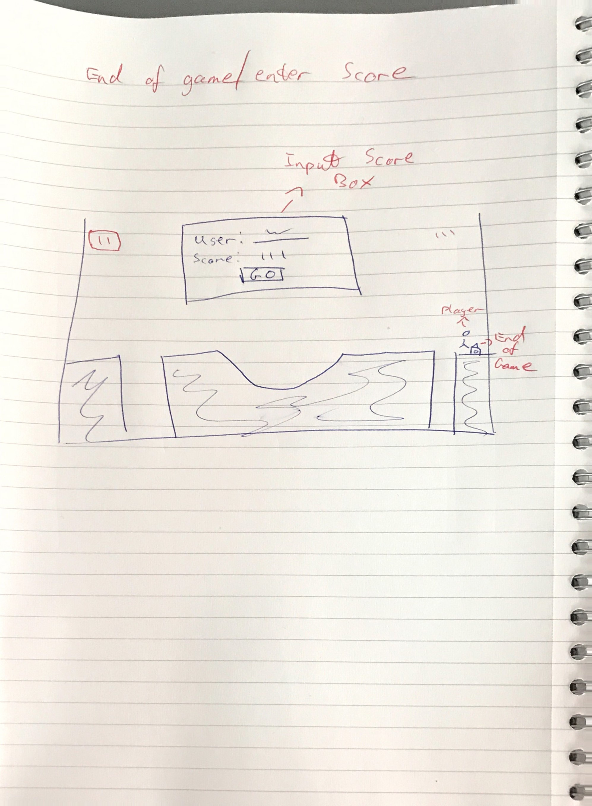**Entering score:**

Once the game has ended and you have completed it the user will be asked to enter a name to save their score on the high score page. They will simply enter a name they want; the score will be displayed, and they must press go to enter the score successfully.

**References:**

https://www.youtube.com/watch?v=ZH2wGpEZVgE -- Super Mario bros

<https://www.raywenderlich.com/738-introduction-to-ufps-unity-fps-tutorial> -- tutorial exploring FPS gaming

<https://forum.unity.com/threads/creating-a-2d-puzzle-game-where-to-start.282896/> -- puzzle game design platform

<https://developer.amazon.com/blogs/appstore/post/a08b3316-4fdc-400b-884d-1ada24b485c1/designing-fun-platforming-levels-tips-and-best-practices> -- design ideas