FTMB0517001

**USER’s MANUAL**

*Four Tack – A STAR Multi Channel Acoustic Audio Calibration System*

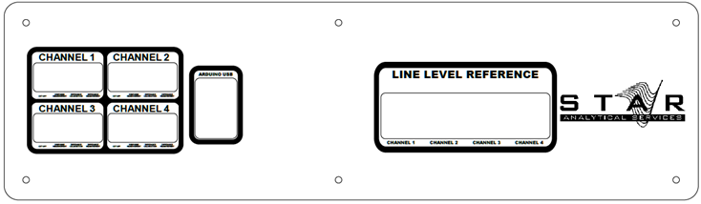**Capstone Design 2016-17**

**Team Leader**

Matthew Tidwell

**Team Members**

Adam Benevides

Patrick Chaves

Massoud Massoud

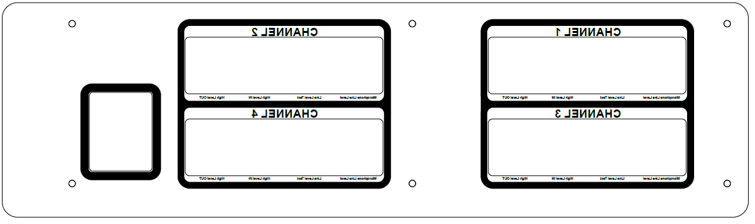Gbade Ogunwumi

**Faculty Advisor**

Dr. Karen Payton

**Project Sponsor**

S.T.A.R.

Dr. Richard Goldhor

Rev 0 – 4/22/2017

**1.0 GENERAL INFORMATION**

**GENERAL INFORMATION**

**1.1 System Overview**

The *Four Track Measurement**Box* is a multi-channel implementation of the ARTA measurement box (AMB). The system consists of a desktop box unit as well as a front-end graphical user interface.

In general, the hardware subsystem :

* Implements four individual AMBs
  + All original AMB functionality remains in-tact
* Allows for switching channels and modes using the integrated pushbuttons as well as software
  + Via Arduino control system
* Accommodates industry-standard audio connectors for ease-of-use

In general, the software subsystem :

* Controls channel and mode switching within the FTMB
  + Via serial communication with Arduino control system
* Provides up-to-date status verification of all modes and channels found on the FTMB
* Interfaces to and automates various simulation software included in the ARTA package.
  + ARTA
  + STEPS
  + LIMP

The hardware is contained in a robust desktop unit. The software is packaged as a distributable *.exe* package.

**1.2 Project References**

This system was designed and completed as a capstone design project at the University of Massachusetts Dartmouth during the 2016-17 academic year. Speech Technology and Applied Research (S.T.A.R.) requested the project and will be the intended end-user.

**1.3 Organization of the Manual**

This manual will be separated into two main sections - a high-level user instruction manual as well as a low-level design description. The former will provide insights into the everyday use of the system and the latter will allow for future reproduction and expansion.

**1.6 Acronyms and Abbreviations**

AMB – ARTA Measurement Box

FTMB – Four Track Measurement Box

GUI – Graphical User Interface

**2.0 GETTING STARTED**

**GETTING STARTED**

This section provides a general walkthrough of the system from initiation through exit.

**2.1 Required Materials**

The following tools and materials are required for full functionality of the FTMB. In no particular order :

* (1) FTMB Desktop Unit
* (1) MOTU 986mk3 or higher*
* (1) Behringer U-Phoria UMC404HD*
* (1) Power amplifier*
* (4) Loud speakers*
* (4) Microphones*
* (4) ¼” to ¼” Phono Cables
* (12) XLR Male to Female Cables
* (4) Microphone Cables
* (8) SpeakON Cables
* (1) Host Computer
  + Windows 10 or higher
  + FTMB Software
  + ARTA Software Suite*
  + MOTU Interfaces*
  + Behringer U-Phoria Interfaces*

* This manual assumes proper knowledge of all hardware and software not directly included in the FTMB system.

**2.2 Initial Assembly**

Using the diagram attached on the following page (Figure 1), assemble the overall test setup. A brief description is provided below. Order of operations is inconsequential, however, do not power anything on until completed.

1. Connect the FTMB to the host PC via a USB cable.
2. Connect the Behringer U-Phoria UMC404HD to the host PC via the included USB cable.
3. Connect the MOTU unit to the host PC via USB or Firewire.
4. Connect the microphones to the INPUT[1:4] ports on the MOTU via XLR.
5. Route OUTPUT[5:8] from the MOTU into the *Microphone Line Level* ports for each of the four channels on the FTMB via XLR.
6. Route the *Line Level Reference* ports on the FTMB to the INPUT [1:4] ports on the Behringer U-Phoria UMC404HD via ¼” to ¼” phono cables.
7. Connect INPUT [5:8] from the MOUT to *Line level Test* ports for each channel on the FTMB.
8. Connect OUTPUT [1:4] of the MOTU to the power amp channels 1-4 via XLR.
9. Route the output of each power amp channel to its corresponding *High Level In* ports on the FTMB via SpeakON cables.
10. Connect each loud speaker to its corresponding *High Level Out* port on the FTMB via SpeakON cables.
11. Provide power to the FTMB, MOTU, Behringer, and Power Amp and turn all devices on.

The diagram below outlines the entire system setup described on the previous page.

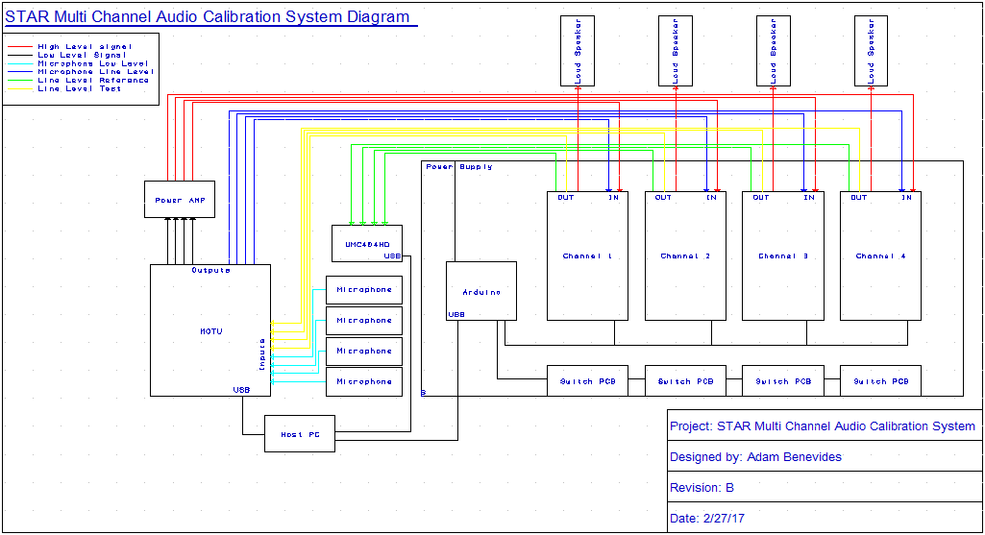

Figure 1 - System Setup Diagram

**2.3** **Launching the FTMB GUI**

Once the entire system has been assembled, the next step is to initialize the software.

1. Ensure the MOTU and Behringer are properly configured. Again, this manual assumes proper knowledge of all devices and software not directly include in the FTMB package.
2. Launch the FTMB software included as a .exe program.

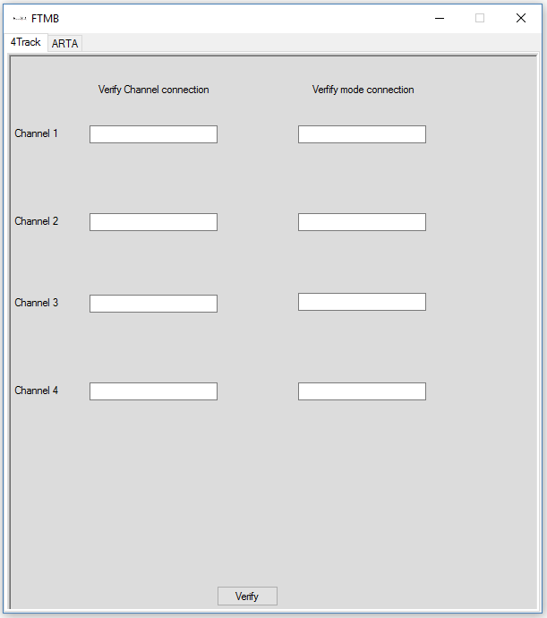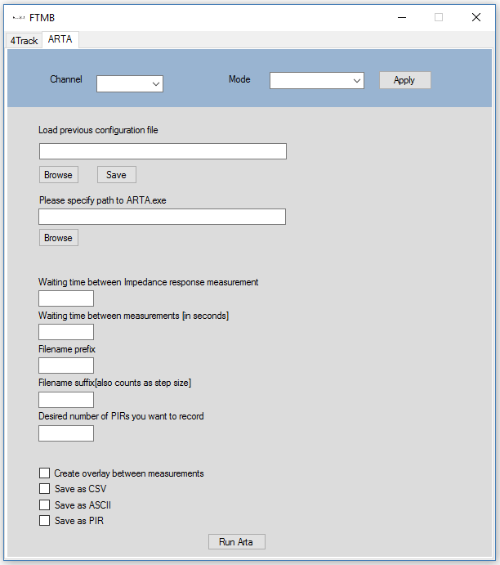The FTMB software GUI should appear as shown below. The image on the left shows the validation tab while the figure on the right is the configuration tab.

Figure : FTMB software initial tab, FTMB second tab

**2.3.1 GUI Description**

This section will describe the functions incorporated in this software to allow you to perform your custom automated measurements with the built-in ARTA software (ARTA, LIMP). Note: The full version of ARTA will need to already be installed on the running PC to be able to perform these measurements.

On the next page, there is a full description of all relevant modules found within the FTMB software.

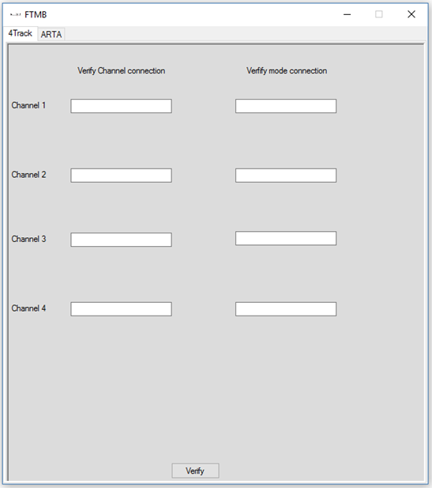

10

9

8

7

6

4

5

3

2

1

1. **Channel and Mode selection**

This section contains two drop down menus and a button, Channel, Mode and Apply respectively. The Channel dropdown menu contains four possible options named 1,2,3,4 corresponding to the four channels in the FTMB box. Similarly, the Mode dropdown menu contains four possible options, named Frequency Response, Impedance Response, Impedance Calibration and Cut off corresponding to the four modes the FTMB was designed to perform. Apply initiates a connection between the GUI and the FTMB to configure these settings.

1. **Loading configuration files**

This section allows you to load/save configuration files to pre-fill sections of the GUI. The

 button opens a file browser dialog and allows you to select the configuration file of choice. The will also open a file browser dialog and allow you to write a configuration file of choice. This section also contains a text box where you can manually input the path to your configuration file.

1. **Finding the ARTA application**

To perform automation with ARTA, the GUI needs to have access to the ARTA .exe files. This section allows you to specify the path to the .exe file, either by manually entering the path in the textbox or by clicking on the  button to open a file dialog browser and selecting the .exe file.

1. **Impedance measurement wait time**

This section contains a textbox that relates to how many seconds worth of data will be collected, when running the GUI in Impedance response mode.

1. **Iteration wait time**

This section contains a textbox that relates to the number of iterations of a measurement you wish to perform. Entering a number into this field will specify how long the GUI will wait before running the next iteration of the measurement.

**6, 7. Choosing a Filename**

This section is where you choose a filename that will be used to save your measurement. You simply enter the name into textbox and that name will be associated with your measurement. Field **7** will also be used in choosing a file name, a number will be entered into the field and this number will count as a step size when saving files. Example: Filename prefix: Arta, Filename suffix: 2 will be saved as Arta2 on the first iteration and as Arta4 on the second iteration etc.

**8. Number of PIR to record**

This section contains a textbox that expects a number value corresponding to number/iterations of measurements you want to perform.

**9. Save types**

This section contains check boxes of the possible save types that this GUI can perform. All save types can be checked at the same time.

**10. Channel verification**

**Screen Clipping**The function of the second tab of the FTMB GUI is to verify each what mode each channel is currently set to. This is as simple as clicking the button on the second tab of the FTMB GUI. This will cause the textboxes of each channel to pre-fill with a numerical value from 1-4 for the channel and text which could either be (FR – Frequency response, IR- Impedance response, IC- Impedance calibration or CO- Cut off) for the mode.

**3.0 Running ARTA Measurements**

**3.0 Running ARTA**

This section gives an insight into the built-in ARTA measurements that this GUI can perform. Refer to the above section on how to set-up the GUI to run measurements as this section will only show the ARTA interface.

**3.1 Frequency Response**

The ARTA software is used to perform this measurement, ARTA is used to measure impulse Reponses, transfer functions and real-time analyzer. However, the GUI is built to be able to perform impulse responses, which in turn can be used to find the frequency response.

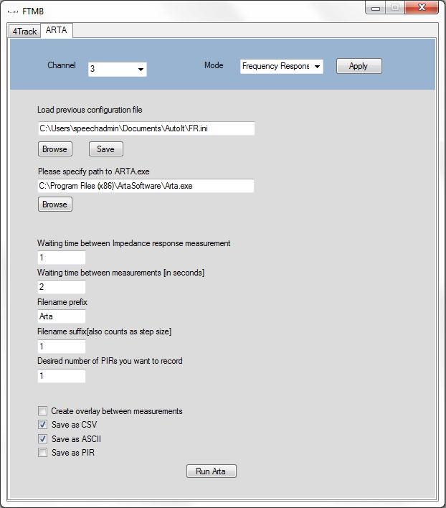

Figure : Frequency response example using FTMB GUI

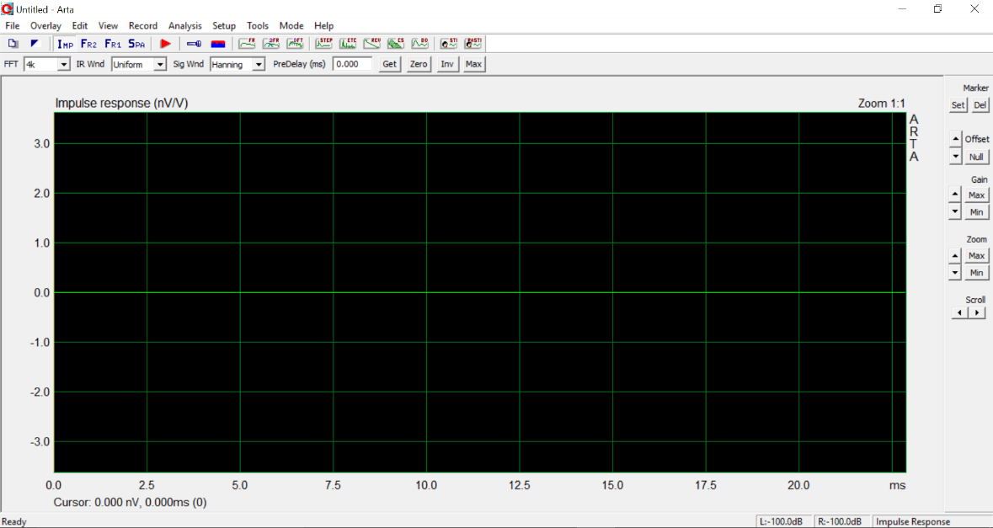

Figure : ARTA initial screen

**3.1.1 Setting up ARTA**

On the first iteration of your measurement, the FTMB GUI will prompt you with forms that will allow you to configure your audio devices along with your soundcard and microphone settings. These settings will be retained throughout the process of that measurement. Refer to figure 5 and 6 to familiarize with the configuration forms.

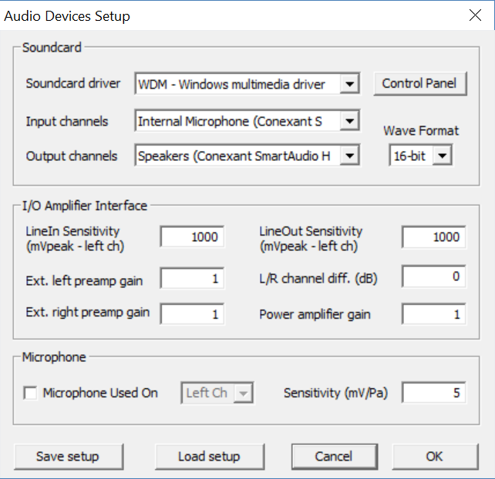

Figure : ARTA audio device setup

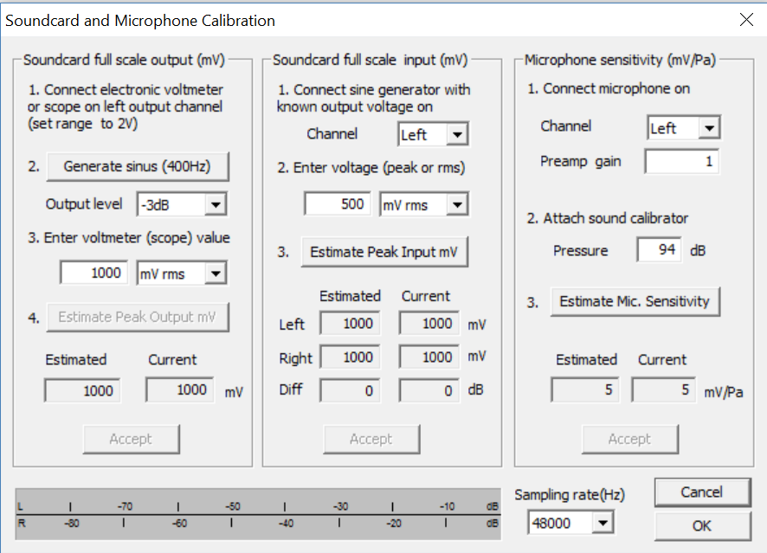

Figure : ARTA Calibration Setup

**3.1.2 Running the Frequency response measurement**

The figures below show the steps the FTMB GUI performs during its automation, during this process the user will not have to and is recommended not to interact with the ARTA software, as this may hinder the performance of the FTMB GUI.

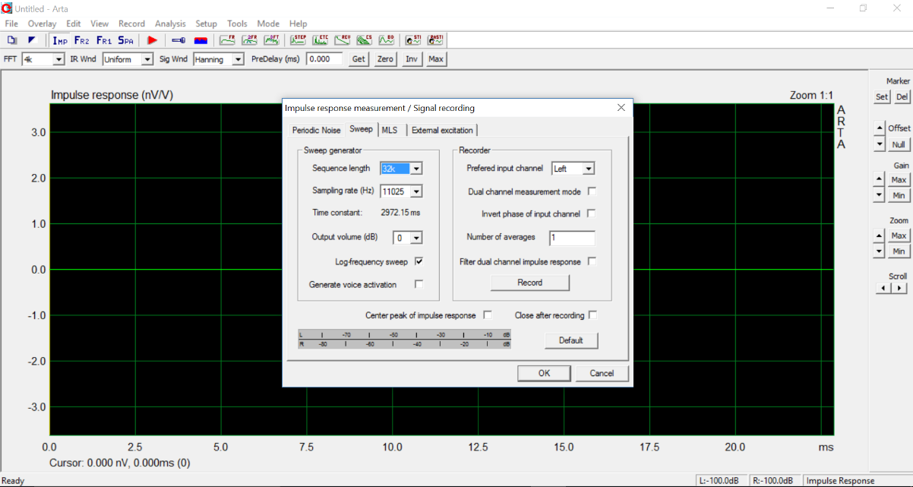

Figure : Impulse response page

The FTMB GUI will open a pop-up window by clicking on record in the main ARTA window, this will then click on the Record button in the pop-up window and start the measurement. After the measurement is concluded, the data from the measurements will be exported as per your choice in the save type field of the FTMB GUI. The image below shows an sample of frequency response result.

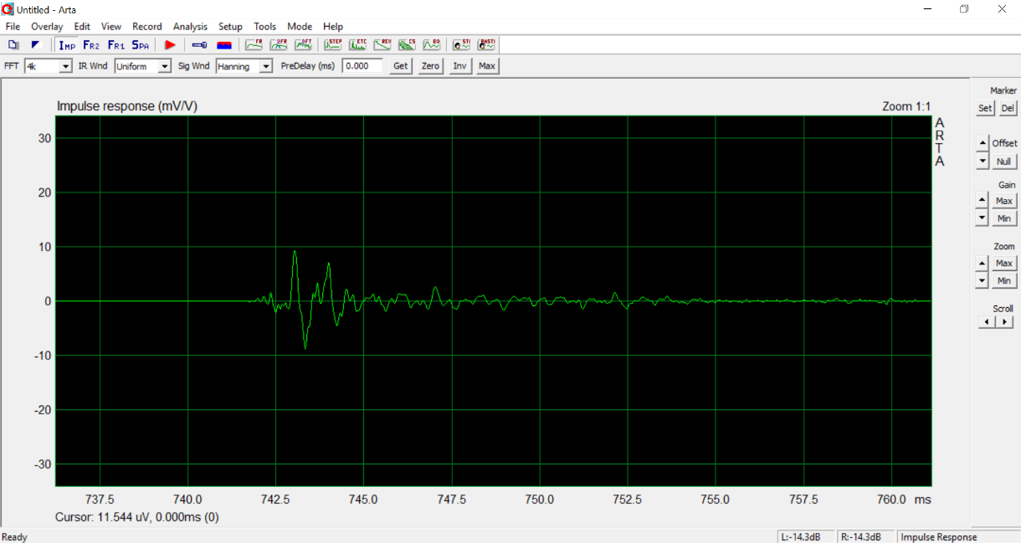

Figure : Impulse response result

**3.2 Impedance Response**

Limp is the software used to perform this measurement, Limp can also be used for impedance measurement and determining the Thiele-Small (TS) parameters. Figure 9 below depicts an example of the parameters that would be used to run an impedance response measurement using the FTMB GUI.

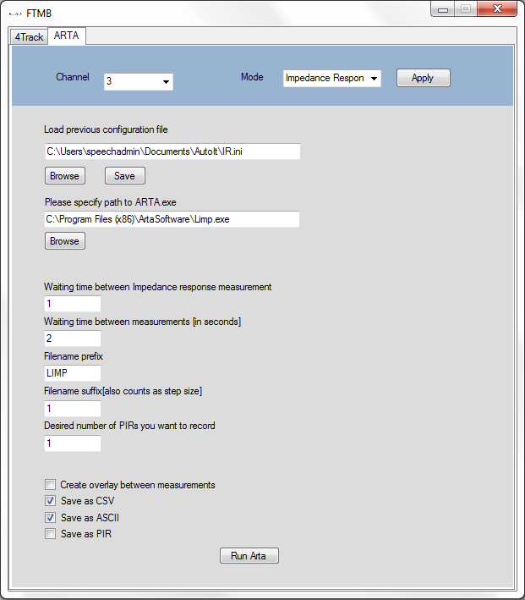

Figure : Impedance response example using FTMB GUI

**3.2.1 Setting up LIMP**

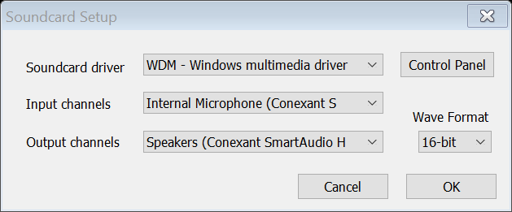The FTMB GUI initiates with a soundcard, measurement and generator setup when running in impedance response mode. Figure 10,11,12 all show images of these windows for you to familiarize with.

Figure : LIMP soundcard setup

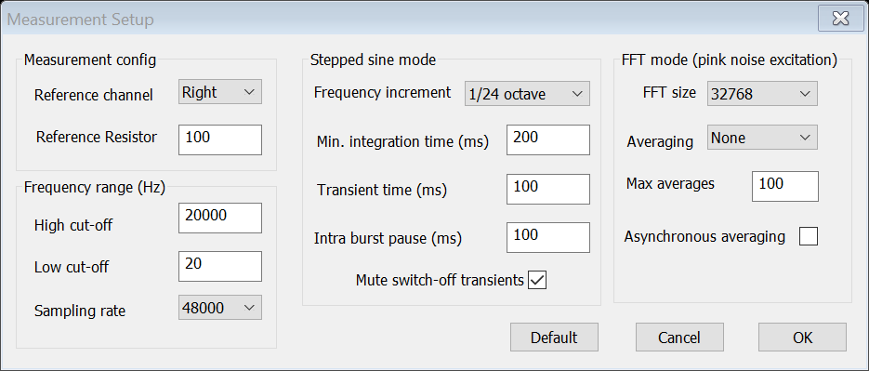

Figure : LIMP Measurement setup

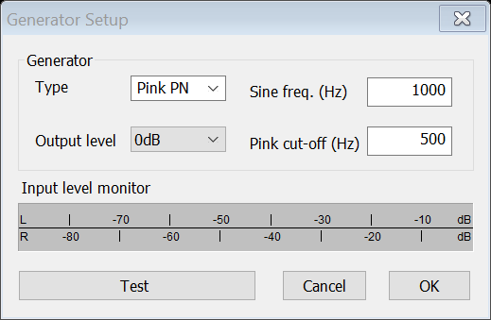

Figure : LIMP Generator setup

**3.2.2 Running Impedance Response Measurement**

The figure below shows the step(s) the FTMB GUI will perform when running in impedance response mode. The start button highlighted in red in the figure below will be clicked automatically and data will be collected for as long as is indicated on the “waiting time between impedance response measurement” parameter in the FTMB GUI, in this scenario it will be a second.

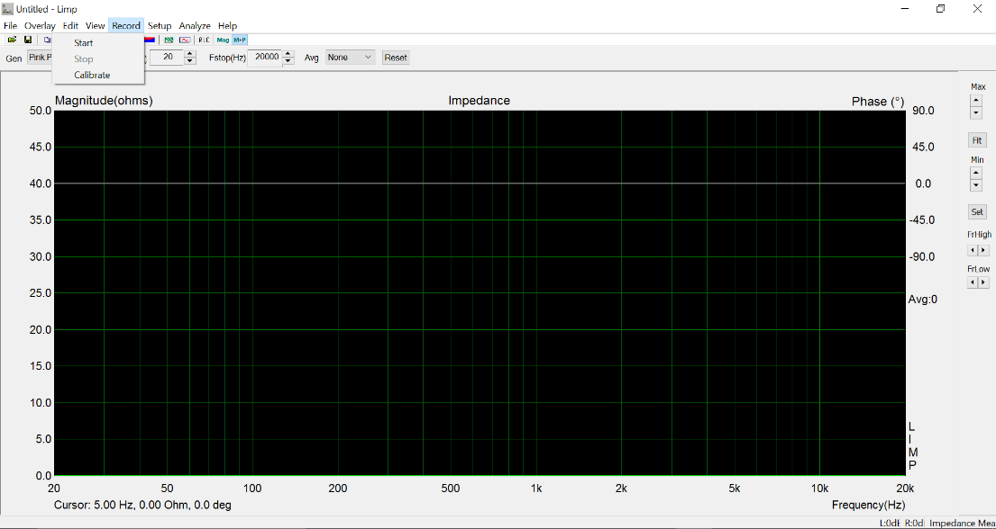

Figure : Running Impedance response

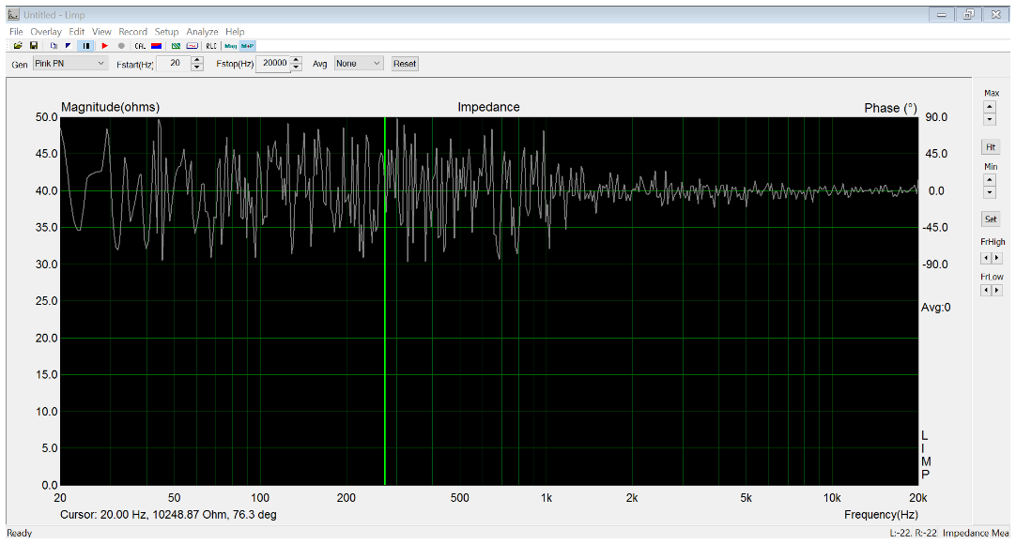

Figure : An example impedance response result

Figure 14 shows a sample result of an impedance response measurement. Similar to the previous section, once this measurement has concluded the data will be collected and exported as per the save types that were indicated in the configuration of the FTMB GUI.

**3.3 Impedance Calibration**

This mode is used to calibrate the input signals per channel into the FTMB relative to each other. Figure 15 shows an example setup that would be used to run an impedance calibration measurement.

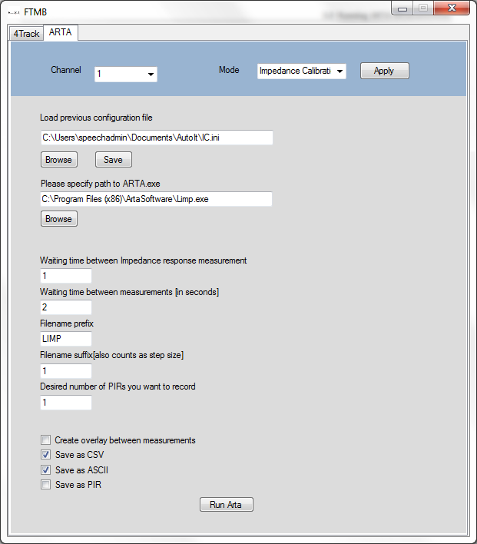

Figure : Example impedance calibration setup using the FTMB GUI

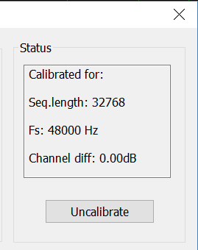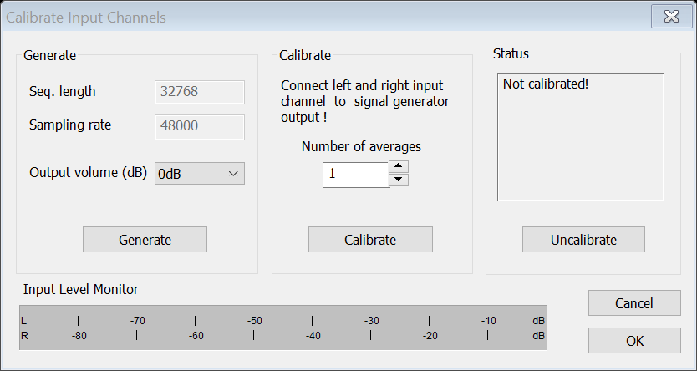

Figure : LIMP calibration window and result

Figure 16 shows the impedance calibration LIMP window; the highlighted button is the control that is clicked when the FTMB GUI is run in impedance calibration mode. After this measurement has concluded, you will notice a change to the status pane either stating “Not Calibrated!” or “Calibrated for” with the corresponding parameters.

**4.0 Low-Level Descriptions for**

**Expansion/Reproduction**

**4.1 Disassembling the FTMB**

Using the diagrams attached on the following pages, disassemble the FTMB. A brief description is provided below.

1. Turn off the FTMB and disconnect all power cables.
2. Disconnect all other cables from the FTMB.
3. Using a 1/8th inch allen wrench, remove the four corner screws holding the front and back panels to the enclosure.
4. Carefully disconnect all internal connectors from the front and back panels, including the power supply.
5. Using a 5/64th inch allen wrench, remove the four corner screws holding the FTMB internal plate to the enclosure.
6. Cut all zip ties from their mounts, while being careful not to damage any wires.
7. Unplug all wire to board connectors and unscrew wires from the relay modules.
8. With all circuit wiring free, separate the wire bundle from the plate.
9. Using a 1/16th inch allen wrench, remove the screws holding in each circuit board.
10. Remove the Arduino Mega from its plate and remove the screws holding the plate with a 1/16th inch allen wrench.

To reassemble the FTMB, simply follow these steps in reverse order.

On the next few pages is a collection of figures which depict the drawings of all panels, PCBs and their associated BOM. These can be used for reference in assembly.

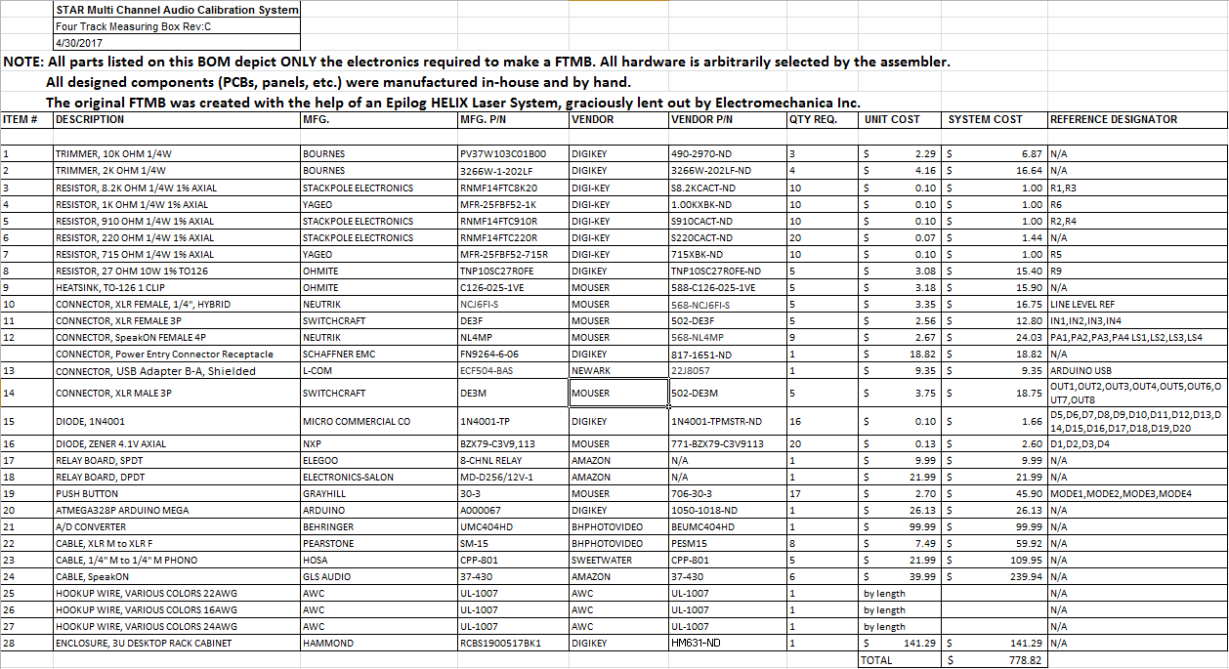

Below is an image of the AMB PCB and its schematic. An Epilog HELIX Laser System was used to burn away a paint mask; this reveals the copper to be etched by ferric chloride. After the copper was etched, acetone is used to remove the paint mask. A drill press is used to drill the proper sized holes for the PCB components.

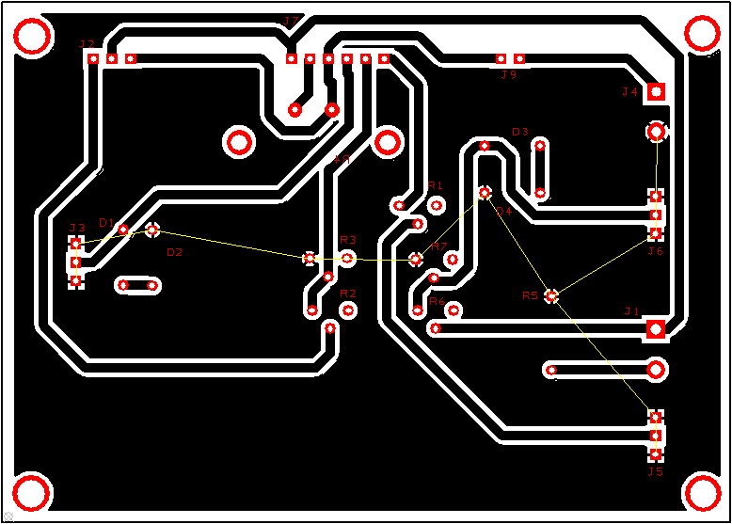

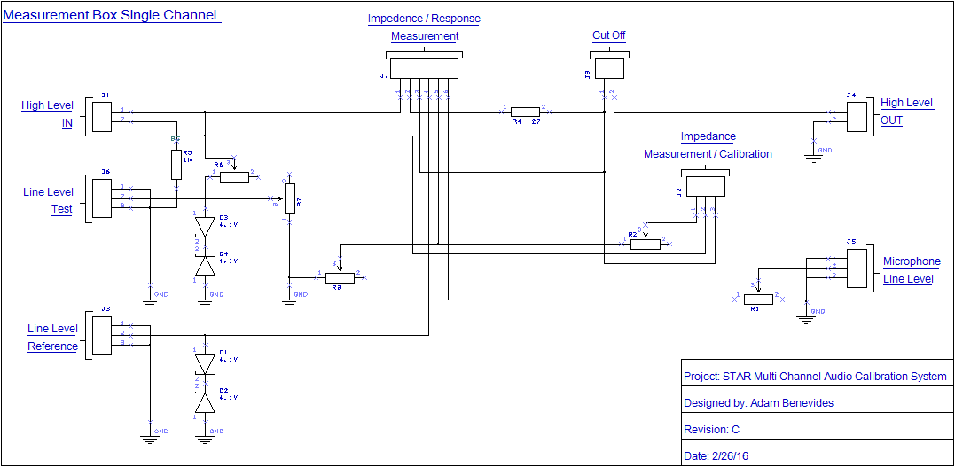

Below is a drawing of the front and rear panels. This was cut out of a 24 inch x 18 ich, 1/8th inch thick piece of black acrylic on an Epilog HELIX Laser System.





The panel overlays are cut from 1/16th inch clear acrylic and are mirrored so the printed side is against the inner panel. This helps reduce wear on the acrylic imaging and improves the overall appeal of the panel.

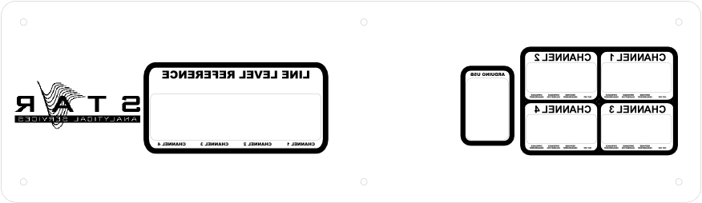

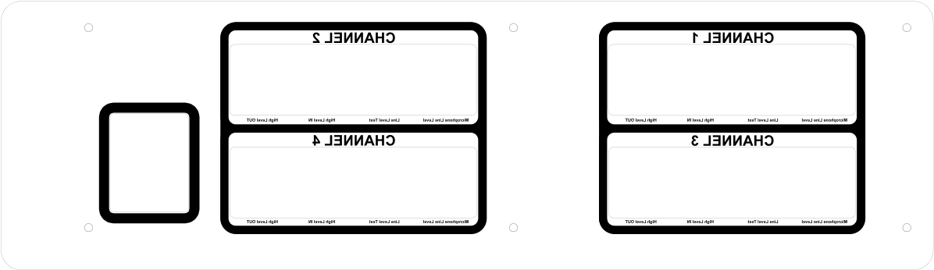

Below is an image of the internal plate. Like the overlays, it’s created with clear acrylic and mirrored. It’s made from 3/8th inch clear acrylic.

