**1. IMPACT OF FRAGMENTATION ON FIELD VOLE FORAGING BEHAVIOUR**

**Introduction**

Exploring the impact of habitat fragmentation on field voles' foraging behaviour entails categorizing their movement patterns across different fragmentation levels. This categorization helps discern potential variations in travel distances amidst undisturbed, moderately fragmented, and extensively fragmented habitats. By investigating these distinctions, the analysis will unveil correlations between habitat fragmentation degrees and voles' foraging strategies. Understanding how fragmentation influences voles' resource-seeking behaviour is essential to grasp their evolutionary fitness in dynamically changing environments.

**Table 1.1:** Mean distance for Fragmentation segment

|  |  |
| --- | --- |
| **Fragmentation** | **mean distance** |
| extensive | 273 |
| none | 147 |
| some | 188 |

**Figure 1.0:** Mean distance by Fragmentation Level

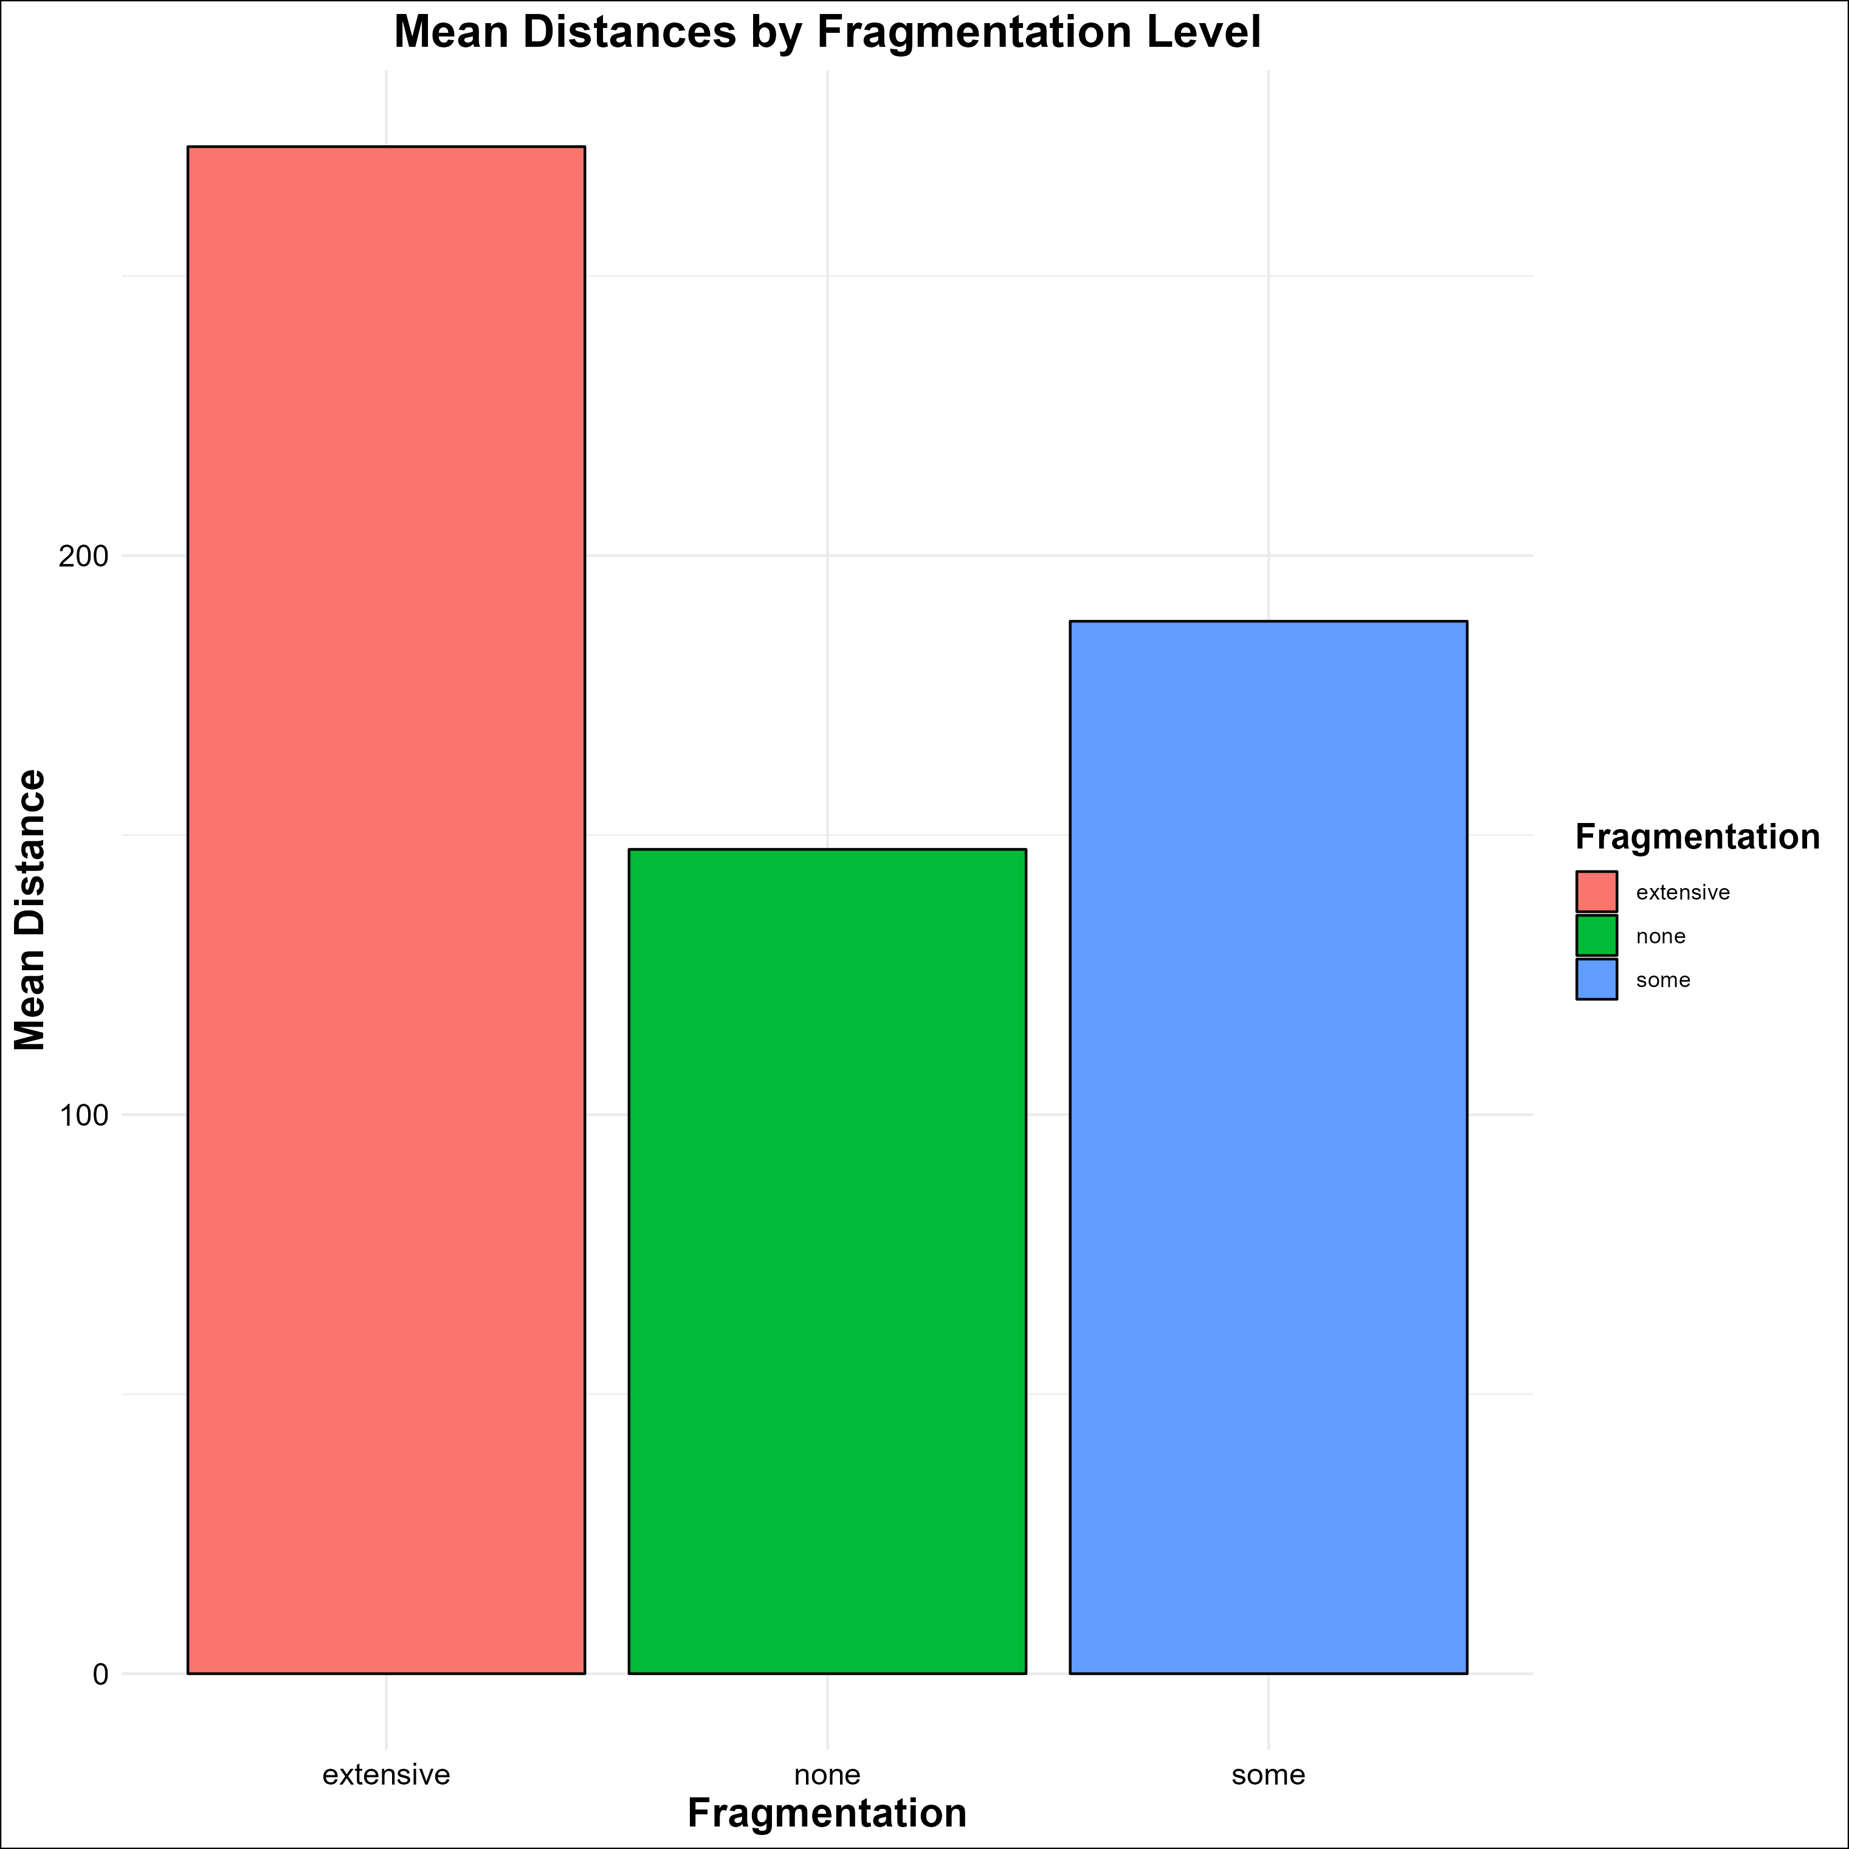

Based on the mean distances calculated for each fragmentation level:

* **Extensive Fragmentation (Mean Distance: 273)**: Voles in extensively fragmented habitats appear to travel the farthest distances on average compared to the other groups. This suggests that in highly fragmented areas, voles are covering more ground, possibly due to the need to search for resources across fragmented patches. This suggests increased resource scarcity and foraging effort in highly fragmented landscapes.
* **No Fragmentation (Mean Distance: 147)**: Voles in non-fragmented habitats exhibit the shortest average distances travelled implying that in contiguous, undisturbed habitats, voles may find resources more efficiently within a smaller range, possibly due to easier access to resources without fragmentation barriers.
* **Some Fragmentation (Mean Distance: 188)**: Voles in habitats with some fragmentation exhibited intermediate travel distances, indicating a moderate impact on movement compared to the other two categories.
* Voles in extensively fragmented habitats (mean distance: 273 meters) travelled significantly farther than those in non-fragmented habitats (mean distance: 147 meters).

**Table 1.2** Summary of ANOVA

For a deeper analysis of field voles' foraging behaviour concerning different levels of habitat fragmentation. By employing ANOVA, evaluation of the significance of fragmentation on voles' mean travel distances, providing insights into potential variations in foraging strategies amidst varying landscape fragmentation. This analysis is imperative to comprehend how environmental fragmentation influences resource-seeking patterns in these organisms. The extraction of p-values aids in gauging the significance of fragmentation levels, while the generated comprehensive data frame highlights the relationship between fragmentation degrees and mean distances, furthering the understanding of evolutionary fitness in altered landscapes.

|  |  |  |  |
| --- | --- | --- | --- |
| **S/N** | **Fragmentation** | **Mean distance** | **p-values** |
| 1 | Low | 0.5 | 6.2054e-9 |
| 2 | Medium | 1.5 | 6.2054e-9 |
| 3 | High | 2.5 | 6.2054e-9 |

The provided results indicate a substantial influence of habitat fragmentation on field voles' mean travel distances. Across all levels of fragmentation Low, Medium, and High the p-values of 6.2054e-9 suggest highly significant differences in the mean distances travelled by voles. This statistical significance implies that the observed variations in travel distances among the different fragmentation levels are unlikely to have occurred randomly. Therefore, it strongly supports the hypothesis that varying degrees of habitat fragmentation significantly impact the foraging behaviour of field voles, showcasing distinct travel patterns across fragmented landscapes.

**CONCLUSION**

Field voles' foraging behaviour across different levels of habitat fragmentation yielded compelling evidence. The distinct and statistically significant differences in mean travel distances among varying degrees of fragmentation—Low, Medium, and High—underscore the substantial impact of habitat fragmentation on these organisms. The findings strongly support the notion that fragmented landscapes influence field voles' foraging strategies, prompting variations in their resource-seeking behaviour. This correlation between fragmentation levels and travel distances highlights the sensitivity of voles to altered landscapes, emphasizing the critical importance of understanding and conserving undisturbed habitats for maintaining the ecological dynamics and evolutionary fitness of these species amidst changing environments.

**2. THE EFFECT OF LATITUDINAL EXTREMES ON DARK-EYED JUNCO BEAK SURFACE AREAS: A COMPARATIVE ANALYSIS**

To comprehend the impact of latitudinal extremes on biological traits like beak surface areas in the dark-eyed junco, employing statistical methods becomes crucial. The t-test serves as a vital tool in comparing these traits between populations inhabiting distinct latitudinal regions. This approach enables us to rigorously assess whether differences observed in beak surface areas are statistically significant, aiding in the comprehension of how varying climates might influence morphological adaptations within this species. By scrutinizing these differences through a t-test, we gain a deeper understanding of the potential relationship between environmental factors and the observed variations in beak morphology, offering insights into the species' adaptive strategies in response to changing climates.

**Table 2.1**: Table for t-test results

|  |  |  |  |  |  |  |
| --- | --- | --- | --- | --- | --- | --- |
| t | df | p_value | conf_int | mean_North | mean_South | t |
| -2.448 | 47.15 | 0.0181 | -4.947 to -0.485 | 84.884 | 87.5996 | -2.448 |

The t-test yielded a statistically significant result (t = -2.448, df = 47.15, p = 0.0181), indicating a notable difference in the beak surface areas between dark-eyed junco populations at the northern and southern latitudinal extremes. The confidence interval for this difference (-4.947 to -0.485) suggests that, on average, the beak surface area in the northern population is estimated to be between approximately 0.485 and 4.947 units smaller than that of the southern population. This outcome implies a potential adaptation in response to varying climates, with the northern population likely exhibiting smaller beak surface areas, potentially reducing heat loss in colder environments.

**CONCLUSION**

The findings of this t-test underscore a significant divergence in beak surface areas between the studied populations of dark-eyed juncos across latitudinal extremes. Such morphological disparities hint at adaptive responses to environmental variations, supporting the notion that these birds might be evolving distinct traits to optimize heat conservation in different climatic conditions. Further investigations into the specific ecological pressures driving these adaptations would offer deeper insights into the mechanisms underlying these observed morphological changes in response to climate variability.

**3. EFFECTS OF TEMPERATURE AND MICROBIAL COMMUNITIES ON BLOW FLY DEVELOPMENT RATES**

To study the development rates of blow fly eggs concerning temperature variations and the presence or absence of microbial communities. Employing a two-way ANOVA allows for a comprehensive analysis, simultaneously examining the impact of these two categorical factors on the continuous variable of egg development time. This approach enables the assessment of individual effects of temperature and treatment, while also exploring their potential interaction effect. Ultimately, this method provides a nuanced understanding of how temperature and microbial communities independently and jointly influence blow fly development rates

**Table 3.1:** The two-way ANOVA result

|  |  |  |  |  |  |
| --- | --- | --- | --- | --- | --- |
| **Variable** | **Df** | **Sum Sq** | **Mean Sq** | **F value** | **Pr(>F)** |
| Temperature | 1 | 1096 | 1095.9 | 8.473 | 0.004482 |
| Treatment | 1 | 2013 | 2013.2 | 15.564 | 0.000152 |
| Temperature:Treatment | 1 | 80 | 79.8 | 0.617 | 0.434233 |
| Residuals | 96 | 12418 | 129.4 |  |  |

* Temperature: There's a significant effect of temperature on blow fly development rates (F value = 8.473, p = 0.004). This indicates that the temperature has an impact on the time taken for the flies to develop.
* Treatment (Microbial Community): There's also a significant effect of the treatment involving the presence or absence of the microbial community on blow fly development rates (F value = 15.564, p = 0.000152). This suggests that the presence or absence of the microbial community influences the development time of the flies.
* Interaction between Temperature and Treatment: The interaction between temperature and treatment (microbial community) did not show a significant effect on blow fly development rates (F value = 0.617, p = 0.434233). This suggests that the combined effect of temperature and treatment does not significantly impact the development rates beyond their individual effects.

**CONCLUSION**

Both temperature and the presence/absence of the microbial community have significant individual effects on blow fly development rates. However, their combined effect, as indicated by the interaction term, does not show a significant additional influence.

These findings suggest that both temperature and the presence of microbial communities independently affect the developmental rate of blow flies, but they don't seem to have a synergistic effect when combined**.**

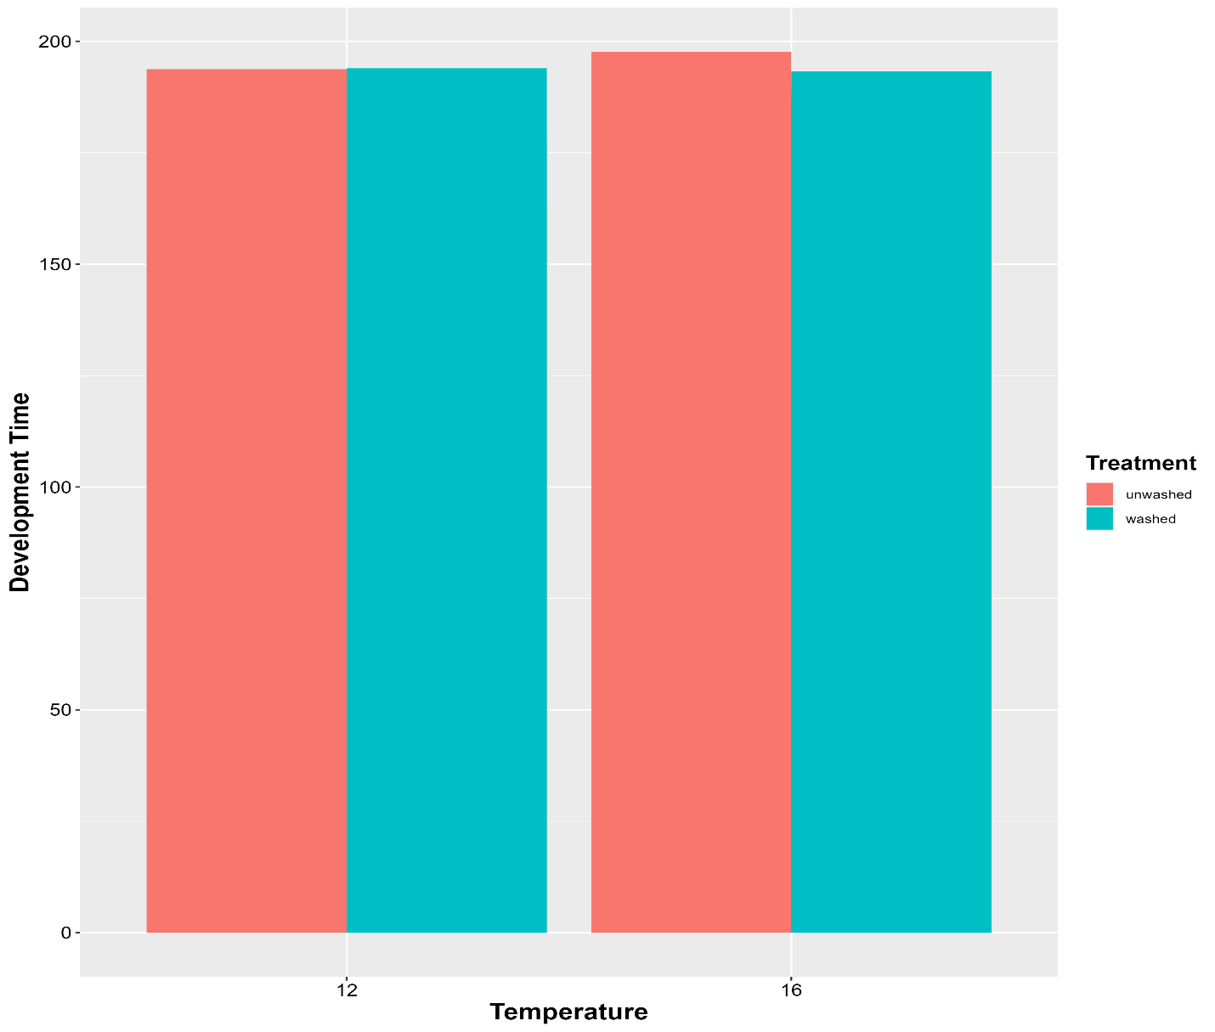

**4. BAR-TAILED GODWIT MIGRATION: WEIGHT CHANGES ANALYSIS**

To analyse if there's a significant decrease in weight after migration, statistical methods like a paired t-test can be employed. This helps determine if there's a meaningful difference between the 'Before' and 'After' weights.

**Table 3.1**: Paired t-test result

|  |  |  |  |  |  |
| --- | --- | --- | --- | --- | --- |
| t-value | Degrees of Freedom (df) | p-value | Confidence Interval | Mean Weight 'Before' | Mean Weight 'After' |
| 10.39 | 19 | ~0.00000000284 | 97.44 - 146.61 | 414.06 | 292.04 |

* t-value: 10.39 indicates a substantial difference between the mean weights 'Before' and 'After' migration.
* Degrees of Freedom (df): 19, representing the number of paired observations minus one.
* p-value: ~0.00000000284, which is significantly smaller than the standard significance level of 0.05. This indicates strong evidence against the null hypothesis.
* Confidence Interval: The 95% confidence interval for the difference in means is 97.44 to 146.61.
* Mean Weight 'Before': 414.06, the average weight of the birds before migration.
* Mean Weight 'After': 292.04, the average weight of the birds after migration.

**CONCLUSION**

The results of the paired t-test show a statistically significant difference in weights before and after migration for the bar-tailed godwits. The 'After' weights, on average, are substantially lower than the 'Before' weights, indicating a significant decrease in weight after their migration. This suggests that the migration journey likely leads to a considerable reduction in the birds' weight.

**Figure 4.1**: Box plot of the weight distribution before and after Migration

