TABLE OF CONTENTS

**CONTENTS PAGE**

1.0 BACKGROUND OF APPLE INC 1

1.1 Core Values and Milestones 2

1.2 Historical Context and Transformative Journey 3

2.0 EXTERNAL ENVIRONMENTAL ANALYSIS: IMPACT ON APPLE INC. IN THE UNITED STATES AND INDIA 3

3.0 ANALYSIS OF APPLE CONSUMER’S BEHAVIOUR IN THE TWO MARKETS (UNITED STATES AND INDIA) 5

3.1 Consumer Behavior in the United States Market 5

3.2 Consumer Behavior in the India Market 5

3.3 Comparative Analysis 6

4.0 ANALYSIS OF APPLE COMPETITOR’S IN THE TWO MARKETS (UNITED STATES AND INDIA) 6

4.1 Competitor Analysis in the United States 6

5.0 MARKET ENTRY STRATEGY EVALUATION FOR APPLE INC. IN THE UNITED STATES AND INDIA 8

5.1 Apple's Entry Strategy in the United States 8

5.2 Apple's Entry Strategy in India 9

5.3 Apple's Success Principles in the U.S. and China 9

5.4 Critical Evaluation: 9

6.0 SEGMENTATION, TAGERTING AND POSITIONING OF APPLE INC IN THE TWO MARKETS (UNITED STATES AND INDIA) 10

6.1 Apple Inc.'s Segmentation, Targeting, and Positioning in the United States 10

6.2 Apple Inc.'s Segmentation Strategy in India: Navigating Diversity 10

6.3 Analysis of Segmentation, Targeting, and Positioning Approaches: A Global Perspective 11

7.0 MARKETING MIX (4 P’S) ASSESSMENT OF APPLE INC IN THE TWO KEY MARKETS (UNITED STATES AND INDIA) 11

7.1 Apple Inc.'s Marketing Strategies in the United States 11

7.2 Apple Inc.'s Marketing Strategies in India 12

7.3 Comparative Analysis of Apple's Marketing Strategies 13

8.0 MARKETING STRATEGIES COMPARISON: U.S. VS. INDIA 13

REFERENCES 17

# 1.0 BACKGROUND OF APPLE INC

Apple Inc. was first established as Apple Computer Company on April 1, 1976, by Steve Jobs, Steve Wozniak, and Ronald Wayne. (Kaliannan and Ponnusamy, 2014). The Headquarter is situated in Cupertino, California, with rapid growth, the company became a global technology giant. (Linzmayer, 2012). Steve Jobs and Steve Wozniak played pivotal roles in directing Apple towards breakthroughs that completely cause a change in the computer software, internet services, and consumer electronics industries space. The early years were defined by the emergence of Apple I and Apple II, which set the stage for Apple's rise in the computer industry. (Sterling, 2012). Despite internal challenges in the mid-1980s, When Steve Job’s returned to Apple, an emergence of new and transformative devices like the iMac, iPad, iPhone, and iPod, which strengthens its stance as a global leader in the tech space (MacIsaac, 2011).

**Figure 1.1:** Apple first logo: created by Ronald Wayne in 1976

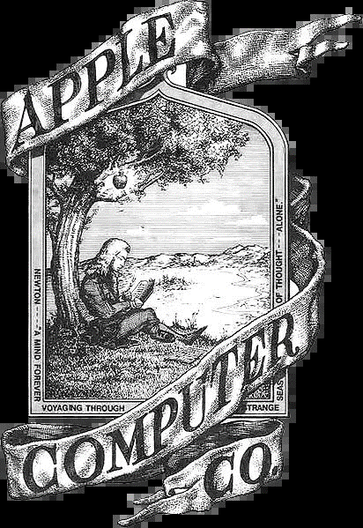

## 1.1 Core Values and Milestones

Apple's guiding principles has been surrounded by innovation, exceptional design, and pushing the frontiers of technology (Apple, 2021). In the late 1990’s the company experienced financial struggles, but a stunning comeback was experienced during the return of Steve Jobs. The "Think different" campaign emancipated Apple's ethos of challenging the impossible (Gibbs, 2014). Despite the constant bad criticism, Apple maintained a devoted spirit, achieving milestones such as becoming the first U.S. company to attain a trillion dollar in 2018, while it also reached $2 trillion in 2020 and $3 trillion in 2022 (NPR, 2006).

**Figure 1.2**: Apple Subsidiaries

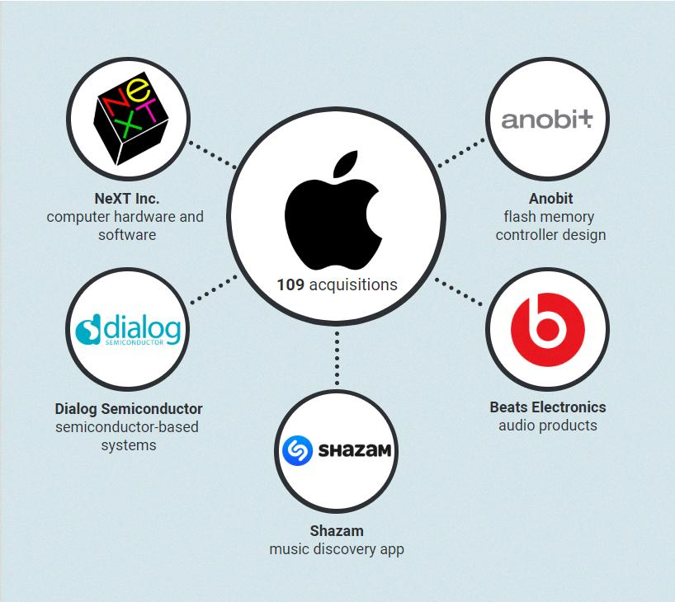

## 1.2 Historical Context and Transformative Journey

Apple's history can be defined by technological innovations and strategic steps towards innovation (The Sydney Morning Herald, 2006). The Apple II series made a name for the company in the personal computer market, with the Macintosh introducing a graphical user interface in 1984 (Shabanek *et al*., 2005). Under Tim Cook's leadership, the company diversified into services, wearables, and original content, solidifying its status as a tech giant (Kim, 2020).

# 2.0 EXTERNAL ENVIRONMENTAL ANALYSIS: IMPACT ON APPLE INC. IN THE UNITED STATES AND INDIA

|  |  |  |
| --- | --- | --- |
| **Factors** | **United States** | **India** |
| Political | Trade tensions pose risks, affecting supply chains and costs. | "Make in India" and "Digital India" initiatives present opportunities for local manufacturing. Complex regulations may pose challenges. Upcoming Personal Data Protection Bill may impact data-driven services. |
| Economic | Economic downturns may decrease demand for premium products. | Growing middle class offers a potential market. Currency fluctuations and economic downturn risks may affect affordability. |
| Social | Privacy concerns and changing demographics impact trust. | Tech-savvy young population provides an opportunity. Shifting consumer preferences and data privacy concerns need adaptation. |
| Technological | Continuous innovation is crucial for maintaining leadership. | Rapid smartphone adoption and 5G technology offer opportunities. Fierce competition from Android-based devices poses a challenge. |
| Legal | Challenges in protecting intellectual property and data privacy. | Adapting to data privacy regulations and complex legal landscape. Compliance adjustments may be necessary. |

Apple faces challenges related to trade tensions in the United States technology market, economic downturns affects demand, and social aspects like privacy concerns. However, continuous innovation remains crucial in the highly competitive technological landscape. In India, the political scenario provides both opportunities and challenges, with initiatives like "Make in India" aligning with Apple's growth goals. Economic factors, which includes a growing middle class, offer potential, while adapting to shifting consumer preferences and data privacy concerns is essential (Apple PESTLE Analysis (2024), 2023).

The swift adoption of smartphones in India provides opportunities, although competition is intense among Android markets. Legal challenges include adapting to data privacy regulations and a complex legal landscape. Navigating these external factors strategically will be key for Apple's success in both markets (McCarthy, 2021).

# 3.0 ANALYSIS OF APPLE CONSUMER’S BEHAVIOUR IN THE TWO MARKETS (UNITED STATES AND INDIA)

## 3.1 Consumer Behavior in the United States Market

Apple's brand transcends its functional products in the United States, as a result it has come to represent luxury and innovation in culture. Having an iPhone in possession in America is seen as trend with sense of enlightenment and sophistication (Apple’s Subsidiaries: The Companies Behind the Tech Giant, n.d.). Cultural nuances, such as the preference for an integrated ecosystem and willingness to pay a premium for perceived quality, shape buying patterns (What is the USP of Apple? n.d.). Apple's recently focuses on sustainability which aligns with the trend where consumers consider ethical concerns in their purchases, reflecting a shift towards socially responsible buying decisions. The inclusion of cultural preferences, aspirational values, and environmental considerations produce a platform where consumer are emotionally connected to the brand.

## 3.2 Consumer Behavior in the India Market

Apple's entry into the Indian market has a distinct consumer behavior trends. Owning an Apple product in India signifies technological sophistication. Unlike the established status in the United States, India's landscape demands adaptation to unique cultures and affordability concerns. The market is driven by customers who are value conscious, leading Apple to innovate and offer compelling value propositions (Ten Trends That Are Altering Consumer Behavior in India, 2020). The significance of retail store located in strategic locations proves effective Indian preferences, emphasizing the importance of local connections. The digital ecosystem provides opportunities in mobile gaming and entertainment, but challenges like the digital divide gears Apple to consider affordability and wider distribution channels.

## 3.3 Comparative Analysis

While Apple's status is firmly established in the United States, In India, a dynamic landscape with shifting aspirations is observed. Cultural values like efficiency and quality resonate with consumers in the United States, while India's market demands an equilibrium between aspiration and affordability (Paul et al., 2006). Although the aspirational Apple ecosystem is valued in all markets, India is distinct due to its emphasis on physical retail and the influence of local and Chinese businesses. American customers are influenced by sustainability and ethical issues, which illustrates a trend that is changing. Apple's ability to adjust, strike a balance between aspirational branding, and satisfy the unique needs of customers in each cultural setting will determine how successful it is in these varied markets.

# 4.0 ANALYSIS OF APPLE COMPETITOR’S IN THE TWO MARKETS (UNITED STATES AND INDIA)

## 4.1 Competitor Analysis in the United States

United States market is highly competitive. Hence, Apple faces a deep competition from key players, each employing distinct strategies to capture market share. Samsung, a strong opponent, is known for cutting-edge technology and Android diversity, attracting a large consumer base. Google Pixel also distinguishes itself with a pure Android experience and superior software features. OnePlus, adopting a "flagship killer" strategy, targets budget-conscious tech enthusiasts with high-end specs at competitive prices (Farooq, 2019). Motorola focuses on affordability and simplicity, catering to practical users. Each competitor has a unique brand positioning and customer loyalty strategy, which contributes to the diverse market ecosystem. The table below provides a concise overview of their brand positioning, strategies, and customer loyalty scores.

|  |  |  |  |
| --- | --- | --- | --- |
| Competitor | Brand Positioning | Strategies | Customer Loyalty |
| Samsung | Cutting-edge technology, Android diversity | Feature-packed devices, competitive pricing | Strong |
| Google Pixel | Clean Android experience, exceptional camera | Timely updates, AI integration | Growing |
| OnePlus | Flagship-level performance at affordable prices | Community engagement, speed-focused approach | Passionate |
| Motorola | Affordability, reliability, no-nonsense function | Practicality, simple design | Steady |

**4.2 Competitor Analysis in India:**

In the dynamic Indian market, Apple's competitors employ strategies tailored to local preferences. Samsung, with a diverse product portfolio, relies on Bollywood appeal and financing options. Xiaomi's unbeatable prices and online-first approach resonate with tech-savvy consumers. Vivo and OPPO focus their strengths on trendy designs and offline marketing to attract a youthful audience. Realme targets budget-conscious gamers with affordable gaming-centric phones. Local players like Micromax and Lava cater to the extreme budget segment. Apple's strategies in India, including budget-friendly options, expanding offline presence, localization, and premium services, are evaluated. The figure below visualizes the competitors' strategies, brand positioning, and customer loyalty scores.

# 5.0 MARKET ENTRY STRATEGY EVALUATION FOR APPLE INC. IN THE UNITED STATES AND INDIA

## 5.1 Apple's Entry Strategy in the United States

The emphasis on cutting-edge technology and design set Apple apart, attracting early adopters and establishing it as a trendsetter. The company established partnerships with retailers like RadioShack and Sears to facilitate distribution. However, due to their expensive product proce limited accessibility and production issues affected meeting demand. The entry strategy was effective in creating a premium brand image and securing a loyal customer base. Yet, challenges such as pricing and distribution constraints could have initially limited the broader market impact, necessitating strategic adjustments.

## 5.2 Apple's Entry Strategy in India

Apple's entry into the Indian tech space is stemmed from a strategic evolution. Initially targeting affluent consumers, Apple's premium positioning created a niche market. However, challenges related to affordability and limited accessibility prompted adjustments. The introduction of budget-friendly options and increased presence in tier-2 and tier-3 cities shows the company’s adaptability, and also its flexibility in addressing price sensitivity (Cohan, 2023). Apple faces intense competition from Chinese and Indian brands despite these adjustments, the competitive landscape poses challenges to market share, emphasizing the need for continuous innovation and adaptation to evolving consumer preferences.

## 5.3 Apple's Success Principles in the U.S. and China

Apple's success principles in the U.S. and China highlight key factors. In the U.S., a user-centric approach, commitment to simplicity, and exceptional in-store experiences contribute to dominance. In China, Apple adapts its strategies to local dynamics, balancing premium positioning with affordability. The commitment to simplicity and innovation remains crucial in both markets, enabling Apple to navigate challenges and maintain its global success.

## 5.4 Critical Evaluation:

Apple's entry strategies showcase a dynamic interplay of strengths and challenges in the U.S. and India. While innovation and strategic partnerships were pivotal in the U.S., affordability adjustments and localized adaptations became imperative in India. Apple's success principles, emphasizing user-centricity and simplicity (Manji, 2022), demonstrate adaptability across diverse markets. However, the company must continue to innovate and navigate evolving landscapes to sustain its success globally.

# 6.0 SEGMENTATION, TAGERTING AND POSITIONING OF APPLE INC IN THE TWO MARKETS (UNITED STATES AND INDIA)

## 6.1 Segmentation, Targeting, and Positioning in the United States

Apple's Segmentation, Targeting, and Positioning (STP) strategy in the United States exemplify precision and innovation. The company segments its market based on demographic, psychographic, and behavioural factors, tailoring offerings for young professionals, creative individuals, and affluent households. Targeting is diversified through product differentiation, finely tuned marketing campaigns, and tailored retail experiences in Apple Stores. The strategic positioning as a premium brand synonymous with high-quality design and innovation resonates with consumers seeking exclusivity. This STP strategy exhibits strengths in precise targeting, premium positioning, and ecosystem loyalty. However, challenges include limited reach to budget-conscious consumers and potential threats from competitors offering similar experiences at lower prices. Future opportunities lie in exploring more budget-friendly options and recognizing diverse needs within existing segments.

## 6.2 Apple Inc.'s Segmentation Strategy in India

In India, Apple's Segmentation Strategy recognizes the diverse market dynamics and price sensitivity. Segments include affluent urban residents, tech-savvy individuals, and budget-conscious consumers. Apple's targeting approaches encompass a differentiated product portfolio, localized marketing campaigns featuring Bollywood celebrities, and an expanded physical presence in tier-2 and tier-3 cities. The positioning retains a premium aspirational value, associating Apple with high quality and cutting-edge technology. While the strategy exhibits strengths in effective targeting and cultural localization, challenges include limited reach to budget-conscious consumers and competition from affordable alternatives. Future opportunities involve exploring micro-segmentation based on regional preferences, collaborations with local developers, and offering affordable financing options.

## 6.3 Analysis of Segmentation, Targeting, and Positioning Approaches

Apple's global STP strategy demonstrates its adaptability to diverse markets. While maintaining a consistent premium positioning globally, Apple direct its segmentation and targeting approaches to suit the unique characteristics of each market. The company's emphasis on innovation, design, and a seamless ecosystem remains consistent, fostering brand loyalty. Localized techniques are utilized to tackle market issues, such as appealing to cost-conscious consumers. The secret to Apple's STP strategy's success is its capacity to maintain a worldwide brand image while navigating a variety of market environments. Apple's global success has been sustained in part because of its agility and attention to local differences.

# 7.0 MARKETING MIX (4 P’S) ASSESSMENT OF APPLE INC IN THE TWO KEY MARKETS (UNITED STATES AND INDIA)

## 7.1 Apple Inc.'s Marketing Strategies in the United States

In the United States, Apple's marketing strategies epitomize precision and elegance across the four Ps. In product strategies, Apple's diverse portfolio aligns with varied consumer needs, emphasizing innovation and design to set its products apart. Premium pricing and freemium models strike a balance between exclusivity and accessibility. Distribution channels, from iconic stores to online platforms, optimize accessibility. Promotional activities craft a minimalist yet compelling narrative, resonating with the American audience (Greenspan, 2015). Cultural influences play a crucial role, aligning with the American values of innovation and premium experiences. This strategic blend ensures Apple's dominance in the competitive U.S. market.

## 7.2 Apple Inc.'s Marketing Strategies in India

Although the Apple ecosystem is recognised in all markets, India is distinct due to its culture of physical retail and the influence of local and Chinese businesses. American customers are influenced by sustainability and ethical issues, which shows a trend that is changing. Apple's ability to adjust, strike a balance between aspirational branding, and satisfy the unique needs of customers in each cultural setting will determine how successful it is in these varied markets. Cultural influences are central, shaping marketing efforts to align with India's unique dynamics (Apple Market Entry Strategy in India - 467 Words | StudyMode, n.d.). Apple's ability to balance global consistency with local relevance underpins its success in navigating the dynamic Indian market

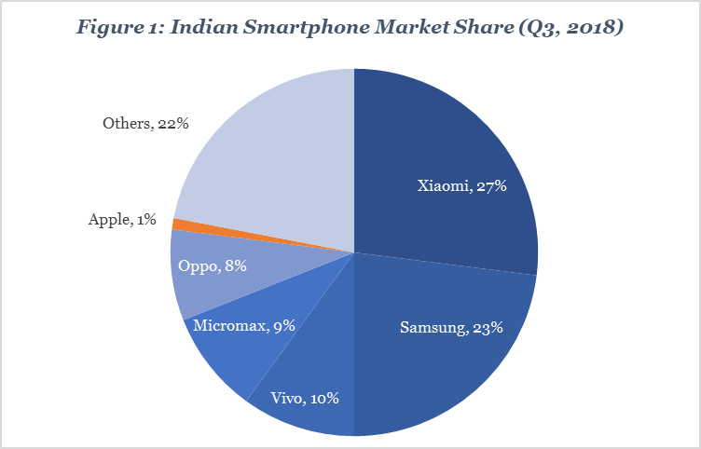.

## 7.3 Comparative Analysis of Apple's Marketing Strategies

Apple's global marketing strategies shows consistency and adaptability. In the U.S., precision and elegance is the approach, which resonates with American values. In India, adaptability and localization take center stage, aligning with the diverse cultural landscape. The four Ps – product, pricing, distribution, and promotion – seamlessly integrate global brand principles with local nuances. While premium positioning remains consistent, the strategies flexibly cater to diverse market demands. This duality underscores Apple's prowess in crafting a global brand identity while respecting and embracing the unique characteristics of each market, contributing to its sustained success on a global scale.

# 8.0 MARKETING STRATEGIES COMPARISON: U.S. VS. INDIA

|  |  |  |
| --- | --- | --- |
| **Aspect** | **United States** | **India** |
| Product Strategies | - Diverse product portfolio targeting various segments. | - Tiered portfolio catering to diverse affordability levels. |
|  | - Emphasis on innovation, design, and seamless integration. | - Localization with features like cricket scores on Siri. |
|  | - Focus on high-end models for professionals and enthusiasts. | - Strong focus on services, promoting an ecosystem beyond hardware. |
| Pricing Models | - Premium positioning with tiered pricing. | - Premium pricing for high-end iPhones, addressing affordability concerns. |
|  | - Financing options and collaborations with carriers. | - Segment-specific pricing structures for online and offline channels. |
| Distribution Channels | - Iconic Apple Stores offering a premium experience. | - Strategic offline presence with Apple Stores in major cities. |
|  | - Multi-channel distribution, including online platforms. | - Strong online focus with partnerships with e-commerce platforms. |
|  | - Strategic offline expansion in suburban and rural areas. | - Collaboration with Indian retailers and mobile carriers. |
| Promotional Activities | - Minimalist and elegant marketing. | - Localized marketing with Bollywood celebrities and regional ads. |
|  | - Targeted campaigns for different segments. | - Digital focus on social media, influencer partnerships, and online advertising. |
|  | - Celebrity endorsements and word-of-mouth marketing. | - Emphasis on the ecosystem and seamless integration in promotions. |
| Cultural Influences | - Minimalist and global approach in marketing. | - Localization efforts with tailored campaigns for Indian culture. |
|  | - Use of sleek visuals and simple messaging. | - Adaptation to Indian preferences with region-specific content. |
|  | - Celebrity endorsements aligning with global trends. | - Efforts to resolve localization issues and enhance user experience |

**Similarities:**

1. Diverse Product Portfolios: Both markets benefit from Apple's strategy of offering a diverse range of products targeting various consumer segments.
2. Premium Positioning: Apple maintains a premium brand image in both the United States and India, leveraging exclusivity and status.
3. Online Presence: Both markets experience a strong online focus, with e-commerce platforms playing a crucial role in reaching consumers.

**Differences:**

1. Localization in India: Apple adapts its product features and marketing strategies more significantly in India, considering cultural nuances and preferences.
2. Offline Expansion: While Apple Stores are iconic in the U.S., India witnesses strategic offline expansion in major cities and efforts to improve accessibility in suburban and rural areas.
3. Pricing Strategies: India sees more explicit segmentation in pricing structures, addressing the significant price sensitivity of the market.

**Adaptations:**

1. Localized Marketing in India: To gain more love and build a lasting relationship with the Indian people, Apple tailors its marketing campaigns, celebrity endorsements, and advertising content,
2. Affordability Strategies in India: Acknowledging the price-sensitive nature of the Indian market, Apple developed considerable affordability strategies, which includes budget-friendly models and partnerships for financing.
3. Offline Presence Adaptation: In India, Apple places its offline presence to fit the diverse geographical landscape, not only major cities are targeted but rural and suburban areas.

# REFERENCES

Ten Trends That Are Altering Consumer Behavior in India (2020) BCG Global. [Online] https://www.bcg.com/publications/2019/ten-trends-altering-consumer-behavior-india.

What is the USP of Apple? (n.d.) Quora. [Online] <https://www.quora.com/What-is-the-USP-of-Apple>.

Apple’s Subsidiaries: The Companies Behind the Tech Giant (n.d.) H.O.M.E. [Online] <https://h-o-m-e.org/apple-subsidiaries/>.

McCarthy, N. (2021) 20 Years On: The Global Apple Store Empire [Infographic]. Forbes. [Online] <https://www.forbes.com/sites/niallmccarthy/2021/05/14/20-years-on-the-global-apple-store-empire-infographic/>.

Apple PESTLE Analysis (2024) (2023) Business Model Analyst. [Online] <https://businessmodelanalyst.com/apple-pestle-analysis/>.

MacIsaac, D. (ed.) (2011) “iOS physics learning apps (for Apple products iPhone, iPod Touch, iPad).” The Physics Teacher. American Association of Physics Teachers (AAPT), 50(1) pp. 61–61.

Sterling, C. H. (2012) “1. CBQ REVIEW ESSAY: Steve Jobs and Apple Computer.” Communication Booknotes Quarterly. Informa UK Limited, 43(1) pp. 1–10.

Kaliannan, M. and Ponnusamy, V. (2014) “Apple was sweeter when Steve Jobs held sway.” Human Resource Management International Digest. Emerald, 22(4) pp. 25–28.

Kim, H. (2020) “Comparison of Strategic Leadership: Steve Jobs and Tim Cook.” Business and Management Studies. Redfame Publishing, 6(3) p. 17.

Shabanek, M., Kelly, S. and Plumpton, S. (2005) “Introducing the OS X spoken interface for Apple Macintosh computers.” International Congress Series. Elsevier BV, 1282, September, pp. 1061–1062.

İŞLER, F. and SEÇKİN, Z. (2023) “A research of Steve Jobs and Tim Cook’s leadership approaches.” Ömer Halisdemir Üniversitesi İktisadi ve İdari Bilimler Fakültesi Dergisi. Omer Halisdemir Universitesi, 16(3) pp. 844–858.

Apple. (2021). Apple now has 1.65 billion active devices worldwide. Retrieved January 27, 2021

Gibbs, S. (2014, December 5). Steve Wozniak: Apple starting in a garage is a myth. The Guardian. Archived from the original on April 25, 2015. Retrieved November 12, 2019.

NPR. (2006, September 29). A Chat with Computing Pioneer Steve Wozniak. Retrieved July 9, 2017

The Sydney Morning Herald. (2006, September 28). Apple co-founder tells his side of the story. Retrieved July 9, 2017.

Linzmayer, O. W. (Year of Publication not provided). Apple Confidential: The Real Story of Apple Computer, Inc. The Denver Post. Archived from the original on April 14, 2012.

Paul, P., Roy, A. and Mukhopadhyay, K. (2006) “The Impact of Cultural Values on Marketing Ethical Norms: A Study in India and the United States.” Journal of International Marketing. SAGE Publications, 14(4) pp. 28–56.

Farooq, U. (2019) Top Apple Competitors - Analysis of Apple Competitors | Marketing Tutor. Marketing Tutor. [Online] <https://www.marketingtutor.net/apple-competitors/>.

Cohan, P. (2023) Apple’s 46% Revenue Pop In India Won’t Reverse Tech Giant’s Shrinking Top Line. Forbes. [Online] <https://www.forbes.com/sites/petercohan/2023/04/25/apples-46-revenue-pop-in-india-wont-reverse-tech-giants-shrinking-top-line/>.

Greenspan, R. (2015) Apple’s Marketing Mix: 4P Analysis - Panmore Institute. Panmore Institute. [Online] <https://panmore.com/apple-inc-marketing-mix-4ps>.

Manji, D. A. (2022) “Innovation Strategies and Corporate Performance: Perspective from India.” Journal of Strategic Management. Stratford Peer Reviewed Journal & Book Publishing, 6(5) pp. 11–26.

Apple Market Entry Strategy in India - 467 Words | Studymode (n.d.) Apple Market Entry Strategy in India - 467 Words | Studymode. [Online] https://www.studymode.com/essays/Apple-Market-Entry-Strategy-In-India-914322.html.