**Analysing Income Inequality: Taxes and Transfers Impact**

# Abstract

*This study addresses the rising income disparity in wealthy countries, particularly in OECD nations, focusing on the redistributive impacts of income taxes and transfers on households. Using a subset of the Leiden LIS Budget Incidence Fiscal Redistribution Dataset covering 10 countries (Canada, Australia, China, Austria, United States, United Kingdom, France, Germany, India, Brazil) from 2000 to 2014, the research employs meticulous methodology analysing median and mean equivalized income, primary income observations, fiscal redistribution measures, and Gini coefficients. The study reveals a significant increase in income inequality over the past two decades, highlighting the urgent need for comprehensive policy considerations. It delves into the redistributive consequences of welfare state components, emphasizing the pivotal role of state survivors' and old age payments and social assistance benefits. The nuanced nature of the redistribution dilemma is underscored, emphasizing the necessity of a sophisticated analytical approach.*

**Keywords:** Income inequality, Redistributive impacts, Fiscal redistribution, Socio-economic dynamics

**JEL:** D31, H23, I38

# 1.0 INTRODUCTION

# In most wealthy countries during the past few decades, there has been a worrying trend toward rising income disparity, which is especially noticeable in OECD countries (Burkhauser *et al*., 2016). The increase in inequality that has been caused mostly by a larger variation in primary income since the mid-1980s (OECD, 2008, 2011, 2015) has drawn a lot of attention from sociologists, economists, and political scientists (Jessen,2016). One crucial factor impacting disposable income distribution is the tax-transfer system, with redistributive impacts arising from both transfers and taxes.

# In light of this, this study carefully examines how taxation and income transfers to households affect redistributive consequences. Though earlier research suggested a "welfare state retrenchment," more recent studies cast doubt on this idea, particularly those that make use of the Luxembourg Income Study (LIS) dataset. Surprisingly, most welfare states showed more attempts at redistribution in the 1980s and 1990s, which was in line with their original intent.

# The goal in this study is to add to the current conversation by concentrating on the in-depth examination of the

# redistributive effects that income taxes and transfers have on households. The Study examines the implications on income distribution explicitly using harmonized LIS data across time and countries. It is expected that social transfers will mostly help lower-class populations, while income taxes will predominantly target the wealthy, thereby affecting the redistribution of income.

# This work examines the combined effects of income taxes and transfers on income distribution by comparing pre- and post-government income using the conventional budget incidence approach. Based on preliminary findings, there appears to be a noteworthy reduction in income disparity, primarily due to social benefits. This study contributes to the greater knowledge of the complex processes of income distribution by offering both a snapshot of current inequality levels and a longitudinal analysis from 1967 to 2014.

# The goal of this study is to clarify the nuances surrounding income inequality and provide insight into how redistribution has changed over time and between nations

# 2.0 LITERATURE REVIEW

# In the last two to three decades, most OECD nations have seen a noticeable change in the distribution of household income, with an increasing tendency towards inequality. (Burkhauser *et al*., 2016). This problem affects homes headed by individuals of working age as well as the general populace. In addition to being noticeable in the highest income levels of the distribution, the growing income gaps also show up as a worrisome increase in the prevalence of extremely low incomes, which has led to a rise in relative poverty measures in a significant number of nations. (OECD, 2008a). Although there is a chance that the recent

# economic crisis would lessen the top incomes, inequality's overall trajectory remains complex. Those who were already at a disadvantage prior to the crisis includes expected to see a decline in income going forward, exacerbating already existing inequalities (OECD, 2011c; Immervoll and Peichl, 2011). Compounding these challenges, austerity measures implemented by some countries to curtail spending levels pose a significant threat to the redistributive capacity of government budgets. This historical context sets the stage for an exploration into the role and impact of government redistribution policies on the evolving landscape of income inequality, particularly focusing on "non-elderly" households (Immervoll and Richardson, 2011)

# The study by Caminada, Goudswaard, and Wang (2012) looks at social transfers, taxation, and income inequality in 20 OECD nations between the middle of the 1980s and the middle of the 2000s. Using micro-data from the Luxembourg Income Study, the study applies a sequential accounting budget incidence decomposition technique to assess home market inequality and the redistributive impact of social programs. The results show that primary household inequality has increased, with two thirds of the increase being countered by tax-benefit systems. Redistribution is greatly aided by some

# social programs, such as survivorship plans and public

# old age pensions. The research gives vital insights into emerging patterns and the effectiveness of tax-benefit regimes during this era.

# During the "welfare state retrenchment" era, pivotal studies like Caminada, Goudswaard, and Wang (2012) and van Oorschot (2006) explored the changing landscape of 20 OECD nations from the mid-1980s to the mid-2000s. They highlighted a notable rise in primary household inequality, despite the mitigating effect of tax-benefit systems, aligning with discussions on the diminishing redistributive role of welfare states. Simultaneously, van Oorschot's study on European welfare states revealed differential rationing of benefits and shifting perceptions of deservingness among citizens. The consistent pattern emerged, ranking elderly individuals as most deserving, followed by sick and disabled people, with immigrants perceived as least deserving.

# The Luxembourg Income Study (LIS) revolutionized inequality analysis. Unprecedented cross-national and chronological comparisons were made possible by its painstakingly harmonized data from several nations and historical periods. LIS standardized income criteria, adjusted for purchasing power, and imputed top incomes, assuring data comparability. This exposed alarming worldwide trends: growing economic disparity among industrialized countries, undermining earlier convergence theories. Critical conversations regarding globalization, economic policies, and their distributional effects were sparked by LIS data. It was used by researchers to assess labour laws, social programs, and tax reforms, guiding their choices with solid facts.

# 3.0 DATASET

# The Leiden LIS Budget Incidence Fiscal Redistribution Dataset on Income Inequality 2017 is a valuable resource for conducting in-depth analyses of income inequality and the redistributive impact of social transfers and taxes across 47 countries spanning the period from 1967 to 2014. This dataset, which was compiled by Jinxian Wang and Koen Caminada, provides a thorough understanding of the dynamics of income distribution and enables scholars and decision-makers to examine patterns, deviations, and the efficacy of fiscal measures during the previous 50 years. The dataset enables a comprehensive understanding of the ways in which diverse factors contribute to income inequality and the ways in which fiscal policies affect overall economic well-being. It contains thorough data on a variety of income sources, including labour and capital income, social security transfers, and taxes.

# This dataset allows researchers to analyse welfare state redistribution's causes and effects, identify best practices, and address important questions about the sources of variance in the amount and nature of redistribution across nations and over time.

# 4.0 METHODOLOGY

# Data on variables such as median and mean equivalized income, primary income observations, and fiscal redistribution measures are imported in the first stage from several worksheets. Based on particular study goals, a carefully chosen group of nations is included, including the United States, Canada, Australia, China, Austria, and others. The objective of this targeted method is to enable an in-depth examination specific to the selected group.

# Subsequently, recognizing the temporal dimension of the data. A structured framework is established using panel data methods, and within-country dynamics are captured through the use of fixed effects regression. By doing this step, the study is better able to identify trends within the selected subset. Seaborn time series data visualisations give a clear picture of how income dynamics change over

# time by graphically presenting the evolution of mean equivalized income and primary income observations for particular countries. In order to investigate the redistributive effects of social programmes comprehensively, the methodology also investigates fiscal redistribution measures and Gini coefficients by combining datasets. For selected nations, visualisations show overall fiscal redistribution measures and Gini coefficients across time, strengthening the narrative and promoting a greater comprehension of the processes underlying income inequality.

# In the next steps, the emphasis is on fine-tuning data for a focused analysis. Adjusting the 'Row Labels' column in "A2 Pivot" enables us to filter for particular nations, such as Austria, Brazil, and Germany, and extract the primary country names. Concurrently, the 'LIS Dataset' column in "A2 Budget size & Target" is adjusted with respect to nation names, and the dataset is refined to include only relevant nations such as Australia, Austria, and Brazil. The information aggregation is crucial to the analysis, especially for columns like "A2 Budget size & Target’s "Efficiency (transfers)" and "Budget size (transfers)". Mean values are determined by country grouping to provide comparative insights into the effectiveness of social transfers, encompassing nations such as Brazil, Austria, and Australia.

Fine-tuning data for a targeted analysis was the focus of the subsequent steps. The 'Row Labels' column in "A2 Pivot" can be adjusted to allow us to extract the primary

country names and filter for certain countries, such Brazil, Germany, and Austria. At the same time, the nation names in the "LIS Dataset" column of "A2 Budget size & Target" are changed, and the dataset is filtered to only contain pertinent countries like Australia, Austria, and Brazil. The analysis depends on the information aggregation, particularly for columns

like "Efficiency (transfers)" and "Budget size (transfers)" in "A2 Budget size & Target". The mean values are calculated using a country-by-country grouping that offers comparative insights into the efficacy of social transfers. This grouping includes countries like Brazil, Austria, and Australia.

The analysis extends to a time series examination of social programs, focusing on pivotal columns like 'Old-age/Disability/Survivor,' 'Sickness,' 'Family/Children,' 'Education,' 'Unemployment,' 'Housing,' 'General/food/medical assistance,' 'Other transfers,' 'Residual,' and 'Income taxes.' Employing Seaborn, the visual representation unfolds the dynamic impact of these programs on poverty and inequality across the years for countries including Canada, Australia, China, Austria, India, and Brazil. The line plots illuminate trends, offering a comprehensive understanding of how social programs evolve over time, with markers denoting distinct data points. This approach enhances clarity, enabling nuanced insights into the temporal dynamics of each program's impact.

**5.0 DISCUSSION**

The "A1 Descriptive" worksheet's descriptive statistics provide an extensive overview of the dataset, demonstrating an increasing trend in median and mean equivalency income over a range of areas and nations between 1967 and 2014. The general improvement in living standards is indicated by this upward trend in income. The in-depth analysis revealed a steady and positive increase in mean equivalized income for a few

OECD nations throughout the previous 20 years.

The steady rise in mean equivalency income highlights improvements in the state of the economy. However, the differences among nations highlight the ongoing problem of income inequality, thus it is important to proceed with caution when evaluating these developments. Not everyone has benefited equally from increased incomes

thus, more research is needed to understand the underlying causes of these differences.

**Figure 1: Variation of Mean equivalized income of selected countries across time (2000 – 2014)**

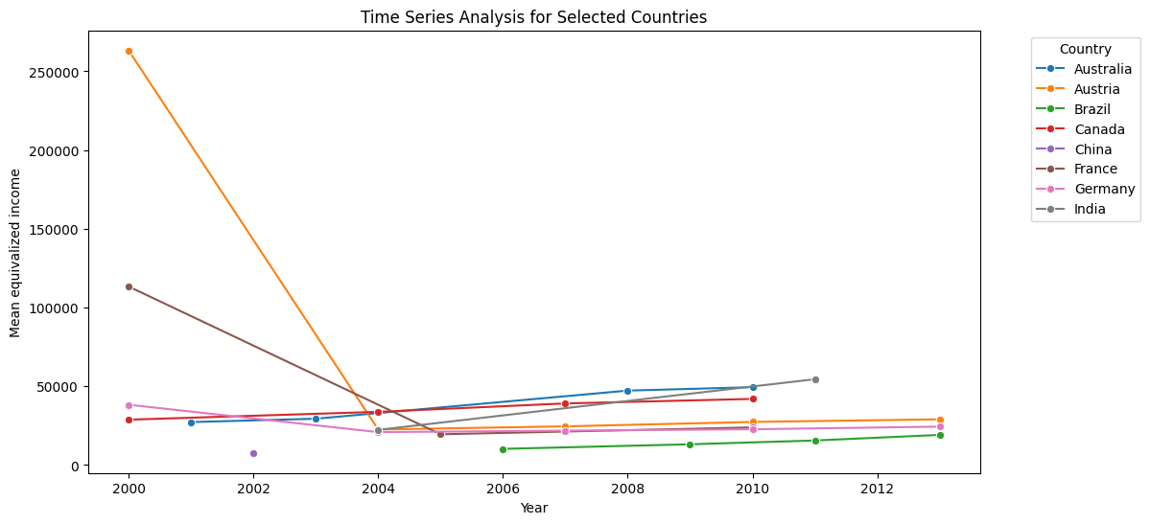

Examining patterns in main and discretionary income distribution in 20 LIS nations between 1985 and 2005, the analysis shows a significant rise in income inequality. The research, mostly based on Gini coefficients, delineates specific patterns around the years 1985, 1995, and 2005. The average saw a sharp increase in income disparity, which was especially noticeable in the first ten years. The reason for this growing disparity is an increase in the primary income distribution, which has been somewhat offset by family taxes and state cash transfers. But during the next ten years, the rise in primary income inequality corresponds with a corresponding rise in disposable income inequality, indicating a persistent problem with income distribution parity.

Notably, the data presented validates the OECD's views regarding the growing disparity in market wages among non-elderly adults. The data reveals a significant 13% increase in primary income inequality during the two-decade period when averaged across the chosen nations. The swift increase in inequality highlights the urgent need for all-encompassing policy considerations in order to address the various reasons that are contributing to this trend and to develop policies that will effectively promote a fairer distribution of income

**Figure 2: Trends of Number of Observations for Primary Income over the years**

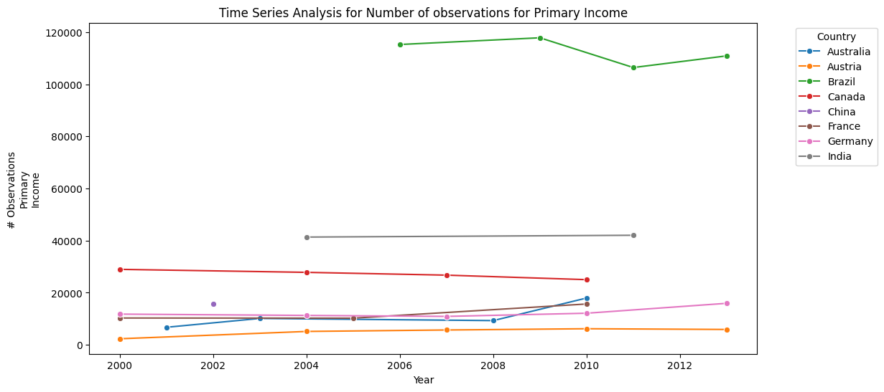

with an observed increase in income inequality over the past two decades. The Gini coefficient, representing income distribution, has risen for all countries in the selected group. Possible drivers include economic growth favouring top earners and potential policy changes, such as less progressive tax structures. This surge in income inequality poses risks, including reduced social mobility and heightened crime rates.

**Figure 3: Fiscal Redistribution over Time for Selected Countries**

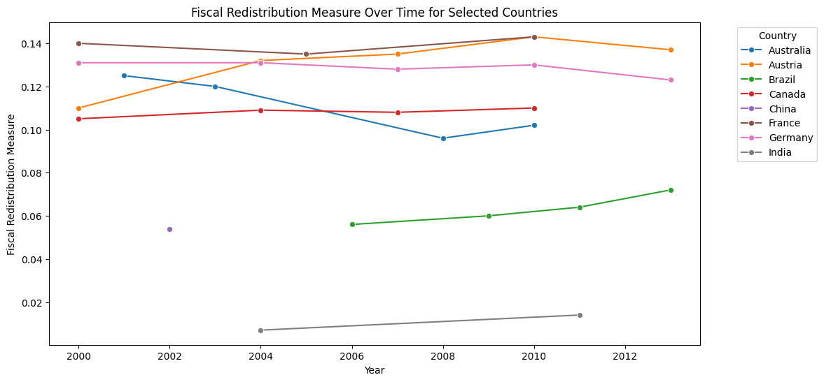

Moving on to the redistributive consequences of various welfare state components, the in-depth analysis takes a close look at 12 LIS nations over an extended period of time. State survivors' and old age payments show up as significant redistribution contributors, making up about one-third of the total and being crucial in driving up redistribution overall between 1985 and 2005. The influence of social assistance payments, which are aimed at low-income groups, and near-cash benefits on lowering income inequality is highlighted by the fact that they collectively contribute significantly to the growth in redistribution. Benefits for illness, work-related injuries, disease, and disability have different redistributive impacts in different nations, highlighting the complex relationship between welfare programmes and income distribution.

In addressing the third question on changes in the redistributive power of different social programmes over time, the study highlights the dynamic nature of these impacts. For example, during the past ten years, the state's share of old age and survivors’ payments has increased, suggesting changing trends in the ways that particular programmes affect the allocation of income. The study period observed oscillations in the redistributive effects of unemployment compensation pay-outs, highlighting the necessity of a nuanced comprehension of the temporal dynamics of social programmes.

**Table 1: Average Values of Budget size and Efficiency(transfers) from 2000 -2014**

|  |  |  |
| --- | --- | --- |
| Country | Budget size (transfers) | Efficiency (transfers) |
| Australia | 0.120125 | -0.335500 |
| Austria | 0.260000 | 0.043571 |
| Brazil | 0.205750 | 0.179500 |
| Canada | 0.146167 | -0.139000 |
| China | 0.127000 | 0.324000 |
| France | 0.262714 | 0.087286 |
| Germany | 0.189500 | -0.144083 |
| India | 0.058000 | 0.079500 |
| United Kingdom | 0.150652 | -0.161652 |
| United States of America | 0.134567 | -0.134834 |

Through analysing the redistributive impacts of many social programmes and taxation in multiple nations, we can discern trends that provide insight into the plausible existence of the "paradox of redistribution." State survivors' and old age payments stand out as important drivers of redistribution, contributing between one-third and sixty percent of the total increase in redistribution among the nations under study between 2005 and 2010. This emphasises how important pension-related benefits are in reducing income inequality. Furthermore, social assistance benefits—which are directed towards low-income populations—represent a sizable portion of the overall redistribution, accounting for 20% of the increase in redistribution. The degree to which these advantages may effectively reduce inequality varies; in the majority of countries, greater levels of inequality reduction were attained in the mid-2000s.

Contributing about 13 percent of the total rise in redistribution are the redistributive effects of compensation for disability, occupational injury and disease, and illness. Interestingly, the trends differ throughout nations, demonstrating the complex effects of these initiatives. Nonetheless, the information supplied does not make the redistribution dilemma particularly clear. The comprehensive dissection of various transfers, encompassing family benefits, indicates a heterogeneous terrain about their influence on inequality.

The role of taxes in redistribution is complex, with cross-country differences. While taxes on income became more progressive in some countries, changes in the redistributive effect of taxes are influenced by factors such as tax reforms and variations in effective income-tax rates. The paradox of redistribution, as discussed by Korpi and Palme (1998), is a nuanced phenomenon that depends on the interplay of country-specific factors, institutional frameworks, and policy mix. The information provided hints at the intricate nature of redistribution dynamics, emphasizing the need for a sophisticated analytical approach to thoroughly assess the presence of the paradox across different contexts.

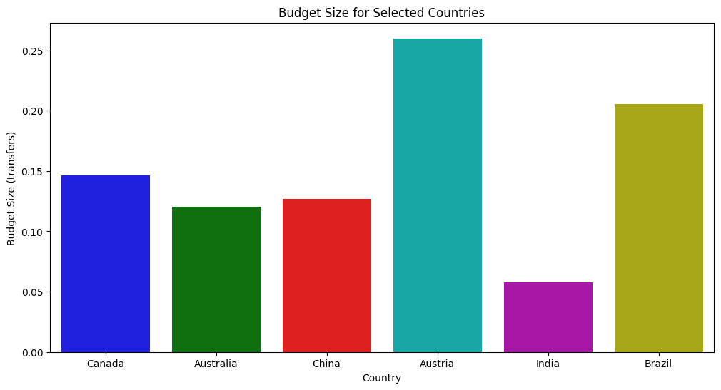

Significant differences are seen when the social benefit environment is examined between 2000 and 2014 in a number of different nations, such as Canada, Australia, China, Austria, the United States, the United Kingdom, France, Germany, India, and Brazil. The average amount of social benefits in relation to the total

In

come of the household illustrates changes throughout time. A

general growth in the size of social benefits was seen by the mid-2000s in all nations, demonstrating a shared understanding of the significance of social programmes. But there were differences in the amount and rate of this increase, with some countries like Canada and Australia exceeding others in this regard.

Targeting social assistance to the impoverished efficiently shows a variety of patterns. By the middle of the 2000s, Australia had sharpened its focus on the impoverished, while France and Germany had taken a more global stance. In the chosen nations, it seems that benefit targeting has become more effective over time. In 2005, there was a shift in the focus of transfers to the poor, especially in France, Germany, and the US, which led to concerns about the fairness of resource distribution. Further research is necessary to understand the specific policies and contextual elements driving these patterns among the chosen nations during the stated period, as well as the interplay between budget size, targeting efficiency, and their impact on inequality.

**6.0 CONCLUSION**

The findings align with the literature highlighting the widening wealth gap within countries. Governments' efforts in increasing fiscal redistribution, particularly through state old age and survivors benefits and social assistance programs, are commendable steps toward mitigating income inequality. However, the variations in the redistributive effects of different programs underscore the need for continuous evaluation and adaptation of social policies to address evolving socio-economic dynamics.

The Leiden LIS Budget Incidence Fiscal Redistribution Dataset on Income Inequality 2017 has been important in unravelling the complexity of income distribution, fisca

l policies, and social programme efficiency across 47

countries from 1967 to 2014. This study's thorough examination illuminated the changing terrain of income inequality over the previous fifty years, highlighting trends, discrepancies, and the significant influence of fiscal policies. The study examined the redistributive dynamics by breaking down different aspects of the welfare state and taxes, and it found that state survivors' and old age pay-outs, social assistance benefits, and other transfers made a big difference. The results provide a deeper understanding of the redistribution conundrum by demonstrating how context affects it and

underscoring the necessity for advanced analytical techniques to fully appreciate its nuances of income inequality and the effectiveness of social programs.

# REFERENCES

Burkhauser, R. V., Herault, N., Jenkins, S. P. and Wilkins, R. (2016) “What Has Been Happening to UK Income Inequality Since the Mid-1990s? Answers from Reconciled and Combined Household Survey and Tax Return Data.” SSRN Electronic Journal. Elsevier BV.

Jessen, R. (2016) “Why has Income Inequality in Germany Increased from 2002 to 2011? A Behavioural Microsimulation Decomposition.” *SSRN Electronic Journal*. Elsevier BV.

OECD (2008a), Growing Unequal? Income Distribution and Poverty in OECD Countries, OECD, Paris.

Immervoll, H., A. Peichl and K. Tatsiramos, eds., (2011), Who Loses in the Downturn? Economic Crisis, Employment and Income Distribution (Research in Labour Economics, Volume 32), Emerald Group Publishing Limited.

Immervoll, H. and Richardson, L. (2011) Redistribution Policy and Inequality Reduction in OECD Countries: What Has Changed in Two Decades? Redistribution Policy and Inequality Reduction in OECD Countries: What Has Changed in Two Decades? by Herwig Immervoll, Linda Richardson: SSRN. [Online].

van Oorschot, W. (2006) “Making the difference in social Europe: deservingness perceptions among citizens of European welfare states.” Journal of European Social Policy. SAGE Publications, 16(1) pp. 23–42.

Korpi, W., and J. Palme (1998), ‘The Paradox of Redistribution and Strategies of Equality: Welfare State Institutions, Inequality, and Poverty in the Western Countries’, American Sociological Review 63: 661-687