THE USE OF SIMULATIONS IN INVESTMENT DECISION- MAKING AND FINANCING

**Abstract**

The economic efficiency and financial stability of a significant investment project can directly affect the success and long-term viability of the company. The proposed approach innovatively integrates Monte Carlo simulation techniques into traditional investment and financing decision-making. The investment assessment is based on simulations. The evaluation process begins by determining the economic efficiency of the project and its financial stability using the financial criterion Net Present Value (*NPV*) for different project financing variants – expressed by different ratios between own resources and external resources. This is followed by a risk assessment of the input variables affecting the *NPV*. The profitability is maximized by optimizing the production program using the OptQuest tool. The maximum loan interest rate using simulations at different interest rates is determined in the last step. The proposed approach is practically unknown and not applied in business practice. The risk assessment inclusion in investment decision-making and long-term financing should become an integral part of business practice.

**Key Words:** Economic Efficiency of Investments, Monte Carlo Simulation, Risk, Optimization

# INTRODUCTION

In general, the project investment decision-making includes an investment plan made for investment and investment return [1]. The basis of investment decision-making is the calculation of selected criteria for its economic efficiency [2]. Economic efficiency of investment projects refers to its ability to generate positive returns and benefits that outweigh the costs incurred over a given period. Several researchers [3-6] use the Net Present Value (*NPV*) in its evaluation, while others try to adapt it to specific needs [7-9]. In this context, determination of cash flows of investment projects plays a key role in their evaluation [2]. The financial stability of the project is closely related to its economic efficiency, it is the ability of the project to maintain financial flows and withstand financial challenges [6]. It is an important aspect of project management, as the financial stability of the project directly affects the success and long-term viability of the company [10].

There could be different approaches when deciding on investing in production. Deterministic approach can be used where the future is assumed to be predictable, outputs are non-random [11]. Also, for large investment projects sensitivity analysis is an important tool to determine which factors need further analysis and/or can jeopardize the future of a project [12]. In addition, McWilliam [13] claims in his research study that the values of uncertain but non- random parameters can have a deterministic character also. An alternative to the deterministic approach is the stochastic approach, dealing with randomness, which considers uncertainty and the probability of future events, allowing investors to work with a range of possible

outcomes. This way, it is possible to deal better with uncertainty and risks in investment decisions. Herraiz-Cañete et al. [14] concluded in their research study that for the advanced phases of the project, the stochastic approach is recommended.

Hu and Chen [1] declare in their study that with the development of project investment decision-making management, the influence of a single factor should be considered, along with the influence of interrelated and mutual restricting factors for project investment decision- making. They have used a stochastic approach and an expert evaluation of the identified factors in their stochastic multicriteria decision-making model. Expert systems are gaining popularity in many fields of human activity [15, 16]. The systems can be applied in estimations, for example, for estimating fuzzy linear regression model parameters [17] or in probabilistic risk assessment [18]. The general project risk has been managed with the help of expert system already in 2003 [19]. Santos et al. [20] also dealt with the multi-stage stochastic investment planning model for making investment decisions under uncertainty in their study. One of their goals and results was the minimization of the *NPV* of costs.

Several researchers have used Monte Carlo simulation in stochastic modelling. DiCesare et al. [21] successfully applied Monte Carlo simulation modelling together with return on invested capital operational mapping in healthcare facility. An inspirational source for this article is the methodology designed and verified in a research study [22]. Its authors used the Monte Carlo method as part of stochastic modelling to simulate the financial risks of investment activities of companies. Another example of the use of the Monte Carlo simulation technique are public- private partnership projects examined by Han et al. [23]. The application of the Monte Carlo method to the optimization of industrial production is evident from several studies. It was also used by the authors in a research study dealing with the optimization of the food industry production [24], energy production [25], and production of the zirconium isotope 89Zr [26].

Another important thing when deciding on investments is the method of financing. Companies have two basic options: to use their own financial resources or external re-sources. Several authors state that currently there is no single approach to choosing the optimal ratio of equity and debt capital [27]. Debt-to-equity ratio in project investment valuation was also researched by Nukala and Rao [28]. In order to determine the advantage of using equity capital or debt capital, it is necessary to know the price of equity capital, derive the marginal interest rate and compare it with the price of debt capital (loan interest rate). The marginal interest rate can be found by stochastic approach using Monte Carlo simulations [29]. To complete the overall picture, even if this article mainly uses the financial aspect when deciding on an investment project, it is necessary to state that this may not always be the case. For example, as reported by Carr et al. [30], it should be noted that evidence from field studies suggests that investment decisions are not always primarily based on financial considerations. The study by Sawhney [31] was also processed in this context. He investigated investments in advanced manufacturing technology that are heavily influenced by non-financial considerations.

As already mentioned, this article deals with assessment of economic efficiency and financial stability of an investment project. The investment project is designed for a manufacturing industrial company and is about expanding production with new products (straight and rotary knives) that the company could offer to the market as part of an expanded product portfolio. The aim of the article is to use a modern stochastic approach in evaluating the economic efficiency of an investment project, in optimizing the production program and in deciding on the form of its financing (own resources vs. external resources). A significant contribution and novelty of this article is that the proposed stochastic approach is practically unknown and unapplied in the business practice, while it is very important to include the risk criterion in real decision-making.

# MATERIAL AND METHODS

## Problem description

The basis for the assessment of economic efficiency and financial stability is an investment project with a development character aimed at complex technical and technological equipment of the premises of the already existing production hall. The purpose of the project is to achieve a better position of the company on the market by expanding the current product portfolio. This will be achieved by introducing the production of new straight and rotary knives for industrial purposes. Also, the purpose is to increase the employment in the region. There is a demand for new products on the market. Long-term orders with an annual volume (the so-called lower limit) of 3,000 pieces for straight and rotary knives have been placed.

## Methodology for investment assessment

The goal is to present a modern way of assessing the economic efficiency of an investment project and of its financing using a software tool based on Monte Carlo simulations. It is aimed at maximizing the profitability of the project, which is monitored by the financial criterion of Net Present Value (*NPV*). The methodological procedure is in accordance with the set goal and is divided into four steps (see Fig. 1).

Figure 1: Methodology for solving the investment problem.

In the first step, the economic efficiency and financial stability of the investment project is comprehensively assessed in terms of its profitability using the *NPV* financial criterion. When determining profitability, it is based on the most probable values of the input variables. Economic efficiency is expressed by the financial criterion *NPVE*, hereinafter referred to as *NPV*_100 % E. Consideration of the method of financing is included in the *NPV* calculation, which takes into account the interest tax shield.

In the second step, the risk of the investment project is analysed using stochastic approach. Risk analysis is carried out using the Monte Carlo simulation method. This approach is based on a stochastic model in which probability distributions are defined for individual input risk variables. The resulting profitability is expressed by the mean *NPV* and other statistical data.

In the third step, the task is to maximize the profitability of the investment project by optimizing the production program. Production optimization is carried out using the OptQuest tool. The result of both approaches is such a production program that maximizes the mean *NPV* of the assessed investment project.

The fourth step is aimed at defining the interest rate of the loan, which would represent a turning point in the method of financing the investment project, where the use of external financial resources (under the given conditions) becomes more advantageous than internal financial resources. When determining the so-called marginal interest rate, Monte Carlo simulations are used.

# RESEARCH RESULTS AND INTERPRETATION

## 3.1 Economic efficiency and financial stability of the project

The assessment of the economic efficiency of the project in terms of its profitability is carried out using the financial criterion *NPVE*, which considers the time value of money. The method of calculating the *NPVE* financial criterion is presented using the Eqs. (1) to (4).

𝑁

|  |  |
| --- | --- |
| 1  𝑁𝑃𝑉𝐸 = ∑ 𝐶𝐹𝑛 ∙ (1 + 𝑟 )𝑛 − 𝐼𝐶  𝑛=1 𝑑 | (1) |
| 2 2  𝐶𝐹𝑛 = (∑ 𝑆𝑛𝑗 − ∑ 𝐶𝑛𝑗) ∙ (1 − 𝑇𝑛) + (𝐷𝑛 ∙ 𝑇𝑛) − ∆𝑁𝐶𝑊𝐶𝑛  𝑗=1 𝑗=1 | (2) |
| 2 2  𝑆𝑛 = ∑(𝑝𝑛𝑗 ∙ 𝑝𝑣𝑛𝑗) − ∑(𝑝𝑛𝑗 ∙ 𝑝𝑣𝑛𝑗 ∙ 𝑓𝑛𝑗)  𝑗=1 𝑗=1 | (3) |
| 2  𝐶𝑛 = ∑(𝑐𝑛𝑗 ∙ 𝑝𝑣𝑛𝑗) + 𝐶𝐸𝑛 + 𝑃𝐸𝑛 + 𝐶𝑅𝑎𝑀𝑛 + 𝐶𝑜𝑡ℎ𝑒𝑟 𝑛  𝑗=1 | (4) |

Where: *CFn* – cash flow in year *n*; *n* – number of years of life of the investment; *N* – life of the investment; *rd* – discount rate coefficient; *IC* – investment costs; *S* – sales; *C* – costs; *j* – product range (A, B); *D* – depreciation; *T* – income tax rate; *NCWC* – non-cash working capital; *p* – price of product; *c* – average material costs; *pv* – physical volume of material consumption; *f* – forfeit or waste of material; *CE* – energy consumption; *PE* – personal expenses; *CRaM* – repair and maintenance costs, *Cother* – other costs and *DPB* – discounted payback period.

The assessment of financial stability considers the method of financing the investment project. This means that the project can be financed using both internal and external financial resources. In this case, an external financial source means a long-term bank loan with a 6-year maturity. Repayment of the loan is planned once a year, always at the end of the year in the form of an annuity. The choice of the form of financing an investment project is influenced by key factors such as the prices of equity (own capital) and debt capital.

The assessment of the financial stability of the project is carried out with four alternatives of financing, in the ratio of own capital to debt capital as follows: 75 % : 25 %; 50 % : 50 %; 25 % : 75 %; 0 % : 100 %. Financing options are assessed using *NPV*, which considers the interest tax shield. It is the amount that the company saves on income tax due to the payment of interest on debt capital. The interest tax shield has the character of perpetuity, it is repeated every year and its current value is determined by capitalization. The current value of the interest tax shield increases the profitability of an investment project using a loan compared to the profitability of a project that is financed only with internal resources. Considering the taxation of investment income (with other assumptions unchanged), along with increasing debt ratio, the average total cost of capital decreases and both the financial performance of equity (own capital) and the financial performance of the investment expressed – by the *NPV* financial criterion – increase. The method of calculation is presented using Eqs. (5) to (8).

|  |  |
| --- | --- |
| 𝑁𝑃𝑉 = 𝑁𝑃𝑉𝐸 + 𝑃𝑉 𝑇𝑆 | (5) |
| 𝑇𝑆 = 𝐷 ∙ 𝑟𝑑 ∙ 𝑟𝐷 | (6) |
| 𝐸 𝐷  𝑟𝑑 = 𝑟𝐸 ∙ 𝐸 + 𝐷 + 𝑟𝐷 ∙ (1 − 𝑇) ∙ 𝐸 + 𝐷 | (7) |

𝑛=1

|  |  |
| --- | --- |
| 𝑃𝑀  1  𝑃𝑉 𝑇𝑆 = ∑ 𝑇𝑆𝑛 ∙ (1 + 𝑟 )𝑛  𝑑 | (8) |

Where: *TS* – a tax shield; *PV TS* – present value of tax shield; *rE* – cost of equity capital;

*E* – equity capital; *rD* – cost of debt capital; *D* – debt capital; *PM* – debt maturity period.

Table I: Selected input variables to *NPV* calculation.

|  |  |  |  |
| --- | --- | --- | --- |
| **Input variables** | **Unit** | **Value** | |
| **Straight knives** | **Rotary knives** |
| Planned production | pcs/year | 9,200 | 5,000 |
| Average production time | h/pcs | 0.25 | 0.35 |
| Price | EUR/pcs | 3,500 | 4,250 |
| Average material consumption | kg/pcs | 35.2 | 20.5 |
| Nominal time of the line | h/year | 4,200 | |
| Operating time of the line | h/year | 4,032 | |
| Number of shifts | day | 2 | |
| The length of a shift | h/shift | 8 | |
| Income tax | % | 21 | |
| Cost of own capital/equity | % | 12 | |
| Cost of debt capital (interest rate) | % | 10.9 | |
| Investment costs | EUR | 28,670,000 | |

Table I shows the input variables needed to calculate the financial criterion *NPV*. The *NPV* values for individual financing alternatives, including financing with 100 % own capital, are shown in Table II.

Table II: NPV for selected project financing alternatives.

|  |  |  |  |  |  |  |
| --- | --- | --- | --- | --- | --- | --- |
| **Financial criterion** | **Unit** | **Share of internal and external financial resources** | | | | |
| 100 % own  capital/ 0 % debt capital | 75 % own  capital/ 25 % debt capital | 50 % own  capital/ 50 % debt capital | 25 % own  capital/ 75 % debt capital | 0 % own  capital/ 100 % debt capital |
| *NPV* | EUR | 15,484,428 | 16,307,876 | 17,164,776 | 18,056,881 | 18,986,054 |

Under the stated input conditions, with 100 % financing of the project from internal financial resources, the profitability of the investment project expressed through the financial criterion of *NPV* was reached in the amount of EUR 15,484,428. With 100 % financing of the project from external financial resources up to EUR 18,986,054. Under the given conditions, it is clear from the calculated values that it is most advantageous to finance the investment entirely from a loan. This is relatively rare, because banks and financial institutions generally require the participation of companies in the co-financing of investment projects.

## 3.2. Investment project risk analysis

Risk analysis is carried out using Monte Carlo simulations. Monte Carlo simulations represent a repeated recalculation of the output variable – in this case, the *NPV* financial criterion – based on a mathematical model that does not consist of deterministic variables, but of stochastic variables. Their stochastic character is determined by a probability distribution that expresses the variability of each input variable. In this case study, an expert estimate of the development of selected input variables is applied, the change of which is realistically expected and can significantly affect the *NPV*. Selected risk input variables and their probability distributions are presented in Table III.

Monte Carlo simulation performed 10,000 recalculations of the *NPV* indicator. The output was obtained in the form of a histogram, which presents the probabilistic nature of *NPV* forecasts, i.e., mean *NPV* for individual financing alternatives.

Table III: Distribution function of selected input variables.

|  |  |  |  |
| --- | --- | --- | --- |
| **Risk factor** | **Unit** | **Statistical characteristic** | **Probability distribution** |
| Price of straight knives | EUR/pcs | Likeliest 3,500; Min. 3,300;  Max. 3,800 | Triangular |
| Labour intensity required to produce rotary knives | standard hours/pcs | Mean 0.35; Std. Dev. 0.03 | Normal |
| Price of rotary knives | EUR/pcs | Likeliest 4,250; Min. 4,100;  Max. 4,300 | Triangular |
| Average price of material | EUR/kg | Likeliest 98; Min. 95;  Max. 108 | Triangular |
| Material consumption in the production of straight knives | kg/pcs | Likeliest 35.2; Min. 35;  Max. 37 | BetaPERT |
| Material consumption in the production of rotary knives | kg/pcs | Likeliest 20.5; Min. 20;  Max. 21.5 | BetaPERT |

Figure 2: Overlay chart of mean *NPV* by financing alternatives and statistical characteristics.

Fig. 2 shows an overlay graph in cumulative numbers, which presents the mean *NPV* of individual financing alternatives according to their size, from left to right = from the lowest to

the highest. Part of Fig. 2 is a table with statistical characteristics of individual investment financing alternatives. Mean *NPV* varies from EUR 12,604,276 (when financing only from own capital) to EUR 15,844,110 (when financing only from debt capital).

Risk analysis consists of assessing the uncertainty of achieving the goal based on selected indicators. A useful tool can be a sensitivity analysis, the result of which is the identification of the input variables that have the greatest impact on the uncertainty of the output, i.e. to what extent the uncertainty of the input variable is reflected in the uncertainty of the output. The sensitivity analysis itself is based on the outputs of Monte Carlo simulations, and it shows the risk variables in descending order from the most serious to the least serious in the form of a bar diagram. Fig. 3 shows the output of the sensitivity analysis showing the five input variables having the greatest impact on the uncertainty of the *NPV* output. The output is shown for the financing alternative: 100 % equity (only own capital used) on the left side of the figure, and 0 % equity (no own capital used) on the right side of the figure, i.e., 100 % external financial resources. In both cases, the most risky input variables are: the price of the material and the price of straight knives. The uncertainty of the price of the material contributes to the uncertainty of the output by almost 52 %. It is a cost item therefore it is shown on the left (negative) side of the graph.

Considering that the influence of risk variables on the uncertainty of the output is the same in both alternatives, we assume that the form of financing has no effect on the riskiness of the input variables. Other statistical parameters also indicate the uncertainty of the output, e.g., standard deviation or coefficient of variation, which can be found in the table in Fig. 2.

Figure 3: Sensitivity analysis for *NPV* (100 % E; 0 % E).

## 3.3. Optimization of the production plan

The aim of optimization is to create such a production program that the profitability of the investment will be as high as possible, i.e., in order to maximize the economic efficiency and financial stability of the investment measured by the *NPV* financial criterion. At the same time, all restrictive conditions regarding time and market limits as well as contractual obligations must be respected. The optimized variables, called decision variables, are the produced volumes of straight knives (Q straight) and rotary knives (Q rotary).

On the other hand, optimization constraints refer to the upper and lower limits of produced volumes. The lower limits, for example, are set out based on the contractually agreed quantities with the customers, and the upper limits usually are based on the market estimate in terms of the maximum amount that can be sold on the market per year. Another limiting factor is the time fund. Therefore, the time required for production must not be longer than the effective time fund of production equipment. The set parameters of optimization are presented in Table IV.

Table IV: Optimization conditions and constraints.

|  |  |  |  |
| --- | --- | --- | --- |
| **Optimization conditions** | | **Constraints for optimization** | |
| Optimization goal | mean *NPV* maximization | Q straight knife | min. 3,000 pcs,  max. 12,000 pcs |
| Simulation trials | 1,000 | Q rotary knife | min. 3,000 pcs,  max. 6,000 pcs |
| Decision variables | Q straight, Q rotary | The time needed for production | ≤ *Tef*. |

With Monte Carlo simulations, it is possible to optimize the production program using the OptQuest – an additional program of Crystal Ball. In this way, the uncertainty of the input variables and their stochastic character defined by the probability distribution are considered during the optimization. The output of the simulation is the optimal value of decision variables (the number of straight knives and rotary knives), including statistical indicators describing the probabilistic nature of this output. The optimization output is shown in Fig. 4, where the Performance Chart presents all the solutions that were obtained by Monte Carlo simulations, while the best result is the optimal value of the manufactured number of products. It can be seen from the table under the Performance Chart that it is optimal to produce 3,212 pieces of rotary knives and 12,000 pieces of straight knives.

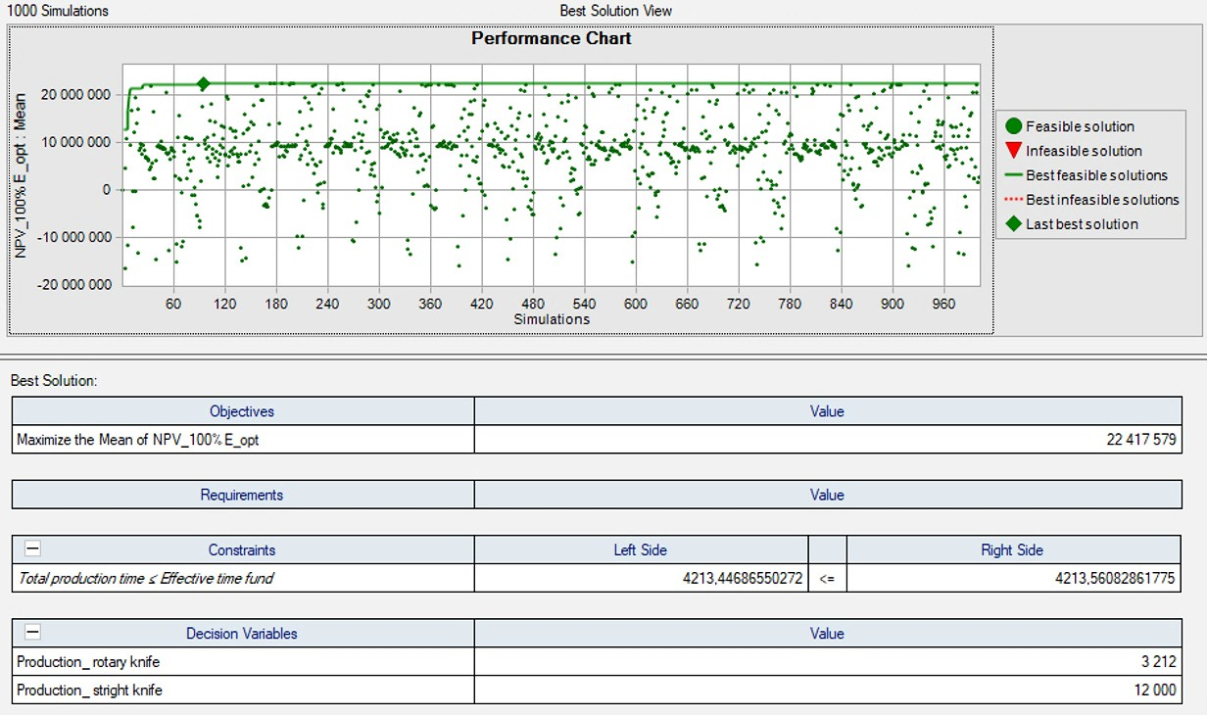

Figure 4: The output of the optimization of the production program with financing 100 % from own capital.

Fig. 5 shows the *NPV* histogram for the optimally determined volume of production when financing the project only with equity (own capital). Mean *NPV* is more than EUR 22.4 mil., which means that by setting production to this optimal number, with a probability of 89.97 %, a higher value of mean *NPV* will be achieved than with the original production program.

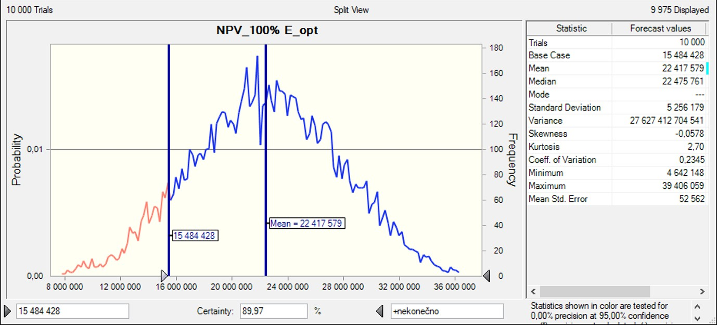

Figure 5: *NPV* histogram for optimized production program (100 % equity financing – own capital).

## 3.4 Determination of the marginal interest rate of debt capital

It is clear from the previous analysis that it is better to finance the given investment (at the fixed price of own capital 12 % and debt capital 10.9 % per annum) from external financial resources. The question in the optimization of financing is the level of the interest rate of the loan at which this ratio will be reversed, and the financing of the investment from own capital will be more effective.

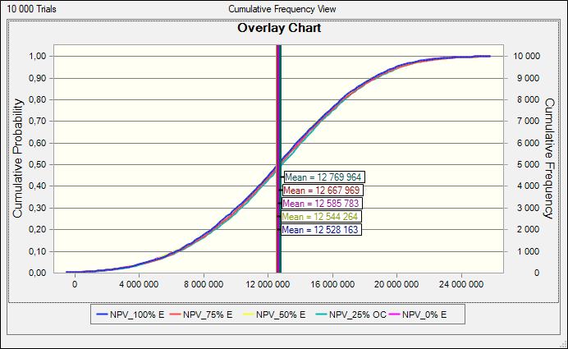

Figure 6: Cumulative overlay chart at the marginal interest rate of debt capital.

Given that the assessed financial criterion is *NPV* – the interest tax shield is taken into account in its calculation and at the same time the stochastic nature of the input variables is considered – this marginal interest rate was determined by repeated simulations at different loan interest rates. The marginal interest rate of debt capital was confirmed as 15.6 % per annum. It is the rate at which the mean *NPV* is the same for all financing variants (Fig. 6). The achieved profitability from the investment does not depend on the form of financing. A further increase in the interest rate favours using equity capital instead of debt capital.

# CONCLUSION

Deciding on an investment and the method of financing the investment is among the activities that significantly affect the future economic and financial stability of the company. The article aimed to present a modern way of assessing investment projects and their financing using Monte Carlo simulations. In the case study presented, we demonstrate the application of Monte Carlo simulations in a few steps. First, the economic efficiency of the investment was assessed, and the risk factors were considered. The economic efficiency of the investment was assessed by the dynamic method – using the *NPV* financial indicator. The *NPV* indicator was evaluated for five financing variants with different ratios of own/debt capital. *NPV* increased with the increase in the share of debt capital. The advantage of external financial sources was supported not only by a lower interest rate but also by an interest tax shield. The second step was to optimize the production program to maximize *NPV*. The aim of the optimization was to determine the production program that would achieve maximum *NPV* while respecting production and market constraints. The last step was to identify the marginal interest rate of debt capital, at which the mean *NPV* is the same for all financing variants. The marginal interest rate represents the maximum interest rate at which debt capital is more advantageous than own capital. The marginal interest rate was confirmed through repeated simulations at different interest rates.

The novelty of the article lies in the application of a modern approach, based on Monte Carlo simulations, to the evaluation of the economic efficiency of the investment, in the optimization of the production program, and in deciding on the form of financing of the investment project. In the applied approach, simulations were used to consider the simultaneous impact of the uncertainty of many input variables on the final *NPV* criterion, determining the optimal production volume and deciding on the form of project financing. Simulation software based on Monte Carlo simulations is a progressive tool for the decision-making process. For this reason, future research intends to use simulations in further areas, e.g., forecasting input variables, demand, and prices.

The research contributes to the research field by innovatively integrating Monte Carlo simulation techniques into traditional investment and financing decision-making. It extends static risk assessments by incorporating dynamic factors. Practical demonstration of that approach through the real-world case study allows practitioners to easily implement Monte Carlo simulations for investment efficiency assessment, risk analysis, and financing decision- making. The limits of this approach lie in the reliability of the results. These directly depend on the quality of the risk assessment, the uncertainty definition, and the interpretation of the results. All this hangs on the assessor's expertise, knowledge of the issue, and knowledge of working with the software tool. The use of a simulation software tool without a relevant knowledge background would not be sufficient to improve the quality of the decision-making process.

**ACKNOWLEDGEMENTS**

This paper was developed within the projects: APVV-21-0120, KEGA 010ŽU-4/2023, KEGA 005TUKE-4/2022, APVV-19-0418, APVV-21-0195, and project with ITMS code: 313011T567.

**REFERENCES**

1. Hu, J.; Chen, C. (2021). Exploration of normal stochastic multicriteria decision-making and legal dilemma in project investment, *Mathematical Problems in Engineering*, Vol. 2021, Paper 1082186, 10 pages, doi[:10.1155/2021/1082186](https://doi.org/10.1155/2021/1082186)
2. Bartošová, V.; Majerčák, P.; Hrašková, D. (2015). Taking risk into account in the evaluation of economic efficiency of investment projects: traditional methods, *Procedia Economics and Finance*, Vol. 24, 68-75, doi[:10.1016/s2212-5671(15)00614-0](https://doi.org/10.1016/s2212-5671(15)00614-0)
3. Marchioni, A.; Magni, C. A. (2018). Investment decisions and sensitivity analysis: NPV- consistency of rates of return, *European Journal of Operational Research*, Vol. 268, No. 1, 361- 372, doi[:10.1016/j.ejor.2018.01.007](https://doi.org/10.1016/j.ejor.2018.01.007)
4. Mellichamp, D. A. (2019). Profitability, risk, and investment in conceptual plant design: optimizing key financial parameters rigorously using *NPV%*, *Computers & Chemical Engineering*,

Vol. 128, 450-467, doi[:10.1016/j.compchemeng.2019.04.016](https://doi.org/10.1016/j.compchemeng.2019.04.016)

1. Garcia, R. C.; Contreras, J.; Correia, P. F.; Muñoz, J. I. (2010). Transmission assets investment timing using net present value curves, *Energy Policy*, Vol. 38, No. 1, 598-605, doi[:10.1016/](https://doi.org/10.1016/j.enpol.2009.10.012) [j.enpol.2009.10.012](https://doi.org/10.1016/j.enpol.2009.10.012)
2. Lee, H.-Y. (2011). An integrated model for planning development projects using ACO and construction simulation, *Civil Engineering and Environmental Systems*, Vol. 28, No. 4, 285-300, doi[:10.1080/10286608.2011.604415](https://doi.org/10.1080/10286608.2011.604415)
3. Espinoza, D.; Morris, J. W. F. (2013). Decoupled NPV: a simple, improved method to value infrastructure investments, *Construction Management and Economics*, Vol. 31, No. 5, 471-496, doi[:10.1080/01446193.2013.800946](https://doi.org/10.1080/01446193.2013.800946)
4. Kopczewska, K. (2016). Efficiency of regional public investment: an NPV-based spatial econometric approach, *Spatial Economic Analysis*, Vol. 11, No. 4, 413-431, doi[:10.1080/](https://doi.org/10.1080/17421772.2016.1217346) [17421772.2016.1217346](https://doi.org/10.1080/17421772.2016.1217346)
5. Dobrowolski, Z.; Drozdowski, G. (2022). Does the net present value as a financial metric fit investment in green energy security?, *Energies*, Vol. 15, No. 1, Paper 353, 16 pages, doi[:10.3390/en15010353](https://doi.org/10.3390/en15010353)
6. Suhányi, L.; Suhányiová, A.; Korečko, J.; Bednárová, L.; Kádárová, J.; Derkawi, H.; Bačová, K. (2021). Relations between the inflow of foreign direct investments and economic indicators in OECD countries, *Acta Montanistica Slovaca*, Vol. 26, No. 4, 810-824, doi[:10.46544/ams.v26i4.17](https://doi.org/10.46544/ams.v26i4.17)
7. Yang, H.; Choi, S. G. (2019). Deterministic system analysis to guarantee worst case performance for optimal ESS and PV sizing, *IEEE Access*, Vol. 7, 98875-98892, doi[:10.1109/](https://doi.org/10.1109/access.2019.2903313) [access.2019.2903313](https://doi.org/10.1109/access.2019.2903313)
8. Van Groenendaal, W. J. H.; Kleijnen, A. P. C. (1998). Identifying important factors in deterministic investment problems using design of experiments, *Proceedings of the 1998 Winter Simulation Conference*, 713-718, doi[:10.1109/WSC.1998.745055](https://doi.org/10.1109/WSC.1998.745055)
9. McWilliam, S. (2001). Anti-optimisation of uncertain structures using interval analysis, *Computers & Structures*, Vol. 79, No. 4, 421-430, doi[:10.1016/s0045-7949(00)00143-7](https://doi.org/10.1016/s0045-7949(00)00143-7)
10. Herraiz-Cañete, Á.; Ribó-Pérez, D.; Bastida-Molina, P.; Gómez-Navarro, T. (2022). Forecasting energy demand in isolated rural communities: a comparison between deterministic and stochastic approaches, *Energy for Sustainable Development*, Vol. 66, 101-116, doi[:10.1016/](https://doi.org/10.1016/j.esd.2021.11.007) [j.esd.2021.11.007](https://doi.org/10.1016/j.esd.2021.11.007)
11. Rutkauskas, A. V.; Stasytytė, V. (2020). Stochastic informative expert system for investment, *Journal of Business Economics and Management*, Vol. 21, No. 1, 136-156, doi[:10.3846/](https://doi.org/10.3846/jbem.2020.11768) [jbem.2020.11768](https://doi.org/10.3846/jbem.2020.11768)
12. Ordu, M. (2022). A simulation-based decision-making approach to evaluate the returns on investments, *International Journal of Simulation Modelling*, Vol. 21, No. 3, 441-452, doi[:10.2507/IJSIMM21-3-609](https://doi.org/10.2507/IJSIMM21-3-609)
13. İçen, D.; Günay, S. (2019). Design and implementation of the fuzzy expert system in Monte Carlo methods for fuzzy linear regression, *Applied Soft Computing*, Vol. 77, 399-411, doi[:10.1016/](https://doi.org/10.1016/j.asoc.2019.01.029) [j.asoc.2019.01.029](https://doi.org/10.1016/j.asoc.2019.01.029)
14. Yazdi, M.; Hafezi, P.; Abbassi, R. (2019). Methodology for enhancing the reliability of expert system applications in probabilistic risk assessment, *Journal of Loss Prevention in the Process Industries*, Vol. 58, 51-59, doi[:10.1016/j.jlp.2019.02.001](https://doi.org/10.1016/j.jlp.2019.02.001)
15. Ahuja, A.; Rödder, W. (2003). Project risk management by a probabilistic expert system, Leopold- Wildburger, U.; Rendl, F.; Wäscher, G. (Eds.), *Operations Research Proceedings 2002*, Springer,

Berlin, 329-334, doi[:10.1007/978-3-642-55537-4_53](https://doi.org/10.1007/978-3-642-55537-4_53)

1. Santos, S. F.; Fitiwi, D. Z.; Bizuayehu, A. W.; Shafie-Khah, M.; Asensio, M.; Contreras, J.; Cabrita, C. M. P.; Catalao, J. P. S. (2017). Novel multi-stage stochastic DG investment planning with recourse, *IEEE Transactions on Sustainable Energy*, Vol. 8, No. 1, 164-178, doi[:10.1109/tste.2016.2590460](https://doi.org/10.1109/tste.2016.2590460)
2. DiCesare, R.; Toor, J.; Wolfstadt, J.; Raveendran, L.; Chung, S.; Rampersaud, R.; Milner, J.; Koyle, M. (2021). Using return on investment operational and Monte Carlo modeling techniques to predict financial performance in a tertiary care outpatient clinic, *Urology Practice*, Vol. 8, No. 4, 487-494, doi[:10.1097/upj.0000000000000235](https://doi.org/10.1097/upj.0000000000000235)
3. Tobisova, A.; Senova, A.; Rozenberg, R. (2022). Model for sustainable financial planning and investment financing using Monte Carlo method, *Sustainability*, Vol. 14, No. 14, Paper 8785, 18 pages, doi[:10.3390/su14148785](https://doi.org/10.3390/su14148785)
4. Han, Z.; Porras-Alvarado, J. D.; Sun, J.; Zhang, Z. (2017). Monte Carlo simulation-based assessment of risks associated with public-private partnership investments in toll highway infrastructure, *Transportation Research Record: Journal of the Transportation Research Board*,

Vol. 2670, No. 1, 59-67, doi[:10.3141/2670-08](https://doi.org/10.3141/2670-08)

1. Koroteev, M.; Romanova, E.; Korovin, D.; Shevtsov, V.; Feklin, V.; Nikitin, P.; Makrushin, S.; Bublikov, K. V. (2022). Optimization of food industry production using the Monte Carlo simulation method: a case study of a meat processing plant, *Informatics*, Vol. 9, No. 1, Paper 5, 18 pages, doi[:10.3390/informatics9010005](https://doi.org/10.3390/informatics9010005)
2. Wang, Y.; Liu, J.; Han, Y. (2020). Production capacity prediction of hydropower industries for energy optimization: evidence based on novel extreme learning machine integrating Monte Carlo, *Journal of Cleaner Production*, Vol. 272, Paper 122824, 8 pages, doi[:10.1016/](https://doi.org/10.1016/j.jclepro.2020.122824) [j.jclepro.2020.122824](https://doi.org/10.1016/j.jclepro.2020.122824)
3. Alfuraih, A.; Alzimami, K.; Ma, A. K.; Alghamdi, A. (2013). Optimization of 89Zr production using Monte Carlo simulations, *Journal of Radioanalytical and Nuclear Chemistry*, Vol. 296, No. 2, 1025-1029, doi:[10.1007/s10967-012-2074-6](https://doi.org/10.1007/s10967-012-2074-6)
4. Bondina, N.; Bondin, I.; Pavlova, I.; Gulina, A. (2022). Methodological approaches to optimizing the structure of owned and loan capital of agricultural enterprises, *Scientific Papers Series Management, Economic Engineering in Agriculture & Rural Development*, Vol. 22, No. 2, 129- 135
5. Nukala, V. B.; Presada Rao, S. S. (2021). Role of debt-to-equity ratio in project investment valuation, assessing risk and return in capital markets, *Future Business Journal*, Vol. 7, No. 1,

Paper 13, 23 pages, doi[:10.1186/s43093-021-00058-9](https://doi.org/10.1186/s43093-021-00058-9)

1. Janekova, J.; Fabianova, J.; Kadarova, J. (2021). Selection of optimal investment variant based on Monte Carlo simulations, *International Journal of Simulation Modelling*, Vol. 20, No. 2, 279-290, doi[:10.2507/IJSIMM20-2-557](https://doi.org/10.2507/ijsimm20-2-557)
2. Carr, C.; Kolehmainen, K.; Mitchell, F. (2010). Strategic investment decision making practices: A contextual approach, *Management Accounting Research*, Vol. 21, No. 3, 167-184, doi[:10.1016/j.mar.2010.03.004](https://doi.org/10.1016/j.mar.2010.03.004)
3. Sawhney, R. S. (1991). An activity-based approach for evaluating strategic investments in manufacturing companies, *Journal of Manufacturing Systems*, Vol. 10, No. 5, 353-367.