NIGERIA’S TAX REVENUE MOBILIZATION: LESSONS FROM SUCCESSFUL REVENUE REFORM EPISODES1

# Nigeria’s Tax Revenue Mobilization and Tax Capacity

* 1. **Nigeria has one of the lowest revenue-to-GDP ratios in the world, which makes its fiscal position vulnerable to shocks.** General government revenue in Nigeria was 7.3 percent of GDP for 2021—less than half of the average in countries belonging to the Economic Community of West African States (ECOWAS) and nearly a third of the average of countries in Sub-Saharan Africa (SSA)—and ranked as 191st out of 193 countries in the world (Figure 1). Nigeria’s fiscal revenue also shows a declining trend, mainly due to declining oil revenue over the past decade (Figure 2).2 Non-oil revenue has stagnated at around 4-5 percent of GDP in the past decade. Nigeria’s very low tax revenue and continued reliance on volatile (downward-trend) oil revenue pose a threat to fiscal sustainability. This paper focuses on non-oil tax revenue—for which policies are under direct control of the authorities—, excluding oil revenue showing large volatility by external oil price shock.

|  |  |
| --- | --- |
| **Figure 1. Revenue: Nigeria and Peers**  (Percent of GDP)    Source: IMF WEO database  Note: General government revenue in 2021 | **Figure 2. Nigeria’s Revenue Trends**  (Percent of GDP)    Source: IMF WEO database |

* 1. **Nigeria’s low tax revenue has been mainly driven by the narrow bases of its indirect taxes, low tax compliance, large amount of tax exemptions as well as low rates.** Tax compliance and tax morale are still very low. Nigeria’s VAT collection efficiency (C-efficiency ratio)—the ratio of actual revenues to potential revenue3—is the lowest among peer African

1 Prepared by Il Jung (FAD).

2 After the oil shock in 2015, Nigeria’s already low revenue decreased further to the lowest level in the world. Despite the recent rebound in international oil prices, Nigeria’s oil revenue is still very low, due to the huge amount of implicit fuel subsidies (i.e., deductions by NNPC from gross oil revenue), continued contraction in oil production, and oil theft.

3 VAT C-efficiency ratio is defined as VAT revenue divided by the product of VAT rate and private consumption.

countries (Figure 4). According to recent surveys (McCulloch, 2020; 2019), almost half of the respondents agreed with the statement, “I would not pay my taxes if I would not be caught” (Figure 5). Furthermore, Nigeria offers large amount of tax incentives (tax expenditures)—including tax holidays, generous allowances, and exemptions—which has eroded the revenue base.

According to the 2021 Tax Expenditure Statement (TES), the revenue foregone by tax expenditures was estimated at around 4 percent of GDP (N6.8 trillion) in 2021, which made Nigeria one of the costliest tax expenditure countries in SSA (Figure 6). Nigeria’s indirect taxes (i.e., VAT and excise) have the lowest rates—around half of the average of ECOWAS countries (Figure 3)—with their narrow bases, which significantly undermine tax revenues.

|  |  |
| --- | --- |
| **Figure 3. Tax Rates: Nigeria and ECOWAS Countries**  (Percent) | **Figure 4. VAT C-Efficiency Ratios: Nigeria and Peers**  (Percent) |
| **Figure 5. Nigeria: Results of Tax Morale Survey**  (Percent) | **Figure 6. Tax Expenditure: Nigeria and Peers**  (Percent of GDP) |

* 1. **The authorities have adopted a national plan aiming to raise the revenue-to-GDP ratio to 15 percent by 2025.** The authorities recognize the limited fiscal space and have developed and updated a “Strategic Revenue Growth Initiative (SRGI)” with four main objectives: (i) raising revenue-to-GDP ratio to 15 percent by 2025; (ii) expanding the tax base; (iii) countering tax

evasion and encouraging the payment of taxes by citizens; and (iv) enhancing transparency in the tax system. The SRGI has several important tax and customs administration measures, but it does not include any specific plan for raising tax rates. Given Nigeria’s very low level of tax revenues, administration measures alone will not be sufficient to raise needed resources. Bolder tax policy measures—including raising indirect tax rates to the level comparable to ECOWAS countries and rationalizing numerous tax incentives—will need to be adopted.

* 1. **Nigeria has a potential to further increase revenue if priority tax reforms were accompanied.** According to empirical studies (Gaspar et all, 2016), there is a tipping point between tax capacity and growth, and the minimum revenue-to-GDP ratio associated with a significant acceleration in growth/development is 12½ to 13 percent. Other literature found that Nigeria’s tax capacity (or tax frontier)4 is estimated to be about 8-11 percent of GDP (IMF, 2018a; Fenochietto and Pessino, 2013)5. Nigeria’s current revenue is well below this tipping point and tax revenue (4.5 percent of GDP in 2021) is also well below the capacity (Figure 7), which implies there is a potential to further increase revenue. To fill Nigeria’s tax gap (or tax potential), an effective strategy leveraging on the SRGI and findings of recent IMF TA missions is urgently needed. For this, it is helpful to identify lessons from successful revenue reform experiences in peer SSA countries, and to this end, section B draws lessons from past large revenue mobilization episodes elsewhere. Section C presents implications for Nigeria’s tax reform path going forward.

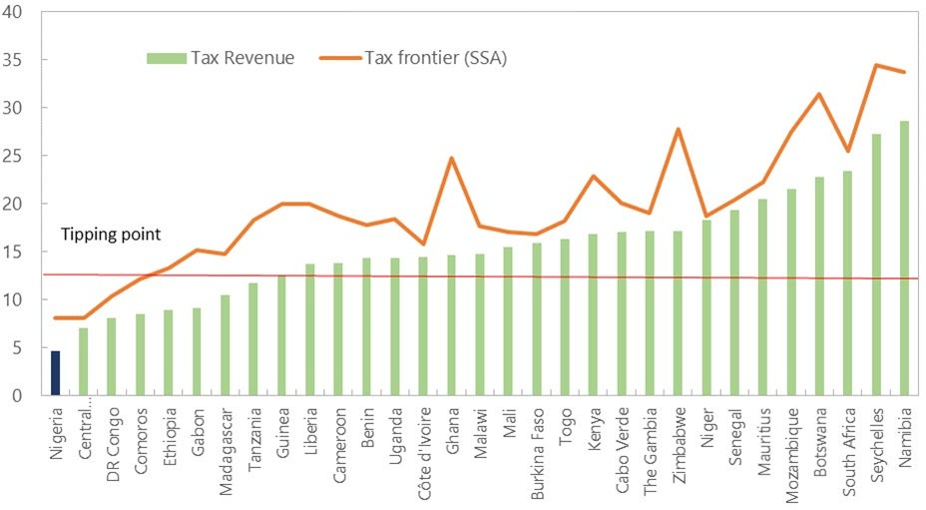

**Figure 7. Nigeria’s Tax Potential: Estimates of Tax Frontier for SSA Countries**

(Percent of GDP)

Source: IMF Sub-Saharan Africa Regional Economic Outlook (2018), WEO database

Note: Tax frontier (or tax capacity) is defined as the highest level of tax revenue that a country can be expected to achieve given certain economic and institutional conditions.

Tax revenue is 2021 data, and tax frontier estimates are based on SSA sample of IMF REO (2018).

4 The “tax frontier” (or “tax capacity”) is defined as the highest level of tax revenue (usually measured in percent of GDP) that a country can be expected to achieve given certain macroeconomic and institutional conditions. The “tax gap” (or “tax potential”) is defined as the distance between actual tax revenue and tax frontier (IMF REO, 2018).

5 According to IMF (2018a), Nigeria’s tax frontier (or tax capacity) is estimated to be 8.1 percent of GDP for SSA sample, 10.7 percent of GDP for EMDE sample, and 11.1 percent of GDP for all country sample.

# Lessons from Successful Revenue Reform Episodes in SSA

1. **We have identified four cases of large and sustained revenue mobilizations in SSA****6****, which could provide possible roadmaps for Nigeria.** This paper focuses on the profile of non- resource tax revenues during the post global financial crisis (GFC, 2010-2021)—which seems to differ from the literature covering the period before/around GFC (2000-2015) (Akitoby et al, 2018; IMF, 2018a). A successful episode is defined as a minimum increase in tax revenue of 2.5 percentage point of GDP over a five-year period (i.e., average 0.5 percentage point increase per year over five years)7. For the post-GFC period (2010-2021), only 12 episodes are identified in 40 SSA countries (Table 1). The episodes are further narrowed down by two additional criteria: (i) the episodes should be sustained with no substantial decline for five years after the episode8 and (ii) the episodes in fragile states are excluded, since they may not be applicable to other countries given their unique social and economic environments9. Then, only four episodes are identified: Mauritania, Rwanda, The Gambia, and Uganda.

|  |  |  |  |  |  |  |  |  |
| --- | --- | --- | --- | --- | --- | --- | --- | --- |
| **Table 1. Nigeria: Identified Episodes of Successful Tax Revenue Mobilization in SSA** | | | | | | | | |
|  | Episode1/ (year) | Tax revenue increase (%p of GDP) | Sustained  2/ | Fragile state | IMF  program | Real growth | |  |
| Preceding  5Y ave. | 5Y ave. in  episode |
| Burundi | 2015-2019 | 4.8 | S | 1 | 2008-2015 | 4.6 | -0.1 |
| Central African R. | 2014-2018 | 4.2 | S | 1 | 2006-2009 | -5.6 | 3.5 |
| Chad | 2016-2020 | 7.8 | NS | 1 | 2017-2020 | 4.6 | -0.9 |
| **The Gambia** | **2010-2015** | 3.5 | S | - | 2012-2015 | 2.5 | 1.3 |
| Guinea | 2011-2016 | 2.7 | NS | - | 2012-2015 | 3.1 | 5.6 |
| Guinea-Bissau | 2013-2017 | 3.1 | S | 1 | 2010-2013 | 3.7 | 4.1 |
| Mali | 2012-2016 | 3.0 | S | 1 | 2013-2016 | 4.3 | 4.1 |
| **Mauritania** | **2010-2014** | 4.1 | S | - | 2006-2013 | 4.7 | 3.9 |
| Mozambique | 2010-2014 | 8.3 | S | 1 | 2010-2016 | 7.5 | 7.1 |
| Niger | 2010-2014 | 2.5 | NS | 1 | 2008-2015 | 5.2 | 6.6 |
| **Rwanda** | **2010-2015** | 3.5 | S | - | 2010-2016 | 8.7 | 7.3 |
| **Uganda** | **2012-2017** | 3.1 | S | - | 2010-2016 | 6.7 | 4.5 |
| Sources: IMF WEO database, IMF MONA database.  1/ Episodes are identified based on the following criterion: at least 2.5%p increase in tax revenue-to-GDP ratio over 5 years (average 0.5%p increase per year for 5 years without fall) with no substantial decline2 for 5 years after the episode.  2/ “S (Sustained)” means tax revenue-to-GDP ratio increased or stayed the same or slightly fell but less than one-third of overall tax increase (of episode period) for 5 years after the episode period ends. | | | | | | | | |

6 Outside the SSA countries, there are many other identified episodes based on our criterion (i.e., Maldives (2010- 14), Belgium (2009-2013), France (2010-14), Nepal (2010-14), Myanmar (2010-14), Armenia (2010-14), Denmark (2010-14), etc.). However, this paper mainly focuses on the SSA countries for comparison with Nigeria.

7 0.5 percentage point of GDP per year is often used in the IMF program conditionality, which is the rational for this paper’s criterion. Also, the literature has used different (or arbitrary) criteria to identify the episodes: (i) Akitoby et al (2018; 2019) used the increase in tax revenue by at least 0.5 percentage point of GDP per year over a minimum of three years; (ii) IMF (2018a) used 2 percentage point of non-resource GDP over a three-year period.

8 This paper assesses the episode as “sustained” if tax revenue-to-GDP ratio increased or stayed the same or slightly fell but less than one-third of overall tax increase (of episode period) for 5 years after the episode period ends.

9 This criterion is based on the literature (Akitoby et al, 2019).

1. **Common lessons from the identified episodes—Mauritania (2010-14), Rwanda**

**(2010-15), The Gambia (2010-15), and Uganda (2013-17)—of successful revenue reforms** are as follows (see boxes 1-4 for details):

* + *The identified cases conducted both tax administration and tax policy reforms as a package.* All four identified countries implemented several tax administration measures and tax policy reforms (i.e., tax rate increase, base broadening, and tax incentive rationalizations) in parallel. The literature also supports that a package reform tended to be more successful in revenue mobilization (Akitoby et al, 2019).
  + *All four countries mainly focused on indirect tax (VAT and excise) reforms and reduction of tax exemptions as effective revenue booster.* The Gambia introduced a VAT to replace a sales tax and a specific excise on tobacco products in 2013. Mauritania raised the excise tax rate on tobacco from 10 to 30 percent and extended VAT coverage to the mining sector in 2012. Uganda increased several excise rates on locally produced spirits from 45 to 60 percent and on cigarettes by almost 60 percent in 2014, as well as reducing many VAT exemptions. Rwanda raised its excise rate on airtime of mobile phones from 5 to 10 percent in 2011-14 and removed incentives granting VAT exemptions on imports for investment certificate holders. These indirect tax reforms contributed to significant revenue gains in the identified episodes.
  + *Tax administration reforms mainly focused on improving compliance through strengthening taxpayer segmentation and automation*. Uganda expanded its taxpayer segmentation approach to the medium taxpayer by creating the MTO, combined with “e-tax services” to facilitate taxpayers’ registration, filing and payments. The Gambia implemented a detailed “Compliance Improvement Plan (CIP)” for large taxpayers. Rwanda introduced new electronic filing and payment systems during 2010–11 with the implementation of electronic tax registration.
  + *During the tax reform period, some countries introduced redistributive measures with fuel subsidy reform.* In Mauritania and The Gambia, fuel subsidy reforms with mitigating measures (i.e., targeted cash transfers for the most vulnerable) were undertaken, since indirect tax reforms were usually regressive.
  + *High-level political commitment and buy-in from key stakeholders played a critical role for reform success.* Uganda announced and implemented national revenue plans with strong political will, and Mauritania launched social dialogues with civil society and opposition groups, which helped enhance buy-in from key stakeholders and reduce resistance to the reforms.
  + *Another common factor is that the episodes coincided with robust growth and IMF programs*. The identified episodes frequently overlapped with the IMF programs and/or strong technical assistance support and tended to show relatively robust growth during the episode period (Table 1).

## Box 1. Mauritania Case (2010-14): A Package of Reforms that Combine Indirect Tax Reforms with Redistributive Measures and Fuel Subsidy Reform1/

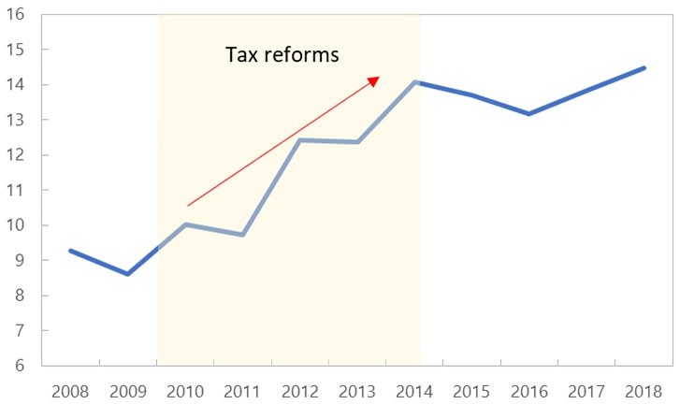

**Mauritania: Tax Revenue**

(Percent of GDP)

Source: IMF WEO database

**Mauritania achieved a sizable increase in tax revenue through a package of indirect tax and fuel subsidy reforms with some redistributive measures.**

Mauritania’s tax-to-GDP ratio significantly increased by 4.1 percentage points of GDP during 2010–2014 (Figure 8).

Especially, it is notable that, despite the commodity price boom, Mauritania enhanced non-commodity tax revenue, avoiding the resource curse and ultimately reducing heavy dependence on commodity revenue.

* + - **Mauritania broadened its VAT base by extending coverage to the mining sector.** The VAT was extended to cover the mining sector, and mining companies now receive reimbursement only if they can prove that their purchases have been acquired from formal domestic suppliers. This provides an

incentive for local supplier to register and become formal. As a result, the tax identification numbers increased from 1,789 in 2011 to 5,860 in 2013 and the VAT revenue increased by 2½ percentage points of GDP during 2009-2013.

* + - **They also increased excise tax rates on tobacco, with removing CIT exemptions.** In 2012, the Mauritanian authorities raised excise rates on tobacco from 10 percent to 30 percent. Also, they removed the CIT exemption of the main gold company in 2012, which contributed to the increase in CIT revenue by 1.3 percentage points of GDP.
    - **During the tax reform period, they introduced some redistributive measures associated with fuel subsidy reform.** Since indirect tax reforms (e.g., VAT and excises) were usually regressive, fuel subsidy reforms and mitigating measures were undertaken as a package during this period. To offset undesired effects on income distribution, they introduced a targeted cash transfer program for vulnerable households adversely affected by the reforms in 2012.
    - **They strengthened social dialogues with key stakeholders, which helped reduce resistance to the reforms.** There was a military coup in August 2008, but with the new presidential election in mid- 2009, Mauritania returned to a constitutional order and a stable reform-minded government coalition. At that time, the government launched social dialogues with civil society, the opposition, and interest groups, which helped enhance buy-in from key stakeholders and reduce resistance to the reforms.

1/ This box is based on Akitoby et al. (2019, IMF) and IMF’s country staff report.

## Box 2. Rwanda Case (2010-15): Reforms Focusing on Raising the Rates of Indirect Taxes and Removing Tax Exemptions1/

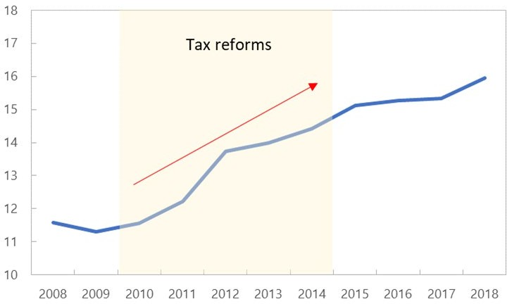

**Rwanda: Tax Revenue**

(Percent of GDP)

Source: IMF WEO database

**Rwanda achieved a steady and sustained increase in tax collection through bold indirect tax reforms and tax incentive rationalization.**

Especially, the reform focused on raising the rates of indirect taxes as an effective revenue booster, combined with removing numerous exemptions. As a result, Rwanda’s tax-to-GDP ratio increased by 3½ percentage points of GDP during 2010–2015 (Figure 9). With these reforms, Rwanda’s heavy dependence on donor aid was significantly reduced during the reform period.

* + - **Rwanda’s tax reforms mainly focused on raising the rates for several indirect taxes.** From July 2012, Rwanda’s tax rate for imported construction materials increased from 5 percent to 10 percent. The excise tax rate on airtime of mobile phones was also

increased from 5 to 8 percent, then to 10 percent during 2011-2014. In 2015, the authorities increased tariffs for water and electricity by 19 and 35 percent, respectively. Furthermore, the FY15/16 budget included a new excise tax on petroleum, higher excise tax rate on tobacco and import tax on non-EAC products, which significantly increased tax revenue.

* + - **The authorities also removed lots of tax exemptions.** For this, they revised the investment tax code to streamline several tax exemptions. Incentives granting VAT exemptions on imports for investment certificate holders were also removed, which broadened the existing narrow tax base.
    - **They implemented tax administration measures for improving compliance by better utilizing risk management and automation systems.** Especially, new electronic filing and payment systems were introduced during 2010–2011, with the implementation of electronic tax registration. Also, basic risk management approaches and direct bank payment of tax was introduced to reduce leakages. The tax and business registration processes were integrated to ease cost of doing business. Furthermore, they automated tax and custom operations and implemented a customs Single Window for trade facilitation. The Rwanda Revenue Authority (RRA) enforced VAT compliance by introducing electronic transactions device (ETD) and withholding VAT at source by government departments, and increased collection of tax arrears.

1/ This box is based on Akitoby et al. (2019, IMF) and IMF’s country staff report.

## Box 3. The Gambia Case (2010-15): A Package of Reforms on Indirect Taxes and Tax Administration with the Elimination of Fuel Subsidies1/

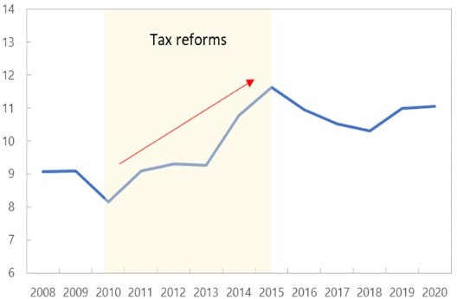

**The Gambia: Tax Revenue** (Percent of GDP)

Source: IMF WEO database

**The Gambia embarked on a package of indirect tax reforms and strengthened tax administration measures with fuel subsidy removal during 2010-2015.**

As a result, the Gambia achieved a sizable increase in tax-to-GDP ratio from 8 percent in 2010 to 11.6 percent in 2015 (by about 3½ percentage points of GDP) (Figure 10). Specifically, the increase in indirect tax revenues contributed over half of the overall increase.

* + - **The Gambian authorities introduced a new VAT to replace a sales tax in 2013.** Under the new VAT system, all supplies are considered taxable unless specified, while under the sales tax, only the supplies specified were taxable, which broadened the tax base. As a result, the introduction of VAT— which was a part of The Gambia’s commitment

towards the ECOWAS protocol—lifted tax revenue by about 1-1.5 percentage points of GDP during the reform period.

* + - **They introduced a specific excise on tobacco products.** In 2013, they revised the base of excise tax on cigarettes from weight to the number of packs, which increased the equivalent tax rate on cigarettes by about 25 percent. In addition, they introduced a new excise on non-cigarette tobacco products, and as a result, excise revenue from tobacco products increased by 0.5 percentage points of GDP during 2012-2014.
    - **They strengthened tax and customs administration through Compliance Improvement Plan (CIP).** The Gambia Revenue Authority (GRA) strengthened its audit capacity through hiring and training of staff and implemented a detailed “Compliance Improvement Plan (CIP)” for large taxpayers. Especially, for the launch of VAT, new tax and customs administrative procedures were implemented, and a monitoring function was established. As a result, about 86 percent of large taxpayers filed their income tax returns in 2012, up from 79 percent in 2011. Also, a new customs and excise law—which reflects international best practice in customs administration and provides platform for customs modernization—was enacted, with the custom department upgrading its IT system.
    - **Combined with tax measures, untargeted fuel subsidies were eliminated.** In Gambia, revenue losses from fuel subsidies reached 0.8 percent of GDP in 2011. To eliminate them, they reformed the fuel pricing formula towards flexibly changing retail price to reflect changes in international prices. From 2013, monthly fuel price adjustments were implemented, and fuel subsidies were eliminated in July 2014, which increased fuel tax revenues.

1/ This box is based on Akitoby et al. (2019, IMF) and IMF’s country staff report.

## Box 4. Uganda Case (2013-17): Reforms on Indirect Taxes and PIT Based on Comprehensive National Revenue Plans Supported by Strong Political Will1/

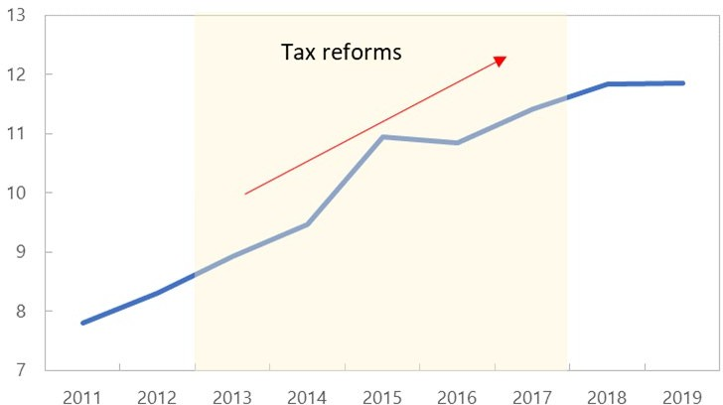

**Uganda: Tax Revenue**

(Percent of GDP)

Source: IMF WEO database

**Uganda implemented reforms on indirect taxes, PIT, and taxpayer segmentation, based on comprehensive national revenue plans supported by strong political will.**

As a result, Uganda’s tax-to-GDP ratio significantly increased by 3.1 percentage points of GDP during 2012–2017 (Figure 11).

* + - **Uganda’s VAT reform focused on eliminating numerous exemptions.** The VAT system was reformed by submitting a new tax code to reduce many VAT exemptions. This included: eliminating VAT exemptions on sales of motor vehicles and trailers; extending VAT to computers; terminating VAT exemptions on hotels; and increasing the VAT threshold.
    - **The authorities increased several excise rates**

**with broadening the base, as well as raising PIT rate in top bracket.** They increased excise duty on locally produced spirits from 45 percent to 60 percent, and increased excise duty on cigarettes by almost 60 percent in 2014. To broaden the base, they imposed excise duty on imported fresh juices, and increased excise taxes on a variety of products including fuel, sugar, mobile money transfers, and international calls. Furthermore, they increased the PIT rate (i.e., the marginal rate in its top bracket) from 30 to 40 percent, which significantly increased revenue.

* + - **Uganda’s tax administration reforms focused mostly on better segmentation of taxpayers.** The authorities established a high net-worth individuals (HNWI) unit as part of the LTO. They established a list of potential HNWI taxpayers and conducted outreach to educate them on their rights and obligations to pay taxes. After the establishment of the unit, the number of taxpayers and tax collection of this segment increased substantially. Also, taxpayer segmentation approach was expanded to the medium taxpayer segment (that accounts 20-25 percent of tax collection) with the creation of the MTO. Furthermore, they improved the quality of its taxpayer services by using “e-tax services” to facilitate taxpayers’ registration, filing and payments, and implemented the Regional Electronic Cargo Tracking System (RECTS), a web-based system to monitor transit cargo in the EAC in 2017, which improved tax collection.
    - **Uganda implemented comprehensive national revenue plans with strong political will.** The authorities made political commitment for the reforms with strong political will. They announced and initiated the “National Development Plan (NDP) 2011-2015” targeting to raise the revenue-to-GDP ratio by about 0.5 percent per year over the medium term and adopted a “Medium-Term Revenue Strategy (MTRS)” in 2017.

1/ This box is based on Akitoby et al. (2019, IMF) and IMF’s country staff report.

# Implications: Nigeria’s Tax Reform Path Forward

1. **Successful revenue reform episodes in peer SSA countries could provide useful lessons for Nigeria.** Although there is no one-size-fits-all strategy, we can find a tax reform path suitable to Nigeria’s specific circumstances. Based on these cross-country experiences, staff recommends: (i) implementing a package reform of tax administration and tax policy measures; (ii) focusing mainly on indirect tax (VAT and excise) reforms and tax incentive rationalizations as effective revenue booster; (iii) undertaking tax administration measures for improving compliance by strengthening taxpayer segmentation and automation; and (iv) launching social dialogue with key stakeholders as well as high-level political commitment as an effective reform strategy. The detailed measures that can be considered are presented as follows:

### A Package of Reforms

1. **Below are key components of package reform of tax administration and tax policy.** Details can be found in the following IMF TA reports (Baer et al., 2021; IMF 2018b; Yavwa, 2022; IMF, 2015)10.

### VAT Reforms

1. **VAT reform in Nigeria could be an effective and strong revenue booster**. The literature has shown VAT is a strong revenue booster, and the countries that implemented VAT reform tend to raise more revenue than those without these reforms (Keen and Lockwood, 2010; Akitoby et al, 2019). Nigeria’s VAT reforms could include:
   * *Streamlining numerous VAT exemptions, based on a systemic review for exempted items*. Nigeria’s generous VAT exemptions need to be streamlined to a better-targeted way that focuses more on basic items consisting of a larger share of the poor’s consumption basket. Also, exemptions should basically be set for the public provision of non-commercial goods and services. These calls for the need for a comprehensive review for Nigeria’s current VAT exemptions.
   * *Introducing some basic rules of modern consumption tax in Nigeria’s VAT system.* To prevent breaking up businesses into small companies with a view to avoid the VAT filling threshold, “anti-fragmentation rule” should be urgently added to the legislation.
   * *Adopting the VAT rate comparable to Nigeria’s peer ECOWAS country average (around 15 percent),* as the recovery gains strength and compliance improves. This includes further increasing VAT rate from the current 7.5 percent to 10 percent by 2023 and to 15 percent by 2027. This could be accompanied by introducing proper input tax credits and a registration threshold. Raising the VAT rate by 2.5 percentage points could additionally collect revenue by

10 This paper’s recommendations are basically drawing on the diagnostics of technical assistance provided by IMF’s Fiscal Affairs Department. Some original inputs are from Katherine Baer et al (2021) “Federal Republic of Nigeria: Priorities for Revenue Administration Reform in Difficult Times” (IMF Fiscal Affairs Department, Technical Report) and IMF (2018b) “Mobilizing Tax Revenue in Nigeria” (IMF Selected Issue Paper, February 2018).

around 0.3 percentage point of GDP. While VAT has usually a regressive nature, raising its rate under the Nigeria’s current VAT system—with large exemptions and very low rate for basic items—could be less regressive.11, *12*

### Excise Reforms

1. **Excise reforms in Nigeria could contribute to both revenue mobilization and correction of externalities.** Raising excise rates and broadening the tax base could be effective measures to raise revenue quickly without fundamental changes to the tax system since they are more inelastic than other taxation sources and can correct negative externalities (Akitoby et al., 2019). Nigeria’s excise reforms could include:
   * *Gradually raising the excise rates to the average level of Nigeria’s peer (ECOWAS) countries* (around 50 percent)*.* As economic recovery gains strength, Nigeria’s excise rates on tobacco and alcohol (i.e., about 20-30 percent) could be doubled in real terms. Raising excise rates can be attained by any mix of increases in specific rates and ad-valorem rates—generally, specific excises are preferable, since they are simpler to administer and less vulnerable to avoidance through undervaluation (WB, 2021)13. Raising excise rates to the ECOWAS average level could yield the estimated revenue of about 1 percent of GDP in the medium term (WB, 2021).
   * *Broadening the base by introducing new excises for the correction of externalities and revenue mobilization.* The authorities could consider introducing, for example: (i) new environmental charges on the use of plastic bags/bottles, aluminum cans, light bulbs, and fossil fuels14; (ii) charges on road transport infrastructure to reduce pollution and congestion—i.e., by

11 Regarding the distributional impact of the increase in VAT rate, the findings of the literature have been mixed. Although many studies have shown that VAT is regressive in advanced economies (IMF 2018b), the results for developing countries are ambiguous (Bastagli et al., 2012). They have shown that in developing countries, VAT may be less regressive or rather slightly progressive, due to a bunch of VAT exemptions or lower rates for basic consumption items—consisting of a larger share of the poor’s consumption basket than the rich’s consumption basket. According to IMF (2018b), Nigeria’s household survey data shows that the share of VAT payments in income is larger in the richer households than in the poorer households—which implies that raising VAT rate in Nigeria could likely have a slightly progressive (or less regressive) impact, under the Nigeria’s current VAT structure.

12 The VAT and excise rate (7.5 and 20-30 percent, respectively) is significantly lower (around a half) than the peer ECOWAS average (15 and 50 percent, respectively) and both have been very effective tools in mobilizing domestic revenues in other developing countries. On the contrary, reforms for personal/corporate income tax (PIT/CIT) and property tax are not recommended in this paper. The highest rates for PIT and CIT (which is 24 and 30 percent, respectively) in Nigeria is broadly in line with the averages of the EMDEs or ECOWAS (25 and 26 percent for PIT, 23 and 28 percent for CIT, respectively). Staff does not recommend raising the PIT and CIT rates, except for closing loopholes for CIT exemptions. The property taxation also requires significant preparation time and groundwork.

13 IMF (2018b) indicates that theoretically specific excises are preferable to ad-valorem excises in terms of the correction of externalities since external costs on the society of smoking/drinking/polluting are independent of the products’ sales price. Also, excises could easily increase revenues without major administrative costs or hiring of additional staff, because specific excises require only counting (e.g., cigarettes) or measuring (e.g., alcohol) or volume (e.g., fuels) and they don’t generate any contentious valuation issues.

14 The 2023-25 MTEF document mentions “introduction of green surcharge on imported vehicles” as one of the medium-term plans.

introducing an additional fuel duty on gasoline and diesel (but kerosene mostly used by the poor needs to be exempted); (iii) tax excises on luxury goods; (iv) new excises on gambling and lotteries including online betting (MTEF 2023-25). For these, a comprehensive review for all excise duties/levies should be conducted (IMF, 2018b). In addition to these, they could consider modernizing controls on excise-taxed products.

**Table 2. Nigeria: Excise Duty Rates**

(Percent)

Sources: Tax aide (2022) / National Customs Service.

Note: 1/ The FGN, with effect from 1 June, commenced implementation of increasing ad valorem rate on cigarettes from 20 percent to 30 percent.

2/ Excises on sugar sweetened beverage (SSB) (Finance Act 2021) and telecom services have been implemented since H2 2022.

|  |  |  |  |  |  |  |  |
| --- | --- | --- | --- | --- | --- | --- | --- |
|  | **Cigarettes** | **Wine** | **Whiskey** | **Beer & Stout** | **Tobacco products** | **Sugar sweetened**  **beverage**2 | **Telecom service**2/ |
| Ad-valorem rates | 30%1/ | 20% | 20% | N/A | N/A | N/A | 5% |
| Fixed/Specific rates | N84k per pack (20 stick) | N40 per liter | N50 per liter | N50 per liter | N1,000 per kg / N3,000 per litre | N10 per liter | - |

### Tax Incentive Rationalization

1. **Tax incentive rationalization is urgent to boost revenue.** The authorities could consider:
   * *Streamlining tax expenditures based on a comprehensive and periodic review*. A comprehensive and periodic review for the objective of each specific tax expenditure is needed, including a cost-benefit analysis of each tax expenditure.15 After the review, streamlining the identified tax expenditures should start with a suspension of introduction of new tax incentives, followed by rationalizing the existing ones (IMF, 2018b)16. In this process, tax expenditure should be scrutinized equally as budget expenditures, and the sunset clauses should be conducted mandatorily.
   * *Transitioning inefficient tax incentives towards better-targeted investment incentives.* In general, for LICs, there exist more desirable options for investment tax incentives than tax holidays and income tax exemptions (IMF, 2015). These include: (i) investment tax credits and accelerated depreciation—which usually generate more investment per dollar spent than tax holidays and

15 The recent publication of “2021 Tax Expenditure Statement (TES)” is welcomed, but its analysis does not cover a specific appraisal for each tax expenditure—just focusing on estimating their overall size. IMF FAD is planning to conduct technical assistance for tax expenditure review in the near-term.

16 The 2023-25 MTEF exemplifies “capital gains tax exemptions and corporate bonds’ interest income exemptions” as the areas of tax expenditure needed to be reduced.

income tax exemptions; and (ii) tax incentives targeted at export-oriented sectors—which appear to be more effective than those targeted domestic market sector.

### Tax Administration Reform

1. **The authorities should improve compliance by strengthening taxpayer segmentation and automation and adopting a well-designed implementation roadmap**. They could consider the followings:
   * *The coverage of automation system needs to be further expanded under well-designed roadmap:*
2. While “TaxPro Max” system is already operating three core modules of registration, filing, and payment (as well as audit and investigation modules that will be deployed before the end of 2022) 17, the other back-office modules such as risk/debt management, refund and compliance are still processed manually, and need to be included in the system (Yavwa, 2022);
3. Taxpayers registered in the system should be further enlarged18 through mandatory participation of the Large Taxpayer Office (LTO) and the Medium Taxpayer Office (MTO) (iii) Last but not least, all these measures should be implemented under a well-designed roadmap.
   * *Strengthening the segmentation of taxpayers, especially focusing on the LTOs*. Since the LTOs in Nigeria account for about 70 percent of taxes collected by the FIRS (ISORA, 2019), their performance is crucial. The authorities could consider reviewing the adequacy of the penalty regime for non-compliance in the LTOs (Baer et al., 2021).
   * *Additional administration reforms could be considered in the areas of VAT, Customs, and PAYE*

as follows (Baer et al., 2021):

* *Developing a Compliance Improvement Program (CIP).* The FIRS could develop a CIP as a first step—focusing on enforcement measures on non-compliant taxpayers, basic compliance activities such as filing, payment and reporting requirements, and targeting the LTO and MTO registrants in the near-term.
* *Designing and implementing a “comprehensive customs modernization program” beyond “e-customs”, which* includes improving the effectiveness of customs’ overall processes such as valuation, exemptions, control, and monitoring, with full implementation of “e-customs”.
* *Enhancing the effectiveness of States IRS’s Pay-As-You-Earn (PAYE) administration.* The authorities need to consider: (i) reviewing the PAYE system to introduce a modern IT- based process for the State IRSs; (ii) using direct assessment of employees only where there is no possibility of collecting the PAYE from an employer; and (iii) establishing a

17 The FIRS confirmed during the mission (November 2022) that the TaxPro Max team conducted a user acceptance test for the tax audit and investigation modules and these modules will be deployed before the end of 2022. These are notable progress.

18 As of March 2022, the number of taxpayers registered in the TaxPro Max system is 400,562.

large employee compliance office (LEOs) in those states that collect PAYE from large businesses.

* + *Strengthening inter-agency coordination and data sharing.* Data discrepancies and fragmentations still exist in Nigeria. Further data matching is needed in Nigeria to reduce administrative costs through strengthened inter-agency coordination. (e.g., institutionalizing the exchange of import data between the NCS and FIRS, sharing risk assessments and key compliance-related data between the FIRS and the State IRSs, etc.).

### Reform Strategy: Political Commitment and Social Dialogue

1. **The authorities are encouraged to prepare an effective reform strategy with political commitment and social dialogue with key stakeholders.** As key revenue reform strategies, the literature has highlighted the importance of strong political commitment and buy-in from key stakeholders (Akitoby et al., 2019), because tax reforms usually accompany strong resistance. Especially in LICs with weak institutions and widespread corruption, “high-level political commitment” is essential to reduce resistance of vested interest groups, enhance inter-agency coordination, and gain reform momentum. Also, “social dialogue” with key stakeholders should be accompanied to reduce resistance. Empirical studies have shown that “communication” is a key part of successful reforms (Inchauste and Victor, 2017)— those that made clear the reason for reform, compensated those worst affected, and ensured that the benefit is widely shared tended to be more successful (Rentschler and Bazilian, 2017).

**References**

Akitoby, B., Baum, A., Hackney, C., Harrison, O., Primus, K., and Salins, V., 2018, “Large Tax Revenue Mobilization in Low-Income Countries and Emerging Markets: Lessons from a New Database”, IMF Working Paper No. 18/234.

Akitoby, B., Honda, J., B., Miyamoto, Primus, K., and Sy, M., 2019, “Case Studies in Tax Revenue Mobilization in Low-Income Countries”, IMF Working Paper No. 19/104.

Baer, K., Okello, A., Montagnat-Rentier, G., Muyangwa, M., Sanya, B., Smith, D., Gaperi, H., Bennet, D., Hartnett, D., Brimble, B., Parent, G., and Veltri, R., 2021, “Federal Republic of Nigeria: Priorities for Revenue Administration Reform in Difficult Times”, IMF Fiscal Affairs Department, Technical Report.

Bastagli, F., Coady, D., and Gupta, S., 2012, “Income Inequality and Fiscal Policy”, IMF Staff Discussion Note 12/08, Washington DC.

Gaspar, V., Jaramillo, L., and Wingender, P., 2016, “Tax Capacity and Growth: Is there a Tipping Point?” IMF Working Paper 16/234.

Fenochietto, R., and Pessino, C., 2013, “Understanding Countries’ Tax Effort”, IMF Working Paper No. 13/244.

Inchauste, G., and Victor, D., 2017, “The Political Economy of Energy Subsidy Reform”. World Bank, Washington, D.C.

International Monetary Fund (IMF), 2015, “Options for Low Income Countries' Effective and Efficient Use of Tax Incentives for Investment”, Report Prepared for the G20 Development Working Group by the Platform for Collaboration on Tax (Washington)

———, 2018a, “Domestic Revenue Mobilization in Sub-Sahara Africa”, IMF Sub-Saharan Africa Regional Economic Outlook. Chapter 2, April 2018.

———, 2018b, “Mobilizing Tax Revenue in Nigeria”, IMF Selected Issue Paper, February 2018, <https://www.imf.org/en/Publications/CR/Issues/2018/03/07/Nigeria-Selected-Issues-45700>

———, 2018c, “Distributional Impact of Fiscal Reforms in Nigeria”, IMF Selected Issue Paper, February 2018.

———, 2022, “The impact of Fuel Subsidy Reemergence in Nigeria”, IMF Selected Issue Paper, February 2022.

———, “Tax Policy Assessment Framework”, <https://www.imf.org/external/np/fad/tpaf/pages/vat.htm>

International Survey on Revenue Administration (ISORA), Country Level Public Data-Nigeria-2019, <https://data.rafit.org/?sk=5a3bd47d-bec2-41a9-8f37-e5dbb98e3dcf&sId=1637356423160>

Keen, M., and Lockwood, B., 2010, “The Value Added Tax: Its Causes and Consequences,” Journal of Development Economics, Vol. 92, pp. 138-151.

McCulloch, N., Moerenhout, T., and Yang, J., 2020, “Building a Social Contract? Understanding Tax Morale in Nigeria”, The Journal of Development Studies, 57/2, pp 226-243.

McCulloch, N., and Moerenhout, T, 2019, “The Nigerian Tax Perception Survey”, Institute of Development Studies, Columbia University, [https://www.slideshare.net/ICTDTax/the-nesg-](https://www.slideshare.net/ICTDTax/the-nesg-nigerian-tax-perception-survey) [nigerian-tax-perception-survey](https://www.slideshare.net/ICTDTax/the-nesg-nigerian-tax-perception-survey)

Nigeria’s Budget Office of the Federation, Federal Ministry of Finance, Budget and National Planning, 2022, “2023-2025 Medium-Term Expenditure Framework (MTEF) and Fiscal Strategy Paper.

Rentschler, J., and Bazilian, M., 2017, “Policy Monitor: Principles for Designing Effective Fossil Fuel Subsidy Reforms”. Rev. Environ. Econ Pol., 11 (1), 138-155.

Tax aide, 2022, “Nigeria’s 2022 Pro-Health Taxes”, [https://taxaide.com.ng/2022/07/07/nigerias-](https://taxaide.com.ng/2022/07/07/nigerias-2022-pro-health-taxes/?utm_source=rss&utm_medium=rss&utm_campaign=nigerias-2022-pro-health-taxes) [2022-pro-health-taxes/?utm_source=rss&utm_medium=rss&utm_campaign=nigerias-](https://taxaide.com.ng/2022/07/07/nigerias-2022-pro-health-taxes/?utm_source=rss&utm_medium=rss&utm_campaign=nigerias-2022-pro-health-taxes) [2022-pro-health-taxes.](https://taxaide.com.ng/2022/07/07/nigerias-2022-pro-health-taxes/?utm_source=rss&utm_medium=rss&utm_campaign=nigerias-2022-pro-health-taxes)

World Bank, 2022, “Nigeria Public Finance Review: Fiscal Adjustment for Better and Sustainable Results”, (upcoming).

World Bank, 2021, “Resilience Through Reforms”, Nigeria Development Update.

Yavwa, Y., 2022, “Nigeria: A Review of the Implementation of TaxPro Max”, IMF Fiscal Affairs Department, Technical Report, (upcoming).