**Questions**

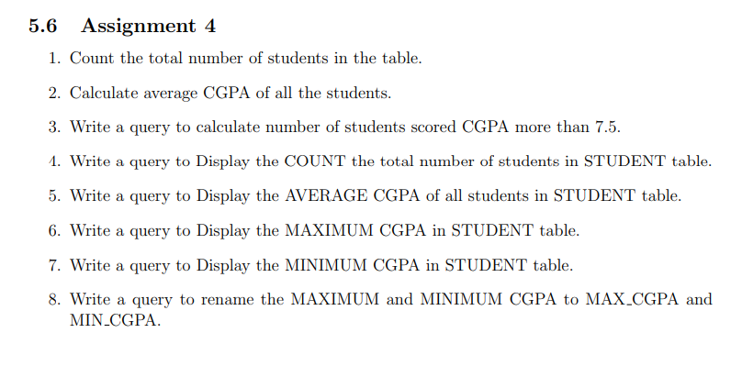

**Table students_ganesh:**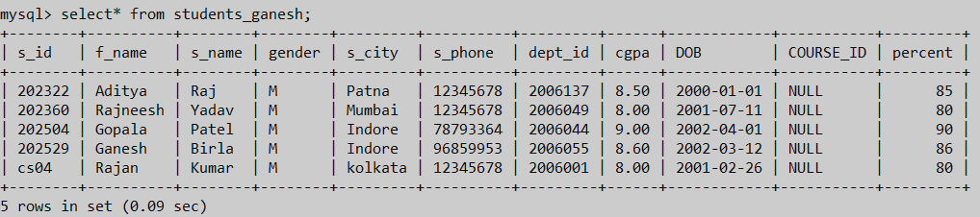

**Output 5.1**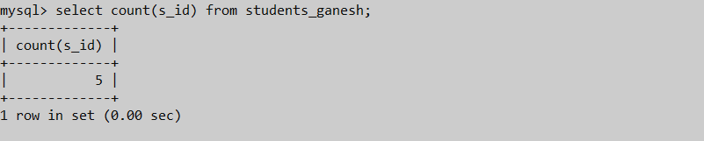

**Output 5.2**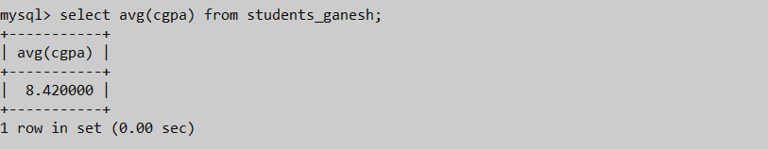

**Output 5.3**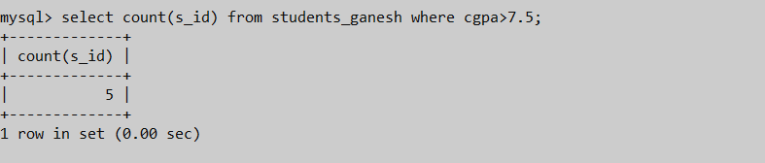

**Output 5.4**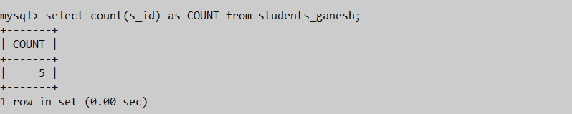

**Output 5.5**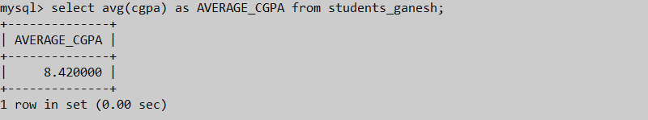

**Output 5.6**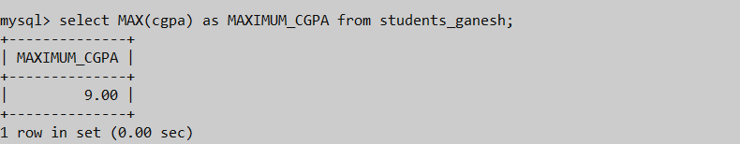

**Output 5.7**

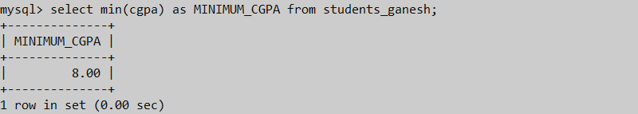

**Output 5.8**