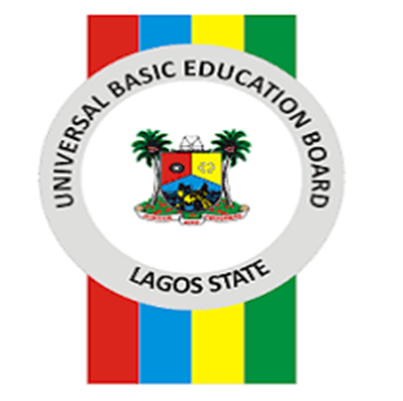

**LAGOS STATE UNIVERSAL BASIC EDUCATION BOARD**

**PROJECT ZERO**

**INTRODUCTION**

* **Global**

Typically, Sub-Saharan governments invest 5 percent or more of Gross National Product (GNP) on education. This is supported by major investment from others including corporates and International organizations. Yet sadly, millions of young Africans lack access to quality education. This situation presents an educational system, burdened with inadequate facilities, students crammed into over-crowded classrooms as a result of chronic shortages of teachers and infrastructure. Worse still, millions of others receive no schooling at all. Consequently, employers are plagued with short falls in technical expertise and skill shortages, finding it difficult to recruit the talent they need to create prosperity and improve lives, amidst of staggering youth unemployment.

The COVID-19 pandemic has further created the largest disruption of education systems in history, affecting nearly 1.6 billion learners in more than 190 countries and all continents. Closures of schools and other learning spaces have impacted 94 percent of the world’s student population, up to 99 percent in low and lower-middle income countries.

This crisis is exacerbating pre-existing education disparities by reducing the opportunities for many of the most vulnerable children, youth, and adults – those living in poor or rural areas, girls, refugees, persons with disabilities and forcibly displaced persons – to continue their learning. Children from the poorest households are four times more likely to be out of school than those of the richest households. These disparities between rural and urban areas also remain high (The Global Goal 2016).

* **Local**

Nigeria sits on the verge of a demographic explosion. Soon, one-in- eight children born on this planet will be a Nigerian (United Nations 2012). The quality of education in the region will be a key factor in making these demographics an extraordinary opportunity or a terrible threat. As more than 30 percent of school age children in Nigeria do not have access to Basic Education.

Lagos State is Africa’s most populous city, occupying 0.4% of Nigeria’s territorial landmass. With a soaring population of 24million people, a population growth 10 times faster than that of New York and Los Angeles, and a population size greater than that of 32 African nations combined, the State education system faces all of the challenges of a fast-growing megacity.

Challenges range from dearth of infrastructure, domestication and implementation of a Statewide Early Childhood Development (ECD), Special Needs education, shortage of Teachers with lack of Capacity Building, blooming number of Out-Of-School-Children (due to population growth, not just from the natural population but also high influx from other neighboring states exerting enormous pressure on limited resource) to increased teacher migration to suburbs due to high living expense in the city.

Leveraging a firm commitment from the Lagos State government to contribute a significant part of its annual budget to fund Basic Education and the annual allocation from the Universal Basic Education Commission (a federal government arm responsible for Basic Education in Nigeria), the state (state’s education system has been experiencing tremendous improvement through…) continued to improve school systems through the infusion of technology in education, infrastructure improvement, teachers recruitment and capacity building, Capacity building for

teachers including fresh recruitment gradual implementation of Early Childhood Development, School Feeding, etc. However, for a multitude of reasons, the Basic Education system is still behind global standards and yet to nip Out-of-School-Children menace in the bud.

The recent pandemic has exacerbated existing education challenges, forced our schools to close in an unprecedented manner, increased the number of unemployment, and aggravated the already existing poverty in this part of the world. Now more than ever, we anticipate an alarming increase in the number of OOSC. Early data collected in November 2019, upon school resumption showed that **over 21,000 pupils enrolled in various public primary schools in the state, did not resume in the initial first 2 weeks of school resumption;** truancy was mostly associated to the socio-economic status of parent or guardian.

There is an urgent need to reach out to all stakeholders and partners who are passionate about the education affairs and the future of our children to support ACCESS AND RETENTION of OOSC

**A CALL TO ACTION:**

Lagos State recognize that serious threat awaits an uneducated environment. Consequently, the State designed a multifaceted approach tagged PROJECT ZERO.

Project Zero is a partner-led initiative designed to tackle the menace of OOSC. The initiative was borne out of the THEMES agenda of Governor Babajide Olusola Sanwoolu which prioritizes quality education for all children of school going age in Lagos State. Project Zero symbolizes ZERO tolerance for OOSC and also re-emphasizes the Lagos state 2007 Child Right Law which stresses the right to free and compulsory primary education.

The **goal** of Project Zero is to enroll pupils of school going age who are out of school back into government owned primary schools.

The overall **objective** of this engagement is to mobilize a critical mass of stakeholders (both private and development partners) within the Basic Education space to accelerate support for Basic Education and tackle the menace of OOSC by supporting and enrolling children who are out of school.

The Lagos State Universal Basic Education Board (LASUBEB) commenced Project Zero in November 2019 – a period when its schools were slated to resume amid COVID 19. In anticipation of school resumption, LASUBEB reached out to private sector actors already working in the Basic Education space to support the first phase of Project Zero. The outcome was successful. Out of the 21,000 pupils that were initially out of school, over 14,000 pupils were remobilized, and out of these 14000 pupils, 4,549 were directly supported by Project Zero.

It is pertinent to state that while the first phase of Project Zero focused on children on the verge of dropping out of school due to the socioeconomic impacts of COVID-19, the second phase is strictly focused on Out-of-School-Children (OOSC).

**PROJECT ZERO PHASE II IMPLEMENTATION**

Project Zero phase II is tagged Voluntary Enrollment Lagos Support (Project Zero VELAGS).

The School Based Management Committee (SBMC) and the Social Mobilization Officer (SMO) at the LGEA level will be at the core of Project Zero phase II. SBMCs are voluntary groups made up of a range of individuals who are interested in the quality of education in the school domiciled within their environs, that is local individuals involved with schools. SBMCs consist of school authorities, parents, students, religious and traditional rulers, farmers and women’s groups who have specialized knowledge about their context and conflict dynamics, if empowered with necessary tools they are in the best position to devise practical solutions for enrolling OOSC.

SBMCs and SMOs with support of the state government will Identify, Map and Support OOSC back to school by providing starter kits-comprising of **School uniform, Bags, Sandals, Socks, Note books and Writing materials.**

Our target is 20,000 school age children in the Phase 2.

To further support this initiative, LASUBEB will engage multi-sector actors ranging from Teachers, Parents, School Based Management Committee, Private Sectors, Bilateral and Multilateral Organizations, Non-Governmental Organizations and Civil Society Organizations.

**Monitoring**

**Civil Society Action Coalition on Educational For All** (CSACEFA); a coalition of CSOs working on education issues in Nigeria is on standby to support in implementation and physical monitoring of this programme. The Coalition monitored and gathered data for phase 1 pro bono. [ Likewise, **EKO EXCEL** an education reform programme by the Lagos State government will deploy technology to electronically monitor Project Zero.

**Partnership/Sustainability**

Phase 2, will also be implemented in collaboration with the **Ministry of Women Affairs and poverty Alleviation,** this is to support the parents of indigent pupils to acquire skills and access economic resource needed to sustain the child beyond the provision of the initial starter kits.

The aim of a multi-sector partnership is to leverage knowledge, expertise, reach and resources, benefiting from a combined and varied strengths as we work together towards the shared goal of zero tolerance to OOSC in Lagos State. This is because issues affecting OOSC are complex, and in many cases, are influenced by interrelated social, environmental, and economic factors that can best be addressed with a holistic multi-sectorial approach.

**STRATEGY**

Our strategy will revolve around four (4) major techniques:

Sensitization of stakeholders:

* Radio Jingles on local stations- catchy and easy to memorize—in English and other Nigerian Languages to get community bought in and build a widespread name for the project.
* House to house campaign
* Market place campaign
* Advocacy visit to key influencers- pastors of churches, Imam, local chiefs etc.
* Rallies at the LGEA and distribution of fliers etc.

Capacity Building

* Training of SBMC/PF and SMOs on Identification and placement of OOSC

Identification of OOSC:

* Engagement with various Stakeholders
* - Security agencies(LNSC)
* - Correctional homes,
* - Ministry of Youth and Social Development and

- NGOs already in the OOSC space

Enrollment of OOSC

* Serve a warning notice to defaulting parents of identified OOSC (yellow card)
* Map identified OOSC to the nearest school
* SMO facilitate child registration documentation
* SBMC stands as child guarantor
* Starter pack provided comprising school uniform, School Bag, Note Books, Sandals and Writing Materials

**THANK YOU**

