KEYS 2022 Open Science Activity

Greg Chism

2022-June-07

# Starting a story: KEYS research question activity

## Description:

Story telling is deeply rooted in our history. The goal of this activity is to use storytelling to connect Open Science concepts to a research question that each KEYS students form and develop. (90 mins)

## Objectives:

1. Students will produce a research question and will relate Open Science concepts to each stage of the workflow from question to conclusion.
2. Students will work with peers to test their ability to receive feedback and utilize Open Science best practices in their workflows.
3. Students will leave with the confidence to ask questions about Open Science best practices during their internships.

## Lesson plan:

Students will create and refine a research question during activity breaks

### Open science

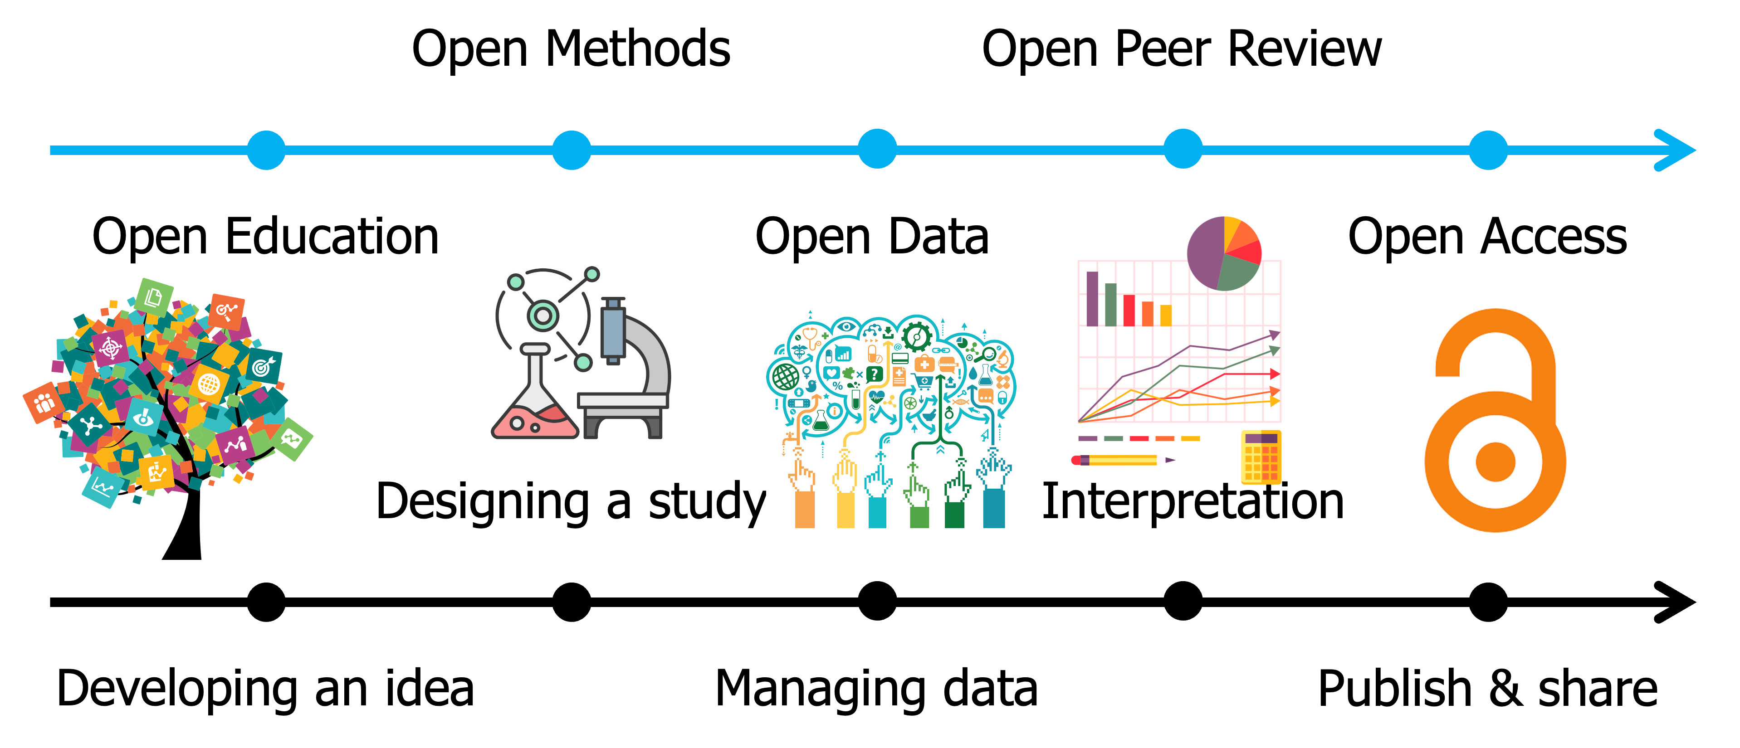

### Research project

## **Start their story / developing an idea (15 mins)**

Students will come up with a research question to start their story (10 mins)

* Going outside to the BSRL courtyard (if remote via Zoom outside of their home), or by examining the provided image (flower with a bumblebee and crab spider).
* Discussing question with peers, during and/or after forming a question (encourages feedback & collaboration).
* Alternatively, a research question can be provided to students without one.
* Determining the answer to their research question.

Students will consider what information they might need to answer their question (5 mins)

* Understanding the importance of open education.

## **Constructing the narrative / designing a study (20 mins)**

Students will design a hypothetical experiment to answer their research question (10 mins)

* Asking what data would be required to answer their research question.
* Determining how the data will need to be collected.
* Discussing this research methodology with peers.
* KEYS helpers will be available to help with methods.
* Write six lines of hypothetical data.

Students will apply the F.A.I.R principles throughout, starting here (10 mins)

* **Metadata**: ensuring that they or a peer will have the information needed to reproduce steps throughout the research study.
* **F**indable: describing where the data would be and how someone would find it – write the metadata.
* **A**ccessible: describing how metadata will be accessed and by whom.
* **I**nteroperable: describing how the metadata is usable by anyone to reproduce their study.
* **R**eusable: ensuring that the metadata is thorough enough for a peer to reproduce the work (see next section).

## **Conflict points to overcome / managing data (20 mins)**

Students will give their metadata to a peer to test the successful application of the F.A.I.R. principles. (10 mins)

* In-person: either going back outside or viewing the provided flower image as appropriate.
* Remote: providing enough metadata to either go to a hypothetical field site or view the provided flower image.

Students will revise data structure and metadata as appropriate.  (10 mins)

* Discussing the peer’s success in understanding the metadata.
* Revising metadata with peer.

## **First test for the student / interpretation (15 mins)**

Students will understand objective vs. subjective data (10-15 mins)

* If their data is objective, what is the subjective version?
* If their data is subjective, what is the objective version?

## **Final test for the student / publish & share (20 mins)**

Students will peer reviewing each other’s work. (10 mins)

* Thinking about what would improve interpretations.

Students will discuss open access (the whole picture – 10 mins)

* Considering where each part of their research goes
* Examples:
* GitHub
* Dryad
* Jupyter notebooks
* R Markdown & R scripts