Insert Logo and Project Name
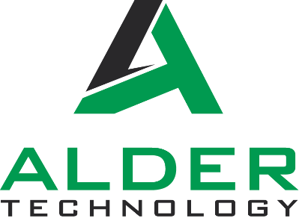
Print Address here
Simon Alder
Alder Technology pty Ltd
Head Office
112/17 Lynch Street
Hawthorn, Vic 3122

NSW Technology Centre
Dapto, NSW

Client Details
Client
Contact Name
Email
Address

Document Control
Title
Author
Proposal ID
Version | 1.0
Purpose | For Consideration
Date

Version Tracking
Version | Author | Purpose/Updates |  | Date
1.0 |  | For Consideration

Alder Technology Contact Details
Company Name | Alder Technology Pty Ltd
ABN | 16 647 061 890
Head Office | Level 27, 101 Collins Street  Melbourne VIC 3000
NSW Office | Level 57, 19-29 Martin Place  Sydney NSW 2000
Website | www.aldertech.com.au
Please direct any queries to the following
Title | Alternate Contact |  | Author
Name | Simon Alder |  | George Coles
Telephone | 0409 502 711 |  | 0419 709 701
Email | simon@aldertech.com.au |  | george@aldertech.com.au

Executive Summary
Alder Technology is pleased to provide this proposal to McCormack for the works at 8 Exhibition Street. We have included an option for each room which allows for a full Microsoft Teams Room, as well as BYOD functionality.

We have based our solution on the new Windows based MTR solution from Maxhub. This has a best in class camera (Quad Cam), and importantly is a fully windows based solution. Unlike the android solutions common to most all in one bars, it runs a full Windows 11 software stack for Teams Rooms. It allows full Azure based management, is IP based and is expandable to include a full processed audio system where required. This new product suite uses AI for camera framing and audio in room, and represents a new generation of product, giving unprecedented control over both video and audio. From a client perspective, provides a fully featured MTR solution (being a Windows based unit), and provides an excellent in room experience, at an exceptional value for money, especially in the mid to large spaces. The video and audio experience of this next generation bar far exceed the capabilities of most conferencing soundbars on the market today.

All equipment we select is Teams Certified and IP based. This allows remote monitoring, support and fault rectification, with 90% of faults on an IP based system able to be remotely rectified within one hour. This means less downtime, less time with technicians onsite, and a better user experience.

The IP based solution allows us to complete a very efficient installation. We anticipate a maximum of three days onsite depending on options, with all network cabling pre run and fit off by the communications contractor. We need not be onsite until the very end of the project, with a live network and clean rooms.

All rooms include full room based commissioning, with video and audio engineering providing fencing, tuning and noise suppression, meaning the system only includes what is meant to be included – no noises from outside, or capturing participants walking past a window.

We are please to submit the following pricing,

Full Meeting Room Solution - $110,555.00 Exclusive of GST.

This solution is for ten meeting rooms plus the open Teams Lounge Meet. In the large 16P meeting room, the solution will be determined on the room acoustics. An expanded audio option is included to provide this meeting space with a processed audio solution, which is highly advised considering the amount of glass and high potential reverb in the room.
A further option is included for Room Booking Panels.
We trust this meets your requirements, and look forward to the opportunity to present this solution to you.

About Alder Technology
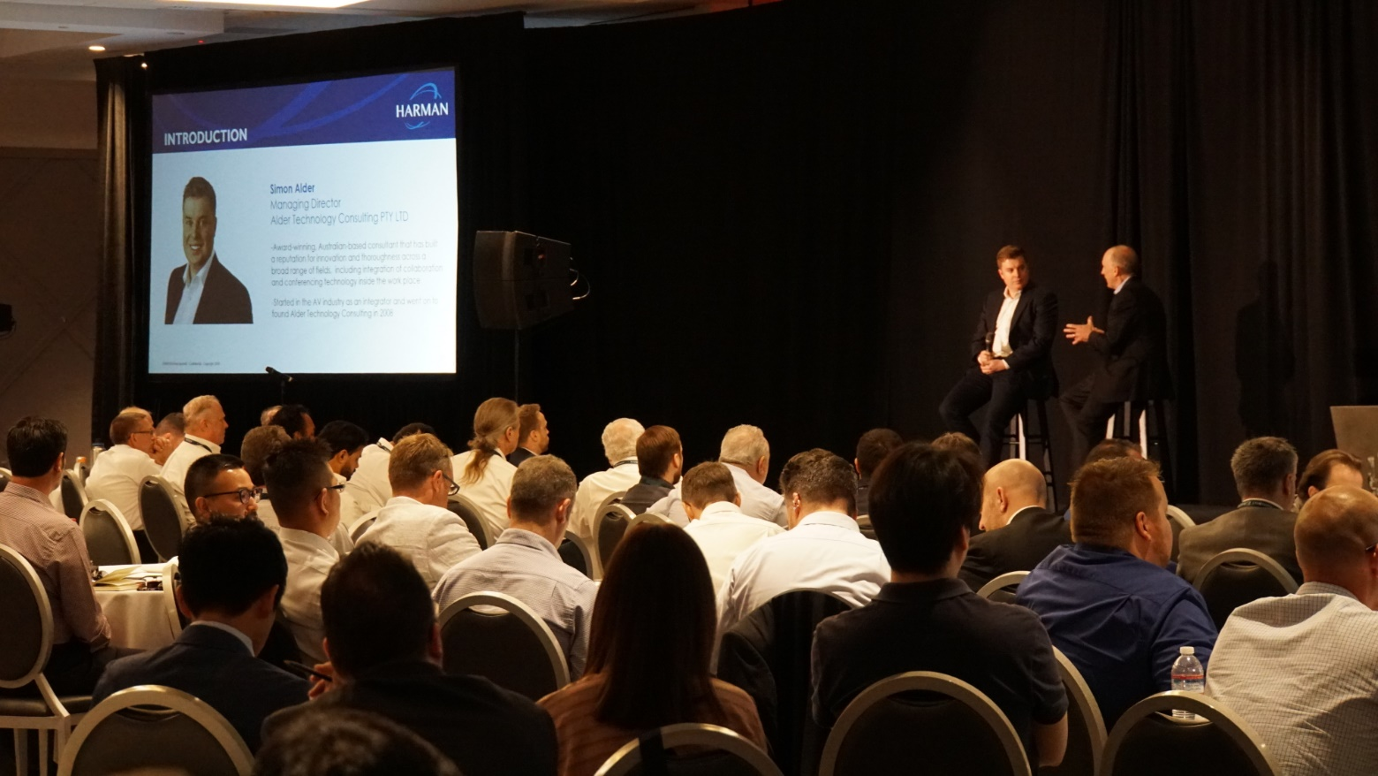

Founded in 2008 Alder Technology has become a leading provider of technology solutions, audio visual consulting, project management and implementation advisory services. With offices in Melbourne, Sydney and Brisbane, Alder Technology services all states of Australia and boasts a diverse client base across all major sectors.

The traditional consulting arm of Alder Technology focuses on the new construction and refurbishment industry, assisting high profile clients in tertiary education, government and commercial sectors implement successful audio visual systems in new buildings and renovations/retrofits. In 2019 Alder Technology expanded into implementation services, and has been at the forefront of Microsoft Teams implementations, working with leading IT vendors and partners to deliver world class conferencing experiences in the new hybrid workplace.

Key Concepts
There are a number of key concepts which must be reviewed prior to delivery of the solution. These form the basis of the meeting room experience, and are crucial to the design and delivery of effective spaces.

Video
There are two main considerations with video in this project, video in and video out.
For video in, it is important that there is not too much hardware used, and that the software is used for presentation of content as much as possible in lieu of hardware (as explained below).
For video out, the height of the display is extremely important. Ideally, participants should be seated at a distance of no more than 6x the height of the screen, and no closer than 2x the height of the screen (see below image).
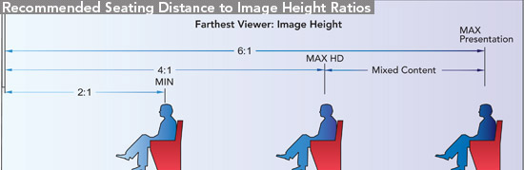
This is important because this is for traditional presentation only, which is appropriate in dual display rooms, where content is on a full display and participants on another. This changes in single display Teams rooms, as the “Brady Bunch” effect of multiple windows with the far end participants reduces the content size even more. So even though the display may be an 85”, the actual content window may be only a 75” or less. Therefore, where screen sizes are a bit small for the room, dual screen should be strongly considered if larger displays are out of budget.

Audio
Audio is the most important part of the meeting. You can turn your camera off and still have an effective conversation. But when the audio is poor, people do not have a good experience, and when a good experience is not provided, people do not use the asset. Poor audio choices do not save money, they waste money through under-utilisation. The focus must be on Speech Intelligibility (SI).
The key aspects for speech to be clearly heard and understood are:
- Low ambient noise level, ensuring the intended speech is clearly prominent above all other noise.
- Control of late echoes, standing waves and reverberation, limiting the noise build-up in the room that interrupts and muddles the discussion.
There are many factors which contribute to a good audio experience for the user. The following must be taken into consideration:

User Experience  Hybrid working has created a new baseline experience for users. In the past, users were accepting of poor audio in a meeting room. Now, post covid and amidst the hybrid working revolution, users have a new appreciation for what a good experience is. Working from home. they have speakers on their ears, a microphone right in front of their mouth, and a camera framing them perfectly. If a meeting room does not deliver this experience, users won’t adopt it. | 

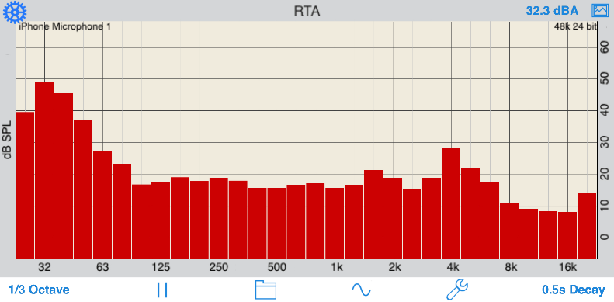 | Ambient Noise  Ambient Noise is a critical factor in the meeting room. Air conditioning, road noise or office noise that is picked up by the microphones may be transferred to the far end.  Typically, VC system suppliers recommend ambient noise levels of 30-35dBA to have a good buffer between speech and the background noise level. This is generally much lower than a base-building provision of 40-45dBA, suitable for open office areas. We often see meeting rooms with ambient noise levels above 50dBA.
Reverb (RT60)  Typically suppliers of VC systems recommend a reverberation time (RT60) in the range of 0.3 to 0.5s. This is typically more subdued or dead than a standard meeting room. The recently released Australian Standard AS/NZS 2107:2016 goes further, recommending a range of 0.2-0.4s for dedicated VC / audio conference rooms.  Internal finishes should be carefully selected to provide the right balance of absorption and reflection.  This is not always possible, and audio visual electronics are required to compensate for high reverb. | 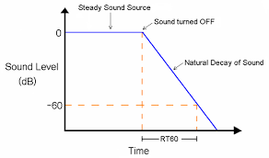

Software Based Conferencing:
The software based conference room, whether it be MS Teams, Zoom, Cisco or other, is specialist, and should not be considered IT, nor should it be considered AV. It is a specialist hybrid of the two, and room designs must reflect this. In all aspects, it is important to use the software in the way it was designed. Additional hardware such as wireless presenters and control processors fix the functionality in place, and do not allow the system to grow as new features and benefits are added over time.
Equipment Selection  These rooms run on software now, not hardware. Adding unnecessary hardware can interfere with this software, limiting its functionality. Similarly, placing non-certified hardware can cause conflicts in your system, reducing the room’s effectiveness and limiting support options from your software provider. Hardware must be Teams Certified. | 
Networking  Software based conferencing is now ubiquitous, and as the room count rises, so do the networking requirements. Conferencing software has specific port and QoS requirements and the bandwidth can be surprising. For example, at full throttle with screen sharing enabled, Microsoft Teams can run at up to 10Mbs/6Mbs Upload/Download. | 
The Room Itself  There are now far more factors to consider in a room. As rooms have become simpler, they move away from racks, meaning power and data is relocated into the room and more data is required than old analogue systems. Additionally, rooms are being turned into conferencing rooms that were never intended for conferencing. The acoustic delta must be made up, either with room treatments, or audio visual smarts. | 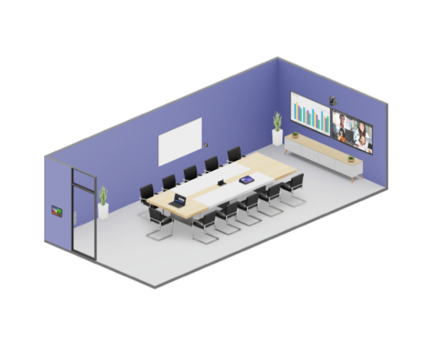

Alder Technology Meeting Rooms Implementation
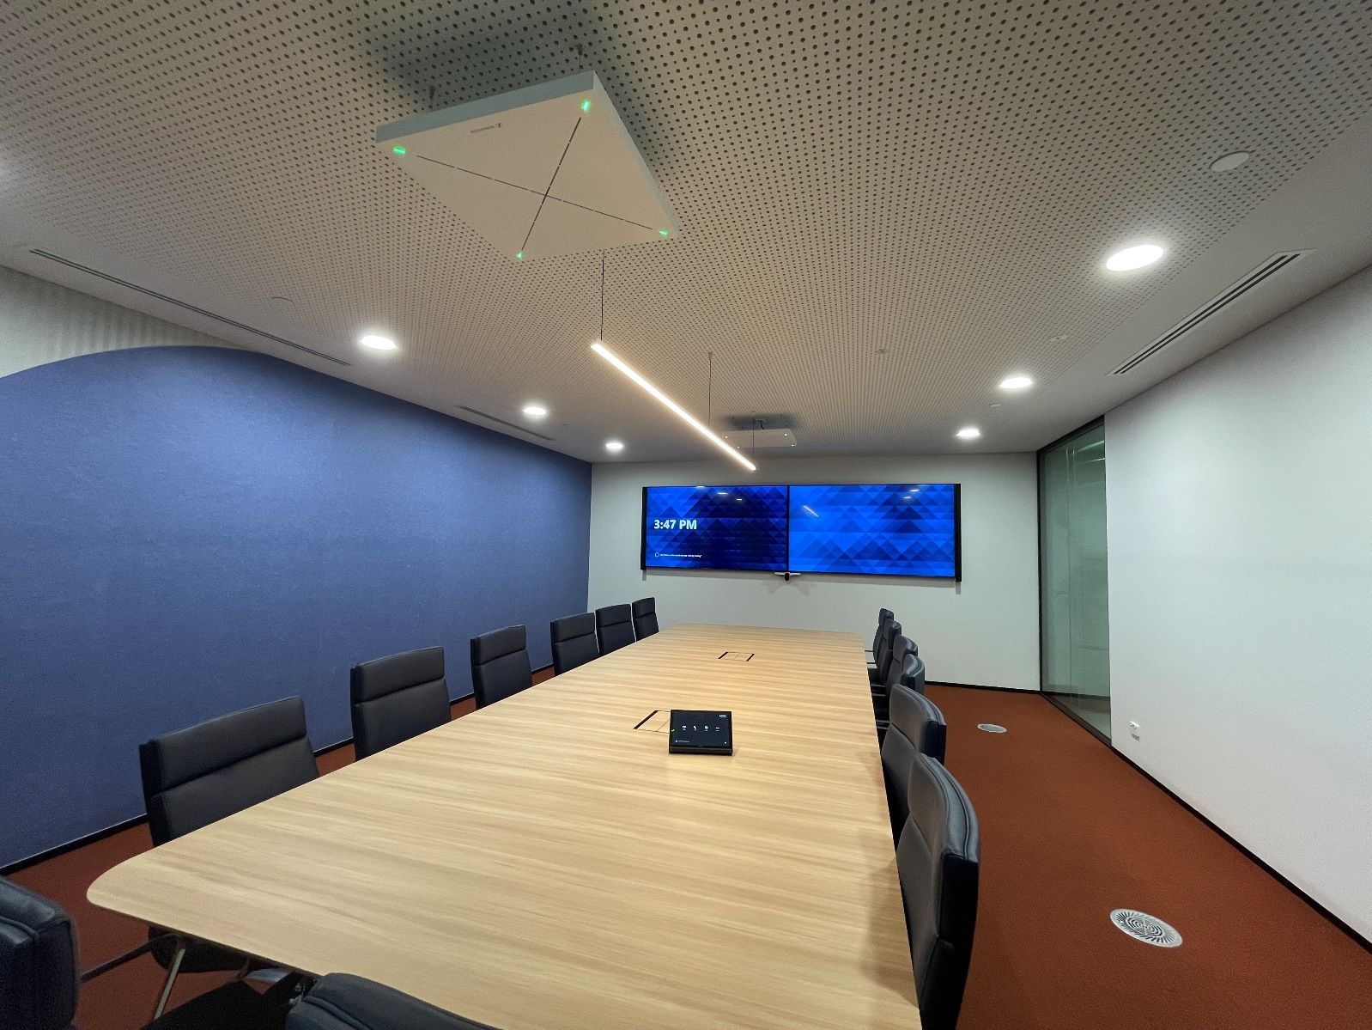

Meeting rooms hardware is simpler than ever, but the combination of audio visual, network and software make them more complex than ever to deliver. Once they are complete, when done correctly they provide users with the greatest ease of use we have seen in meeting rooms to date. Alder Technology implements only meeting rooms, with vast experience in delivering conferencing and collaboration rooms in a software environment.
There are four main areas of focus when delivering a new age conferencing room:
- Network Based Systems
- Audio Choices
- Staging and preparation
- Ongoing Maintenance, Service and Support
Network Based Systems
Where possible, every piece of equipment is IP based, and Power over Ethernet where available. Whilst there is Teams certified hardware which is not IP based, no other option gives the flexibility, monitorability and supportability of IP based hardware. IP based systems provide the best options for pre-staging, deployment and support. It minimises installation time and increases uptime of the system.

The MTR  There are many different manufacturers of Microsoft Teams Rooms, and the choice of vendor is important. We select vendors that have a robust cloud management platforms, allowing for offsite configuration, remote troubleshooting, and a management throughout the unit lifecycle.  These are software based solutions. Updates from Microsoft will cause issues or conflicts in the system. The remote cloud platform allows these risks to be mitigated, and quickly resolved should they occur with minimal impact to the room. | 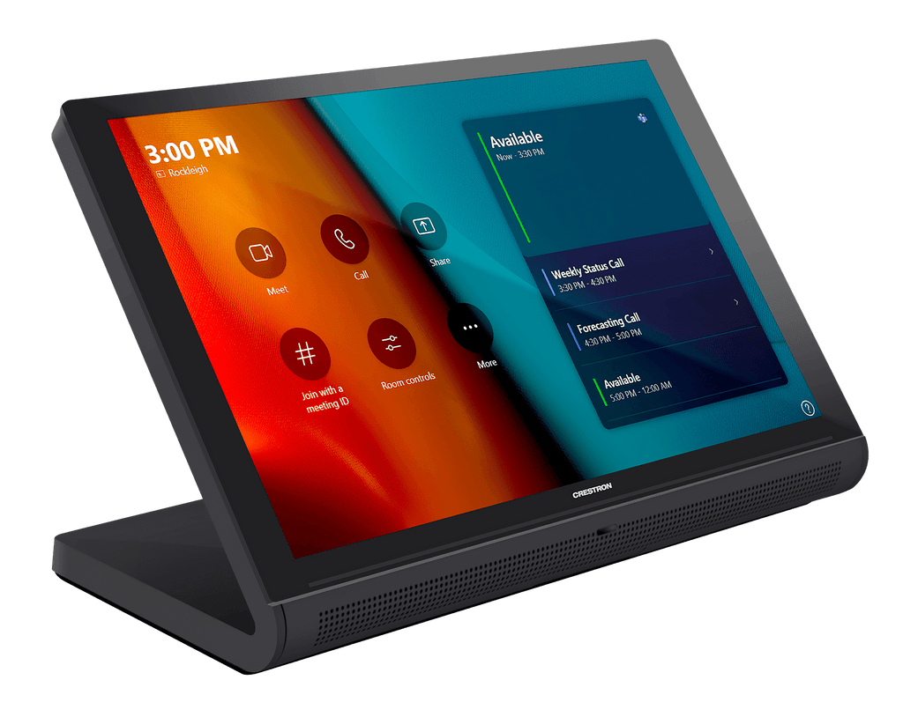

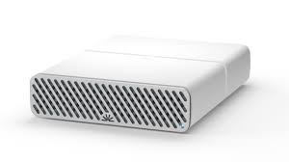 | Audio Processing  A network based processor gives many advantages, not the least of which is the remote monitoring capability. Paired with its microphones and speakers, the system can be remotely supported, room retuned, and critical updates deployed to give the best experience with new and exciting features from the conferencing software. Software based conferencing is constantly tweaking its audio algorithms, and quick changes are often required to adapt to the new requirements.  A second network port on the processor allows for all multicast audio and video traffic to be kept off the client network, isolated for performance and security reasons, whilst remaining monitorable through the control processor.
Speakers and Microphones  Network based speakers and microphones allow for multiple channels of audio to be sent across the room on a single cable. Removing specialist cabling from the room means the room can be pre wired for power and data, greatly reducing time at installation. The network based products greatly reduce installation errors, and the units are visible the moment they are connected. Network based technology also reduces the amount of equipment required. The same processor can do any size meeting room and amplifiers are not required. The system can be scaled to any size room simply by adding microphones and speakers | 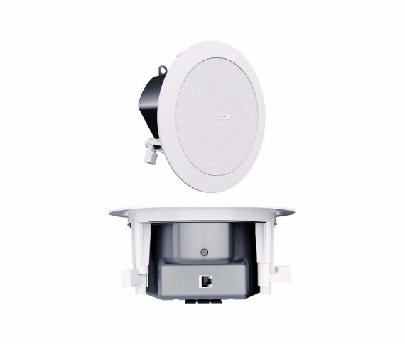  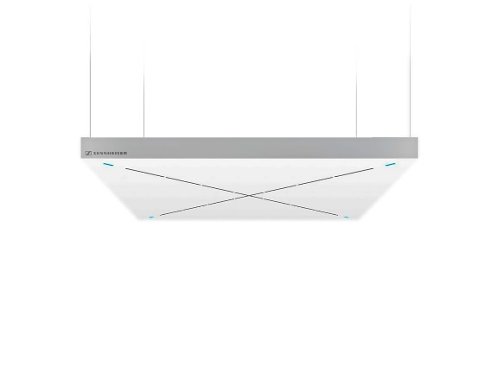
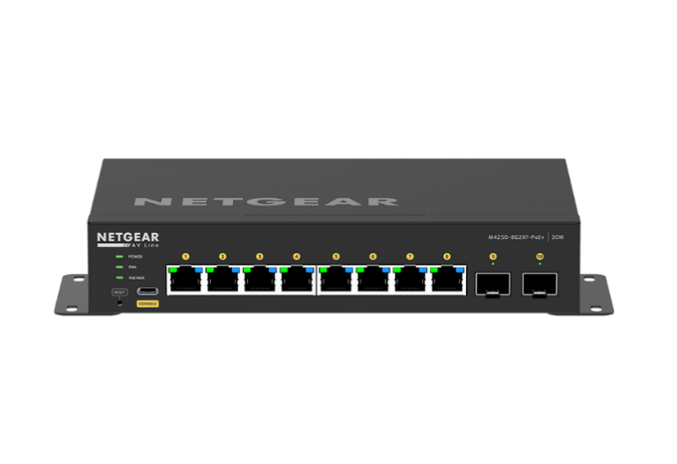 | AV Networks  Running a segregated network allows for all multicast traffic to be isolated off the client network. Additional speakers, microphones and cameras can be added to spare network ports, scaling between medium, large, extra large and flexible rooms.  The network switch can be monitored via the Out of Band port, allowing remote configuration, and remedial action such as bouncing POE ports to hard reset microphones, cameras and speakers when required. This is completed natively within the monitoring system from Azure without requiring any user connectivity to the local network.
Conferencing Soundbars  In smaller rooms, conferencing soundbars are used as the combine cameras, microphones and speakers in a convenient and cost effective single unit. Traditionally, these have been difficult to monitor in any detail. The soundbars selected have network connectivity, and in addition are native Teams units, which sync to MS Teams for automatic firmware updates to ensure compatibility with new software updates from Microsoft. | 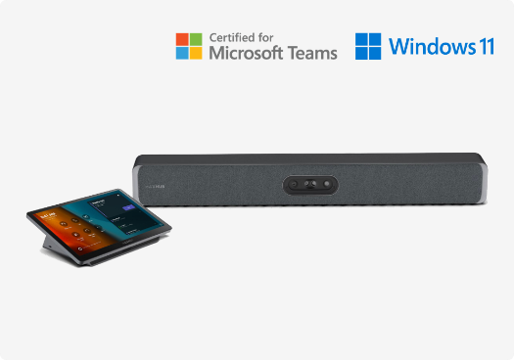

Dedicated Audio Systems  A dedicated audio system is required when the distance to the furthest participant is over the maximum range of a conferencing soundbar, or the room acoustics are poor. We define poor acoustics as over 50dBA ambient noise, or an RT60 value of above 0.7 seconds. When the room acoustics are poor a processor, network based microphone and POE speakers are required.  It is not only the equipment selection that is important, placement is also vital. During the pre installation walk through, the speakers and microphones will be located in the room, and their heights determined. In rooms with poor RT60, microphones may need to be suspended lower to get them closer to the speaker and get a better result. | 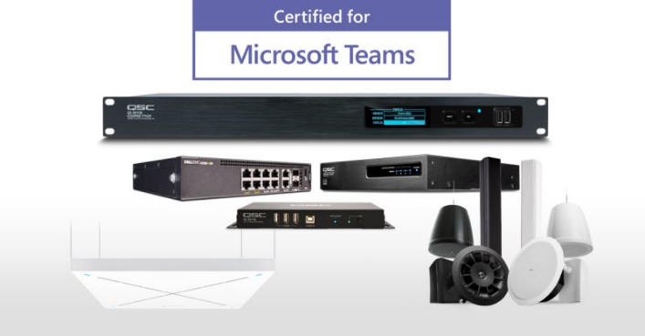

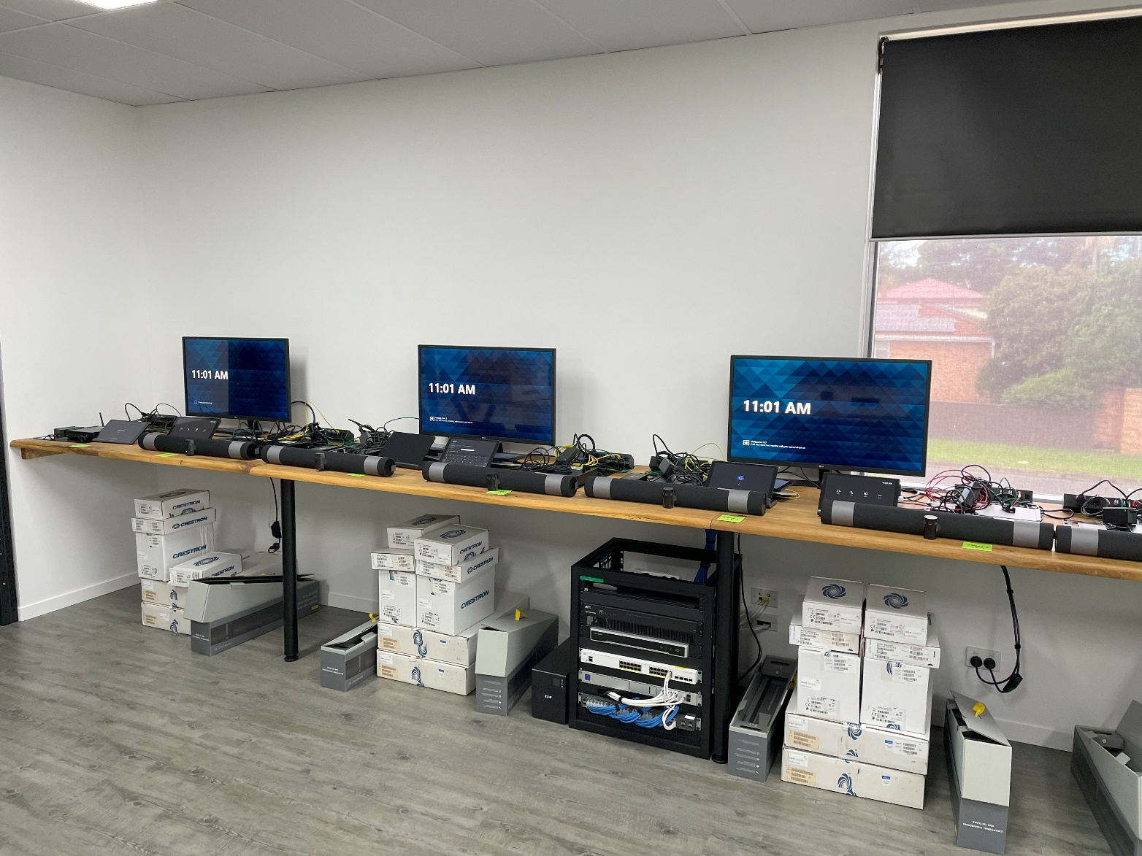
Staging and Preparation:

A key difference in our approach to most vendors is the extensive staging and preparation process we go through on every project. The staging is the most important element in our process. It sets the tone for the project, greatly reduces errors and time onsite, and provides certainty with the installation. Many vendors will “drop ship” equipment to site. There are no updates, no testing, and no idea if the equipment even works. It is reliant on technicians scrambling onsite to try and update an commission the hardware.
Based in our Technology Centre, our staging area is able to prepare up to 15 rooms simultaneously, and coupled with over 100m2 of warehousing floor, we are able to scale very small to very large projects efficiently. Each item is firmware updated, configured and tested. We open and label every cable to be used in the project, and the cable used for testing is the cable that will be installed in the room. We input client credentials, and we make test calls with the system. The items are carefully packed and shipped to site, knowing they are working 100% when they leave the Tech Centre.
The benefits of our staging are numerous:
- Rooms are able to be updated, configured and tested in 2-3 days. With up to 15 rooms simultaneously, 60 rooms can be prepared in as little as two weeks.
- The preparation of these rooms means that on site installers can be scaled to meet the demand of the rooms. At Guild Group, 15 complex MTR’s, representing over $500k in value, were delivered onsite defect free in just four working days.
- All equipment is registered as an asset in the cloud. It comes online instantly once it is installed on the client site. As such, if there are issues onsite, it can be narrowed down quickly as it was working on the bench. This saves an enormous amount of time onsite debugging and fault finding.
- The client has access to all information before the equipment even hits site. Equipment details (Serial Number, MAC address etc) can be provided for network planning or accounting purposes, and test calls made to the equipment on the bench for licensing verification.
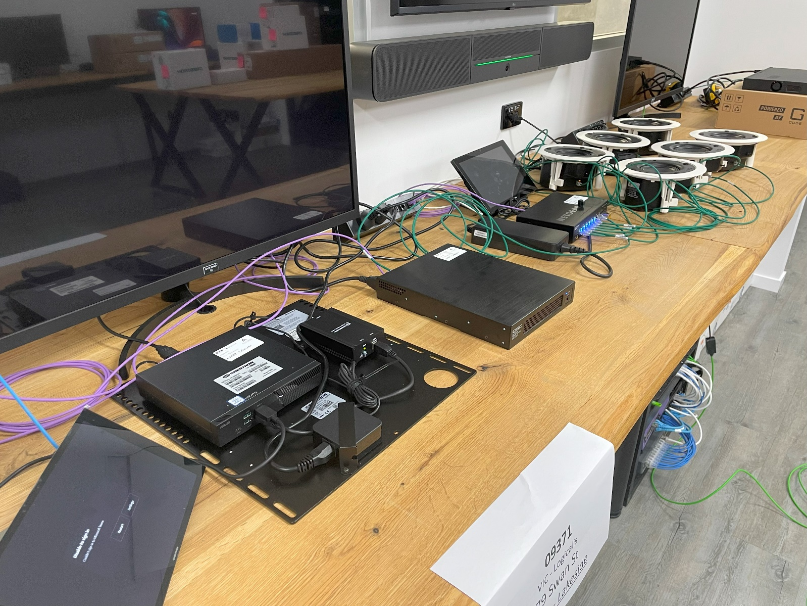

Maintenance and Support
It is essential that all equipment is placed on a managed service contract. Unlike Cisco, Microsoft does not own its own hardware. It relies on partnerships with third party vendors, such as Crestron and QSC, to provide the hardware to make its software run. Like any software, it needs constant updating, and this can cause issues, conflicts and downtime. The managed service contract provides remote and onsite support, both preventative and reactionary, to keep uptime high.

Cloud Based Monitoring  The main reason for network based equipment is our ability to monitor and maintain that equipment. Any updates, changes or tuning can be done remotely via our custom dashboard.  When an update installs overnight which causes a conflict, the fix can be sent remotely, and in many cases will be sent pre-emptively with the update from Microsoft. | 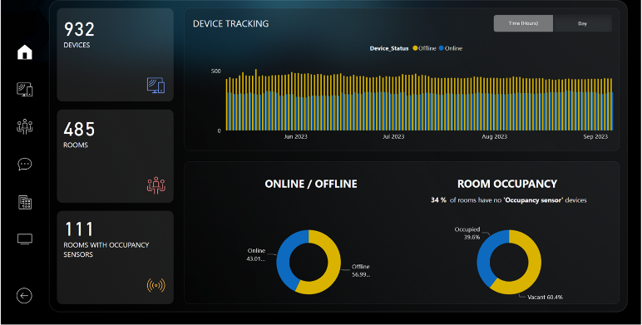
If anything happens on the networking side, we can see in real time any changes to the system. If a touch screen console is unplugged, we will immediately be alerted.
Even the AV network switch is monitored, allowing us to “bounce” POE ports to hard reset any hardware such as cameras or speakers.
This greatly increases room uptime. Having to get a technician out to site is time consuming, and technicians may not be available straight away. Having this level of remote access and control keeps rooms up and running longer.
Onsite Support
Every now and then onsite support is required. A power supply might fail in a display, or a critical hardware fault may “brick” a Teams unit. Where we cannot fix something remotely, all onsite work is included. There are no hidden costs, no call out fees and no “gotchas”. The maintenance agreement is all inclusive, such is our confidence in the stability of these systems.

Room Installation
New meeting rooms will bring increased functionality and productivity to the office, but they can’t be taken offline for weeks, and they can’t become white elephants once delivered, with poor audio or difficult user experience. The below represents the Alder Technology promise to get high quality rooms delivered quickly.

Methodology:
We note the following processes completed with all Microsoft Teams Rooms
- Rooms are audited to confirm design, power, data and any works in conjunction that are required. We meet with your team to go through network, M365 and logistic requirements. You will be assigned a dedicated project manager, and we will help you every step of the way.
- All equipment will be unboxed in an “IT Bench” at our warehouse, connected to the network and preconfigured, tested and ready to go. From here, we will have all equipment updated with firmware, latest MS Teams software, and all settings and updates required for monitoring the systems for ongoing support. Rooms will be “working” prior to installation which shall create a more efficient install and minimise impact to the business. This eliminates one of the biggest pain points of a retrofit – a technician occupying a room for days with a laptop trying to debug systems, denying use to the staff who need the room.
- All equipment will be installed onsite after any additional required power/data has been installed by other contractors.
- Once physical installation is complete, Alder Technology will complete the commissioning of rooms and audio engineering as well as user training.

Proposed Solution
Our proposed solution from Maxhub is a full Microsoft Teams Rooms solution, which also allows for BYOD capability.
The Maxhub solution represents an exciting new Teams certified product. It has best in class video and audio in the bar, but importantly is Windows based, the only type of its kind. This gives us the full functionality of the Quad Cam and AI microphone array in the bar, as well as the full stack solution from Microsoft with the Windows 11 OS. It is a new product which represents best in class for the new generation of solutions.

Installation Services:

Each room will have the following services:
- Coordination of M365 and Networking requirements with client for all rooms.
- Coordination of all trades in association (power, data etc.).
- Offsite configuration and update.
- Supply and Installation of Equipment
- Full Commissioning Services
- Audio Engineering
- Project Management
- As Built Documentation, O&M Manuals
- Training

This is a fully supported and managed installation. We do not merely install the equipment and leave you to setup and configure yourself. Our commissioning engineer will assist with all M365 and networking actions required to the performed by the client, and full training of the systems is included and provided.

