TABLE OF CONTENTS
CHAPTER NO | DESCRIPTION | PAGE NO
 | ABSTRACT | i
1 | INTRODUCTION | 1-11
1 | 1.1 GENERAL | 1
1 | 1.2 OBJECTIVE | 2
1 | 1.3 EXISTING SYSTEM | 3
1 | 1.3.1 DISADVANTAGES OF EXISTING SYSTEM | 4
1 | 1.3.2 LITERATURE SURVEY | 5
1 | 1.4 PROPOSED SYSTEM | 7
1 | 1.4.1 ADVANTAGES OF PROPOSED SYSTEM | 9
1 | 1.5 SCOPE OF THE PROJECT | 9
1 | 1.5.1 PURPOSE OF THE PROJECT | 10
1 | 1.6 ORGANISATION OF THE REPORT | 11
2 | SYSTEM ANALYSIS AND METHODOLOGY | 12-18
2 | 2.1 GENERAL | 12
2 | 2.1.1 METHODOLOGIES | 12
2 | 2.1.2 AGILE METHODOLOGY | 13
2 | 2.2 MODULES | 14
2 | 2.2.1 KNOWLEDGE INGESTION & RAG ENGINE MODULE | 14
2 | 2.2.2 INTERACTIVE WEB VISITOR REQUEST MODULE | 15
2 | 2.2.3 AI AUTO-CATEGORIZATION MODULE | 16
2 | 2.2.4 SUPERADMIN & SYSTEM CONFIGURATION MODULE | 17
2 | 2.2.5 DEPARTMENT ADMIN DASHBOARD MODULE | 17
3 | REQUIREMENTS ENGINEERING | 19-20
3 | 3.1 GENERAL | 19
3 | 3.2 HARDWARE REQUIREMENTS | 19
3 | 3.3 SOFTWARE REQUIREMENTS | 19
4 | DESIGN ENGINEERING | 21-32
4 | 4.1 GENERAL | 21
4 | 4.1.1 USE CASE DIAGRAM | 22
4 | 4.1.2 CLASS DIAGRAM | 23
4 | 4.1.3 OBJECT DIAGRAM | 24
4 | 4.1.4 STATE DIAGRAM | 25
4 | 4.1.5 ACTIVITY DIAGRAM | 26
4 | 4.1.6 SEQUENCE DIAGRAM | 27
4 | 4.1.7 COLLABORATION DIAGRAM | 28
4 | 4.1.8 COMPONENT DIAGRAM | 29
4 | 4.1.9 DATA FLOW DIAGRAM | 30
4 | 4.1.10 E-R DIAGRAM | 31
4 | 4.1.11 ARCHITECTURE DIAGRAM | 32
5 | DEVELOPMENT TOOLS | 33-35
5 | 5.1 DJANGO FRAMEWORK | 33
5 | 5.2 PYTHON | 33
5 | 5.3 CHROMADB AND VECTOR EMBEDDINGS | 34
5 | 5.4 NVIDIA NIM LLM API | 34
5 | 5.5 FRONTEND TECHNOLOGIES | 34
6 | IMPLEMENTATION | 36-52
6 | 6.1 GENERAL | 36
6 | 6.2 requirements.txt | 36
6 | 6.3 .env.example | 36
6 | 6.4 orgbot/models.py | 37
6 | 6.5 orgbot/services/chunking.py | 38
6 | 6.6 orgbot/services/embeddings.py | 39
6 | 6.7 orgbot/services/vector_store.py | 40
6 | 6.8 orgbot/services/page_index.py | 41
6 | 6.9 orgbot/services/llm_client.py | 42
6 | 6.10 orgbot/services/rag_engine.py | 43
6 | 6.11 orgbot/services/categorizer.py | 44
6 | 6.12 orgbot/views.py | 46
6 | 6.13 orgbot/department_views.py | 47
6 | 6.14 orgbot/admin.py | 49
6 | 6.15 static/orgbot/chat.js | 51
7 | VARIOUS SNAPSHOTS | 53-68
7 | 7.1 VARIOUS SNAPSHOTS | 53
7 | 7.1.1 Landing / Home Page | 54
7 | 7.1.2 About the Organization Section | 55
7 | 7.1.3 Ask Our AI Assistant Section | 56
7 | 7.1.4 Chatbot Greeting and Instant Reply | 57
7 | 7.1.5 Missing-Data Notice and Web Visitor Request Form | 58
7 | 7.1.6 Answer Generated from the Knowledge Base | 59
7 | 7.1.7 Department Analytics Dashboard | 60
7 | 7.1.8 Department Request Directory | 61
7 | 7.1.9 Manage Visitor Request (Reply, Forward, Delete) | 62
7 | 7.1.10 Incoming Forwarded Requests | 63
7 | 7.1.11 Django Admin - Users (Department Accounts) | 64
7 | 7.1.12 Django Admin - Departments | 65
7 | 7.1.13 Django Admin - Knowledge Documents | 66
7 | 7.1.14 Django Admin - Organization Profile | 67
7 | 7.1.15 Django Admin - Visitor Requests | 68
8 | SOFTWARE TESTING | 69-72
8 | 8.1 DEVELOPING METHODOLOGIES | 69
8 | 8.2 TYPES OF TESTS | 69
8 | 8.2.1 UNIT TESTING | 69
8 | 8.2.2 FUNCTIONAL TESTING | 70
8 | 8.2.3 SYSTEM TESTING | 70
8 | 8.2.4 PERFORMANCE TESTING | 71
8 | 8.2.5 INTEGRATION TESTING | 71
8 | 8.2.6 ACCEPTANCE TESTING | 71
8 | 8.2.7 BUILD THE TEST PLAN | 72
9 | APPLICATION | 73-74
9 | 9.1 GENERAL | 73
9 | 9.2 FUTURE ENHANCEMENT | 73
10 | CONCLUSION | 75-77
10 | 10.1 CONCLUSION | 75
10 | 10.2 REFERENCES | 76

RAG CHATBOT WITH DEPARTMENT REQUEST ROUTING

ABSTRACT:
Educational institutions and other organizations receive a continuous stream of visitor questions whose answers already exist in brochures, notices and documents, yet visitors must search several pages or wait for a call or e-mail. Static websites and rule-based chatbots cannot handle rephrased questions, and generic AI assistants do not know the organization’s data. This project presents a Django web application with an embedded RAG chatbot that answers from the organization’s own uploaded data and routes everything else to the right department.
Uploaded .txt and .json files are chunked and embedded into ChromaDB with an offline hashing embedding function (vector method) and mirrored in a JSON page index (keyword fallback). Questions are answered by vector search with a distance threshold of 0.90, falling back to the page index, and the context is passed to an NVIDIA NIM model with a second model as automatic fallback. When Dashboard Mode is on and data is missing, an inline visitor form collects name and e-mail, and an AI categorizer assigns the request to one of ten departments, defaulting to General.
The system has five modules: Knowledge Ingestion & RAG Engine, Interactive Web Visitor Request, AI Auto-Categorization, Superadmin & System Configuration, and Department Admin Dashboard. Department admins track analytics, reply by SMTP e-mail and forward requests, so that no question is left unanswered.

CHAPTER 1

CHAPTER 1
INTRODUCTION

1.1 GENERAL
Educational institutions, hospitals, companies and public offices receive a continuous stream of questions from the people who visit their websites: What courses are offered? How can I reach the admission office? What are the library timings? Who should I contact about hostel fees? Most of these answers already exist somewhere in brochures, notices and internal documents, but a visitor has to search through several pages, or wait for a phone call or an e-mail, before getting them. For an organization with many departments, even the staff find it difficult to decide which department should answer a particular question.
This project builds a web-based Organization RAG Chatbot that answers visitor questions from the organization’s own documents and, when the answer is not available, routes the question to the right department. The application is developed with Django for the backend and HTML, CSS and JavaScript for the frontend. Retrieval-Augmented Generation (RAG) is used so that every answer is grounded in the uploaded .txt and .json knowledge files: the files are chunked, embedded and stored in ChromaDB (vector method), and are also mirrored as page-level entries in a JSON page index (keyword fallback). The retrieved context is handed to an NVIDIA NIM hosted Large Language Model, with a second model configured as an automatic fallback.
The system also contains a Dashboard Mode. When the superadmin switches it on and a visitor asks something that is not present in the database, the chatbot displays an inline Web Visitor Request Form (name and e-mail). The submitted question is classified by an AI categorizer into one of the active departments (General, Admission, Studies, Hostel, Canteen, Cleaning, Library, Sports, Travel, Maintenance), and the department admin answers it from a dedicated dashboard by SMTP e-mail, or forwards it to another department. The screenshots in this report use St. Peter’s Engineering College as the sample organization.

1.2 OBJECTIVE
The objective of this project is to design and implement an intelligent, web-based knowledge assistant that answers questions about an organization using only the organization’s own uploaded data, and that converts every unanswered question into a tracked request that reaches the correct department. The project combines semantic retrieval, a keyword-based fallback, a hosted language model and a department workflow in a single Django application, so that the organization does not need separate tools for the chatbot, the enquiry desk and the e-mail follow-up.
A further objective is to make the system dependable and easy to operate: two retrieval methods with automatic fallback, two language models with automatic retry, a fully offline embedding function that needs no model download, and an administration interface through which a non-technical superadmin can upload documents, create departments and toggle features. The specific objectives of the system are:
- Answer visitor questions accurately from the organization’s own .txt and .json documents.
- Provide two retrieval methods - ChromaDB vector search and a page-index keyword fallback - with automatic switching.
- Generate natural-language answers with an NVIDIA NIM LLM and retry automatically with a fallback model.
- Capture unanswered questions through an inline Web Visitor Request Form when Dashboard Mode is on.
- Auto-categorize each request to the most suitable department using AI, defaulting to General.
- Let department admins track, reply to (SMTP e-mail) and forward requests from a secure dashboard.

1.3 EXISTING SYSTEM
Most organizations handle visitor enquiries through a static website, a printed brochure, a telephone helpline and a shared enquiry e-mail address. Where a chatbot exists, it is usually a rule-based widget with a fixed list of questions and canned replies, or a generic AI assistant that has never seen the organization’s documents and therefore answers from general knowledge. These approaches work while the organization is small and the questions are predictable, but they break down as the number of departments, documents and visitors grows.
Because the existing systems do not connect the answer to the organization’s own data, staff are left to maintain parallel channels: answering the same questions repeatedly by phone, forwarding e-mails by hand from the front office to the right department, and keeping informal lists of who handles what. This extra coordination is itself a source of delay and error, and a visitor’s question is easily lost when it reaches the wrong desk. A system that retrieves answers from uploaded documents and routes the remaining questions automatically removes the need for these workarounds.

1.3.1 DISADVANTAGES OF EXISTING SYSTEM
- Static and hard-to-search information: Visitors must browse several pages or download brochures to find a single fact, which is slow and often unsuccessful.
- Rule-based chatbots with fixed replies: Keyword-triggered bots fail on rephrased questions and cannot be updated without developer effort.
- Generic AI answers without grounding: A general-purpose language model has not seen the organization’s data and may produce confident but incorrect statements (hallucination).
- Manual routing of enquiries: Questions that cannot be answered immediately are forwarded by hand to departments, causing delays and lost requests.
- No tracking or analytics: There is no record of how many requests are pending, cleared or forwarded, so the management cannot measure responsiveness.

1.3.2 LITERATURE SURVEY
Title: Retrieval-Augmented Generation for Knowledge-Intensive NLP Tasks
Year: 2020
Author: P. Lewis, E. Perez, A. Piktus, F. Petroni, V. Karpukhin et al.
Description: The authors introduce Retrieval-Augmented Generation, in which a generator is conditioned on passages fetched from an external document index. They show that grounding generation in retrieved text improves factual accuracy on open-domain question answering. This paper is the conceptual basis of the vector-first, LLM-second pipeline used in this project.
Title: Dense Passage Retrieval for Open-Domain Question Answering
Year: 2020
Author: V. Karpukhin, B. Oguz, S. Min, P. Lewis, L. Wu et al.
Description: This work shows that dense vector representations of questions and passages can outperform sparse keyword retrieval for open-domain question answering. It motivates the use of a vector store with a similarity threshold as the primary retrieval method, while the keyword page index is kept as a fallback for fact-heavy content.
Title: The Probabilistic Relevance Framework: BM25 and Beyond
Year: 2009
Author: S. Robertson, H. Zaragoza
Description: The authors describe BM25, the classical keyword-based ranking function used by most search engines. Their analysis of term frequency and document length supports the choice of a simple keyword lookup as a fast and reliable fallback when semantic search returns nothing relevant.
Title: Feature Hashing for Large Scale Multitask Learning
Year: 2009
Author: K. Weinberger, A. Dasgupta, J. Langford, A. Smola, J. Attenberg
Description: This paper presents the hashing trick, which maps features into a fixed-length vector without storing a vocabulary. It directly supports the offline, deterministic hashing embedding function used here, which needs no downloaded model and works identically on any machine.
Title: Sentence-BERT: Sentence Embeddings using Siamese BERT-Networks
Year: 2019
Author: N. Reimers, I. Gurevych
Description: Sentence-BERT produces semantically meaningful sentence embeddings that can be compared with cosine similarity. It represents the upgrade path mentioned for this project: only the embedding module needs to change to move from hashing features to true semantic embeddings.
Title: Survey of Hallucination in Natural Language Generation
Year: 2023
Author: Z. Ji, N. Lee, R. Frieske, T. Yu, D. Su et al.
Description: The survey catalogues the causes of hallucination in generated text and the techniques used to reduce it. Its conclusion that grounding in retrieved evidence reduces unsupported statements justifies restricting the chatbot to answer only from the organization’s own context.
Title: Retrieval-Augmented Generation for Large Language Models: A Survey
Year: 2023
Author: Y. Gao, Y. Xiong, X. Gao, K. Jia, J. Pan et al.
Description: This survey reviews the chunking, retrieval, prompt-construction and generation stages of modern RAG systems. The chunk-embed-retrieve-generate pipeline implemented in this project follows the naive RAG pattern described in the survey.
Title: The Llama 3 Herd of Models
Year: 2024
Author: A. Dubey, A. Jauhri, A. Pandey et al. (Meta AI)
Description: The report describes the Llama 3 and 3.1 family of open language models of different sizes. The primary and fallback chat models used in this project, hosted through NVIDIA NIM, belong to this family, which makes a large-model and small-model pairing practical.

1.4 PROPOSED SYSTEM
The proposed system is a Django web application that combines a colourful landing page, an embedded AI chatbot and a department workflow. A superadmin uploads .txt or .json files through the Django admin; as soon as a file is saved, it is chunked and embedded into ChromaDB and also appended, page by page, to a shared JSON page index. When a visitor asks a question, the RAG engine first performs a vector search with a distance threshold of 0.90; if nothing relevant is found it falls back to the keyword page index. The best context is sent with the question to an NVIDIA NIM language model, and the answer is returned with any URLs converted into clickable links.
When Dashboard Mode is switched on and the requested information is not in the database, the chatbot displays a notice and an inline form for the visitor’s name and e-mail. The request is categorized by AI and assigned to a department, whose admin can reply by SMTP e-mail, forward the request to another department, or delete it. The system:
- Retrieves answers from uploaded documents using ChromaDB vector search with an automatic page-index fallback.
- Uses two NVIDIA NIM models, retrying with the fallback model on error or timeout.
- Preserves source URLs and renders them as clickable links in the chat.
- Shows an inline Web Visitor Request Form when data is missing and Dashboard Mode is True.
- Auto-categorizes requests into active departments using keyword matching plus LLM classification.
- Provides department dashboards with analytics, request handling, SMTP replies and inter-department forwarding.

1.4.1 ADVANTAGES OF PROPOSED SYSTEM
- Answers grounded in organization data: Every response is generated from retrieved chunks of the organization’s own documents, which reduces incorrect or invented answers.
- Dual retrieval with automatic fallback: The vector method handles meaning-based questions and the page-index method handles exact keyword lookups, so a weak vector match never ends in a blank answer.
- Dual-model resilience: If the primary model is rate-limited, down or returns a bad response, the same question is retried automatically with the fallback model.
- Zero-friction ingestion: Uploading a .txt or .json file in the admin automatically chunks, embeds and indexes it; editing and re-saving re-indexes it after removing the old entries.
- No lost enquiries: Questions that cannot be answered become tracked requests with a status of pending, cleared, forwarded or deleted, and are assigned to a department automatically.
- Lightweight and portable: The embedding function is fully offline, ChromaDB and SQLite are file-based, and the whole application runs with python manage.py runserver on an ordinary computer.

1.5 SCOPE OF THE PROJECT
The scope of this project covers the end-to-end workflow of an organization knowledge assistant: uploading and indexing .txt and .json documents, answering visitor questions through vector search with a page-index fallback, generating answers with NVIDIA NIM models, capturing unanswered questions through the Web Visitor Request Form, categorizing them into departments with AI, and managing them through a department dashboard with SMTP replies and request forwarding. The system is a single-organization application: one OrganizationProfile governs the landing page and Dashboard Mode, and any number of departments can be created by the superadmin. It is designed to run on a standard desktop or a small server with an internet connection for the NVIDIA API, which keeps the solution portable and easy to demonstrate.

1.5.1 PURPOSE OF THE PROJECT
The primary purpose of this project is to reduce the effort an organization spends answering repeated questions and to make sure that no visitor question goes unanswered. Rather than producing a research prototype, the system hands the organization a working tool: upload the documents once, and the chatbot immediately starts answering from them; switch on Dashboard Mode, and every question the chatbot cannot answer is routed to the department that should reply. By making the information one question away for visitors and one dashboard away for staff, the project aims to shorten response time, reduce the load on the front office, and give small and mid-size institutions an AI assistant that previously required a dedicated development team.

1.6 ORGANISATION OF THE REPORT
This report is organised into ten chapters. Chapter 1 introduces the project, its objective, the existing and proposed systems, the literature survey and the scope. Chapter 2 describes the methodology and the functional modules, and Chapter 3 lists the hardware and software requirements. Chapter 4 presents the design through the UML and data design diagrams, Chapter 5 describes the development tools, and Chapter 6 gives the source code of the implementation. Chapter 7 shows the snapshots of the working application, Chapter 8 covers software testing, Chapter 9 discusses the applications and future enhancements, and Chapter 10 concludes the report with the references.

CHAPTER 2

CHAPTER 2
SYSTEM ANALYSIS AND METHODOLOGY

2.1 GENERAL
This chapter describes the process by which the Organization RAG Chatbot was analysed and built, and lists the functional modules that make up the finished application. Methodologies for developing data-driven web software are essential for guiding the project from an initial idea to a working system, ensuring that the ingestion pipeline, the retrieval logic, the language-model integration and the department workflow are delivered incrementally and can be adjusted as real usage shows what matters most to the organization.

2.1.1 METHODOLOGIES
Traditional methodologies such as the Waterfall model follow a strictly sequential approach, where requirements, design, implementation and testing are each completed in turn before the next phase begins. This rigid structure makes it difficult to accommodate changes once development is underway. For a RAG application whose features - ingestion, retrieval, answer generation, visitor requests, categorization, department dashboards - benefit from being refined as each piece is tried against real documents and real questions, a sequential plan is a poor fit. For this reason, the system was developed using an Agile approach, building and testing one module at a time: first knowledge ingestion and the RAG engine, then the visitor request flow, and finally the categorizer, the superadmin controls and the department dashboard layered on top of that stable foundation.

2.1.2 AGILE METHODOLOGY
Agile methodology is a flexible, iterative approach to software development that emphasises small, working increments over a single large release. Rather than designing the entire system up front, the project was broken into short iterations, each of which delivered a usable piece of functionality that could be run and tested immediately - in this project, an iteration typically produced either a working service module or a working page of the web interface.
Steps Involved:
- Sprint Planning: Break the project into small, well-defined units of work, such as the chunking service, the ChromaDB wrapper, the chat API or the department login.
- Design and Development: Implement each unit in isolation - one iteration for chunking.py and embeddings.py, one for vector_store.py and page_index.py, one for llm_client.py and rag_engine.py, and one for each page of the interface.
- Review and Refinement: After each iteration, run the application, review the feature against the original goal - checking that a known fact is retrieved or that a request lands in the right department - and adjust the code or the prompt before moving to the next unit.
Advantages:
- Each module can be built and verified independently, so a slow model response never blocks the department dashboard work.
- Feature scope can be adjusted as soon as a limitation is discovered - for example, a page-index fallback was added once weak vector matches were observed - rather than after the whole system is finished.
- Working software is available early, which made it possible to test real workflows such as uploading a document and asking a question from the first iteration.

2.2 MODULES
- Knowledge Ingestion & RAG Engine Module
- Interactive Web Visitor Request Module
- AI Auto-Categorization Module
- Superadmin & System Configuration Module
- Department Admin Dashboard Module

2.2.1 KNOWLEDGE INGESTION & RAG ENGINE MODULE
The Knowledge Ingestion & RAG Engine Module (orgbot.services.rag_engine) is the core of the application. It processes the source files, builds the vector embeddings in ChromaDB and the page-index structure, and performs context-aware question answering with the NVIDIA NIM LLM API. process_document() chunks a .txt or .json file and inserts the embeddings into the ChromaDB collection; _try_vector_method() queries the store using a distance threshold (VECTOR_DISTANCE_THRESHOLD = 0.90); _try_page_index_method() runs a keyword search over the JSON page index; and answer_question() orchestrates vector retrieval, page-index search, quick-response matching and the final LLM prompt.
Key Features:
- Chunks .txt files and flattens any shape of .json file into readable text before indexing.
- Stores embeddings in ChromaDB using an offline, deterministic hashing embedding function.
- Mirrors every document as page-level entries in media/page_index/page_index.json.
- Falls back from vector search to keyword search when no match is below the distance threshold.
- Sends the retrieved context to the primary NVIDIA model and retries with the fallback model on failure.

2.2.2 INTERACTIVE WEB VISITOR REQUEST MODULE
The Interactive Web Visitor Request Module (orgbot.views) handles the chat interaction on the public landing page and detects when data is missing from the database. chat_api() serves the /api/chat/ POST endpoint; when Dashboard Mode is True and the requested data is missing, it sets show_visitor_form to True and returns the custom notice. render_answer_html() renders the answer text, turns URLs into clickable links and embeds the inline Web Visitor Form (Name and Email) in the chat bubble. submit_visitor_request() serves the /api/submit-visitor-request/ POST endpoint, which receives the visitor details, triggers the AI categorization and creates the request record.
Key Features:
- Serves the chat endpoint and returns the answer together with the retrieval method and model used.
- Shows the notice “The relevant data you asked about is not in my Database…” when information is missing.
- Renders the inline Name and Email form inside the chat bubble.
- Creates a VisitorRequest record and assigns it to a department after categorization.

2.2.3 AI AUTO-CATEGORIZATION MODULE
The AI Auto-Categorization Module (orgbot.services.categorizer) classifies each unresolved visitor query into the most appropriate active department. categorize_query() fetches the active departments (General, Admission, Studies, Hostel, Canteen, Cleaning, Library, Sports, Travel, Maintenance), runs a fast keyword match, and then invokes an NVIDIA LLM classification prompt to route the query. If no match is found, or the answer is ambiguous, the request defaults to General so that it is never left unassigned.
Key Features:
- Reads the list of active departments dynamically from the database.
- Combines fast keyword matching with LLM prompt classification.
- Defaults to the General department when classification fails or is ambiguous.

2.2.4 SUPERADMIN & SYSTEM CONFIGURATION MODULE
The Superadmin & System Configuration Module (orgbot.admin) gives the superadmin control over organization parameters, department creation and feature toggles. OrganizationProfileAdmin controls the singleton organization settings and the dashboard_mode switch. DepartmentAdmin creates departments and automatically generates and synchronises the associated Django User account and password credentials used for department logins. KnowledgeDocumentAdmin uploads documents and triggers the automated vector-embedding ingestion pipeline.
Key Features:
- Edits the organization name, tagline, about text, contact details and theme.
- Toggles dashboard_mode (True / False) with a single checkbox.
- Creates departments with automatic login accounts.
- Re-indexes a knowledge document automatically whenever its file is edited and saved.

2.2.5 DEPARTMENT ADMIN DASHBOARD MODULE
The Department Admin Dashboard Module (orgbot.department_views) is a dedicated portal for department admins to track analytics, manage requests, send SMTP e-mail replies and transfer requests between departments. department_login() and department_logout() authenticate the department accounts; analytics_dashboard() shows real-time counters for Total Received, Pending, Cleared, Forwarded Out and Deleted requests; requests_list() and request_detail() list the assigned queries and process e-mail dispatch, soft deletion and forwarding; and forward_requests_list() with accept_forwarded_request() show incoming forwarded requests and transfer ownership on acceptance.
Key Features:
- Separate login for every department using its own credentials.
- Analytics page with live counters for each request status.
- Reply form that sends a formatted e-mail to the visitor and marks the request as Cleared.
- Forward and Accept workflow for requests received by the wrong department.

CHAPTER 3

CHAPTER 3
REQUIREMENTS ENGINEERING

3.1 GENERAL
This chapter lists the hardware and software requirements needed to develop and run the Organization RAG Chatbot. Because the embedding function is fully offline and the heavy language-model work is performed by the hosted NVIDIA NIM service, the application itself needs only modest resources and runs comfortably on an ordinary modern computer, with no dedicated GPU required. The requirements below are the minimum configuration needed to build and demonstrate the application.

3.2 HARDWARE REQUIREMENTS
PROCESSOR: Intel Core i3 or above (dual core minimum)
RAM: 4 GB minimum (8 GB recommended)
STORAGE: 10 GB of free disk space (ChromaDB, uploaded documents and media)
MONITOR: 15-inch or larger, 1366 x 768 resolution or above
OPERATING SYSTEM: Windows 10 / 11, Linux or macOS
INTERNET: Required for installing packages, the NVIDIA NIM API and SMTP e-mail

3.3 SOFTWARE REQUIREMENTS
OPERATING SYSTEM: Windows 10 / 11
PROGRAMMING LANGUAGE: Python 3.10 or above
BACKEND FRAMEWORK: Django (with Django admin)
VECTOR DATABASE: ChromaDB with an offline hashing embedding function
LANGUAGE MODEL: NVIDIA NIM hosted models (primary and fallback) from build.nvidia.com
DATA STORAGE: SQLite (Django ORM), ChromaDB store and page_index.json
E-MAIL: SMTP server configured through Django e-mail settings
FRONT END: HTML5, CSS3, JavaScript (chat widget and landing page)
CONFIGURATION: .env file holding the NVIDIA model names and API keys
IDE: Visual Studio Code or any Python IDE

CHAPTER 4

CHAPTER 4
DESIGN ENGINEERING

4.1 GENERAL
This chapter presents the design of the system through the standard UML and data design diagrams. The design follows the five modules of the application - Knowledge Ingestion & RAG Engine, Interactive Web Visitor Request, AI Auto-Categorization, Superadmin & System Configuration and Department Admin Dashboard - and every diagram below is drawn against the concrete classes, routes, services and pages of the application, so that the design and the code in Chapter 6 can be read side by side.

4.1.1 USE CASE DIAGRAM
The use case diagram shows the three actors of the system. The Web Visitor asks questions in the chat, receives a RAG answer and, when information is missing, submits the visitor form so that the request is auto-categorized. The Superadmin uploads knowledge documents, manages departments, toggles Dashboard Mode and edits the organization profile. The Department Admin logs in to the department portal, views analytics, replies to a visitor by SMTP e-mail and forwards or accepts requests. The question and form use cases are linked to the answer and categorization use cases by <<include>> relations.
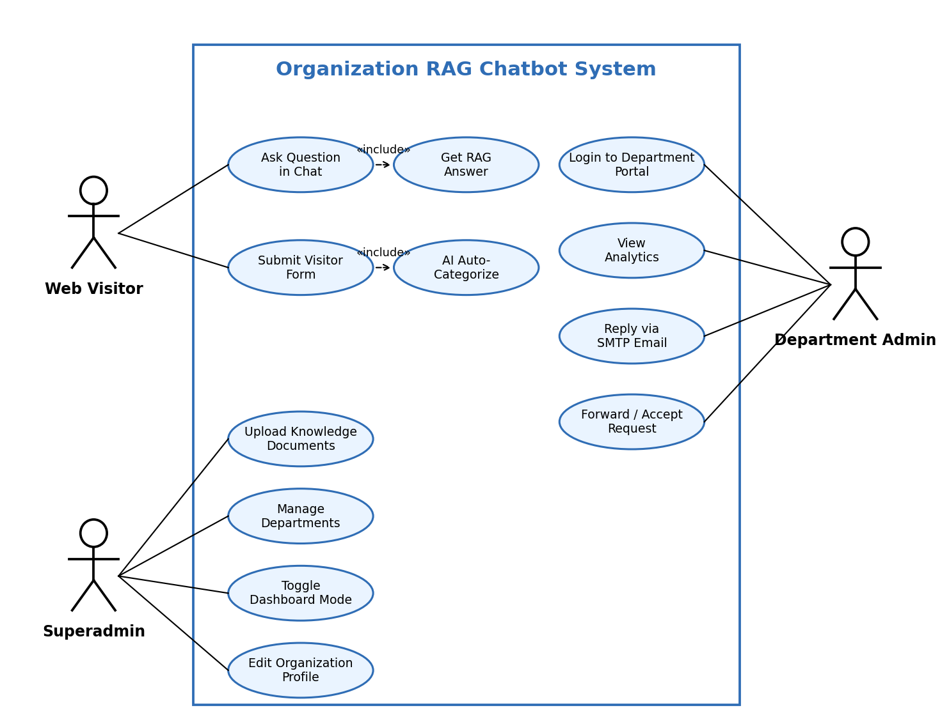
4.1.1 USE CASE DIAGRAM

4.1.2 CLASS DIAGRAM
The class diagram captures the main classes of the system. OrganizationProfile holds the organization settings and the dashboard_mode switch, and KnowledgeDocument stores each uploaded file with its chunk count. RAGEngine uses the indexed documents and sends prompts to LLMClient, which manages the primary and fallback models. Categorizer classifies a query and assigns it to a Department, and each Department handles many VisitorRequest records, which carry the visitor details, the status, the reply message and the forwarding fields.
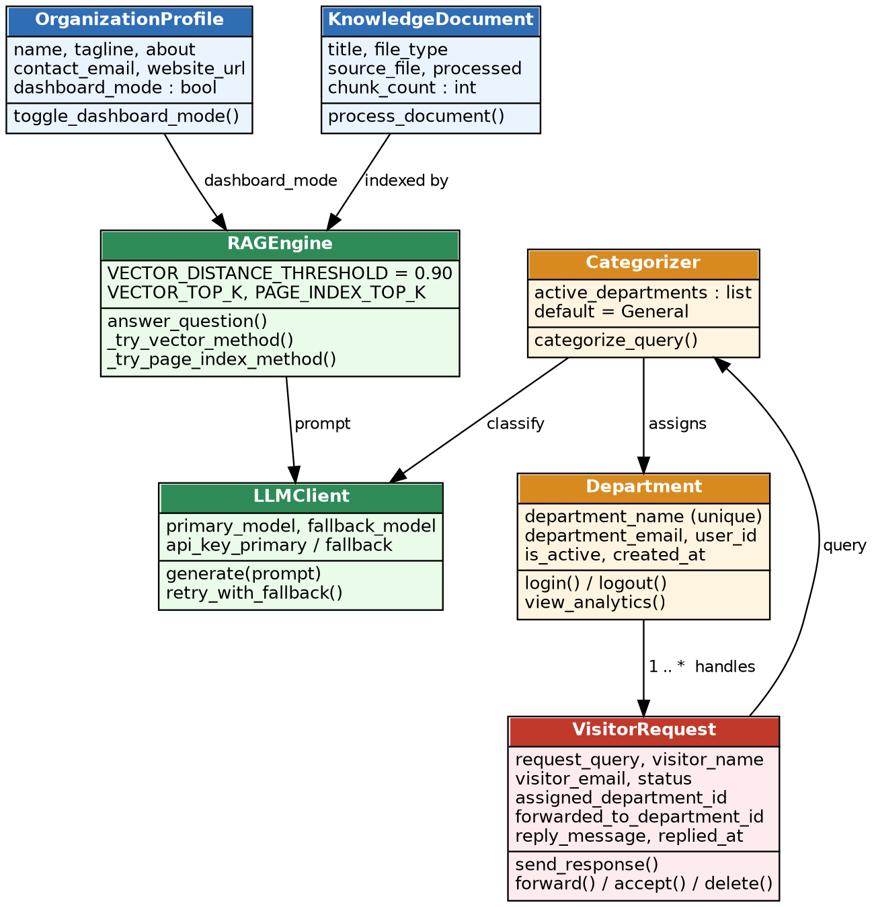
4.1.2 CLASS DIAGRAM

4.1.3 OBJECT DIAGRAM
The object diagram instantiates the class diagram for a concrete session: the organization St. Peter’s Engineering College has dashboard_mode set to True, and the RAGEngine object finds no relevant data for the visitor’s question “library timings?”. The VisitorRequest object (status pending, visitor Saranya) is classified by the Categorizer object as Library, assigned to the Library Department object, and the department’s reply is sent through the SMTP mailer, after which the status becomes cleared.
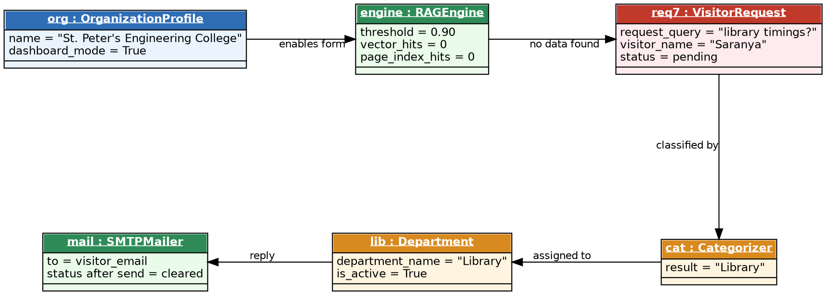
4.1.3 OBJECT DIAGRAM

4.1.4 STATE DIAGRAM
The state diagram follows the life cycle of a visitor request. The request enters the Pending state when the visitor submits the form and stays pending after it has been categorized into a department. From Pending it moves to Cleared when the department admin sends the response by SMTP e-mail, to Forwarded when the admin forwards it to another department, or to Deleted when it is soft-deleted. A forwarded request returns to Pending when the recipient department clicks Accept.
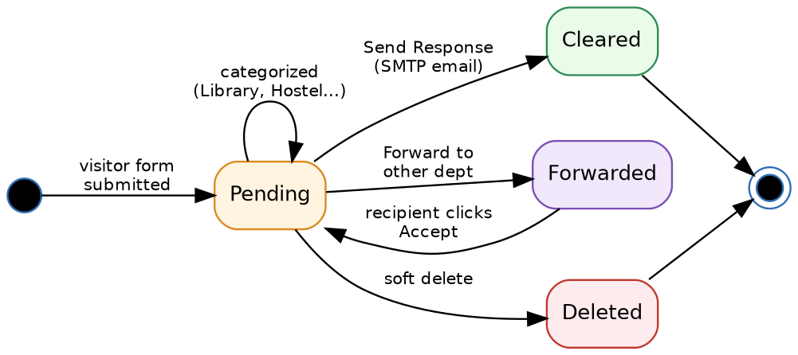
4.1.4 STATE DIAGRAM

4.1.5 ACTIVITY DIAGRAM
The activity (process flow) diagram traces one full workflow. The visitor enters a query, the RAG engine searches the vector store and, when needed, the page index, and checks whether data is available. If data is found, the LLM generates the answer and the chatbot displays it. If data is not found and dashboard_mode is True, the chatbot shows the notice and the visitor form, the visitor submits name and e-mail, the AI categorizer assigns a department, and the department admin logs in, reads the request and either replies by SMTP e-mail (status Cleared) or forwards it to a target department, where the recipient accepts it.
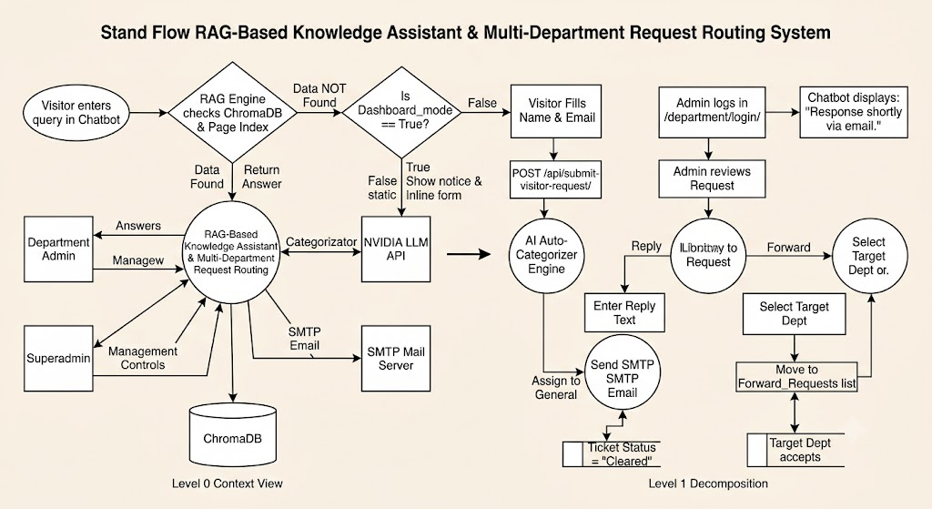
4.1.5 ACTIVITY DIAGRAM

4.1.6 SEQUENCE DIAGRAM
The sequence diagram shows how a visitor question flows through the running application. The browser posts the question to /api/chat/, the chat API calls answer_question() on the RAG engine, which queries ChromaDB and the page index, and sends the prompt with the retrieved context to the NVIDIA LLM. The answer, or a data-not-found notice with the visitor form, returns to the chat. When the visitor submits the form, the request is categorized by the LLM, assigned to a department, and the department admin’s response is sent to the visitor by the SMTP server.
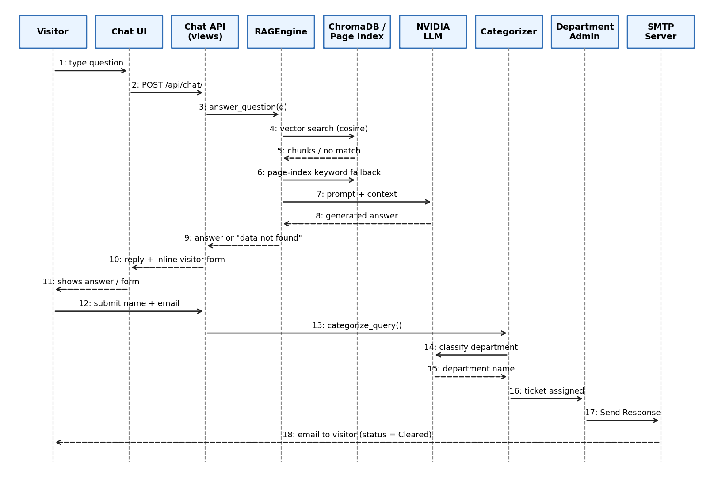
4.1.6 SEQUENCE DIAGRAM

4.1.7 COLLABORATION DIAGRAM
The collaboration diagram shows the same interaction as objects exchanging numbered messages. The :WebVisitor asks the :ChatUI, which posts to the :ChatAPI; the API calls the :RAGEngine, which exchanges the prompt and the answer with the :NvidiaLLM. If data is missing, the visitor submits the form, the :Categorizer classifies the query with the LLM and creates a :VisitorRequest, which is assigned to a :Department; the department sends its reply through the :SMTPServer, which e-mails the visitor. The numbering preserves the order of the sequence diagram.
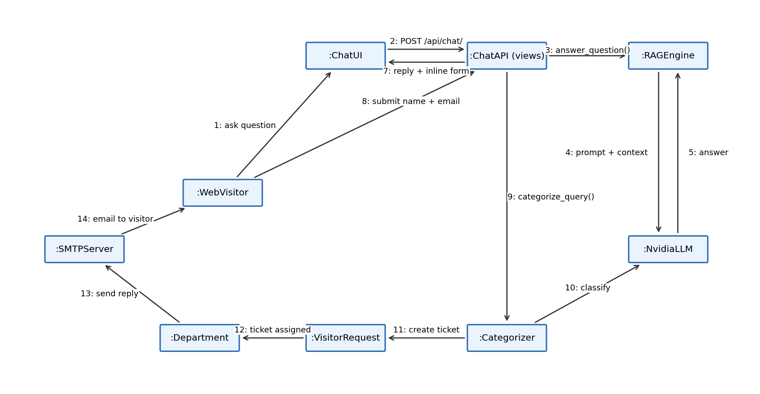
4.1.7 COLLABORATION DIAGRAM

4.1.8 COMPONENT DIAGRAM
The component diagram divides the system into four layers. The Presentation layer contains the landing page with the chat widget, the department dashboard and the Django admin. The Application layer contains orgbot.views, orgbot.department_views and orgbot.admin. The Service layer contains rag_engine.py, categorizer.py, ingestion.py and llm_client.py. The Data layer holds ChromaDB, page_index.json and SQLite, and the two external services are the NVIDIA NIM API and the SMTP mail server.
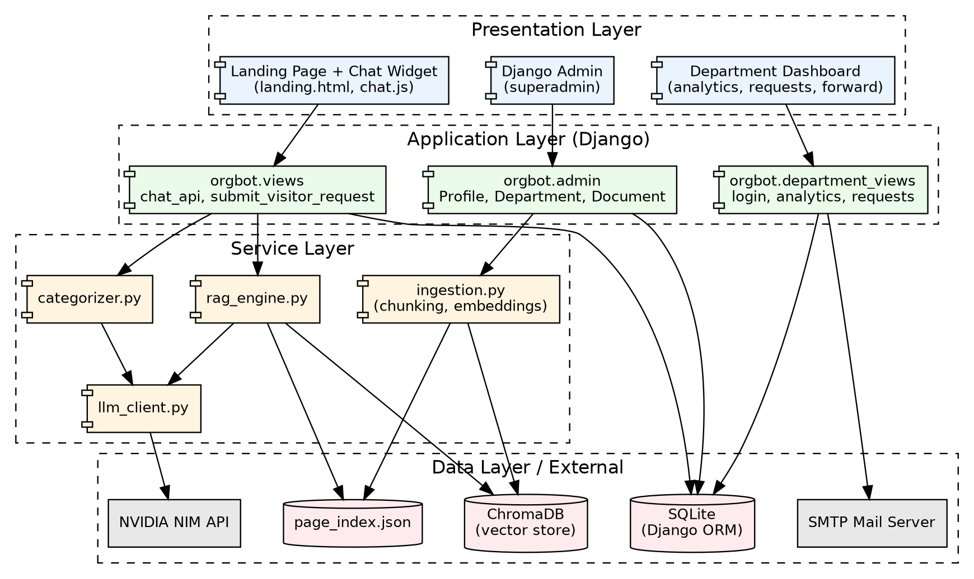
4.1.8 COMPONENT DIAGRAM

4.1.9 DATA FLOW DIAGRAM
The data flow diagram shows the movement of data between the five external entities and the five modules. The Web Visitor sends a query to Module 1, which searches ChromaDB and the page index and calls the NVIDIA LLM API. Visitor form inputs flow to Module 3, which categorizes the request and stores it in the department database. The Department Admin reads and answers requests through Module 5, which sends the SMTP e-mail, while the Superadmin manages the organization and departments through Module 4. The Level 0 context view and the Level 1 decomposition are shown together.
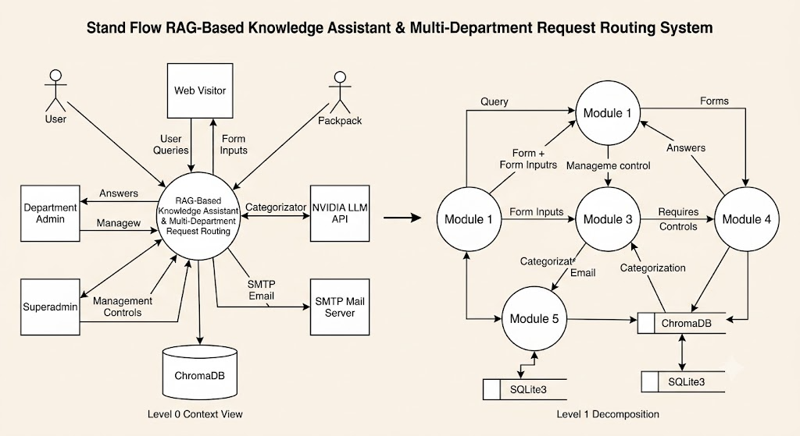
4.1.9 DATA FLOW DIAGRAM

4.1.10 E-R DIAGRAM
The entity-relationship diagram shows the conceptual data schema. OrganizationProfile is a singleton holding the organization settings and the dashboard_mode flag. Department has a one-to-one link with the Django User used for authentication. VisitorRequest belongs to a Department as the assigned department and may also point to a second Department as the forwarded-to department, so Department has two one-to-many relationships with VisitorRequest. KnowledgeDocument records each uploaded file, its type, its processed flag and its chunk count.
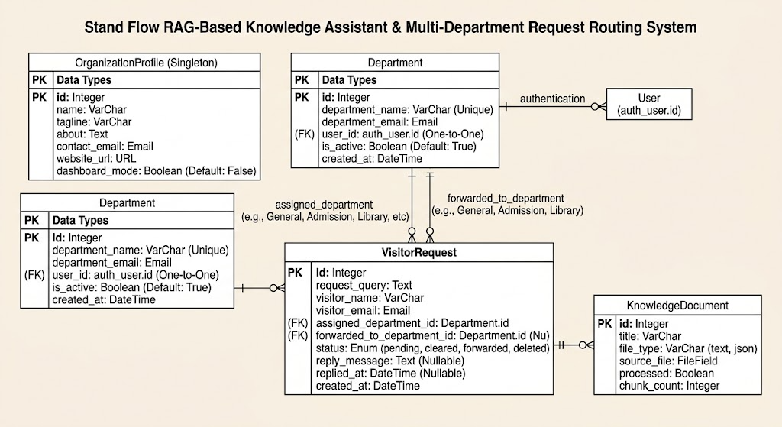
4.1.10 E-R DIAGRAM

4.1.11 ARCHITECTURE DIAGRAM
The architecture diagram presents the five modules and the functional requirements they satisfy. Module 1 (Knowledge Ingestion & RAG Engine) provides vector retrieval with page-index fallback; Module 2 (Interactive Web Visitor Request) provides the chat endpoint and the inline form; Module 3 (AI Auto-Categorization) routes requests to departments; Module 4 (Superadmin & System Configuration) holds the dashboard-mode toggle and ingestion controls; and Module 5 (Department Admin Dashboard) provides analytics, SMTP replies and forwarding.
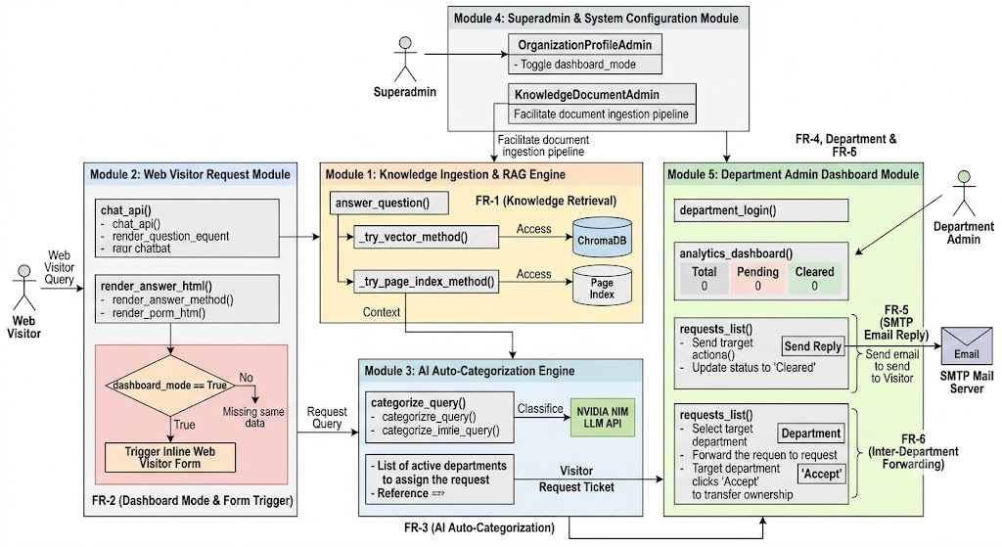
4.1.11 ARCHITECTURE DIAGRAM

CHAPTER 5

CHAPTER 5
DEVELOPMENT TOOLS

5.1 DJANGO FRAMEWORK
Django is a high-level Python web framework that follows the Model-View-Template pattern and ships with an object-relational mapper, a URL router, an authentication system and an automatically generated administration interface. In this project, Django hosts the landing page, the chat and visitor-request APIs and the department dashboard, and its admin site is the superadmin console for uploading knowledge documents, creating departments and toggling Dashboard Mode. The built-in User model is linked one-to-one with each Department to provide secure department logins, and the ORM stores organization settings and visitor requests in SQLite without writing SQL.

5.2 PYTHON
Python is the programming language of the entire backend. Its readable syntax, large ecosystem and strong support for text processing make it well suited to a RAG pipeline: chunking, embedding, retrieval, prompt construction and HTTP calls to the language-model API are all written in plain Python modules under orgbot/services. Python 3.10 or above is required, and a virtual environment keeps the project dependencies isolated from the rest of the system.

5.3 CHROMADB AND VECTOR EMBEDDINGS
ChromaDB is an open-source, file-based vector database that stores embeddings together with their text and metadata and returns the nearest chunks for a query using cosine distance. It needs no separate server, which suits a portable application. The embeddings are produced by a small, offline, deterministic bag-of-words feature-hashing function, so the project needs no model download and no heavy machine-learning dependency such as torch. A similarity threshold of 0.90 decides whether a retrieved chunk is relevant enough to be used.

5.4 NVIDIA NIM LLM API
NVIDIA NIM provides hosted language models, available through build.nvidia.com with a free tier, behind an OpenAI-compatible chat-completion interface. The project configures two models, for example nvidia/llama-3.1-nemotron-70b-instruct as the primary and meta/llama-3.1-8b-instruct as the fallback, each with its own API key. The same API is used for two jobs: generating the final answer from the retrieved context and classifying unresolved questions into departments.

5.5 FRONTEND TECHNOLOGIES
The frontend is built with HTML5, CSS3 and JavaScript. Django templates (base.html and landing.html) render the colourful landing page with its hero section and gallery, and style.css provides five light colour themes - teal, indigo, sunset, ocean and rose. chat.js implements the embedded chat widget: it posts the visitor’s question to /api/chat/, renders the answer and the inline visitor form, and submits the form to /api/submit-visitor-request/. The department dashboard uses a separate dark sidebar layout for analytics, requests and forwarded requests.

CHAPTER 6

CHAPTER 6
IMPLEMENTATION

6.1 GENERAL
This chapter presents the source code that implements the modules described in Chapter 2, developed using Visual Studio Code with the Django framework and Python. The listing below covers the requirements file, the environment configuration, the Django models, the service modules for chunking, embedding, vector storage, page indexing, language-model access, retrieval-augmented answering and department categorization, the visitor and department views, the admin configuration and the chat widget script. To keep the report concise, only the key portions of each file are reproduced here.

6.2 requirements.txt
Django>=4.2
chromadb>=0.4.22
requests>=2.31.0
python-dotenv>=1.0.0
numpy>=1.26.0

6.3 .env.example
NVIDIA_MODEL_PRIMARY=nvidia/llama-3.1-nemotron-70b-instruct
NVIDIA_API_KEY_PRIMARY=nvapi-xxxxxxxx
NVIDIA_MODEL_FALLBACK=meta/llama-3.1-8b-instruct
NVIDIA_API_KEY_FALLBACK=nvapi-yyyyyyyy
VECTOR_TOP_K=4
VECTOR_DISTANCE_THRESHOLD=0.90
PAGE_INDEX_TOP_K=3
EMAIL_HOST=smtp.gmail.com
EMAIL_PORT=587
EMAIL_HOST_USER=your-address@gmail.com
EMAIL_HOST_PASSWORD=your-app-password

6.4 orgbot/models.py
from django.contrib.auth.models import User
from django.db import models

class OrganizationProfile(models.Model):
name = models.CharField(max_length=200)
tagline = models.CharField(max_length=300, blank=True)
about = models.TextField(blank=True)
contact_email = models.EmailField(blank=True)
website_url = models.URLField(blank=True)
dashboard_mode = models.BooleanField(default=False)

def save(self, *args, **kwargs):
self.pk = 1 # singleton
super().save(*args, **kwargs)

class Department(models.Model):
department_name = models.CharField(max_length=100, unique=True)
department_email = models.EmailField()
user = models.OneToOneField(User, on_delete=models.CASCADE)
is_active = models.BooleanField(default=True)
created_at = models.DateTimeField(auto_now_add=True)

class VisitorRequest(models.Model):
STATUS = [("pending", "Pending"), ("cleared", "Cleared"),
("forwarded", "Forwarded"), ("deleted", "Deleted")]
request_query = models.TextField()
visitor_name = models.CharField(max_length=150)
visitor_email = models.EmailField()
assigned_department = models.ForeignKey(
Department, on_delete=models.PROTECT, related_name="assigned_requests")
forwarded_to_department = models.ForeignKey(
Department, null=True, blank=True, on_delete=models.SET_NULL,
related_name="forwarded_requests")
status = models.CharField(max_length=10, choices=STATUS, default="pending")
reply_message = models.TextField(null=True, blank=True)
replied_at = models.DateTimeField(null=True, blank=True)
created_at = models.DateTimeField(auto_now_add=True)

class KnowledgeDocument(models.Model):
title = models.CharField(max_length=200)
file_type = models.CharField(max_length=10) # text | json
source_file = models.FileField(upload_to="knowledge/")
processed = models.BooleanField(default=False)
chunk_count = models.IntegerField(default=0)

6.5 orgbot/services/chunking.py
import json

def flatten_json(data, prefix=""):
"""Turn any JSON structure into readable 'key: value' lines."""
lines = []
if isinstance(data, dict):
for k, v in data.items():
lines += flatten_json(v, f"{prefix}{k}: " if not isinstance(v, (dict, list)) else f"{prefix}{k} - ")
elif isinstance(data, list):
for item in data:
lines += flatten_json(item, prefix)
else:
lines.append(f"{prefix}{data}")
return lines

def read_text(path, file_type):
raw = open(path, encoding="utf-8", errors="ignore").read()
if file_type == "json":
return "\n".join(flatten_json(json.loads(raw)))
return raw

def chunk_text(text, size=700, overlap=120):
paragraphs = [p.strip() for p in text.split("\n") if p.strip()]
chunks, current = [], ""
for p in paragraphs:
if len(current) + len(p) + 1 <= size:
current = f"{current}\n{p}".strip()
else:
if current:
chunks.append(current)
current = (current[-overlap:] + "\n" + p).strip() if current else p
if current:
chunks.append(current)
return chunks

6.6 orgbot/services/embeddings.py
import hashlib, math, re

DIM = 512
TOKEN = re.compile(r"[a-z0-9]+")

def _bucket(token):
h = hashlib.md5(token.encode()).hexdigest()
return int(h, 16) % DIM, 1 if int(h[-1], 16) % 2 == 0 else -1

def embed_text(text):
"""Offline, deterministic feature-hashing embedding (no model download)."""
vec = [0.0] * DIM
for tok in TOKEN.findall(text.lower()):
idx, sign = _bucket(tok)
vec[idx] += sign
norm = math.sqrt(sum(v * v for v in vec)) or 1.0
return [v / norm for v in vec]

class HashingEmbeddingFunction:
def __call__(self, input):
return [embed_text(t) for t in input]

6.7 orgbot/services/vector_store.py
import chromadb
from django.conf import settings
from .embeddings import HashingEmbeddingFunction

_client = chromadb.PersistentClient(path=str(settings.BASE_DIR / "chroma_db"))
_collection = _client.get_or_create_collection(
name="org_knowledge",
embedding_function=HashingEmbeddingFunction(),
metadata={"hnsw:space": "cosine"},
)

def add_chunks(doc_id, title, chunks):
ids = [f"{doc_id}-{i}" for i in range(len(chunks))]
metas = [{"doc_id": doc_id, "title": title, "chunk": i} for i in range(len(chunks))]
_collection.add(ids=ids, documents=chunks, metadatas=metas)
return len(chunks)

def delete_document(doc_id):
_collection.delete(where={"doc_id": doc_id})

def search(question, top_k=4):
if _collection.count() == 0:
return []
res = _collection.query(query_texts=[question], n_results=top_k)
return [
{"text": d, "distance": dist, "title": m["title"]}
for d, dist, m in zip(res["documents"][0], res["distances"][0], res["metadatas"][0])
]

6.8 orgbot/services/page_index.py
import json, re
from pathlib import Path
from django.conf import settings

INDEX_FILE = Path(settings.MEDIA_ROOT) / "page_index" / "page_index.json"
STOP = {"the", "is", "a", "an", "of", "to", "and", "in", "for", "what", "how", "are", "do"}

def _load():
if INDEX_FILE.exists():
return json.loads(INDEX_FILE.read_text(encoding="utf-8"))
return []

def _save(entries):
INDEX_FILE.parent.mkdir(parents=True, exist_ok=True)
INDEX_FILE.write_text(json.dumps(entries, indent=2), encoding="utf-8")

def add_pages(doc_id, title, text, page_size=1200):
entries = _load()
pages = [text[i:i + page_size] for i in range(0, len(text), page_size)]
entries += [{"doc_id": doc_id, "title": title, "page": n + 1, "text": p}
for n, p in enumerate(pages)]
_save(entries)
return len(pages)

def remove_document(doc_id):
_save([e for e in _load() if e["doc_id"] != doc_id])

def search(question, top_k=3):
words = [w for w in re.findall(r"[a-z0-9]+", question.lower()) if w not in STOP]
scored = []
for e in _load():
low = e["text"].lower()
score = sum(low.count(w) for w in words)
if score:
scored.append((score, e))
scored.sort(key=lambda s: s[0], reverse=True)
return [e for _, e in scored[:top_k]]

6.9 orgbot/services/llm_client.py
import os, requests

URL = "https://integrate.api.nvidia.com/v1/chat/completions"

def _call(model, key, messages, timeout=40):
headers = {"Authorization": f"Bearer {key}", "Content-Type": "application/json"}
body = {"model": model, "messages": messages, "temperature": 0.2, "max_tokens": 600}
r = requests.post(URL, headers=headers, json=body, timeout=timeout)
r.raise_for_status()
return r.json()["choices"][0]["message"]["content"].strip()

def generate(messages):
"""Try the primary model first; on any error retry with the fallback model."""
models = [
(os.getenv("NVIDIA_MODEL_PRIMARY"), os.getenv("NVIDIA_API_KEY_PRIMARY")),
(os.getenv("NVIDIA_MODEL_FALLBACK"), os.getenv("NVIDIA_API_KEY_FALLBACK")),
]
last_error = None
for model, key in models:
if not model or not key:
continue
try:
return _call(model, key, messages), model
except Exception as exc: # rate limit, timeout, bad response
last_error = exc
raise RuntimeError(f"Both NVIDIA models failed: {last_error}")

6.10 orgbot/services/rag_engine.py
import os
from . import vector_store, page_index, llm_client
from .chunking import read_text, chunk_text

VECTOR_DISTANCE_THRESHOLD = float(os.getenv("VECTOR_DISTANCE_THRESHOLD", 0.90))
NOT_FOUND = "The relevant data you asked about is not in my Database."
QUICK = {"hi": "Hey there! How can I help you today?",
"hello": "Hello! Ask me anything about our organization."}

def process_document(doc):
text = read_text(doc.source_file.path, doc.file_type)
chunks = chunk_text(text)
vector_store.delete_document(doc.id)
page_index.remove_document(doc.id)
n = vector_store.add_chunks(doc.id, doc.title, chunks)
page_index.add_pages(doc.id, doc.title, text)
return n

def _try_vector_method(question):
hits = vector_store.search(question, int(os.getenv("VECTOR_TOP_K", 4)))
good = [h for h in hits if h["distance"] <= VECTOR_DISTANCE_THRESHOLD]
return [h["text"] for h in good]

def _try_page_index_method(question):
pages = page_index.search(question, int(os.getenv("PAGE_INDEX_TOP_K", 3)))
return [p["text"] for p in pages]

def answer_question(question, dashboard_mode=False):
quick = QUICK.get(question.strip().lower().rstrip("!."))
if quick:
return {"answer": quick, "method": "quick_reply", "found": True}
context, method = _try_vector_method(question), "vector"
if not context:
context, method = _try_page_index_method(question), "page_index"
if not context:
if dashboard_mode:
return {"answer": NOT_FOUND, "method": "none", "found": False}
return {"answer": "I could not find that in my data.", "method": "none", "found": False}
messages = [
{"role": "system", "content": "Answer ONLY from the context. Keep any URLs unchanged."},
{"role": "user", "content": "Context:\n" + "\n---\n".join(context) + f"\n\nQuestion: {question}"},
]
answer, model = llm_client.generate(messages)
return {"answer": answer, "method": method, "model": model, "found": True}

6.11 orgbot/services/categorizer.py
from . import llm_client
from orgbot.models import Department

KEYWORDS = {
"Library": ["library", "book", "journal"],
"Hostel": ["hostel", "room", "warden"],
"Canteen": ["canteen", "food", "mess"],
"Admission": ["admission", "apply", "eligibility", "cutoff"],
"Sports": ["sports", "ground", "tournament"],
"Travel": ["bus", "transport", "route"],
"Maintenance": ["repair", "maintenance", "electric"],
"Cleaning": ["clean", "hygiene", "washroom"],
"Studies": ["exam", "syllabus", "timetable", "course"],
}

def categorize_query(query):
active = list(Department.objects.filter(is_active=True)
.values_list("department_name", flat=True))
low = query.lower()
for dept, words in KEYWORDS.items():
if dept in active and any(w in low for w in words):
return dept
prompt = [{"role": "system", "content":
"Classify the query into exactly one of: " + ", ".join(active) +
". Reply with the department name only."},
{"role": "user", "content": query}]
try:
reply, _ = llm_client.generate(prompt)
for name in active:
if name.lower() in reply.lower():
return name
except Exception:
pass
return "General"

6.12 orgbot/views.py
import json
from django.http import JsonResponse
from django.shortcuts import render
from django.views.decorators.http import require_POST
from .models import OrganizationProfile, Department, VisitorRequest
from .services import rag_engine, categorizer
from .services.utils import linkify

def landing(request):
org = OrganizationProfile.objects.first()
return render(request, "orgbot/landing.html", {"org": org})

@require_POST
def chat_api(request):
question = json.loads(request.body).get("message", "").strip()
org = OrganizationProfile.objects.first()
dashboard = bool(org and org.dashboard_mode)
result = rag_engine.answer_question(question, dashboard)
show_form = dashboard and not result["found"]
if show_form:
result["answer"] = (result["answer"] + " Please share your details in the form "
"below so that the particular department admin can respond shortly via your email.")
return JsonResponse({
"answer_html": render_answer_html(result["answer"], show_form),
"method": result["method"], "model": result.get("model", ""),
"show_visitor_form": show_form, "query": question,
})

def render_answer_html(text, show_form):
html = linkify(text)
if show_form:
html += ('<div class="visitor-form"><h4>Web Visitor Request Form</h4>'
'<input id="vName" placeholder="Enter your name">'
'<input id="vEmail" placeholder="Enter your email">'
'<button onclick="submitVisitor()">Submit Request</button></div>')
return html

@require_POST
def submit_visitor_request(request):
d = json.loads(request.body)
dept_name = categorizer.categorize_query(d["query"])
dept = (Department.objects.filter(department_name=dept_name).first()
or Department.objects.get(department_name="General"))
VisitorRequest.objects.create(
request_query=d["query"], visitor_name=d["name"],
visitor_email=d["email"], assigned_department=dept)
return JsonResponse({"ok": True, "department": dept.department_name})

6.13 orgbot/department_views.py
from django.contrib.auth import authenticate, login, logout
from django.contrib.auth.decorators import login_required
from django.core.mail import send_mail
from django.shortcuts import render, redirect, get_object_or_404
from django.utils import timezone
from .models import Department, VisitorRequest, OrganizationProfile

def department_login(request):
if request.method == "POST":
user = authenticate(request, username=request.POST["username"],
password=request.POST["password"])
if user and hasattr(user, "department"):
login(request, user)
return redirect("analytics")
return render(request, "orgbot/department_login.html")

def department_logout(request):
logout(request)
return redirect("department_login")

@login_required
def analytics_dashboard(request):
d = request.user.department
mine = VisitorRequest.objects.filter(assigned_department=d)
counts = {
"received": mine.count() + d.forwarded_requests.count(),
"pending": mine.filter(status="pending").count(),
"cleared": mine.filter(status="cleared").count(),
"forwarded_out": mine.filter(status="forwarded").count(),
"deleted": mine.filter(status="deleted").count(),
}
return render(request, "orgbot/analytics.html", {"counts": counts})

@login_required
def requests_list(request):
qs = VisitorRequest.objects.filter(
assigned_department=request.user.department).exclude(status__in=["deleted", "forwarded"])
return render(request, "orgbot/requests.html", {"requests": qs})

@login_required
def request_detail(request, pk):
req = get_object_or_404(VisitorRequest, pk=pk, assigned_department=request.user.department)
org = OrganizationProfile.objects.first()
if request.method == "POST":
action = request.POST.get("action")
if action == "reply":
body = (f"We are from {org.name} with department of {req.assigned_department.department_name}. "
f"You asked '{req.request_query}' on {req.created_at:%d/%m/%Y}. "
f"The response from department is - '{request.POST['reply']}'")
send_mail("Response to your enquiry", body, None, [req.visitor_email])
req.reply_message, req.replied_at, req.status = request.POST["reply"], timezone.now(), "cleared"
elif action == "forward":
req.forwarded_to_department_id, req.status = request.POST["department"], "forwarded"
elif action == "delete":
req.status = "deleted"
req.save()
return redirect("requests_list")
return render(request, "orgbot/request_detail.html", {"req": req,
"departments": Department.objects.filter(is_active=True)})

@login_required
def forward_requests_list(request):
qs = VisitorRequest.objects.filter(forwarded_to_department=request.user.department, status="forwarded")
return render(request, "orgbot/forward_requests.html", {"requests": qs})

@login_required
def accept_forwarded_request(request, pk):
req = get_object_or_404(VisitorRequest, pk=pk, forwarded_to_department=request.user.department)
req.assigned_department, req.forwarded_to_department, req.status = request.user.department, None, "pending"
req.save()
return redirect("requests_list")

6.14 orgbot/admin.py
from django.contrib import admin, messages
from django.contrib.auth.models import User
from .models import OrganizationProfile, Department, VisitorRequest, KnowledgeDocument
from .services import rag_engine

@admin.register(OrganizationProfile)
class OrganizationProfileAdmin(admin.ModelAdmin):
list_display = ("name", "dashboard_mode")
def has_add_permission(self, request):
return not OrganizationProfile.objects.exists() # singleton

@admin.register(Department)
class DepartmentAdmin(admin.ModelAdmin):
list_display = ("department_name", "department_email", "is_active")
fields = ("department_name", "department_email", "password", "is_active")
def get_form(self, request, obj=None, **kw):
from django import forms
form = super().get_form(request, obj, **kw)
form.base_fields["password"] = forms.CharField(widget=forms.PasswordInput, required=False)
return form
def save_model(self, request, obj, form, change):
username = obj.department_name.lower().replace(" ", "_")
user, _ = User.objects.get_or_create(username=username, defaults={"email": obj.department_email})
if form.cleaned_data.get("password"):
user.set_password(form.cleaned_data["password"]); user.save()
obj.user = user
super().save_model(request, obj, form, change)

@admin.register(KnowledgeDocument)
class KnowledgeDocumentAdmin(admin.ModelAdmin):
list_display = ("title", "file_type", "processed", "chunk_count")
def save_model(self, request, obj, form, change):
obj.file_type = "json" if obj.source_file.name.endswith(".json") else "text"
super().save_model(request, obj, form, change)
try:
obj.chunk_count = rag_engine.process_document(obj)
obj.processed = True
obj.save()
messages.success(request, f"Indexed {obj.chunk_count} chunks.")
except Exception as exc:
messages.error(request, f"Indexing failed: {exc}")

admin.site.register(VisitorRequest)

6.15 static/orgbot/chat.js
const box = document.getElementById("chatBox");
let lastQuery = "";

function addBubble(html, who) {
const div = document.createElement("div");
div.className = "bubble " + who;
div.innerHTML = html;
box.appendChild(div);
box.scrollTop = box.scrollHeight;
}

async function sendMessage() {
const input = document.getElementById("chatInput");
const text = input.value.trim();
if (!text) return;
lastQuery = text;
addBubble(text, "user");
input.value = "";
const res = await fetch("/api/chat/", {
method: "POST",
headers: {"Content-Type": "application/json", "X-CSRFToken": getCsrf()},
body: JSON.stringify({message: text}),
});
const data = await res.json();
addBubble(data.answer_html + '<small class="tag">' + data.method + '</small>', "bot");
}

async function submitVisitor() {
const name = document.getElementById("vName").value.trim();
const email = document.getElementById("vEmail").value.trim();
if (!name || !email) return alert("Please enter your name and email.");
const res = await fetch("/api/submit-visitor-request/", {
method: "POST",
headers: {"Content-Type": "application/json", "X-CSRFToken": getCsrf()},
body: JSON.stringify({name, email, query: lastQuery}),
});
const data = await res.json();
addBubble("Thank you! Your request was sent to the " + data.department +
" department. You will receive a reply by email.", "bot");
}

CHAPTER 7

CHAPTER 7
VARIOUS SNAPSHOTS

7.1 VARIOUS SNAPSHOTS
This chapter presents the snapshots of the working application. It shows the public side of the system - the landing page, the about section, the Ask Our AI Assistant section, the chatbot greeting, the missing-data notice with the Web Visitor Request Form and an answer generated from the knowledge base - followed by the department dashboard, which covers the analytics, the request directory, the request detail page and the forwarded requests, and finally the Django admin screens used by the superadmin to manage users, departments, knowledge documents, the organization profile and visitor requests.

7.1.1 Landing / Home Page
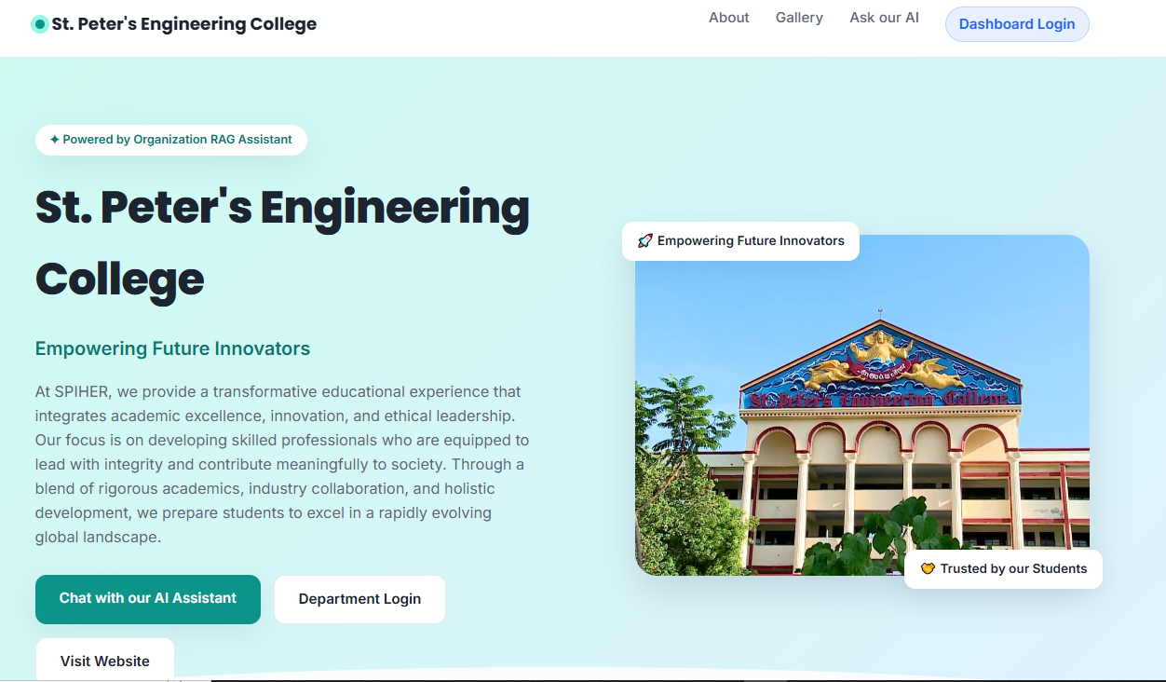
7.1.1 LANDING / HOME PAGE

7.1.2 About the Organization Section
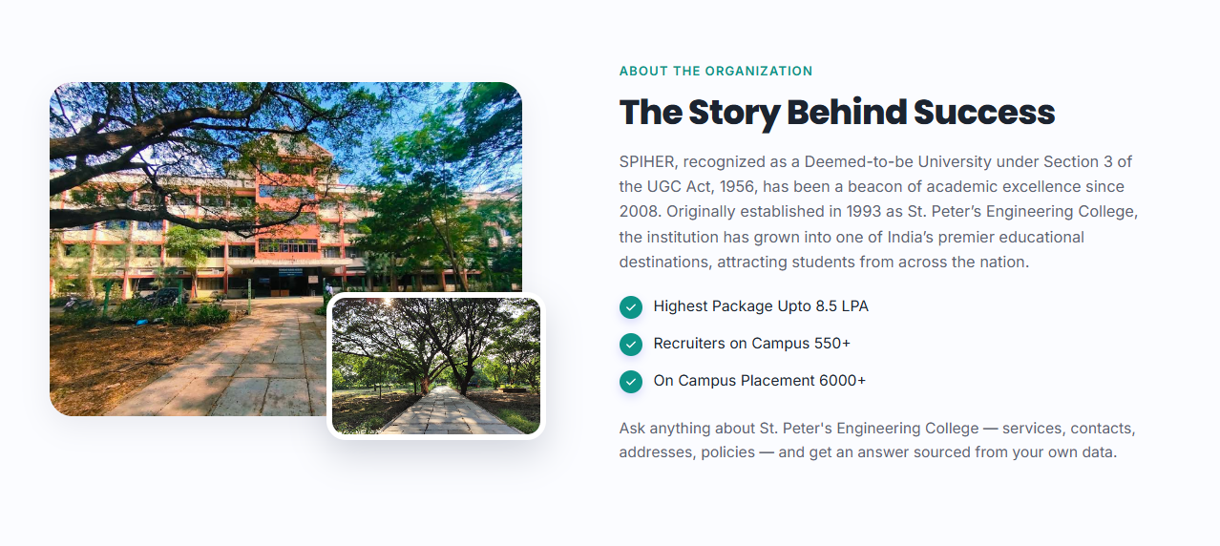
7.1.2 ABOUT THE ORGANIZATION SECTION

7.1.3 Ask Our AI Assistant Section
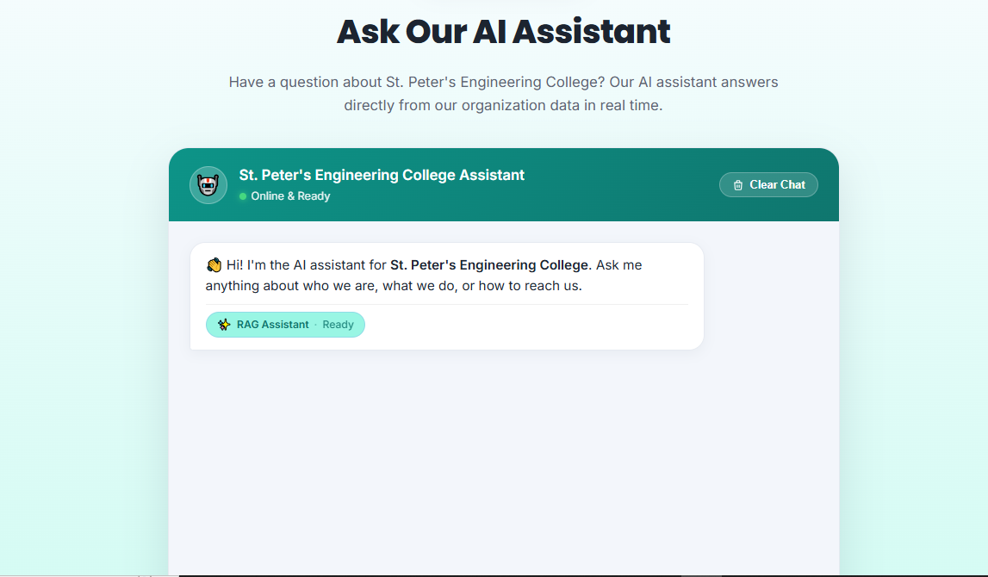
7.1.3 ASK OUR AI ASSISTANT SECTION

7.1.4 Chatbot Greeting and Instant Reply
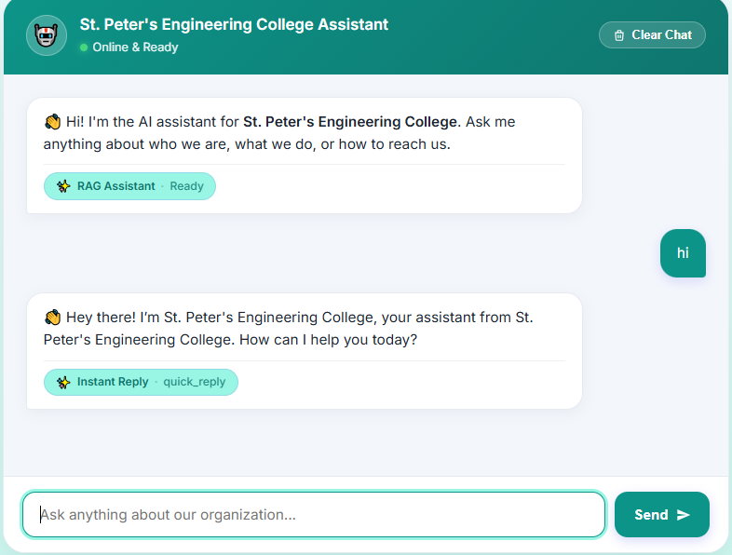
7.1.4 CHATBOT GREETING AND INSTANT REPLY

7.1.5 Missing-Data Notice and Web Visitor Request Form
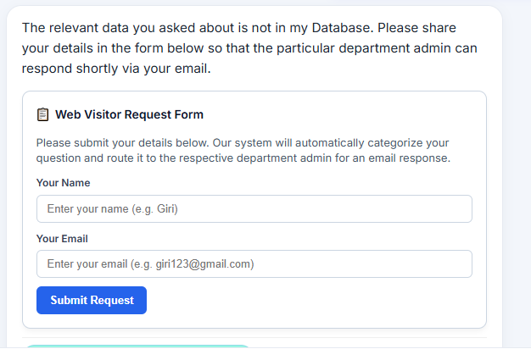
7.1.5 MISSING-DATA NOTICE AND VISITOR FORM

7.1.6 Answer Generated from the Knowledge Base
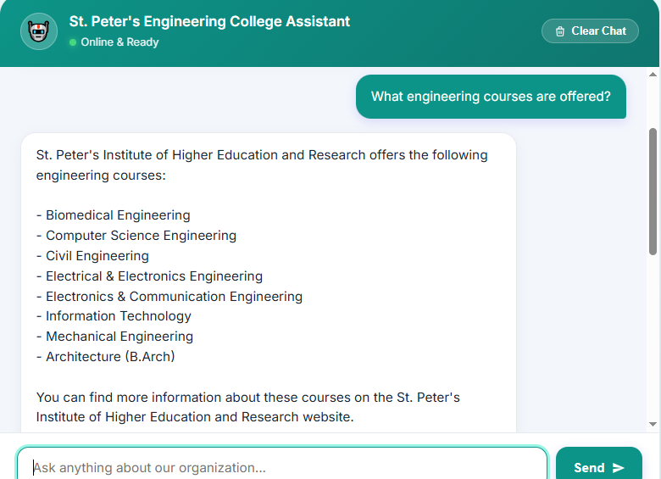
7.1.6 ANSWER FROM THE KNOWLEDGE BASE

7.1.7 Department Analytics Dashboard
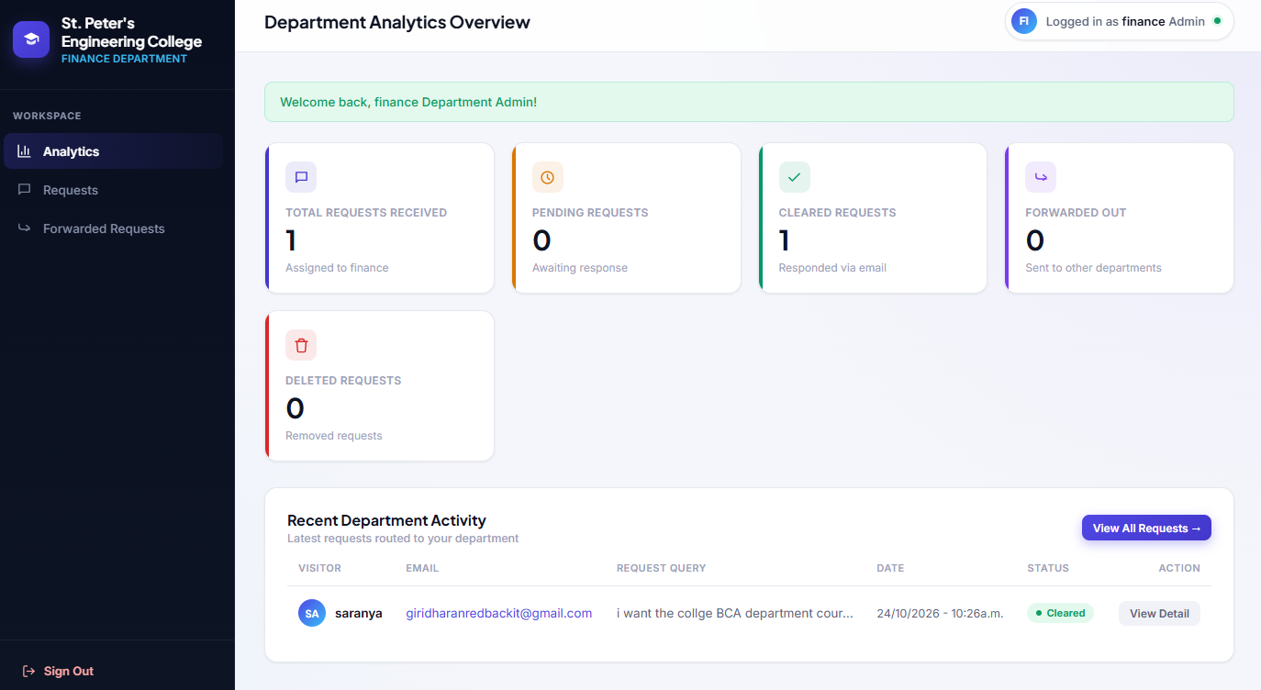
7.1.7 DEPARTMENT ANALYTICS DASHBOARD

7.1.8 Department Request Directory
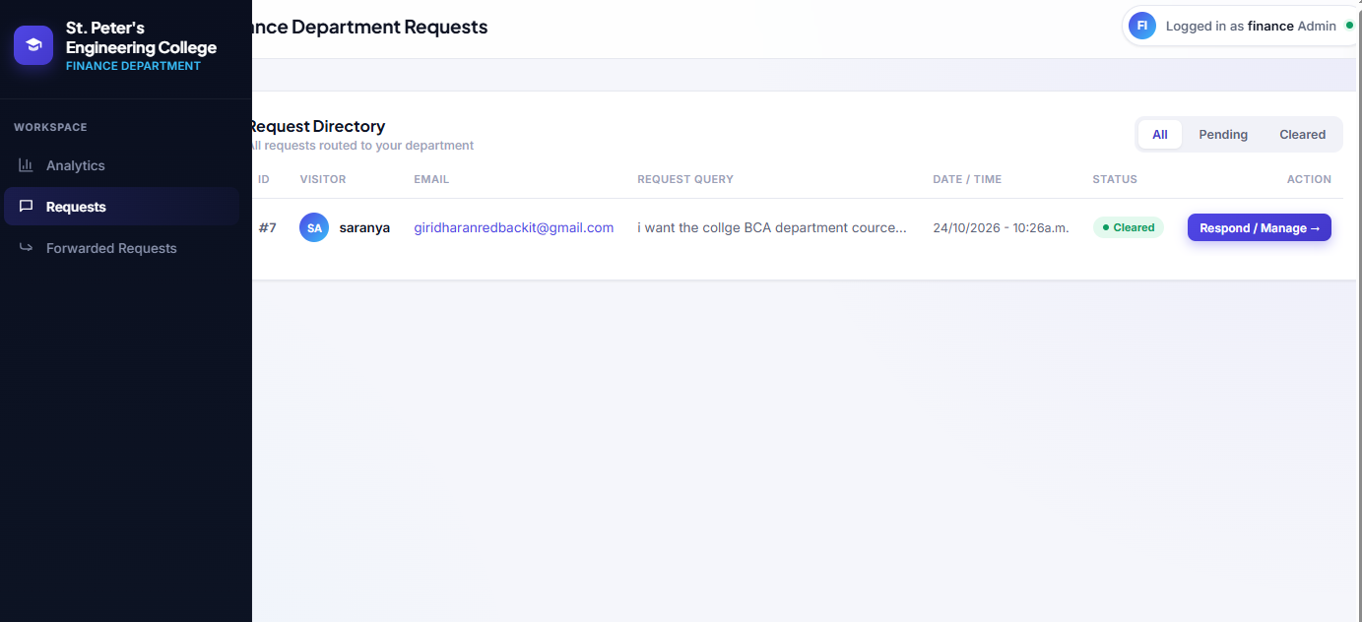
7.1.8 DEPARTMENT REQUEST DIRECTORY

7.1.9 Manage Visitor Request (Reply, Forward, Delete)
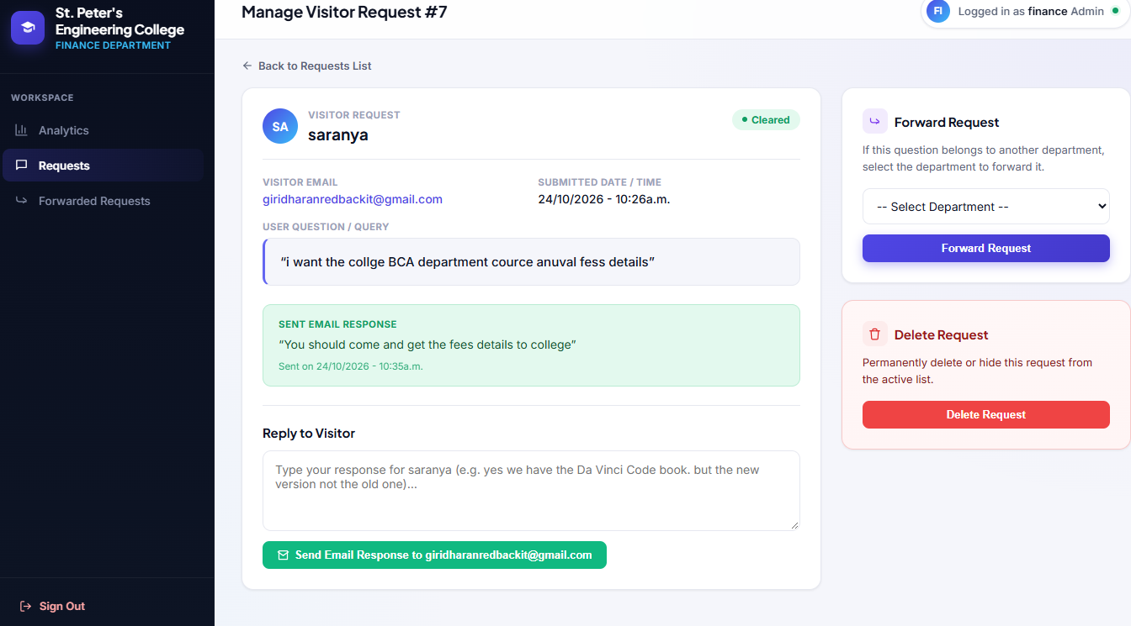
7.1.9 MANAGE VISITOR REQUEST

7.1.10 Incoming Forwarded Requests
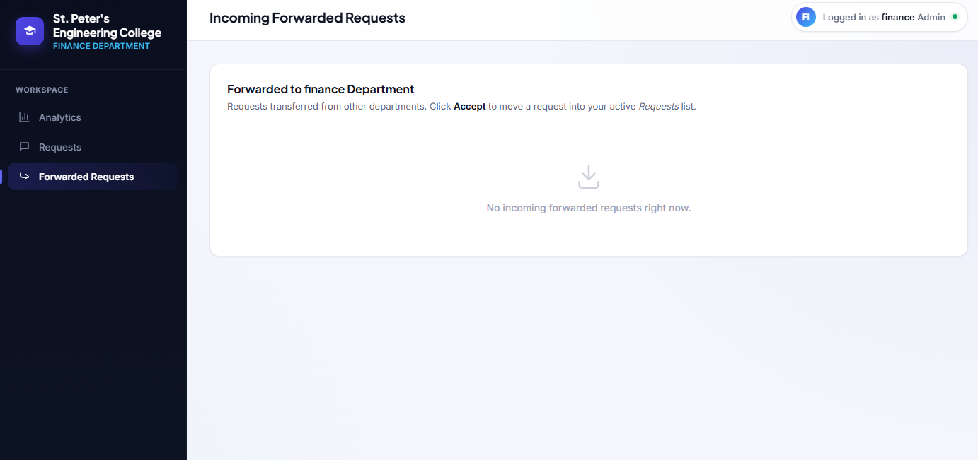
7.1.10 INCOMING FORWARDED REQUESTS

7.1.11 Django Admin - Users (Department Accounts)
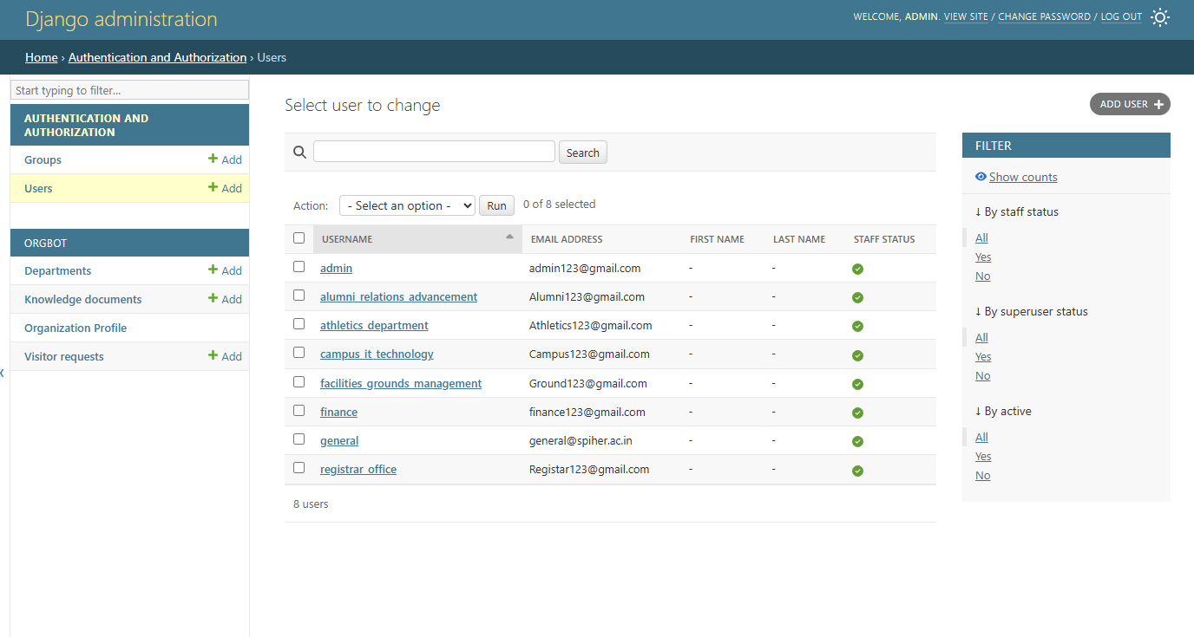
7.1.11 DJANGO ADMIN - USERS

7.1.12 Django Admin - Departments
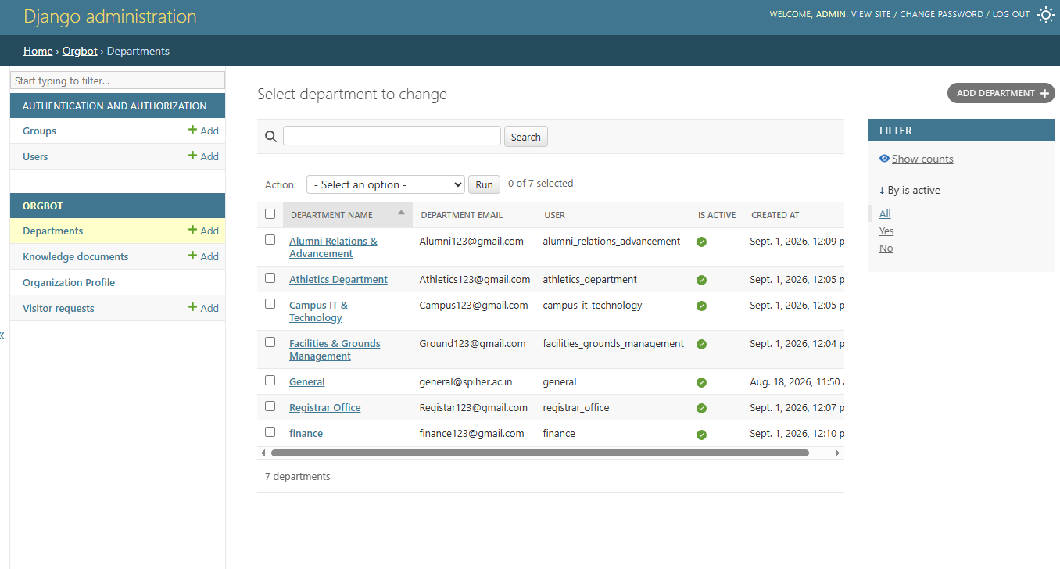
7.1.12 DJANGO ADMIN - DEPARTMENTS

7.1.13 Django Admin - Knowledge Documents
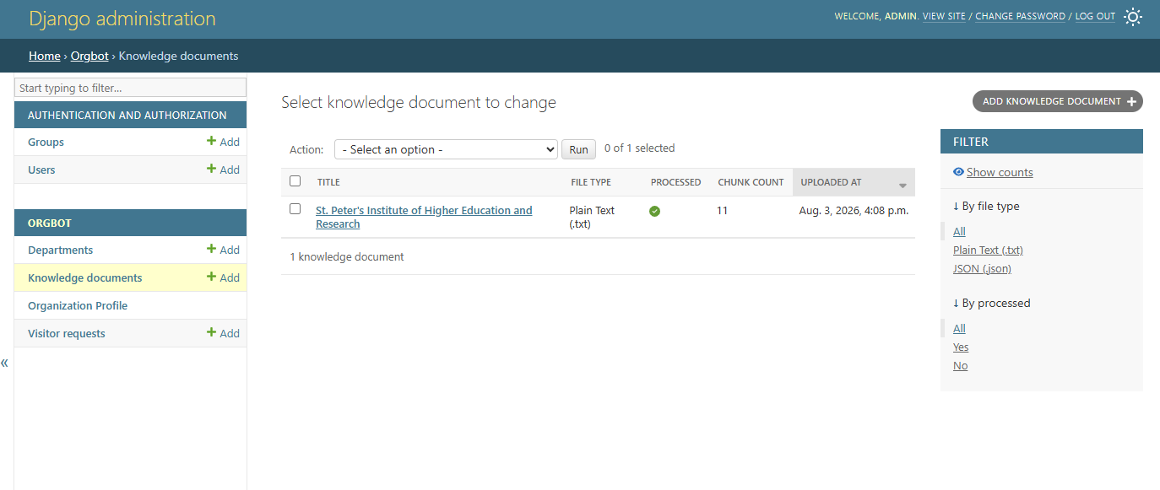
7.1.13 DJANGO ADMIN - KNOWLEDGE DOCUMENTS

7.1.14 Django Admin - Organization Profile
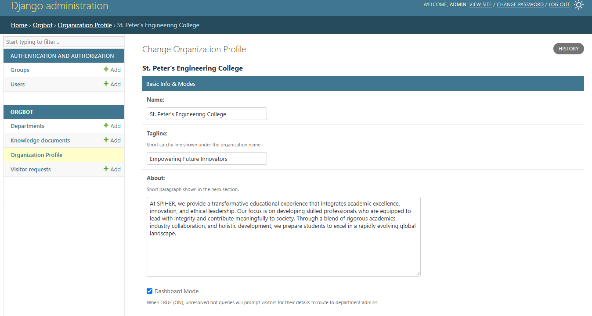
7.1.14 DJANGO ADMIN - ORGANIZATION PROFILE

7.1.15 Django Admin - Visitor Requests
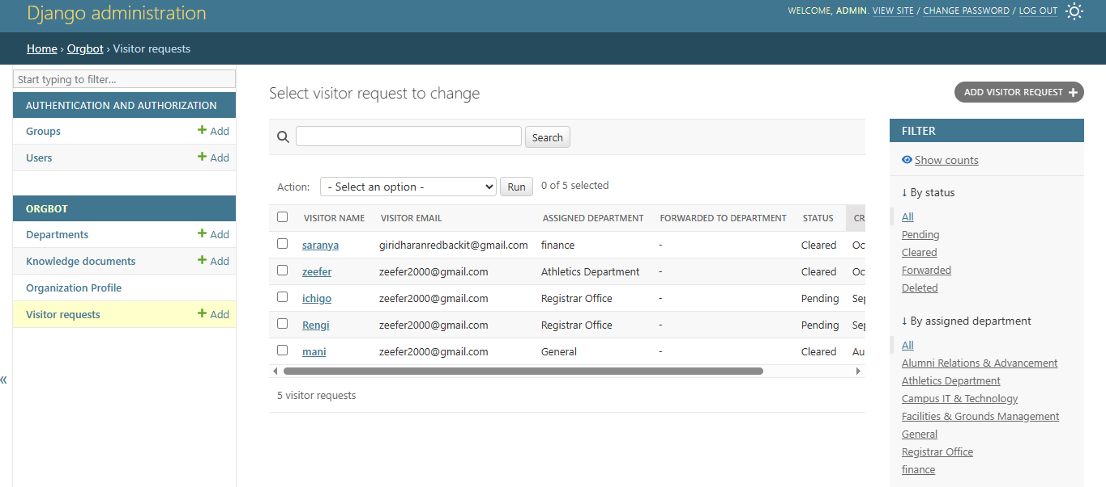
7.1.15 DJANGO ADMIN - VISITOR REQUESTS

CHAPTER 8

CHAPTER 8
SOFTWARE TESTING

8.1 DEVELOPING METHODOLOGIES
Testing of the system was carried out in an incremental fashion that matched the development methodology: every module was tested as soon as it was completed, before the next module was built. The ingestion pipeline was first verified by uploading sample .txt and .json files and checking the chunk counts reported in the admin; the retrieval logic was verified by asking questions whose answers were known to be in, or missing from, the uploaded data; and the web application was tested end-to-end in the browser by exercising the chat, the visitor form and every page of the department dashboard. Defects found at each stage were fixed and re-tested before the module was marked complete.

8.2 TYPES OF TESTS

8.2.1 UNIT TESTING
Each function of the service layer was tested in isolation. chunk_text() was checked to produce overlapping chunks within the size limit, and flatten_json() was checked against nested dictionaries and lists. embed_text() was verified to be deterministic, returning the same unit-length vector for the same text on every run. The vector store was checked by adding chunks, searching with a related question and deleting the document, and the page index was checked by adding pages, searching by keyword and removing the entries. categorize_query() was called directly with sample questions to confirm the expected department and the General default.

8.2.2 FUNCTIONAL TESTING
Every function specified in Chapter 2 was executed through the user interface: document upload in the admin, chat questions, the missing-data notice, the inline visitor form, department login, the analytics counters, e-mail replies, forwarding and acceptance. For example, a question about the engineering courses was answered from the uploaded data, while an unrelated question with Dashboard Mode on displayed the notice and the Name and Email form. The values shown in the dashboard were cross-checked against the request records in the Django admin.

8.2.3 SYSTEM TESTING
The complete system was run from a clean start: the virtual environment was created, dependencies were installed from requirements.txt, the .env file was filled with the NVIDIA keys, migrations were applied, a superadmin was created and the server was started with python manage.py runserver. The full workflow - create the organization profile, add departments, upload documents, ask questions as a visitor, submit a request, reply from the department dashboard and forward a request - was then executed end to end to confirm that all five modules work together.

8.2.4 PERFORMANCE TESTING
Performance testing focused on the response time of the chat endpoint. Retrieval from ChromaDB and the JSON page index was observed to be fast for the document sizes used, so the response time is dominated by the call to the NVIDIA NIM model. The automatic retry with the fallback model was tested by supplying an invalid primary key, confirming that the visitor still receives an answer, and the quick-reply path for greetings was confirmed to respond instantly without calling the language model.

8.2.5 INTEGRATION TESTING
Integration testing verified that the modules exchange data correctly: a document saved in the admin appears in both ChromaDB and page_index.json; a question flows from chat.js through chat_api() and the RAG engine to the language model and back as rendered HTML; a submitted visitor form creates a VisitorRequest that is assigned by the categorizer; and a department reply is delivered through SMTP and changes the request status to Cleared in both the dashboard and the admin.

8.2.6 ACCEPTANCE TESTING
Acceptance testing compared the finished application against the functional requirements FR-1 to FR-6. The uploaded documents were retrievable, the Dashboard Mode toggle controlled the visitor form, requests were assigned to departments with General as the default, the department dashboard showed correct counters, the e-mail reply used the required message format, and a forwarded request left the sender’s list and appeared in the recipient’s Forward_Requests section until accepted.

8.2.7 BUILD THE TEST PLAN
The tests were organised into a simple plan executed in this order: first, ingestion validation (supported file types, chunk counts, re-indexing on edit); second, retrieval validation (vector hit, page-index fallback and no-match behaviour with Dashboard Mode on and off); third, workflow testing (visitor form, categorization, reply, forward, accept and delete); and fourth, interface testing (landing page, chat widget and every dashboard and admin page). Any failure at a stage sent the module back to development before the next stage was started.

CHAPTER 9

CHAPTER 9
APPLICATION

9.1 GENERAL
The Organization RAG Chatbot is applicable wherever an organization must answer a large number of repeated questions from its own documents and route the remaining ones to the right people: colleges and universities handling admission, hostel, library and transport enquiries, schools, hospitals and clinics with several service desks, government offices and municipal bodies with public-facing departments, and companies running customer-support or HR help desks. Because the interface is a plain web page, it can be embedded into an existing website, and because the retrieval layer and the embeddings run locally, only the questions and the retrieved context are sent to the hosted language model. The five modules map directly onto the daily jobs of the people involved: what the visitor asks (Web Visitor Request), what the system knows (Knowledge Ingestion & RAG), who should answer (Auto-Categorization), how the system is configured (Superadmin) and how requests are handled (Department Dashboard).

9.2 FUTURE ENHANCEMENT
Several enhancements could extend the system beyond its current scope. The offline hashing embedding function could be replaced with true semantic embeddings from sentence-transformers or an NVIDIA embedding model, which only requires changing embeddings.py, and support for PDF and DOCX documents could be added to the ingestion pipeline. The chatbot could keep conversation history so that follow-up questions are understood in context, and answers could display their source documents as citations. Multi-language support would allow visitors to ask questions in regional languages, and a voice interface would make the assistant accessible on mobile devices. On the workflow side, e-mail or SMS notifications could alert department admins to new requests, service-level reminders could highlight requests pending for too long, and richer analytics could chart requests by department and over time. Deploying the application to a production server with HTTPS would let the whole organization share one live assistant.

CHAPTER 10

CHAPTER 10
CONCLUSION

10.1 CONCLUSION
This project set out to replace scattered, manual handling of visitor enquiries with a single, data-grounded assistant, and the resulting Organization RAG Chatbot meets that goal. By combining a vector-first retrieval method in ChromaDB with an automatic page-index fallback, two NVIDIA NIM language models with automatic retry, an AI categorizer and a department dashboard with SMTP replies and request forwarding, the application answers what it knows and routes what it does not. Django proved well suited to this kind of admin-driven application: the admin interface gives the superadmin control over documents, departments and Dashboard Mode without any code changes, while the service-layer structure keeps chunking, embedding, retrieval, language-model access and categorization modular and replaceable. Testing across the modules confirmed that the system behaves reliably for the core workflows of uploading a document, asking a question, submitting a request, replying by e-mail and forwarding a request between departments. With the future enhancements outlined above - semantic embeddings, richer document support, conversation memory and notifications - the system has a clear path toward becoming a full-fledged institutional help-desk platform.

10.2 REFERENCES
- P. Lewis, E. Perez, A. Piktus, F. Petroni, V. Karpukhin et al., “Retrieval-augmented generation for knowledge-intensive NLP tasks,” in Advances in Neural Information Processing Systems (NeurIPS), vol. 33, 2020.
- V. Karpukhin, B. Oguz, S. Min, P. Lewis, L. Wu et al., “Dense passage retrieval for open-domain question answering,” in Proc. Conf. Empirical Methods in Natural Language Processing (EMNLP), 2020.
- S. Robertson and H. Zaragoza, “The probabilistic relevance framework: BM25 and beyond,” Foundations and Trends in Information Retrieval, vol. 3, no. 4, pp. 333-389, 2009.
- K. Weinberger, A. Dasgupta, J. Langford, A. Smola and J. Attenberg, “Feature hashing for large scale multitask learning,” in Proc. Int. Conf. Machine Learning (ICML), pp. 1113-1120, 2009.
- N. Reimers and I. Gurevych, “Sentence-BERT: Sentence embeddings using Siamese BERT-networks,” in Proc. EMNLP-IJCNLP, 2019.
- Z. Ji, N. Lee, R. Frieske, T. Yu, D. Su et al., “Survey of hallucination in natural language generation,” ACM Computing Surveys, vol. 55, no. 12, 2023.
- Y. Gao, Y. Xiong, X. Gao, K. Jia, J. Pan et al., “Retrieval-augmented generation for large language models: A survey,” arXiv:2312.10997, 2023.
- A. Dubey, A. Jauhri, A. Pandey et al., “The Llama 3 herd of models,” arXiv:2407.21783, 2024.
- Django Software Foundation, “Django documentation,” https://docs.djangoproject.com.
- Chroma, “Chroma documentation - the open-source embedding database,” https://docs.trychroma.com.

