Find average of payload mass and standard deviation payload mass versus mission outcome.

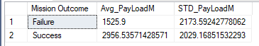

Standard deviation is too wide to be considered. Also indicate that there is no correlation between Payload Mass and Mission Outcome.

Perhaps it’s related to the Payload Orbit? Let’s find out.

