**Storage Cloud file sharing**

**Description:**

**This storage file sharing will be used for team members to share date, code and information.**

**Environments and Technologies Used**

* **Microsoft Azure**

**Operating Systems Used**

* **Windows 11**

**List of Prerequisites**

**Installation Steps**

1. **Make an Azure account**

1. **Make a Git hub account**

1. **Go to Azure and create a new resource group, which serves as the main foundation for this project. After creating the resource group, it will appear at the bottom, as shown in the image.**

1. **(Storage Groups): Next, navigate to the top left of your portal and select "Storage Accounts." This will take you to the storage section, where you can create a new storage account. Once created, the account will appear at the bottom under "Name."**

1. **After you’ve created your storage account, you will want to click directly onto you storage accounts name to create a container. When you do you will want left under storage accounts and click containers.**

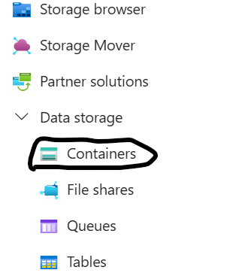

1. **After selecting "Container," you will be prompted to create a new container by clicking the "Plus Container" button, as shown in the image. Once the container is created, it will appear at the bottom as displayed. By clicking on the container's name, you will proceed to the next step: File Sharing.**

1. **After creating your container, you can begin sharing your files with yourself or others. The first step is to click the "Upload" button at the top, as indicated by the black circle. Once your files are uploaded, they will appear at the bottom, highlighted in yellow.**
2. **Top of Form**
3. **Bottom of Form**

1. **You need to create a new user account under Azure Entra ID.**

1. **Then you will see default overview.**



1. **9.) After navigating to the "Over" tab, click on "All Users" as indicated in black. Next, select "Create New User," which is highlighted in yellow. Once these steps are completed, your username will appear at the bottom, also highlighted in yellow.**

1. **After this, you will be prompted to create authentication keys, which will include a QR code for user sign-in, as shown at the bottom. Please note that the QR code or file may display an error if it was generated for a single account**.

1. **After completing your creation and practice, you will need to delete the resource group. This action will also remove the associated storage, files, containers, authentication settings, and the QR code used for sign-in with Entra ID. Additionally, Entra ID will be closed. It’s important to ensure the resource group is deleted to avoid any unwanted charges.**