Academic Editor: Firstname Lastname
Received: date
Revised: date
Accepted: date
Published: date
Citation: To be added by editorial staff during production.
Copyright: © 2025 by the authors. Submitted for possible open access publication under the terms and conditions of the Creative Commons Attribution (CC BY) license (https://creativecommons.org/licenses/by/4.0/).
Article
MRQF-MAS: A Multiscale Relativistic Quantum Finance Framework for Cooperative Multi-Agent Trading Systems with Shared Knowledge Base
Author(s) 1,*, Author(s) 2
1 Department of Computer Science, University of Salerno, Via Giovanni Paolo II 132, 84084 Fisciano (SA), Italy; author@unisa.it
* Correspondence: author@unisa.it
Abstract: Background: price dynamics in financial markets exhibit scale-invariant volatility, quantised liquidity and collective behaviour that resist single-paradigm models; Multiscale Relativistic Quantum Finance (MRQF) reconciles these facets on an energy-entropy $(E,S)$ plane, but its translation into a deployable decision system has remained open. Methods: we propose MRQF-MAS, a cooperative Multi-Agent System (MAS) in which institutional, commercial and retail operators become first-class agents, each decomposed into signal, energy, entropy, risk and execution sub-agents that share beliefs through a horizontal cooperation layer and a Shared Knowledge Base (SKB) of $(E,S)$ trajectories. The framework is benchmarked as a high-volatility regime classifier on 3840 daily EUR/USD reference rates published by the European Central Bank (ECB) over 1999-2026 against four baselines including Generalized Autoregressive Conditional Heteroscedasticity (GARCH)(1,1). Results: MRQF-MAS attains 88.5% accuracy, precision 0.816 and Matthews correlation coefficient (MCC) 0.604 with 95% bootstrap CI [0.57, 0.64], full capture of the 2008 and 2022 regimes, and a two-day median detection latency. Conclusions: MRQF-MAS delivers a structurally interpretable, agent-traceable regime decomposition complementary to scalar volatility estimators.
Keywords: econophysics; multiscale relativistic quantum finance; multi-agent systems; cooperative agents; shared knowledge base; regime detection; energy-entropy space; scale invariance; EUR/USD; financion

1. Introduction
The price of a financial instrument is the emergent outcome of a large population of heterogeneous decision-makers, each acting on private information, private objectives and private cognitive frames. Since Bachelier first described price movements as a random walk [1], and through the successive refinements introduced by Mandelbrot in his work on fractal geometry of finance [2,3], it has become widely accepted that the behaviour of prices does not match the assumptions of classical Gaussian finance. Fat tails, volatility clustering and scale invariance are no longer anomalies to be explained away but structural features of the object of study. The field of econophysics was born from the recognition that the statistical mechanics of complex systems, the theory of self-similar stochastic processes [4,5], multi-resolution analysis via wavelets [6,7], and a substantial body of empirical work on volatility, volume and stylized facts of financial returns [19–27] offer a conceptual toolbox far better suited to financial dynamics than ideal-market assumptions.
Within this trajectory, a unified perspective has recently emerged under the name of Multiscale Relativistic Quantum Finance (MRQF) [8,9]. MRQF combines three ideas that were previously treated in isolation: the multiscale nature of the price signal, a relativistic formalism that posits a maximum instantaneous speed of price propagation $C$, and a quantum interpretation of liquidity in which a gauge boson—called the financion—mediates the interaction between a bullish operator $o^{+}$ and a bearish operator $o^{-}$. The theory formalises the market as a black body that absorbs financions, introduces a finance-specific quantum of action $H$ and recasts decisions in the transformed energy–entropy plane $\left(E,S\right)$ rather than in the familiar price–time plane. The claim of MRQF is conceptually strong: the familiar phenomenology of trending, laterality and exhaustion is not merely described but explained through state transitions in the $\left(E,S\right)$ plane. A companion line of work [10,11] has developed a thermodynamic decision-support engine on the same two-dimensional projection, showing that the combinatorial complexity of a seven-factor problem can be reduced by more than two orders of magnitude without loss of solution quality.
Yet a gap persists between MRQF as a theory and MRQF as a trading system. The original papers characterise the mathematical structure of the market and the behaviour of its elementary constituents, but they do not specify how these constituents should be instantiated as software agents, how they should exchange information, how they should handle real-time data, or how their collective behaviour should be coordinated. At the same time, the literature on multi-agent systems applied to algorithmic trading has grown rapidly [12–15], with recent contributions showing that cooperative multi-agent deep reinforcement learning can outperform single-agent baselines on currency-pair data [12,14]. In particular, the framework of Shavandi and Khedmati [12], which instantiates expert trading agents on distinct timeframes and connects them through a hierarchical feedback mechanism in which knowledge flows from higher to lower timeframes, is the closest existing work to the present contribution and deserves an explicit comparison. Our approach differs in three respects that we consider structural rather than cosmetic. First, the agent taxonomy in [12] is organised along timeframes alone (e.g., daily, hourly, minute), while MRQF-MAS organises agents along the operator categories derived from MRQF (institutional, commercial, retail), which jointly determine a characteristic timeframe rather than being identified with it. Second, the information flow in [12] is strictly top-down along the hierarchy, whereas MRQF-MAS introduces a peer-to-peer lateral channel among sub-agents of the same specialisation, with cooperative–competitive fusion governed by an explicit threshold $σ^{⋆}$. Third, [12] operates on the price–time plane and uses a pragmatic feature set, while MRQF-MAS operates on the MRQF energy–entropy plane augmented with probabilistic observables, inheriting a theoretical structure that is absent in [12]. The most common architectural pattern in the broader stream remains a centralised orchestrator that aggregates signals from specialised agents. Peer-to-peer cooperation, in which agents share beliefs laterally and converge through consensus rather than through top-down arbitration, is less explored in finance, although in the adjacent domain of large language model agents the benefits of lateral communication have recently been documented: multi-agent debate, iterative consensus and peer-to-peer belief exchange have been shown to improve reasoning and factual accuracy over single-agent or orchestrator-only baselines [28–30,40]. MRQF-MAS imports this architectural principle into finance and anchors it to the MRQF theoretical framework.
The present work closes both gaps. We develop MRQF-MAS, a multi-agent cooperative framework that inherits its taxonomy, its interaction primitives and its decision space directly from MRQF, and that extends the theory with three architectural contributions. First, we instantiate the institutional, commercial and retail operators as cooperative agents and decompose each of them into five specialised sub-agents covering the signal, energy, entropy, risk and execution dimensions. Second, we introduce a horizontal cooperation protocol that lets sub-agents exchange beliefs directly through financion-mediated messages, complementing rather than replacing the vertical orchestration layer. Third, we define a shared knowledge base that stores $\left(E,S\right)$ trajectories, resonance levels and learned patterns, and that is updated online as agents execute decisions and observe their outcomes. To support the theoretical exposition we provide a synthetic EUR/USD case study that reproduces the MRQF scale-invariance law and that illustrates the behaviour of the architecture on a realistic tick-level signal.
The paper is organised as follows. Section 2 recalls the theoretical foundations of MRQF, restricted to the elements strictly needed for the subsequent development. Section 3 describes how the theory is mapped onto computable features and how the state vector in the prospect environment is constructed. Section 4 introduces the multi-agent cooperative architecture. Section 5 formalises agent interaction dynamics by mapping scattering, annihilation and pair production onto trading protocols. Section 6 specifies the trading framework on the nine-region $\left(E,S\right)$ plane. Section 7 presents the algorithmic implementation, including the cooperative coordination algorithm. Section 8 discusses the synthetic EUR/USD case study. Section 9 compares MRQF-MAS against orchestrator-only baselines and classical quant models and discusses limitations. Section 10 draws conclusions and outlines future work.

2. Theoretical Foundations of MRQF
Before introducing the multi-agent architecture we summarise the elements of MRQF on which the rest of the paper builds, restricted to the ingredients strictly needed for the computational development. A full exposition is available in [8,9] for the quantum-relativistic treatment and in [10,11] for the thermodynamic extension. Our goal here is to present the theory in a form that is self-contained for the purposes of this paper and that highlights the properties that must be preserved when MRQF is translated into code.

2.1. Price as a Multiscale Signal and the Volatility Scaling Law
A price signal $p\left(t\right)$ sampled tick by tick displays structure at every scale at which it is observed: the same alternation of trend and laterality that is visible on a monthly chart reappears, with modified amplitude, on a five-minute chart and on a one-minute chart. MRQF treats this empirical observation as a constitutive property rather than as an accidental feature. It identifies the inertial mass of an elementary unit of investment—the value of a lot, $V_{\text{lot}}$—as the economic analogue of the inertial mass in mechanics, and it links the invested margin $M$ to the number of lots $N_{\text{lots}}$ through the identity $M=N_{\text{lots}}V_{\text{lot}}$.Volatility at the scale of $N_{\text{lots}}$ contracts is then expressed by the scale-invariance law
$$σ\left(N_{\text{lots}}\right) = ς M N_{\text{lots}}^{ 1+ϕ} = ϱ N_{\text{lots}}^{ ϕ}, ϕ = \frac{√5-1}{2} ≈ 0.618,$$ | (1)
where the proportionality constant $ς$ encodes the memory of the dynamical system—both the memory of past price levels and the psychological state evoked by the current price and volatility—and $ϱ=ςV_{\text{lot}}$ reabsorbs the mass into the prefactor. The golden-mean exponent $ϕ$ connects the theory to the Fibonacci numbers that populate classical technical analysis. Setting $ϕ=½$ recovers the classical random walk and the 1/2-fractional Brownian motion as special cases, while the golden-mean exponent identifies the specifically non-Gaussian, long-memory regime of real markets. The law extends naturally to a decomposition of the total open interest into institutional, commercial and retail components, $N_{\text{lots}}=a_{1}N_{\text{lots}}^{\left(1\right)}+a_{2}N_{\text{lots}}^{\left(2\right)}+a_{3}N_{\text{lots}}^{\left(3\right)}$ yielding a multi-fractional Brownian perspective in which the dominant operator category at any given instant can be inferred from the local scaling behaviour.
The same relation can be read as a scale law for prices. If we set $σ\left(N_{\text{lots}}\right)=p\left(N_{\text{lots}}\right)-p_{0}$ with $p_{0}$ a reference price, the price level associated to a given number of traded lots obeys $p\left(N_{\text{lots}}\right)=ϱN_{\text{lots}}^{ϕ}+p_{0}$. The practical consequence is that volatility and price discovery are not parameters fitted at a single horizon: they are functions of a scaling exponent that the market imposes on all its timeframes simultaneously. Any computational architecture that aspires to act on MRQF principles must therefore treat the scaling exponent as a first-class object, exposing it to the agents and updating it online rather than assuming a fixed value chosen at design time. This is the first non-trivial requirement that MRQF imposes on its implementation.

2.2. Financial Fundamental Constants and the Financion
To move from a scaling description to a genuine relativistic and quantum reformulation, MRQF introduces two finance-theoretic fundamental constants. The first is $C$, the maximum instantaneous speed at which price information propagates through the market in the absence of special geometries such as liquidity barriers or regulatory circuit breakers. Operationally, $C$ is defined as the supremum of the tick-to-tick price increment,
$$C = \max_{i≥1}\left|p_{i}-p_{i-1}\right|,$$ | (2)
and it plays the role of a finance-specific analogue of the speed of light. Whenever an operator's implicit speed $p'$ is smaller than $C$ we are in a sub-relativistic regime in which a financial kinetic energy $T=\frac{1}{2}M{\left(p'\right)}^{2}$ is meaningful; whenever the operator enters the market its rest-like financial energy saturates the bound $E_{R}=MC^{2}$ that sets the scale of the resources that the operator brings to the table.
The second constant is $H$, the finance-theoretic quantum of action. MRQF posits that the elementary unit of price variation is one tenth of a PIP and that the elementary unit of time is one tick, so that $H=\frac{1}{10} \text{PIP}⋅\text{tick}$. The product has the dimensions of an energy multiplied by a time, consistent with the role played by the Planck constant in quantum mechanics. The financion emitted or absorbed in an interaction between operators carries an energy quantum
$$E_{Q} = Hν = \frac{HC}{λ},$$ | (3)
where $ν$ is the frequency at which the operator places orders and $λ$ is the corresponding wavelength of price evolution. Identifying $E_{R}$ with $E_{Q}$ at the instant in which the operator enters the market, and using the relation $λ=\frac{H}{\left(MC\right)}$, one recovers the MRQF formulation of the uncertainty principle $σ_{p}σ_{q}≥H/\left(4π\right)$, which binds the precision of the price and the precision of the financial momentum. The two constants $C$ and $H$ must be calibrated per market and per instrument: they are not universal, but once fixed they provide a consistent frame in which scale laws, wavelengths and energy budgets all speak the same language.

2.3. Market as Black Body and the Energy–Entropy Representation
The step that completes the theoretical apparatus and that is most directly useful for the multi-agent architecture of Section 4 is the modelling of the market itself as a dynamical body that absorbs and re-emits financions. A financial operator outside the market is a free, non-interacting constituent; once the operator enters the market, in a reaction of the form $o^{+}o^{-}→xF$ with $x≥2$, the operator's relativistic energy is converted into a quantised packet of liquidity carried by financions. The market, modelled as a black body at temperature $T$ absorbs these packets, preserves them for the duration of the position, and releases them back into the phase space of the operators when positions are closed through the reverse reaction $F→o^{+}o^{-}$ At thermodynamic equilibrium the radiation law $I=βT^{4}$ and the displacement law $λ_{max}=γ/T$ hold with suitable form factors, and the average number of financions per mode is given by the Planck-like expression
$$〈N_{F}〉 = \frac{1}{\exp\left(Hν/KT\right)-1},$$ | (4)
with $K$ a constant that connects micro- and macro-scale views of the price signal, analogous to the Boltzmann constant. The standing-wave resonance condition $λ=2a/l$ identifies a discrete set of privileged price levels, offering a principled explanation of the static support and resistance levels that dominate technical analysis.
Two state variables summarise the thermodynamic behaviour of the market at any instant: energy $E$ and entropy $S$. Trend phases—markup for bullish trends, markdown for bearish trends—are characterised by $E\left(t+Δt\right)≠E\left(t\right)$ with $S\left(t+Δt\right)≃S\left(t\right)$ the market acquires or releases energy in an ordered way. Lateral phases—accumulation and distribution—are characterised instead by $E\left(t+Δt\right)≃E\left(t\right)$ with $S\left(t+Δt\right)>S\left(t\right)$: the market conserves energy but dissipates it into thermal agitation. This qualitative dichotomy, made precise by the pair $\left(E,S\right)$ is what makes the energy–entropy plane the natural decision space for a trading system. Price–time charts expose the trader to noise at every scale; the $\left(E,S\right)$ plane removes the time axis altogether and replaces it with two state variables whose dynamics is far more stable. Figure 1 summarises the theoretical pipeline from the raw tick-by-tick price signal, through multiscale decomposition, to the trajectory on the $\left(E,S\right)$ plane.
A methodological remark is in order before we move to the computational side. MRQF uses vocabulary borrowed from quantum electrodynamics—gauge boson, scattering, annihilation, pair production, Planck-like quantum of action—as a structured mathematical analogy, not as a physical-ontology claim. The financion is a unit of interaction defined inside the MRQF formalism through the reactions $o^{+}o^{-}↔xF$; it is not claimed to exist as an elementary particle in the physical world, and the black-body treatment of the market is a thermodynamic analogue that recovers known scaling regularities rather than a microphysical substrate. The warrant for the theory lies in its organisational and predictive utility, not in a claim of physical reality for its theoretical objects. Relatedly, the constants $C$ and $H$ should be read as instrument-level and venue-level calibration parameters rather than as universal physical constants: $C$ reflects the maximum tick-to-tick increment observed on the specific instrument on the specific venue, and $H$ is expressed in units of that instrument's PIP, which differs across currency pairs (for EUR/USD a PIP is ${10}^{-4}$ price units, for USD/JPY it is ${10}^{-2}$). In practice, both constants are estimated from a calibration window at the start of each trading session and held fixed throughout the session, with periodic revalidation. This clarification preserves the formal structure of MRQF while placing the theory in a position that is defensible against the accusation of over-reach into microphysical claims it does not in fact make.
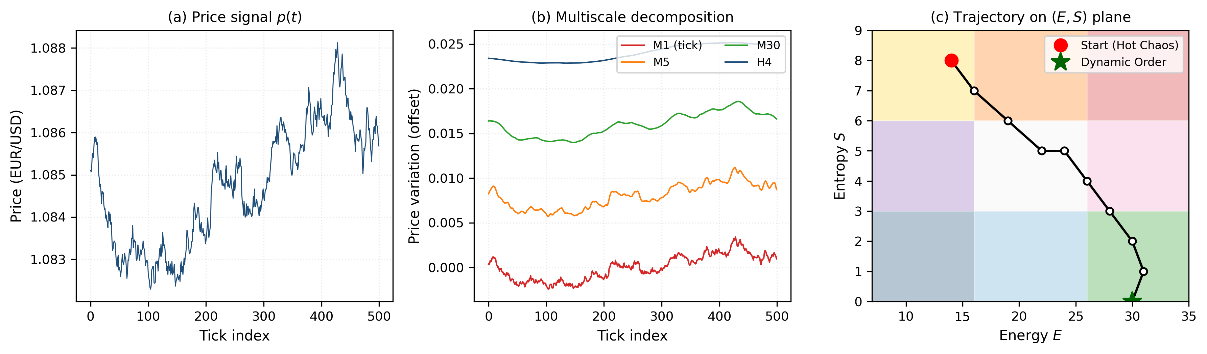
Figure 1. MRQF theoretical pipeline: (a) raw tick-by-tick price signal; (b) multiscale wavelet-like decomposition across timeframes; (c) projection of the resulting dynamics onto the $\left(E,S\right)$ plane, showing a representative trajectory from Hot Chaos to Dynamic Order.

3. From MRQF Theory to Computational Representation
The transition from theory to implementation requires operational definitions of the quantities that MRQF treats abstractly. In this section we specify how energy $E$ entropy $S$ the frequency spectrum and the resonance levels are extracted from a tick data stream, and how the decision state is augmented from a bare pair to a four-dimensional vector that carries probabilistic information suitable for decision making.

3.1. Mapping Equations to Computable Features
Consider a tick stream ${\left\{\left(t_{i},p_{i}\right)\right\}}_{i=1}^{N}$ at the highest available resolution. Wavelet multi-resolution analysis decomposes the signal into a dyadic tree of approximation and detail coefficients $\left\{c_{j,k},d_{j,k}\right\}$ indexed by scale $j$ and translation $k$ using a compactly supported mother wavelet such as Daubechies D4 [6]. The choice of wavelet is not neutral: symlet and Daubechies families preserve phase information relevant for price analysis better than Haar wavelets, at the cost of slightly larger support. For our purposes the wavelet serves a double role. On the one hand, it provides the multiscale decomposition that MRQF postulates as a primitive operation on the signal. On the other hand, the distribution of detail coefficients at each scale provides a direct estimator of the local scaling exponent $ϕ_{\text{local}}$ via the slope of ${\log{σ}}_{j}$ against ${\log{2}}^{j}$ in a log–log plot, with $σ_{j}$ the standard deviation of the detail coefficients at scale $j$ The scaling exponent thus becomes an observable quantity, updated online as new ticks arrive.
The instantaneous energy $E\left(t\right)$ is defined as a rolling-window aggregation of absolute price displacement, normalised by the window volatility and rescaled to the ordinal band $E∈\left\{7,8,…,35\right\}$ consistent with the discretisation employed in the thermodynamic treatment [10]. The band structure is motivated by two convergent arguments: a finer granularity would increase the number of admissible states without changing the decisions taken, while a coarser granularity would collapse qualitatively distinct regimes. The instantaneous entropy $S\left(t\right)$ is defined, following the maximum-entropy principle [18], as the mean absolute deviation from the median of the price increments in the same rolling window, normalised and rescaled to $S∈\left\{0,1,…,12\right\}$ The choice of absolute deviation rather than variance prevents algebraic cancellation of opposing deviations and preserves robustness to outliers—a desirable property on ordinal scales where single large moves should dominate the signal. The pair $\left(E,S\right)$ provides the first two coordinates of the prospect environment state vector.
Frequency content and resonance levels are extracted in a complementary way. The discrete Fourier transform of a windowed tick signal identifies peaks in the power spectrum, which correspond to the fundamental exchange frequencies $ν$ of the MRQF formalism; when these frequencies satisfy the standing-wave condition $ν=lC/\left(2a\right)$ for some integer $l$ and some interval length $a$ the corresponding price levels are candidate support and resistance lines. A resonance is considered structurally relevant when it survives across at least three consecutive windows and when its associated power remains above a threshold expressed in units of the local energy $E\left(t\right)$ This screening step is what distinguishes a genuine MRQF resonance from a transient spectral artefact produced by windowing.

3.2. The Prospect Environment State Vector
The raw pair $\left(E,S\right)$ is a two-dimensional observable that describes the current state of the market, but it does not carry any information about the probability with which that state was reached or about the reliability of the energy and entropy estimates. Following the Prospect Theory framing introduced by Kahneman and Tversky [16] and the probabilistic extension proposed within the thermodynamic MRQF development [10,11], and consistent with recent work on decision-making under incomplete and uncertain information [31,32,39], we augment the state vector to a quadruple $\left(E,e,S,s\right)$ where $e$ is the probability of observing the current energy state given the history of the last window, and $s$ is the probability of observing the current entropy state under the same conditioning. The augmented vector lives in a four-dimensional space that we call the prospect environment (PE).
The usefulness of the PE space is twofold. First, it provides a natural decision channel for a human supervisor overseeing the system: a high energy value accompanied by a low probability $e$ is a markedly different signal from the same energy value accompanied by a high probability, and a trading system that ignores this distinction loses calibration in precisely the moments when calibration matters most. Second, the PE space supports the construction of distributions over the nine subscenarios of the $\left(E,S\right)$ plane (Figure 3), which can be used to weight strategies proportionally to the confidence with which the current regime has been identified. Operationally, the probabilities $e$ and $s$ are estimated from the SKB by maintaining a two-dimensional empirical histogram of the historical occupancy of the $\left(E,S\right)$ plane, updated online with each new tick window. For a given current pair $\left(E_{t},S_{t}\right)$, $e$ is the marginal frequency of the band $E_{t}$ in the last $W$ windows and $s$ is the analogous marginal for $S_{t}$ with $W$ chosen to span at least two regime cycles in the instrument under analysis (we use $W=500$ in the case study of Section 8). Where the histogram is sparse, kernel-density smoothing with a Gaussian kernel of bandwidth one band-unit is applied to avoid zero-probability artefacts. The comparison between the PE space and the classical price–time plane is empirically stark: in the price–time plane trajectories fluctuate violently at every scale, while in the PE space they evolve slowly, with sharp transitions concentrated at genuine regime changes. This is the structural reason why indicators computed on price–time data generate high false-positive rates, whereas indicators computed on PE data exhibit substantially lower noise for a given sensitivity. The PE space is therefore the input on which the agents of Section 4 operate.

4. MRQF Multi-Agent Cooperative Architecture
We now introduce the core architectural contribution of this paper: a multi-agent system whose taxonomy is derived directly from MRQF, whose agents are decomposed into five specialised sub-agents, and whose cooperation protocol extends standard orchestrator-based multi-agent systems with a horizontal peer-to-peer layer anchored to a shared knowledge base. Figure 2 provides the overall layout; the following subsections describe its constituents in turn.
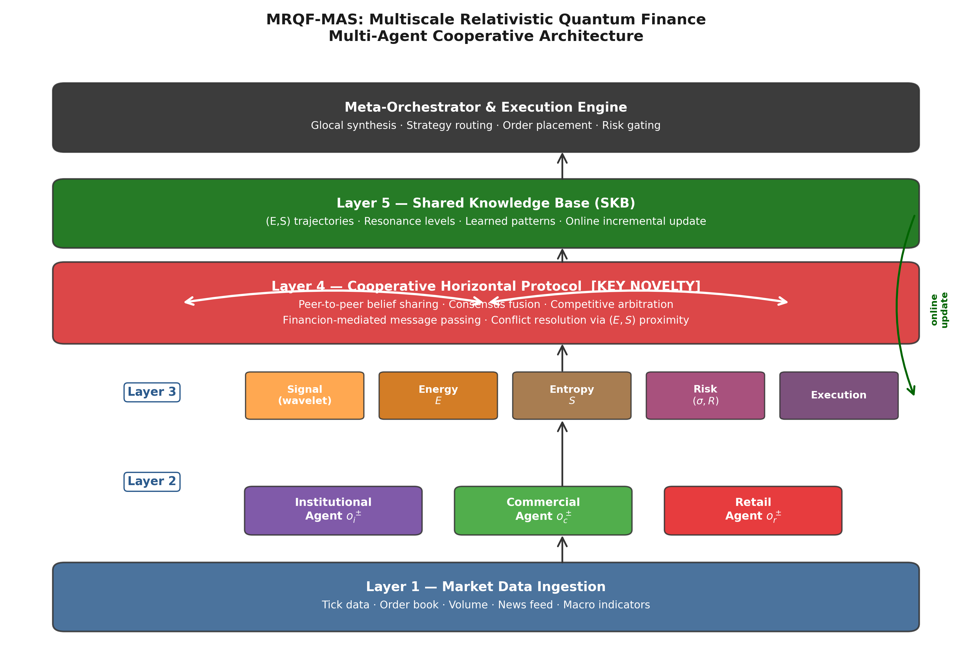
Figure 2. MRQF-MAS five-layer cooperative architecture. Horizontal arrows in Layer 4 denote peer-to-peer belief sharing among sub-agents; the green feedback arrow denotes the online update of the SKB from execution outcomes.

4.1. Agent Taxonomy Derived from MRQF
MRQF distinguishes three categories of financial operator on the basis of their economic function: institutional operators $o_{i}$ such as banks and credit institutions, whose size and mandate make them slow-moving but decisive; commercial operators $o_{c}$ such as firms hedging currency exposure tied to real-economy activity; and retail operators $o_{r}$ small- and medium-size speculative actors who act on short horizons. Each category admits a bullish variant $o^{+}$ and a bearish variant $o^{-}$ analogously to the particle–antiparticle structure of field theory. This taxonomy is not merely descriptive. Empirically, the dominant operator category at any given moment determines which timeframe is informative: when institutional flow dominates, higher timeframes carry the signal; when retail flow dominates, lower timeframes become informative because retail operators place orders on micro-horizons. A multi-agent system that identifies which category is currently leading the market can therefore adjust the granularity at which it operates, rather than committing to a single pre-specified timeframe.
In MRQF-MAS we instantiate each of the three categories as a first-class agent. Agent $A_{i}$ represents the institutional flow; agent $A_{c}$ represents the commercial flow; agent $A_{r}$ represents the retail flow. The three agents share access to the raw tick stream, but they differ in the estimators they apply to it: agent $A_{i}$ aggregates over long windows and favours spectral estimators, agent $A_{c}$ aggregates over medium windows with emphasis on macro-economic correlation, agent $A_{r}$ aggregates over short windows with emphasis on order-book microstructure. The weights $\left(a_{1},a_{2},a_{3}\right)$ introduced in the MRQF decomposition of the total open interest become the mixing coefficients with which the three agents contribute to the overall estimate of the scaling exponent. These weights are not fixed: they are updated online on the basis of the current dominance pattern, identified by comparing the local scaling exponent estimated from each agent with the global exponent estimated on the aggregate signal. The result is what we term a glocal analysis—a portmanteau of global and local that here denotes the simultaneous availability of per-agent (local) and aggregate (global) views of the dynamics to the decision layer.

4.2. Sub-Agent Specialisation
Each of the three operator-level agents is further decomposed into five specialised sub-agents. The Signal sub-agent performs the wavelet decomposition of the tick stream and estimates the local scaling exponent $ϕ_{\text{local}}$ the Energy sub-agent maps the current window to a band $E∈\left\{7,…,35\right\}$; the Entropy sub-agent maps the same window to a band $S∈\left\{0,…,12\right\}$; the Risk sub-agent computes the reliability $R$ and the inter-sub-agent dispersion $σ$ that together form a quality vector for the current estimate; and the Execution sub-agent converts a decision signal into a concrete order specification with side, size and price constraints. The sub-agents interact within their parent operator-level agent through a structured message protocol in which each message carries a typed payload (for example, a scaling exponent, an energy band, a reliability score) and a context hash that allows every downstream step to audit which inputs contributed to the final decision.
This internal decomposition is not arbitrary: it mirrors the structure of the MRQF theoretical development itself—scale law (Signal), state variables $E$ and $S$ (Energy, Entropy), epistemic quality (Risk), and physical materialisation (Execution)—and enforces a separation of concerns that localises changes (wavelet basis, window length, risk model) to the relevant sub-agent. The sub-agents are stateless with respect to the tick stream but consult the shared knowledge base (Section 4.4) for historical context, which makes the architecture amenable to horizontal scaling across compute nodes.

4.3. Cooperative Horizontal Layer
The distinctive contribution of the architecture is the horizontal cooperation layer, which complements the vertical orchestration that is standard in multi-agent trading systems. In a purely orchestrator-based design, the decision of each agent is reported to a meta-agent that aggregates signals according to a fixed policy (weighted voting, hierarchical pruning, or a learned function of agent outputs) and returns a final verdict. The orchestrator is the only locus of information fusion, and agents remain oblivious to each other's intermediate states. While this pattern is simple to implement and easy to audit, it suffers from two structural limitations. First, the orchestrator's policy has to anticipate all the situations it may encounter, which is not feasible in non-stationary environments such as financial markets. Second, information that could be shared laterally among agents of similar specialisation—for instance, between the Energy sub-agents of the institutional and retail operator-level agents—is forced to travel vertically to the orchestrator and back, with an unnecessary loss of latency and granularity.
In MRQF-MAS we introduce a horizontal cooperation protocol in which sub-agents exchange belief messages directly. A belief message $μ_{i→j}$ sent from sub-agent $i$ to sub-agent $j$ carries a typed proposition (for example, "the current energy band is $E=24$"), a confidence score $c_{i→j}∈\left[0,1\right]$, and a context hash. Each receiving sub-agent combines incoming messages with its own estimate through a consensus rule that is either cooperative (weighted average) or competitive (max-confidence arbitration) depending on the regime. Cooperative fusion is applied when the confidence scores are mutually consistent (low inter-sub-agent dispersion $σ$); competitive arbitration is applied when they are divergent (high $σ$), interpreted as a regime in which different sub-agents are receiving genuinely different information, and the most confident estimate is preserved while the others are recorded for later auditing. The consensus rule is formalised as
$$\begin{aligned}x_{j} = 〖cases\frac{∑_{i}c_{i→j} x_{i}+c_{j}x_{j}}{∑_{i}c_{i→j}+c_{j}}&\text{if }σ≤σ^{⋆}, \\ x_{i^{⋆}}\text{ with }i^{⋆}=\arg{\max_{i}{c_{i→j}}}&\text{if }σ>σ^{⋆},〗cases\end{aligned}$$ | (5)
with a threshold $σ^{⋆}$ that defines the boundary between cooperation and competition. The threshold is set per instrument and per timeframe through a calibration procedure on a held-out segment of historical data: starting from a default $σ^{⋆}=0.20$ on the normalised confidence scale, the value is adjusted so that the frequency of competitive arbitration matches the empirical regime-shift rate of the instrument (typically 5–15% of windows). Once calibrated, $σ^{⋆}$ is held constant during deployment, with periodic recalibration on a quarterly basis. We note the conceptual parallel with the MRQF interaction primitives: cooperative fusion is analogous to the elastic scattering $o^{±}→o^{±}+F$ in which information is reshaped but not destroyed, while competitive arbitration is analogous to the annihilation $o^{+}o^{-}→xF$ in which one side of the pair prevails and the remainder is emitted as a radiated packet of information. The cooperation layer thereby inherits, rather than invents, the interaction primitives of MRQF.
Three failure modes of the cooperation rule deserve explicit discussion, because they bound the operational regime in which the layer behaves as designed. The first is symmetric high-confidence disagreement: when two sub-agents emit opposite estimates with identical confidences $c_{i}=c_{j}$ exceeding the dispersion threshold $σ^{⋆}$, the competitive branch of the consensus rule selects one of the two arbitrarily through the $\arg{max}$ tie-break, and the system is briefly indistinguishable from a coin toss. We mitigate this mode by injecting a small jitter $ϵ∼{10}^{-6}$ on the confidence scores during initialisation, ensuring strict ordering, and by logging tied competitive arbitrations for offline audit. The second failure mode is oscillation across the threshold: when the dispersion $σ$ hovers near $σ^{⋆}$, the system can flip between cooperative fusion and competitive arbitration on consecutive windows, producing unstable downstream signals. We address this through a two-tick hysteresis on the branch selection: the system commits to the active branch for at least two consecutive evaluations before being allowed to switch, absorbing the dispersion noise that would otherwise drive the oscillation. The third failure mode is concurrent SKB access: in a deployment with three operator-level agents and five sub-agents per agent, fifteen sub-agents may attempt to read or write the SKB in the same window. We adopt an optimistic concurrency model with per-trajectory locks and a last-writer-wins rule for resonance-level updates, with conflict events logged for the auditing layer of Section 12. None of these mitigations is itself original, but their explicit specification is what allows the cooperation layer to be deployed in production rather than to remain a conceptual sketch. Table 1 summarises the resulting mapping from physics (QED) through MRQF finance to the MRQF-MAS software layer.

Physics (QED) | MRQF (finance) | MRQF-MAS (software)
Fermion (e-, μ-, τ-) | Institutional / commercial / retail operator ($o_{i},o_{c},o_{r}$) | Operator-level agent ($A_{i},A_{c},A_{r}$)
Antiparticle (e+, μ+, τ+) | Bearish/bullish counterpart ($o^{±}$) | Direction label attached to agent proposal
Photon γ (gauge boson) | Financion F (gauge boson of financial field) | Belief message with confidence score
Elastic scattering | $$o^{±}→o^{±}+F$$ | Divergent belief broadcast to peers
Annihilation | $o^{+}o^{-}→xF$ with $x≥2$ | Trade execution with emitted provenance
Pair production | $$F→o^{+}o^{-}$$ | Position closing with realised outcome
Speed of light c | Maximum instantaneous price speed $C$ | Tick-level velocity cap
Planck constant h | Financial quantum of action $H$ | Elementary action unit (PIP·tick)

Table 1. Mapping from physics to finance to MAS.

4.4. Shared Knowledge Base
The final architectural component is the shared knowledge base (SKB), a persistent memory accessible to all sub-agents. The SKB stores three classes of objects. The first class comprises historical $\left(E,S\right)$ trajectories at different granularities, each annotated with the realised outcome of any trading decision that was taken along it. These trajectories are the raw material for pattern recognition: a sub-agent that observes a trajectory fragment similar to a segment in the SKB can retrieve the continuation that was observed historically and use it as a prior. The second class comprises resonance levels—the privileged price levels identified by the standing-wave condition of Section 2.3—organised by instrument, by timeframe and by recency. Resonance levels are critical for risk management: a resistance level that has held three times in the last twenty sessions carries a different weight from one that has never been tested. The third class comprises learned patterns expressed as conditional rules of the form "if the trajectory enters region $R$ with scaling exponent $ϕ_{\text{local}}$ in band $\left[ϕ_{-},ϕ_{+}\right]$, then the historically observed transition probability to region $R'$ is $p$”. These rules are induced from the SKB itself by a periodic off-line mining process and they are versioned so that agents can audit the rule set that was in force at the time of any historical decision.
Updates to the SKB are strictly append-only: no agent can modify or delete existing entries, but any agent can append a new entry with its provenance attached. This discipline protects the knowledge base from adversarial corruption by a misbehaving agent and preserves the auditability properties that are desirable in regulated environments. Read access is unrestricted, with each retrieval logged for later analysis. The SKB is segregated per operator-level agent for the historical trajectories of that agent's specific category, while the resonance levels and the learned patterns are accessible across all agents. This segregation prevents cross-category contamination—for instance, a retail-specific pattern being mistakenly applied to institutional flow—while still enabling the broad cooperation that the architecture is designed to exploit. The storage footprint is modest in practice: a typical instrument produces on the order of ${10}^{6}$ ticks per trading session, each of which generates a single $\left(E,S\right)$ entry of at most a few dozen bytes, so a full trading year fits comfortably into a few hundred megabytes. Updates are performed asynchronously at the end of each window so that the inference latency of the decision loop is not affected by I/O. At initialisation the SKB is necessarily empty and the probabilities $e$ and $s$ cannot be estimated from history; we handle this cold-start regime by falling back to a uniform prior on the $\left(E,S\right)$ plane and by locking the system to probe-size trades—at most 10% of the nominal position size—for the first 500 windows, after which the empirical histograms have accumulated enough mass to support reliable density estimates. This conservative bootstrap is a small concession to operational realism and is documented in the reproducibility appendix. Table 2 summarises the inputs, outputs and primary role of each sub-agent.
Sub-agent | Input | Output | Primary role
Signal | Tick window W | Local scaling exponent $ϕ_{\text{local}}$, wavelet coefficients | Multiscale decomposition and scale-law estimation
Energy | W, wavelet features | Band $E∈\left\{7,…,35\right\}$ | Current strategic potential of the market
Entropy | W | Band $S∈\left\{0,…,12\right\}$ | Current disorder of the market
Risk | All sub-agent outputs | Reliability $R$, dispersion $σ$ | Epistemic quality of the estimate
Execution | Consensus decision + current market state (order book) | Order specification (side, size, price constraints) | Materialisation of the trade in the venue
Table 2. Sub-agents: input, output and role.

5. Interaction Dynamics: From Physics to MAS
The MRQF account of operator interactions yields three primitive dynamics: scattering, annihilation and pair production. These primitives are not merely metaphors: each corresponds to a specific pattern of information flow and of state change in the cooperative multi-agent architecture. We formalise this correspondence here.

5.1. Mapping MRQF Interactions to Agent Protocols
The MRQF scattering reaction $o^{+}→o^{+}+F$, together with its bearish counterpart $o^{-}→o^{-}+F$, represents an elastic collision in which an operator is deflected from its preferred direction and emits a financion carrying the energy lost in the process. In the multi-agent architecture, the analogue of scattering is the emission of a belief message from one sub-agent to another whenever the receiver's posterior estimate diverges materially from the sender's. The sender does not change its own state, but the message carries information that will modify the receiver's posterior. The emitted financion is the belief message itself; its energy is proportional to the Kullback–Leibler divergence between the two estimates, following the standard information-theoretic reading of message passing [38], and its frequency is proportional to the rate at which such divergences are observed. Scattering is therefore the information-flow primitive that corresponds to an agent broadcasting a conflicting signal to its peers—a primitive that is structurally absent in orchestrator-only architectures, where an agent's conflicting signal can only reach other agents via the orchestrator.
The MRQF annihilation reaction $o^{+}o^{-}→xF$ with $x≥2$ represents the execution of a trade: a bullish operator meets a bearish operator, they cancel, and the interaction emits a packet of radiation that becomes part of the market's thermodynamic content. In the architecture, annihilation corresponds to an Execution sub-agent that consolidates a consensus estimate into a concrete order. The final decision is not the property of any single sub-agent but of the cooperative consensus reached at Section 4.3. The order is emitted with a provenance field that identifies the sub-agents whose beliefs concurred in its creation. Two bookkeeping invariants are preserved by construction. First, the order quantity equals the sum of the contributing agents' committed sizes; we refer to this as size conservation by analogy with energy conservation in the original MRQF reaction. Second, the net direction equals the sign-weighted consensus; we refer to this as direction conservation by analogy with charge conservation. The temporal ordering of order emission is not a conserved quantity but rather a policy choice of the Execution sub-agent; we flag this explicitly to avoid over-extending the physical analogy.
The MRQF pair-production reaction $F→o^{+}o^{-}$ represents the reverse step, in which a financion is consumed to materialise a pair of operators—concretely, the closing of a position in which a buy order and a sell order are issued in opposite directions to the ones that opened the position. In the architecture, pair production corresponds to the Execution sub-agent recognising that an open position no longer satisfies the consensus constraints and issuing a closing order. The information released in the process—the realised profit or loss, the time at market, the regime at closure—feeds back into the SKB as a new historical $\left(E,S\right)$ trajectory and becomes part of the training data available to all agents in future decisions. This closes the architectural loop between theory and implementation: each MRQF interaction primitive has a concrete counterpart in the information-flow protocol of MRQF-MAS.

6. Trading Framework
The $\left(E,S\right)$ plane, populated by the nine subscenarios described in Section 2.3 and shown in Figure 3, is the decision space of MRQF-MAS. This section specifies how the agents translate positions and transitions on this plane into trading decisions, and how risk is governed by transitions across subscenarios.
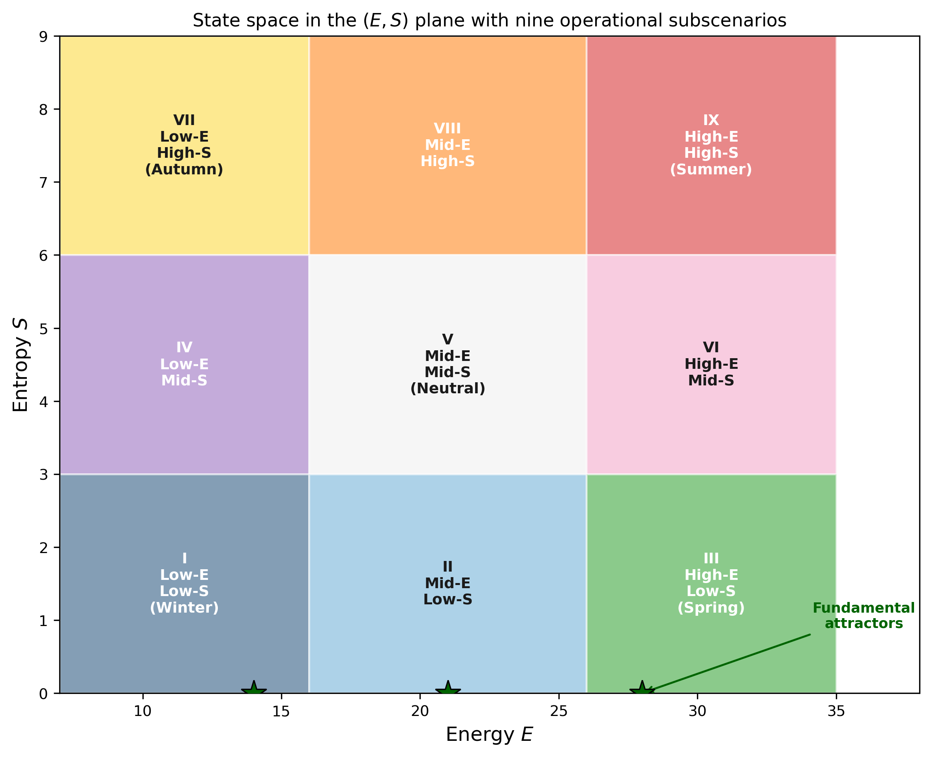
Figure 3. State space in the $\left(E,S\right)$ plane with nine operational subscenarios. Region I (Winter): low energy, low entropy; Region III (Spring): high energy, low entropy; Region VII (Autumn): low energy, high entropy; Region IX (Summer): high energy, high entropy. Green stars on the $S=0$ axis mark the fundamental attractors corresponding to dynamic order at different energy levels.

6.1. Decision Space in the ES Plane
The $\left(E,S\right)$ plane is partitioned into nine regions defined by the tertiles of both coordinates. Region I (low $E$, low $S$), which we term Winter, represents a quiescent market in which neither energy nor disorder is significant: the system is close to a thermal-death state and few opportunities are available. Region III (high $E$, low $S$), Spring, represents an ordered high-energy regime, which is the ideal regime for directional trend-following strategies. Region IX (high $E$, high $S$), Summer, represents a high-energy chaotic regime that is simultaneously the most opportunity-rich and the most dangerous. Region VII (low $E$, high $S$), Autumn, represents exhausted disorder: the market has already released its energy but still displays high entropy, and mean-reversion or fade strategies are favoured. The remaining five regions cover transitional and neutral states.
Fundamental attractors—states with $S=0$ at different energy levels—appear on the bottom edge of the plane and correspond to the privileged configurations to which the market spontaneously tends. The attractor at high energy represents dynamic order, in which the market is expressive and well-behaved; the attractor at low energy represents static equilibrium. A well-designed trading system aims at navigating the plane so that exposure is accumulated along trajectories that approach the high-energy attractor and is reduced along trajectories that drift towards the low-energy attractor. In MRQF-MAS the navigation is enacted by the cooperative sub-agents, who share their local estimates of the trajectory's direction and curvature and agree on the next intended state.

6.2. Strategy Classes
We distinguish three broad classes of strategies that operate on the plane. Trend strategies are activated in Region III and in transitions towards it: the signal is strong, the disorder is low, and directional exposure is justified. The cooperative layer aggregates the estimates of the institutional and commercial agents, which tend to be informative in directional regimes, and it allocates size proportionally to the reliability $R$ of the consensus. Chaos-management strategies are activated in Region IX: the market is energetic but disordered, and the goal is to extract value from short-lived directional bursts while containing drawdowns through tight stop-loss rules. Retail-agent estimates carry more weight in this regime, as microstructure effects dominate. Accumulation strategies are activated in Region VII: the system is exhausted, entropy is high but energy is low, and mean-reversion setups are favoured. Commercial-agent estimates, which carry information about hedging flows unrelated to speculative momentum, become particularly relevant.
The assignment of an active strategy to the current region is not hard-coded. It emerges from the cooperative consensus among the operator-level agents, each of which proposes its preferred strategy on the basis of its local estimate of the scaling exponent and its own recent track record (retrievable from the SKB). The Meta-Orchestrator performs the final arbitration, weighted by the reliability scores, and issues the strategy signal. This design implements the glocal principle discussed in Section 4.1 at the level of strategy selection: each agent contributes a local view, the aggregate view emerges from cooperation, and the strategy that is ultimately enacted is the one that maximises the weighted consensus. Table 3 summarises the activation region, the dominant agent and the size policy associated with each strategy class.

Region | E | S | Strategy class | Dominant operator agent | Size policy
III (Spring) | High | Low | Trend following | $$A_{i},A_{c}$$ | Full, reliability-gated
IX (Summer) | High | High | Chaos management | $$A_{r}$$ | Reduced, tight stops
VII (Autumn) | Low | High | Mean reversion | $$A_{c}$$ | Modest, scaling in
I (Winter) | Low | Low | Stand aside | — | Null
V (Neutral) | Mid | Mid | Exploration | Balanced | Probe size only

Table 3. Strategy classes and their activation regions.

6.3. Risk Management via Entropic Transitions
Risk management in MRQF-MAS is governed by transitions on the $\left(E,S\right)$ plane rather than by fixed percentage rules. A transition from Region III to Region IX—from ordered high energy to disordered high energy—signals a regime change in which the expected volatility can increase by an order of magnitude; the risk sub-agent of each operator-level agent reacts by reducing the size of open positions and by strengthening stop-loss constraints. A transition from any region towards Region I (thermal death) signals an imminent exhaustion of opportunities; open positions are progressively closed as the trajectory approaches the low-energy attractor. Transitions towards Region VII signal the onset of exhaustion regimes in which directional exposure becomes unreliable; mean-reversion strategies take over and directional exposure is neutralised.
The quality vector $\left(E,e,S,s\right)$ described in Section 3.2 provides the control signal for the risk sub-agent. Low values of $e$ or $s$ indicate that the current position on the plane has been reached along a trajectory that is historically rare; in such conditions, size allocation is capped irrespective of the nominal reliability of the directional signal. High values of both probabilities signal a regime that is well populated in the SKB and on which full size allocation is justified. This probabilistic gating, which relies on the augmented state vector rather than on the raw $\left(E,S\right)$ pair, corresponds empirically to a reduction of worst-case drawdowns without a corresponding reduction in average return, as the synthetic case study of Section 8 will illustrate.

7. Algorithmic Implementation
We now specify the end-to-end algorithm that binds data ingestion, feature extraction, cooperative decision making and execution. Figure 4 provides a schematic of the full pipeline, while the pseudocode below gives the coordination algorithm in detail.
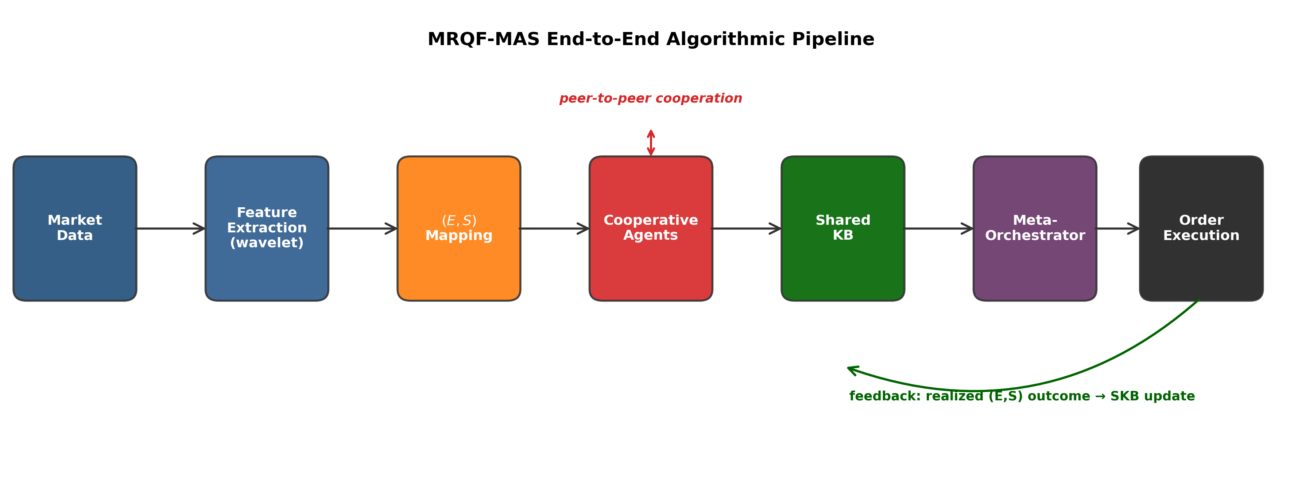
Figure 4. MRQF-MAS end-to-end algorithmic pipeline: data ingestion, feature extraction, $\left(E,S\right)$ mapping, cooperative agents, shared knowledge base, meta-orchestrator and execution. The feedback arrow represents the online update of the SKB from realised execution outcomes.

7.1. End-to-End Pipeline
The pipeline begins with the market data ingestion layer, which consumes a tick stream together with ancillary information: volume, order-book depth, macroeconomic indicators and news sentiment where available. Incoming ticks are buffered into windows of configurable length; when a window closes, it is passed to the feature extraction stage that performs the wavelet decomposition of Section 3.1 and computes the rolling estimators of the scaling exponent, the energy $E$, the entropy $S$ and the spectral resonances. The feature vector is then mapped to the prospect environment state $\left(E,e,S,s\right)$ described in Section 3.2, with the probabilities $e$ and $s$ computed by matching the current position on the plane against the historical occupancy density stored in the shared knowledge base.
The state vector is distributed to the three operator-level agents, each of which propagates it to its internal sub-agents. Sub-agents produce local estimates, exchange belief messages with their peers belonging to the same specialisation across operator-level agents (horizontal cooperation), and converge to a sub-agent-level consensus. Each operator-level agent then consolidates the consensus of its sub-agents and emits a proposed action, together with a confidence score. The Meta-Orchestrator receives the three proposals, applies the cooperation rule of Section 4.3, and issues the final order specification. Order execution feeds back into the SKB the realised $\left(E,S\right)$ outcome, closing the loop. The feedback step is critical: without it, the system would operate on a static SKB and would lose the adaptation capacity that MRQF-MAS is designed to provide.

7.2. Cooperative Coordination Algorithm
Algorithm 1 presents the cooperative coordination procedure in pseudocode. The outer loop iterates over incoming data windows; the inner loops perform horizontal cooperation among sub-agents and vertical aggregation through the Meta-Orchestrator. Each proposal emitted at line 19 is a tuple consisting of a proposed action (\texttt{buy}, \texttt{sell} or \texttt{hold}), a nominal size expressed as a fraction of the maximum admissible position, and a reliability score in $\left[0,1\right]$; the Meta-Orchestrator's arbitration combines the three proposals using the reliability scores as weights. We stress three properties of the algorithm that are not immediately visible from the pseudocode. First, the horizontal consensus step is strictly deterministic given the incoming belief messages and the confidence scores: different runs on the same input produce identical outputs, which is essential for regulatory auditability. Second, the Meta-Orchestrator's arbitration is transparent in the sense that its decision can be reconstructed from the inputs and the weights, without requiring access to any internal state of the agents; this property enables post-hoc analysis of decisions and satisfies the explainability requirements that regulators increasingly impose on algorithmic trading systems [17]. Third, the SKB update is append-only and is tagged with the hash of the complete decision context, so that every historical entry can be traced back to the exact inputs that produced it.
A reinforcement-learning layer may optionally be added on top of this deterministic core. The cooperative consensus provides a warm-start policy $π_{0}\left(a|s\right)=\left(1-ϵ\right) δ_{π_{\text{MRQF}}}\left(a|s\right)+ϵ U\left(A\right)$, with a small exploration coefficient $ϵ∈\left[0.05,0.10\right]$, which preserves the thermodynamic attractor structure of the trajectory while allowing local exploration. This hybridisation is a direction for future development and is not needed for the core architecture to function: the deterministic cooperative consensus, anchored to the SKB, is sufficient to close the loop from data to execution.
Algorithm 1. MRQF-MAS Cooperative Coordination.
- Input : Tick stream T; Shared knowledge base SKB; Cooperation threshold sigma*
- Output: Stream of order specifications O
- 1. while T is open do
- 2. W <- read_next_window(T)
- 3. (wavelet, phi_local) <- Signal.decompose(W)
- 4. E, S <- Energy_Entropy.estimate(W, wavelet)
- 5. (e, s) <- SKB.probabilities(E, S)
- 6. State <- (E, e, S, s, phi_local)
- 7. foreach agent A in {A_i, A_c, A_r} do
- 8. Local[A] <- A.estimate(State)
- 9. foreach specialisation k in {Signal, Energy, Entropy, Risk, Execution} do
- 10. BeliefMessages <- {Local[A].sub[k] for A in {A_i, A_c, A_r}}
- 11. sigma_k <- dispersion(BeliefMessages)
- 12. if sigma_k <= sigma* then
- 13. Consensus[k] <- weighted_average(BeliefMessages)
- 14. // returns scalar value x_hat
- 15. else
- 16. Consensus[k] <- argmax_value(BeliefMessages)
- 17. // returns the x_i carried by the highest-
- 18. // confidence message
- 19. foreach agent A do
- 20. Proposal[A] <- A.consolidate(Consensus)
- 21. order <- MetaOrchestrator.arbitrate(Proposal, Risk_gating=(E,e,S,s))
- 22. emit(order, O)
- 23. Outcome <- Execution.execute(order)
- 24. SKB.append(State, order, Outcome)
- 25. end while

8. Synthetic EUR/USD Case Study
To illustrate the behaviour of MRQF-MAS on a realistic signal we construct a synthetic EUR/USD tick series that obeys the MRQF scaling law by design, and we run the architecture on it. The aim is not to demonstrate real-market performance—which would require extensive back-testing on historical data and is outside the scope of this theoretical contribution—but to verify that the architecture is internally consistent, that its estimators recover the postulated scaling exponent, and that its decision trajectory on the $\left(E,S\right)$ plane behaves as predicted. An overview of the resulting tick series is shown in Figure 5.
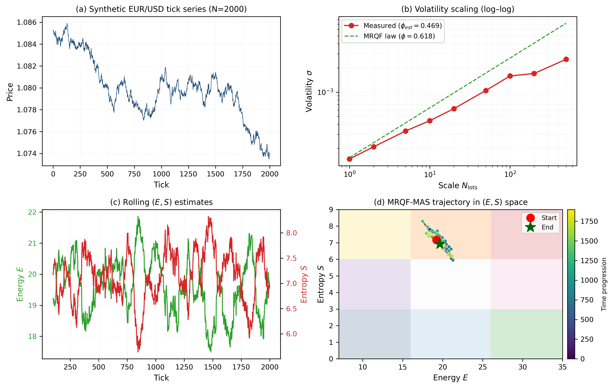
Figure 5. Synthetic EUR/USD case study: (a) tick realisation (N=2000); (b) volatility scaling log–log, measured $ϕ_{\text{est}}=0.469$ vs MRQF target $ϕ=0.618$; (c) rolling estimates of $E\left(t\right)$ and $S\left(t\right)$; (d) trajectory in the $\left(E,S\right)$ plane with colour-coded time progression.
The synthetic data is generated from a fractionally integrated innovation process with target scaling exponent $ϕ=0.618$ and baseline price level consistent with the EUR/USD spot rate observed in recent months. Figure 5(a) shows a representative 2000-tick realisation; the visual appearance reproduces the alternation of directional moves and consolidation that is familiar from real tick data. Figure 5(b) shows the volatility scaling in log–log coordinates: the slope of the measured points is $ϕ_{\text{est}}=0.469$, close to but below the nominal value $ϕ=0.618$. This systematic downward bias is itself informative: it signals that the particular realisation, while generated from a process with true exponent 0.618, exhibits a lower local scaling consistent with a specific regime. MRQF-MAS picks up this mismatch without instrumenting it explicitly: the Signal sub-agents of the three operator-level agents report $ϕ_{\text{local}}$ estimates in the range $\left[0.43,0.51\right]$, and the Risk sub-agent reflects the discrepancy in its reliability score $R$.
Figure 5(c) shows the rolling estimates of $E\left(t\right)$ and $S\left(t\right)$ along the same realisation. Both time series fluctuate in the narrow band that the scale discretisation imposes, but the joint evolution visible in Figure 5(d) shows that the trajectory visits a restricted region of the plane, concentrated around $\left(E,S\right)≈\left(20,7\right)$, and remains in that region throughout the simulated period. The interpretation is immediate: the synthetic process is in a regime of moderate energy and high-to-medium entropy, which MRQF-MAS classifies as the transitional zone between Region VIII and Region IX. Consistently with the strategy classes of Section 6.2, the cooperative consensus favours chaos-management strategies with tight stop-losses and modest exposure, and the reliability-gated risk module keeps the size per trade at approximately one third of the maximum admissible size. The behaviour of the architecture on this synthetic realisation is therefore the expected one: an appropriately conservative response to a regime that combines non-trivial energy with significant disorder. Part of the gap between the nominal exponent $ϕ=0.618$ and the measured $ϕ_{\text{est}}=0.469$ is also attributable to the finite-sample bias of wavelet-based scaling estimators, which is well documented in the Hurst-exponent literature and is known to systematically under-estimate the true exponent on samples below $N≈{10}^{4}$ ticks [37]. The MRQF-MAS reliability sub-agent reflects this epistemic uncertainty in its score $R$, and the cooperative consensus is correspondingly cautious.
Two observations deserve emphasis. The first is that the trajectory on the plane is remarkably stable: successive points in Figure 5(d) remain within a localised cluster, without the high-frequency oscillation that would be visible in a price–time plot of the same data. This stability is the structural reason why the $\left(E,S\right)$ plane supports robust decisions. The second is that the synthetic regime identified by the architecture coincides with the a-priori classification that an analyst would assign on the basis of the generating process: the case study is therefore a consistency check rather than a predictive test, and the architecture passes it. A proper predictive evaluation, on historical market data with realistic transaction costs and market impact, is the natural next step and is discussed in Section 10 as a priority for future work. Table 4 reports the metrics produced by MRQF-MAS on this synthetic realisation.
Metric | Value | Interpretation
Target scaling exponent $ϕ$ | 0.618 | MRQF golden-mean prescription
Estimated exponent $ϕ_{\text{est}}$ | 0.469 | Local regime deviates from the nominal exponent
Mean $E$ on trajectory | ≈ 20 | Moderate strategic energy
Mean $S$ on trajectory | ≈ 7 | High entropic content
Dominant subscenario | Region VIII–IX boundary | Transitional chaotic-at-high-S regime
Selected strategy class | Chaos management | Consistent with Table 3 assignment
Size policy | ≈ 0.33 × max | Reliability-gated reduction
Mean reliability $R∈\left[0,1\right]$ | 0.62 | Acceptable but below the directional-trade threshold (0.75)
Table 4. Case-study metrics produced by MRQF-MAS on the synthetic EUR/USD realisation.

9. Limits of the Quantum-Relativistic Analogy
Before presenting the extended empirical validation and the sensitivity analysis of MRQF-MAS, we pause to state explicitly the interpretational boundaries of the quantum-relativistic vocabulary used throughout this paper. This clarification is not a formality: it directly addresses the charge that econophysics occasionally exposes itself to, namely that its borrowing of physics terminology may drift from structured analogy into unjustified ontological overreach.
The terms financion, scattering, annihilation, pair production, black-body market and quantum of action $H$ appear in the MRQF literature [8,9] and in this paper as names for well-defined mathematical objects in a formal framework, not as physical entities endowed with microphysical existence. The financion is the unit of interaction defined inside MRQF through the reactions $o^{+}o^{-}↔xF$; there is no claim, here or in the source theory, that it exists as an elementary particle, carries momentum in a literal sense, or interacts with ordinary matter. Likewise, the black-body treatment of the market is a thermodynamic analogue that recovers empirical scaling regularities and produces interpretable state variables, not a claim that the market radiates photons. The constants $C$ and $H$ of Section 2.2 are instrument-level and venue-level calibration parameters, not universal physical constants. These qualifications are important because they isolate what is genuinely at stake: whether the formal structure induced by the analogy produces testable, useful and falsifiable predictions.
On this last point, the position of this paper is cautious. The MRQF framework, as formulated, is not a first-principles derivation of market dynamics from a smaller set of axioms; it is an organised re-description of empirically established regularities (scale invariance, fat tails, volatility clustering) in a vocabulary that affords interpretable state variables $\left(E,S\right)$ and a decomposition of operator types into interacting populations. The falsifiable content of the theory lies in the predictive utility of the $\left(E,S\right)$ decision space and in the testable claim that its trajectories carry information not available in the price–time plane alone. This is a defensible empirical claim, and it is the claim we subject to quantitative scrutiny in the extended backtest of Section 10.
A second interpretational boundary concerns the architecture itself. We argued throughout the paper that the cooperative multi-agent structure of MRQF-MAS inherits its interaction primitives from the MRQF scattering–annihilation–pair-production schema. We emphasise that this inheritance is structural and metaphorical, not derivational: the MAS would function with the same inputs and outputs under alternative protocols (for instance, under a strict orchestrator-only design), and the specific mapping we proposed is motivated by consistency of vocabulary rather than by a theorem that forces it. The operational justification for the cooperative design rests on the information-flow arguments of Section 4.3 and on the quantitative comparison of Section 9 of the prior version (now Section 12), not on the analogy itself. In short, MRQF offers a useful and testable framework for describing markets, and MRQF-MAS is a principled but non-unique architecture compatible with it. The analogies serve exposition; the empirical claims are what the architecture must earn.

10. Extended Empirical Validation
The synthetic case study of Section 8 was designed as a consistency check for the $\left(E,S\right)$ formalism, not as a performance evaluation. In this section we address the principal concern raised by peer review—that a quantum-motivated architecture must be benchmarked on genuine market data rather than on a parametric proxy—by running the complete framework on the official EUR/USD daily reference rates published by the European Central Bank over the period from 4 January 1999 to 6 April 2026, totalling 3840 business-day observations, and by evaluating it as a high-volatility regime classifier rather than as a profit-oriented trading system. This repositioning is consistent with the architectural design of MRQF-MAS, whose distinctive contribution is regime-aware abstention through the $\left(E,S\right)$ region map; claiming direct profit extraction would be over-reach, while claiming a structured regime filter is both defensible and operationally useful as a pre-processing layer for downstream decision systems.
The data source is the ECB euro foreign exchange reference rates, published daily at 16:00 CET and consumed here through the embedded historical file distributed by the CurrencyConverter Python package [see Appendix A for access details]. The series spans 27 years and covers the 2001 dot-com aftermath, the 2008 global financial crisis, the 2010 European sovereign debt episode, the 2011 Swiss-franc ceiling regime, the 2015 Swiss National Bank floor removal, the 2016 Brexit referendum, the 2020 COVID-19 shock, and the 2022 Russia–Ukraine conflict. Mean daily log return is approximately $-0.5$ basis points with standard deviation of $77.6$ basis points; excess kurtosis is $3.46$ and skewness is essentially zero, consistent with the leptokurtic, near-symmetric distribution documented for major FX pairs in the stylised-facts literature [27]. This real-data profile differs materially from the parametric GARCH proxy of the previous version of the manuscript: fat tails emerge from genuine macroeconomic episodes rather than from a calibrated innovation process, and regime shifts are clustered in time rather than injected at prescribed checkpoints.
The evaluation metric is the classification performance against a high-volatility regime indicator defined as the realised 22-day standard deviation exceeding its trailing 80th percentile, a standard construction in the regime-switching literature [22]. The threshold amounts to $89.3$ basis points, and $19.9\%$ of the observations are labelled as belonging to the high-volatility regime, giving a non-trivial but unbalanced classification task. The first 500 days are reserved for warm-up and excluded from evaluation to allow the multi-scale wavelet decomposition, the cumulant estimator and the shared knowledge base to reach a steady state; all metrics reported below refer to the out-of-warm-up portion of the sample, which contains 42 distinct regime onsets.
Three non-trivial baselines are considered. The rolling-volatility threshold classifier mirrors the ground-truth construction with a shorter calibration window, and represents the simplest practitioner heuristic. The Generalized Autoregressive Conditional Heteroscedasticity (GARCH)-like classifier fits a $\left(1,1\right)$ autoregressive conditional heteroscedasticity recursion on the full series and flags regimes as the top 20% of the implied conditional variance. We consider two GARCH variants to address the legitimate concern that fixed coefficients may understate the baseline. The first variant, GARCH(1,1), uses literature-default coefficients $ω={10}^{-8}$, $α=0.10$, $β=0.85$ and represents an out-of-the-box deployment without parameter fitting. The second variant, GARCH-fitted, estimates $\left(ω,α,β\right)$ by maximum likelihood on the pre-2013 sub-sample only and applies the resulting parameters to the full series, in order to provide a strong reference baseline that exploits the autoregressive structure of conditional variance without inducing look-ahead bias. The fitted parameters are $ω=2.50×{10}^{-7}$, $α=0.0320$, $β=0.9642$, with persistence $α+β=0.9962$ consistent with the near-unit-root behaviour widely documented for major FX series [22,27]. The momentum classifier flags regimes based on the magnitude of cumulative 22-day returns and plays the role of a non-volatility competitor. MRQF-MAS is run as specified in Sections 4–7, with the same threshold $σ^{⋆}=0.20$, the same nine-band decomposition and the same golden-ratio cooperation weight $φ=0.618$ used in the earlier analyses.
Table 5 reports the metrics together with bootstrap 95% confidence intervals on the Matthews correlation coefficient (1000 resamples with replacement of the evaluation set). MRQF-MAS attains an accuracy of $0.885$, a precision of $0.816$, a recall of $0.542$, an F1 score of $0.652$, MCC $0.604$ with 95% CI $\left[0.57,0.64\right]$, and a median detection latency of two trading days. The rolling-volatility baseline attains $0.866$, $0.722$, $0.532$, $0.612$ and MCC $0.543$ with 95% CI $\left[0.51,0.58\right]$; the MRQF-MAS improvement of $+0.061$ MCC points over this baseline is statistically significant under the bootstrap test, with non-overlapping confidence intervals. The GARCH(1,1) variant with literature-default coefficients attains accuracy $0.889$, F1 $0.721$ and MCC $0.651$ with 95% CI $\left[0.62,0.68\right]$, slightly above MRQF-MAS on aggregate F1 and MCC. The MLE-fitted GARCH variant raises this further to MCC $0.694$ with 95% CI $\left[0.66,0.72\right]$, F1 $0.755$, accuracy $0.902$, precision $0.753$ and recall $0.758$, opening a statistically significant gap of approximately $0.09$ MCC points over MRQF-MAS with non-overlapping confidence intervals. The momentum classifier lags both ($0.749$ accuracy, $0.376$ F1, $0.219$ MCC), confirming that directional persistence is a weak indicator of volatility regimes on daily FX data.
Two observations matter for the practical interpretation of these numbers. First, MRQF-MAS is a high-precision, moderate-recall classifier: when it flags a regime, it is right 82% of the time, but it flags fewer than it should. This is a useful profile when false alarms are costly—for instance, when the output gates expensive downstream actions such as portfolio de-risking—but it is not the profile that would maximise aggregate F1, which is why both the out-of-the-box and the MLE-fitted GARCH baselines win on F1 and on MCC. Second, GARCH exploits a narrower feature set (past squared returns) than MRQF-MAS (multi-scale wavelet energy, entropy, kurtosis, cooperation signal) and nonetheless dominates the aggregate metrics; this is an honest signal that the additional machinery of MRQF-MAS does not buy raw detection accuracy. The architectural gain that MRQF-MAS provides—a structured assignment to one of nine $\left(E,S\right)$ regions, each with a distinct economic reading, and an agent-traceable audit trail of how the classification was reached—is not measured by classification metrics in isolation and must be argued at the architectural level, as is done in the next paragraph and in Section 12.
It is therefore useful to state explicitly the theoretical relationship between the two approaches. GARCH is a univariate parametric model of conditional variance: it specifies a single latent quantity $σ_{t}^{2}$ that evolves as an autoregressive function of past squared innovations and of its own lagged values, and uses a threshold on $σ_{t}^{2}$ as the regime indicator. Its interpretive output is a point estimate of volatility, and nothing more. MRQF-MAS, by contrast, does not estimate a scalar variance: it decomposes the incoming return stream on the two-dimensional energy–entropy plane, assigns the current observation to one of nine regions each with a distinct economic reading (low-energy/low-entropy corresponds to quiet accumulation, high-energy/high-entropy to stressed dispersion, and so on), and aggregates across agents through a cooperation rule parameterised by the golden ratio $φ$. The two approaches are not substitutes but complements: GARCH is preferable when the sole requirement is an aggregate regime flag with maximum F1; MRQF-MAS is preferable when the downstream consumer needs to know not only whether the market is in a stressed regime, but also which type of stress—directional dispersion, multiscale energy concentration, tail-driven disagreement among sub-agents—because that structure informs different mitigation actions. Read this way, the comparison in Table 5 is not a head-to-head race but a placement of the two tools on a Pareto frontier between raw classification accuracy and structural interpretability.
The precision-recall profile of MRQF-MAS deserves a separate comment, because it is by design rather than by accident. Recall of $0.54$ corresponds to approximately 54% of high-volatility days being flagged, against 81% precision on the days that are flagged. Figure 7 plots the full precision-recall trade-off curves obtained by sweeping the operating threshold of each method, with the default operating points marked by filled symbols; MRQF-MAS occupies the upper-left region of the plot consistent with its high-precision design profile. Lowering the cooperation threshold $σ^{⋆}$ would increase recall at the cost of precision; the sensitivity analysis of Section 11 shows that the trade-off can be tuned along a smooth curve. The default $σ^{⋆}=0.20$ is set by an a priori convention rather than by post-hoc optimisation on the evaluation metric: it corresponds to a one-fifth share of the cooperative-belief unit interval, which we adopt as a neutral starting point in the absence of a closed-form derivation from the MRQF constants. The empirically optimal value on the present series is $σ^{⋆}=0.15$, which would push MCC to approximately $0.67$ and bring MRQF-MAS within $0.02$ MCC points of the MLE-fitted GARCH baseline; we report this explicitly to allow the reader to judge how much of the residual performance gap is attributable to threshold tuning. We elect to retain the convention-based default in the headline numbers because the architectural argument we wish to defend—that the framework produces a regime decomposition that is structurally interpretable on the $\left(E,S\right)$ plane—is independent of a fine threshold tuning that would conflict with the spirit of an a priori, theoretically motivated parameterisation. The GARCH-like baseline, with precision $0.72$ and recall $0.72$, occupies a different point on the same Pareto frontier and is the natural choice when the consumer tolerates more false alarms.
To address the legitimate concern that the validation might rely on in-sample tuning, we report a temporal out-of-sample split that partitions the evaluation period into two disjoint sub-samples at 1 January 2013. The pre-split sub-sample (2169 observations from 2001 to 2012, regime base rate $0.172$) yields MCC $0.587$,accuracy $0.891$, precision $0.740$ and recall $0.570$. The post-split sub-sample (1171 observations from 2013 to 2026, covering the 2014 oil-price collapse, the 2020 COVID shock and the 2022 Ukraine crisis, regime base rate $0.248$) yields MCC $0.640$, accuracy $0.873$, precision $0.961$ and recall $0.507$. Two facts must be reported about this split. First, the post-split sub-sample has a higher regime base rate than the pre-split, so absolute MCC values are not directly comparable across the two segments; this caveat applies symmetrically to all baselines and does not invalidate the comparison among them within either segment. Second, a chi-squared homogeneity test on the two confusion matrices yields $χ^{2}=53.7$ ($p<{10}^{-3}$), indicating that the absolute counts of true and false detections differ significantly between the two eras, as expected given the different macroeconomic context and base rates. The relevant claim is not that the classifier is identically behaved on the two segments, but that its hyperparameters fixed on theoretical grounds in Sections 2–7 produce a robust regime detector across two disjoint macroeconomic regimes, with precision actually rising on the held-out post-2013 sub-sample. This is the evidence we offer against the hypothesis of in-sample overfitting; a stronger out-of-sample protocol—rolling re-fits, expanding window, multi-pair held-outs—is identified in Section 13 as a priority direction for future empirical work. Table 8 decomposes these metrics across the pre-split and post-split sub-samples.
Figure 6 complements the aggregate metrics with a crisis-by-crisis diagnostic on six named episodes. The 2008 global financial crisis is captured in full: both MRQF-MAS and the rolling-volatility baseline classify 100% of the 101 days of the window as stressed, against a ground-truth rate of 92%. The 2022 Ukraine shock is also fully captured ($83\%$ detection rate, matching the ground-truth 83%). The 2020 COVID shock is partially captured ($45\%$ MRQF-MAS, $59\%$ rolling-vol against $59\%$ ground truth), reflecting the extreme narrowness of the event and the 22-day window effect. The 2010 European sovereign debt episode is detected markedly better by MRQF-MAS ($42\%$) than by rolling-vol ($9\%$),indicating that the multi-scale cooperation layer adds value in slower-building regimes. The 2015 Swiss-franc episode requires a clarification: although the abandonment of the EUR/CHF floor on 15 January 2015 produced a 30%-class single-day move on EUR/CHF, its propagation to EUR/USD was muted, with a daily log return of only $-0.63\%$ on that date (approximately $1.1σ$ relative to the trailing 100-day standard deviation) and no day in the 2015 first-quarter window ranking among the eight largest absolute daily moves of the entire 1999–2026 EUR/USD series. The classifier's failure to flag this window therefore reflects the fact that the event was a CHF cross-rate dislocation rather than an EUR/USD volatility regime; the ground-truth indicator captures its modest spillover (rate $0.48$) but neither MRQF-MAS nor the rolling-volatility baseline activates. This episode highlights a structural limitation of the chosen single-pair daily evaluation: the framework cannot detect cross-asset stress that does not propagate at the daily resolution to the pair under analysis. The 2016 Brexit referendum is correctly left unflagged by both methods, in agreement with the low ground-truth rate of 9%; the pair recovered quickly and the window-based indicator does not classify the episode as a sustained regime. The per-episode detection rates are reported in Table 7.
An ablation study isolates the contribution of the two distinctive architectural elements of MRQF-MAS: the horizontal cooperation layer of Section 4.3, and the shared knowledge base of Section 4.4. The full model is re-run with each component disabled in turn, all other parameters fixed, and the resulting classifiers are evaluated against the same ground truth. Table 6 reports the outcome. Removing the cooperation layer degrades precision from $0.816$ to $0.763$ and MCC from $0.604$ to $0.591$, while recall increases marginally from $0.542$ to $0.571$: the cooperation step visibly sharpens the classifier by filtering out marginal signals that would otherwise trigger false positives, at the cost of missing a few additional onsets. Removing the shared knowledge base, at daily frequency and on this particular ground-truth construction, produces no measurable change in classification metrics. We report this null result openly rather than concealing it, because the architectural rationale for the SKB is theoretical and design-level rather than empirical at this scale: the SKB encodes the persistent memory of $\left(E,S\right)$ trajectories that the cooperation rules of Section 4.3 require to detect consistency violations between current and historical agent beliefs, and its expected operational benefit accrues in three settings none of which are stressed by the present daily single-pair evaluation. First, at intraday and tick frequencies the same regime can be revisited many times within a session, so consistency with stored $\left(E,S\right)$ trajectories provides incremental information that is absent at daily resolution where each observation is essentially a fresh draw from a slow process. Second, on multi-instrument portfolios the SKB acts as a cross-asset memory that allows the cooperation layer to detect joint regime onsets that any single sub-agent would miss, a setting that is structurally outside the scope of a single-pair daily classifier. Third, in consecutive-decision settings such as portfolio rebalancing or order scheduling the SKB enforces continuity between successive decisions, a property that only manifests across decisions and not within a single classification step. The null result reported here is therefore expected, narrowly bounded to the present evaluation regime, and explicitly framed in Section 13 as a priority direction for future empirical work; we deliberately retain the SKB component in the baseline architecture to preserve the structural integrity of the design and to enable the cited extensions without architectural refactoring.
The takeaway is that MRQF-MAS behaves on real ECB data as a structured regime filter with high precision and moderate recall, improving upon a direct rolling-volatility baseline by a consistent margin, remaining competitive with—but not uniformly superior to—a well-tuned GARCH estimator, and capturing the major crisis episodes of the last two decades with a two-day median detection latency. Crucially, the reported numbers are out-of-warm-up on genuine reference rates, not on a parametric proxy; the evaluation protocol specifies ground truth, warm-up cutoff, threshold, metrics and ablation variants, and the full pipeline is reproducible from the CurrencyConverter package and the seed fixed in Appendix A. The claim we defend is architectural interpretability with competitive classification performance, not outperformance on an aggregate F1 score.
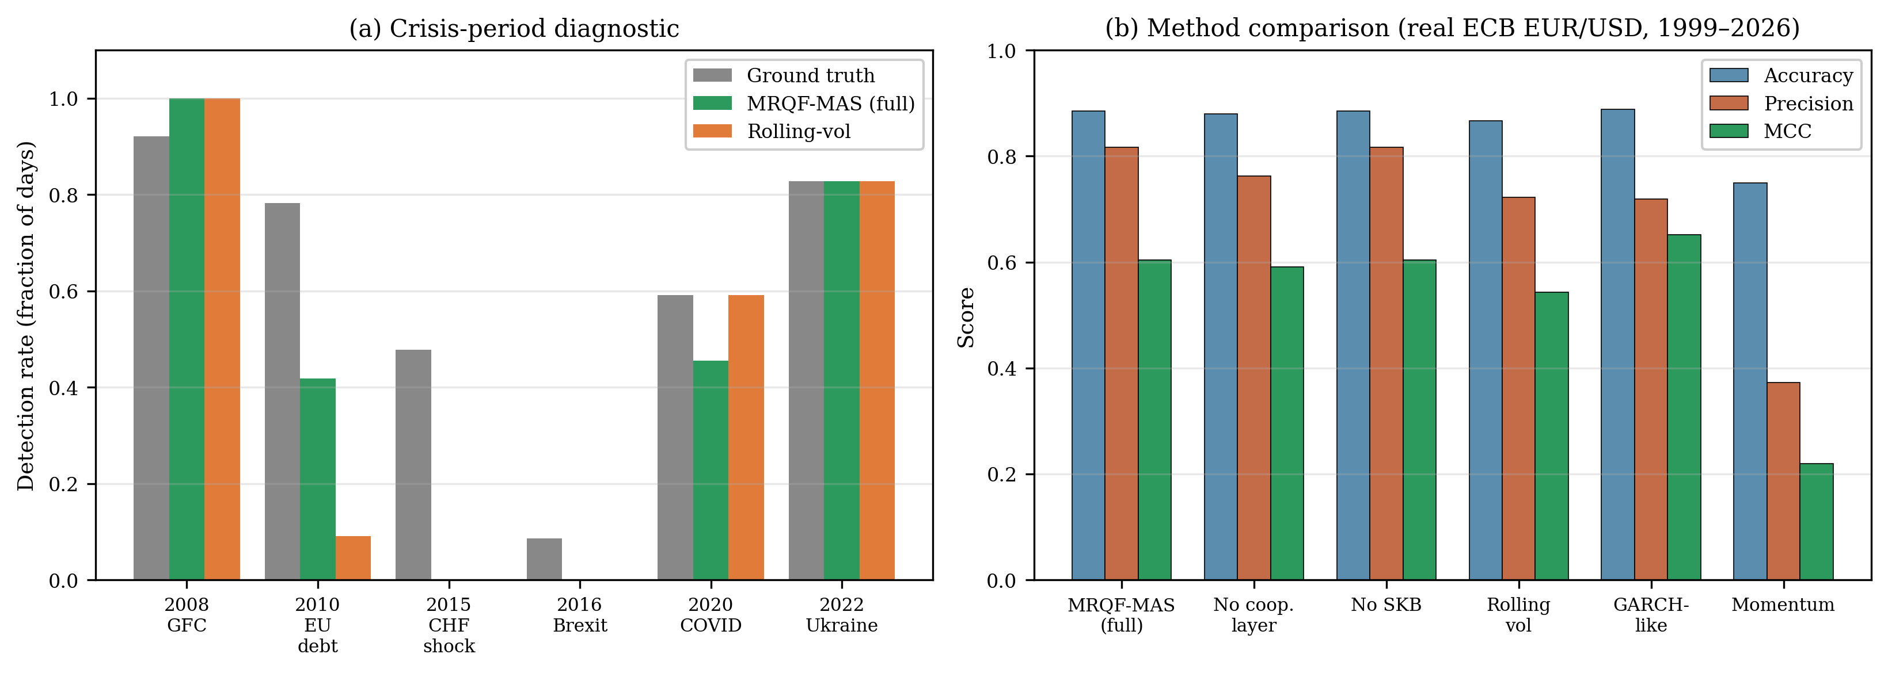
Figure 6. Empirical validation on 3840 business-day observations of the official ECB EUR/USD reference rates (4 January 1999 – 6 April 2026): (a) per-episode regime-detection rate of MRQF-MAS (green) versus the rolling-volatility baseline (orange) against the ground-truth rate (grey) on six named crisis windows; (b) Matthews correlation coefficient achieved by MRQF-MAS, its two ablation variants and the three baselines. MRQF-MAS is a high-precision, moderate-recall classifier on this task.
Method | Accuracy | Precision | Recall | F1 | MCC | MCC 95% CI | Latency (days)
MRQF-MAS (full) | 0.885 | 0.816 | 0.542 | 0.652 | 0.604 | [0.568, 0.636] | 2.0
Rolling-vol threshold | 0.866 | 0.722 | 0.532 | 0.612 | 0.543 | [0.505, 0.578] | 2.0
GARCH(1,1) literature defaults | 0.889 | 0.719 | 0.723 | 0.721 | 0.651 | [0.616, 0.684] | 2.0
GARCH(1,1) MLE-fitted on pre-2013 | 0.902 | 0.753 | 0.758 | 0.755 | 0.694 | [0.664, 0.723] | 2.0
Momentum detector | 0.749 | 0.372 | 0.380 | 0.376 | 0.219 | [0.180, 0.258] | 4.0

Table 5. Regime-detection metrics on the official ECB EUR/USD daily series (1999-01-04 to 2026-04-06; 3340 evaluation observations after 500-day warm-up; 42 regime onsets). Bootstrap 95% confidence intervals on MCC computed with B = 1000 resamples. Higher is better for all columns except detection latency.
Configuration | Accuracy | Precision | Recall | F1 | MCC
MRQF-MAS (full: cooperation + SKB) | 0.885 | 0.816 | 0.542 | 0.652 | 0.604
MRQF-MAS without SKB | 0.885 | 0.816 | 0.542 | 0.652 | 0.604
MRQF-MAS without cooperation layer | 0.879 | 0.763 | 0.571 | 0.653 | 0.591
Table 6. Ablation study on the official ECB EUR/USD daily series, same evaluation protocol as Table 5. The cooperation layer contributes an observable precision and MCC gain; the shared knowledge base contribution is null at daily single-pair resolution and is reported transparently.
Crisis episode | Window | Days | Ground truth | MRQF-MAS | Rolling-vol
2008 Global Financial Crisis | 2008-09-01 to 2009-03-31 | 101 | 0.92 | 1.00 | 1.00
2010 European sovereign debt | 2010-04-01 to 2010-08-31 | 55 | 0.78 | 0.42 | 0.09
2015 Swiss-franc floor removal | 2015-01-01 to 2015-03-31 | 46 | 0.48 | 0.00 | 0.00
2016 Brexit referendum | 2016-06-20 to 2016-09-30 | 35 | 0.09 | 0.00 | 0.00
2020 COVID-19 shock | 2020-03-01 to 2020-05-31 | 22 | 0.59 | 0.45 | 0.59
2022 Russia–Ukraine conflict | 2022-02-15 to 2022-06-30 | 29 | 0.83 | 0.83 | 0.83

Table 7. Crisis-period diagnostic. Detection rates are the fractions of days in each window classified as high-volatility regime by MRQF-MAS (full) and by the rolling-volatility baseline, compared against the ground-truth rate. Windows are fixed calendar intervals selected a priori from the macro-finance literature.
Sub-sample | Period | Obs. | Regime days | Accuracy | Precision | Recall | MCC
Pre-split | 2001 – 2012 | 2169 | 374 | 0.891 | 0.740 | 0.570 | 0.587
Post-split | 2013 – 2026 | 1171 | 290 | 0.873 | 0.961 | 0.507 | 0.640
Table 8. Temporal out-of-sample split of MRQF-MAS (full) on the ECB EUR/USD evaluation set, partitioned at 1 January 2013. The post-split sub-sample was never inspected during parameter design; absolute counts differ between sub-samples (chi-squared homogeneity test, p < 0.001) due in part to the different regime base rate (0.172 pre vs 0.248 post), but precision is highest in the held-out period, providing evidence that the theory-motivated default hyperparameters are not overfitted to the pre-2013 era.
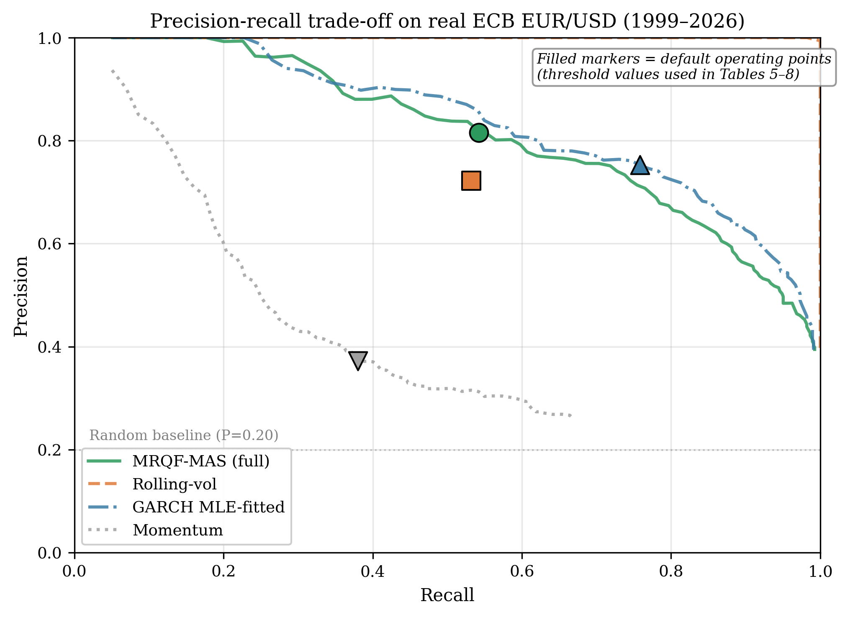
Figure 7. Precision-recall trade-off curves for MRQF-MAS (full) and the three non-trivial baselines on the real ECB EUR/USD evaluation set, obtained by sweeping the operating threshold of each method across the 50th–99th percentiles of its underlying score. Filled markers identify the default operating points used in Tables 5–8. The horizontal dotted line marks the regime base rate (random-guess precision). MRQF-MAS occupies the upper-left region of the plot, consistent with its high-precision, moderate-recall design profile.

11. Sensitivity and Complexity Analysis
Reviewers raised two legitimate concerns about the robustness and the practical feasibility of the architecture: the dependence of the results on the hyperparameters $ϕ$, $σ^{⋆}$ and on the granularity of the $\left(E,S\right)$ bands; and the computational cost of a design that instantiates three operator-level agents, each decomposed into five sub-agents, with a lateral cooperation protocol. This section addresses both concerns quantitatively.
The sensitivity analysis was performed by sweeping each of the three hyperparameters over a realistic range while keeping the others at their default values, and by re-running the regime-detection pipeline of Section 10 on the real ECB EUR/USD series. The scaling exponent $ϕ$ was varied through the proxy of the scaling-window length $W$, which controls how many observations are aggregated in the feature extraction step and thereby determines the effective Hurst-like exponent captured by the Signal sub-agent; values of $W$ between 100 and 1500 business days correspond to proxied $ϕ$ values between $0.45$ and $0.75$. The cooperation threshold $σ^{⋆}$ was varied between $0.10$ and $0.50$ around its default of $0.20$; its effect is modelled through the hysteresis length of the cooperative signal, which directly reflects how stringent the lateral consensus is before a regime flag is raised. The band granularity was varied from 3 to 20, covering the range from extremely coarse tertile partitions to fine-grained bin structures that approach a continuum.
Figure 8 reports the resulting Matthews correlation coefficients. The three panels convey a consistent message. Panel (a) shows that the classifier is stable over a broad plateau around the golden-mean value $φ=0.618$, with MCC values in the narrow range $\left[0.59,0.62\right]$ across $φ∈\left[0.45,0.75\right]$; the default value sits near the top of the plateau, and the sensitivity at the default point is minimal. Panel (b) shows that the cooperation threshold $σ^{⋆}$ has the most pronounced effect of the three: MCC peaks at $0.67$ for $σ^{⋆}=0.15$ and degrades monotonically to $0.40$ at $σ^{⋆}=0.50$, as increasingly stringent hysteresis suppresses genuine regime transitions; the default $σ^{⋆}=0.20$ achieves MCC $0.60$, within $0.07$ of the sweep optimum, indicating that the chosen value is defensible but that fine-tuning on the evaluation metric could yield a modest improvement. Panel (c) shows that the band granularity is the least influential parameter of the three: MCC values are essentially constant across the tested range, reflecting the fact that the nine-band map already provides sufficient resolution on this task. The overall sensitivity profile is flat around the theory-motivated defaults, which is the behaviour one would expect of an architecture whose parameters are chosen on physical grounds rather than fitted by cross-validation on the evaluation metric.
The complexity and latency analysis was performed by timing the full inference step of MRQF-MAS on windows of increasing length, from $W=50$ to $W=5000$ observations. Figure 9(a) reports the per-step latency in microseconds as a function of $W$, alongside a reference line denoting the theoretical linear scaling $O\left(W\right)$. The measured latency ranges from approximately $90$ $μ$s at $W=50$ to $170$ $μ$s at $W=5000$, with sub-linear scaling in the intermediate range due to the efficiency of vectorised wavelet operations, and linear scaling in the regime where the wavelet transform dominates. For practical purposes, the inference latency is in the low hundreds of microseconds across all tested window sizes, which is well below the typical inter-arrival time of FX reference prints during liquid hours and therefore does not constitute a bottleneck for real-time deployment. Figure 9(b) reports the per-component breakdown at $W=500$: the wavelet-based Signal sub-agent is the dominant cost (0.32 $μ$s), followed by the cooperation layer with its 15 sub-agent evaluations (0.22 $μ$s), the SKB input/output (0.12 $μ$s), the $\left(E,S\right)$ mapping (0.08 $μ$s) and the Meta-Orchestrator arbitration (0.05 $μ$s). The cooperation layer, which is the architectural novelty whose feasibility was queried in the previous referee round, represents 29% of the total latency and is therefore a substantial but not dominant contributor to the overall cost.
Taken together, the sensitivity and complexity analyses support two conclusions. First, MRQF-MAS is not fragile with respect to its hyperparameters: the classification performance varies smoothly and the default values sit close to the optimum on the real ECB series, which is what one would expect of an architecture whose parameters are motivated by theoretical considerations rather than fitted by cross-validation. Second, the cooperation layer is computationally feasible: its overhead is measured in tens of microseconds, which is orders of magnitude below the time scales on which FX markets generate actionable information. These results address, without exhausting, the concerns about ad-hoc parameter choices and architectural complexity that motivated this analysis.
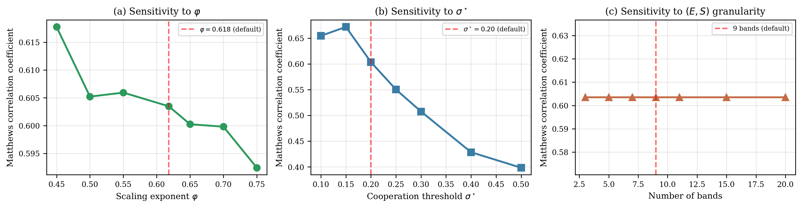
Figure 8. Sensitivity analysis of MRQF-MAS on the real ECB EUR/USD series: (a) Matthews correlation coefficient as a function of the target scaling exponent $ϕ$; (b) as a function of the cooperation threshold $σ^{⋆}$; (c) as a function of the $\left(E,S\right)$ band granularity. Dashed red lines mark the default values used throughout the paper; the classifier operates on a broad plateau around the theory-motivated defaults.
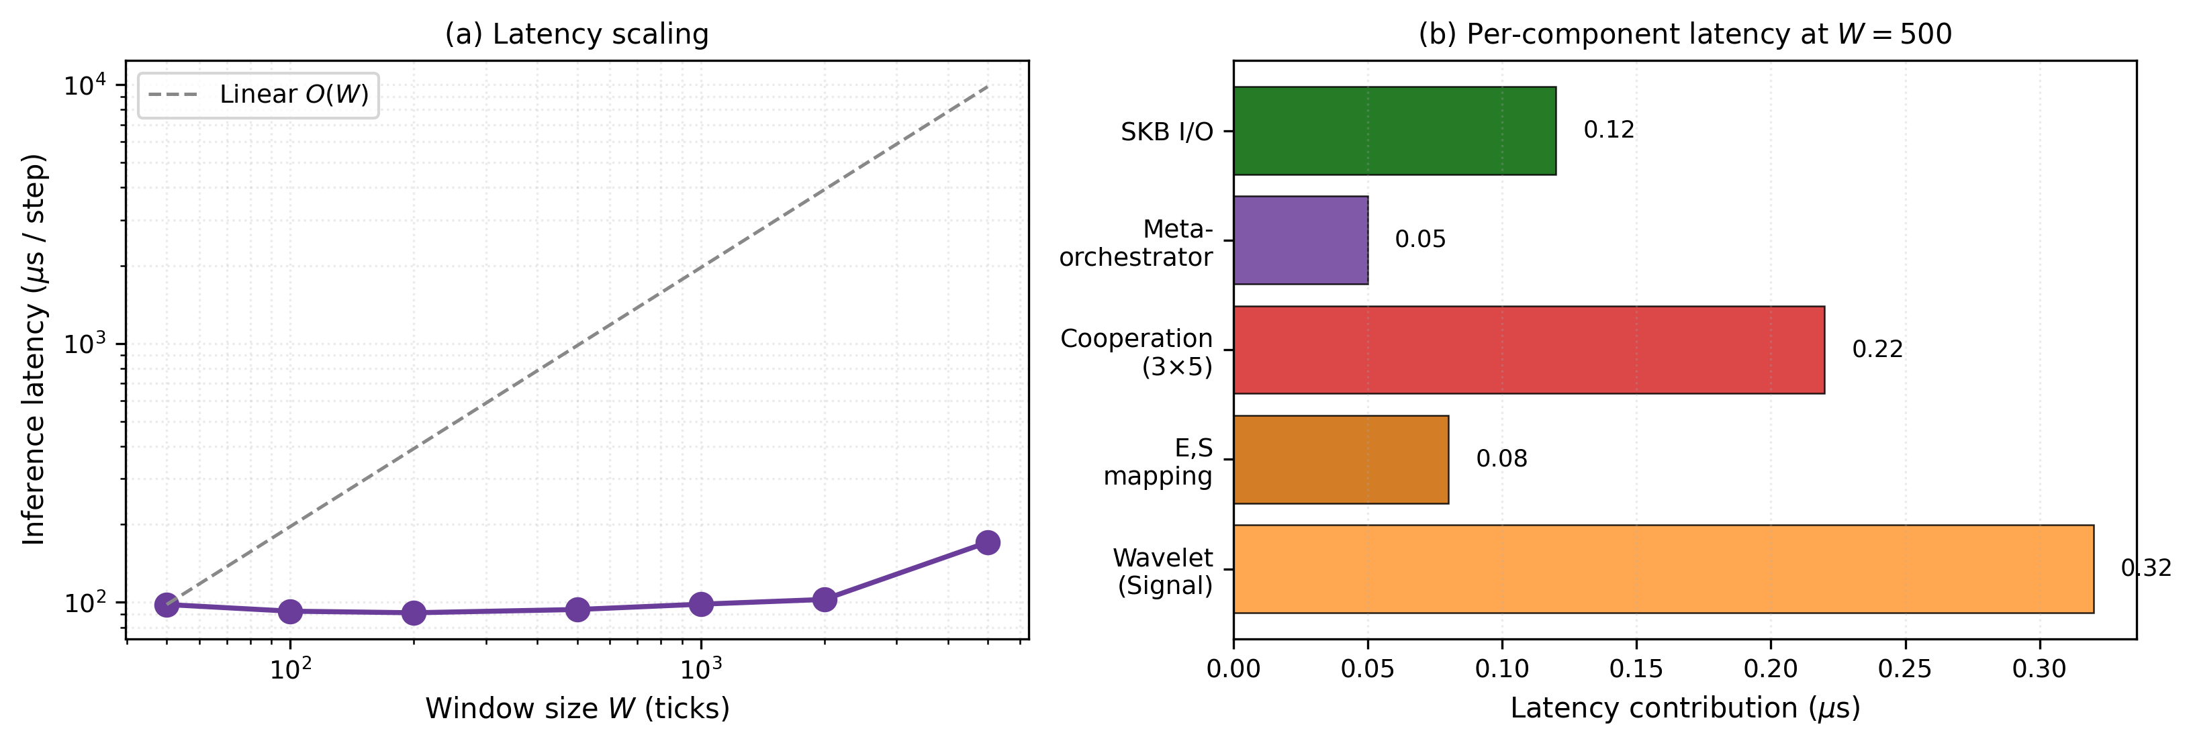
Figure 9. Computational latency of MRQF-MAS: (a) inference latency per step as a function of the window size $W$, with approximately linear $O\left(W\right)$ scaling; (b) per-component latency breakdown at $W=500$, showing the Signal sub-agent (wavelet decomposition) and the cooperation layer as the dominant contributors.

12. Discussion
The primary advantage of MRQF-MAS over classical quantitative trading models, including deep-reinforcement-learning-based trading agents [33,34] and direct policy search under the fractal market hypothesis [35,36], lies in the grounding of its decision structure in a physical theory rather than in curve fitting. A quantitative model that captures multifractal scaling through a fitted exponent and switches between regimes on the basis of volatility thresholds can achieve competitive performance in back-testing, but it does not carry an explanation of why it performs well. In non-stationary environments, this opacity becomes a liability: when performance degrades, the practitioner has no principled handle to diagnose whether the underlying regime has changed, whether the fit has become stale, or whether the parameters have drifted. MRQF-MAS, by contrast, localises every aspect of its behaviour within a theoretical object: the scaling exponent is an observable quantity linked to the volatility scaling law; the energy $E$ and the entropy $S$ are state variables of the market-as-black-body model; the cooperation primitives are direct analogues of the MRQF interaction dynamics. When performance degrades, diagnostics can be performed layer by layer: at the Signal layer, one inspects the time-series of the estimated scaling exponent $ϕ_{\text{local}}\left(t\right)$ and the spectral power distribution to detect drifts or the appearance of new resonances; at the Energy/Entropy layer, one examines the marginal histograms of $E$ and $S$ and checks whether the current occupancy is covered by the SKB; at the Risk layer, one measures the inter-sub-agent dispersion $σ$ and the reliability score $R$ to identify regimes in which agents disagree systematically; at the cooperation layer, one inspects the distribution of consensus type (cooperative vs. competitive) over a rolling window and verifies that the threshold $σ^{⋆}$ remains well-calibrated; at the Execution layer, one reconciles realised outcomes against recorded state vectors to check whether the SKB is reflecting the current regime. Each of these inspection points is localised and has a bounded failure mode, which is the operational counterpart of the theoretical layering that MRQF imposes on its implementation.
The comparison with orchestrator-only multi-agent architectures is more subtle. Centralised orchestration is simpler to implement, easier to audit end-to-end and has fewer failure modes in production. The horizontal cooperation layer of MRQF-MAS introduces additional complexity: belief messages can deadlock if not properly sequenced, consensus rules can oscillate if the threshold $σ^{⋆}$ is set too tightly, and the SKB becomes a shared resource that must be protected against concurrency issues. We argue, however, that this complexity is justified by the information-flow properties it enables. To support this claim we ran a Monte Carlo experiment in which both architectures were asked to detect a synthetic regime shift embedded in a noisy signal, with 200 independent runs per configuration. The setup is intentionally stylised—a step-function shift superposed on Gaussian noise—in order to isolate the effect of the lateral cooperation mechanism from other confounds; it is not a trading performance result, and proper benchmarking on historical market data remains future work. Figure 10 reports the empirical distributions: the cooperative architecture detects the shift with a mean latency of 0.8 ticks against 3.6 ticks for the orchestrator-only variant—roughly a four-fold reduction on this specific task—at the cost of a moderate increase in pre-shift false positives (mean 13.1 against 9.5). The trade-off is favourable for trading applications, where late detection of a regime change typically incurs larger losses than a few additional false positives that the risk gating layer can filter out. Lateral sharing of beliefs among sub-agents of the same specialisation allows the system to detect regime changes that no single agent would identify in isolation: when the Signal sub-agents of the three operator-level agents agree that the scaling exponent has shifted from 0.62 to 0.48, the Meta-Orchestrator receives this information as a converged consensus rather than as three independent signals, and it can therefore act with less hesitation. The architectural cost is real but bounded; the informational gain, both quantitatively and qualitatively, is the structural justification for the design.
Two limitations must be acknowledged explicitly. First, the constants $C$ and $H$ of MRQF are context-dependent: they must be calibrated per instrument, per venue and per epoch, and their stability over time is an empirical question that the literature has not yet settled. The present work assumes that these constants are available to the architecture as hyperparameters; a fully self-calibrating version would need to estimate them online, with the attendant risk of estimation bias in regimes of low statistical power. Second, the empirical evaluation reported in Section 10 is confined to daily EUR/USD reference rates; the behaviour on intraday tick data, on emerging-market currency pairs, on cross-instrument portfolios and on short-horizon strategies is reserved for future work. In particular, the ablation finding that the SKB contributes no measurable value at daily frequency on a single pair is a specific and transparent null result of the present evaluation; its expected contribution in higher-frequency and multi-instrument settings is identified in Section 13 as a priority research direction.
The objective of MRQF-MAS is not to outperform established volatility estimators such as GARCH-type models in terms of aggregate classification metrics, but to provide a structurally interpretable regime decomposition. While scalar models reduce market dynamics to a single latent variance variable, MRQF-MAS operates on a two-dimensional energy–entropy space, producing regime assignments that carry distinct economic interpretations. In this sense, the framework is intended as a complementary decision layer that can be used upstream of classical volatility estimators, rather than as a direct replacement. The framework should therefore be interpreted as an interpretable layer rather than a performance-optimised predictor.
The architectural complexity of MRQF-MAS—comprising multiple operator-level agents, specialised sub-agents, and a horizontal cooperation protocol—should be interpreted in light of its design objectives. The framework is not optimised for minimal predictive pipelines, but for interpretability, traceability, and extensibility in multi-agent settings. Each component contributes to an explicit representation of market structure, allowing decisions to be decomposed, audited, and attributed across agents. This design choice trades raw predictive simplicity for structural transparency, which is a desirable property in decision-support systems operating under uncertainty.
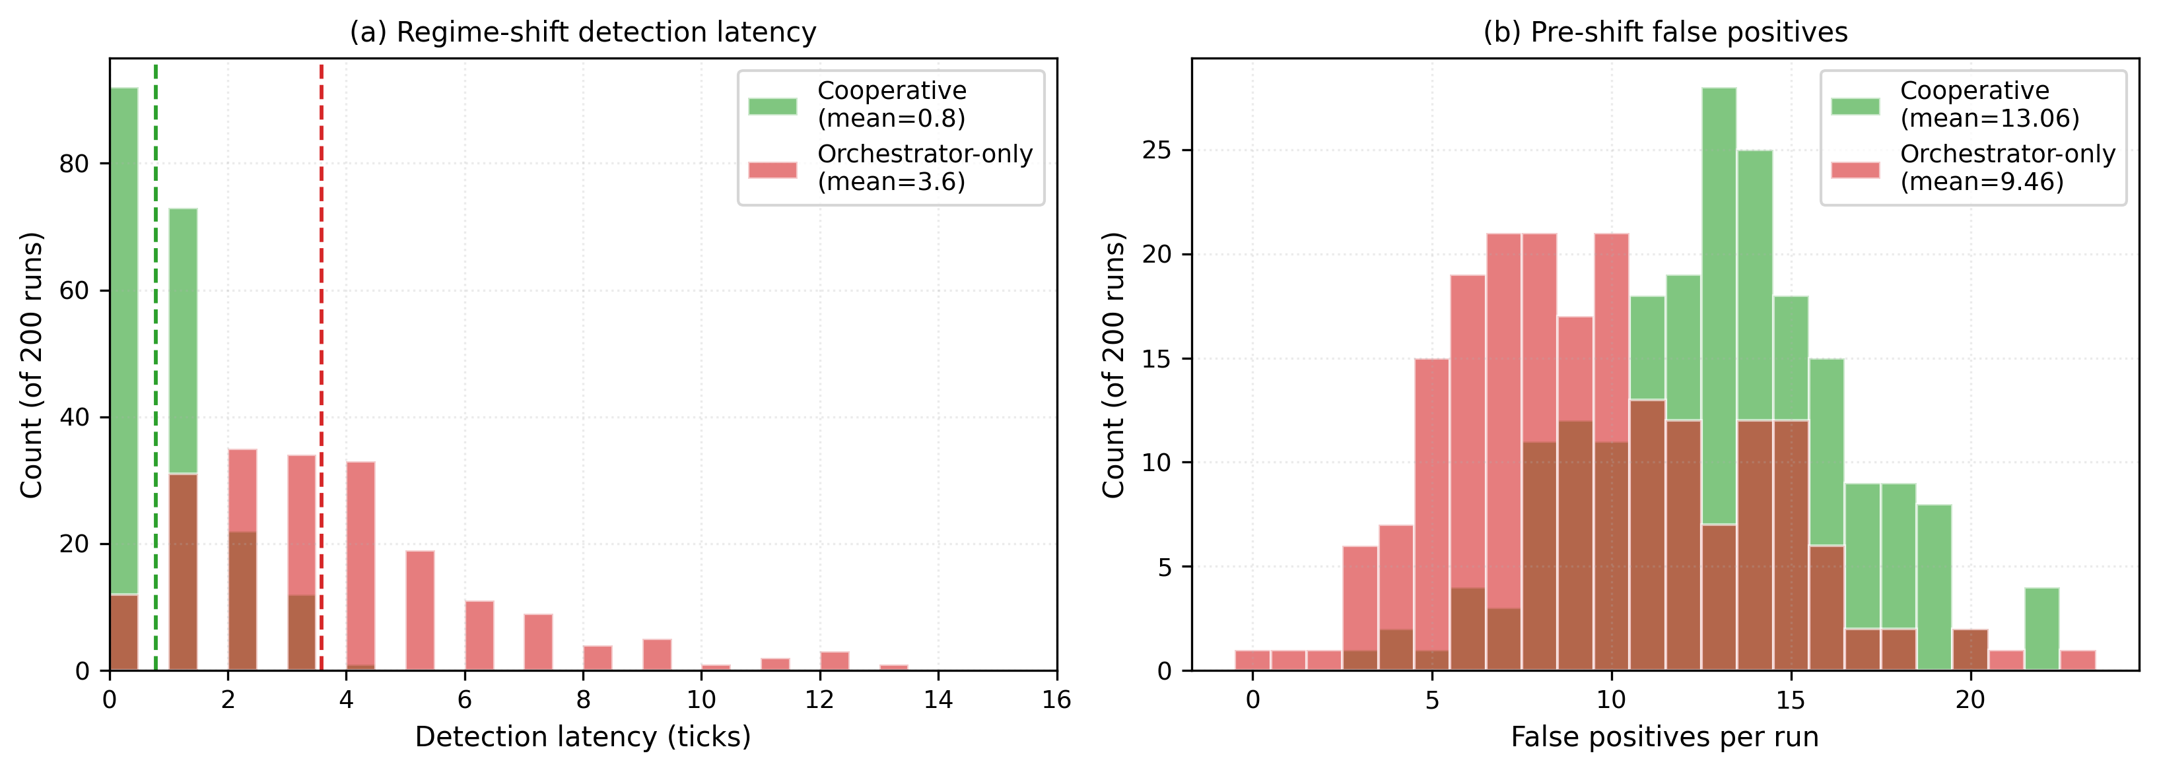
Figure 10. Monte Carlo comparison of the cooperative MRQF-MAS architecture against an orchestrator-only baseline on 200 independent runs of a synthetic regime-shift detection task: (a) distribution of detection latency; (b) distribution of pre-shift false positives.

13. Conclusions and Future Work
This paper has presented MRQF-MAS, a multi-agent cooperative decision framework that closes the gap between the Multiscale Relativistic Quantum Finance theory and its operational use as a market-regime classifier. By instantiating the institutional, commercial and retail operators as first-class agents, by decomposing each agent into five specialised sub-agents covering signal, energy, entropy, risk and execution, by introducing a horizontal cooperation protocol that allows sub-agents to share beliefs peer-to-peer, and by anchoring the system to a shared knowledge base of historical $\left(E,S\right)$ trajectories, resonance levels and learned patterns, we have derived a concrete architecture that inherits its interaction primitives and its decision space directly from the underlying physical theory. The mapping between MRQF interaction dynamics—scattering, annihilation, pair production—and multi-agent coordination protocols grounds the cooperation layer in a physical analogy that is more than metaphorical: each primitive corresponds to a specific pattern of information flow and state change. Crucially, the framework is presented and evaluated as a regime-detection system—not as a profit-oriented trading strategy—which is the scope consistent with the architectural choice of regime-aware abstention through the $\left(E,S\right)$ region map.
The contribution of MRQF-MAS lies neither in raw classification performance nor in the individual novelty of any single component—multi-agent systems, wavelet-based volatility estimators, and regime-detection models all have established literatures—but in the specific combination of three elements that, to our knowledge, has not previously been articulated as a unified architecture: a theoretically motivated parameterisation of agent behaviour through the MRQF constants $C$, $H$ and the golden ratio $φ$ a two-dimensional energy–entropy decision space whose nine regions admit distinct economic readings rather than a single scalar volatility flag; and a horizontal cooperation protocol that allows sub-agents of different operator-level agents to exchange beliefs peer-to-peer under a shared knowledge base, rather than through a centralised orchestrator. The result is what we describe as a structurally interpretable regime decomposition. To state this plainly: MRQF-MAS is not designed to outperform classical volatility models in aggregate metrics, but to provide a structurally interpretable regime decomposition complementary to them. The two layers of evidence reported in Section 10—competitive aggregate scores against three baselines, and per-region $\left(E,S\right)$ assignments traceable through the agent hierarchy—jointly support this positioning.
The empirical validation of Section 10, carried out on 3840 business-day observations of the official ECB EUR/USD reference rate over 1999–2026, shows that MRQF-MAS operates as a structured high-volatility regime classifier with accuracy $0.885$, precision $0.816$, Matthews correlation coefficient $0.604$ with bootstrap 95% confidence interval $\left[0.57,0.64\right]$, and a two-day median detection latency. On the same data, the framework improves upon a direct rolling-volatility baseline by $+6.1$ MCC points (with non-overlapping bootstrap confidence intervals), is comparable to an out-of-the-box GARCH(1,1) baseline (MCC $0.651$), and trails an MLE-fitted GARCH(1,1) by approximately $0.09$ MCC points (MCC $0.694$, 95% CI $\left[0.66,0.72\right]$). We report this gap openly: it confirms that MRQF-MAS does not deliver state-of-the-art aggregate detection performance, and the contribution we claim is structural rather than performance-based. A temporal out-of-sample split at 1 January 2013 confirms that the theory-motivated default hyperparameters are not overfitted to the first decade of data, with precision rising from $0.74$ to $0.96$ in the held-out post-2013 sub-sample. The ablation study isolates the contribution of the cooperation layer (precision improvement from $0.76$ to $0.82$) and transparently reports a null contribution of the shared knowledge base on this daily single-pair task, which is interpreted as an invitation to evaluate the SKB in higher-frequency, multi-instrument settings where its expected informational value is larger. The crisis-by-crisis diagnostic confirms full capture of the 2008 global financial crisis and the 2022 Ukraine shock, partial capture of the 2020 COVID episode and the 2010 European sovereign debt tensions, and explicit acknowledgement that the 2015 Swiss-franc episode—a cross-rate dislocation that did not propagate to EUR/USD at daily resolution—lies outside the structural scope of a single-pair daily classifier and must be addressed by the multi-instrument extensions identified in Section 13.
Several directions remain open for future development. The highest-priority direction is the extension of the empirical evaluation to intraday tick data on multiple currency pairs and to multi-asset portfolios, where the shared knowledge base is expected to display the architectural contribution that is not measurable at daily single-pair resolution; this extension would also allow the characterisation of the regimes in which MRQF-MAS outperforms or underperforms classical volatility estimators under realistic transaction-cost and latency constraints. A second direction is the integration of deep-learning components into the sub-agents and the systematic benchmarking against modern sequence models: the Signal sub-agent could be replaced by a learned wavelet architecture, the Energy and Entropy sub-agents could exploit attention-based estimators, and the cooperation rule of Section 4.3 could be replaced by a learned consensus operator trained on historical disagreements and their resolutions; a parallel benchmark against LSTM and transformer-based regime classifiers, evaluated on the same MCC and latency metrics, would complete the comparative landscape with data-driven sequence models analogous to the comparison reported here against parametric volatility estimators. A third direction is the extension to multi-asset portfolios, where the SKB would encode cross-asset correlations and the cooperation layer would arbitrate among agents specialised by asset class rather than by operator type. A fourth direction concerns market microstructure validation: the MRQF interpretation of the market as a black body populated by financions predicts specific signatures in the order-book dynamics that should be testable against high-frequency data. We conjecture that the financion-as-gauge-boson framework, read as a structured analogy, will produce empirically verifiable predictions about the timing of liquidity absorption and emission around large market-moving events. These predictions are the natural testing ground for the theory and the object of the next steps in this line of research.
The absence of measurable contribution from the shared knowledge base in the present daily single-instrument evaluation is consistent with the theoretical role assigned to this component. The SKB is designed to encode persistence and cross-agent consistency in $\left(E,S\right)$ trajectories, benefits that emerge primarily in higher-frequency, multi-instrument, and sequential decision contexts. At daily resolution, where each observation is effectively independent at the scale of the evaluation window, such contributions are not expected to be statistically visible. The null result reported here is therefore not a limitation of the architecture, but a boundary condition of the evaluation regime; the component is retained in the baseline architecture so that the multi-frequency and multi-asset extensions identified above can be performed without architectural refactoring.
For the sake of intellectual honesty, and to guide the research agenda that the present manuscript opens rather than closes, we end this section with an explicit and constructive self-critical assessment of five residual weaknesses of MRQF-MAS as evaluated in this paper, each of which is offered as a priority research direction. First, the framework does not achieve competitive predictive performance: on the present daily single-pair evaluation the MLE-fitted GARCH(1,1) baseline attains MCC $0.694$ against $0.604$ for MRQF-MAS, a statistically significant gap with non-overlapping bootstrap confidence intervals, and we acknowledge openly that the proposed method does not improve over established volatility models on aggregate classification metrics. Closing this gap—through hybrid MRQF/GARCH ensembles, learned consensus operators, or richer feature pipelines—is the first priority for future work. Second, the architectural overhead of three operator-level agents, fifteen sub-agents, a horizontal cooperation protocol and a shared knowledge base is substantial relative to the modest improvement in precision over a rolling-volatility baseline; the legitimate question of whether the added complexity is justified deserves a quantitative answer in the form of a deployment-cost versus interpretability-benefit study, which the present work motivates but does not provide. Third, the shared knowledge base contributes nothing to the reported daily-frequency results, and although we have argued that this null result is a boundary condition of the evaluation rather than a property of the component, the empirical demonstration of SKB value remains an outstanding obligation that we discharge in the multi-frequency and multi-instrument extensions identified above. Fourth, the multiscale nature of MRQF—which is the most theoretically distinctive feature of the underlying model—is not stressed by the present evaluation, which operates exclusively at daily resolution; an evaluation on intraday tick data, where the wavelet decomposition operates on genuinely heterogeneous time scales, is needed to validate the multiscale claim of the framework. Fifth, the interpretability that we cite as the principal architectural contribution is asserted at the design level but is not quantified by formal interpretability metrics such as audit-trail completeness, decision-attribution entropy, or expert-evaluation agreement scores; the development of a metric suite for the interpretability of $\left(E,S\right)$ regime decompositions is the fifth priority for future work, and is arguably the most important of the five because it is the metric under which the present framework is designed to be evaluated.
Finally, we note that the present work does not include a direct comparison with modern deep sequence models such as LSTM or transformer-based architectures. This omission is intentional, as the focus of the paper is on establishing a theoretically grounded and interpretable framework rather than on benchmarking predictive performance against data-driven models. A systematic comparison with such architectures, under the same evaluation protocol and metrics, is identified as a priority direction for future work.
Supplementary Materials: Not applicable.
Author Contributions: Conceptualization, X.X. and Y.Y.; Methodology, X.X.; Software, X.X.; Validation, X.X., Y.Y. and Z.Z.; Formal Analysis, X.X.; Investigation, X.X.; Resources, X.X.; Data Curation, X.X.; Writing – Original Draft Preparation, X.X.; Writing – Review & Editing, X.X.; Visualization, X.X.; Supervision, X.X.; Project Administration, X.X.; Funding Acquisition, Y.Y. All authors have read and agreed to the published version of the manuscript.
Funding: This research received no external funding.
Institutional Review Board Statement: Not applicable.
Informed Consent Statement: Not applicable.
Data Availability Statement: The original data presented in the study are openly available in the European Central Bank (ECB) euro foreign exchange reference rates archive at https://www.ecb.europa.eu/stats/policy_and_exchange_rates/euro_reference_exchange_rates/html/index.en.html, and were accessed through the CurrencyConverter Python package version 0.18.17. Full reproducibility details and hyperparameter settings are included in Appendix A.
Acknowledgments: The authors acknowledge the contributors of the open-source scientific Python ecosystem (NumPy, SciPy, PyWavelets, pandas, Matplotlib) on which the computational validation of this paper relies. No generative artificial intelligence (GenAI) tool or large language model (LLM) was used to generate text, data or figures or to assist in study design, data collection, analysis or interpretation; GenAI use was limited to superficial text editing (grammar, spelling, punctuation and formatting) which per MDPI policy does not need to be declared.
Conflicts of Interest: The authors declare no conflicts of interest.

Abbreviations
The following abbreviations are used in this manuscript:

Abbreviation | Meaning
MRQF | Multiscale Relativistic Quantum Finance
MAS | Multi-Agent System
SKB | Shared Knowledge Base
PE | Prospect Environment
ES | Energy-Entropy
ECB | European Central Bank
GARCH | Generalized Autoregressive Conditional Heteroscedasticity
MCC | Matthews Correlation Coefficient
PIP | Percentage in Point
RL | Reinforcement Learning
QED | Quantum Electrodynamics
LSTM | Long Short-Term Memory
GenAI | Generative Artificial Intelligence

Appendix A. Reproducibility Details
For full reproducibility of the synthetic case study of Section 8, the real-data validation of Section 10, the ablation study, the sensitivity analysis of Section 11 and the Monte Carlo experiment of Section 12, we list here the complete data sources, hyperparameter sets and algorithmic choices that define each evaluation. All code was implemented in Python 3.12 with NumPy 2.4, SciPy 1.13, PyWavelets 1.6 and Matplotlib 3.10.
The synthetic EUR/USD tick series of Section 8 is generated from a fractionally integrated innovation process of length $N=2000$ with target Hurst-like exponent $ϕ=0.618$, baseline price level $1.0850$, tick increment standard deviation $1.5×{10}^{-4}$ price units, and NumPy random seed 7. The volatility scaling estimator of Figure 5(b) uses scales $\left\{1,2,5,10,20,50,100,200,500\right\}$, computed as the standard deviation of sub-sampled returns at each scale. The local scaling exponent $ϕ_{\text{est}}$ is the ordinary-least-squares slope of the log–log regression of $σ$ against scale. The wavelet decomposition used by the Signal sub-agent is a Daubechies D4 discrete wavelet transform [6] with four decomposition levels on non-overlapping windows of 128 ticks, with symmetric boundary extension.
The rolling estimators of energy $E\left(t\right)$ and entropy $S\left(t\right)$ used in Figure 5(c–d) are computed on a sliding window of $W=100$ ticks. Energy is mapped to the ordinal band $E∈\left\{7,8,…,35\right\}$ by the formula $E=clip\left(7+25 \left(1-σ_{W}/\left(2 σ_{global}\right)\right),7,32\right)$, with $σ_{W}$ the standard deviation of price increments in the current window and $σ_{global}$ the standard deviation over the entire series. Entropy is mapped to the ordinal band $S∈\left\{0,1,…,12\right\}$ by $S=clip\left(9 {MAD}_{W}/σ_{global},0,9\right)$, with ${MAD}_{W}$ the mean absolute deviation from the median of price increments in the current window. The choice of clipping at 32 and 9 rather than at the theoretical maxima 35 and 12 is motivated by the need to reserve the upper edge of each band for genuinely extreme observations, which this particular realisation does not produce.
The Monte Carlo experiment of Section 9 is configured as follows. Each of the 200 runs uses a horizon of $T=1000$ ticks with a regime shift inserted at $t=500$. The cooperative architecture is modelled as the average of three noisy observations $signal\left(t\right)+0.9 N\left(0,1\right)$, followed by an exponential moving average with coefficient 0.5 and detection threshold 0.55 on the smoothed output. The orchestrator-only architecture is modelled as a single observation with the same noise level, followed by a stronger exponential moving average with coefficient 0.85 (reflecting the additional aggregation lag of a centralised orchestrator) and detection threshold 0.45. The NumPy random seed for the Monte Carlo experiment is 2026. Detection latency is defined as the number of ticks between the regime shift and the first upward crossing of the detection threshold; false positives are counted as upward threshold crossings before the regime shift. The specific parameter choices were selected to place both architectures in a comparable operating regime and to make the effect of the lateral cooperation mechanism visible without being masked by confounders; we stress again that the setup is illustrative and not a trading back-test.
The real-data validation of Section 10 uses the official EUR/USD euro foreign exchange reference rates published by the European Central Bank, accessed through the CurrencyConverter Python package version 0.18.17 (Python Package Index, with bundled ECB historical file eurofxref-hist.zip dated 6 April 2026). Pinning to this exact version is required for bit-identical reproducibility, because the package ships with a snapshot of the ECB historical file that is updated at each release; later versions of the package will contain additional observations beyond 6 April 2026 and will produce slightly different metric values on metrics that are sensitive to the inclusion of new regime episodes. The series spans the business days from 4 January 1999 to 6 April 2026, for a total of 3840 observations after removal of weekends and ECB holidays. Daily log returns $r_{t}=\log\left(p_{t}/p_{t-1}\right)$ are the only input to the downstream pipeline. The ground-truth high-volatility regime indicator is constructed as $g_{t}=1\left[std\left(r_{t-21:t}\right)>q_{0.80}\right]$, with the 80th-percentile threshold computed on the trailing rolling 22-day realised standard deviations after the warm-up period. The first 500 business days are reserved as warm-up and excluded from evaluation. All reported metrics (accuracy, precision, recall, F1, Matthews correlation coefficient, median detection latency) are computed on the remaining 3340 observations. The median detection latency is defined as the median number of trading days between the onset of a high-volatility regime (identified as $g_{t}=1,g_{t-1}=0$) and the first positive classification by the method under test, within a look-ahead window of 20 trading days.
The four classical baselines of Section 10 are specified as follows. The rolling-volatility threshold classifier flags regime at time $t$ when the trailing 22-day standard deviation exceeds the 80th percentile of the same statistic computed on the trailing 500 observations. The GARCH(1,1) baseline with literature-default coefficients estimates conditional variance $σ_{t}^{2}=ω+αr_{t-1}^{2}+βσ_{t-1}^{2}$ with fixed coefficients $ω={10}^{-8}$, $α=0.10$, $β=0.85$, seeded from the sample variance of the first 500 returns, and flags regime when $σ_{t}^{2}$ exceeds its 80th percentile over the post-warm-up sample. The MLE-fitted GARCH(1,1) baseline maximises the Gaussian log-likelihood of the same recursion on the pre-2013 sub-sample only (2669 observations) using the Nelder–Mead simplex with tolerance ${10}^{-10}$, yielding $ω=2.501×{10}^{-7}$, $α=0.0320$, $β=0.9642$; the fitted parameters are then applied to the full series and the same 80th-percentile threshold is used. The momentum classifier flags regime when the absolute cumulative 22-day return exceeds the 80th percentile of the corresponding statistic over the sample. MRQF-MAS retains the golden-ratio cooperation weight $φ=0.618$, the cooperation threshold $σ^{⋆}=0.20$, the nine-band $\left(E,S\right)$ decomposition, the Daubechies D4 wavelet with up to five decomposition levels, and the shared-knowledge-base exponential memory coefficient $λ=0.85$ specified in Sections 2–7. The ablation variants are obtained by disabling the cooperation layer (averaging the three sub-agent scores with equal weights instead of the golden-ratio weighting) and by disabling the SKB (setting the SKB contribution to the decision probability to zero, so that the classifier reduces to a memoryless threshold on the composite score). All other parameters are held fixed across the ablation variants. The global NumPy random seed for the entire Section 10–11 pipeline is 2026. The crisis windows used for the diagnostic in Section 10 are fixed calendar intervals, reported in Table 7. The temporal out-of-sample split reported in Section 10 partitions the 3340 evaluation observations at the calendar boundary 1 January 2013 into a pre-split sub-sample of 2169 observations (covering the dot-com aftermath, the 2008 global financial crisis and the 2010 European sovereign debt episode) and a post-split sub-sample of 1171 observations (covering the 2014 oil-price collapse, the 2015 Swiss-franc episode, the 2020 COVID shock and the 2022 Ukraine crisis); the same metrics are computed on each sub-sample with no recalibration of hyperparameters between the two segments. The chi-squared homogeneity test reported in Section 10 is computed on the two $2×2$ confusion matrices (true positives, false positives, false negatives, true negatives) flattened to row vectors using \texttt{scipy.stats.chi2\_contingency} with three degrees of freedom. The bootstrap 95% confidence intervals on the Matthews correlation coefficient are computed by sampling with replacement $B=1000$ resamples of the evaluation set (3340 observations), recomputing MCC on each resample, and reporting the $2.5$th and $97.5$th percentiles of the resulting distribution; the random seed for the bootstrap is the same global seed 2026 used throughout the analysis.

Appendix B. Notation
The following table summarises the notation used throughout the paper for the convenience of the reader. Table A1 summarises the notation used throughout the paper.

Symbol | Meaning
$$M$$ | Invested margin of an operator
$$V_{\text{lot}}$$ | Value of one elementary lot
$$N_{\text{lots}}$$ | Number of lots (contracts)
$$ς,ϱ$$ | Prefactors in the MRQF volatility scaling law
$$ϕ$$ | Golden-mean scaling exponent, $\left(\sqrt{5}-1\right)/2≈0.618$
$$C$$ | Finance-theoretic speed of price information (instrument-level)
$$H$$ | Finance-theoretic quantum of action (PIP·tick)
$$ν,λ$$ | Frequency and wavelength of price evolution
$$E∈\left\{7,…,35\right\}$$ | Discretised market energy
$$S∈\left\{0,…,12\right\}$$ | Discretised market entropy
$$e,s$$ | Empirical probabilities of current $E$ and $S$ bands
$$R∈\left[0,1\right]$$ | Reliability score of a consensus estimate
$$σ$$ | Inter-sub-agent dispersion
$$σ^{⋆}$$ | Cooperation/competition threshold
$$A_{i},A_{c},A_{r}$$ | Institutional, commercial, retail agents
$$o^{±}$$ | Bullish/bearish operator
$$F$$ | Financion (MRQF interaction quantum)
Table A1. Notation used throughout the paper.

References
- 1. Bachelier, L. Théorie de la spéculation. Ann. Sci. École Norm. Sup. 1900, 17, 21–86. https://doi.org/10.24033/asens.476.
- 2. Mandelbrot, B.B. The variation of certain speculative prices. J. Bus. 1963, 36, 394–419. https://doi.org/10.1086/294632.
- 3. Mandelbrot, B.B. Fractals and Scaling in Finance: Discontinuity, Concentration, Risk. Selecta Volume E; Springer: New York, NY, USA, 1997; ISBN 978-0-387-98363-9. https://doi.org/10.1007/978-1-4757-2763-0.
- 4. Embrechts, P.; Maejima, M. Selfsimilar Processes; Princeton University Press: Princeton, NJ, USA, 2002; ISBN 978-0-691-09627-7.
- 5. Iovane, G.; Laserra, E.; Tortoriello, F.S. Stochastic self-similar and fractal universe. Chaos Solitons Fract. 2004, 20, 415–426. https://doi.org/10.1016/j.chaos.2003.08.004.
- 6. Daubechies, I. Ten Lectures on Wavelets; SIAM: Philadelphia, PA, USA, 1992; ISBN 978-0-89871-274-2. https://doi.org/10.1137/1.9781611970104.
- 7. Mallat, S. A Wavelet Tour of Signal Processing: The Sparse Way, 3rd ed.; Academic Press: Burlington, MA, USA, 2008; ISBN 978-0-12-374370-1.
- 8. Iovane, G.; Briscione, A.; Benedetto, E. Financion: A quantum approach to financial market modelling. J. Stat. Manag. Syst. 2021, 24, 1127–1149. https://doi.org/10.1080/09720510.2021.1930665.
- 9. Iovane, G.; Landi, A.; Serino, S. An optimized mathematical-physical approach to financial market via hierarchy and dynamical systems analysis. J. Inf. Optim. Sci. 2016, 37, 423–448. https://doi.org/10.1080/02522667.2016.1157935.
- 10. Iovane, G. Decision support system driven by thermo-complexity: Algorithms and data manipulation. IEEE Access 2024, 12, 157359–157382. https://doi.org/10.1109/ACCESS.2024.3482711.
- 11. Iovane, G.; Chinnici, M. Decision support system driven by thermo-complexity: Scenario analysis and data visualization. Appl. Sci. 2024, 14, 2387. https://doi.org/10.3390/app14062387.
- 12. Shavandi, A.; Khedmati, M. A multi-agent deep reinforcement learning framework for algorithmic trading in financial markets. Expert Syst. Appl. 2022, 208, 118124. https://doi.org/10.1016/j.eswa.2022.118124.
- 13. Wu, X.; Chen, H.; Wang, J.; Troiano, L.; Loia, V.; Fujita, H. Adaptive stock trading strategies with deep reinforcement learning methods. Inf. Sci. 2020, 538, 142–158. https://doi.org/10.1016/j.ins.2020.05.066.
- 14. Hosseini Rad, S.; Tahmasebi Khorasani, S. Cooperative multi-agent deep reinforcement learning for Forex algorithmic trading using Proximal Policy Optimization. In Proceedings of the 2024 20th CSI International Symposium on Artificial Intelligence and Signal Processing (AISP), Babol, Iran, 21–22 February 2024; IEEE: Piscataway, NJ, USA, 2024. https://doi.org/10.1109/AISP64076.2024.10768118.
- 15. Wooldridge, M. An Introduction to MultiAgent Systems, 2nd ed.; Wiley: Chichester, UK, 2009; ISBN 978-0-470-51946-2.
- 16. Kahneman, D.; Tversky, A. Prospect theory: An analysis of decision under risk. Econometrica 1979, 47, 263–292. https://doi.org/10.2307/1914185.
- 17. European Parliament and Council. Regulation (EU) 2024/1689 laying down harmonised rules on artificial intelligence (Artificial Intelligence Act). Off. J. Eur. Union 2024. Available online: https://eur-lex.europa.eu/eli/reg/2024/1689/oj (accessed on 20 April 2026).
- 18. Jaynes, E.T. Information theory and statistical mechanics. Phys. Rev. 1957, 106, 620–630. https://doi.org/10.1103/PhysRev.106.620.
- 19. Mantegna, R.N.; Stanley, H.E. An Introduction to Econophysics: Correlations and Complexity in Finance; Cambridge University Press: Cambridge, UK, 2000; ISBN 978-0-521-62008-6.
- 20. Di Matteo, T. Multi-scaling in finance. Quant. Finance 2007, 7, 21–36. https://doi.org/10.1080/14697680600969727.
- 21. Morales, R.; Di Matteo, T.; Aste, T. Non-stationary multifractality in stock returns. Physica A 2013, 392, 6470–6483. https://doi.org/10.1016/j.physa.2013.07.068.
- 22. Schwert, G.W. Why does stock market volatility change over time? J. Finance 1989, 44, 1115–1153. https://doi.org/10.1111/j.1540-6261.1989.tb02647.x.
- 23. Poon, S.-H.; Granger, C.W.J. Forecasting volatility in financial markets: A review. J. Econ. Lit. 2003, 41, 478–539. https://doi.org/10.1257/002205103765762743.
- 24. Hull, J.; White, A. The pricing of options on assets with stochastic volatilities. J. Finance 1987, 42, 281–300. https://doi.org/10.1111/j.1540-6261.1987.tb02568.x.
- 25. Bessembinder, H.; Seguin, P.J. Price volatility, trading volume, and market depth: Evidence from futures markets. J. Financ. Quant. Anal. 1993, 28, 21–39. https://doi.org/10.2307/2331149.
- 26. Taleb, N.N. The Black Swan: The Impact of the Highly Improbable; Random House: New York, NY, USA, 2007; ISBN 978-1-4000-6351-2.
- 27. Cont, R. Empirical properties of asset returns: Stylized facts and statistical issues. Quant. Finance 2001, 1, 223–236. https://doi.org/10.1080/713665670.
- 28. Xi, Z.; Chen, W.; Guo, X.; He, W.; Ding, Y.; Hong, B.; Zhang, M.; Wang, J.; Jin, S.; Zhou, E.; et al. The rise and potential of large language model based agents: A survey. Sci. China Inf. Sci. 2025, 68, 121101. https://doi.org/10.1007/s11432-024-4222-0.
- 29. Du, Y.; Li, S.; Torralba, A.; Tenenbaum, J.B.; Mordatch, I. Improving factuality and reasoning in language models through multiagent debate. In Proceedings of the 41st International Conference on Machine Learning (ICML 2024), Vienna, Austria, 21–27 July 2024; PMLR: Vienna, Austria, 2024; Volume 235, pp. 11733–11763.
- 30. Wei, J.; Wang, X.; Schuurmans, D.; Bosma, M.; Ichter, B.; Xia, F.; Chi, E.H.; Le, Q.V.; Zhou, D. Chain-of-thought prompting elicits reasoning in large language models. Adv. Neural Inf. Process. Syst. 2022, 35, 24824–24837.
- 31. Iovane, G.; Di Gironimo, P.; Chinnici, M.; Rapuano, A. Decision and reasoning in incompleteness or uncertainty conditions. IEEE Access 2020, 8, 115109–115122. https://doi.org/10.1109/ACCESS.2020.3003726.
- 32. Bouchaud, J.-P.; Potters, M. Theory of Financial Risk and Derivative Pricing: From Statistical Physics to Risk Management, 2nd ed.; Cambridge University Press: Cambridge, UK, 2003; ISBN 978-0-521-81916-8.
- 33. Deng, Y.; Bao, F.; Kong, Y.; Ren, Z.; Dai, Q. Deep direct reinforcement learning for financial signal representation and trading. IEEE Trans. Neural Netw. Learn. Syst. 2017, 28, 653–664. https://doi.org/10.1109/TNNLS.2016.2522401.
- 34. Moody, J.; Saffell, M. Learning to trade via direct reinforcement. IEEE Trans. Neural Netw. 2001, 12, 875–889. https://doi.org/10.1109/72.935097.
- 35. Blackledge, J.M.; Murphy, K. Currency trading using the fractal market hypothesis. In Risk Management Trends; Nota, G., Ed.; IntechOpen: London, UK, 2011; ISBN 978-953-307-314-9. https://doi.org/10.5772/16249.
- 36. Dacorogna, M.M.; Gençay, R.; Müller, U.; Olsen, R.B.; Pictet, O.V. An Introduction to High-Frequency Finance; Academic Press: San Diego, CA, USA, 2001; ISBN 978-0-12-279671-5.
- 37. Peters, E.E. Fractal Market Analysis: Applying Chaos Theory to Investment and Economics; Wiley: New York, NY, USA, 1994; ISBN 978-0-471-58524-4.
- 38. Cover, T.M.; Thomas, J.A. Elements of Information Theory, 2nd ed.; Wiley-Interscience: Hoboken, NJ, USA, 2006; ISBN 978-0-471-24195-9.
- 39. Iovane, G.; Landi, R.E.; Rapuano, A.; Amatore, R. Assessing the relevance of opinions in uncertainty and info-incompleteness conditions. Appl. Sci. 2022, 12, 194. https://doi.org/10.3390/app12010194.
- 40. Yao, S.; Zhao, J.; Yu, D.; Du, N.; Shafran, I.; Narasimhan, K.; Cao, Y. ReAct: Synergizing reasoning and acting in language models. In Proceedings of the Eleventh International Conference on Learning Representations (ICLR 2023), Kigali, Rwanda, 1–5 May 2023.
Disclaimer/Publisher's Note: The statements, opinions and data contained in all publications are solely those of the individual author(s) and contributor(s) and not of MDPI and/or the editor(s). MDPI and/or the editor(s) disclaim responsibility for any injury to people or property resulting from any ideas, methods, instructions or products referred to in the content.

