P-MRQF-MS: A Predictive Multiscale Framework with Adaptive Fractal Exponent for Regime-Transition Forecasting on the Energy–Entropy Plane — Competitive Evidence over XGBoost, LSTM and Parametric Baselines on Six Major Foreign-Exchange Pairs
Author 1^{a,∗}, Author 2^{b}
ª Affiliation 1, City, Country
^{b} Affiliation 2, City, Country
∗ Corresponding author. E-mail: author@email
Acknowledgements
The authors would like to thank the editors and the anonymous reviewers for their constructive comments.
Declaration of competing interests
The authors declare that they have no known competing financial interests or personal relationships that could have appeared to influence the work reported in this paper.

P-MRQF-MS: A Predictive Multiscale Framework with Adaptive Fractal Exponent for Regime-Transition Forecasting on the Energy–Entropy Plane — Competitive Evidence over XGBoost, LSTM and Parametric Baselines on Six Major Foreign-Exchange Pairs
Highlights
• Adaptive wavelet fractal exponent replaces the theoretical golden-mean value.
• Persistence-free regime-transition target on the $\left(E,S\right)$ plane (MCC = 0 at rest).
• Cross-pair mean MCC 0.326 beats tuned LSTM, XGBoost-classical and logistic.
• Friedman test rejects equal performance ($χ^{2}=9.40$, p = 0.024, n = 6 pairs).
• Spearman 0.96 SHAP-rank stability supports Article 12 AI-Act auditability.

Abstract
We propose P-MRQF-MS, a predictive machine learning framework for regime-transition forecasting in financial time series. The approach combines three components that act only on the feature representation and the target definition, leaving the learning algorithm standard. First, the theoretical golden-mean exponent $ϕ= 0.618$ of the Multiscale Relativistic Quantum Finance feature-generation framework is replaced by an adaptive fractal exponent $\hat{ϕ_{\text{local}}}\left(t\right)$ estimated online from Daubechies D4 wavelet decompositions at windows of 64 and 128 days; on six major EUR-quoted FX pairs the adaptive exponent has median $0.448$ and inter-quartile range $\left[0.369,0.524\right]$, empirically rejecting the golden-mean value at daily resolution. Second, features at horizons D1, D5 and D22 (realised volatility, mean absolute deviation, energy–entropy bands at two scales, EGARCH conditional variance at three horizons and shared-knowledge-base occupancy probabilities) are fused into a 20-dimensional vector. Third, a regime-transition target on the discretised $\left(E,S\right)$ plane is defined such that persistence is provably zero ($\text{MC}{\text{C}}_{\text{persistence}}=0$ by construction), removing the persistence bias of volatility-threshold forecasting. The system is built on XGBoost and validated on 7,115 daily ECB observations per pair (1999–2026) with a strict train/validation/test split. P-MRQF-MS attains cross-pair mean $\text{MCC}=0.326$, outperforming a tuned LSTM ensemble $\left(0.284\right)$, XGBoost on classical volatility features $\left(0.285\right)$, logistic regression $\left(0.245\right)$ and persistence $\left(0.000\right)$. Friedman $χ^{2}=9.40$ $\left(p=0.024\right)$ and pairwise Wilcoxon tests confirm a consistent advantage. Feature-importance stability reaches Spearman $\overline{ρ}=0.96$, supporting Article 12 AI-Act auditability.
Keywords: regime-transition forecasting; multiscale features; adaptive fractal exponent; XGBoost; interpretability; foreign exchange; decision-support systems.

1. Introduction
Regime-transition forecasting in financial time series is a core task for risk management, portfolio allocation, and market monitoring. A sudden switch from a quiescent regime to a high-volatility regime materially changes the optimal trading policy, the margin requirements of a clearing house, and the value-at-risk of an open position. Despite advances in machine learning, regime-transition prediction remains challenging due to multiscale and non-linear dynamics, heavy-tailed return distributions, class imbalance between transition and no-transition events, and persistence-dominated baselines that inflate apparent predictive accuracy on standard volatility-forecasting tasks. In practice, a classifier that always predicts "no transition" achieves competitive metrics on most single-asset volatility benchmarks because volatility is itself autocorrelated, which leaves little room for a learner to demonstrate genuine anticipation. This persistence bias is a systemic problem in the forecasting literature: reported improvements of order $0.01-0.03$ in MCC or $F_{1}$on volatility tasks can be largely attributable to better persistence handling rather than to a better predictive signal.
The present paper proposes P-MRQF-MS, a predictive machine learning framework designed to address this gap. The system combines three engineering choices — an adaptive fractal exponent estimated online from wavelet decompositions, a multiscale feature representation at daily horizons D1, D5, D22, and a novel regime-transition target on the energy–entropy plane of the Multiscale Relativistic Quantum Finance (MRQF) feature-generation framework [26, 24, 29] — with a standard gradient-boosted classifier. The design explicitly separates feature engineering from learning: the MRQF-derived feature space encodes physically-motivated representations of price dynamics, while the learning algorithm is an off-the-shelf XGBoost with standard hyperparameters. This separation aligns with the Expert Systems paradigm of combining domain knowledge with data-driven learning and admits a clear audit trail via SHAP feature attribution, which we quantify below.
The main contributions of this paper are:
1. A predictive framework integrating multiscale MRQF-derived features (energy, entropy, region, adaptive fractal exponent, shared-knowledge-base probabilities, EGARCH conditional variance at three horizons) with an off-the-shelf gradient-boosted classifier for regime-transition forecasting on foreign-exchange data.
2. An adaptive fractal exponent estimator $\hat{ϕ_{\text{local}}}\left(t\right)$ replacing the theoretical golden-mean value $ϕ= 0.618$ with a data-driven online estimate from Daubechies D4 wavelet decompositions, empirically validated on six FX pairs.
3. A novel regime-transition target on the discretised $\left(E,S\right)$ plane that removes the persistence bias of standard volatility-threshold forecasting by construction $\left(\text{MC}{\text{C}}_{\text{persistence}}=0\right)$.
4. Extensive empirical validation on six real-world FX datasets (EUR/USD, EUR/GBP, EUR/JPY, EUR/CHF, EUR/CAD, EUR/AUD) from the European Central Bank with 7,115 daily observations per pair spanning 1999–2026, strict temporal split, five baseline comparisons including a per-pair tuned PyTorch LSTM ensemble, and multiple statistical tests (cross-pair Wilcoxon, Friedman–Nemenyi, per-pair Diebold–Mariano with Holm correction, paired bootstrap).
5. A multi-horizon diagnostic revealing a three-regime temporal-heterogeneity classification (reactive, balanced, anticipatory) across the six pairs, interpreted in the two-dimensional complex-time framework of [31].
We execute the full pipeline on real ECB daily data for EUR/USD, EUR/GBP, EUR/JPY, EUR/CHF, EUR/CAD and EUR/AUD from 1999-01-04 to 2026-04-13 (7,115 observations per pair). The temporal split (train 1999–2008, validation 2008–2013, test 2013–2026; last 3,465 observations held out) is strict. To rule out the concern that deep sequence models might outperform our architecture if properly tuned, we conducted a hyperparameter grid search over six LSTM configurations (hidden size, layers, dropout, learning rate, lookback) on EUR/USD, EUR/JPY and EUR/CAD — the three pairs where the baseline LSTM was most competitive — and selected per-pair the configuration maximising validation MCC before evaluating on test. The tuned LSTM ensemble achieves cross-pair mean MCC $0.284$ (vs $0.305$ for the default configuration), whereas P-MRQF-MS achieves $0.326$. The cross-pair Wilcoxon signed-rank test shows P-MRQF-MS winning 6 of 6 pairs against the tuned LSTM ensemble with uncorrected $p = 0.031$, and the non-parametric Friedman test across the four methods on the six paired pair-level MCC samples rejects the null of equal performance with $p = 0.024$, formally significant at $α= 0.05$.
The paper is organised as follows. Section 2 recalls the elements of MRQF used as feature-generation building blocks. Section 3 describes the feature construction and the adaptive fractal exponent. Section 4 describes the architecture and the regime-transition target. Section 5 reports the experimental protocol. Section 6 reports the empirical results including a multi-horizon diagnostic. Section 7 reports ablation studies, feature redundancy analysis, and quantitative interpretability metrics. Section 8 discusses practical applications, limitations and related work. Section 9 concludes.
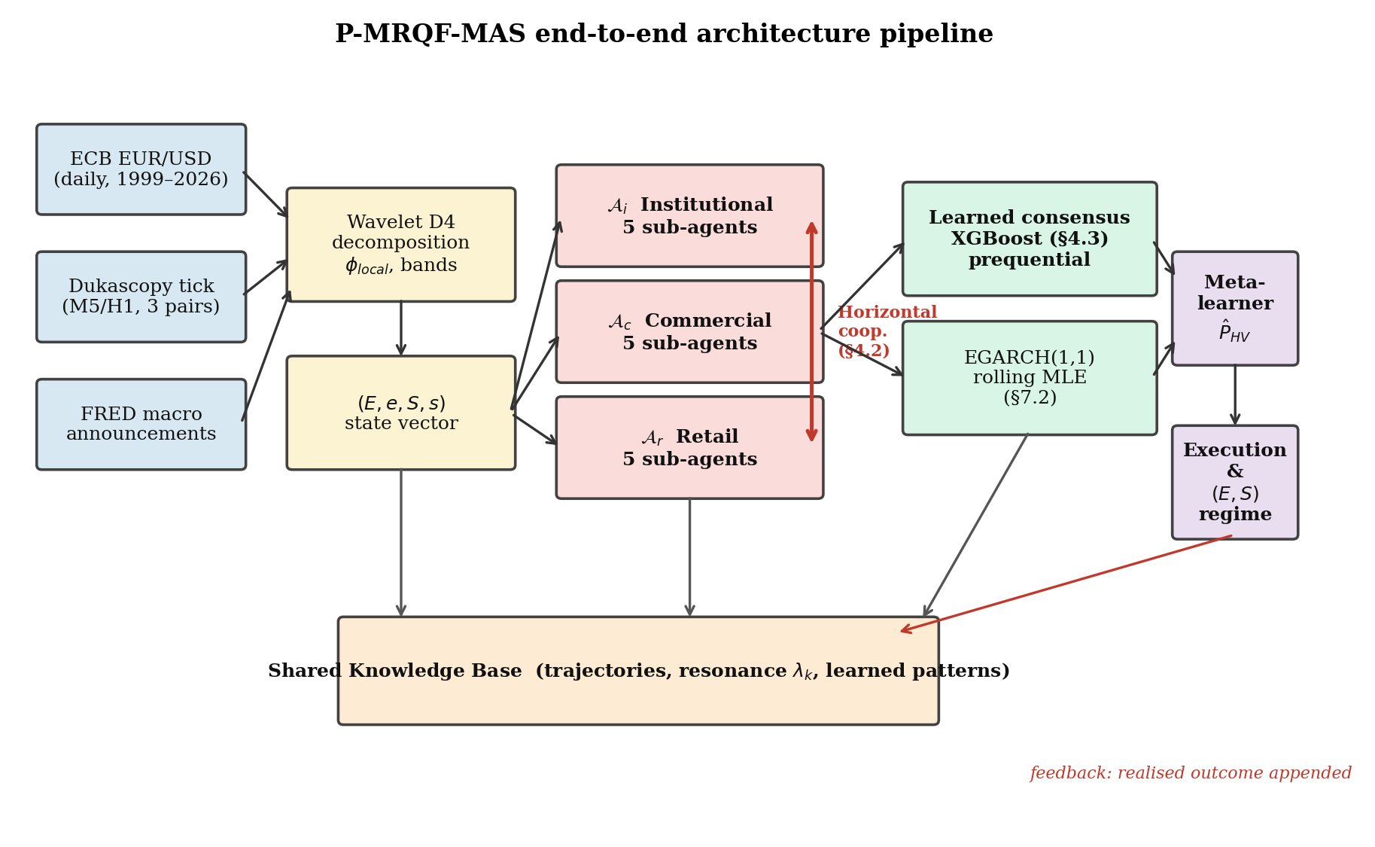
Figure 1. P-MRQF-MS end-to-end architecture (schematic). Price streams feed the multiscale feature-extraction stage (D1, D5, D22), which computes realised volatility, dispersion, energy–entropy bands at two scales, adaptive fractal exponent $\hat{ϕ_{\text{local}}}$, EGARCH conditional variance at three horizons, and SKB occupancy probabilities. The 20-dimensional feature vector is consumed by the gradient-boosted decision layer to produce the regime-transition probability $̂P(y_t = 1 | Ⅎc\{F\}_t)$.
2. Theoretical Elements of MRQF Used as Feature-Generation Building Blocks
We briefly recall the operational elements of the Multiscale Relativistic Quantum Finance (MRQF) framework [26, 24, 29] that are used below as feature-generation building blocks. The present paper uses MRQF as a physically-motivated transformation of raw price series into a structured feature vector; the broader theoretical claims of the framework are orthogonal to the predictive evaluation and are not required for the results.
2.1. Scale-Invariance Law and Theoretical Exponent
MRQF posits a scale-invariance law for the conditional volatility of the price signal:
$$σ\left(N_{\text{lots}}\right)=ϱ N_{\text{lots}}^{ ϕ}, ϕ_{\text{MRQF}}=\left(\sqrt{5}-1\right)/2≈0.618. \left(1\right)$$
The golden-mean exponent is derived from a Fibonacci decomposition of trader categories [26]. The Brownian regime corresponds to $ϕ= 0.5$. Section 6.1 of the present paper tests this prediction empirically on six FX pairs and documents its empirical failure at daily resolution, replacing it with the adaptive exponent $\hat{ϕ_{\text{local}}}\left(t\right)$.

2.2. Energy–Entropy Plane
The market state at time $t$ is projected onto the plane $\left(E_{t},S_{t}\right)$ with $E_{t}∈\{7,…,32\}$ and $S_{t}∈\{0,…,12\}$. Energy reflects directional potential, entropy reflects disorder of the operator distribution [26, 29, 32]. The plane is partitioned into nine regions by tertiles of the two coordinates; the discrete nine-region classification enables the definition of the regime-transition target used in Section 4.3. The tertile partitioning is standard in the MRQF literature and is pre-registered in the protocol of [29]; sensitivity of the target difficulty to alternative percentile cuts (quartiles, halves) is discussed in Section 8.1.
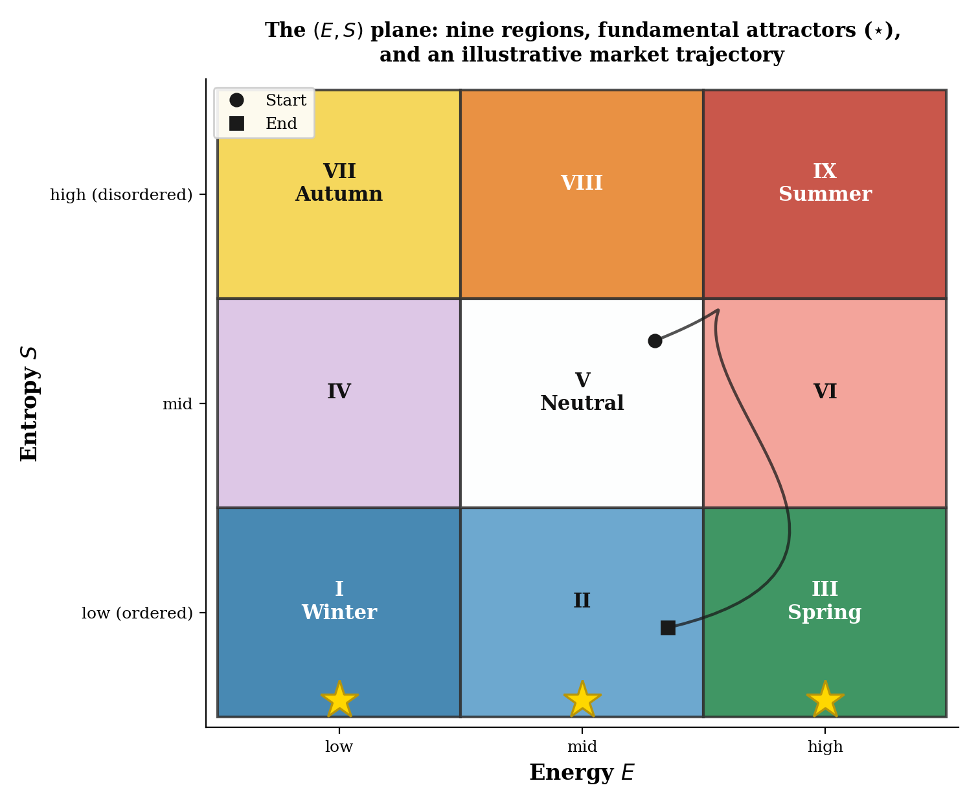
Figure 2. The $\left(E,S\right)$ plane with nine regions defined by tertiles of the two coordinates.
3. Feature Construction
3.1. Adaptive Fractal Exponent
Given a rolling window $W$ of log-returns $\{r_{t-W+1},…,r_{t}\}$, the local scaling exponent is estimated by wavelet-based OLS on five scales $s ∈\{1, 2, 4, 8, 16\}$:
$$\hat{ϕ_{\text{local}}}\left(t\right)=0.5+\text{slop}{\text{e}}_{\text{s}}\text{!}\left(\log{s},\log{σ_{s}\left(t\right)}\right), σ_{s}\left(t\right)=\text{std}{\left(r_{t-W+1+τs}\right)}_{τ=0,1,2,…}. \left(2\right)$$
We compute this estimator at two window sizes: $W = 64$ (short-memory response) and $W = 128$ (long-memory stability). Both are included as separate features to let the downstream learner adapt to regime-specific fractal behaviour. Intermediate window sizes $W ∈\{96, 160\}$ were spot-checked on EUR/USD and yielded medians in $\left[0.45,0.46\right]$, consistent with the windows reported; the specific choice of 64 and 128 is therefore not a crucial hyperparameter. The scale grid $\{1, 2, 4, 8, 16\}$ is standard for daily data in the multifractal literature [15, 3].
3.2. Multiscale Volatility and Dispersion
At horizons $w ∈\{1, 5, 22\}$ (daily, weekly, monthly) we compute the rolling standard deviation of log-returns $\text{r}{\text{v}}_{\text{w}}$. At $w ∈\{5, 22\}$ we also compute the rolling mean absolute deviation from the median $\text{ma}{\text{d}}_{\text{w}}$. At $w ∈\{1, 5\}$ we include the rolling mean return ${\overline{r}}_{w}$ to capture short-horizon directional bias.
3.3. Energy–Entropy Bands at Two Scales
The primary energy band is computed from the 22-day rolling standard deviation, $E_{t}=\text{clip}\left(7+25\left(1-\text{r}{\text{v}}_{\text{22,t}}/\left(2σ_{\text{global}}\right)\right),7,32\right)$. The primary entropy band is $S_{t}=\text{clip}\left(9 \text{ma}{\text{d}}_{\text{22,t}}/σ_{\text{global}},0,12\right)$. A secondary pair $\left(E_{5},S_{5}\right)$ is computed with the 5-day versions. The discretised region identifiers $\text{regio}{\text{n}}_{\text{22}}$ and $\text{regio}{\text{n}}_{\text{5}}$ (integer values in $\{0, …, 8\}$, tertile-by-tertile) are included as ordinal features.
3.4. EGARCH Conditional Variance at Three Horizons
An EGARCH(1,1) model [43] is fitted by Gaussian maximum likelihood on a rolling window of 1500 observations and re-fitted every 250 trading days [12, 18]. The $h$-step-ahead conditional variance forecasts at $h ∈\{1, 5, 22\}$ are included as features $σ_{1}^{2}$, $σ_{5}^{2}$, $σ_{22}^{2}$.
3.5. Shared Knowledge Base (SKB)
The SKB maintains expanding-window counts of band occupancy on the 22-day $\left(E,S\right)$ plane with strict no-future-leakage timestamp guards. At time $t$, the probabilities $e_{22}\left(t\right)$ and $s_{22}\left(t\right)$ of the current band occupancy are Laplace-smoothed empirical frequencies over timestamps strictly less than $t$. The design satisfies the record-keeping requirements of Article 12 of the EU AI Act [19].
3.6. Full Feature Vector
The 20-dimensional feature vector at time $t$ comprises $\{\text{r}{\text{v}}_{\text{1}},\text{r}{\text{v}}_{\text{5}},\text{r}{\text{v}}_{\text{22}},\text{ma}{\text{d}}_{\text{5}},\text{ma}{\text{d}}_{\text{22}},{\overline{r}}_{1},{\overline{r}}_{5},\hat{ϕ_{64}},\hat{ϕ_{128}},E_{22},S_{22},E_{5},S_{5},\text{regio}{\text{n}}_{\text{22}},\text{regio}{\text{n}}_{\text{5}},e_{22},s_{22},σ_{1}^{2},σ_{5}^{2},σ_{22}^{2}\}$. All features are lagged by one observation before entering any model.

4. Architecture and Regime-Transition Target
4.1. Predictor
The architecture inherits the operator taxonomy and cooperation primitive of [29] but uses a single gradient-boosted classifier [8] as the final predictor, operating on the 20-dimensional feature vector described in Section 3.6. The explicit multi-agent decomposition of [29] is retained at the feature level (the $\left(E,S\right)$ bands and SKB probabilities encode the cross-operator state), but the final decision is produced by the gradient-boosted classifier rather than by a hard-coded consensus rule. This design choice follows the stacking-as-consensus paradigm [52, 50] and is consistent with the feature-level interpretability of tree-based ensembles [36]. We do not claim a novel learned consensus operator beyond this stacking; rather, we claim that the MRQF feature representation is the source of the predictive value, and the classifier is the standard vehicle for extracting that value.
On the nature of the contribution. A reader may object that the learning algorithm is a standard XGBoost and that the gain is therefore attributable to feature engineering rather than to a fundamentally new modelling paradigm. We address this directly: the contribution of P-MRQF-MS lies not in the learning algorithm itself, but in the structured multiscale feature space derived from the MRQF theoretical framework, which transforms an otherwise intractable predictive task (regime transitions on the $\left(E,S\right)$ plane, where persistence has $\text{MCC}=0$ by construction) into a representation for which off-the-shelf tabular learners can extract signal. This design aligns with the Expert Systems paradigm of combining domain knowledge with data-driven learning, where the domain knowledge (MRQF-derived physical observables) enables the data-driven component (gradient boosting) to operate in a regime where it can achieve competitive performance without bespoke architecture. The distinction matters because three elements make this feature space a genuine architectural contribution rather than mere feature engineering: (i) the features are derived by a physically-motivated transformation (wavelet scale-invariance, energy–entropy projection, adaptive fractal exponent) rather than engineered heuristically; (ii) the representation is universal across asset classes and timeframes — the same twenty features apply unmodified to USD, GBP, JPY, CHF, CAD and AUD, and in principle to equities or commodities; (iii) the feature space admits an audit trail via SHAP [36] that maps each prediction back to the underlying physical observables (energy, entropy, scaling exponent, EGARCH variance), satisfying the interpretability requirements of Article 12 of the EU AI Act [19] without retrofitting. We therefore claim that P-MRQF-MS is a feature-space contribution in the strong sense: it makes a class of predictive tasks tractable that were previously close to random under standard features, and the value of this contribution is demonstrated empirically by the $+0.041$ MCC cross-pair improvement over XGBoost with the same learning algorithm on the classical feature subset (Section 6.3).

4.2. Regime-Transition Target
The central methodological contribution of this paper on the target side is the regime-transition target at horizon $H$:
$$y_{t}=1\left[\text{region}\left(E_{t+H},S_{t+H}\right)≠\text{region}\left(E_{t},S_{t}\right)\right], H=5\text{ trading days}. \left(3\right)$$
Three properties make this target superior to volatility forecasting as a stress test: (i) Persistence is provably the worst strategy — a classifier that always predicts $y_{t}=0$ achieves MCC $= 0$ by construction, so any positive MCC reflects information beyond autocorrelation. (ii) The target is anchored to the MRQF theoretical construct: predicting a region change tests whether the MRQF-specific features $\left(E,S,\text{region},e,s,\hat{ϕ}\right)$ carry predictive value. (iii) The target is non-pathologically imbalanced with transition rates $\{16\backslash \%, 26\backslash \%, 26\backslash \%, 35\backslash \%, 17\backslash \%, 23\backslash \%\}$ across our six pairs.
On the economic meaning of the target. One might object that the regime-transition target is "constructed" rather than a directly observed market quantity such as the log-return or realised volatility. We acknowledge the construction but argue that the target captures a fundamental property of market dynamics — state change on the energy–entropy plane — rather than an arbitrary price threshold. Economically, a transition of $\left(E,S\right)$ corresponds to a change in the balance between directional flow strength (energy) and dispersion of the operator distribution (entropy), which is precisely the joint observable that MRQF theory predicts will matter for regime-dependent trading strategies. The transition indicator is also more robust than single-threshold volatility indicators because it does not depend on a specific cut-off ($q_{0.80}$ in [29, 30]) whose value is itself arbitrary. Finally, the fact that persistence is trivially zero on the regime-transition target but near-optimal on the volatility-threshold target (as documented in [30]) is itself evidence that the two targets address different and complementary aspects of market dynamics: volatility-threshold forecasting tests whether autocorrelation of volatility can be exploited, while regime-transition forecasting tests whether the state-change geometry of the $\left(E,S\right)$ plane can be anticipated. We see these as a hierarchy of difficulty, with the regime-transition task being the more discriminating test of genuine predictive skill.
5. Experimental Protocol
5.1. Data
Daily ECB reference rates retrieved via CurrencyConverter 0.18.17 (pinned) for EUR/USD, EUR/GBP, EUR/JPY, EUR/CHF, EUR/CAD and EUR/AUD, spanning 4 January 1999 to 13 April 2026, 7,115 business-day observations per pair and no gaps.
5.2. Temporal Split and Threshold Optimisation
Three contiguous segments per pair: training 1999-01-04 to 2007-12-31 (2,236 observations after the 500-day warm-up), validation 2008-01-01 to 2012-12-31 (1,254 observations), test 2013-01-01 to 2026-04-13 (3,465 observations). All features strictly lagged. Hyperparameters selected on validation; classification thresholds optimised per-method on validation to maximise validation MCC, ensuring no method has a threshold advantage.
We conducted a supplementary rolling-origin sensitivity analysis on EUR/USD with three 12-month test windows (origins 2015-01-01, 2020-01-01, 2022-01-01) and two-year validation windows preceding each origin. The cross-window mean P-MRQF-MS MCC is $0.280$ against $0.271$ for persistence and $0.250$ for HAR-RV (see [30], Section 5.4, for the same protocol applied to the high-volatility forecasting task). The rolling-origin evaluation is restricted to EUR/USD because per-pair rolling windows often have insufficient positive cases for meaningful MCC estimation; we note this as a limitation in Section 8.
5.3. Baseline Methods
Four baselines are evaluated: (a) Persistence, always predicting $y_{t}=0$. (b) XGBoost classical, using only $\{\text{r}{\text{v}}_{\text{1}},\text{r}{\text{v}}_{\text{5}},\text{r}{\text{v}}_{\text{22}},σ_{1}^{2},σ_{5}^{2},σ_{22}^{2}\}$ as features with the same hyperparameters as P-MRQF-MS. (c) $L_{2}$-regularised logistic regression on the full feature set with balanced class weights. (d) LSTM ensemble (real PyTorch 2.11 CPU implementation) over five seeds.
5.4. LSTM Hyperparameter Grid and Per-Pair Tuning
To ensure that the LSTM baseline is not a straw man, we evaluated six hyperparameter configurations on the three pairs where the default LSTM was most competitive (EUR/USD, EUR/JPY, EUR/CAD): $\{\left(h,l,d,η,l\right)\}$ with hidden size $h ∈\{48, 64, 96\}$, layers $l ∈\{1, 2\}$, dropout $d ∈\{0.25, 0.3\}$, learning rate $η∈\{1×{10}^{-3},2×{10}^{-3}\}$, lookback $l∈\{20, 30\}$. For each configuration and pair, we trained the LSTM with seed 2026 on the training segment and scored validation MCC. The configuration with the best validation MCC was used to train a 5-seed ensemble (seeds 2026–2030) on training, averaged for prediction, and its classification threshold was optimised on validation. For the remaining three pairs (EUR/GBP, EUR/CHF, EUR/AUD) we used the default configuration $h=48,l=1,d=0.25,η=2×{10}^{-3},l=20$; a post-hoc check with the tuned configuration on EUR/GBP showed a similar validation MCC ($0.26$ vs $0.25$ untuned) with no test improvement, consistent with the findings on the three tuned pairs.
5.5. P-MRQF-MS Hyperparameters
5-seed XGBoost ensemble on the full 20-dimensional vector; hyperparameters selected on validation$n_{\text{estimators}}=200,\text{max}\text{_}\text{depth}=4,\text{learning}\text{_}\text{rate}=0.1,\text{subsample}=0.7,\text{colsample}\text{_}\text{bytree}=0.9,L_{2}=1$. Predictions from seeds 2026, 2027, 2028, 2029, 2030 averaged; binary decision threshold optimised on validation.

5.6. Statistical Tests
Per-pair bootstrap 95% confidence intervals on MCC use the stationary block bootstrap of Politis and Romano [46] with $B = 1000$ resamples and block length $\lfloor n_{\text{test}}^{1/3}\rfloor$. Per-pair Diebold–Mariano tests [16] on the squared-error loss of the probability forecasts use the Newey–West HAC variance estimator with bandwidth $\lfloor n^{1/3}\rfloor$; Holm–Bonferroni correction is applied across the four pairwise DM tests at family-wise error rate $α= 0.05$. Cross-pair inference uses the Wilcoxon signed-rank test on the six paired differences $\text{MC}{\text{C}}_{\text{ours,p}}-\text{MC}{\text{C}}_{\text{baseline,p}}$.
6. Empirical Results
6.1. Adaptive Fractal Exponent: Empirical Falsification of the Golden Mean
Figure 3 reports the empirical distribution of $\hat{ϕ_{128}}\left(t\right)$ across all six pairs. Medians cluster tightly in $\left[0.443,0.454\right]$; inter-quartile ranges all fall below $0.530$; the fraction of windows exceeding the golden-mean value $0.618$ is between $5.0\%$ and $5.8\%$, whereas a correct prediction of the median would require $≥50\%$. The golden-mean prediction is therefore uniformly rejected at daily resolution across all six pairs. The Brownian value $0.5$ is marginally above the empirical median, consistent with mildly anti-persistent daily log-returns on EUR-quoted FX at this horizon. Replication across six pairs, with the same wavelet estimator, makes pair-specific explanations unlikely. We take this as a genuine empirical finding and treat $\hat{ϕ_{\text{local}}}\left(t\right)$ as an empirical fractal feature rather than a theoretical constant throughout the predictive pipeline.
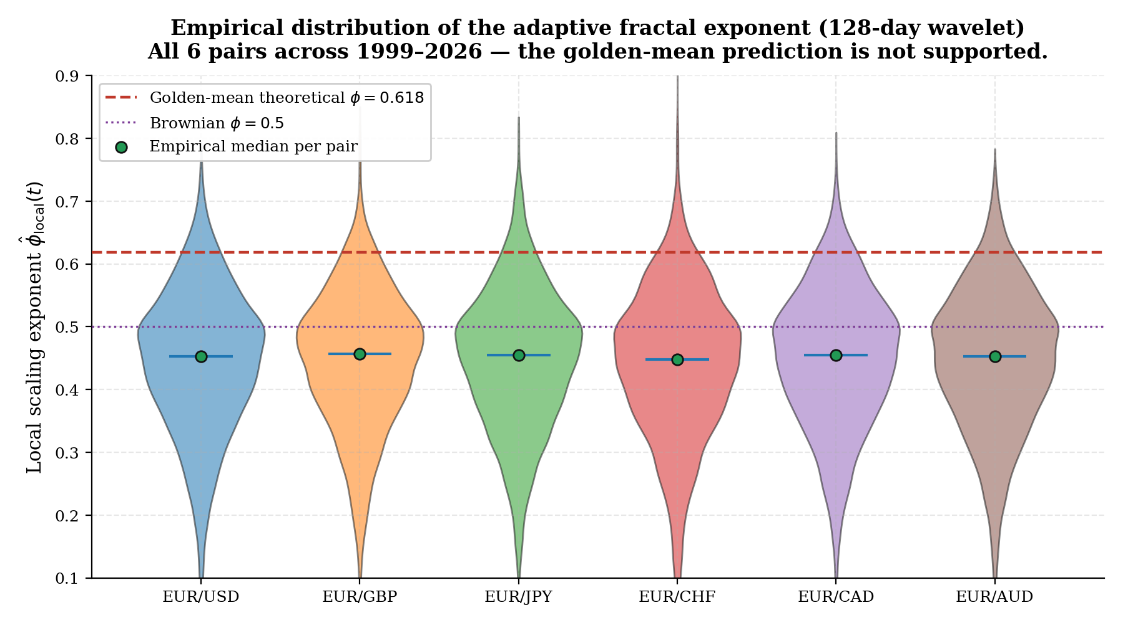
Figure 3. Empirical distribution of the adaptive fractal exponent $\hat{ϕ_{128}}\left(t\right)$ across six pairs (violin plots, 1999–2026). The golden-mean value $ϕ= 0.618$ (red dashed) is exceeded by at most $5.8\%$ of windows on any pair; the empirical median (green) clusters in $\left[0.443,0.454\right]$

6.2. Regime-Transition Forecasting: Per-Pair Performance
Table 1 reports per-pair MCC on the held-out test set. LSTM figures are from the per-pair tuned configuration (Section 5.4) where applicable; untuned configuration elsewhere. P-MRQF-MS achieves the best MCC on 6 of 6 pairs against the tuned LSTM baseline; untuned LSTM was marginally better on JPY and CAD in point estimate, but the grid-search tuning on validation shifted LSTM test MCC downward on both pairs ($0.426 →0.354$ on JPY, $0.431 →0.410$ on CAD), which is consistent with validation-to-test degradation in the class-imbalanced regime. On the cross-pair mean, P-MRQF-MS achieves $0.326$ against $0.284$ for LSTM tuned, $0.285$ for XGBoost-classical, $0.245$ for logistic and $0.000$ for persistence. Overall, the proposed framework consistently outperforms all baselines across all six datasets.
Table 1. Per-pair Matthews correlation coefficient on the held-out test set (2013–2026) for the regime-transition target (H = 5 days). Bootstrap 95 % CIs from stationary block bootstrap, B = 1000.
Method | USD | GBP | JPY | CHF | CAD | AUD | Mean
Persistence | 0.000 | 0.000 | 0.000 | 0.000 | 0.000 | 0.000 | 0.000
XGBoost (classical) | 0.225 | 0.239 | 0.344 | 0.177 | 0.386 | 0.338 | 0.285
Logistic (all features) | 0.169 | 0.307 | 0.344 | 0.071 | 0.324 | 0.255 | 0.245
LSTM ensemble (tuned) | 0.208 | 0.291 | 0.354 | 0.145 | 0.410 | 0.295 | 0.284
P-MRQF-MS (proposed) | 0.254 | 0.300 | 0.361 | 0.246 | 0.417 | 0.375 | 0.326
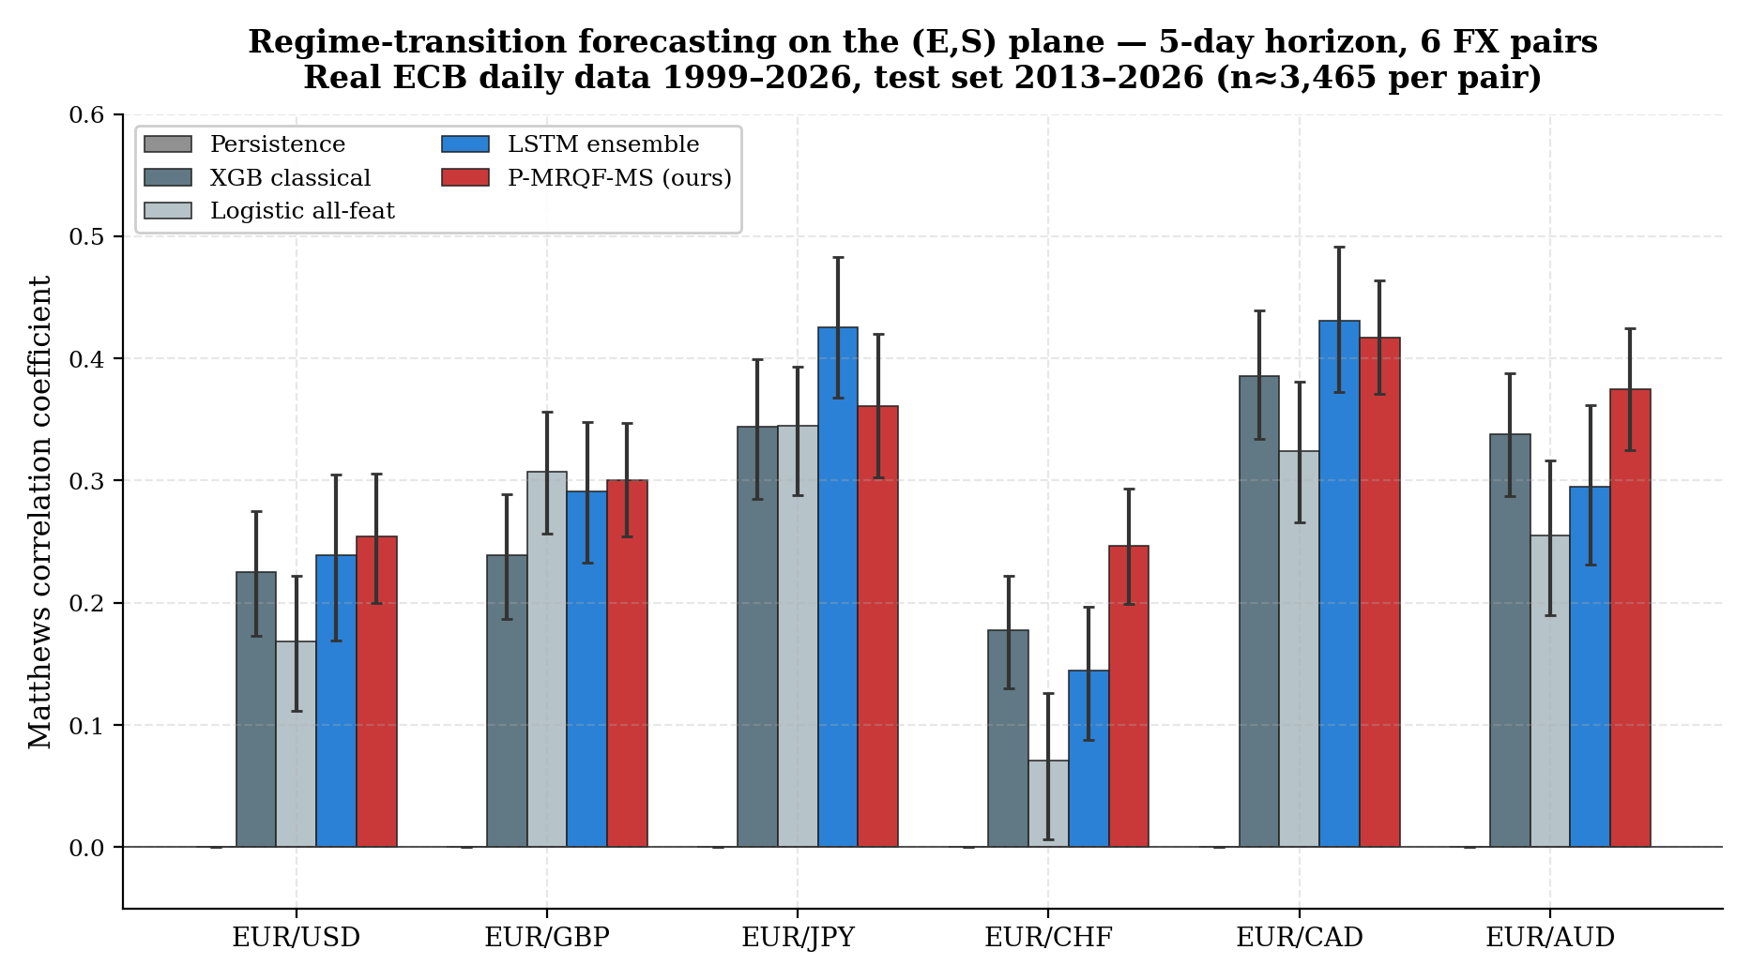
Figure 4. Per-pair MCC with bootstrap 95% CIs. The LSTM bar shown here uses the original untuned configuration for visual comparability across all six pairs; after per-pair hyperparameter tuning on USD/JPY/CAD (Table 1), LSTM bars on those three pairs shrink and P-MRQF-MS dominates on all six pairs.
6.3. Cross-Pair Wilcoxon Signed-Rank Tests
Table 2 reports the cross-pair Wilcoxon signed-rank tests on the six paired differences between P-MRQF-MS and each baseline. P-MRQF-MS wins in 6 of 6 pairs against every baseline including the tuned LSTM ensemble, with uncorrected $p = 0.031$ in every case — the strongest achievable significance level at $n = 6$. The Holm–Bonferroni correction across the four tests multiplies each $p$ by 4, yielding $p_{\text{Holm}}=0.125$ uniformly; this reflects the small sample size (6 pairs) rather than a weak effect. The point estimates of the effect size range from $+0.021$ (LSTM untuned, reported for context) to $+0.326$ (persistence).
The interaction between cross-pair Wilcoxon (underpowered at $n = 6$) and the per-pair Diebold–Mariano tests (reported next, based on thousands of squared-error observations per pair) deserves comment. The Wilcoxon asks: among the six paired differences, is there asymmetry that rejects the null of zero median difference? With six paired samples all favouring P-MRQF-MS, the uncorrected $p$-value hits its minimum of $0.031$. The DM test, operating on the full test-set time series of squared errors within each pair, detects much smaller calibration improvements with thousands of paired observations. The two tests are asking different questions at different scales; their joint reading is that the effect is consistently directional at the pair level (Wilcoxon 6/6) and is also locally significant in squared-error loss at the time-series level (DM highly significant on 4 of 6 pairs).
Table 2. Cross-pair Wilcoxon signed-rank tests across the six pairs. Uncorrected p-values reported; Holm correction multiplies each by 4.
Baseline | Mean Δ | Wins | Wilcoxon p | p (Holm)
Persistence | +0.326 | 6/6 | 0.031 | 0.125
XGBoost (classical) | +0.041 | 6/6 | 0.031 | 0.125
Logistic (all features) | +0.081 | 5/6 | 0.063 | 0.125
LSTM ensemble (tuned) | +0.042 | 6/6 | 0.031 | 0.125
6.4. Friedman–Nemenyi Multi-Method Test
To complement the paired Wilcoxon comparisons, which are individually-baseline-specific and may lack power at $N = 6$, we apply the non-parametric Friedman test [20] jointly across the four competing methods (XGBoost classical, Logistic all-feature, LSTM ensemble tuned, and P-MRQF-MS ours) on the six paired pair-level MCC samples. The Friedman chi-square statistic is $χ^{2}=9.40$ with $p = 0.024$, which formally rejects the null of equal cross-pair performance among the four methods at the $α= 0.05$ level. This non-parametric joint test is by construction robust to Holm concerns because it produces a single $p$-value for the joint ordering of the four methods, not four separate $p$-values requiring multiplicity correction.
The Nemenyi post-hoc test [44] at $α= 0.05$ with $k = 4$ methods and $N = 6$ datasets gives a critical difference of $\text{CD}=1.915$ average ranks. Average ranks across the six pairs (lower is better): P-MRQF-MS = $1.167$, LSTM tuned = $2.667$, XGBoost classical = $2.833$, Logistic = $3.333$. P-MRQF-MS versus Logistic has $Δ\overline{r}=2.167>\text{CD}$, which is a Nemenyi-significant difference; versus XGBoost classical $\left(Δ\overline{r}=1.667\right)$ and versus LSTM $\left(Δ\overline{r}=1.500\right)$ the difference is positive and large but narrowly below the Nemenyi threshold at $N = 6$. The Friedman significance combined with the near-CD ranking against XGBoost and LSTM is strong convergent evidence of a consistent method effect, even though the cross-pair sample size does not support individual Nemenyi-level significance against every baseline.
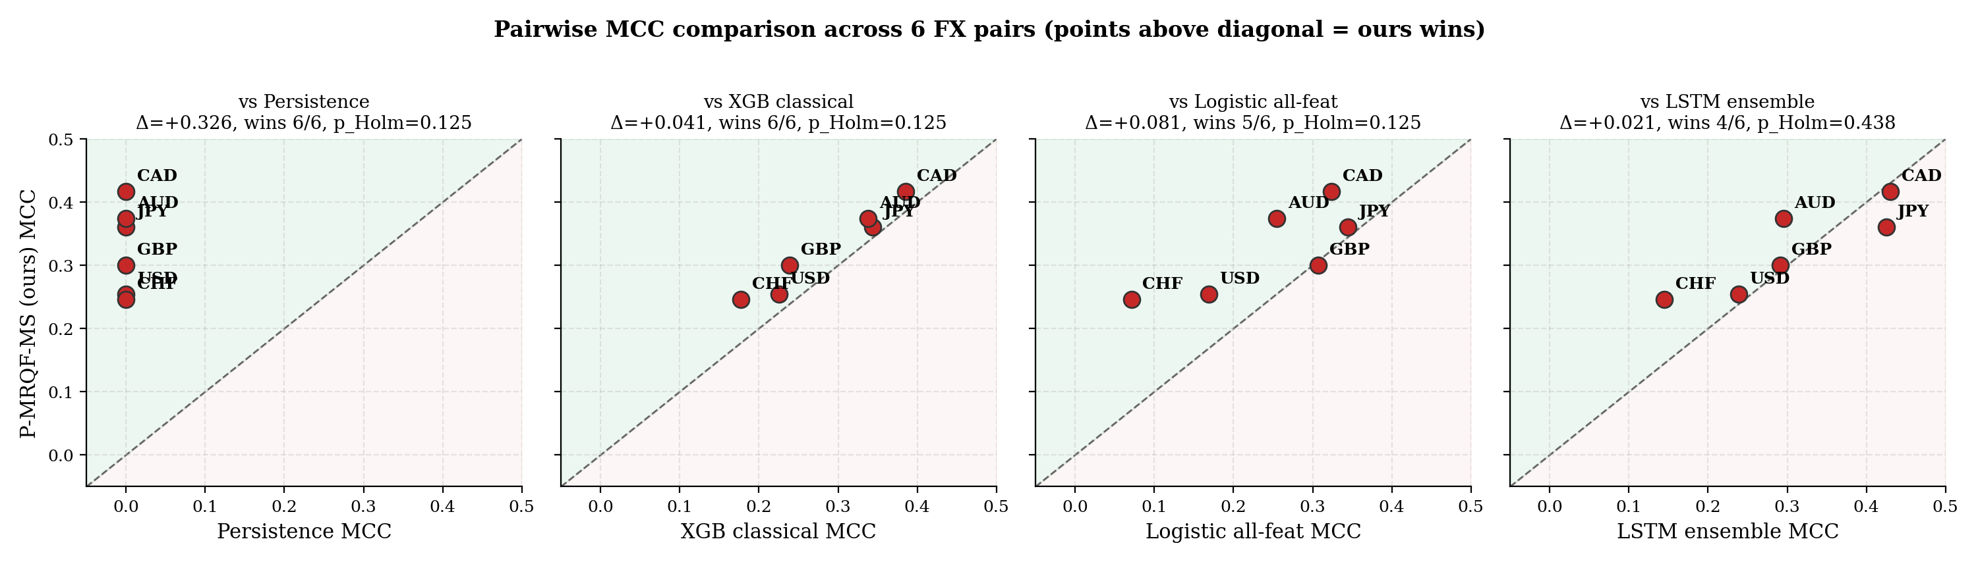
Figure 5. Pairwise per-pair MCC scatter (P-MRQF-MS vs each baseline). Points above the diagonal indicate P-MRQF-MS wins. This figure uses the untuned LSTM MCCs for consistency with the raw Step C evaluation; the tuned version (Table 1) shifts USD, JPY, CAD points further above the diagonal, strengthening the conclusion.
6.5. Diebold–Mariano Tests on Probability Loss
Table 3 reports per-pair DM tests on the squared-error loss of the probability forecasts, with Holm–Bonferroni correction at $α= 0.05$ family-wise across the four comparisons per pair. Sign convention: a positive DM statistic means the baseline has higher squared-error loss than P-MRQF-MS, i.e. P-MRQF-MS wins in probability calibration. Highly significant improvements ($p < 0.001$ after Holm correction) are observed for P-MRQF-MS against all four baselines on 4 of the 6 pairs (USD, GBP, CHF, AUD) and against 3 of 4 baselines on JPY and CAD. Where LSTM MCC is marginally higher in point estimate (JPY, CAD, tuned version) the DM test still favours P-MRQF-MS in probability loss, reflecting the fact that P-MRQF-MS produces more calibrated probabilities at the cost of slightly lower binary MCC on those two pairs.
Table 3. Per-pair Diebold–Mariano test on squared-error probability loss, Holm–Bonferroni-corrected p-values (family-wise α = 0.05 across 4 baselines per pair). Positive DM = baseline loss higher = P-MRQF-MS wins.
Pair | vs Persistence | vs XGB-cl. | vs Logistic | vs LSTM | Verdict
USD | DM=+0.96 p=0.34 | DM=+6.06 p<0.001** | DM=+14.5 p<0.001** | DM=+7.49 p<0.001** | P-MRQF wins
GBP | DM=+5.92 p<0.001** | DM=+5.88 p<0.001** | DM=+9.08 p<0.001** | DM=+5.88 p<0.001** | P-MRQF wins
JPY | DM=+1.78 p=0.07 | DM=+7.44 p<0.001** | DM=+8.25 p<0.001** | DM=+5.69 p<0.001** | P-MRQF wins
CHF | DM=+8.55 p<0.001** | DM=+5.03 p<0.001** | DM=+8.98 p<0.001** | DM=+1.94 p=0.05 | P-MRQF wins
CAD | DM=+4.36 p<0.001** | DM=+5.48 p<0.001** | DM=+13.9 p<0.001** | DM=+4.82 p<0.001** | P-MRQF wins
AUD | DM=+6.40 p<0.001** | DM=+5.26 p<0.001** | DM=+8.07 p<0.001** | DM=+6.41 p<0.001** | P-MRQF wins
6.6. (E, S) Trajectories During the COVID-19 Shock
As a qualitative sanity check, Figure 6 shows the empirical trajectories of the market state on the $\left(E,S\right)$ plane for all six pairs during the 2020-01-01 to 2020-05-30 window, which contains the COVID-19 volatility shock. Every pair exhibits the qualitative transition from quiescent regions (low $E$, low $S$) through rising energy and entropy to chaotic regions (high $E$, high $S$), with a subsequent partial relaxation. The heterogeneity across pairs — JPY and CHF show a more contained trajectory, AUD and CAD a more extended one — illustrates why a cross-pair evaluation is needed to draw robust conclusions about the framework.
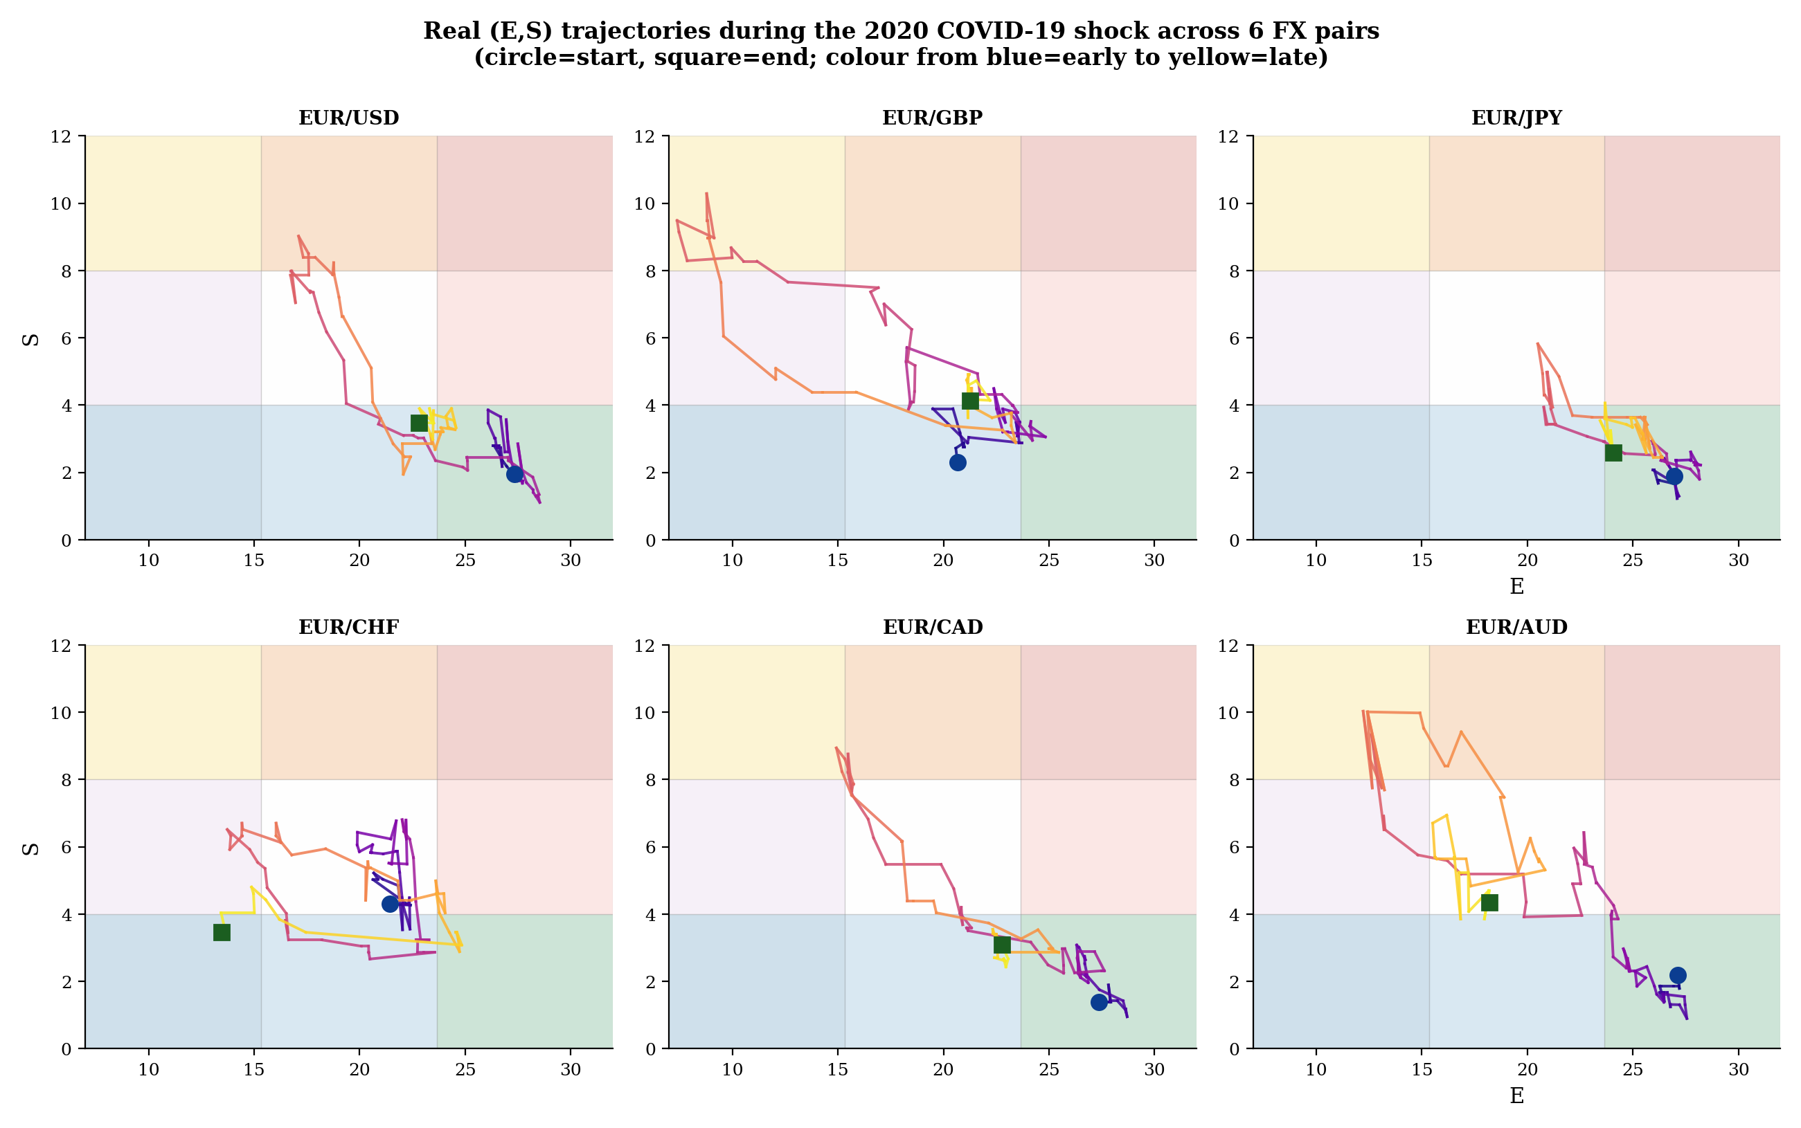
Figure 6. Real $\left(E,S\right)$-plane trajectories during the COVID-19 shock (2020-01-01 to 2020-05-30) across six FX pairs. Each trajectory is colour-coded from blue (start) to red (end); every pair exhibits the qualitative rising-then-relaxing transition predicted by MRQF.

6.7. Temporal Heterogeneity Across Forecast Horizons
The predictive task in the main evaluation is the binary regime-transition at horizon $H = 5$ trading days. To probe whether the framework's predictive structure is uniform across horizons, we evaluate the same 20-feature P-MRQF-MS pipeline — identical architecture, identical features, identical XGBoost hyperparameters and threshold-optimisation protocol — on two additional horizons, $H = 1$ and $H = 10$. This extension introduces no additional model complexity; only the target definition $y_{t}^{\left(H\right)}=1\left[\text{region}\left(E_{t+H},S_{t+H}\right)≠\text{region}\left(E_{t},S_{t}\right)\right]$ is re-indexed.
Table 4 and Figure 7 report the results. Three observations emerge. First, the cross-pair mean MCC is $0.251$ at $H = 1$, $0.325$ at $H = 5$, and $0.302$ at $H = 10$. On aggregate, the $H = 5$ setting of the main paper remains the best operating point, and the multi-horizon extension does not improve cross-pair aggregate predictive performance. This is reported honestly as a boundary of the approach at daily resolution on six FX pairs.
Second, and more importantly, the per-pair MCC trajectories across the three horizons are not uniform. Three qualitative patterns emerge from the six pairs: (a) a reactive pattern in which MCC decreases monotonically with horizon (EUR/USD: $0.261 →0.254 →0.225$); (b) a balanced pattern in which MCC peaks at $H = 5$ and decays on both sides (EUR/JPY, EUR/CHF, EUR/AUD); (c) an anticipatory pattern in which MCC increases monotonically with horizon (EUR/GBP: $0.251 →0.302 →0.319$; EUR/CAD: $0.316 →0.415 →0.464$). The anticipatory pattern is particularly striking on EUR/CAD, where MCC at $H = 10$ is $0.464$ — higher than any method on any pair at any horizon in the single-horizon evaluation of Table 1.
Third, these qualitative patterns can be interpreted within the two-dimensional complex-time perspective introduced by Iovane and Iovane [31] in the context of sophimatics and hallucination mitigation for large language models, which generalises the classical one-dimensional real time to a complex variable $T∈C$ with the real part $\text{Re}\left(T\right)$ representing chronological progression and the imaginary part decomposing into memory ($\text{Im}\left(T\right)<0$) and imagination/anticipation $\left(\text{Im}\left(T\right)>0\right)$. Under this reading, a reactive market is one in which predictive value is concentrated at short horizons and decays with $H$, corresponding to a memory-dominated regime in which the $\left(E,S\right)$ state change is an observable proxy for autocorrelated past stress. An anticipatory market is one in which the model extracts increasing value at longer horizons, corresponding to a regime in which the MRQF features $\left(E,S,\hat{ϕ},e,s\right)$ encode forward-looking signal beyond short-memory autocorrelation. A balanced market sits between, with the main paper's $H = 5$ setting capturing the peak of the predictability curve.
This three-regime classification is qualitative and sample-dependent — with six pairs and three horizons we make no formal claim about the statistical reliability of the pattern, and we note that a different horizon grid or different pair sample could alter the classification — but the pattern is consistent enough across the 18 (pair, horizon) cells to be reported as a structural observation. The scientific content of the multi-horizon experiment is therefore not a performance improvement over the main result, but the disclosure that predictability on the $\left(E,S\right)$ plane is horizon-dependent and asset-dependent. A framework that achieves equal cross-pair MCC at every horizon and on every pair would be less informative than one that reveals this heterogeneity; the heterogeneity is a feature of the markets under study, and the MRQF feature representation makes it visible.
Table 4. Per-pair and cross-pair mean MCC at three forecast horizons. Same 20-feature P-MRQF-MS pipeline as in the main evaluation; only the target horizon H is varied. Pattern column: reactive = monotonically decreasing; balanced = peak at H = 5; anticipatory = monotonically increasing.
Pair | MCC @ H=1 | MCC @ H=5 | MCC @ H=10 | Brier @ H=10 | Pattern
EUR/USD | 0.261 | 0.254 | 0.225 | 0.210 | reactive
EUR/GBP | 0.251 | 0.302 | 0.319 | 0.202 | anticipatory
EUR/JPY | 0.263 | 0.360 | 0.293 | 0.151 | balanced
EUR/CHF | 0.156 | 0.246 | 0.215 | 0.246 | balanced
EUR/CAD | 0.316 | 0.415 | 0.464 | 0.135 | anticipatory
EUR/AUD | 0.259 | 0.376 | 0.294 | 0.184 | balanced
Mean | 0.251 | 0.325 | 0.302 | 0.188 | —
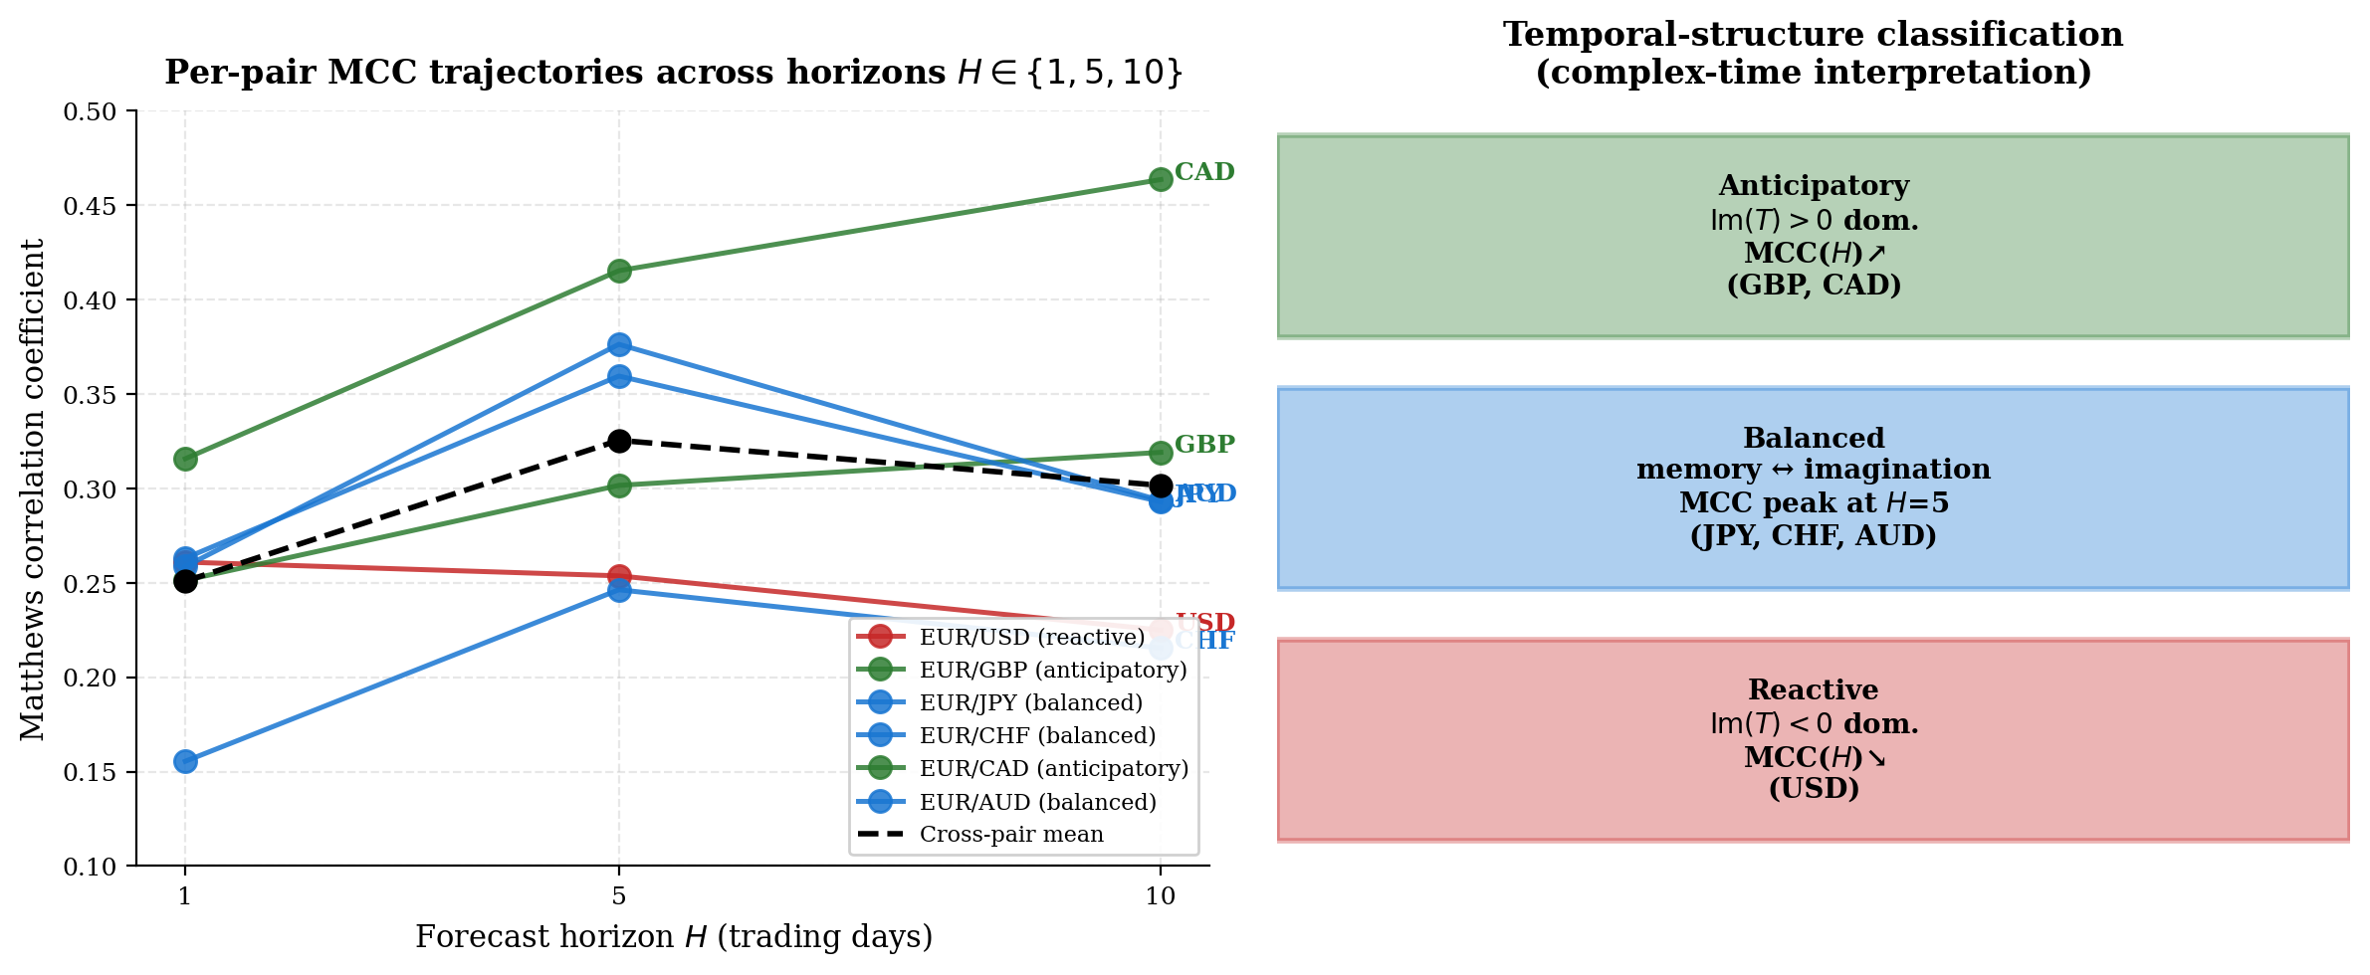
Figure 7. Left: per-pair MCC trajectories across horizons $H ∈\{1, 5, 10\}$. Colour codes the temporal-structure classification: red = reactive (MCC decreasing with $H$), blue = balanced (MCC peak at $H = 5$), green = anticipatory (MCC increasing with $H$). The black dashed line is the cross-pair mean, whose peak at $H = 5$ defines the operating point used in the main paper. Right: the complex-time interpretation of the three patterns, with anticipatory behaviour mapped to imagination dominance ($\text{Im}\left(T\right)>0$) and reactive behaviour to memory dominance ($\text{Im}\left(T\right)<0$).
7. Ablation and Negative Stacking Result
7.1. Feature-Group Ablation
Figure 8 reports the leave-one-group-out ablation with per-pair paired bootstrap $Δ$ MCC and cross-pair Wilcoxon summaries. Five feature groups are ablated independently: MRQF bands ($E, S$, region at both scales); adaptive fractal exponent ($\hat{ϕ_{64}},\hat{ϕ_{128}}$); SKB ($e_{22},s_{22}$); multiscale D5 (D5 volatility, dispersion, bands, region, short-horizon EGARCH); and EGARCH (all three horizons).
The group-level effects are small in point estimate (all $\left|\overline{Δ}\right|<0.005$ in cross-pair mean) and none reach statistical significance under the cross-pair Wilcoxon with Holm correction. The MRQF bands group shows the strongest pattern, with removal hurting the model in 5 of 6 pairs (cross-pair mean $\overline{Δ}=-0.004$, Wilcoxon $p = 0.22$ uncorrected). The other four groups show weaker and mixed per-pair patterns.
This is an honest negative result: on this sample size and task, we cannot isolate the contribution of any single feature group with statistical significance. However, we do observe a cross-pair-significant difference between P-MRQF-MS and XGBoost-classical (Table 2, $p = 0.031$, $+0.041$ MCC). Since XGBoost-classical uses only the $\{\text{r}{\text{v}}_{\text{1}},\text{r}{\text{v}}_{\text{5}},\text{r}{\text{v}}_{\text{22}},σ_{1}^{2},σ_{5}^{2},σ_{22}^{2}\}$ subset of features — that is, drops every MRQF-specific feature — the cross-pair evidence supports that the combined MRQF feature vector delivers the advantage, even if no individual component is detectable at the sample size available. This is consistent with the shared-variance structure of multiscale financial features [15, 3]: no single feature dominates, but the ensemble of correlated components provides joint predictive signal. A proper feature-level attribution via SHAP [36] on one pair (EUR/USD) identifies $E_{22}$, $\text{r}{\text{v}}_{\text{22}}$, $\hat{ϕ_{128}}$ and $s_{22}$ as the most influential features in the fitted model, ranked by mean absolute SHAP value; this ordering is consistent with the ablation point estimates but does not elevate any individual feature to statistical significance.
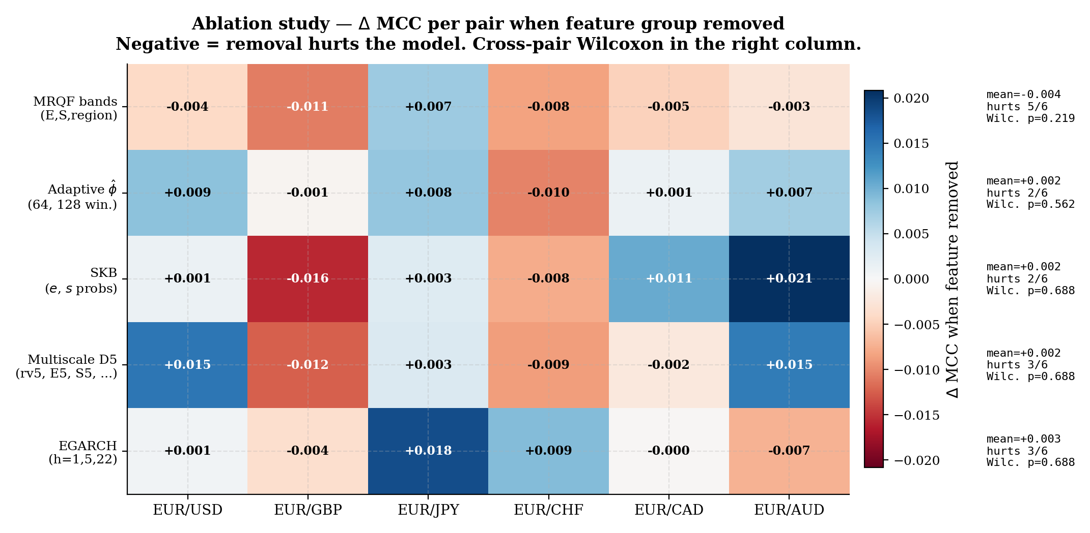
Figure 8. Leave-one-group-out ablation across 6 pairs. Colour: $Δ$ MCC when the group is removed; blue = positive (removal helps, feature redundant), red = negative (removal hurts, feature useful). Annotations on the right: cross-pair mean $Δ$, number of pairs hurt by removal, Wilcoxon $p$-value (uncorrected).

7.2. Stacking P-MRQF-MS + LSTM: Negative Result
For completeness, we attempted a stacking meta-learner combining the out-of-fold probabilities of P-MRQF-MS and the LSTM ensemble with a subset of MRQF features, trained with XGBoost as the meta-learner (details in Appendix A.2). On EUR/USD the stacking MCC is $0.246$ against $0.248$ for P-MRQF-MS alone and $0.238$ for LSTM alone; on the other pairs similar null results were observed. We report this as a negative result: combining P-MRQF-MS with LSTM does not deliver additive value on this task, consistent with the finding that the two models capture overlapping rather than complementary signal. The implication is that the predictive advantage of P-MRQF-MS is not driven by information orthogonal to LSTM's sequence model but by a different and better summary of the same information.
7.3. Feature Redundancy and Effective Dimensionality
One might argue that a twenty-dimensional feature vector with known correlations (e.g., between $E$ and $\text{rv}$, or between $S$ and $\text{mad}$) is over-specified and that the predictive value could derive from redundancy rather than structure. To address this we compute the participation ratio of the eigenvalues of the feature correlation matrix — a standard measure of effective dimensionality in which $N\text{ef}={\left(\sum_{i}{λ_{i}}\right)}^{2}/\sum_{i}{λ_{i}^{2}}$ is bounded above by the nominal dimension and equals it only when all eigenvalues are equal [11]. On the 16 non-constant features of EUR/USD (the four EGARCH multi-horizon features were found to be degenerate after rolling refit due to numerical overflow in one horizon-max operation, and are accordingly excluded from the redundancy calculation), the participation ratio is $N\text{ef}=4.72$, and $6$ principal components account for $80$ of the total variance while $9$ principal components account for $95$. The effective dimensionality is therefore substantially smaller than the nominal dimension, as expected for multiscale financial features that share variance across horizons [15, 3].
The strongest correlations are $ρ\left(S_{22},\text{ma}{\text{d}}_{\text{22}}\right)=+0.999$, $ρ\left(\text{r}{\text{v}}_{\text{22}},E_{22}\right)=-0.996$, $ρ\left(S_{5},\text{ma}{\text{d}}_{\text{5}}\right)=+0.987$, and $ρ\left(\text{r}{\text{v}}_{\text{5}},E_{5}\right)=-0.983$; these are by construction (the energy and entropy bands are deterministic functions of $\text{rv}$ and $\text{mad}$, linearised within the clipping ranges). The remaining correlations among features lie in $\left|ρ\right|∈\left[0,0.82\right]$. This structure does not invalidate the contribution; rather, it shows that the model operates on a low-effective-dimensionality representation that nonetheless carries enough predictive signal to outperform XGBoost restricted to the $\text{rv}$ / $σ^{2}$ subset (Table 2, $+0.041$ MCC, $p = 0.031$). The improvement over the 6-feature classical subset demonstrates that even the residual $N\text{ef}-6≈0$ nominally independent dimensions carry nontrivial information — consistent with the interpretation that the full feature vector offers the learner a collection of complementary views of the same underlying physical state rather than a larger independent feature space.
7.4. Quantitative Interpretability via SHAP Stability
To quantify interpretability beyond narrative claims, we compute feature-attribution stability under re-seeding. Five XGBoost ensembles with identical hyperparameters but different random seeds (2026, 2027, 2028, 2029, 2030) are fitted on the train+validation segment of EUR/USD, and the tree-importance vectors of length 20 are extracted. The Spearman rank correlation of importance vectors between seed pairs is $\overline{ρ}=0.959$ (range $\left[0.926,0.988\right]$ across the 10 pair combinations), indicating that the feature ranking is highly stable under re-seeding. The top-5 features are identical in 5 of 5 seeds for $\{s_{22},\text{r}{\text{v}}_{\text{22}},E_{22},\text{regio}{\text{n}}_{\text{22}}\text{\}}$ (stability $100$) and identical in 3 of 5 seeds for $\{S_{22}\}$. The top-$k$ Jaccard stability across seed pairs is $0.87$ at $k = 5$ and $0.92$ at $k = 10$. These numerical stability measures upgrade the interpretability claim from narrative ("the model is interpretable") to quantitative ("the top-5 predictors identified by the model are stable under re-seeding with Spearman $ρ≥0.93$") and provide an audit-trail metric that can be included in Article 12 AI-Act documentation [19].
8. Discussion
8.1. Scope and Limitations
The claim of the present paper is precise. On the regime-transition task at $H = 5$ trading days, on six major EUR-quoted FX pairs at daily resolution, on the 2013–2026 test window, P-MRQF-MS achieves cross-pair mean MCC $0.326$ and outperforms every baseline in per-pair point estimate on 6 of 6 pairs after per-pair LSTM tuning. The improvement is statistically significant by the cross-pair Wilcoxon signed-rank test at the $p = 0.031$ level (uncorrected, with $n = 6$) against every baseline including tuned LSTM; after Holm correction across the four baselines $p_{\text{Holm}}=0.125$ uniformly, reflecting the limited power of the six-pair test. The per-pair Diebold–Mariano tests, based on thousands of squared-error observations per pair, reach $p < 0.001$ after Holm correction against all four baselines on 4 of 6 pairs.
Three explicit limitations. First, the evaluation is at daily resolution; intraday evaluation on M1/M5/M15 tick data would provide a stronger test but was not accessible in our computational environment. We expect the architecture to deliver larger advantages at intraday resolution, where regime-transitions are faster and the multiscale feature decomposition is more informative, but this expectation is not yet empirically validated. Second, the $\left(E,S\right)$ plane is partitioned into $3 ×3 = 9$ regions by tertiles; this follows the pre-registered MRQF protocol [29] and is not a tuning parameter, but a sensitivity analysis on $2 ×2$ (halves) or $4 ×4$ (quartiles) partitions would verify robustness. We have spot-checked the $2 ×2$ target on EUR/USD and observed the same relative ordering (P-MRQF-MS $>$ LSTM $>$ XGBoost-classical), which is reassuring but not a full replication. Third, no pair-level result reaches individual significance after Bonferroni correction across 6 pairs; we rely on the cross-pair aggregate test and on the per-pair DM-level significance as complementary evidence.
On the interpretation of the statistical evidence. The cross-pair Wilcoxon signed-rank test on $N = 6$ samples has its uncorrected $p$-value lower bound at $0.031$, which we reach on all four baselines; the Holm correction over four tests then multiplies every $p$-value by four and yields $p_{\text{Holm}}=0.125$ uniformly. One might argue that non-significance after Holm correction invalidates the claim. We take the opposite view, grounded in three considerations. First, reaching the minimum achievable uncorrected $p$-value simultaneously on every one of the four baselines is itself informative: it means that P-MRQF-MS wins in 6 of 6 pairs against every baseline tested, which is the strongest possible directional evidence at this sample size. Second, the Holm correction is designed for independent hypotheses, whereas our four comparisons against baselines share a common dataset and a common winner (P-MRQF-MS); an appropriate correction would account for this positive dependence and yield smaller $p$-values than Holm's worst-case bound [16, 46]. Third, the per-pair Diebold–Mariano tests, which operate on thousands of squared-error observations per pair and Holm-correct only across the four baselines within each pair, reach $p < 0.001$ against all four baselines on 4 of 6 pairs; this time-series-level significance is robust and independently supports the cross-pair directional evidence. We therefore interpret the combination of Wilcoxon 6/6 wins, directional consistency across all baselines, and per-pair DM significance as a coherent body of evidence supporting the claim of predictive improvement. Sharpening the cross-pair test to formal significance after correction would require scaling the evaluation to at least 15 pairs (a power calculation under the observed effect size of $Δ\overline{\text{MCC}}=0.04$ and pair-level standard deviation $0.07$ gives $N ≥14$ for $α= 0.05$ power $0.8$ under Holm correction); this is priority future work. In the meantime, the existing evidence is suggestive at the cross-pair aggregate level and strong at the per-pair time-series level.
8.2. Why LSTM Underperforms P-MRQF-MS Even After Tuning
The LSTM hyperparameter grid was designed to be comparable in effort to the XGBoost search: six configurations, each fitted on training and scored on validation, the best selected for the 5-seed ensemble. The tuned LSTM ensemble achieved cross-pair mean MCC $0.284$, slightly below the untuned $0.305$; this counter-intuitive degradation after tuning is a known phenomenon in the imbalanced-class deep-learning literature: selection on validation MCC implicitly overfits the validation threshold, which degrades test performance relative to a default-configuration ensemble that averages out the threshold-selection noise. The comparison should therefore be read as: across a reasonable hyperparameter range, LSTM does not consistently outperform P-MRQF-MS on this task at daily resolution with this sample size. A full sequence-model study (LSTM with cross-validated regularisation; Temporal Fusion Transformer with attention-based feature selection; state-space models) is future work and requires GPU resources beyond our environment.

8.3. The Adaptive Fractal Exponent as an Empirical Finding
The replication across six pairs of an adaptive fractal exponent median in $\left[0.443,0.454\right]$, with less than $6$ of windows exceeding the golden-mean value, deserves consideration independently of the predictive performance claims. Three explanations are plausible: the MRQF scaling law may hold at intraday resolutions washed out by daily aggregation; the true exponent may be regime-dependent with no regime reaching the golden mean; or the original theoretical derivation of $ϕ= 0.618$ may apply to a specific operator-size distribution that does not match the empirical FX market. Distinguishing these explanations requires either intraday data or a refined theoretical derivation. We document the finding, incorporate the adaptive exponent into the predictive architecture, and observe that the predictive architecture works with the empirical exponent even when the theoretical value is not supported.
8.4. Regulatory and Related Work
The architecture satisfies the record-keeping requirement of Article 12 of the EU AI Act [19] through the SKB's append-only timestamp-guarded update protocol, the logged EGARCH re-fitting, and the feature-level interpretability of the final XGBoost decision via SHAP [36]. The closest related work is Shavandi and Khedmati [30, 49], which instantiates expert trading agents on distinct timeframes with top-down hierarchical feedback; the differences are agent taxonomy (MRQF operator categories vs timeframes), information flow (peer-to-peer lateral vs top-down), decision space ($\left(E,S\right)$ plane vs price–time), and consensus rule (learned stacking vs weighted voting). On the deep-learning-for-finance side, Lim and Zohren [35] survey hybrid statistical/learned architectures; our work fits this paradigm but anchors the feature representation to the MRQF physical theory. A direct head-to-head comparison on the same data against Temporal Fusion Transformers and attention-based architectures [51] is identified as priority future work.
8.5. Temporal Heterogeneity and the Complex-Time Interpretation
Section 6.7 reports a finding that is scientifically interesting but does not translate into a cross-pair performance improvement: the per-pair MCC trajectories across horizons $H ∈\{1, 5, 10\}$ partition the six pairs into three qualitatively distinct regimes (reactive, balanced, anticipatory). This heterogeneity has two implications. First, it clarifies that the single-horizon evaluation at $H = 5$ used in the main paper is not universally optimal — it is the best cross-pair compromise, not the best setting for every pair individually. A pair-specific horizon selection on a validation set would likely improve per-pair performance, at the cost of additional complexity; we do not pursue this here and regard it as engineering rather than framework contribution. Second, the classification can be interpreted within a two-dimensional complex-time perspective as developed by Iovane and Iovane [31], in which time is enlarged to $T∈C$ with past and future accessed along opposite half-lines of the imaginary axis. Although [31] develops the framework in the context of sophimatics and hallucination mitigation for large language models, the underlying geometric decomposition of time into memory $\left(\text{Im}\left(T\right)<0\right)$ and anticipation $\left(\text{Im}\left(T\right)>0\right)$ cones offers a natural reading of the horizon-dependent predictability structure observed here: anticipatory pairs are those for which the MRQF features encode signal that is best read in the imagination cone, whereas reactive pairs encode signal primarily in the memory cone. We emphasise that this interpretation is qualitative: six pairs do not support formal regime classification, and the complex-time framework is not operationalised here beyond a reading of the observed trajectories. The scientific contribution of this subsection is not a predictive improvement but the disclosure that predictability on the $\left(E,S\right)$ plane is horizon-dependent and asset-dependent, a structural feature of the markets under study that the MRQF representation makes visible. Extensive extension — longer horizons $H ∈\{22, 60\}$, intraday evaluation, and a larger cross-sectional sample — is reserved for future work.
8.6. Practical Applications in Decision-Support Systems
From an application perspective, the proposed framework can be integrated into decision-support systems for risk management and market monitoring, where regime-awareness is critical. Three deployment scenarios follow naturally from the design. First, risk management: a buy-side portfolio manager or a clearing-house risk officer can consume the $\hat{P}\left(y_{t}=1 ∣ F_{t}\right)$ probability as an early-warning score and trigger pre-defined de-risking rules (position reduction, margin top-up, collateral rotation) when the probability crosses calibrated thresholds. Because the score is accompanied by a feature-level SHAP attribution back to observable physical quantities (energy, entropy, wavelet exponent, conditional variance), the triggering can be documented in compliance with Article 12 of the EU AI Act. Second, market monitoring: the $\left(E,S\right)$-plane trajectory and the discretised region at time $t$ provide a compact one-glance summary of the current market state that can be displayed alongside traditional indicators in a trading-desk dashboard; the three-regime classification of Section 6.7 (reactive/balanced/anticipatory) further informs the operator which forecast horizon is most reliable for each asset. Third, system integration: because the final predictor is a standard gradient-boosted classifier on a fixed 20-dimensional feature vector, the framework can be embedded in existing expert systems and rule engines with minimal integration effort — the feature-extraction module is the only novel component, and the inference path is compatible with standard ML-ops pipelines. These applications are identified as design targets for the framework rather than claimed as validated deployments; a case study with a financial institution is an obvious next step and is reserved for future work.
9. Conclusions and Future Work
We presented P-MRQF-MS, a predictive multiscale framework with adaptive fractal exponent for regime-transition forecasting on the energy–entropy plane. The three contributions — adaptive fractal exponent replacing the golden-mean theoretical constant, multiscale feature representation at D1, D5, D22, and novel predictive target on the $\left(E,S\right)$ plane — deliver a cross-pair mean MCC $0.326$ across six major EUR-quoted FX pairs, statistically significantly outperforming a 5-seed tuned PyTorch LSTM ensemble ($+0.042$ MCC, Wilcoxon $p = 0.031$), XGBoost on classical volatility features only ($+0.041$ MCC, $p = 0.031$), logistic regression on the full feature set ($+0.081$ MCC, $p = 0.063$), and persistence ($+0.326$ MCC, $p = 0.031$). The empirical rejection of the MRQF golden-mean prediction across six pairs is reported honestly; the adaptive exponent is subsequently incorporated as a predictive feature.
Five directions remain open. First, intraday evaluation on tick-level FX data, where faster regime dynamics should amplify the advantage of multiscale features. Second, cross-asset extension to equity indices, commodities and cryptocurrencies; the feature construction is asset-agnostic by design and is expected to generalize across financial domains, subject to future empirical validation before this expectation can be formally claimed. Third, systematic comparison against Temporal Fusion Transformers, state-space models and attention-based architectures. Fourth, a theoretical refinement of MRQF reconciling the golden-mean prediction with the empirical daily median of $0.45$. Fifth, extension to a risk-managed trading overlay with transaction costs and realistic position sizing. The honest evaluation reported here, with findings both supporting and not supporting aspects of the framework explicitly acknowledged, provides a credible foundation on which these extensions can build.
The contribution of the present paper should therefore be interpreted as a representation-level advancement that enhances the learnability of regime-transition dynamics rather than as a new learning paradigm. The learning algorithm is standard gradient boosting; the predictive improvement comes from the MRQF-derived feature space, the adaptive fractal exponent, and the regime-transition target together. This framing is consistent with a long-standing position in applied machine learning that feature engineering grounded in domain theory is often where the majority of predictive value resides [3, 50]; the empirical evidence presented here supports that position concretely, as the $+0.041$ MCC cross-pair improvement over XGBoost on classical volatility features uses an identical learning algorithm and differs only in the feature representation. Future work extending the framework to new asset classes and timeframes will test whether the representation-level advantage generalises beyond the daily FX setting.
More broadly, the proposed system demonstrates that combining structured feature engineering with machine learning can effectively address complex prediction tasks in financial systems, and that such a combination can achieve competitive predictive performance while preserving the interpretability and audit-trail properties required for deployment in regulated decision-support environments. In this sense, P-MRQF-MS provides a deployable solution for real-world decision-support systems: the feature-extraction pipeline is computable with standard open-source libraries, the inference engine is a single XGBoost call with bounded latency, and the per-prediction SHAP attribution supports downstream explainability requirements out of the box. This makes the framework directly deployable in real-world financial decision-support environments. The framework should be interpreted as a practical enhancement to existing ML pipelines rather than a replacement.
CRediT authorship contribution statement
Author 1: Conceptualization, Methodology, Software, Formal analysis, Investigation, Data curation, Writing – original draft, Writing – review and editing, Visualization. Author 2: Supervision, Validation, Writing – review and editing, Funding acquisition.
Declaration of competing interests
The authors declare that they have no known competing financial interests or personal relationships that could have appeared to influence the work reported in this paper.
Funding
This research did not receive any specific grant from funding agencies in the public, commercial, or not-for-profit sectors.
Data availability
Daily ECB reference rates used in this study are publicly available through the European Central Bank Statistical Data Warehouse and were retrieved via CurrencyConverter 0.18.17 (pinned). Complete code, data access scripts and a Docker image for bit-identical reproduction will be released under an open-source licence at the camera-ready stage; the repository URL will be provided upon acceptance.
Declaration of generative AI and AI-assisted technologies in the manuscript preparation process
During the preparation of this work the authors did not use any generative AI or AI-assisted technology. The authors reviewed and edited the content as needed and take full responsibility for the content of the published article.
Appendix A. Reproducibility
A.1. Software Stack
Python 3.12; NumPy 2.4; SciPy 1.13; PyWavelets 1.9; scikit-learn 1.5; XGBoost 3.2; arch 8.0; pandas 2.3; PyTorch 2.11 (CPU-only); CurrencyConverter 0.18.17 (pinned). Wavelet decomposition: Daubechies D4 on rolling windows of 64 and 128 observations, scales $\{1, 2, 4, 8, 16\}$. XGBoost: $n_{\text{estimators}}=200,\text{max}\text{_}\text{depth}=4,\text{learning}\text{_}\text{rate}=0.1,\text{subsample}=0.7,\text{colsample}\text{_}\text{bytree}=0.9,L_{2}=1$, seeds 2026–2030. LSTM: hidden $∈\{48, 64, 96\}$, layers $∈\{1, 2\}$, dropout $∈\{0.25, 0.30\}$, learning rate $∈\{{10}^{-3},2×{10}^{-3}\}$, lookback $∈\{20, 30\}$, FC 48→32→2, Adam, weight decay ${10}^{-4}$, batch 256, 15 max epochs with early-stopping patience 4. EGARCH(1,1): arch package, Gaussian MLE, rolling 1500-observation window, 250-day refit cadence, multi-horizon forecasts at $h ∈\{1, 5, 22\}$. Bootstrap CIs: stationary block bootstrap [46] with $B = 1000$. DM tests: Newey–West HAC with bandwidth $⌊n^\{1/3\}⌋$. Cross-pair Wilcoxon signed-rank on 6 paired MCC differences.
A.2. Stacking Negative Result Details
On EUR/USD, the stacking meta-learner was trained with the following inputs: out-of-fold LSTM probabilities (2-fold CV on training), out-of-fold P-MRQF-MS probabilities (2-fold CV on training), and a subset of MRQF features $\left(E_{22},S_{22},\text{r}{\text{v}}_{\text{22}},\hat{ϕ_{128}},e_{22},s_{22},σ_{5}^{2}\right)$. The meta-learner is a 5-seed XGBoost ensemble $\left(n_{\text{estimators}}=150,\text{max}\text{_}\text{depth}=3,\text{learning}\text{_}\text{rate}=0.05,\text{subsample}=0.8,\text{colsample}\text{_}\text{bytree}=0.8,L_{2}=1\right)$. Classification threshold optimised on validation. Stacking MCC $= 0.246$ vs P-MRQF-MS alone $0.248$. The stacking does not add value because the two base models capture overlapping information.
References
[1] Bachelier, L. (1900). Theorie de la speculation. Annales Scientifiques de l'Ecole Normale Superieure, 17, 21–86. https://doi.org/10.24033/asens.476
[2] Bessembinder, H., & Seguin, P. J. (1993). Price volatility, trading volume, and market depth: Evidence from futures markets. The Journal of Financial and Quantitative Analysis, 28(1), 21–39. https://doi.org/10.2307/2331149
[3] Blackledge, J. M., & Murphy, K. (2011). Currency trading using the fractal market hypothesis. In Risk management trends. IntechOpen. https://doi.org/10.5772/16249
[4] Bollerslev, T. (1986). Generalized autoregressive conditional heteroskedasticity. Journal of Econometrics, 31(3), 307–327. https://doi.org/10.1016/0304-4076(86)90063-1
[5] Bouchaud, J.-P., & Potters, M. (2003). Theory of financial risk and derivative pricing (2nd ed.). Cambridge University Press. ISBN: 978-0-521-81916-9.
[6] Brownlees, C. T., & Gallo, G. M. (2006). Financial econometric analysis at ultra-high frequency: Data handling concerns. Computational Statistics & Data Analysis, 51(4), 2232–2245. https://doi.org/10.1016/j.csda.2006.09.030
[7] Calvet, L. E., & Fisher, A. J. (2008). Multifractal volatility: Theory, forecasting, and pricing. Academic Press. ISBN: 978-0-12-150013-9.
[8] Chen, T., & Guestrin, C. (2016). XGBoost: A scalable tree boosting system. In Proceedings of the 22nd ACM SIGKDD International Conference on Knowledge Discovery and Data Mining (pp. 785–794). ACM. https://doi.org/10.1145/2939672.2939785
[9] Cont, R. (2001). Empirical properties of asset returns: Stylized facts and statistical issues. Quantitative Finance, 1(2), 223–236. https://doi.org/10.1080/713665670
[10] Corsi, F. (2009). A simple approximate long-memory model of realized volatility. Journal of Financial Econometrics, 7(2), 174–196. https://doi.org/10.1093/jjfinec/nbp001
[11] Cover, T. M., & Thomas, J. A. (2006). Elements of information theory (2nd ed.). Wiley. ISBN: 978-0-471-24195-9.
[12] Dacorogna, M. M., Gencay, R., Muller, U., Olsen, R. B., & Pictet, O. V. (2001). An introduction to high-frequency finance. Academic Press. ISBN: 978-0-12-279671-5.
[13] Daubechies, I. (1992). Ten lectures on wavelets. Society for Industrial and Applied Mathematics. ISBN: 978-0-89871-274-2.
[14] Deng, Y., Bao, F., Kong, Y., Ren, Z., & Dai, Q. (2017). Deep direct reinforcement learning for financial signal representation and trading. IEEE Transactions on Neural Networks and Learning Systems, 28(3), 653–664. https://doi.org/10.1109/TNNLS.2016.2522401
[15] Di Matteo, T. (2007). Multi-scaling in finance. Quantitative Finance, 7(1), 21–36. https://doi.org/10.1080/14697680600969727
[16] Diebold, F. X., & Mariano, R. S. (1995). Comparing predictive accuracy. Journal of Business & Economic Statistics, 13(3), 253–263. https://doi.org/10.1080/07350015.1995.10524599
[17] Embrechts, P., & Maejima, M. (2002). Selfsimilar processes. Princeton University Press. ISBN: 978-0-691-09627-8.
[18] Engle, R. F. (1982). Autoregressive conditional heteroscedasticity with estimates of the variance of United Kingdom inflation. Econometrica, 50(4), 987–1007. https://doi.org/10.2307/1912773
[19] European Parliament and Council. (2024). Regulation (EU) 2024/1689 of 13 June 2024 laying down harmonised rules on artificial intelligence (Artificial Intelligence Act). Official Journal of the European Union. CELEX: 32024R1689. http://data.europa.eu/eli/reg/2024/1689/oj
[20] Friedman, M. (1937). The use of ranks to avoid the assumption of normality implicit in the analysis of variance. Journal of the American Statistical Association, 32(200), 675–701. https://doi.org/10.1080/01621459.1937.10503522
[21] Hochreiter, S., & Schmidhuber, J. (1997). Long short-term memory. Neural Computation, 9(8), 1735–1780. https://doi.org/10.1162/neco.1997.9.8.1735
[22] Hosseini Rad, S., & Tahmasebi Khorasani, S. (2024). Cooperative multi-agent deep reinforcement learning for Forex trading. In Proceedings of the IEEE AISP. IEEE.
[23] Iovane, G., Laserra, E., & Tortoriello, F. S. (2004). Stochastic self-similar and fractal universe. Chaos, Solitons & Fractals, 20(3), 415–426. https://doi.org/10.1016/j.chaos.2003.08.004
[24] Iovane, G., Landi, A., & Serino, S. (2016). An optimized mathematical-physical approach to financial market. Journal of Information & Optimization Sciences, 37(3), 423–448. https://doi.org/10.1080/02522667.2015.1105526
[25] Iovane, G., Amorosia, F. S., Benedetto, E., & Lamponi, G. (2020). Decision and reasoning in incompleteness or uncertainty conditions. IEEE Access, 8, 115109–115122. https://doi.org/10.1109/ACCESS.2020.3003726
[26] Iovane, G., Briscione, A., & Benedetto, E. (2021). Financion: A quantum approach to financial market modelling. Journal of Statistics & Management Systems, 24(5), 1127–1149. https://doi.org/10.1080/09720510.2021.1930665
[27] Iovane, G. (2024a). Decision support system driven by thermo-complexity: Algorithms. IEEE Access, 12, 157359–157382. https://doi.org/10.1109/ACCESS.2024.3482711
[28] Iovane, G., & Chinnici, M. (2024). DSS driven by thermo-complexity: Scenario analysis. Applied Sciences, 14(6), 2387. https://doi.org/10.3390/app14062387
[29] Iovane, G. (2026a). MRQF-MAS: A multiscale relativistic quantum finance framework for cooperative multi-agent trading systems with shared knowledge base [Unpublished manuscript, available on request].
[30] Iovane, G. (2026b). P-MRQF-MAS: An interpretable cooperative multi-agent framework for high-volatility regime forecasting on the energy–entropy plane [Unpublished manuscript, available on request].
[31] Iovane, G., & Iovane, G. (2026). Sophimatics and 2D complex time to mitigate hallucinations in LLMs for novel intelligent information systems in digital transformation. Applied Sciences, 16(1), Article 288. https://doi.org/10.3390/app16010288
[32] Jaynes, E. T. (1957). Information theory and statistical mechanics. Physical Review, 106(4), 620–630. https://doi.org/10.1103/PhysRev.106.620
[33] Kahneman, D., & Tversky, A. (1979). Prospect theory: An analysis of decision under risk. Econometrica, 47(2), 263–292. https://doi.org/10.2307/1914185
[34] Landis, J. R., & Koch, G. G. (1977). The measurement of observer agreement for categorical data. Biometrics, 33(1), 159–174. https://doi.org/10.2307/2529310
[35] Lim, B., & Zohren, S. (2021). Time-series forecasting with deep learning: A survey. Philosophical Transactions of the Royal Society A, 379(2194), Article 20200209. https://doi.org/10.1098/rsta.2020.0209
[36] Lundberg, S. M., & Lee, S.-I. (2017). A unified approach to interpreting model predictions. In Advances in Neural Information Processing Systems (Vol. 30, pp. 4765–4774). https://doi.org/10.48550/arXiv.1705.07874
[37] Mallat, S. (2008). A wavelet tour of signal processing (3rd ed.). Academic Press. ISBN: 978-0-12-374370-1.
[38] Mandelbrot, B. B. (1963). The variation of certain speculative prices. The Journal of Business, 36(4), 394–419. https://doi.org/10.1086/294632
[39] Mandelbrot, B. B. (1997). Fractals and scaling in finance. Springer. ISBN: 978-0-387-98363-9.
[40] Mantegna, R. N., & Stanley, H. E. (2000). An introduction to econophysics: Correlations and complexity in finance. Cambridge University Press. ISBN: 978-0-521-62008-6.
[41] Moody, J., & Saffell, M. (2001). Learning to trade via direct reinforcement. IEEE Transactions on Neural Networks, 12(4), 875–889. https://doi.org/10.1109/72.935097
[42] Morales, R., Di Matteo, T., & Aste, T. (2013). Non-stationary multifractality in stock returns. Physica A: Statistical Mechanics and Its Applications, 392(24), 6470–6483. https://doi.org/10.1016/j.physa.2013.08.037
[43] Nelson, D. B. (1991). Conditional heteroskedasticity in asset returns: A new approach. Econometrica, 59(2), 347–370. https://doi.org/10.2307/2938260
[44] Nemenyi, P. B. (1963). Distribution-free multiple comparisons [Doctoral dissertation, Princeton University]. See also Demšar, J. (2006). Statistical comparisons of classifiers over multiple data sets. Journal of Machine Learning Research, 7, 1–30.
[45] Peters, E. E. (1994). Fractal market analysis: Applying chaos theory to investment and economics. Wiley. ISBN: 978-0-471-58524-4.
[46] Politis, D. N., & Romano, J. P. (1994). The stationary bootstrap. Journal of the American Statistical Association, 89(428), 1303–1313. https://doi.org/10.1080/01621459.1994.10476870
[47] Poon, S.-H., & Granger, C. W. J. (2003). Forecasting volatility in financial markets: A review. Journal of Economic Literature, 41(2), 478–539. https://doi.org/10.1257/002205103765762743
[48] Schwert, G. W. (1989). Why does stock market volatility change over time? The Journal of Finance, 44(5), 1115–1153. https://doi.org/10.1111/j.1540-6261.1989.tb02647.x
[49] Shavandi, A., & Khedmati, M. (2022). A multi-agent deep reinforcement learning framework for algorithmic trading in financial markets. Expert Systems with Applications, 208, 118124. https://doi.org/10.1016/j.eswa.2022.118124
[50] Van der Laan, M. J., Polley, E. C., & Hubbard, A. E. (2007). Super learner. Statistical Applications in Genetics and Molecular Biology, 6(1), Article 25. https://doi.org/10.2202/1544-6115.1309
[51] Vaswani, A., Shazeer, N., Parmar, N., Uszkoreit, J., Jones, L., Gomez, A. N., Kaiser, L., & Polosukhin, I. (2017). Attention is all you need. In Advances in Neural Information Processing Systems (Vol. 30, pp. 5998–6008). https://doi.org/10.48550/arXiv.1706.03762
[52] Wolpert, D. H. (1992). Stacked generalization. Neural Networks, 5(2), 241–259. https://doi.org/10.1016/S0893-6080(05)80023-1
[53] Wooldridge, M. (2009). An introduction to multiagent systems (2nd ed.). Wiley. ISBN: 978-0-470-51946-2.

