EXPLORATORY DATA ANALYSIS (EDA) PROJECT
Sales Data Analysis
Submitted by: Saiprasad Rajendra Devadhe
Roll No.: 123
Class/Division: TE/A
College: Amrutvahini College of Engineering Sangamner
Academic Year: 2026–27

1. Abstract
This project performs Exploratory Data Analysis on a sales dataset to uncover patterns, trends, relationships and business insights. The workflow includes data inspection, missing-value treatment, duplicate removal, outlier detection using the IQR method, statistical summaries, correlation analysis and visualization using Python.

2. Objectives
Understand dataset structure; handle missing values and duplicates; detect outliers; generate statistical summaries; identify correlations; visualize trends; and present findings in a structured report.

3. Dataset Description
The dataset contains sales transactions with Order ID, Date, Product, Category, Region, Quantity, Unit Price, Discount, Sales and Profit. The raw dataset intentionally contains quality issues for demonstrating EDA.

4. Tools and Technologies
Python 3.x, Pandas, NumPy, Matplotlib and Jupyter Notebook/Google Colab.

5. Methodology
The raw data was inspected, duplicate records were removed, missing numeric values were replaced with medians, missing Region values were replaced with the mode, and Quantity outliers were detected and capped using the IQR rule. Sales was recalculated after cleaning.

6. Results
Initial records: 606. Duplicates removed: 6. Missing cells handled: 35. Outliers detected: 7. Final records: 600. Total Sales: 479,360.03. Total Profit: 84,629.90. Top Product: Laptop. Top Category: Electronics. Top Profit Region: North.

7. Key Findings
Monthly trends show changing sales across the year. Category and regional comparisons reveal differences in contribution. The Sales vs Profit plot helps examine the relationship between revenue and profitability. The correlation matrix summarizes numerical relationships.

8. Conclusion
The EDA successfully transforms raw transactional data into useful information. Cleaning, statistical summaries, correlation analysis and visualization provide a strong foundation for business decision-making and future predictive modeling.

9. Future Scope
Build an interactive Power BI/Tableau dashboard, perform sales forecasting, segment customers, analyze product profitability, and automate the EDA workflow.
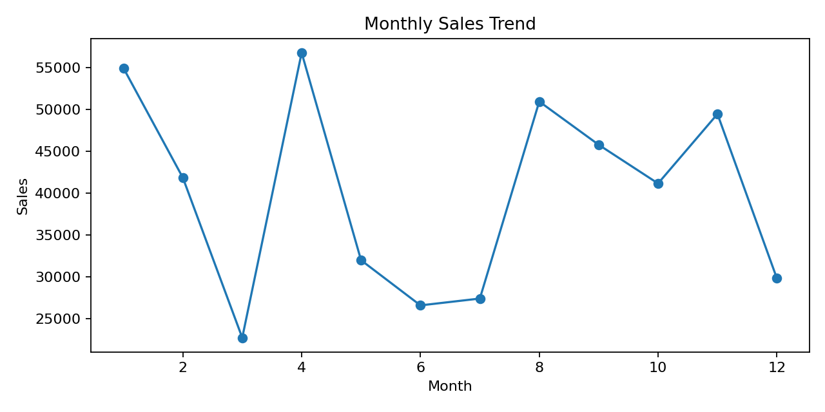
Figure 1: Monthly Sales Trend
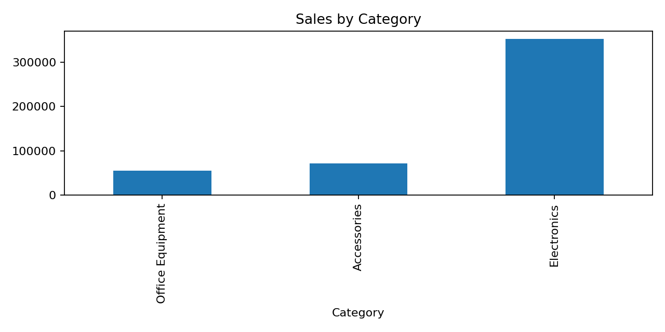
Figure 2: Sales by Category
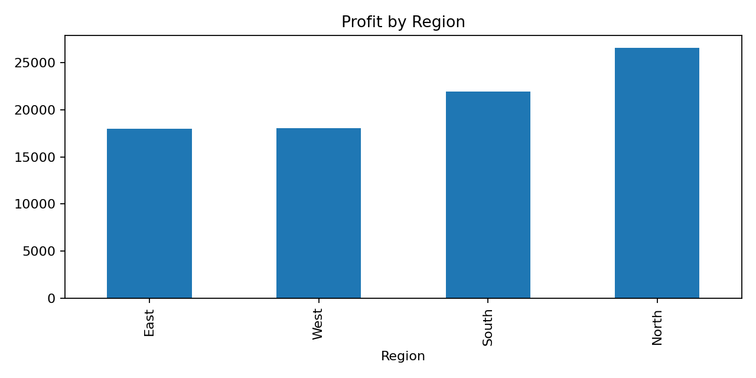
Figure 3: Profit by Region
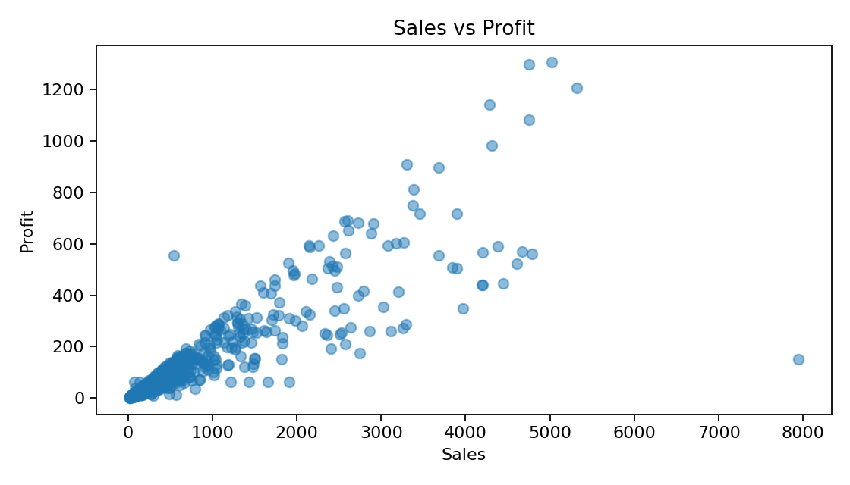
Figure 4: Sales vs Profit
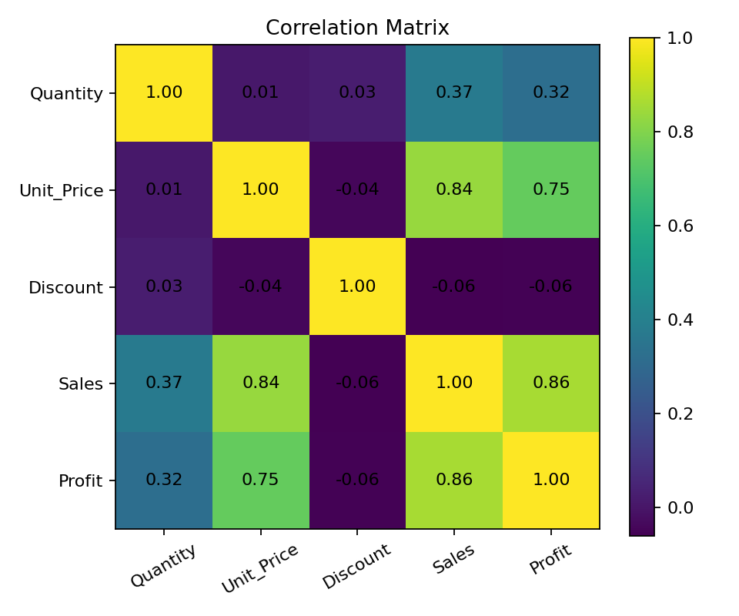
Figure 5: Correlation Matrix

10. References
Python Documentation; Pandas Documentation; NumPy Documentation; Matplotlib Documentation.

