REAL-WORLD DATA PROJECT
Retail Sales Analysis and Demand Prediction
Submitted by: Saiprasad Rajendra Devadhe
Roll No.: 123
Class/Division: TE/A
College: Amrutvahini College of Engineering Sangamner
Academic Year: 2026–27

1. Abstract
This project applies data science techniques to a retail-sales dataset. It performs data cleaning, exploratory analysis, visualization and supervised machine learning. A Random Forest regression model is used to predict units sold from product, price, promotion, channel, region and calendar features.

2. Problem Statement
Retail businesses need to understand product and regional performance and estimate demand for inventory planning. This project analyzes retail transactions and builds a demand-prediction model.

3. Objectives
Inspect and clean the dataset; analyze revenue and profit; identify trends and relationships; build a Random Forest demand model; evaluate predictions using MAE, RMSE and R²; and provide business recommendations.

4. Dataset
The raw dataset contains 1,005 transaction rows with intentional missing values, duplicate records and demand extremes. The cleaned dataset contains 1,000 records. Fields include date, product, category, region, channel, promotion, units sold, unit price, discount, revenue, cost and profit.

5. Data Preparation
Missing cells identified: 37. Duplicate rows removed: 5. Demand outliers detected using IQR: 21. Numerical missing values were median-imputed and categorical missing values were filled with the mode. Revenue was recalculated after cleaning.

6. Business Analysis
Total revenue is 3,691,048.02; total profit is 1,097,280.28; profit margin is 29.73%. The top product by revenue is Smartphone, while West generated the highest regional revenue.

7. Predictive Modeling
An 80:20 train-test split was used. Categorical variables were one-hot encoded and numerical variables were imputed. Random Forest Regression was selected to model nonlinear demand relationships.

8. Model Evaluation
MAE = 3.449 units, RMSE = 4.348 units, and R² = 0.8558. Lower MAE/RMSE indicate smaller prediction errors, while a higher R² indicates stronger explanatory performance.

9. Key Findings
Revenue varies by product and month. Promotional transactions tend to increase demand. Product, price, channel and calendar features provide useful information for demand prediction. The analysis can support inventory and promotion decisions.

10. Recommendations
Use demand predictions for inventory planning; monitor high-revenue products; evaluate promotions using both revenue and profit; compare online and physical-store performance; and retrain the model as new data becomes available.

11. Conclusion
The project demonstrates an end-to-end real-world data workflow from raw data to actionable insight and predictive modeling. The combination of EDA and Random Forest regression provides both descriptive and predictive value.

12. Future Scope
Deploy the model through a dashboard/API, compare advanced boosting models, add time-series forecasting, incorporate customer-level features, and monitor model drift.
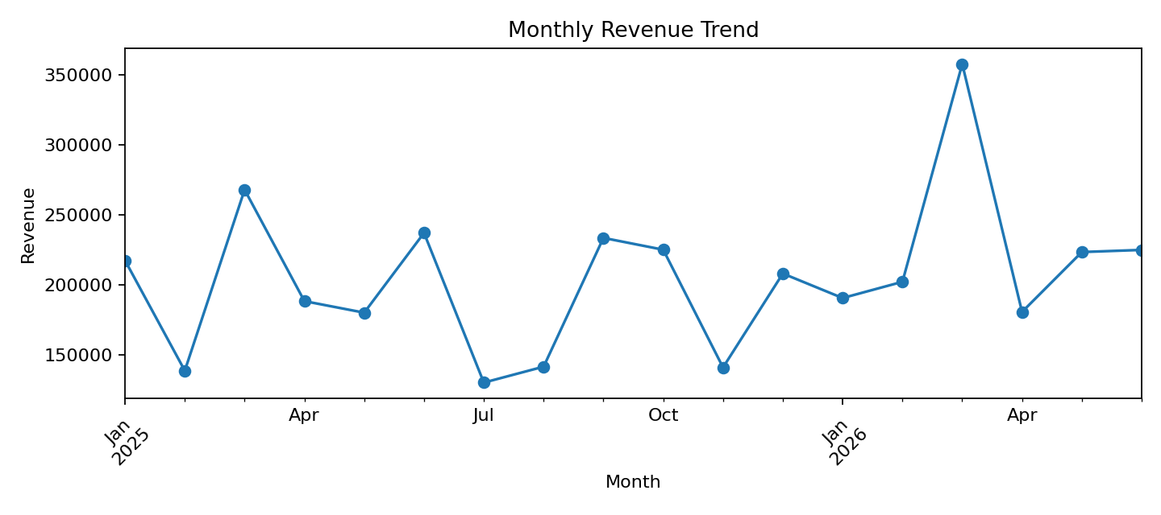
Figure: Monthly Revenue Trend
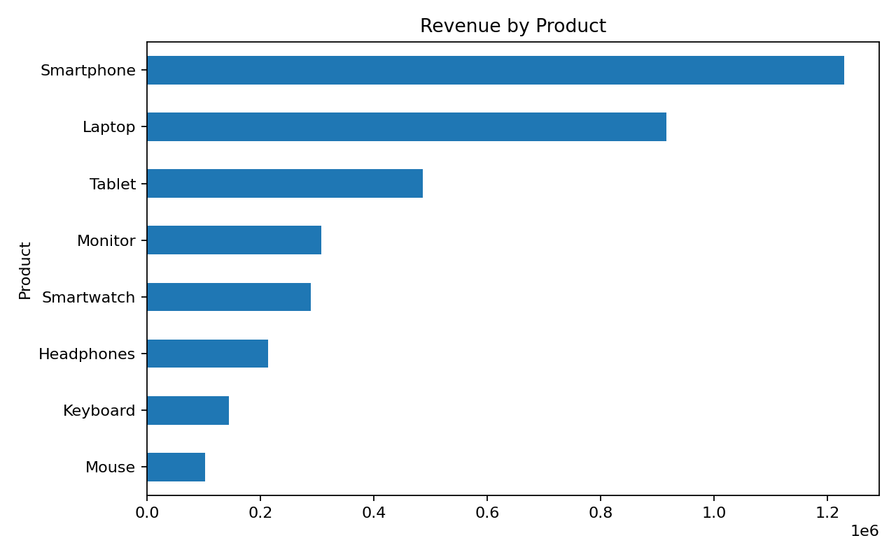
Figure: Revenue by Product
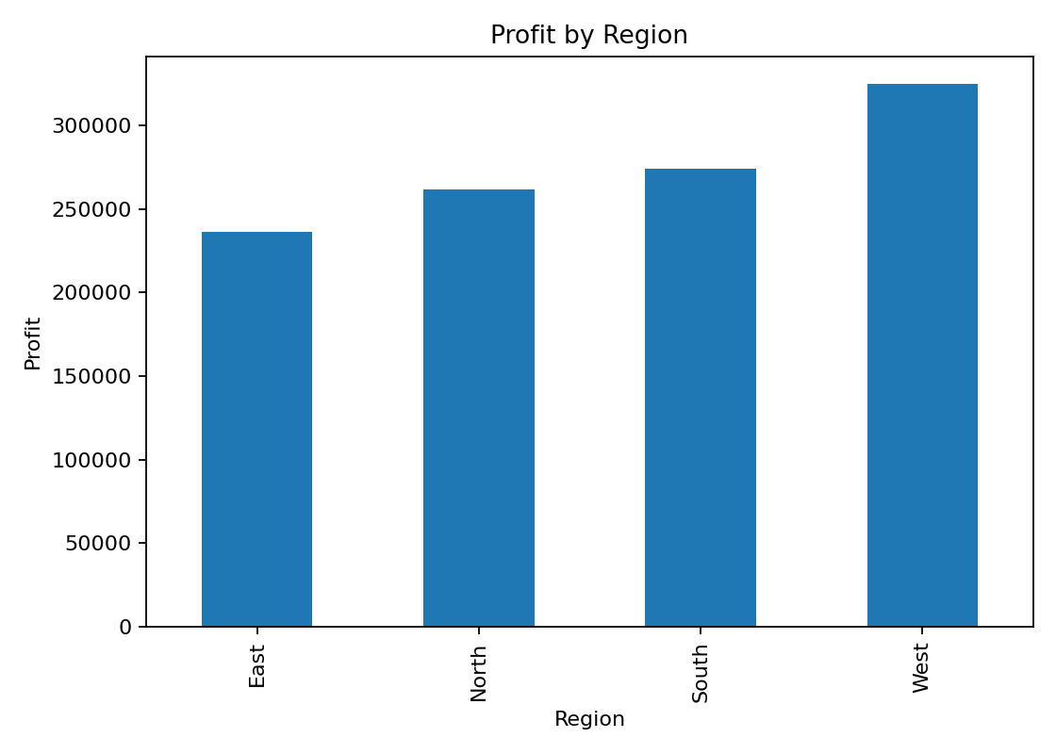
Figure: Profit by Region
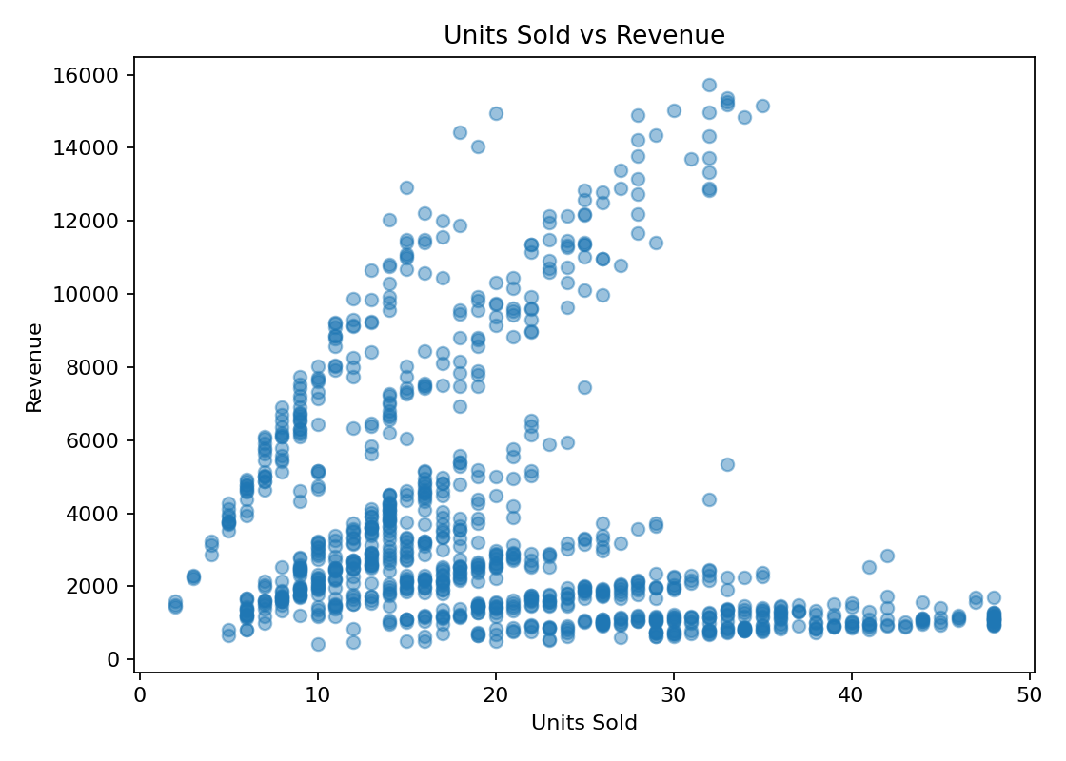
Figure: Units Sold vs Revenue
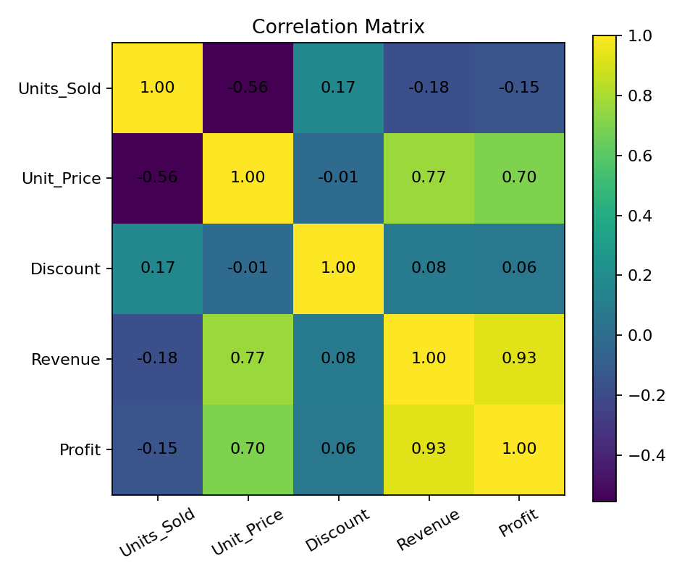
Figure: Correlation Matrix
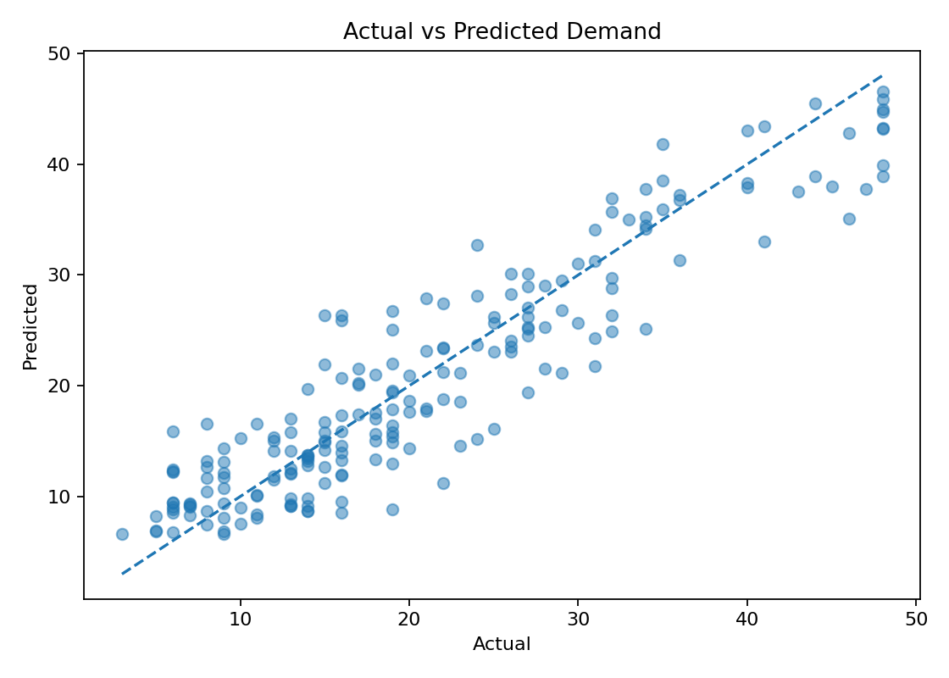
Figure: Actual vs Predicted Demand

13. References
Python Documentation; Pandas Documentation; NumPy Documentation; Scikit-learn Documentation; Matplotlib Documentation.

