PREDICTIVE MODELING USING MACHINE LEARNING
Customer Churn Prediction using Random Forest
Submitted by: Saiprasad Rajendra Devadhe
Roll No.: 123
Class/Division: TE/A
College: Amrutvahini College of Engineering Sangamner
Academic Year: 2026–27

1. Abstract
This project develops a supervised machine-learning model to predict customer churn. The workflow covers data inspection, missing-value handling, duplicate removal, outlier treatment, feature encoding, model training and evaluation. A Random Forest classifier is evaluated using accuracy, precision, recall, F1-score, confusion matrix and ROC-AUC.

2. Objectives
Prepare a customer dataset; handle missing values, duplicates and outliers; transform categorical and numerical features; train a Random Forest classifier; evaluate performance; visualize results; identify useful churn-related patterns.

3. Dataset Description
The project contains 1200 unique customer records with demographic, contract, payment, service, tenure, monthly-charge and churn information. The raw dataset intentionally contains data-quality issues for preprocessing practice.

4. Tools and Technologies
Python 3.x, Pandas, NumPy, Scikit-learn, Matplotlib and Jupyter Notebook/Google Colab.

5. Preprocessing
Duplicates are removed. Missing numerical values are imputed with the median and missing categorical values with the most frequent category inside the Scikit-learn pipeline. Monthly-charge outliers are capped using the IQR method. Categorical variables are one-hot encoded and numerical variables standardized.

6. Algorithm
Random Forest is an ensemble of decision trees. It is appropriate for classification because it can learn nonlinear relationships and interactions between customer attributes. The model uses 250 trees, maximum depth 8, class balancing and random state 42.

7. Train-Test Split
The data is divided into 80% training and 20% testing using stratified sampling. Preprocessing is performed through a pipeline to avoid leakage.

8. Model Performance
Accuracy = 0.7792
Precision = 0.4000
Recall = 0.3556
F1 Score = 0.3765
ROC-AUC = 0.7391

9. Confusion Matrix
The test confusion matrix is [[171, 24], [29, 16]]. It shows correct and incorrect churn classifications.
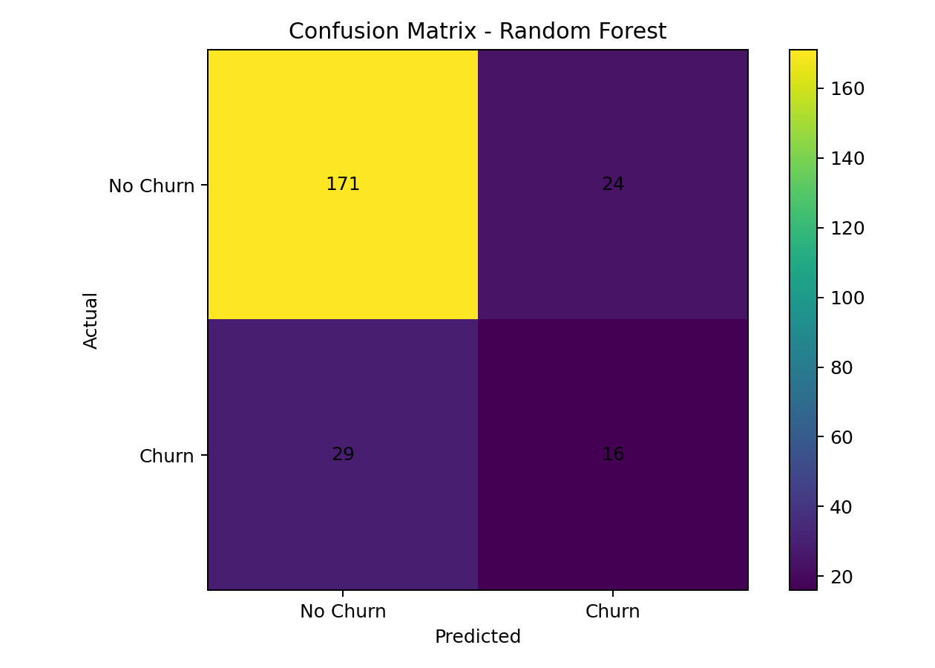
Figure 1: Confusion Matrix

10. ROC Curve
The ROC curve shows the trade-off between true-positive and false-positive rates across thresholds. The AUC summarizes discrimination performance.
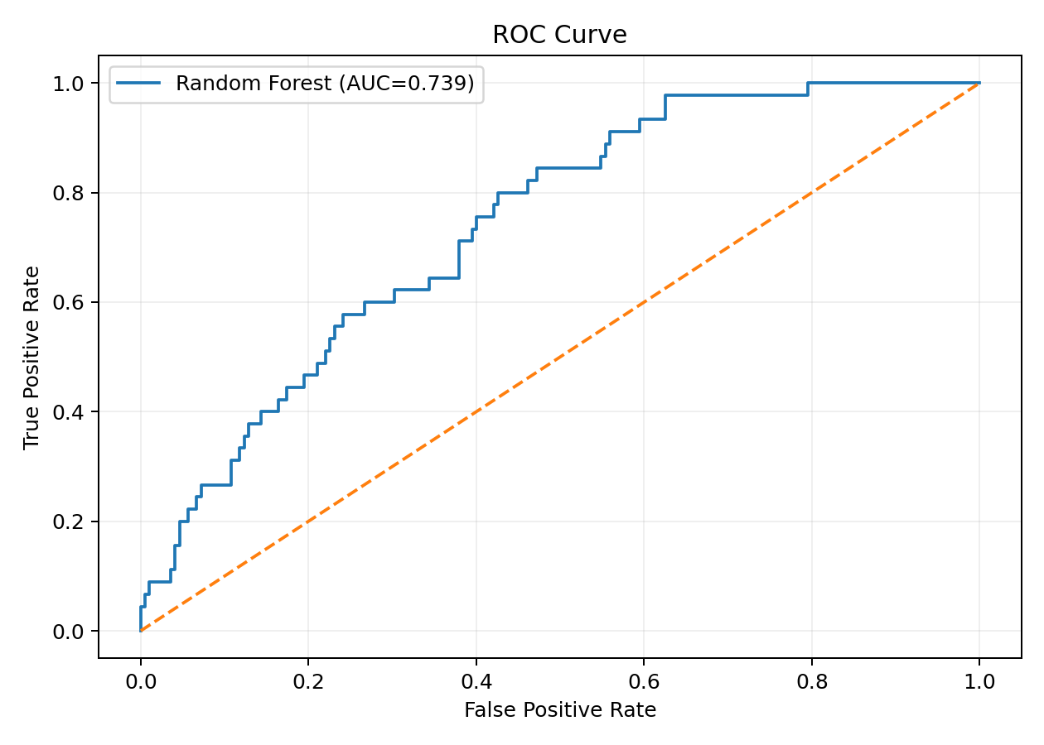
Figure 2: ROC Curve

11. Feature Importance
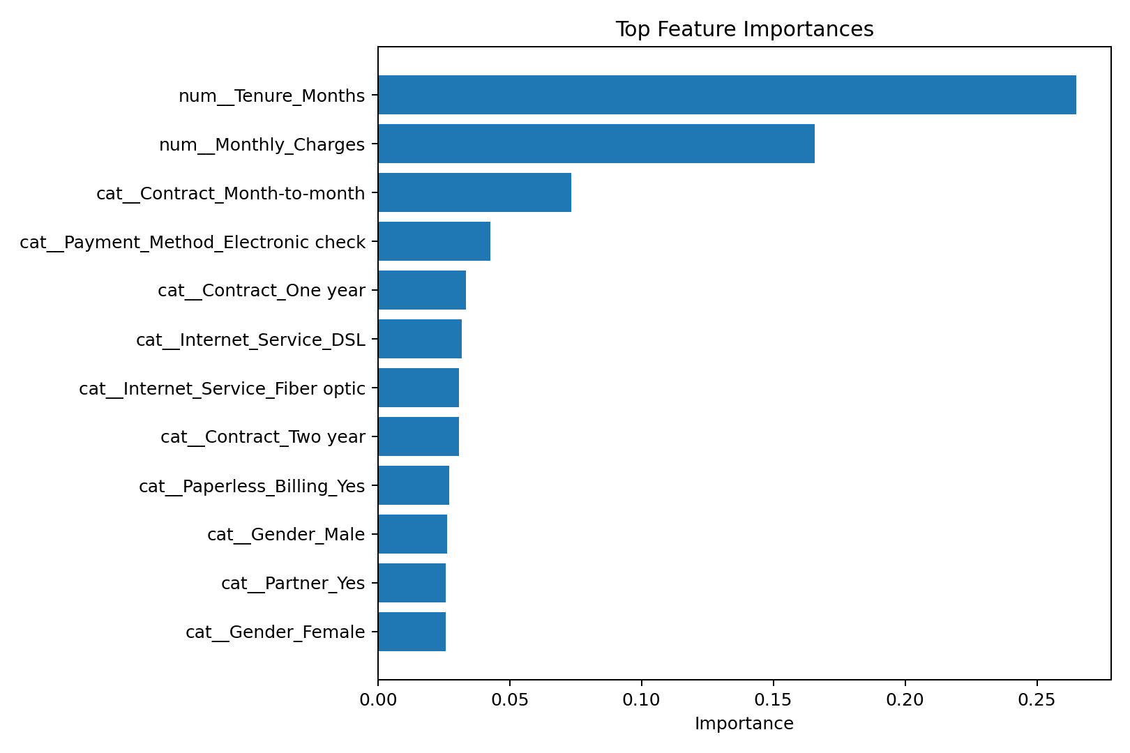
Figure 3: Top Feature Importances

12. Additional Visual Analysis
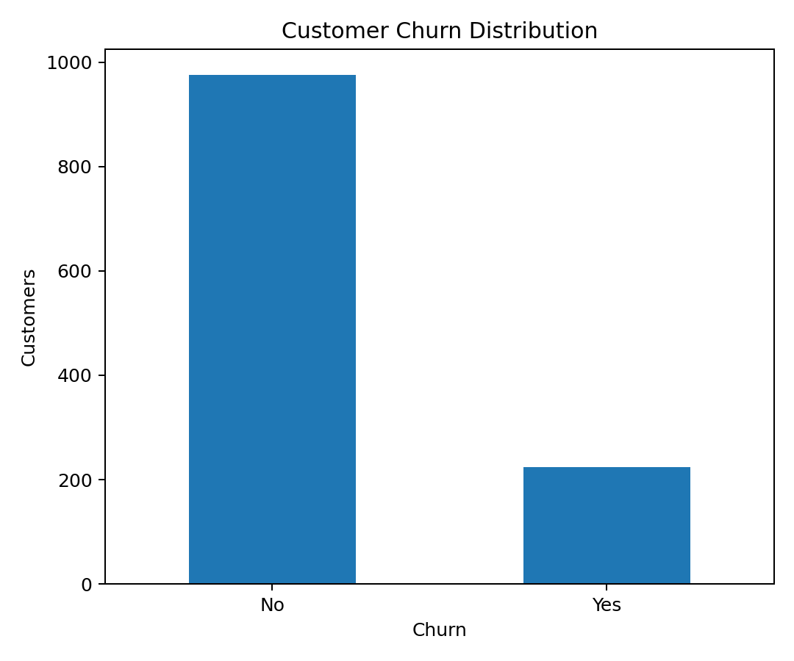
Figure 4: Churn Distribution
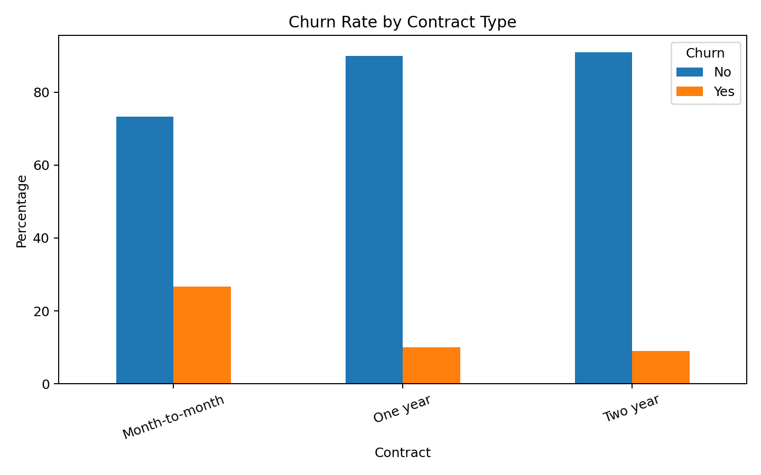
Figure 5: Churn Rate by Contract Type

13. Key Findings
- Contract type and customer tenure provide important predictive information.
- Payment method, internet service and monthly charges also contribute to churn prediction.
- The confusion matrix makes false positives and false negatives interpretable.
- ROC-AUC provides a threshold-independent view of model discrimination.

14. Conclusion
The project successfully implements a complete supervised machine-learning workflow. The Random Forest classifier learns patterns from customer attributes and produces measurable churn predictions. The evaluation metrics and visualizations demonstrate practical model assessment.

15. Future Scope
Compare additional algorithms, tune hyperparameters, deploy the model as a web application/API, add SHAP-based explainability and retrain on larger real-world datasets.

16. References
Python Documentation — https://docs.python.org/
Pandas — https://pandas.pydata.org/docs/
Scikit-learn — https://scikit-learn.org/stable/
Matplotlib — https://matplotlib.org/stable/

