DATA CLEANING & VISUALIZATION PROJECT
Sales Data Cleaning and Visualization Analysis
Submitted by: Saiprasad Rajendra Devadhe
Roll No.: 123
Class/Division: TE/A
College: Amrutvahini College of Engineering Sangamner
Academic Year: 2026–27

1. Abstract
This project demonstrates a complete data cleaning and visualization workflow using Python. A sales dataset was inspected for missing values, duplicate records and outliers. Pandas was used for preprocessing and aggregation, while Matplotlib was used to create visual reports. The final clean dataset was analyzed to identify sales, profit, product, category, regional and monthly trends.

2. Objectives
- Understand the structure and quality of a raw dataset.
- Identify and handle missing values.
- Detect and remove duplicate records.
- Detect and handle numerical outliers using the IQR method.
- Create meaningful visualizations using Python.
- Extract business insights from cleaned data.

3. Tools and Technologies
Python 3.x, Pandas, NumPy, Matplotlib, Jupyter Notebook/Google Colab, CSV.

4. Dataset Description
The dataset contains sales transactions with Order ID, Date, Product, Category, Region, Customer ID, Quantity, Unit Price, Discount, Sales and Profit. A project-ready sample dataset is included with intentional data-quality problems to demonstrate preprocessing.

5. Data Cleaning Methodology
Issue | Method | Purpose
Missing categorical values | Mode imputation | Preserve valid category labels
Missing numeric values | Median imputation | Reduce influence of extreme values
Duplicate rows | drop_duplicates() | Avoid double counting
Quantity outliers | IQR + capping | Limit abnormal transaction quantities
Date values | pd.to_datetime() | Enable time-based analysis
Derived values | Recalculate Sales | Keep dependent fields consistent

6. Dataset Quality Summary
Metric | Value
Initial records | 325
Missing cells before cleaning | 24
Duplicate records removed | 5
Quantity outliers detected | 4
Final records | 320
Missing cells after cleaning | 0

7. Visualizations and Findings

Monthly Sales Trend
The monthly line chart helps identify periods of higher and lower sales.

Sales by Category
Category-level aggregation shows which business category contributes most to sales.

Profit by Region
Regional comparison highlights the strongest profit-generating region.

Sales vs Profit
The scatter plot helps examine the relationship between transaction sales and profit.

Sales by Product
Product aggregation identifies the products with the highest sales contribution.
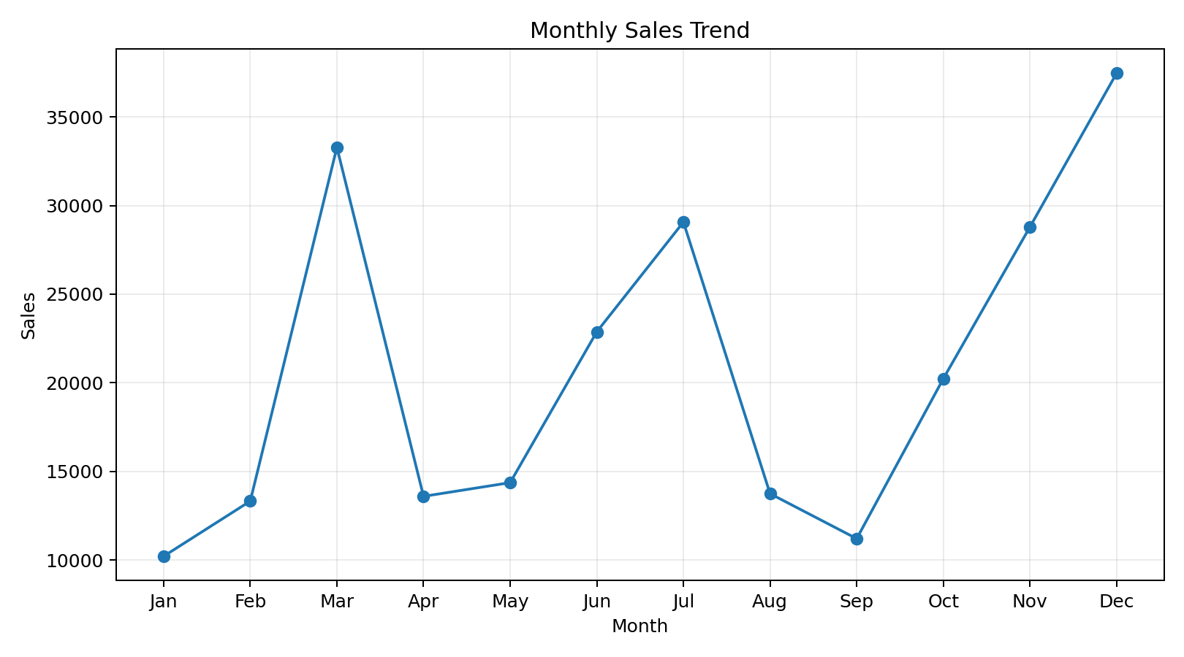
Figure 1: Monthly Sales Trend
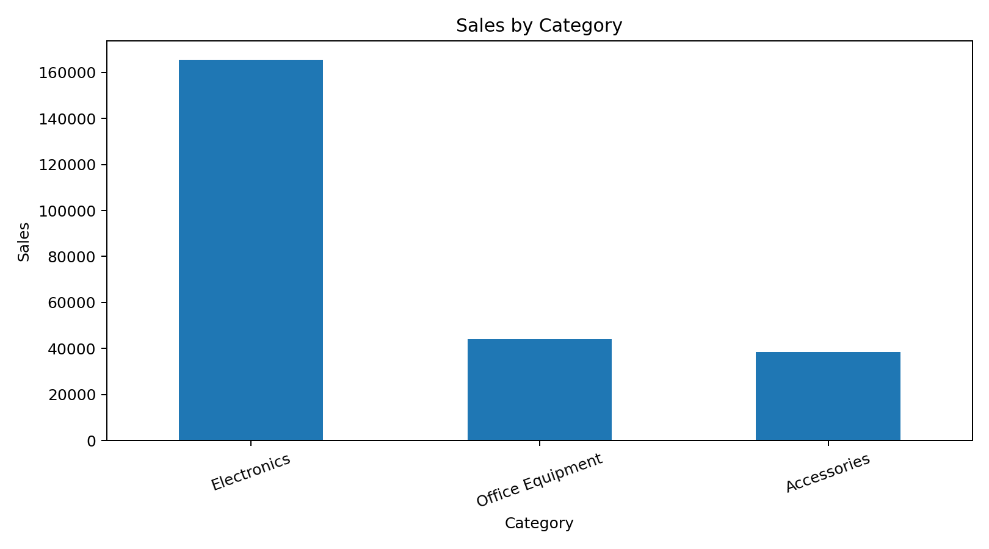
Figure 2: Sales by Category
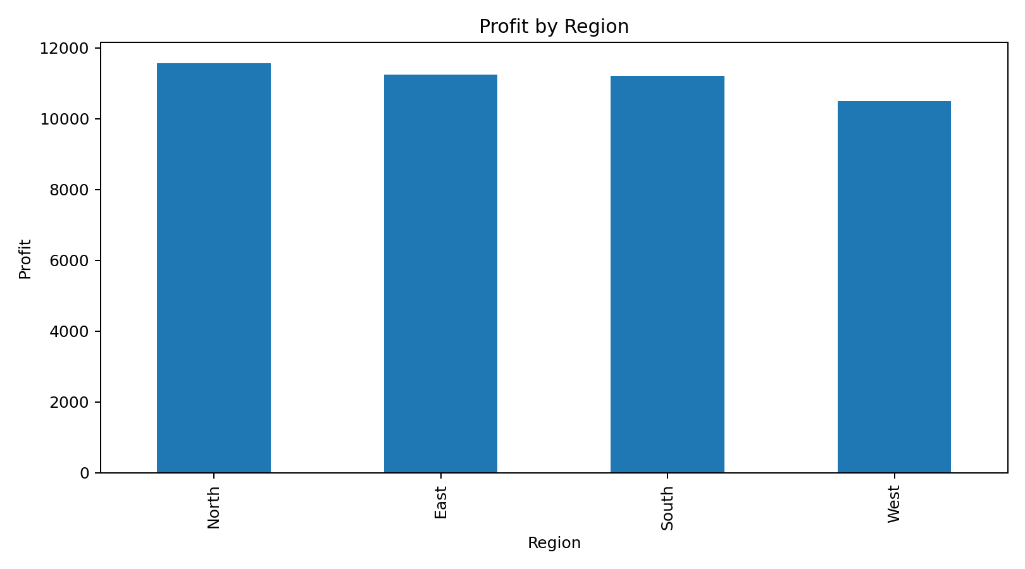
Figure 3: Profit by Region
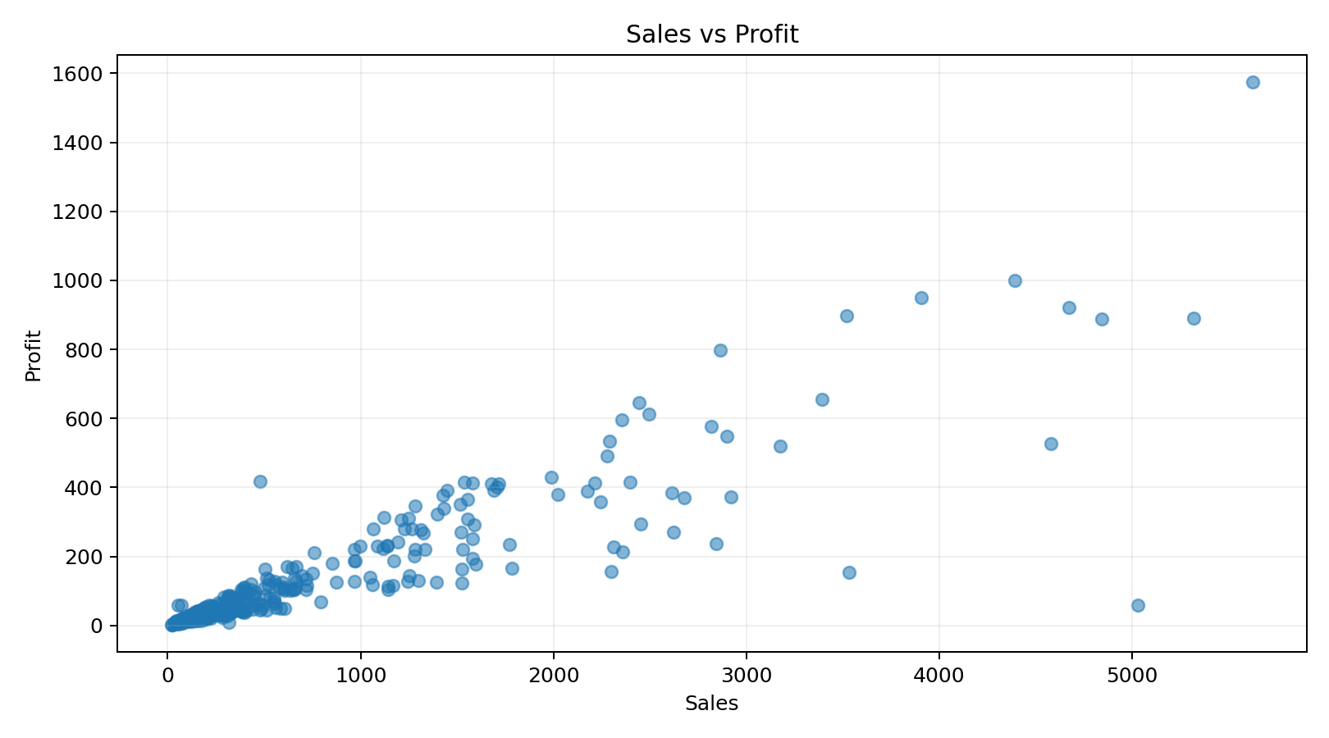
Figure 4: Sales vs Profit
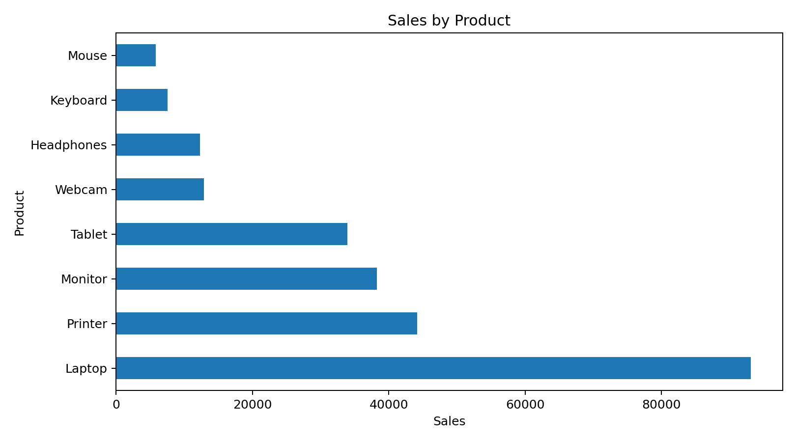
Figure 5: Sales by Product

8. Key Results
Total sales after cleaning: 248,181.14
Total profit after cleaning: 44,506.01
Top product by sales: Laptop
Top category by sales: Electronics
Top region by profit: North

9. Conclusion
The project successfully demonstrates how raw business data can be converted into a reliable and interpretable dataset. Missing values were imputed, duplicate records were removed, outliers were identified and capped, and visualizations were created to communicate trends. The workflow provides a practical foundation for exploratory data analysis and data-driven decision making.

10. Future Scope
- Build an interactive dashboard using Power BI, Tableau or Plotly.
- Add predictive sales forecasting using machine learning.
- Automate data validation and quality checks.
- Include customer segmentation and product recommendation analysis.

11. References
1. Python Documentation – https://docs.python.org/
2. Pandas Documentation – https://pandas.pydata.org/docs/
3. Matplotlib Documentation – https://matplotlib.org/stable/

