Solent University

School: Department of Science and Engineering

Course: Software Engineering

Module: Mobile Application Development (COM527)

Assessment: Assessment Report

Students: 102535666

Date: 15/12/25

Due: 05/05/26

1. “A user should be able to view a map of their current area on their smartphone or tablet. This map should always be positioned at the user's current (GPS) position on the earth; when the user changes their physical location, the map should reflect this.”
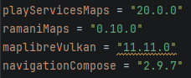
I will first start with this task by setting up the dependencies in my build.gradle and libs.versions.toml files. I will add MapLibre with Vulkan support, the Ramani Maps Compose wrapper, and the standard AndroidX libraries needed for Compose.
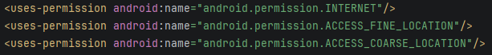
Then in the AndroidManifest.xml, I will set up the ACCESS_FINE_LOCATION and ACCESS_COARSE_LOCATION permissions, as well as INTERNET, since the map tiles will be gathered remotely from OpenFreeMap.

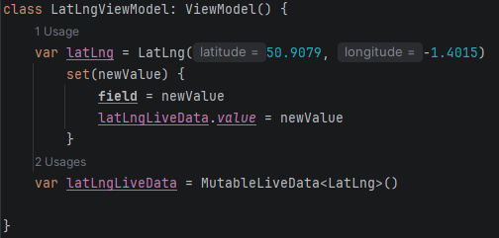
To manage the location state in both the activity and UI, I will need to add a LatLngViewModel class that will hold a latLng property backed by a MutableLiveData object. Whenever the latLng is updated, i.e. the user's location changes, it should automatically push the new value to latLngLiveData, making it observable from the UI layer.
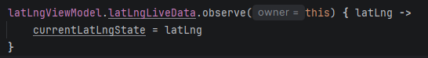
In the MainActivity, I will add the LocationListener interface. This will allow me to override the onLocationChanged function, where I will update the ViewModel's latLng with the current coordinates gathered by the device itself.
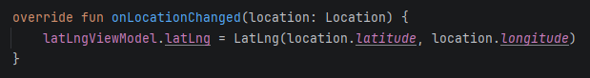
To start receiving GPS updates, I will create a GPS function that will retrieve the LocationManager system service and call requestLocationUpdates, which I will set to update every 2 seconds or after 5 metres of movement. This will keep the GPS accurate without slowing the machine down too much.
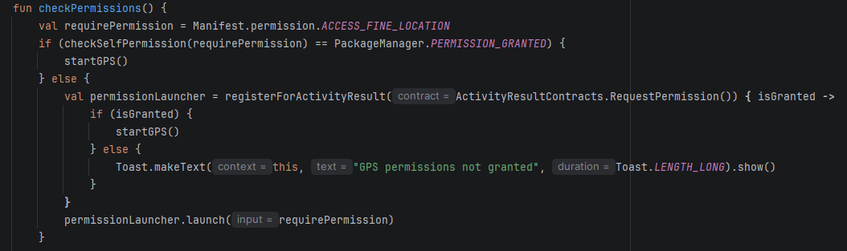
I will also write a checkPermissions function that will check whether the location permission has already been granted. If they haven’t, then it will launch a permission request. This will make sure that the GPS function is only called if the user approves the use of their location. A Toast message was shown if they denied it.
Inside the setContent itself, I will use a mutablestate variable to hold the current LatLng and zoom level, observed the ViewModel's LiveData to keep that state updated, and pass the values into a MapLibre composable via a CameraPosition, causing the map to recentre automatically whenever the user's location changed. This was all placed inside a Scaffold with innerpadding to prevent any overlap of the devices interfaces with the application itself.
