Solent University

School: Department of Science and Engineering

Course: Software Engineering

Module: Mobile Application Development (COM527)

Assessment: Assessment Report

Students: 102535666

Date: 15/12/25

Due: 05/05/26

1. “A user should be able to view a map of their current area on their smartphone or tablet. This map should always be positioned at the user's current (GPS) position on the earth; when the user changes their physical location, the map should reflect this.”
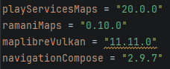
I will first start with this task by setting up the dependencies in my build.gradle and libs.versions.toml files. I will add MapLibre with Vulkan support, the Ramani Maps Compose wrapper, and the standard AndroidX libraries needed for Compose.
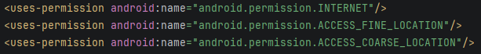
Then in the AndroidManifest.xml, I will set up the ACCESS_FINE_LOCATION and ACCESS_COARSE_LOCATION permissions, as well as INTERNET, since the map tiles will be gathered remotely from OpenFreeMap.

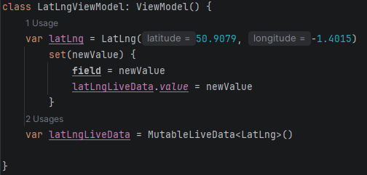
To manage the location state in both the activity and UI, I will need to add a LatLngViewModel class that will hold a latLng property backed by a MutableLiveData object.
Whenever the latLng is updated, i.e. the user's location changes, it should automatically push the new value to latLngLiveData, making it observable from the UI layer.
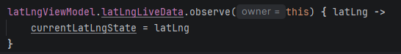
In the MainActivity, I will add the LocationListener interface. This will allow me to override the onLocationChanged function, where I will update the ViewModel's latLng with the current coordinates gathered by the device itself.
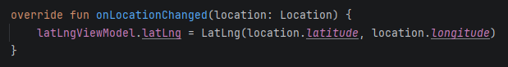
To start receiving GPS updates, I will create a GPS function that will retrieve the LocationManager system service and call requestLocationUpdates, which I will set to update every 2 seconds or after 5 metres of movement. This will keep the GPS accurate without slowing the machine down too much.
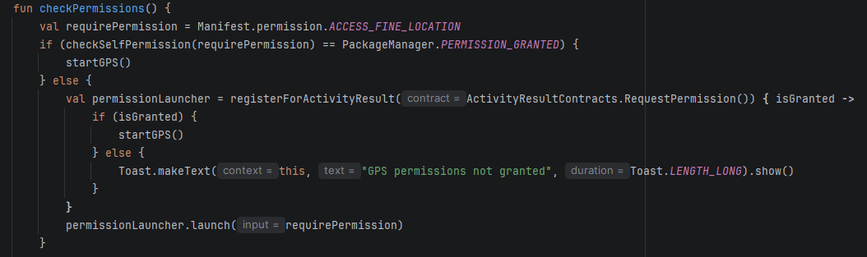
I will also write a checkPermissions function that will check whether the location permission has already been granted. If they haven’t, then it will launch a permission request. This will make sure that the GPS function is only called if the user approves the use of their location. A Toast message was shown if they denied it.
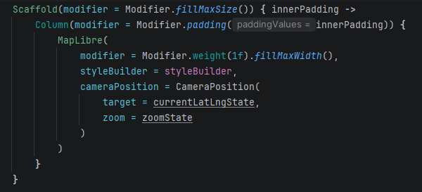
Inside the setContent itself, I will use a mutablestate variable to hold the current LatLng and zoom level, observed the ViewModel's LiveData to keep that state updated, and pass the values into a MapLibre composable via a CameraPosition, causing the map to recentre automatically whenever the user's location changed. This was all placed inside a Scaffold with innerpadding to prevent any overlap of the devices interfaces with the application itself.

2. “A user should be able to add a new point of interest at their current GPS location. The user should be able to input the following information:
- name;
- type (pub, restaurant, hotel, historical site, etc);
- description.
- POI code in hexadecimal which must begin with 0x4d4144 (validate this)
The input should be done using a separate screen, making use of Jetpack Compose navigation. The point of interest should appear on the map as a marker as soon as it has been added. For now you can just use buttons for navigation – there is no need to use an app bar, a navigation bar, or the navigation drawer just yet.”

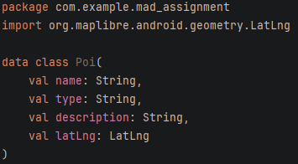
I will first begin by creating a POI data class to store the information of each point of interest. This will give me a reusable structure that can be passed around between my screens and be stored in my ViewModel.

I then plan to update my LatLng ViewModel to also include the POI list rather than adding a second ViewModel as this already holds the GPS location. I will add MutableLiveData<List<Poi>> so that the MainActivity can observe the list, meaning that whenever a POI is added the UI can then automatically know to redraw any makers on the map. I will then add a function to the ViewModel which will add a given POI in its parameter to the list.
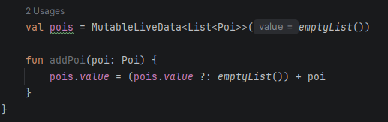
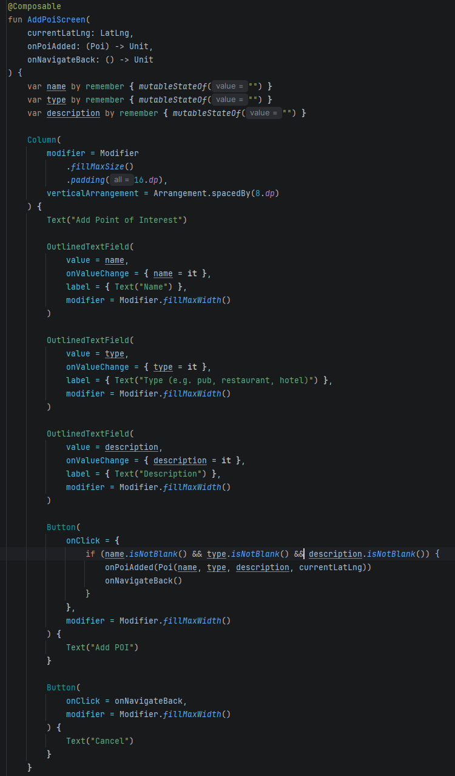
I will then add a separate composable for the POI screen. I plan to put this in its own separate file to prevent code from clustering in the MainActivity. I will add two callback functions to the parameter of the composable. One will be for when a POI I added and the other will be for when the user wishes to navigate back to the home screen. I will also make it so the users current LatLng is also passed as a parameter for the POIs location. I will make the POI screen itself using three labeled text fields for the name, type and description of the point of interest and one button to add the poi which will use the two callback functions. I will also add a simple error handler which will prevent a POI from being added if any of the text fields are empty.
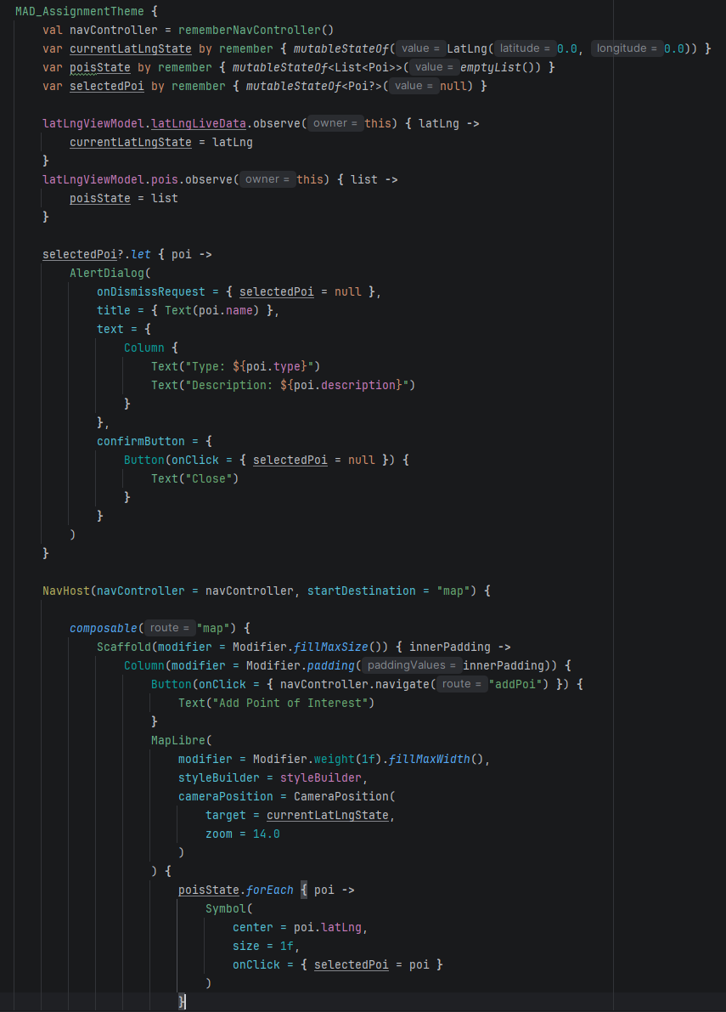
I will finally update the main composable to include the map page and the add poi page using the compose navigation. I will add the NavHost which will contain the two routes for the map page and the add poi page. I will then be able to define the callback functions for the onPoiAdded and onNavigateBack. onPoiAdded will add the new poi to the ViewModel and the onNavigateBack will return the user to the previous page they were on. I will place a Symbol marker inside the MapLibre lambda. The map will then be redrawn whenever the poisState changes. This will then loop through poisState and place a Symbol at each POI's LatLng. This makes it so new markers appear automatically the moment a POI is added. I will make it so an alert dialog appears when the marker is clicked on, displaying the markers details including its name, type and description. This allows me to test that the marker has been added correctly.

3. “A user should be able to save all points of interest added to a local SQLite database.”

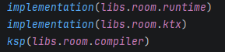
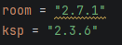
I will first begin this task by adding the dependencies for Room.

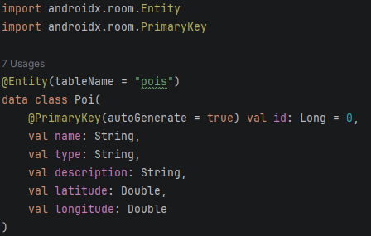
I will then update my POI data class to be a room entity instead. This will allow me to easily save any POI to the local database.

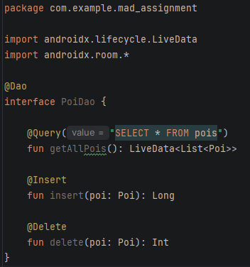
I will next add the POI Data Access Object (DAO), this will set the methods for the database so it can be changed or searched. I plan to make it so that when the database returns all the POIs it contains, it will return it as a LiveData<List<Poi>>. This will make sure that the UI is automatically updated with a new list of POIs whenever the database is changed. For now, I will give it three functions, getAllPois(), insert() and delete().

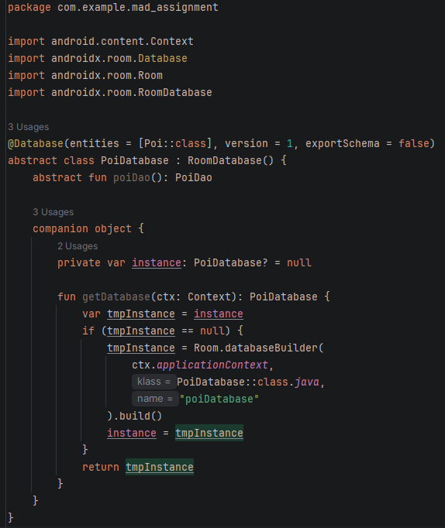
I plan to next create the file for the database itself. This will be placed within an abstract function which allows my other files to access its DAO and all the database operations within it. Inside it I will put a getDatabase() function which will check that a database doesn’t already exist, if not it will create one and save it, otherwise it will simply return the one that already exists.
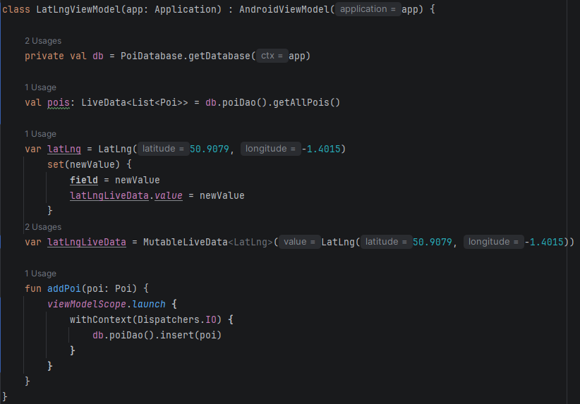
I will next update my Viewmodel. I will first change the ViewModel for a AndroidViewModel so that it can access the application context which will be needed to open the database. I plan to update the poi variable so that it gathers all the pois from the database as LiveData allowing it to automatically update when a new POI is added. Because of this, I will also need to change the addpoi function in the Viewmodel so that it adds the poi to the database instead of list using the poiDao’s insert function.

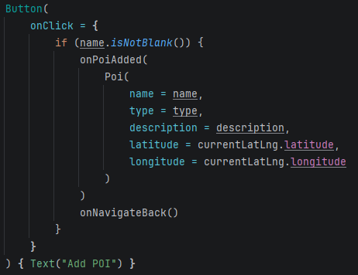
I will then update the button for my AddPoiScreen. I will simply change the Poi structure in the button so that it fits the databases poi structure since the latitude and longitude for the pois in the database are separate variables.

I will then need to change the MainActivity so that the Poi is converted back into the LatLng so that the map can properly mark its location.
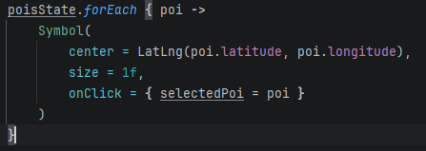

Just to confirm that this all worked, I added a new poi and checked Android Studios App Inspecter to show my databases contents with which the poi I added had been successfully added to the database.

4. “A user should be able to load all existing points of interest from a local SQLite database. These should be displayed on the map as either markers (symbols) or circles. When a user clicks on the marker a dialog box should appear containing details of the point of interest.”

I have already set up the loading process for the POIs for task 3. This is done on startup and whenever the database is updated. However, to fit this task better I will change the code to use a button instead, this will make testing easier and give the user more control.

I will start this by changing the DAO to return a plain list instead of the LiveData since the POIs will no longer be automatically loaded.

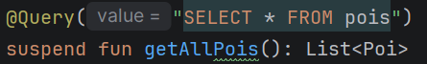

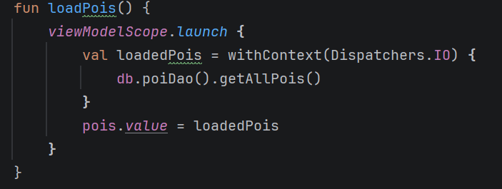
I will also need to add a new function to the ViewModel which will load all the POIs from the database. It will run the database query on Dispatchers.IO in the background, then set the result to pois.value which should triggers the observer in MainActivity which will then update the map.

I will then also need to change the poi variable so that it holds a plain list of pois instead of being assigned directly from the DAO’s live data since it no longer returns LiveData.

I will then lastly need to add the load buttons to the MainActivity. This will call the load poi function in the view model, loading all the pois from the database into the UI.
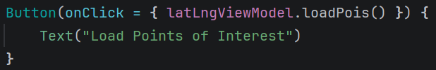

5. “Allow the user to search for points of interest by TYPE, by inputting the TYPE in a text field. This should search the local database. The matching places should appear on the map as markers or circles. Again a dialog box should appear when the user clicks on each place.”

I will start this task by adding new query to my DAO. This will search the poi database using a given type to find any pois with that match that type. This will then return a list of all the matching pois found.

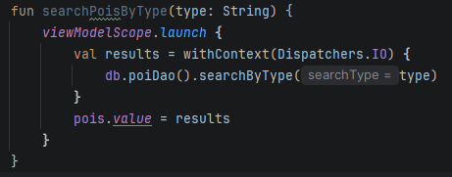
I will next create a new function in the ViewModel. This will use the search by type function from the DAO. This will have the type as a parameter to search with and add the results to the pois.value. This makes it so when a user searches a type, it only displays markers relating to that type. Then to display all the pois again the user will simply need to load the pois again.

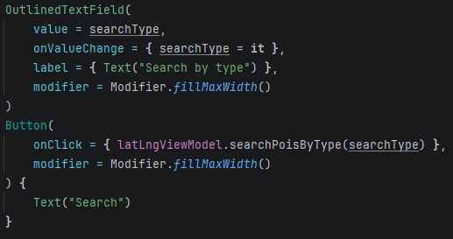
Then I will add an outlined text field to my MainActivity which will be used by the user to input the accommodation type that they are searching for. This will then be followed by a button which, when clicked, will take the inputted data and call the search pois by type function using the inputted data as the parameter.

6. “The user should be able to load points of interest from the web. You should connect to the following web service (use the supplied Node server and access from the emulator):
http://10.0.2.2:3000/poi/all
A database of POIs, sourced from OpenStreetMap (copyright OpenStreetMap contributors and licensed under the Open Database License) will be provided.
When the POIs are loaded they should be shown on the map as markers and saved to the database. To avoid duplicate entries in the database, check whether the point of interest with that ID is already present before adding it.”

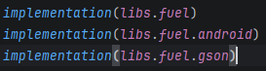
To complete task I will be using fuel so that my application can communicate across the web. To begin with I will need to add all the dependencies relating to fuel and import it where it is needed.

On top of this I will need to add usesCleartextTraffic=”true” to my application. This is because Android doesn’t allow access to insecure servers (HTTP) which my server is. By using this it disables the restriction allowing my app to communicate with the server.

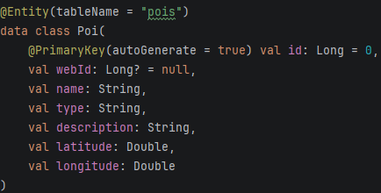
I will update my poi entity to include a separate ID. This is because currently room automatically designates IDs to the pois which have been added, so to match the web pois IDs, a new id field should be added to prevent IDs from being mistakenly rewritten.

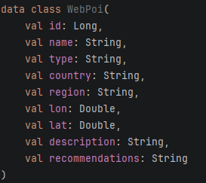
I will then create a new data class for the pois coming from the web. This will be a separate class to my poi entity class as they both currently have different feilds. GSON will parse the JSON from the web into this new data class’s objects which will then be converted into my Poi entity to then be saved on the local database.

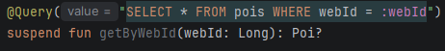
I will also then need to add a new DAO method which will be used for duplicate checking. This will gather all the secondary IDs to be used for comparison.

This will need a new function which I will store within my ViewModel. This will use the web servers get request using the “http://10.0.2.2:3000/poi/all” url which will gather all the pois in the web data base. The function will then, within a coroutine so it can handle the database operations, check each poi in the web database and compare its id with the ones in the local database. The ones that have an id which already exists in the local database are skipped to prevent duplicates. For those that are not skipped will be added to the local database.
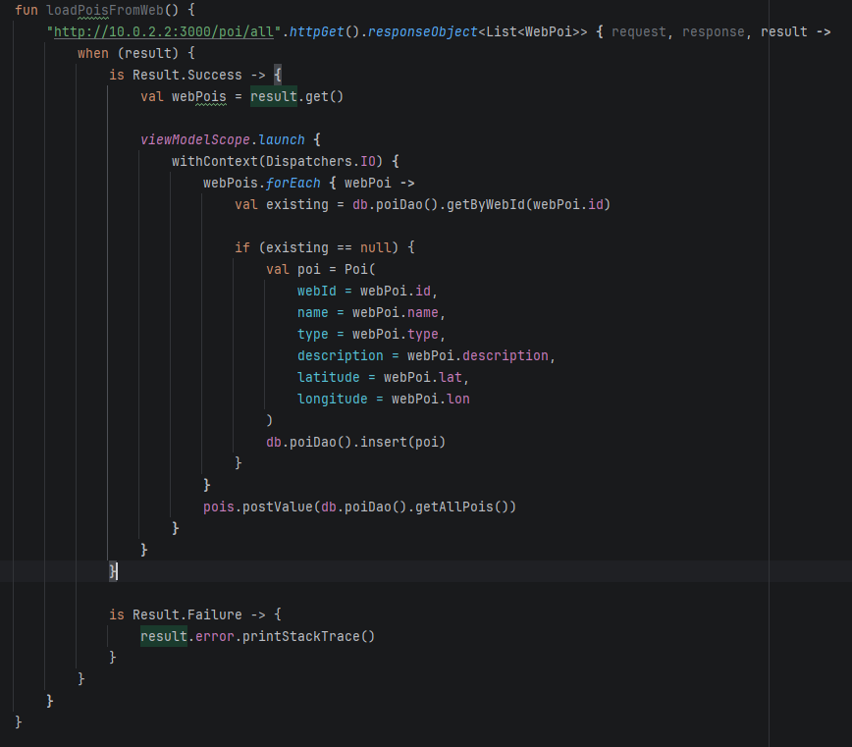

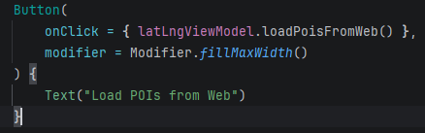
Then finally for this task I will need to add a new button in the MainActivity which uses the new function.

7. “A point of interest should be saved to the web after it has been added to the map and before it is added to the database.
Again, use the supplied Node server) with a method of POST:
http://10.0.2.2:3000/poi/create
The following POST parameters must be specified:
- name (the point of interest name)
- type (the point of interest type)
- description (the point of interest description)
- lat (the latitude)
- lon (the longitude).
- API ID. This should be set to the value 0x4d4144
The server will return an ID, and you should use this ID to save it in the database.”

To start this task, I will need to change my addPoi() function in the Viewmodel. I will change the function so that instead of inserting the poi into the local database straight away it will first POST to the server using the http://10.0.2.2:3000/poi/create url, which will return the ID, then the function will use this ID as the webId then save it locally using the poi DAO insert function.. This makes sure that the poi is only added to the local database if it is successfully added to the web data base. This prevents any misalignment between the two databases.

I will need to make sure to decode the returned ID to a string and then to a long to make sure it matches the typing in the local database.

Since the original poi has webId set to null, I will use .copy() to create a new Poi object with the same fields but with the null webId replaced by the ID returned by the server. The original poi will then be removed. This makes sure that the record saved to the local database has a webId that matches the server.

