Solent University

School: Department of Science and Engineering

Course: Software Engineering

Module: Web Application Development (COM518)

Assessment: Assessment Report

Students: 102535666

Date: 15/12/25

Due: 27/04/26

Part A – Develop a very simple REST API
“You should first develop a simple JSON-based REST web API using Node.js and Express which allows clients to”:
1. “Look up all accommodation in a given location”:
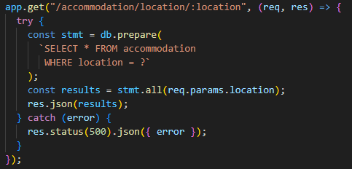
For this first task, I will create a simple GET endpoint at /accommodation/location/:location. The location will be taken as a URL parameter and passed into a prepared statement querying the accommodation table of the given database. This should then return the full result set as JSON, and because it's a GET request I can then test it directly in the browser. I will finally contain this in a try{} and catch{} statement so if the GET request results in an error, the error will be returned in place of the JSON from the database.
2. “Look up all accommodation of a given type in a given location (e.g. all hotels in Hampshire).”
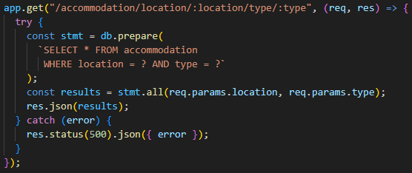
For Task 2, I will add a second GET endpoint at /accommodation/location/:location/type/:type. By using two URL parameters for the location and type, both parameters will then feed into a single prepared statement filtering using both the location and type.Like the previous GET endpoint, I will be able to easily test it in the browser and will be contained in a try{} and catch{} statement similarly to the previous task.

3. “Book a place of accommodation for a given number of people on a given date. The API should expect the accommodation ID, the number of people, and the date.”
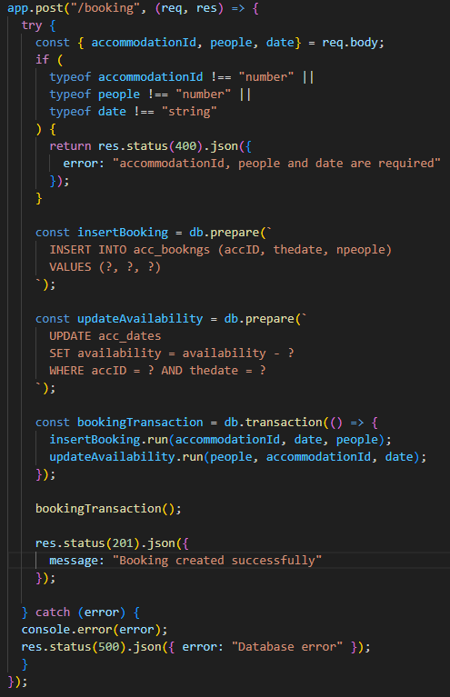
For Task 3, I plan to create a POST endpoint at /booking that will read the accommodationId, people, and date from a given JSON request body. I will add a type check to return a 400 error if any field is missing or if the values given are the wrong type. I also plan to wrap the two database statements, inserting into acc_bookngs and decreasing the availability in acc_dates, inside a db.transaction(). This will make sure that both operations will either succeed or fail together, this would prevent one change happening without the other in the event of an error which would make the database inaccurate. I will then test the endpoint using the Thunder Client. Like the previous tasks I will also wrap this inside a try{} and catch{} statement.

Part B – Develop a simple AJAX-based TypeScript front-end
For the frontend I will choose to use React with TypeScript, in an attempt to gain the extra credits.
I plan to structure the app around three files, first being the App.tsx as the root component holding the shared state, and two child components a SearchComponent and a ResultsComponent.
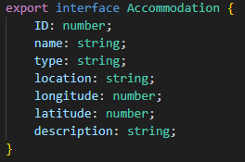
I will define an Accommodation interface in App.tsx and then export it so both child components could share the same type, avoiding any unneeded duplication.

4. “Write an HTML page (which MUST be named index.html) which allows the user to search for all accommodation in a given location. The user should be able to enter a location, and then, using TypeScript, the page should communicate with your REST API to find all points of interest in that region. The JSON must be parsed, and the results presented to the user in a user-friendly way.”
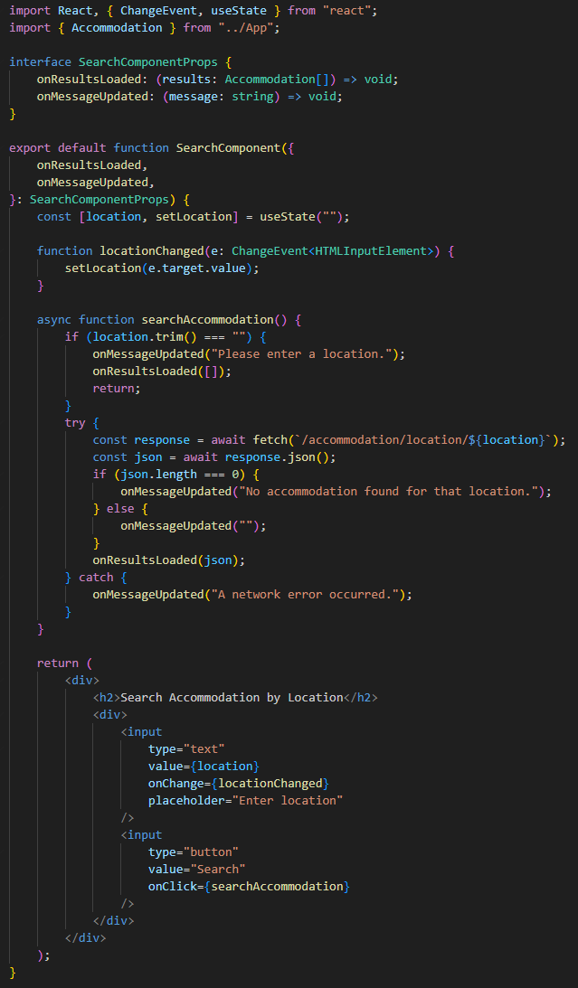
Specifically for task 4, the SearchComponent I will create will manage its own location input state. When the user clicks Search, it will fire an async fetch to /accommodation/location/:location and pass the parsed JSON up to App via the onResultsLoaded callback. If the location field is empty or the response is empty, a message is displayed to the user through onMessageUpdated.

5. “Modify your code to process the search results, so that you create a “Book” button for each result. When the user clicks on this button, you should send an AJAX POST request to the REST API (task 3) to book the accommodation. For now, hard-code the number of people to one, and the date to any of the available dates in the database. In other words, the user does not have to enter the number of people or the date at this stage.”
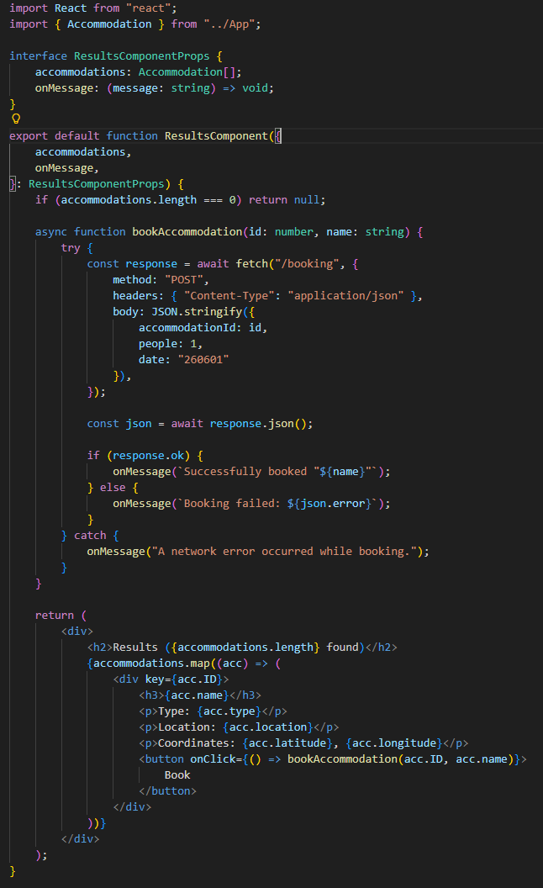
For Task 5, ResultsComponent will receive an accommodation array and render a “card” for each result showing name, type, location, and coordinates. Each card will include their own Book button. Clicking it will fire an AJAX POST to /booking with accommodationId set to the result's ID, with the people hard coded to 1, and date hard coded to a date present in the database such as 260601. The response will then be used to update the message shown to the user either a success confirmation or an error from the API.

Part C – Adding simple error-checking

6. “Add error-checking to task 3, so that if any of the details (ID, number of people, date) are blank, an appropriate HTTP error code is sent back to the client. Then, modify task 5 to test for the HTTP code returned from the server and display an appropriate user-friendly message to the user, which will be understood by a non-technical user.”
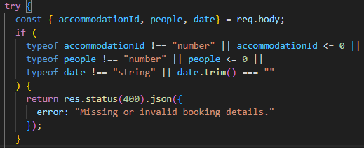
Although I had already added error checking to task 3 when originally doing the task. I will tweak the error handling to be broader and include more potential misinputs/incorrect inputs that the user could make. For instance, I will make the error handling include if the user inputs 0 for the accomodationID or the number of people, as the ID can’t be zero nor can the number of people for the booking. Moreover, I will make it so the error handling also prevents an empty string for the date to ensure that the availability is correctly reduced for the given date. I will also change the returned error message that is given to the user to better reflect the broader error handler.

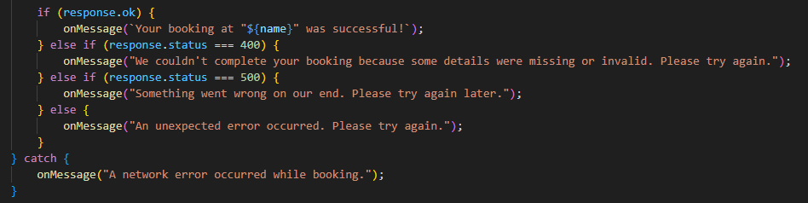
Similarly to the task 3 error handling, I will improve upon tasks 5 current error handling. I plan to change the if statement, which checks whether the response is okay, to also include specific error statuses so the message that is returned better reflects the error shown to the user. For example, if a status of 400 is returned, which reflects an invalid input by the user, it will display the appropriate message informing the user that the given details are invalid. On the other hand, if a status of 500 is returned, which reflects a server-side error, it will inform the user that there is an error on our end. If any other status code is returned, not including an okay response, the user is simply informed that an unknown error has occurred. This will make sure that all errors are handled and displayed appropriately.

Part D – Adding a map
7. “Using Leaflet, add an OpenStreetMap map to Task 4, so that the results are displayed as markers on the map. When a user clicks a marker, the accommodation name and description should appear as a popup.
You must use Leaflet and OpenStreetMap. In particular, Google Maps is NOT acceptable.”

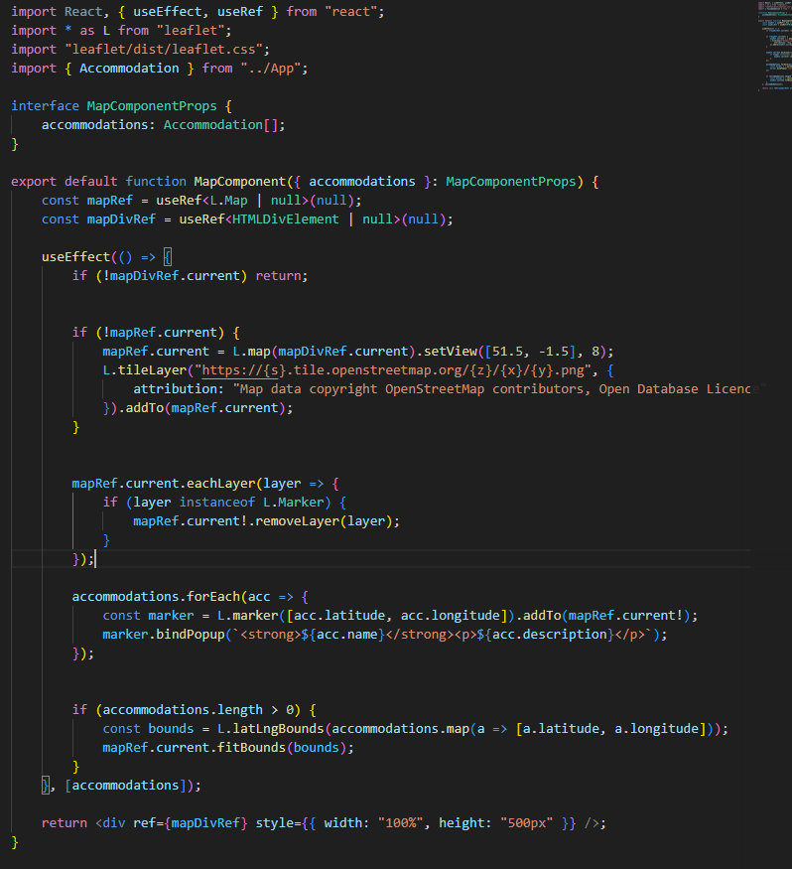
Since I am using react, I will need to set up a separate component for the map to use Leaflet directly inside React using useref, which will reference the map div, and useEffect, which will initialise the map and markers. For each Accommodation inside an Accommodation list given in the parameter of the component, a marker will be added for each Accommodation, being given their own popup including their name and description when the marker is clicked. I will also, for ease of visuals, make it so the map shows all the current markers on the map of the location which was searched. This puts all relevant markers on display for the user to see and select.

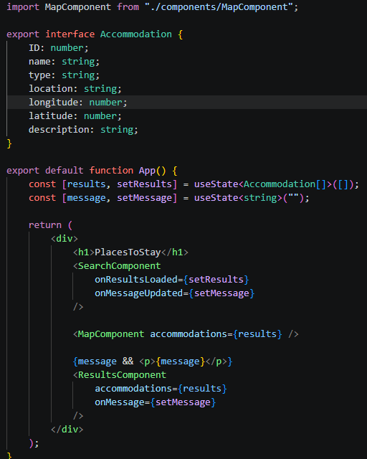
To finalise this task, I then simply need to add the component to the App.tsx

Part E – logins and sessions
8. “Implement a session-based login system. A user should be able to login from the main index page via a login form. If a user logs in successfully, a message should appear within a <div> on the index page, e.g.

Logged in as jsmith

If the user reloads the page, the login status needs to be maintained, with the “Logged in as” message appearing if the user is logged in, or the login form if not.
There is no need to implement a signup facility, as the provided database contains existing users.”

For the session-based login system I will first need to set up a declaration file for express-session-better-sqlite3 as it does not have the corresponding @types declaration package.

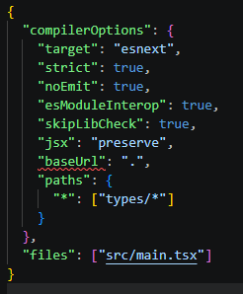
I will then update my tsconfig file by adding the paths option so Typescript can find the declaration file.

