Mystery Drive Image Forensic Report
Geldi Omeri
3/26/2019
19 Pages

Index

Contents
Index 2
Summary 3
Authentication 5
Physical Image Layout 7
Analysis Table 11
Item Details 12
Item Hidden Message in Unpartitionable Space: 12
Message within theTermite.txt: 14
Image within anna1.doc: 15
HiPaul.docx: 16
Item Link within thePurist.txt 18

Summary

I began the investigation by creating 2 copies of the master image. A “mysteryDriveImage – Autopsy.dd” file, meant to be analyzed through Autopsy, and a “mysteryDriveImage – WinHex.dd” file, which would be analyzed through WinHex. Opening both copies up with their respective tools, I initially checked them for the general partition set up.
Autopsy showed 5 volumes within the drive image. Volume 1 which included 128 unallocated sectors, a FAT16 partitioned volume 2, an unallocated volume 3, a FAT16 partitioned volume 4, and an unallocated volume 5. The first volume contained the Master Boot Record and partition table for the drive. The second and fourth volume were regular FAT16 partitions that were also visible in the partition table. The third volume did not show up in the partition table but appears to have originally been a FAT16 partition. The final volume was simply unpartitioned space.
I checked the physical layout in WinHex afterwards to make sure it lines up with what Autopsy showed. WinHex displayed the information in a different manner but essentially confirmed what Autopsy had shown. The starting sectors where unallocated and held the MBR and partition table. In WinHex it showed the same information but had called the volumes with filesystems partitions, in which there were three, while the unallocated space was simply unpartitioned. Partitions 1 and 3 had FAT16 filesystems. Partition 2 was shown as having a FAT16 filesystem in WinHex but also appeared as a lost partition, as well as not showing up in the partition table again. This indicates that it could have been deleted and had not be overwritten yet. Finally, the unallocated space at the end was shown in more detail as two spaces. An unpartitioned space and an unpartitionable space following it.
Images of all of this was taken and provided as well as a Technical Details Report provided by WinHex. This report provides a more detailed view of the number of sectors each partition contains, the number of clusters it contains, and the number and percentage of unfilled, free clusters also. Lastly, a diagram was created showcasing all the partitioned and unallocated space in the drive image.
Following the analysis of the physical layout, I began to examine the drive and search for any items of importance. Five total items were discovered. The first was a hidden message at the end of the drive within its unallocated, unpartitionable space. The message was informing whoever the recipient was that the person they will be meeting should look like their picture and will go by the name of Anna. Correlating to this item was a file located in the third partition named “anna1.doc” that contained a picture of a woman. Potentially the picture the message was referring to.
After this a text search for the word “meet” was done in WinHex and discovered another message, this time in a file named “theTermite.txt.” This text file contained the poem The Termite by Ogden Nash at the top followed by a lot of random characters. Near the end was a hidden message that appeared to be either from a man name Paul or talking to him. The message talked about the structure of a poison called ricin and that the creator of this message would explain it when they would meet up. With the knowledge that the name Paul was of importance, a .docx file named “HiPaul.docx” became more relevant to the investigation. This file was kept in the first partition and was not hidden. Opening it up showed a message that appeared to be written for Paul from a person named Craig. The message mentioned that the flash drive was being given to Paul and contained pictures of two musicians, some of their music, and some other files on it that Craig did not delete.
Finally, a text search in WinHex for the word “ricin” found a link placed underneath the text file “thePurist.txt.” This text file holds another poem by Ogden Nash and the file is held in the same folder as the previously mentioned theTermite.txt file. The link was found not far below the poem and would direct to a Wikimedia page. The page contained an image of a plant named Ricinus communis. This plant is used in the creation of the ricin poison and could be part of what was referred to in the message which mentioned the ricin poison’s structure.
Overall, the finds include two hidden messages, one hidden link, one direct message via a word document, and one image. The word document gives names to the sender, Craig, and recipient of the drive, Paul, as well as potentially hinting at further information in other files. The hidden messages indicate that Paul and Craig planned to meet to discuss the ricin poison, while the link showcased one of the main parts in the poison’s creation. The final hidden message at the end of drive appears to be informing Paul of a meeting with a woman who goes by Anna and looks like a picture provided in the drive. This meeting could potentially revolve around the ricin poison considering the other items but there is no direct indication of that found in this drive.

Authentication

Original
MD5 Hash = 7224DCA799CAAADBCC0848C8217BBB40
SHA1 Hash = 83A368D987399A7ECCB6A23FD78C35889D94C972

WinHex
MD5 Hash = 7224DCA799CAAADBCC0848C8217BBB40
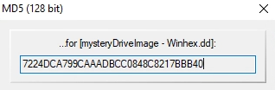

SHA1 Hash = 83A368D987399A7ECCB6A23FD78C35889D94C972
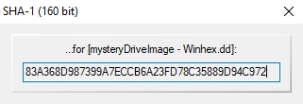

Autopsy
MD5 Hash = 7224DCA799CAAADBCC0848C8217BBB40
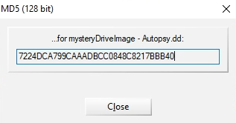

SHA1 Hash = 83A368D987399A7ECCB6A23FD78C35889D94C972
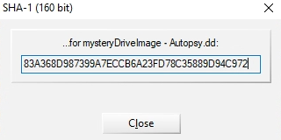

Physical Image Layout

The drive contains the starting sectors which includes the Master Boot Record and the boot sectors, three FAT16 partitions, and unallocated space at the end of the drive. The starting sectors contains sectors 0 – 127 which include the MBR with the partition table. Partition 1 contains sectors 128 - 186,495 and contains 46,492 clusters. Partition 2 contains sectors 186,496 - 211,071, 24,344 clusters, and appears to be a lost partition, potentially deleted. Partition 3 contained sectors 211,072 - 239,743 and clusters 14,260. The unallocated space at the end contains sectors 239,744 - 251,647 and includes both an unpartitioned space and an unpartitionable space at the end.
Below are images of the partition locations in both Autopsy and WinHex, the partition table in hex values, a WinHex Technical Details Report, and a diagram of the physical locations.

WinHex

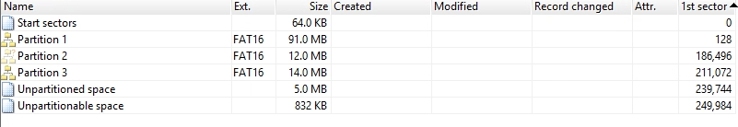
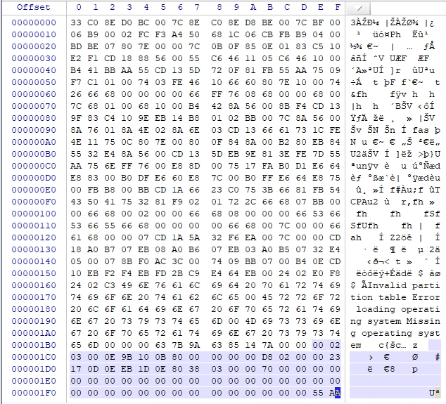
Autopsy

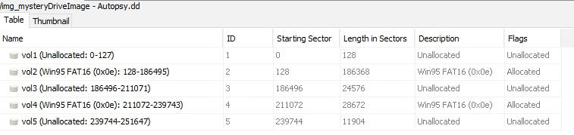
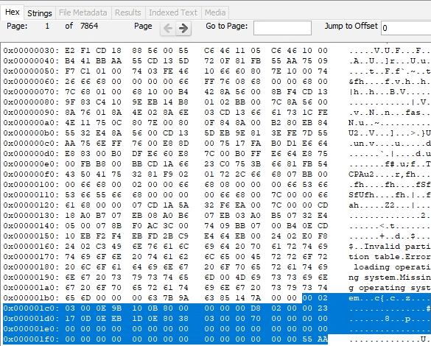

WinHex Technical Details Report

WinHex 18.0 SR-3
03/24/2019, 18:04:37

[D:\Users\gomeri\Desktop\midterm\mysteryDriveImage - Winhex.dd]

Total capacity: 128,843,776 bytes = 123 MB
Bytes per sector: 512
Sector count: 251,648

Partitioning style: MBR
Disk signature: 7A148563
Unpartitionable space: 1,664 Sectors

Partition 1
Sectors 128 - 186,495
Partition table: Sector 0
File system: FAT16
Name: NV1
Total capacity: 95,420,416 bytes = 91.0 MB
Sector count: 186,368
Usable sectors: 185,968
First data sector: 400
Bytes per sector: 512
Bytes per cluster: 2,048
Free clusters: 38,054 = 82% free
Total clusters: 46,492
FAT1 = FAT2
Volume label date: 03/11/2019 00:06:52
Clean shut down: Yes
I/O error-free: Yes
Serial No.: 37A392FA (hex)
Serial No.: FA92A337 (hex, rev)
Serial No.: 4203914039 (dec, rev)

Partition 2, lost
Sectors 186,496 - 211,071
File system: FAT16
Name: NEW VOLUME
Total capacity: 12,582,912 bytes = 12.0 MB
Sector count: 24,576
Usable sectors: 24,344
First data sector: 232
Bytes per sector: 512
Bytes per cluster: 512
Free clusters: 24,341 = 100% free
Total clusters: 24,344
FAT1 = FAT2
Volume label date: 03/11/2019 00:04:50
Clean shut down: Yes
I/O error-free: Yes
Serial No.: 78AEF3E2 (hex)
Serial No.: E2F3AE78 (hex, rev)
Serial No.: 3807620728 (dec, rev)

Partition 3
Sectors 211,072 - 239,743
Partition table: Sector 0
File system: FAT16
Name: NV2
Total capacity: 14,680,064 bytes = 14.0 MB
Sector count: 28,672
Usable sectors: 28,520
First data sector: 152
Bytes per sector: 512
Bytes per cluster: 1,024
Free clusters: 8,922 = 63% free
Total clusters: 14,260
FAT1 = FAT2
Volume label date: 03/11/2019 00:06:10
Clean shut down: Yes
I/O error-free: Yes
Serial No.: 41DD23E4 (hex)
Serial No.: E423DD41 (hex, rev)
Serial No.: 3827555649 (dec, rev)

Unused inter-partition space:
Sectors 0 - 127 (64.0 KB)
Sectors 239,744 - 251,647 (5.8 MB)
= 5.9 MB

Layout Diagram
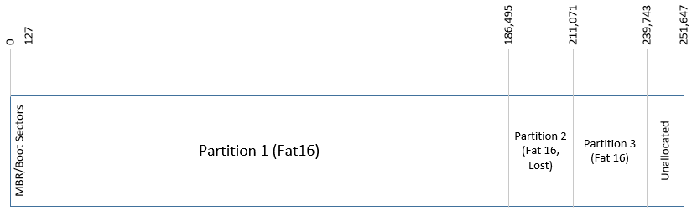

Analysis Table

Item # | Item Description | General Location | Cluster Location & Size | Sector Location & Size | Byte Location & Size
1 | Hex String with two sentences in it that gives instructions for meeting with someone named Anna. | End of the drive within the unallocated and unpartitionable space. | No clusters since it is an unallocated space with no filesystem. | Sectors:  251,644 - 251,647  Size: 4 Sectors | Bytes:  07ADF9D0 – 07ADFFC8  Size:  1,528 Bytes
2 | Text file named theTermite.txt. It contains within it a message regarding a poison at the end of its hex string. | In partition 1 within the nash folder. | Clusters:  8,286 – 8,428  Size:  142 Clusters | Sectors:  33,664 - 34,235  Size:  571 Sectors | Bytes:  01060000 -010A770D  Size:  292,621 Bytes
3 | A .doc file named anna1.doc with an image of a woman. | Contained within partition 3. | Clusters:  5 – 551  Size:  546 Clusters | Sectors:  211,230 – 212,323  Size:  1,093 Sectors | Bytes:  00013C00 - 0009C756  Size:  559,958 Bytes
4 | A .docx file named HiPaul.docx that contains a message to Paul from what appears to be Craig. | Contained within Partition 1 | Clusters:  8,228 – 8,235  Size:  7 Clusters | Sectors:  33,304 – 33,335  Size:  31 Sectors | Bytes:  01043000-01046A69  Size:  14,953 Bytes
5 | A text file named thePurist.txt that contains a link to an image of the plant Ricinus communis. | Contained within partition 1 within the nash folder. | Clusters:  8,240 – 8,283  Size:  43 Clusters | Sectors:  33,480 – 33,652  Size:  172 Sectors | Bytes:  01049000 -0105E936  Size:  88,374 Bytes

Item Details

Item #1

Hidden Message in Unpartitionable Space

This item is not a file of any sort. It is simply data hidden at the end of the drive, within the unallocated, unpartitionable section. This area of the drive is a good place to hide a message in as it is not easy to access normally. The message hidden in this area is split up into two sentences a few sectors apart. The message reads out, “Make sure she looks like her pictures. The person that you will meet will go by the name of Anna.”
This message appears to give directions on meeting up with a person who will go by the name of Anna, which may or may not be their real name, and how to identify them properly. The information is likely sensitive considering the location in which it was hidden in. The location and hex figures of this message can be seen below.
Autopsy
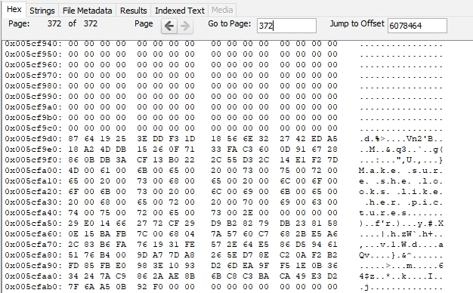
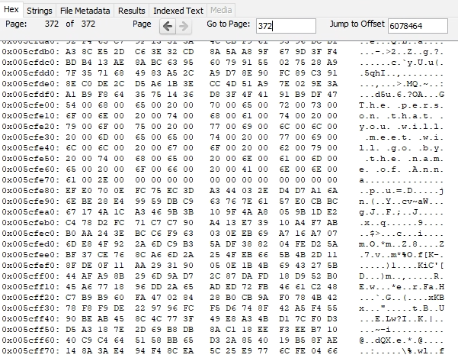

WinHex
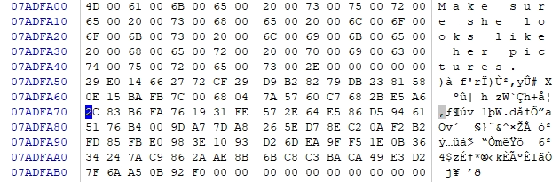

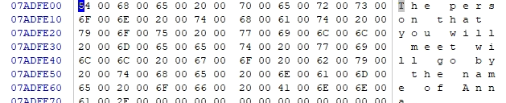

Item #2

Message within theTermite.txt

This item is a message hidden at the end of the file name “theTermite.txt.” The first portion of this text files contents is of a poem by Ogden Nash called The Termite. This file is within a folder named “nash” which contains several other text files with more Ogden Nash poems. The folder resides in the first partition of the drive. The hidden message at the end of theTermite.txt file reads, “Paul: This is the structure of the ricin as a deadly poison. I’ll exaplin it to you when we meet.”
This message is either to or from a person named Paul. The message refers to the structure of a poison named ricin and that it will be explained when the people communicating through the message meet. It is likely that this message was hidden in theTermite.txt file among other poem themed text files to try and hide this message and make the text file seem less conspicuous. Images of the hex figures and the location can be seen below.
Autopsy
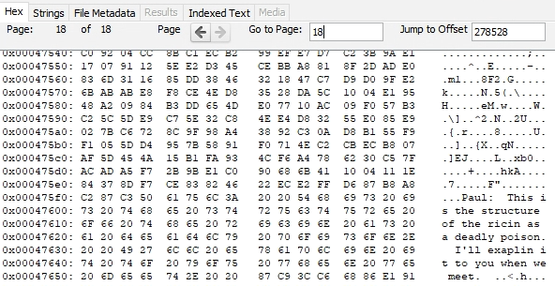
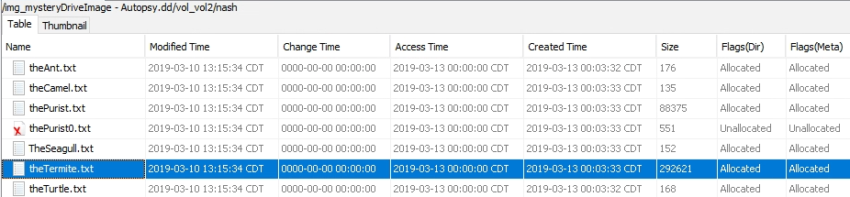

WinHex
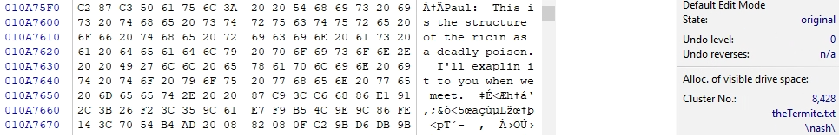
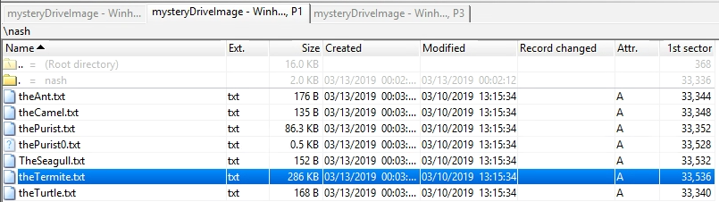

Item #3

Image within anna1.doc

This item is a .doc file that contains an image of a woman within it. The file is contained within the third partition of the drive. The file being named anna1 most likely indicates that the woman in the image is called Anna or goes by that name.
This item correlates with the first item discussed, the message regarding a meetup with a person by the name of Anna and to make sure she looks like her picture. This is likely the picture that the message was referring to. Images of the picture and its location can be seen below.
The Picture

Autopsy
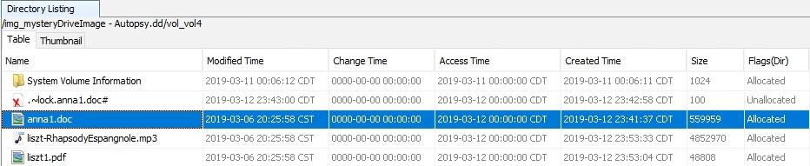

WinHex
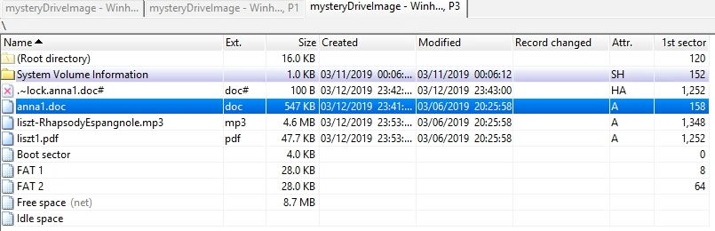

Item #4

HiPaul.docx

This item is a .docx file with a message that appears to be from a person named Craig to another person named Paul. The file is held within the first partition of the drive. The message was written in a word processing software and is not hidden like some of the other items. The message reads out, “Hi Paul: Here is the old flash drive that I told you about that had the pics of Enescu and Liszt and some of their music. There may be some other files on it that I didn’t delete. Craig.”
This file appears to be a message left by a person named, Craig, for the recipient named, Paul, after they received the hard drive. The message states that there are some pictures of some artists and some of their music on the drive as well as some left-over files. Images of the message and file’s location can be seen below.

LibreOffice
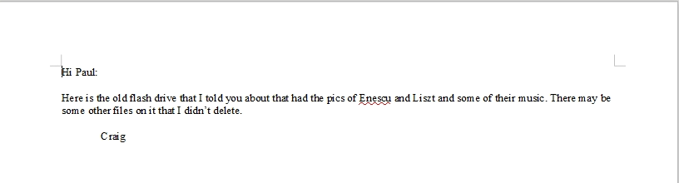

Autopsy
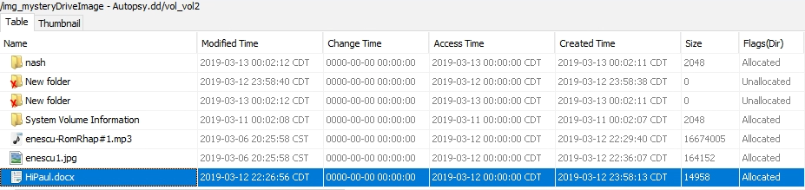

WinHex
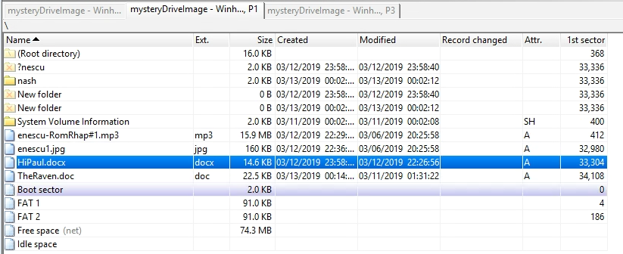

Item #5

Item Link within thePurist.txt

This item is a link hidden within the text file, “thePurist.txt.” The first portion of the text file contains the poem The Purist by Ogden Nash. The link placed underneath the poem in the text file. The file is located within the folder named “nash” that is within the first partition. Within the folder are several other text files of poems by Ogden Nash. The link as show is “File source: http://commons.wikimedia.org/wiki/File:Ricinus_communis_006.JPG.”
This link points to a wikimedia page that contains an image of a plant called Ricinus communis. This item correlates with an item that refers to a type of poison called “ricin,” which can be concocted with the use of a Ricinus communis plant. Images of the hex values, location of the link, the link itself, and picture of the plant can all be seen below.

Autopsy
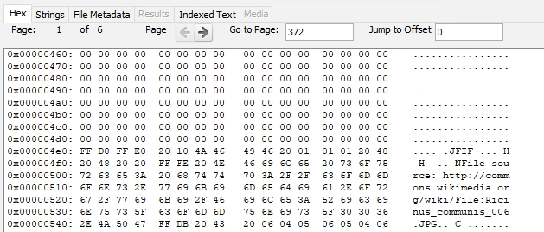
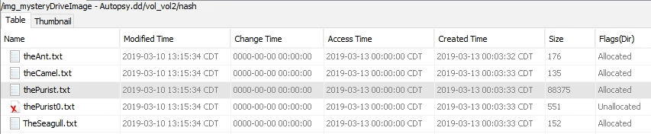

WinHex
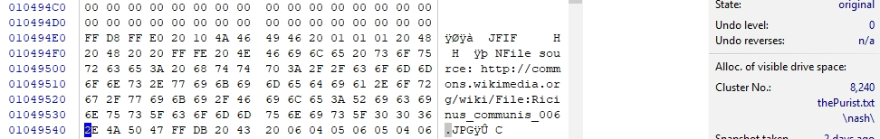
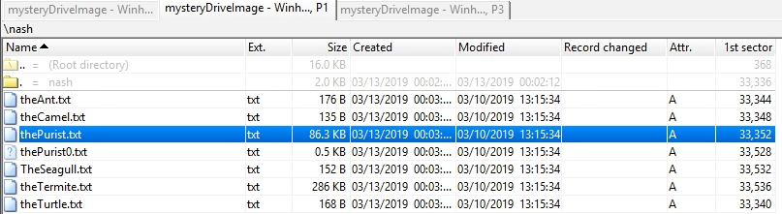

Wikimedia
http://commons.wikimedia.org/wiki/File:Ricinus_communis_006.JPG

Ricinus communis
