

A级达标线上测试报告


学院 人工智能学院 专业 人工智能

学号 23009290073

姓名 高晨曦

手机 13309118502 完成日期 2026-10-01

成绩

题目名称: 温度测控仿真系统

一、题目要求
软件环境：推荐采用 Proteus 8.17 SP2 及以上仿真软件，Arduino IDE，虚拟串口
驱动软件 Virtual Serial Port Driver（VSPD）。
实现功能：使用 Arduino UNO 微控制器，搭建一个 PC 上位机远程温度检测控制系统。
·系统框图如下：
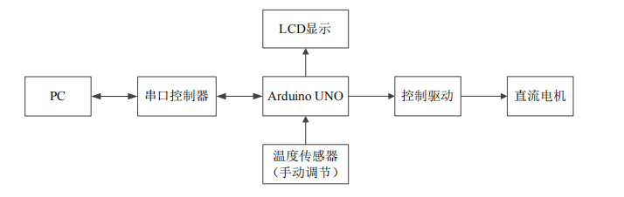
·功能：Arduino UNO（Atmega328P）通过串行接口组件与上位机 PC 进行双向
通信，PC 上位机软件向 Arduino UNO 发送学生自己的学号，Arduino UNO 收到
后向 PC 机发送当前的温度值，并且在 LCD 上显示学生的学号、当前的温度值。
PC 上位机软件显示收到的温度值。
Arduino UNO 控制驱动直流电机，当环境温度高于温度阈值（（30+学号末位
数）℃）时，启动直流电机转动；当环境温度低于（含等于）温度阈值（（30+
学号末位数）℃）时，直流电机停止转动。同时，实时环境温度在 LCD 和 PC
上位机软件显示。如：学生学号末位数为 5，手动调节传感器温度高于设定的温
度阈值 35℃（30+5=35）时，驱动直流电机开始转动。
LCD 第一行显示 ID：学号，第二行显示 TEMP：温度值
必须自行编写 PC 上位机软件，实现 PC 与 Arduino 的双向数据传输及管理控制。
编程语言不限。
上位机软件 GUI 界面 Title 必须显示学生自己的学号和姓名；必须有发送窗口显示发送的学号；必须有接收窗口显示接收到的温度值；GUI 界面上需要有串口
打开关闭功能。

仿真结果展示
1. 温度阈值计算过程与计算结果
本人完整学号为 23009290073，学号末位数为 3。
温度阈值 = 30 + 学号末位数 = 30 + 3 = 33 ℃
控制逻辑：当环境温度 T > 33.0 ℃ 时，直流电机转动；当环境温度 T ≤ 33.0 ℃ 时，直流电机停止转动。
- 环境温度高于温度阈值（33.0 ℃）时的仿真截图
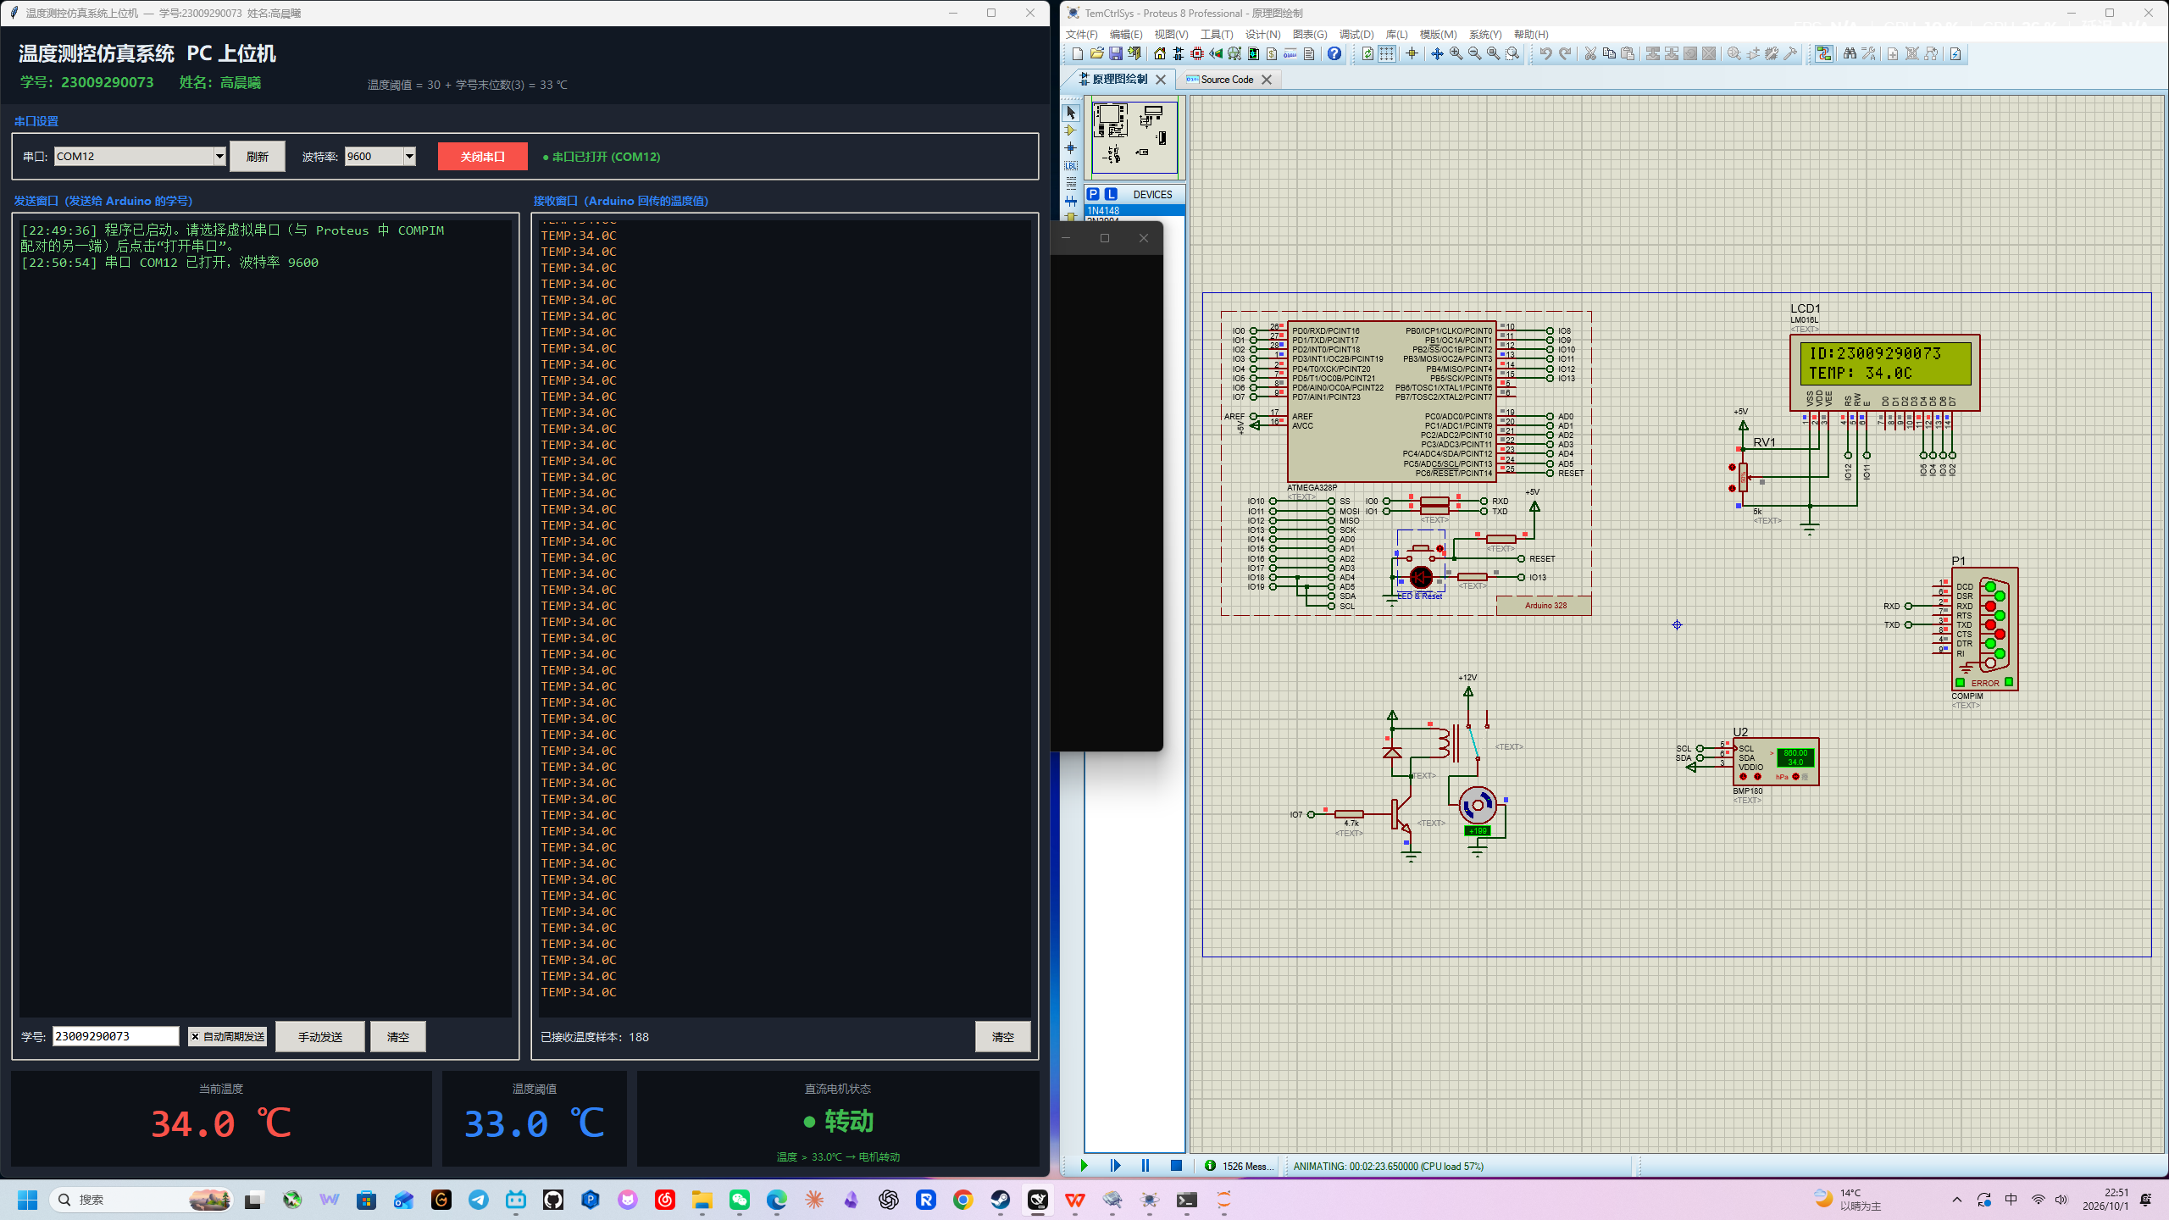
图中可见：① 上位机发送窗口显示学号 23009290073；② 传感器（BMP180）显示温度 34.0 ℃；③ LCD 第一行显示 ID：23009290073，第二行显示 TEMP：34.0 ℃；④ 上位机接收窗口显示温度 34.0 ℃；⑤ 直流电机处于转动状态。传感器、LCD、上位机三处温度值一致，均为 34.0 ℃，学号完全一致。

- 环境温度低于温度阈值（33.0 ℃）时的仿真截图
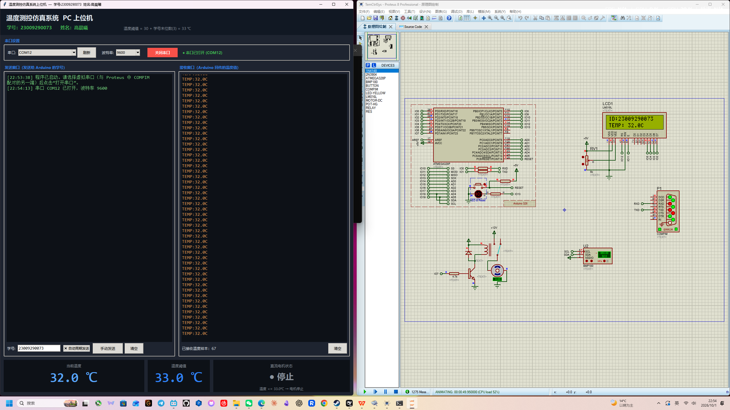
图中可见：① 上位机发送窗口显示学号 23009290073；② 传感器（BMP180）显示温度 32.0 ℃；③ LCD 第一行显示 ID：23009290073，第二行显示 TEMP：32.0 ℃；④ 上位机接收窗口显示温度 32.0 ℃；⑤ 直流电机处于停止状态。传感器、LCD、上位机三处温度值一致，均为 32.0 ℃，学号完全一致。

参考文献
[1] Bosch Sensortec. BMP180 Digital Pressure Sensor Datasheet, Rev. 2.5[Z]. 2013.
[2] Hitachi. HD44780U (LCD-II) Dot Matrix Liquid Crystal Display Controller/Driver Datasheet[Z]. 1998.
[3] Arduino. Wire Library — Arduino Language Reference[EB/OL]. https://docs.arduino.cc/language-reference/en/functions/communication/wire/.
[4] Arduino. LiquidCrystal Library[EB/OL]. https://docs.arduino.cc/libraries/liquidcrystal/.
[5] Arduino. Serial Library — Arduino Language Reference[EB/OL]. https://docs.arduino.cc/language-reference/en/functions/communication/serial/.
[6] Python Software Foundation. tkinter — Python 3 Standard Library[EB/OL]. https://docs.python.org/3/library/tkinter.html.
[7] pySerial Documentation — API[EB/OL]. https://pyserial.readthedocs.io/en/latest/pyserial_api.html.
[8] Eltima Software. Virtual Serial Port Driver (VSPD) User Manual[EB/OL]. https://www.eltima.com/products/vspdxp/.
[9] Labcenter Electronics. Proteus VSM — Circuit Simulation[EB/OL]. https://www.labcenter.com/simulation/.

四、程序设计
1. Arduino 程序源代码（TemCtrlSys.ino，环境 Arduino UNO / ATmega328P，Arduino AVR 编译，9600 8-N-1）。
/* ============================================================
* Temperature Measurement & Control Simulation System
* Target : Arduino UNO (ATmega328P) @ 16 MHz
* Author : Student ID 23009290073
* Threshold = 30 + last digit of student ID (3) = 33.0 C
*
* Hardware (fixed by the Proteus design):
* LCD1602 LM016L, 4-bit mode
* RS -> D12 EN -> D11
* D4 -> D5 D5 -> D4 D6 -> D3 D7 -> D2
* RW -> GND VEE -> 5k pot (contrast)
* BMP180 temperature/pressure sensor on I2C
* SDA -> A4 (PC4) SCL -> A5 (PC5)
* DC motor driver
* D7 -> 4.7k base resistor -> 2N3904 -> relay -> MOTOR-DC
* COMPIM serial link to PC: COM1 @ 9600 8-N-1
*
* Behaviour:
* 1) PC sends the student ID; the Arduino then streams temperature
* 2) LCD line 1 shows "ID:23009290073", line 2 shows "TEMP:xx.xC"
* 3) temp > 33.0 C -> D7 high, motor runs
* temp <= 33.0 C -> D7 low, motor stops
* ============================================================ */

#include <Wire.h>
#include <LiquidCrystal.h>

/* ---------------- configuration ---------------- */
#define STUDENT_ID "23009290073"
#define TEMP_LIMIT 33.0
/* #define DEBUG_TEMP10 365 */ /* force 36.5 C for hardware-free tests */

/* ---------------- pins ---------------- */
#define MOTOR_PIN 7
#define LCD_RS 12
#define LCD_EN 11
#define LCD_D4 5
#define LCD_D5 4
#define LCD_D6 3
#define LCD_D7 2

/* ---------------- BMP180 registers ---------------- */
#define BMP180_ADDR 0x77
#define BMP180_ADDR2 0x76
#define REG_CALIB 0xAA
#define REG_CTRL 0xF4
#define REG_TEMPDATA 0xF6
#define CMD_TEMP 0x2E

LiquidCrystal lcd(LCD_RS, LCD_EN, LCD_D4, LCD_D5, LCD_D6, LCD_D7);

/* ---------------- globals ---------------- */
uint8_t bmpAddr = BMP180_ADDR;
int16_t CAL_AC1, CAL_AC2, CAL_AC3, CAL_B1, CAL_B2, CAL_MB, CAL_MC, CAL_MD;
uint16_t CAL_AC4, CAL_AC5, CAL_AC6;
long B5;

char rxBuf[32];
uint8_t rxLen = 0;
bool idReceived = false;
long temp10 = 0; /* temperature in 0.1 C steps */
bool motorOn = false;

unsigned long lastSample = 0;
unsigned long lastReport = 0;

/* ============================================================
* I2C helpers
* ============================================================ */
void i2cWriteByte(uint8_t dev, uint8_t reg, uint8_t val)
{
Wire.beginTransmission(dev);
Wire.write(reg);
Wire.write(val);
Wire.endTransmission();
}

uint16_t i2cRead16(uint8_t dev, uint8_t reg)
{
Wire.beginTransmission(dev);
Wire.write(reg);
Wire.endTransmission();
Wire.requestFrom((uint8_t)dev, (uint8_t)2);
uint16_t msb = 0, lsb = 0;
if (Wire.available()) msb = Wire.read();
if (Wire.available()) lsb = Wire.read();
return (uint16_t)((msb << 8) | lsb);
}

/* Reliable presence test: write a scratch value into the control
* register and read it back. (Devices that only ACK still fail this.) */
bool i2cProbe(uint8_t dev)
{
i2cWriteByte(dev, REG_CTRL, 0x00);
uint16_t rb = i2cRead16(dev, REG_CTRL);
return ((rb >> 8) == 0x00); /* readback must match what we wrote */
}

/* ============================================================
* BMP180 calibration read
* ============================================================ */
bool bmp180Init()
{
uint8_t cand[2] = { BMP180_ADDR, BMP180_ADDR2 };
bool ok = false;
for (uint8_t i = 0; i < 2; i++) {
if (i2cProbe(cand[i])) { bmpAddr = cand[i]; ok = true; break; }
}
if (!ok) return false;

CAL_AC1 = (int16_t) i2cRead16(bmpAddr, REG_CALIB + 0);
CAL_AC2 = (int16_t) i2cRead16(bmpAddr, REG_CALIB + 2);
CAL_AC3 = (int16_t) i2cRead16(bmpAddr, REG_CALIB + 4);
CAL_AC4 = i2cRead16(bmpAddr, REG_CALIB + 6);
CAL_AC5 = i2cRead16(bmpAddr, REG_CALIB + 8);
CAL_AC6 = i2cRead16(bmpAddr, REG_CALIB + 10);
CAL_B1 = (int16_t) i2cRead16(bmpAddr, REG_CALIB + 12);
CAL_B2 = (int16_t) i2cRead16(bmpAddr, REG_CALIB + 14);
CAL_MB = (int16_t) i2cRead16(bmpAddr, REG_CALIB + 16);
CAL_MC = (int16_t) i2cRead16(bmpAddr, REG_CALIB + 18);
CAL_MD = (int16_t) i2cRead16(bmpAddr, REG_CALIB + 20);

if (CAL_AC5 == 0 || CAL_AC6 == 0) return false;
return true;
}

/* ============================================================
* Temperature (BMP180 datasheet 4.3.1), result in 0.1 C steps
* ============================================================ */
long bmp180ReadTemp10()
{
i2cWriteByte(bmpAddr, REG_CTRL, CMD_TEMP);
delay(5); /* conversion takes 4.5 ms */

uint16_t ut = i2cRead16(bmpAddr, REG_TEMPDATA);

long X1 = ((long)ut - (long)CAL_AC6) * (long)CAL_AC5 >> 15;
long X2 = ((long)CAL_MC << 11) / (X1 + (long)CAL_MD);
B5 = X1 + X2;
return (B5 + 8) >> 4; /* 0.1 C */
}

/* ============================================================
* LCD (integer maths only - the AVR printf has no float support)
* ============================================================ */
void updateLCD10(long t10)
{
char sign = ' ';
if (t10 < 0) { sign = '-'; t10 = -t10; }

char line[17];
snprintf(line, sizeof(line), "TEMP:%c%ld.%ldC", sign, t10 / 10, t10 % 10);

lcd.setCursor(0, 0);
lcd.print(F(" "));
lcd.setCursor(0, 0);
lcd.print(F("ID:"));
lcd.print(STUDENT_ID);

lcd.setCursor(0, 1);
lcd.print(F(" "));
lcd.setCursor(0, 1);
lcd.print(line);
}

/* ============================================================
* Motor
* ============================================================ */
void updateMotor10(long t10)
{
if (t10 > (long)(TEMP_LIMIT * 10.0f)) { /* > 33.0 C */
digitalWrite(MOTOR_PIN, HIGH);
motorOn = true;
} else {
digitalWrite(MOTOR_PIN, LOW);
motorOn = false;
}
}

/* ============================================================
* setup / loop
* ============================================================ */
void setup()
{
pinMode(MOTOR_PIN, OUTPUT);
digitalWrite(MOTOR_PIN, LOW);

Serial.begin(9600);

lcd.begin(16, 2);
lcd.clear();
lcd.setCursor(0, 0);
lcd.print(F("Temperature Sys"));
lcd.setCursor(0, 1);
lcd.print(F("Waiting for ID.."));

Wire.begin();
delay(100);
bmp180Init();
delay(100);
}

void loop()
{
/* ---------- 1. commands from the PC ---------- */
while (Serial.available() > 0) {
char c = (char)Serial.read();
if (c == '\n' || c == '\r') {
if (rxLen > 0) {
rxBuf[rxLen] = '\0';
idReceived = true;
rxLen = 0;
}
} else {
if (rxLen < sizeof(rxBuf) - 1) rxBuf[rxLen++] = c;
}
}

unsigned long now = millis();

/* ---------- 2. sample, display, drive motor every 200 ms ---------- */
if (now - lastSample >= 200) {
lastSample = now;

#ifdef DEBUG_TEMP10
temp10 = DEBUG_TEMP10;
#else
temp10 = bmp180ReadTemp10();
#endif
if (temp10 < -400) temp10 = -400; /* sensor range -40 .. +85 C */
if (temp10 > 850) temp10 = 850;

updateLCD10(temp10);
updateMotor10(temp10);
}

/* ---------- 3. stream temperature to the PC once the ID arrived ---------- */
if (idReceived && (now - lastReport >= 200)) {
lastReport = now;
long t = temp10;
char sgn = ' ';
if (t < 0) { sgn = '-'; t = -t; }
Serial.print(F("TEMP:"));
if (sgn == '-') Serial.print('-');
Serial.print(t / 10);
Serial.print('.');
Serial.print(t % 10);
Serial.println(F("C"));
}
}
2. 上位机程序源代码（TempMonitor.py，Python 3 + Tkinter + pyserial，9600 8-N-1）。
# -*- coding: utf-8 -*-
"""
================================================================
PC 上位机 —— 温度测控仿真系统
学号: 23009290073 姓名: 高晨曦
功能:
1. 打开/关闭串口，与 Proteus 中的 Arduino UNO(COMPIM) 双向通信
2. 向 Arduino 发送本人完整学号（发送窗口可见）
3. 接收 Arduino 回传的实时温度值（接收窗口可见）
4. 根据温度与阈值(30+学号末位数=33.0℃)的比较，显示直流电机转动/停止状态
运行环境: Python 3.x + pyserial (pip install pyserial)
================================================================
"""

import re
import sys
import time
import tkinter as tk
from tkinter import ttk, messagebox

try:
import serial
from serial.tools import list_ports
except ImportError:
print("缺少 pyserial 库，请先执行: pip install pyserial")
sys.exit(1)

# ---------------------------------------------------------------
# 基本参数
# ---------------------------------------------------------------
STUDENT_ID = "23009290073" # 本人完整学号
STUDENT_NAME = "高晨曦" # 本人姓名
LAST_DIGIT = int(STUDENT_ID[-1]) # 学号末位数 = 3
TEMP_LIMIT = 30 + LAST_DIGIT # 温度阈值 = 33 ℃

BAUD_RATE = 9600 # 必须与 Proteus 中 COMPIM 一致
SEND_PERIOD_MS = 200 # 学号重发周期(ms)

# 本工程用 VSPD 建了一对虚拟串口 COM11 <-> COM12：
# COM11 -> Proteus 里 COMPIM (P1) 使用
# COM12 -> 本上位机使用
# 若你的配对端口不同，把这里改成对应端口即可（界面上也能选）。
PREFERRED_PORT = "COM12"

TITLE = "温度测控仿真系统上位机 — 学号:%s 姓名:%s" % (STUDENT_ID, STUDENT_NAME)

BG = "#1e2430"
FG = "#e6edf3"
ACCENT = "#2f81f7"
GREEN = "#3fb950"
RED = "#f85149"
GRAY = "#8b949e"

class TempMonitorApp:

def __init__(self, root):
self.root = root
self.ser = None # 串口对象
self.conn_state = False # 串口是否已打开
self.rx_buffer = "" # 接收缓冲
self.sample_count = 0 # 已接收温度样本数
self.temp_history = [] # 温度历史，用于判断趋势
self.last_rx_time = 0.0

self._build_ui()

self.refresh_ports()

# 启动周期任务
self.root.after(200, self._tick_send_id)
self.root.after(100, self._tick_read_serial)

# ===========================================================
# 界面构建
# ===========================================================
def _build_ui(self):
self.root.title(TITLE)
self.root.geometry("980x640")
self.root.minsize(880, 580)
self.root.configure(bg=BG)

style = ttk.Style()
try:
style.theme_use("clam")
except tk.TclError:
pass
style.configure("TLabel", background=BG, foreground=FG, font=("Microsoft YaHei", 10))
style.configure("TFrame", background=BG)
style.configure("TLabelframe", background=BG, foreground=ACCENT,
font=("Microsoft YaHei", 10, "bold"))
style.configure("TLabelframe.Label", background=BG, foreground=ACCENT,
font=("Microsoft YaHei", 10, "bold"))
style.configure("TButton", font=("Microsoft YaHei", 10), padding=6)
style.configure("TCombobox", font=("Consolas", 10))

# ---------------- 顶部信息栏 ----------------
top = tk.Frame(self.root, bg="#111823", height=92)
top.pack(fill="x", side="top")
top.pack_propagate(False)

tk.Label(top, text="温度测控仿真系统 PC 上位机", bg="#111823", fg=FG,
font=("Microsoft YaHei", 17, "bold")).place(x=18, y=12)
tk.Label(top, text="学号：%s 姓名：%s" % (STUDENT_ID, STUDENT_NAME),
bg="#111823", fg=GREEN, font=("Microsoft YaHei", 12, "bold")).place(x=20, y=52)
tk.Label(top, text="温度阈值 = 30 + 学号末位数(%d) = %d ℃" % (LAST_DIGIT, TEMP_LIMIT),
bg="#111823", fg=GRAY, font=("Microsoft YaHei", 10)).place(x=430, y=56)

# ---------------- 串口控制条 ----------------
ctl = ttk.LabelFrame(self.root, text=" 串口设置 ")
ctl.pack(fill="x", padx=12, pady=(10, 6))

row = ttk.Frame(ctl)
row.pack(fill="x", padx=10, pady=8)

ttk.Label(row, text="串口:").pack(side="left")
self.cmb_port = ttk.Combobox(row, width=26, state="readonly")
self.cmb_port.pack(side="left", padx=(6, 4))

ttk.Button(row, text="刷新", width=6, command=self.refresh_ports).pack(side="left")

ttk.Label(row, text="波特率:").pack(side="left", padx=(18, 0))
self.cmb_baud = ttk.Combobox(row, width=9, state="readonly",
values=["9600", "19200", "38400", "57600", "115200"])
self.cmb_baud.set(str(BAUD_RATE))
self.cmb_baud.pack(side="left", padx=6)

self.btn_open = tk.Button(row, text="打开串口", width=12, bg=ACCENT, fg="white",
activebackground="#1f6feb", activeforeground="white",
relief="flat", font=("Microsoft YaHei", 10, "bold"),
command=self.toggle_port)
self.btn_open.pack(side="left", padx=(20, 6))

self.lbl_state = tk.Label(row, text="● 串口已关闭", bg=BG, fg=RED,
font=("Microsoft YaHei", 10, "bold"))
self.lbl_state.pack(side="left", padx=8)

# ---------------- 中部：发送 / 接收 ----------------
mid = ttk.Frame(self.root)
mid.pack(fill="both", expand=True, padx=12, pady=4)
mid.columnconfigure(0, weight=1, uniform="c")
mid.columnconfigure(1, weight=1, uniform="c")
mid.rowconfigure(0, weight=1)

# ---- 发送窗口 ----
f_send = ttk.LabelFrame(mid, text=" 发送窗口（发送给 Arduino 的学号） ")
f_send.grid(row=0, column=0, sticky="nsew", padx=(0, 6), pady=4)

self.txt_send = tk.Text(f_send, height=8, bg="#0d1117", fg="#7ee787",
insertbackground=FG, font=("Consolas", 12),
relief="flat", wrap="word")
self.txt_send.pack(fill="both", expand=True, padx=8, pady=(8, 4))

srow = ttk.Frame(f_send)
srow.pack(fill="x", padx=8, pady=(0, 8))
ttk.Label(srow, text="学号:").pack(side="left")
self.var_id = tk.StringVar(value=STUDENT_ID)
ttk.Entry(srow, textvariable=self.var_id, width=18,
font=("Consolas", 11)).pack(side="left", padx=6)
self.var_auto = tk.BooleanVar(value=True)
ttk.Checkbutton(srow, text="自动周期发送", variable=self.var_auto).pack(side="left", padx=4)
ttk.Button(srow, text="手动发送", command=self.manual_send).pack(side="left", padx=6)
ttk.Button(srow, text="清空", width=6,
command=lambda: self.txt_send.delete("1.0", "end")).pack(side="left")

# ---- 接收窗口 ----
f_recv = ttk.LabelFrame(mid, text=" 接收窗口（Arduino 回传的温度值） ")
f_recv.grid(row=0, column=1, sticky="nsew", padx=(6, 0), pady=4)

self.txt_recv = tk.Text(f_recv, height=8, bg="#0d1117", fg="#ffa657",
insertbackground=FG, font=("Consolas", 12),
relief="flat", wrap="word", state="disabled")
self.txt_recv.pack(fill="both", expand=True, padx=8, pady=(8, 4))

rrow = ttk.Frame(f_recv)
rrow.pack(fill="x", padx=8, pady=(0, 8))
self.lbl_count = ttk.Label(rrow, text="已接收温度样本：0")
self.lbl_count.pack(side="left")
ttk.Button(rrow, text="清空", width=6, command=self.clear_recv).pack(side="right")

# ---------------- 底部：温度 / 电机状态 ----------------
bot = ttk.Frame(self.root)
bot.pack(fill="x", padx=12, pady=(4, 12))

# 温度显示
f_temp = tk.Frame(bot, bg="#0d1117", bd=0)
f_temp.pack(side="left", fill="both", expand=True, padx=(0, 6))
tk.Label(f_temp, text="当前温度", bg="#0d1117", fg=GRAY,
font=("Microsoft YaHei", 10)).pack(pady=(8, 0))
self.lbl_temp = tk.Label(f_temp, text="--.- ℃", bg="#0d1117", fg="#ffa657",
font=("Consolas", 34, "bold"))
self.lbl_temp.pack(pady=(0, 10))

# 阈值
f_lim = tk.Frame(bot, bg="#0d1117")
f_lim.pack(side="left", fill="both", padx=6)
tk.Label(f_lim, text="温度阈值", bg="#0d1117", fg=GRAY,
font=("Microsoft YaHei", 10)).pack(pady=(8, 0))
tk.Label(f_lim, text="%d.0 ℃" % TEMP_LIMIT, bg="#0d1117", fg=ACCENT,
font=("Consolas", 34, "bold")).pack(pady=(0, 10), padx=22)

# 电机状态
f_motor = tk.Frame(bot, bg="#0d1117")
f_motor.pack(side="left", fill="both", expand=True, padx=(6, 0))
tk.Label(f_motor, text="直流电机状态", bg="#0d1117", fg=GRAY,
font=("Microsoft YaHei", 10)).pack(pady=(8, 0))
self.lbl_motor = tk.Label(f_motor, text="● 停止", bg="#0d1117", fg=GRAY,
font=("Microsoft YaHei", 22, "bold"))
self.lbl_motor.pack(pady=(2, 10))
self.lbl_rule = tk.Label(f_motor, text="温度 <= %d.0℃ → 电机停止" % TEMP_LIMIT,
bg="#0d1117", fg=GRAY, font=("Microsoft YaHei", 9))
self.lbl_rule.pack()

self.log("程序已启动。请选择虚拟串口（与 Proteus 中 COMPIM 配对的另一端）后点击“打开串口”。")

# ===========================================================
# 日志
# ===========================================================
def log(self, msg):
self.txt_send.insert("end", "[%s] %s\n" % (time.strftime("%H:%M:%S"), msg))
self.txt_send.see("end")

# ===========================================================
# 串口管理
# ===========================================================
def refresh_ports(self):
ports = []
# 端口枚举：pyserial 的 list_ports 有时会漏掉虚拟串口驱动
# (VSPD/com0com) 创建的端口，因为它依赖 SetupAPI 的描述信息。
# 这里以系统 API 枚举为主，再用 pyserial 的描述补全。
names = []

# 1) 系统枚举（最可靠，能列出 VSPD 虚拟口）
try:
import subprocess
ps = ("[System.IO.Ports.SerialPort]::GetPortNames() -join ','")
out = subprocess.run(
["powershell", "-NoProfile", "-Command", ps],
capture_output=True, text=True, timeout=8,
creationflags=getattr(subprocess, "CREATE_NO_WINDOW", 0),
).stdout.strip()
if out:
names = [x.strip().upper() for x in out.split(",") if x.strip()]
except Exception:
names = []

# 2) pyserial 枚举（补充描述；也作为系统枚举失败时的回退）
descs = {}
try:
for p in list_ports.comports():
dev = (p.device or "").upper()
if dev:
descs[dev] = (p.description or "").strip()
if dev not in names:
names.append(dev)
except Exception:
pass

# 3) 兜底：探测 COM1..COM32 中能打开、但上面都没列出的端口
if not names:
for n in range(1, 33):
dev = "COM%d" % n
try:
s = serial.Serial(dev, BAUD_RATE, timeout=0.01)
s.close()
names.append(dev)
except Exception:
pass

# 按端口号排序
def key(d):
m = re.fullmatch(r"COM(\d+)", d)
return (0, int(m.group(1))) if m else (1, d)
names = sorted(set(names), key=key)

for d in names:
dsc = descs.get(d, "")
ports.append("%s - %s" % (d, dsc) if dsc else d)

if not ports:
ports = ["<未检测到串口>"]
self.cmb_port["values"] = ports

# 优先选中首选项端口；否则退回第一个可用端口
pick = None
for i, s in enumerate(ports):
if s.upper().startswith(PREFERRED_PORT.upper() + " ") or \
s.upper() == PREFERRED_PORT.upper():
pick = i
break
self.cmb_port.current(pick if pick is not None else 0)

def toggle_port(self):
if self.conn_state:
self.close_port()
else:
self.open_port()

def open_port(self):
sel = self.cmb_port.get()
if not sel or sel.startswith("<"):
messagebox.showwarning("提示", "未选择有效串口，请确认 VSPD 已创建虚拟串口对并点击“刷新”。")
return
port = sel.split(" ")[0]
try:
self.ser = serial.Serial(port=port,
baudrate=int(self.cmb_baud.get()),
bytesize=serial.EIGHTBITS,
parity=serial.PARITY_NONE,
stopbits=serial.STOPBITS_ONE,
timeout=0.05)
except Exception as e:
messagebox.showerror("串口打开失败", "无法打开 %s：\n%s" % (port, e))
return

self.conn_state = True
self.btn_open.config(text="关闭串口", bg=RED, activebackground="#da3633")
self.lbl_state.config(text="● 串口已打开 (%s)" % port, fg=GREEN)
self.log("串口 %s 已打开，波特率 %s" % (port, self.cmb_baud.get()))
self.var_auto.set(True)

def close_port(self):
if self.ser:
try:
self.ser.close()
except Exception:
pass
self.ser = None
self.conn_state = False
self.btn_open.config(text="打开串口", bg=ACCENT, activebackground="#1f6feb")
self.lbl_state.config(text="● 串口已关闭", fg=RED)
self.lbl_motor.config(text="● 停止", fg=GRAY)
self.log("串口已关闭")

# ===========================================================
# 发送
# ===========================================================
def _write_serial(self, text):
if not self.conn_state or self.ser is None:
return False
try:
self.ser.write(text.encode("ascii", "ignore"))
self.ser.flush()
return True
except Exception as e:
self.log("发送失败：%s" % e)
return False

def manual_send(self):
sid = self.var_id.get().strip()
if not sid:
return
if not self.conn_state:
messagebox.showwarning("提示", "请先打开串口。")
return
if self._write_serial(sid + "\r\n"):
self.log("发送学号 -> %s" % sid)

def _tick_send_id(self):
"""周期发送学号，保证 Arduino 持续回传温度"""
if self.conn_state and self.var_auto.get():
sid = self.var_id.get().strip() or STUDENT_ID
self._write_serial(sid + "\r\n")
self.root.after(SEND_PERIOD_MS, self._tick_send_id)

# ===========================================================
# 接收
# ===========================================================
def clear_recv(self):
self.txt_recv.config(state="normal")
self.txt_recv.delete("1.0", "end")
self.txt_recv.config(state="disabled")
self.sample_count = 0
self.lbl_count.config(text="已接收温度样本：0")

def _append_recv(self, line):
self.txt_recv.config(state="normal")
self.txt_recv.insert("end", line + "\n")
# 限制显示行数，避免长时间运行卡顿
if int(self.txt_recv.index("end-1c").split(".")[0]) > 400:
self.txt_recv.delete("1.0", "100.0")
self.txt_recv.see("end")
self.txt_recv.config(state="disabled")

def _tick_read_serial(self):
if self.conn_state and self.ser is not None:
try:
n = self.ser.in_waiting
if n:
data = self.ser.read(n).decode("ascii", "ignore")
self.rx_buffer += data
while "\n" in self.rx_buffer:
line, self.rx_buffer = self.rx_buffer.split("\n", 1)
line = line.strip()
if line:
self._handle_line(line)
except Exception as e:
self.log("读取异常：%s" % e)
self.close_port()

# 3 秒无数据则提示通信中断
if (self.conn_state and self.last_rx_time and
time.time() - self.last_rx_time > 3.0):
self.lbl_temp.config(text="--.- ℃", fg=GRAY)

self.root.after(80, self._tick_read_serial)

def _handle_line(self, line):
self.last_rx_time = time.time()
self._append_recv(line)

m = re.search(r"(-?\d+(?:\.\d+)?)", line)
if not m:
return
try:
temp = float(m.group(1))
except ValueError:
return

self.sample_count += 1
self.lbl_count.config(text="已接收温度样本：%d" % self.sample_count)

# ---- 显示温度 ----
self.lbl_temp.config(text="%.1f ℃" % temp,
fg=RED if temp > TEMP_LIMIT else "#58a6ff")

# ---- 更新电机状态 ----
if temp > TEMP_LIMIT:
self.lbl_motor.config(text="● 转动", fg=GREEN)
self.lbl_rule.config(text="温度 > %d.0℃ → 电机转动" % TEMP_LIMIT, fg=GREEN)
else:
self.lbl_motor.config(text="● 停止", fg=GRAY)
self.lbl_rule.config(text="温度 <= %d.0℃ → 电机停止" % TEMP_LIMIT, fg=GRAY)

def main():
root = tk.Tk()
TempMonitorApp(root)
root.mainloop()

if __name__ == "__main__":
main()

