T.C.
BAHÇEŞEHİR UNIVERSITY
FACULTY OF ENGINEERING AND NATURAL SCIENCES
DEPARTMENT OF COMPUTER ENGINEERING

PROJECT FINAL REPORT

Biometric Authentication Security System with AI

CMP3010
Course Project

Emirhan Kılıç — 2202372
Batuhan Arda Bekar — 2364860
Gencay Demir Ardıç — 2201656
Gökhan Yavuz — 2202647

İSTANBUL, JUNE 2026

TABLE OF CONTENTS
1 OVERVIEW 3
1.1 Problem Statement and Objectives 3
1.2 Background Information 3
2 METHODOLOGY 4
2.1 Project design 4
2.2 Project components 6
3 WORK PLAN 7
3.1 Tasks and Time Line 7
3.2 Cost Proposal 8
4 REFERENCES 9
5 PHOTOS 9
6 APPENDIX 9

1 OVERVIEW
This project implements a low-cost embedded security system for physical access control that requires two independent biometric factors before a door is unlocked. The first factor is face recognition, performed by a deep-learning model; the second factor is fingerprint verification, performed by a dedicated optical sensor. Access is granted only when both factors resolve to the same registered identity. Every attempt — successful or not — is written to a database together with a timestamp, so the system also keeps a complete audit trail of who tried to enter and when.

1.1 Problem Statement and Objectives
Most access-control systems in everyday use rely on a single factor: a physical key, an RFID card, a numeric PIN, or one biometric trait. The weakness of any single-factor scheme is that the moment that factor is lost, copied, or spoofed, the door opens. A stolen badge, a guessed PIN, or a fingerprint lifted from a glass surface is enough to defeat the system, and in most low-cost installations there is no record of who entered or when.
The general goal of this project is to build an affordable embedded system that demands two independent biometric factors and keeps a timestamped log of every access attempt. The specific objectives are:
- Require two independent biometric factors — a recognised face and a matching fingerprint — and enforce a same-identity rule so that the two checks confirm one person rather than acting as two unrelated unlocks.
- Physically actuate a door lock: unlock on a successful two-factor match and raise an audible and visual alarm on any mismatch until it is manually silenced.
- Record every attempt (granted, denied, mismatch, enrolment) in a database, each entry stamped with the time taken from a hardware real-time clock rather than from a PC clock.
- Use only inexpensive, off-the-shelf components so the design is reproducible on a student budget.
To stay realistic, the deliverable is a working breadboard prototype actuating a small 12 V solenoid lock. Face recognition runs on a laptop over the local Wi-Fi network rather than on the microcontroller itself, because on-device inference was beyond the compute available on the boards used; on-device inference is identified as future work.

1.2 Background Information
Biometric access control is a mature field. Commercial fingerprint door locks and face-unlock systems are widely available, but the majority of affordable products are single-factor, and genuine multi-factor biometric units are typically expensive, proprietary, and closed. A review of the public domain shows that the individual building blocks used here are well established:
- Face recognition by deep embeddings. Modern face recognition maps a face to a high-dimensional embedding vector using a convolutional network trained with a margin-based loss (for example ArcFace). Two faces are compared by the distance between their embeddings rather than by raw pixels. This project uses the open-source InsightFace toolkit, which provides a detector and an ArcFace-style recogniser producing 512-dimensional embeddings.
- Optical fingerprint matching. Low-cost optical sensors such as the AS608/R307 family capture a fingerprint image and perform template extraction and 1:N matching on the sensor itself, returning only a matched template ID over a serial link. This keeps the matching engine completely independent of the face model.
- Embedded orchestration. An 8-bit microcontroller (Arduino Mega 2560) is well suited to coordinating sensors, actuators, and a display in real time, while an ESP32-CAM provides image capture together with Wi-Fi connectivity in a single inexpensive module.
The contribution of this product to society is to make true two-factor physical security with audit logging affordable enough for laboratories, small offices, and homes. Because the design enforces that the face identity equals the fingerprint identity, it provides a meaningful security improvement over stacking two independent single-factor unlocks: an attacker would have to defeat two different biometric engines for the same target identity at the same time. Open, low-cost designs such as this one also lower the barrier for students and makers to learn and extend biometric systems [1].

2 METHODOLOGY

2.1 Project design
The overall design is a pipeline of five stages distributed across three compute nodes — the ESP32-CAM, a PC, and the Arduino Mega 2560 — connected by Wi-Fi and a UART link:
- 1. Capture and stream. The ESP32-CAM captures a JPEG frame and sends it by HTTP POST over Wi-Fi to a Python server running on the PC.
- 2. Recognise (AI). The PC runs InsightFace on the frame, extracts a 512-dimensional embedding, compares it against every enrolled user, and returns the matched user ID.
- 3. Confirm the second factor. The Arduino Mega then asks the user for a fingerprint and checks that it resolves to the same user ID returned by the face stage.
- 4. Decide and act. If both factors match the same identity, the Mega energises the relay and opens the solenoid lock; any mismatch raises the alarm until it is manually silenced.
- 5. Log. Every attempt is written to the database with a timestamp taken from the Mega's DS3231 real-time clock.
The data flow is therefore: ESP32-CAM → (Wi-Fi / HTTP, endpoints /check and /register) → PC Python face server (InsightFace + SQLite) → (UART at 9600 baud through a 1 kΩ/2 kΩ divider) → Arduino Mega 2560 → (digital I/O) → relay-driven lock, OLED display, RGB LED, and buzzer. The governing rule of the whole system is the same-person rule: the face-stage ID must equal the fingerprint-stage ID.
On the recognition side, the model is InsightFace FaceAnalysis with the buffalo_s pack (an SCRFD detector plus an ArcFace-style recogniser), a detector input of 320×320, and GPU (CUDA) execution with CPU fallback. Each detected face yields a 512-dimensional embedding stored as float32 in SQLite and keyed by user ID. Matching uses cosine similarity on L2-normalised embeddings; the distance is defined as d = 1 − (e_in · e_db), and a face is accepted when d ≤ 0.60. A frame with no detected face returns NO_FACE, while a detected but unmatched face returns NO_MATCH. The fingerprint factor uses the sensor's on-board 1:N template matching, an entirely separate engine from the face model, which is what makes the decision genuinely two-factor.
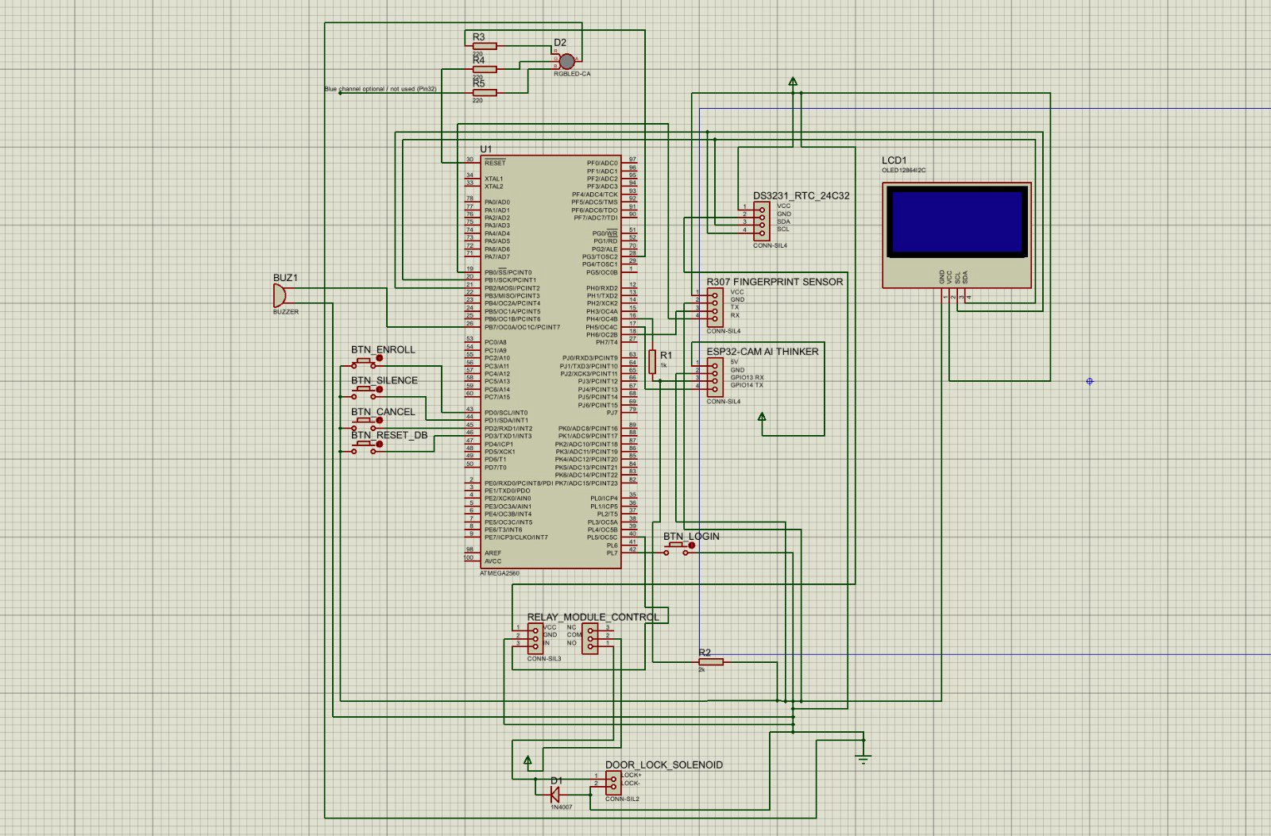
Figure 1. Overall design of the system and circuit schematic (PROTEUS).
Several technical issues were anticipated, and the design addresses each of them:
- 5 V to 3.3 V UART mismatch. The Mega's TX line idles at 5 V, but the ESP32-CAM pins are not 5 V tolerant. The Mega → ESP direction is level-shifted with a 1 kΩ/2 kΩ resistor voltage divider (a cheap, valid alternative to a dedicated logic-level converter), while the ESP → Mega direction is connected directly because 3.3 V is read as a valid logic HIGH by the Mega. A deliberately low baud rate of 9600 is used because inexpensive level shifters tend to corrupt 115200.
- Serial-port contention. The Mega needs more than one hardware UART, which is the main reason a Mega was chosen over an Uno. The fingerprint sensor is on Serial1 (pins 18/19), the ESP32-CAM on Serial2 (pins 16/17), and the USB serial monitor on Serial0, so no two peripherals share a port.
- Link health. A PING/PONG check over the UART lets the Mega confirm the camera node is alive before relying on it for a face check.
- Fail-secure locking. The relay drives a 12 V solenoid through an active-LOW input, so a HIGH output keeps the door locked and a LOW output unlocks it; the lock auto-relocks after three seconds, and a 1N4007 flyback diode across the coil protects the relay from the inductive kickback.
- Trustworthy timestamps. Log times are taken from the Mega's DS3231 real-time clock, not from the PC, so the audit trail is correct even if the PC clock is wrong or the PC is replaced.
The product specifications and the way each was verified are: two-factor enforcement (face match AND fingerprint match AND identical user ID) — verified by presenting deliberately mismatched face/finger pairs and confirming the system raises an ID-mismatch alarm instead of unlocking; correct timestamped logging — verified by reading the /logs endpoint and confirming each event carries the RTC time; and correct actuation — verified physically by confirming the lock opens only on a successful two-factor login and relocks automatically.

2.2 Project components
The project was built and tested in the Embedded Systems Laboratory using the Arduino IDE and Python 3 as the build toolchain, an FTDI USB-TTL adapter to flash the ESP32-CAM, and a breadboard for prototyping. The main components and the reasoning behind each choice are:
- Arduino Mega 2560 — main controller/orchestrator. Chosen over an Arduino Uno because the system needs at least two hardware UARTs (one for the fingerprint sensor, one for the ESP32-CAM) plus many digital pins for five buttons, three LED channels, a relay, and a buzzer. The Uno offers only a single UART, which would force an unreliable SoftwareSerial link at speed.
- ESP32-CAM (AI-Thinker, OV2640) — capture and Wi-Fi gateway. Provides camera capture and Wi-Fi in one cheap module and also serves an MJPEG stream used during enrolment. The alternative, a USB webcam on the PC, was rejected because it removes the independent embedded capture node.
- Laptop / PC — recognition server. Runs InsightFace because deep face recognition is too compute-heavy for the microcontroller. Offloading it to the PC is the pragmatic choice for a prototype; moving to an edge board (Raspberry Pi or ESP32-S3) is noted as future work.
- AS608 / R307 fingerprint sensor — factor 2. Performs template extraction and matching on-sensor over UART, giving an independent second engine without loading the PC or the Mega.
- OLED SSD1306 128×64 (I²C) — status display. Shows prompts, the live clock, the template count, and granted/denied results.
- DS3231 RTC + AT24C32 EEPROM (I²C) — time and storage. Supplies the authoritative timestamps used for every log entry; battery-backed so the time survives power loss.
- Relay + 12 V solenoid lock + 1N4007 flyback diode — door actuator. A fail-secure lock driven through a relay, with the diode protecting against inductive spikes.
- RGB LED (common cathode) + active buzzer — feedback. Green for granted, red plus buzzer for denied, and a separate channel that lights while a login or enrolment is in progress.
- Five push buttons — Login, Enroll, Silence, Cancel, Reset DB. Provide the complete local user interface with no touchscreen required.
- 1 kΩ/2 kΩ resistor divider — level shifting. A low-cost alternative to a dedicated logic-level converter for the 5 V → 3.3 V UART direction.
- Power and glue. A 5 V 2 A supply for the logic and a 12 V 1 A supply for the lock, plus a breadboard, jumper wires, and assorted resistors (220 Ω, 1 kΩ, 2 kΩ, 10 kΩ).
- Software libraries. On the PC: InsightFace (buffalo_s), OpenCV for image decoding, SQLite for storage, and Python's standard-library http.server. On the firmware side: the Adafruit Fingerprint, SSD1306 and GFX libraries, RTClib for the DS3231, and the Espressif esp_camera / Arduino-ESP32 stack.

3 WORK PLAN

3.1 Tasks and Time Line
The project was a four-person team effort, and tasks were divided according to each member's strengths across the firmware, recognition, and server sides of the system. Integration work was carried out jointly. The broad division of responsibilities was as follows:
- Emirhan Kılıç (2202372) — Arduino Mega firmware. Two-factor control logic, the enrolment/admin mode, the OLED user interface, RTC-stamped access logging, the UART command protocol, and the 5 V ↔ 3.3 V level-shifting.
- Batuhan Arda Bekar (2364860) — PC face-recognition engine. InsightFace integration, 512-dimensional embedding extraction, and the cosine-similarity matching and thresholding (main.py).
- Gencay Demir Ardıç (2201656) — ESP32-CAM firmware. Camera capture, Wi-Fi connectivity, the MJPEG stream used for enrolment, and the UART gateway that relays results to the Mega (ESP32CAM_Face.ino).
- Gökhan Yavuz (2202647) — PC server and database. The HTTP endpoints (wifi_server.py), the SQLite schema and timestamped access-log storage (database.py), the enrolment utility, and integration testing.
The schedule below (Table 2) summarises the eleven-week timeline as a Gantt chart, with the active weeks of each task shaded.
Table 2. The project Gantt chart.
TASK LIST | 1 | 2 | 3 | 4 | 5
1. Research and Design
1.1 Define goals; literature search
1.2 Overall design; order parts
2. Construction and Coding
2.1 Assemble capture + face node (ESP32-CAM + PC)
2.2 Assemble controller node (Mega + fingerprint + I/O)
2.3 Prepare software (firmware + Python)
2.4 Integrate all systems (UART, 2-factor, logging)
3. Testing and Documentation
3.1 Prepare the proposal
3.2 Verification
3.3 Prepare the report

3.2 Cost Proposal
Table 1 lists the components used and their estimated costs in Turkish lira, based on typical prices from local electronics retailers. The figures are approximate and intended for planning; actual prices vary between suppliers and over time, so they should be replaced with the real purchase prices once the parts are bought.
Table 1. Components and their estimated costs.
Component | Cost (TL)
Arduino Mega 2560 (clone) | 0
ESP32-CAM (AI-Thinker, OV2640) x 2 | 1200
AS608 / R307 optical fingerprint sensor x 2 | 800
12 V solenoid lock | 200
OLED SSD1306 128×64 display | 120
DS3231 RTC + AT24C32 module | 90
1-channel relay module | 50
RGB LED + active buzzer | 50
Push buttons (×5) | 25
FTDI USB-TTL adapter (FT232RL) | 90
5 V 2 A + 12 V 1 A power adapters | 200
Breadboard, jumpers, resistors, 1N4007 diode | 0
TOTAL | 2825

4 REFERENCES
- InsightFace — 2D face analysis toolkit (FaceAnalysis, buffalo_s, ArcFace). Available from: https://github.com/deepinsight/insightface
- OpenCV — Open Source Computer Vision Library. Available from: https://opencv.org
- Adafruit Fingerprint Sensor Library — driver for AS608 / R307 optical sensors. Available from: https://github.com/adafruit/Adafruit-Fingerprint-Sensor-Library
- Adafruit SSD1306 and Adafruit GFX libraries — OLED display drivers. Available from: https://github.com/adafruit/Adafruit_SSD1306
- Espressif esp32-camera / Arduino-ESP32 — ESP32-CAM firmware stack. Available from: https://github.com/espressif/esp32-camera
- Arduino Mega 2560 — board reference and core. Available from: https://www.arduino.cc
- DS3231 real-time clock and AT24C32 EEPROM — manufacturer datasheets (Maxim Integrated / Microchip).
- AS608 / R307 optical fingerprint module — datasheet.
- SQLite — embedded SQL database engine. Available from: https://www.sqlite.org
- Python http.server — standard-library HTTP server. Available from: https://docs.python.org/3/library/http.server.html

5 PHOTOS
This section should contain photographs of the build. Insert the four images below before submission, replacing each placeholder with the corresponding photo (one of the team-member photos should clearly show a face, as required):
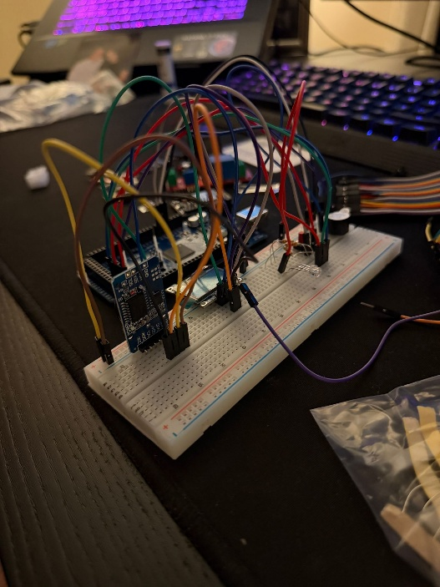

6 APPENDIX
This appendix contains the complete source code of the system with a short explanation of each file. The code is organised into two firmware sketches (the Arduino Mega controller and the ESP32-CAM gateway) and three Python files that make up the PC face-recognition server. The Wi-Fi credentials in the ESP32-CAM sketch have been replaced with placeholders.

