Factors Report 20080102-20161230

**1. gejiangfan02**

**截面指标累计曲线:**

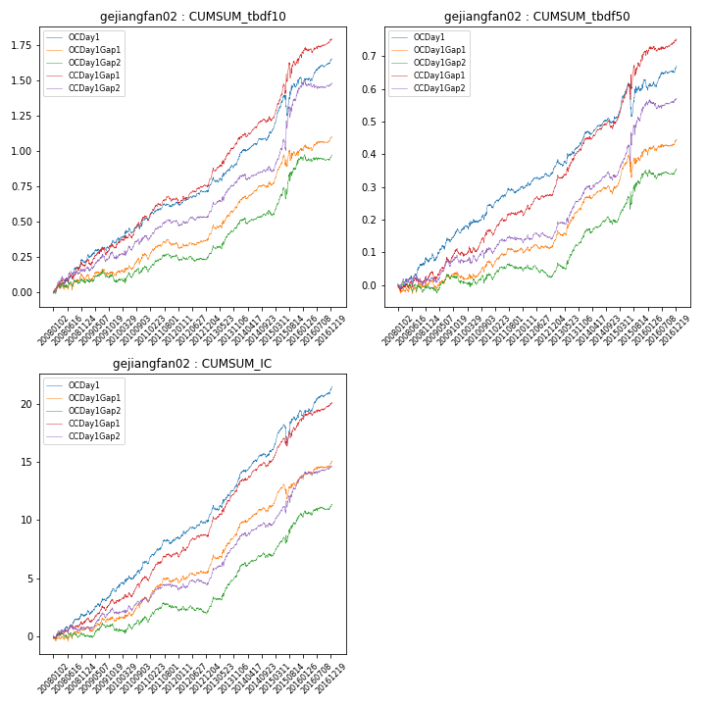

**因子换手率:** 36.29%

**截面指标_OCDay1:**

|  |  |  |  |  |  |  |  |  |
| --- | --- | --- | --- | --- | --- | --- | --- | --- |
| year | annret_tbdf10 | sharpe_tbdf10 | maxdd_tbdf10 | annret_tbdf50 | sharpe_tbdf50 | maxdd_tbdf50 | mean_IC | tstat_IC |
| 2008 | 0.21 | 2.58 | -0.03 | 0.07 | 1.96 | -0.02 | 0.01 | 2.33 |
| 2009 | 0.14 | 2.05 | -0.03 | 0.09 | 2.44 | -0.03 | 0.01 | 2.67 |
| 2010 | 0.17 | 2.33 | -0.04 | 0.09 | 2.39 | -0.02 | 0.01 | 2.93 |
| 2011 | 0.11 | 2.26 | -0.03 | 0.06 | 2.34 | -0.02 | 0.01 | 3.05 |
| 2012 | 0.09 | 1.85 | -0.02 | 0.04 | 1.96 | -0.01 | 0.01 | 2.25 |
| 2013 | 0.24 | 3.69 | -0.04 | 0.11 | 3.35 | -0.02 | 0.02 | 4.59 |
| 2014 | 0.19 | 3.62 | -0.02 | 0.07 | 2.42 | -0.02 | 0.01 | 3.63 |
| 2015 | 0.39 | 2.77 | -0.14 | 0.11 | 1.58 | -0.1 | 0.01 | 2.72 |
| 2016 | 0.13 | 2.26 | -0.05 | 0.04 | 1.38 | -0.03 | 0.01 | 2.67 |

**截面指标_CCDay1Gap1:**

|  |  |  |  |  |  |  |  |  |
| --- | --- | --- | --- | --- | --- | --- | --- | --- |
| year | annret_tbdf10 | sharpe_tbdf10 | maxdd_tbdf10 | annret_tbdf50 | sharpe_tbdf50 | maxdd_tbdf50 | mean_IC | tstat_IC |
| 2008 | 0.18 | 2.06 | -0.04 | 0.02 | 0.65 | -0.02 | 0.0 | 1.6 |
| 2009 | 0.14 | 1.83 | -0.06 | 0.07 | 2.07 | -0.02 | 0.01 | 2.38 |
| 2010 | 0.22 | 3.02 | -0.04 | 0.07 | 1.95 | -0.02 | 0.01 | 2.81 |
| 2011 | 0.12 | 2.46 | -0.04 | 0.06 | 2.43 | -0.02 | 0.01 | 3.25 |
| 2012 | 0.11 | 2.21 | -0.03 | 0.05 | 2.29 | -0.01 | 0.01 | 2.59 |
| 2013 | 0.34 | 5.24 | -0.03 | 0.16 | 4.86 | -0.01 | 0.02 | 5.74 |
| 2014 | 0.13 | 2.27 | -0.03 | 0.06 | 2.06 | -0.02 | 0.01 | 2.85 |
| 2015 | 0.46 | 2.97 | -0.11 | 0.22 | 2.76 | -0.05 | 0.02 | 3.22 |
| 2016 | 0.11 | 1.87 | -0.04 | 0.04 | 1.2 | -0.02 | 0.01 | 2.21 |

**风格暴露:**

|  |  |  |  |  |
| --- | --- | --- | --- | --- |
|  | long | short | corr_OCDay1 | corr_CCDay1Gap1 |
| liquidity10 | 0.04 | -0.04 | 0.21 | 0.17 |
| liquidity20 | -0.0 | 0.01 | 0.22 | 0.18 |
| liquidity5 | 0.09 | -0.09 | 0.18 | 0.16 |
| logmktcap | 0.12 | -0.11 | -0.08 | -0.02 |
| momentum15 | 0.1 | -0.1 | 0.07 | 0.13 |
| momentum30 | 0.07 | -0.06 | 0.09 | 0.16 |
| momentum5 | 0.21 | -0.2 | -0.07 | -0.08 |
| retvolatility30 | 0.06 | -0.05 | 0.16 | 0.09 |