Factors Report 20080102-20161230

**1. factor30**

**截面指标累计曲线:**

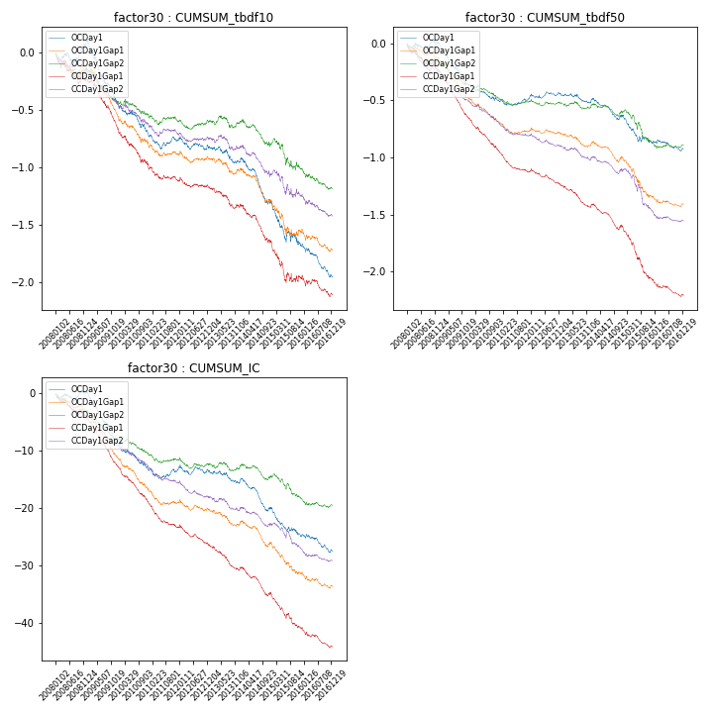

**因子换手率:** 57.67%

**截面指标_OCDay1:**

|  |  |  |  |  |  |  |  |  |
| --- | --- | --- | --- | --- | --- | --- | --- | --- |
| year | annret_tbdf10 | sharpe_tbdf10 | maxdd_tbdf10 | annret_tbdf50 | sharpe_tbdf50 | maxdd_tbdf50 | mean_IC | tstat_IC |
| 2008 | 0.1 | 0.93 | -0.09 | 0.01 | 0.14 | -0.07 | 0.0 | 0.15 |
| 2009 | -0.53 | -6.93 | -0.43 | -0.38 | -7.81 | -0.32 | -0.04 | -8.65 |
| 2010 | -0.26 | -3.32 | -0.23 | -0.14 | -2.81 | -0.14 | -0.02 | -4.0 |
| 2011 | -0.06 | -0.98 | -0.14 | 0.04 | 1.08 | -0.05 | 0.0 | 0.21 |
| 2012 | -0.07 | -1.13 | -0.11 | 0.02 | 0.49 | -0.04 | -0.0 | -0.64 |
| 2013 | -0.13 | -1.81 | -0.14 | -0.07 | -1.65 | -0.08 | -0.01 | -1.86 |
| 2014 | -0.34 | -4.32 | -0.33 | -0.11 | -2.28 | -0.17 | -0.02 | -3.87 |
| 2015 | -0.39 | -2.94 | -0.33 | -0.25 | -3.26 | -0.22 | -0.02 | -3.95 |
| 2016 | -0.27 | -4.16 | -0.25 | -0.05 | -1.29 | -0.1 | -0.01 | -2.69 |

**截面指标_CCDay1Gap1:**

|  |  |  |  |  |  |  |  |  |
| --- | --- | --- | --- | --- | --- | --- | --- | --- |
| year | annret_tbdf10 | sharpe_tbdf10 | maxdd_tbdf10 | annret_tbdf50 | sharpe_tbdf50 | maxdd_tbdf50 | mean_IC | tstat_IC |
| 2008 | -0.24 | -2.35 | -0.24 | -0.23 | -4.07 | -0.21 | -0.02 | -4.4 |
| 2009 | -0.42 | -5.58 | -0.35 | -0.42 | -9.62 | -0.35 | -0.03 | -9.76 |
| 2010 | -0.32 | -3.66 | -0.28 | -0.29 | -5.94 | -0.26 | -0.03 | -6.42 |
| 2011 | -0.15 | -2.58 | -0.15 | -0.17 | -4.98 | -0.17 | -0.02 | -5.29 |
| 2012 | -0.06 | -1.14 | -0.09 | -0.13 | -3.51 | -0.13 | -0.01 | -3.8 |
| 2013 | -0.16 | -2.2 | -0.16 | -0.19 | -4.61 | -0.18 | -0.02 | -4.47 |
| 2014 | -0.31 | -4.12 | -0.29 | -0.17 | -3.71 | -0.21 | -0.02 | -4.3 |
| 2015 | -0.33 | -2.4 | -0.31 | -0.48 | -6.2 | -0.38 | -0.03 | -5.01 |
| 2016 | -0.14 | -1.8 | -0.17 | -0.13 | -3.17 | -0.14 | -0.01 | -3.67 |

**风格暴露:**

|  |  |  |  |  |
| --- | --- | --- | --- | --- |
|  | long | short | corr_OCDay1 | corr_CCDay1Gap1 |
| liquidity10 | -0.31 | 0.28 | 0.27 | 0.26 |
| liquidity20 | -0.21 | 0.2 | 0.21 | 0.2 |
| liquidity5 | -0.43 | 0.4 | 0.33 | 0.32 |
| logmktcap | -0.14 | 0.15 | 0.06 | 0.03 |
| momentum15 | -0.72 | 0.72 | 0.6 | 0.56 |
| momentum30 | -0.54 | 0.53 | 0.5 | 0.46 |
| momentum5 | -1.12 | 1.13 | 0.65 | 0.63 |
| retvolatility30 | -0.23 | 0.21 | 0.16 | 0.16 |