Factors Report 20080102-20161230

**1. factor32**

**截面指标累计曲线:**

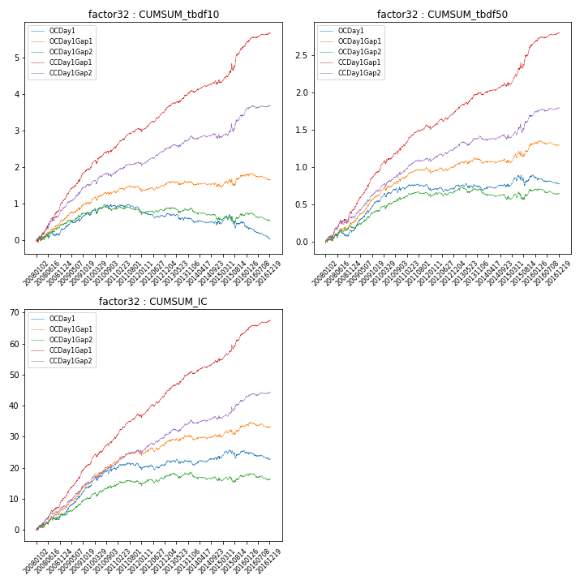

**因子换手率:** 54.7%

**截面指标_OCDay1:**

|  |  |  |  |  |  |  |  |  |
| --- | --- | --- | --- | --- | --- | --- | --- | --- |
| year | annret_tbdf10 | sharpe_tbdf10 | maxdd_tbdf10 | annret_tbdf50 | sharpe_tbdf50 | maxdd_tbdf50 | mean_IC | tstat_IC |
| 2008 | 0.3 | 1.33 | -0.11 | 0.13 | 1.25 | -0.09 | 0.02 | 2.11 |
| 2009 | 0.44 | 2.68 | -0.26 | 0.42 | 4.95 | -0.14 | 0.04 | 4.88 |
| 2010 | 0.22 | 1.22 | -0.39 | 0.17 | 1.97 | -0.35 | 0.02 | 2.85 |
| 2011 | -0.16 | -1.35 | -0.45 | -0.02 | -0.3 | -0.35 | 0.0 | 0.03 |
| 2012 | -0.09 | -0.76 | -0.47 | 0.04 | 0.61 | -0.36 | 0.01 | 1.1 |
| 2013 | -0.15 | -0.95 | -0.45 | -0.02 | -0.28 | -0.36 | -0.0 | -0.11 |
| 2014 | -0.07 | -0.54 | -0.44 | 0.03 | 0.49 | -0.37 | 0.01 | 1.09 |
| 2015 | -0.01 | -0.05 | -0.47 | 0.14 | 1.08 | -0.35 | 0.01 | 0.92 |
| 2016 | -0.42 | -3.08 | -0.59 | -0.11 | -1.87 | -0.42 | -0.01 | -1.77 |

**截面指标_CCDay1Gap1:**

|  |  |  |  |  |  |  |  |  |
| --- | --- | --- | --- | --- | --- | --- | --- | --- |
| year | annret_tbdf10 | sharpe_tbdf10 | maxdd_tbdf10 | annret_tbdf50 | sharpe_tbdf50 | maxdd_tbdf50 | mean_IC | tstat_IC |
| 2008 | 1.07 | 4.94 | -0.08 | 0.4 | 3.87 | -0.04 | 0.04 | 4.94 |
| 2009 | 0.89 | 5.44 | -0.65 | 0.54 | 6.76 | -0.33 | 0.05 | 6.71 |
| 2010 | 0.6 | 3.25 | -0.66 | 0.36 | 4.08 | -0.42 | 0.04 | 4.72 |
| 2011 | 0.46 | 3.71 | -0.66 | 0.23 | 4.14 | -0.42 | 0.03 | 4.54 |
| 2012 | 0.61 | 5.03 | -0.67 | 0.23 | 3.85 | -0.43 | 0.03 | 4.9 |
| 2013 | 0.49 | 3.33 | -0.65 | 0.24 | 3.43 | -0.41 | 0.03 | 3.82 |
| 2014 | 0.27 | 1.95 | -0.67 | 0.13 | 2.09 | -0.43 | 0.02 | 2.83 |
| 2015 | 0.97 | 3.62 | -0.67 | 0.54 | 4.23 | -0.43 | 0.04 | 3.95 |
| 2016 | 0.37 | 3.03 | -0.66 | 0.15 | 2.83 | -0.42 | 0.02 | 3.35 |

**风格暴露:**

|  |  |  |  |  |
| --- | --- | --- | --- | --- |
|  | long | short | corr_OCDay1 | corr_CCDay1Gap1 |
| liquidity10 | 0.11 | -0.13 | -0.15 | -0.13 |
| liquidity20 | 0.01 | -0.03 | -0.07 | -0.07 |
| liquidity5 | 0.35 | -0.37 | -0.24 | -0.23 |
| logmktcap | -0.07 | 0.07 | 0.01 | -0.0 |
| momentum15 | 0.93 | -0.93 | -0.62 | -0.62 |
| momentum30 | 0.6 | -0.6 | -0.48 | -0.45 |
| momentum5 | 1.84 | -1.83 | -0.81 | -0.78 |
| retvolatility30 | -0.03 | 0.01 | -0.04 | -0.01 |