Factors Report 20080102-20161230

**1. factor36**

**截面指标累计曲线:**

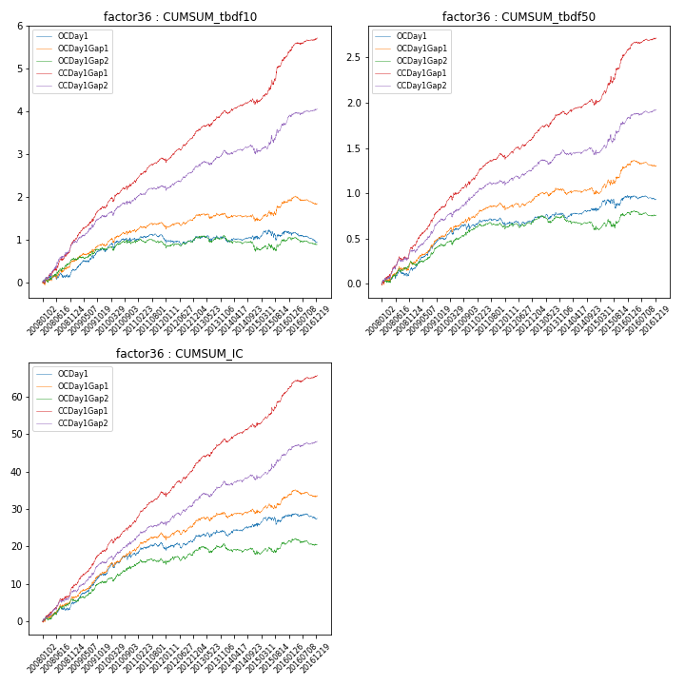

**因子换手率:** 54.08%

**截面指标_OCDay1:**

|  |  |  |  |  |  |  |  |  |
| --- | --- | --- | --- | --- | --- | --- | --- | --- |
| year | annret_tbdf10 | sharpe_tbdf10 | maxdd_tbdf10 | annret_tbdf50 | sharpe_tbdf50 | maxdd_tbdf50 | mean_IC | tstat_IC |
| 2008 | 0.28 | 1.23 | -0.12 | 0.15 | 1.43 | -0.07 | 0.02 | 2.12 |
| 2009 | 0.49 | 3.03 | -0.25 | 0.36 | 4.47 | -0.15 | 0.03 | 4.32 |
| 2010 | 0.25 | 1.36 | -0.43 | 0.15 | 1.73 | -0.32 | 0.02 | 2.71 |
| 2011 | -0.04 | -0.29 | -0.43 | 0.01 | 0.14 | -0.32 | 0.01 | 0.77 |
| 2012 | 0.05 | 0.38 | -0.46 | 0.05 | 0.87 | -0.32 | 0.01 | 1.66 |
| 2013 | -0.02 | -0.13 | -0.43 | 0.04 | 0.49 | -0.31 | 0.01 | 0.69 |
| 2014 | 0.02 | 0.14 | -0.44 | 0.06 | 1.01 | -0.33 | 0.01 | 1.33 |
| 2015 | 0.16 | 0.64 | -0.44 | 0.15 | 1.19 | -0.31 | 0.01 | 1.11 |
| 2016 | -0.25 | -1.96 | -0.54 | -0.03 | -0.52 | -0.33 | -0.0 | -0.54 |

**截面指标_CCDay1Gap1:**

|  |  |  |  |  |  |  |  |  |
| --- | --- | --- | --- | --- | --- | --- | --- | --- |
| year | annret_tbdf10 | sharpe_tbdf10 | maxdd_tbdf10 | annret_tbdf50 | sharpe_tbdf50 | maxdd_tbdf50 | mean_IC | tstat_IC |
| 2008 | 0.96 | 4.45 | -0.08 | 0.4 | 3.98 | -0.04 | 0.04 | 4.84 |
| 2009 | 0.79 | 4.94 | -0.61 | 0.45 | 5.84 | -0.33 | 0.04 | 5.76 |
| 2010 | 0.61 | 3.27 | -0.62 | 0.32 | 3.53 | -0.37 | 0.03 | 4.24 |
| 2011 | 0.48 | 3.98 | -0.62 | 0.23 | 4.13 | -0.37 | 0.03 | 4.69 |
| 2012 | 0.65 | 5.26 | -0.63 | 0.25 | 4.19 | -0.37 | 0.03 | 4.94 |
| 2013 | 0.52 | 3.6 | -0.6 | 0.26 | 3.74 | -0.35 | 0.03 | 4.04 |
| 2014 | 0.23 | 1.63 | -0.63 | 0.11 | 1.71 | -0.38 | 0.02 | 2.77 |
| 2015 | 1.06 | 4.19 | -0.63 | 0.55 | 4.4 | -0.37 | 0.04 | 4.42 |
| 2016 | 0.43 | 3.54 | -0.64 | 0.17 | 3.22 | -0.41 | 0.02 | 3.53 |

**风格暴露:**

|  |  |  |  |  |
| --- | --- | --- | --- | --- |
|  | long | short | corr_OCDay1 | corr_CCDay1Gap1 |
| liquidity10 | 0.19 | -0.21 | -0.16 | -0.15 |
| liquidity20 | 0.08 | -0.1 | -0.08 | -0.09 |
| liquidity5 | 0.39 | -0.42 | -0.24 | -0.24 |
| logmktcap | -0.02 | 0.02 | -0.01 | -0.03 |
| momentum15 | 0.95 | -0.95 | -0.63 | -0.62 |
| momentum30 | 0.63 | -0.63 | -0.51 | -0.47 |
| momentum5 | 1.67 | -1.66 | -0.77 | -0.75 |
| retvolatility30 | 0.03 | -0.05 | -0.05 | -0.02 |