Factors Report 20080102-20161230

**1. factor39**

**截面指标累计曲线:**

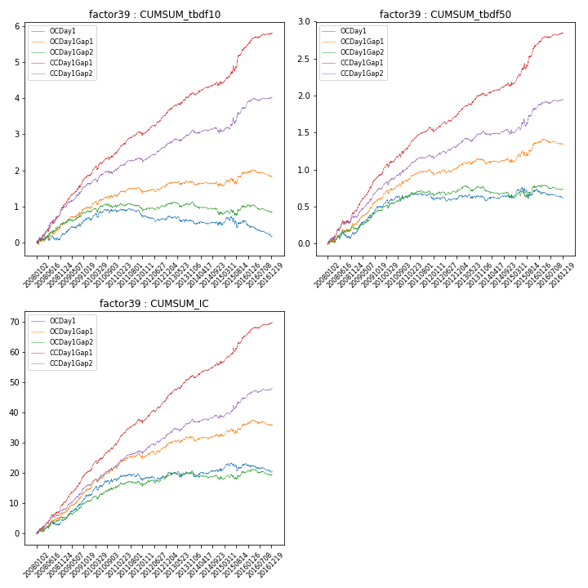

**因子换手率:** 53.21%

**截面指标_OCDay1:**

|  |  |  |  |  |  |  |  |  |
| --- | --- | --- | --- | --- | --- | --- | --- | --- |
| year | annret_tbdf10 | sharpe_tbdf10 | maxdd_tbdf10 | annret_tbdf50 | sharpe_tbdf50 | maxdd_tbdf50 | mean_IC | tstat_IC |
| 2008 | 0.22 | 0.98 | -0.13 | 0.13 | 1.18 | -0.09 | 0.02 | 1.86 |
| 2009 | 0.46 | 2.79 | -0.21 | 0.38 | 4.49 | -0.14 | 0.04 | 4.5 |
| 2010 | 0.23 | 1.21 | -0.41 | 0.14 | 1.48 | -0.33 | 0.02 | 2.48 |
| 2011 | -0.15 | -1.22 | -0.45 | -0.03 | -0.5 | -0.33 | -0.0 | -0.07 |
| 2012 | -0.06 | -0.47 | -0.47 | 0.02 | 0.37 | -0.34 | 0.01 | 0.99 |
| 2013 | -0.13 | -0.82 | -0.45 | -0.02 | -0.26 | -0.33 | -0.0 | -0.09 |
| 2014 | -0.05 | -0.37 | -0.43 | 0.02 | 0.25 | -0.34 | 0.01 | 0.92 |
| 2015 | 0.06 | 0.23 | -0.45 | 0.11 | 0.81 | -0.33 | 0.01 | 0.89 |
| 2016 | -0.41 | -2.88 | -0.59 | -0.11 | -1.8 | -0.39 | -0.01 | -1.74 |

**截面指标_CCDay1Gap1:**

|  |  |  |  |  |  |  |  |  |
| --- | --- | --- | --- | --- | --- | --- | --- | --- |
| year | annret_tbdf10 | sharpe_tbdf10 | maxdd_tbdf10 | annret_tbdf50 | sharpe_tbdf50 | maxdd_tbdf50 | mean_IC | tstat_IC |
| 2008 | 1.0 | 4.64 | -0.08 | 0.42 | 4.01 | -0.04 | 0.04 | 4.92 |
| 2009 | 0.87 | 5.31 | -0.62 | 0.52 | 6.48 | -0.34 | 0.04 | 6.41 |
| 2010 | 0.63 | 3.34 | -0.63 | 0.36 | 3.99 | -0.4 | 0.04 | 4.72 |
| 2011 | 0.52 | 4.09 | -0.64 | 0.24 | 4.22 | -0.41 | 0.03 | 4.8 |
| 2012 | 0.64 | 5.11 | -0.64 | 0.24 | 4.0 | -0.41 | 0.03 | 5.1 |
| 2013 | 0.52 | 3.51 | -0.62 | 0.26 | 3.72 | -0.39 | 0.03 | 4.06 |
| 2014 | 0.29 | 2.06 | -0.65 | 0.14 | 2.14 | -0.42 | 0.02 | 3.03 |
| 2015 | 1.0 | 3.94 | -0.64 | 0.54 | 4.36 | -0.41 | 0.04 | 4.24 |
| 2016 | 0.39 | 3.16 | -0.63 | 0.16 | 2.95 | -0.41 | 0.02 | 3.53 |

**风格暴露:**

|  |  |  |  |  |
| --- | --- | --- | --- | --- |
|  | long | short | corr_OCDay1 | corr_CCDay1Gap1 |
| liquidity10 | 0.14 | -0.16 | -0.16 | -0.13 |
| liquidity20 | 0.04 | -0.05 | -0.08 | -0.07 |
| liquidity5 | 0.36 | -0.39 | -0.24 | -0.22 |
| logmktcap | -0.04 | 0.05 | 0.01 | -0.02 |
| momentum15 | 0.95 | -0.95 | -0.63 | -0.61 |
| momentum30 | 0.62 | -0.62 | -0.49 | -0.45 |
| momentum5 | 1.86 | -1.85 | -0.81 | -0.79 |
| retvolatility30 | -0.01 | -0.01 | -0.04 | -0.01 |