Factors Report 20080102-20161230

**1. factor34**

**截面指标累计曲线:**

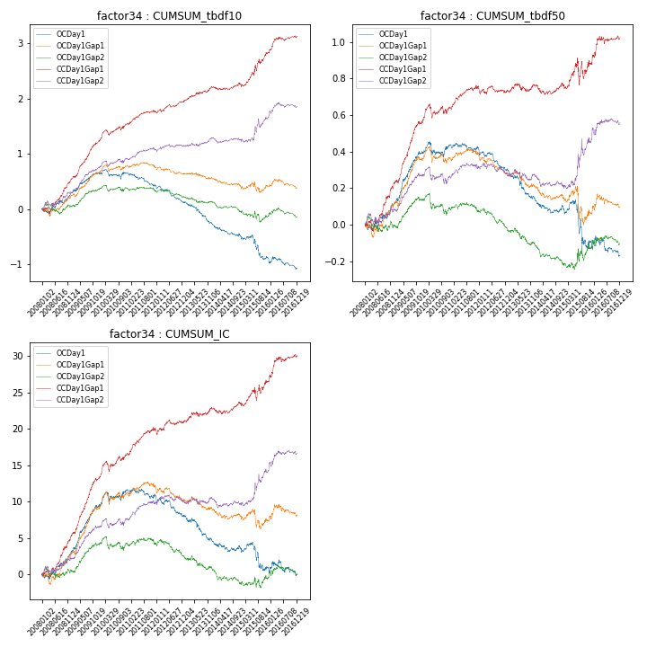

**因子换手率:** 63.13%

**截面指标_OCDay1:**

|  |  |  |  |  |  |  |  |  |
| --- | --- | --- | --- | --- | --- | --- | --- | --- |
| year | annret_tbdf10 | sharpe_tbdf10 | maxdd_tbdf10 | annret_tbdf50 | sharpe_tbdf50 | maxdd_tbdf50 | mean_IC | tstat_IC |
| 2008 | 0.27 | 1.77 | -0.1 | 0.11 | 1.33 | -0.04 | 0.01 | 1.75 |
| 2009 | 0.4 | 3.23 | -0.04 | 0.29 | 4.52 | -0.02 | 0.03 | 4.63 |
| 2010 | -0.02 | -0.14 | -0.17 | 0.04 | 0.54 | -0.08 | 0.01 | 1.31 |
| 2011 | -0.23 | -2.44 | -0.22 | -0.02 | -0.48 | -0.05 | -0.0 | -0.73 |
| 2012 | -0.29 | -3.15 | -0.27 | -0.11 | -2.48 | -0.11 | -0.01 | -2.09 |
| 2013 | -0.4 | -3.42 | -0.33 | -0.16 | -2.77 | -0.16 | -0.01 | -2.5 |
| 2014 | -0.23 | -2.41 | -0.22 | -0.06 | -1.2 | -0.08 | -0.01 | -1.07 |
| 2015 | -0.42 | -1.98 | -0.37 | -0.19 | -1.41 | -0.24 | -0.01 | -1.31 |
| 2016 | -0.16 | -1.27 | -0.21 | -0.06 | -0.81 | -0.11 | -0.0 | -0.44 |

**截面指标_CCDay1Gap1:**

|  |  |  |  |  |  |  |  |  |
| --- | --- | --- | --- | --- | --- | --- | --- | --- |
| year | annret_tbdf10 | sharpe_tbdf10 | maxdd_tbdf10 | annret_tbdf50 | sharpe_tbdf50 | maxdd_tbdf50 | mean_IC | tstat_IC |
| 2008 | 0.52 | 3.59 | -0.1 | 0.22 | 2.9 | -0.06 | 0.02 | 3.76 |
| 2009 | 0.72 | 6.01 | -0.03 | 0.35 | 5.86 | -0.02 | 0.03 | 6.76 |
| 2010 | 0.31 | 2.5 | -0.1 | 0.08 | 1.27 | -0.08 | 0.01 | 2.48 |
| 2011 | 0.21 | 2.23 | -0.03 | 0.1 | 2.14 | -0.02 | 0.01 | 2.69 |
| 2012 | 0.21 | 2.42 | -0.05 | -0.01 | -0.23 | -0.04 | 0.01 | 1.21 |
| 2013 | 0.25 | 2.37 | -0.03 | 0.03 | 0.58 | -0.04 | 0.01 | 1.4 |
| 2014 | 0.05 | 0.61 | -0.06 | -0.0 | -0.05 | -0.05 | 0.0 | 0.69 |
| 2015 | 0.56 | 2.81 | -0.11 | 0.11 | 0.83 | -0.14 | 0.01 | 1.52 |
| 2016 | 0.3 | 2.47 | -0.06 | 0.15 | 2.08 | -0.04 | 0.01 | 2.58 |

**风格暴露:**

|  |  |  |  |  |
| --- | --- | --- | --- | --- |
|  | long | short | corr_OCDay1 | corr_CCDay1Gap1 |
| liquidity10 | -0.03 | 0.01 | -0.11 | -0.06 |
| liquidity20 | -0.06 | 0.05 | -0.07 | -0.02 |
| liquidity5 | 0.25 | -0.28 | -0.18 | -0.12 |
| logmktcap | 0.0 | 0.0 | 0.05 | -0.01 |
| momentum15 | 0.31 | -0.31 | -0.37 | -0.34 |
| momentum30 | 0.16 | -0.17 | -0.28 | -0.22 |
| momentum5 | 0.82 | -0.81 | -0.46 | -0.31 |
| retvolatility30 | -0.06 | 0.04 | -0.08 | -0.01 |