Factors Report 20080102-20161230

**1. factor40**

**截面指标累计曲线:**

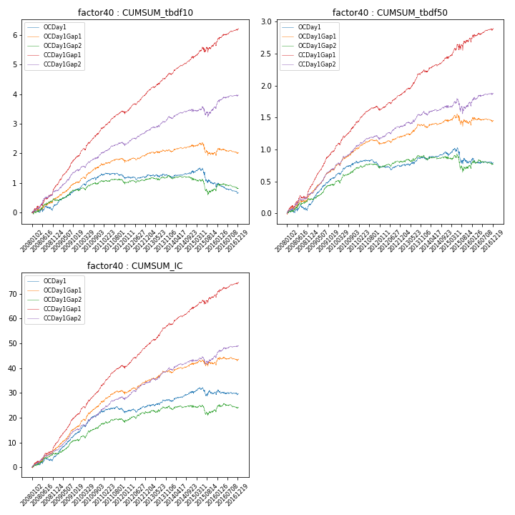

**因子换手率:** 54.23%

**截面指标_OCDay1:**

|  |  |  |  |  |  |  |  |  |
| --- | --- | --- | --- | --- | --- | --- | --- | --- |
| year | annret_tbdf10 | sharpe_tbdf10 | maxdd_tbdf10 | annret_tbdf50 | sharpe_tbdf50 | maxdd_tbdf50 | mean_IC | tstat_IC |
| 2008 | 0.26 | 1.06 | -0.16 | 0.14 | 1.2 | -0.09 | 0.02 | 1.86 |
| 2009 | 0.56 | 3.41 | -0.05 | 0.43 | 5.09 | -0.02 | 0.04 | 5.19 |
| 2010 | 0.49 | 2.97 | -0.1 | 0.25 | 2.89 | -0.03 | 0.03 | 3.98 |
| 2011 | -0.1 | -0.72 | -0.14 | -0.07 | -1.0 | -0.1 | -0.0 | -0.06 |
| 2012 | 0.05 | 0.39 | -0.11 | 0.01 | 0.13 | -0.06 | 0.01 | 1.23 |
| 2013 | -0.01 | -0.03 | -0.09 | 0.13 | 1.55 | -0.03 | 0.01 | 1.31 |
| 2014 | 0.12 | 0.96 | -0.07 | 0.05 | 0.66 | -0.04 | 0.01 | 1.81 |
| 2015 | -0.38 | -1.29 | -0.45 | -0.11 | -0.65 | -0.23 | -0.0 | -0.01 |
| 2016 | -0.32 | -1.85 | -0.3 | -0.02 | -0.24 | -0.09 | -0.0 | -0.21 |

**截面指标_CCDay1Gap1:**

|  |  |  |  |  |  |  |  |  |
| --- | --- | --- | --- | --- | --- | --- | --- | --- |
| year | annret_tbdf10 | sharpe_tbdf10 | maxdd_tbdf10 | annret_tbdf50 | sharpe_tbdf50 | maxdd_tbdf50 | mean_IC | tstat_IC |
| 2008 | 0.89 | 4.06 | -0.09 | 0.41 | 3.83 | -0.05 | 0.04 | 4.58 |
| 2009 | 1.03 | 6.56 | -0.03 | 0.57 | 7.23 | -0.01 | 0.05 | 7.34 |
| 2010 | 0.93 | 5.73 | -0.05 | 0.45 | 5.6 | -0.03 | 0.05 | 6.6 |
| 2011 | 0.54 | 4.1 | -0.06 | 0.21 | 3.21 | -0.06 | 0.03 | 4.53 |
| 2012 | 0.7 | 5.29 | -0.08 | 0.26 | 4.07 | -0.03 | 0.04 | 5.34 |
| 2013 | 0.65 | 4.55 | -0.04 | 0.37 | 4.75 | -0.02 | 0.04 | 5.02 |
| 2014 | 0.56 | 4.43 | -0.06 | 0.21 | 2.98 | -0.03 | 0.03 | 4.24 |
| 2015 | 0.48 | 1.7 | -0.18 | 0.29 | 1.87 | -0.1 | 0.02 | 2.02 |
| 2016 | 0.48 | 2.92 | -0.1 | 0.16 | 1.74 | -0.06 | 0.02 | 2.84 |

**风格暴露:**

|  |  |  |  |  |
| --- | --- | --- | --- | --- |
|  | long | short | corr_OCDay1 | corr_CCDay1Gap1 |
| liquidity10 | 0.13 | -0.15 | -0.02 | -0.01 |
| liquidity20 | 0.02 | -0.04 | 0.05 | 0.04 |
| liquidity5 | 0.35 | -0.37 | -0.09 | -0.09 |
| logmktcap | -0.02 | 0.02 | -0.14 | -0.11 |
| momentum15 | 1.0 | -1.0 | -0.57 | -0.52 |
| momentum30 | 0.63 | -0.63 | -0.44 | -0.39 |
| momentum5 | 1.97 | -1.96 | -0.86 | -0.86 |
| retvolatility30 | -0.02 | 0.0 | 0.09 | 0.09 |