Factors Report 20080102-20161230

**1. factor48**

**截面指标累计曲线:**

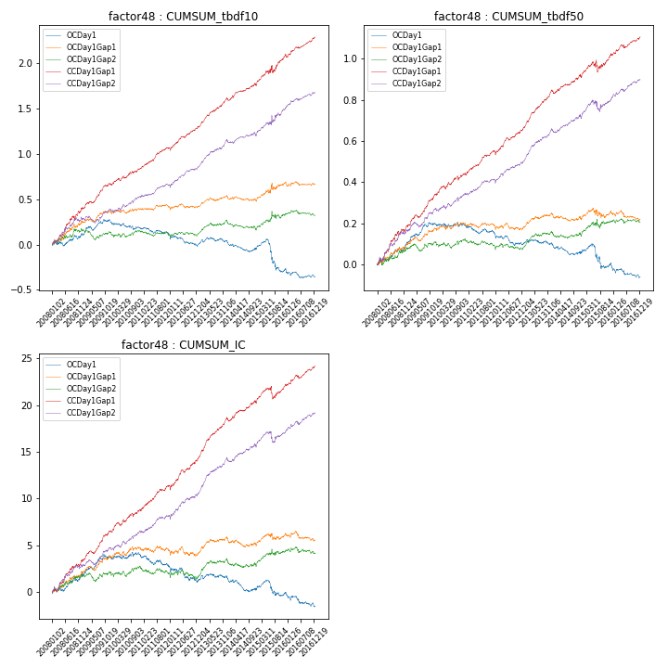

**因子换手率:** 48.78%

**截面指标_OCDay1:**

|  |  |  |  |  |  |  |  |  |
| --- | --- | --- | --- | --- | --- | --- | --- | --- |
| year | annret_tbdf10 | sharpe_tbdf10 | maxdd_tbdf10 | annret_tbdf50 | sharpe_tbdf50 | maxdd_tbdf50 | mean_IC | tstat_IC |
| 2008 | 0.12 | 1.52 | -0.05 | 0.11 | 2.43 | -0.02 | 0.01 | 2.28 |
| 2009 | 0.12 | 1.75 | -0.05 | 0.09 | 2.54 | -0.01 | 0.01 | 2.25 |
| 2010 | -0.06 | -0.94 | -0.09 | -0.0 | -0.02 | -0.02 | 0.0 | 0.51 |
| 2011 | -0.07 | -1.45 | -0.08 | -0.04 | -1.33 | -0.05 | -0.01 | -1.7 |
| 2012 | -0.11 | -1.84 | -0.12 | -0.05 | -1.81 | -0.06 | -0.01 | -1.72 |
| 2013 | 0.03 | 0.54 | -0.05 | -0.0 | -0.11 | -0.03 | 0.0 | 0.38 |
| 2014 | -0.08 | -1.42 | -0.11 | -0.04 | -1.48 | -0.05 | -0.01 | -1.9 |
| 2015 | -0.22 | -1.58 | -0.31 | -0.05 | -0.78 | -0.12 | -0.0 | -0.24 |
| 2016 | -0.09 | -1.49 | -0.1 | -0.07 | -2.23 | -0.07 | -0.01 | -2.02 |

**截面指标_CCDay1Gap1:**

|  |  |  |  |  |  |  |  |  |
| --- | --- | --- | --- | --- | --- | --- | --- | --- |
| year | annret_tbdf10 | sharpe_tbdf10 | maxdd_tbdf10 | annret_tbdf50 | sharpe_tbdf50 | maxdd_tbdf50 | mean_IC | tstat_IC |
| 2008 | 0.4 | 4.12 | -0.03 | 0.19 | 3.79 | -0.02 | 0.01 | 3.92 |
| 2009 | 0.26 | 3.92 | -0.02 | 0.15 | 4.6 | -0.01 | 0.01 | 4.42 |
| 2010 | 0.18 | 2.8 | -0.03 | 0.1 | 3.03 | -0.02 | 0.01 | 3.27 |
| 2011 | 0.23 | 4.39 | -0.02 | 0.11 | 3.91 | -0.01 | 0.01 | 3.7 |
| 2012 | 0.23 | 3.74 | -0.03 | 0.11 | 3.59 | -0.02 | 0.01 | 3.6 |
| 2013 | 0.33 | 5.82 | -0.01 | 0.18 | 6.3 | -0.01 | 0.02 | 6.46 |
| 2014 | 0.15 | 2.75 | -0.03 | 0.07 | 2.35 | -0.02 | 0.01 | 2.63 |
| 2015 | 0.34 | 2.62 | -0.08 | 0.11 | 1.78 | -0.06 | 0.01 | 1.87 |
| 2016 | 0.19 | 3.37 | -0.03 | 0.08 | 2.8 | -0.02 | 0.01 | 3.16 |

**风格暴露:**

|  |  |  |  |  |
| --- | --- | --- | --- | --- |
|  | long | short | corr_OCDay1 | corr_CCDay1Gap1 |
| liquidity10 | 0.47 | -0.47 | -0.46 | -0.39 |
| liquidity20 | 0.39 | -0.39 | -0.41 | -0.36 |
| liquidity5 | 0.56 | -0.56 | -0.5 | -0.39 |
| logmktcap | -0.24 | 0.24 | 0.21 | 0.24 |
| momentum15 | 0.39 | -0.38 | -0.38 | -0.29 |
| momentum30 | 0.26 | -0.25 | -0.28 | -0.19 |
| momentum5 | 0.44 | -0.44 | -0.38 | -0.35 |
| retvolatility30 | 0.25 | -0.24 | -0.26 | -0.22 |