Factors Report 20080102-20161230

**1. factor49**

**截面指标累计曲线:**

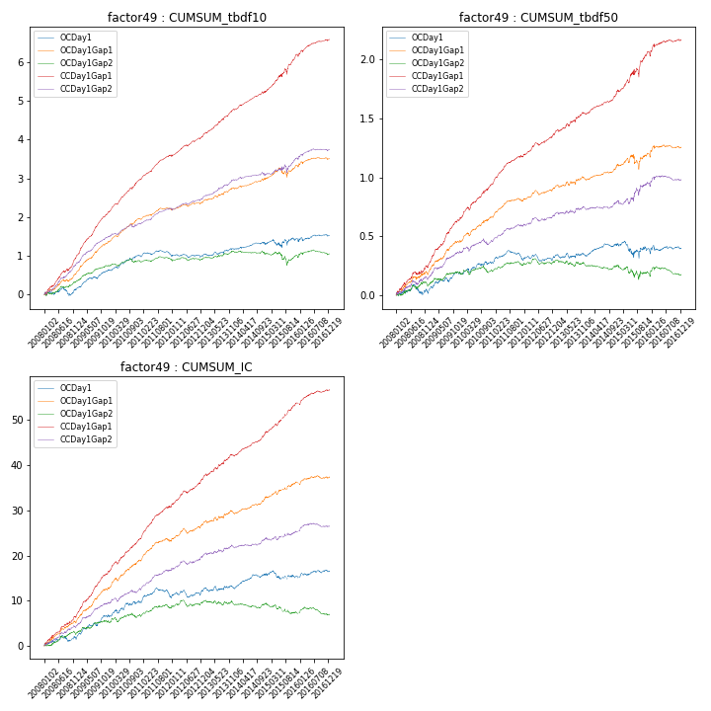

**因子换手率:** 50.3%

**截面指标_OCDay1:**

|  |  |  |  |  |  |  |  |  |
| --- | --- | --- | --- | --- | --- | --- | --- | --- |
| year | annret_tbdf10 | sharpe_tbdf10 | maxdd_tbdf10 | annret_tbdf50 | sharpe_tbdf50 | maxdd_tbdf50 | mean_IC | tstat_IC |
| 2008 | 0.14 | 0.84 | -0.2 | 0.02 | 0.26 | -0.08 | 0.01 | 1.1 |
| 2009 | 0.51 | 4.92 | -0.05 | 0.18 | 3.47 | -0.03 | 0.02 | 4.47 |
| 2010 | 0.36 | 3.57 | -0.05 | 0.08 | 1.48 | -0.03 | 0.01 | 2.17 |
| 2011 | 0.01 | 0.1 | -0.13 | 0.02 | 0.61 | -0.08 | 0.0 | 0.91 |
| 2012 | -0.0 | -0.03 | -0.08 | 0.03 | 0.81 | -0.06 | 0.01 | 1.49 |
| 2013 | 0.19 | 1.83 | -0.07 | 0.01 | 0.29 | -0.04 | 0.0 | 0.59 |
| 2014 | 0.11 | 1.19 | -0.06 | 0.09 | 2.65 | -0.03 | 0.01 | 3.44 |
| 2015 | 0.14 | 0.7 | -0.2 | -0.05 | -0.49 | -0.14 | -0.0 | -0.49 |
| 2016 | 0.09 | 0.7 | -0.09 | 0.01 | 0.18 | -0.04 | 0.01 | 1.29 |

**截面指标_CCDay1Gap1:**

|  |  |  |  |  |  |  |  |  |
| --- | --- | --- | --- | --- | --- | --- | --- | --- |
| year | annret_tbdf10 | sharpe_tbdf10 | maxdd_tbdf10 | annret_tbdf50 | sharpe_tbdf50 | maxdd_tbdf50 | mean_IC | tstat_IC |
| 2008 | 0.98 | 6.51 | -0.06 | 0.25 | 3.38 | -0.03 | 0.03 | 5.36 |
| 2009 | 1.14 | 11.09 | -0.02 | 0.41 | 7.77 | -0.01 | 0.04 | 8.72 |
| 2010 | 0.86 | 8.72 | -0.05 | 0.29 | 5.5 | -0.02 | 0.03 | 6.71 |
| 2011 | 0.6 | 7.36 | -0.04 | 0.23 | 6.3 | -0.01 | 0.03 | 7.2 |
| 2012 | 0.54 | 6.57 | -0.04 | 0.2 | 5.33 | -0.02 | 0.03 | 6.2 |
| 2013 | 0.71 | 7.13 | -0.03 | 0.17 | 3.4 | -0.02 | 0.02 | 4.49 |
| 2014 | 0.46 | 5.2 | -0.04 | 0.2 | 5.65 | -0.01 | 0.02 | 6.71 |
| 2015 | 0.94 | 4.82 | -0.14 | 0.32 | 2.92 | -0.07 | 0.03 | 4.52 |
| 2016 | 0.4 | 3.65 | -0.05 | 0.11 | 1.96 | -0.03 | 0.01 | 3.68 |

**风格暴露:**

|  |  |  |  |  |
| --- | --- | --- | --- | --- |
|  | long | short | corr_OCDay1 | corr_CCDay1Gap1 |
| liquidity10 | -0.23 | 0.23 | 0.18 | 0.2 |
| liquidity20 | -0.24 | 0.24 | 0.22 | 0.23 |
| liquidity5 | -0.17 | 0.18 | 0.14 | 0.14 |
| logmktcap | -0.3 | 0.3 | -0.12 | -0.17 |
| momentum15 | 0.37 | -0.37 | -0.45 | -0.42 |
| momentum30 | 0.22 | -0.21 | -0.35 | -0.31 |
| momentum5 | 0.84 | -0.83 | -0.59 | -0.56 |
| retvolatility30 | -0.29 | 0.29 | 0.33 | 0.32 |