Factors Report 20080102-20161230

**1. factor3**

**截面指标累计曲线:**

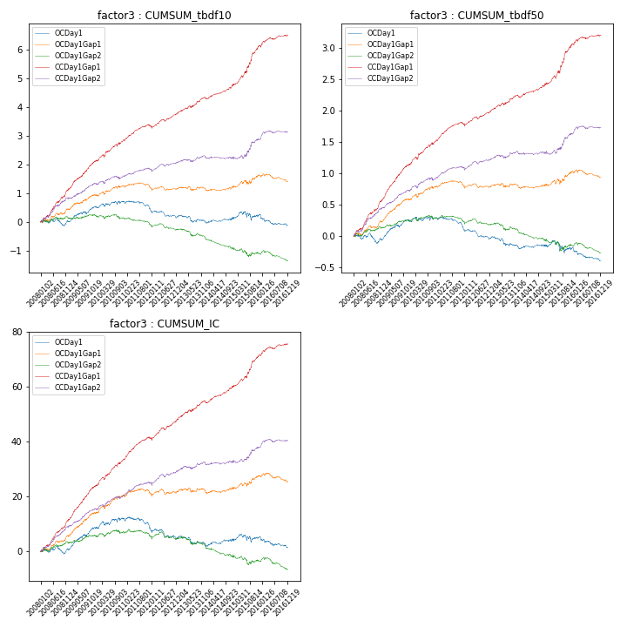

**因子换手率:** 50.38%

**截面指标_OCDay1:**

|  |  |  |  |  |  |  |  |  |
| --- | --- | --- | --- | --- | --- | --- | --- | --- |
| year | annret_tbdf10 | sharpe_tbdf10 | maxdd_tbdf10 | annret_tbdf50 | sharpe_tbdf50 | maxdd_tbdf50 | mean_IC | tstat_IC |
| 2008 | 0.01 | 0.04 | -0.25 | -0.06 | -0.64 | -0.16 | 0.0 | 0.34 |
| 2009 | 0.53 | 3.3 | -0.08 | 0.32 | 4.02 | -0.05 | 0.03 | 4.37 |
| 2010 | 0.17 | 0.96 | -0.1 | 0.03 | 0.3 | -0.06 | 0.01 | 1.35 |
| 2011 | -0.32 | -2.47 | -0.29 | -0.18 | -2.85 | -0.18 | -0.02 | -2.34 |
| 2012 | -0.2 | -1.59 | -0.24 | -0.14 | -2.26 | -0.15 | -0.01 | -1.54 |
| 2013 | -0.18 | -1.14 | -0.23 | -0.15 | -1.86 | -0.15 | -0.01 | -1.22 |
| 2014 | 0.09 | 0.66 | -0.06 | 0.01 | 0.1 | -0.04 | 0.01 | 0.8 |
| 2015 | 0.15 | 0.6 | -0.29 | -0.03 | -0.22 | -0.19 | 0.0 | 0.46 |
| 2016 | -0.38 | -2.57 | -0.33 | -0.2 | -2.89 | -0.19 | -0.02 | -2.31 |

**截面指标_CCDay1Gap1:**

|  |  |  |  |  |  |  |  |  |
| --- | --- | --- | --- | --- | --- | --- | --- | --- |
| year | annret_tbdf10 | sharpe_tbdf10 | maxdd_tbdf10 | annret_tbdf50 | sharpe_tbdf50 | maxdd_tbdf50 | mean_IC | tstat_IC |
| 2008 | 1.15 | 5.95 | -0.07 | 0.57 | 6.32 | -0.03 | 0.05 | 6.42 |
| 2009 | 1.0 | 6.12 | -0.03 | 0.58 | 7.57 | -0.01 | 0.05 | 7.37 |
| 2010 | 0.71 | 3.96 | -0.08 | 0.38 | 4.15 | -0.04 | 0.04 | 4.93 |
| 2011 | 0.47 | 3.81 | -0.08 | 0.26 | 4.5 | -0.04 | 0.03 | 5.0 |
| 2012 | 0.51 | 4.24 | -0.08 | 0.23 | 4.02 | -0.04 | 0.03 | 4.79 |
| 2013 | 0.53 | 3.66 | -0.06 | 0.24 | 3.38 | -0.03 | 0.03 | 3.63 |
| 2014 | 0.46 | 3.5 | -0.06 | 0.19 | 3.05 | -0.03 | 0.02 | 3.72 |
| 2015 | 1.36 | 5.17 | -0.06 | 0.64 | 4.85 | -0.05 | 0.05 | 5.09 |
| 2016 | 0.39 | 2.9 | -0.06 | 0.14 | 2.31 | -0.03 | 0.02 | 3.08 |

**风格暴露:**

|  |  |  |  |  |
| --- | --- | --- | --- | --- |
|  | long | short | corr_OCDay1 | corr_CCDay1Gap1 |
| liquidity10 | 0.26 | -0.25 | -0.21 | -0.21 |
| liquidity20 | 0.15 | -0.14 | -0.12 | -0.13 |
| liquidity5 | 0.48 | -0.47 | -0.3 | -0.29 |
| logmktcap | -0.08 | 0.09 | -0.14 | -0.01 |
| momentum15 | 1.06 | -1.05 | -0.72 | -0.67 |
| momentum30 | 0.73 | -0.72 | -0.6 | -0.53 |
| momentum5 | 2.04 | -2.03 | -0.9 | -0.9 |
| retvolatility30 | 0.09 | -0.08 | -0.03 | -0.06 |