Factors Report 20080102-20161230

**1. factor52**

**截面指标累计曲线:**

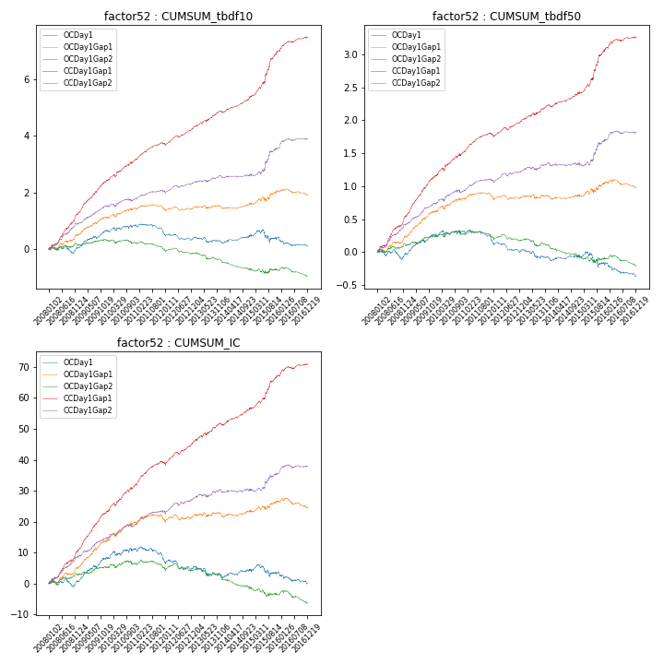

**因子换手率:** 56.76%

**截面指标_OCDay1:**

|  |  |  |  |  |  |  |  |  |
| --- | --- | --- | --- | --- | --- | --- | --- | --- |
| year | annret_tbdf10 | sharpe_tbdf10 | maxdd_tbdf10 | annret_tbdf50 | sharpe_tbdf50 | maxdd_tbdf50 | mean_IC | tstat_IC |
| 2008 | 0.03 | 0.17 | -0.25 | -0.04 | -0.41 | -0.15 | 0.0 | 0.28 |
| 2009 | 0.64 | 4.09 | -0.08 | 0.31 | 3.97 | -0.04 | 0.03 | 4.52 |
| 2010 | 0.18 | 0.99 | -0.12 | 0.04 | 0.42 | -0.06 | 0.01 | 1.21 |
| 2011 | -0.31 | -2.46 | -0.3 | -0.16 | -2.64 | -0.17 | -0.02 | -2.31 |
| 2012 | -0.16 | -1.34 | -0.22 | -0.12 | -2.09 | -0.14 | -0.01 | -1.37 |
| 2013 | -0.11 | -0.78 | -0.18 | -0.12 | -1.59 | -0.13 | -0.01 | -1.31 |
| 2014 | 0.19 | 1.53 | -0.06 | 0.02 | 0.31 | -0.04 | 0.01 | 0.98 |
| 2015 | -0.03 | -0.11 | -0.39 | -0.09 | -0.7 | -0.22 | -0.0 | -0.29 |
| 2016 | -0.32 | -2.19 | -0.29 | -0.2 | -2.85 | -0.18 | -0.01 | -2.3 |

**截面指标_CCDay1Gap1:**

|  |  |  |  |  |  |  |  |  |
| --- | --- | --- | --- | --- | --- | --- | --- | --- |
| year | annret_tbdf10 | sharpe_tbdf10 | maxdd_tbdf10 | annret_tbdf50 | sharpe_tbdf50 | maxdd_tbdf50 | mean_IC | tstat_IC |
| 2008 | 1.27 | 6.8 | -0.06 | 0.55 | 6.23 | -0.03 | 0.04 | 6.45 |
| 2009 | 1.17 | 7.62 | -0.03 | 0.61 | 8.05 | -0.02 | 0.05 | 8.17 |
| 2010 | 0.73 | 4.2 | -0.08 | 0.36 | 3.96 | -0.04 | 0.03 | 4.81 |
| 2011 | 0.55 | 4.72 | -0.06 | 0.25 | 4.42 | -0.04 | 0.03 | 4.94 |
| 2012 | 0.58 | 5.2 | -0.08 | 0.23 | 4.13 | -0.04 | 0.03 | 4.89 |
| 2013 | 0.61 | 4.48 | -0.05 | 0.24 | 3.32 | -0.03 | 0.02 | 3.77 |
| 2014 | 0.53 | 4.33 | -0.05 | 0.2 | 3.09 | -0.03 | 0.02 | 3.7 |
| 2015 | 1.62 | 5.87 | -0.05 | 0.69 | 5.33 | -0.04 | 0.04 | 5.21 |
| 2016 | 0.49 | 3.93 | -0.05 | 0.16 | 2.68 | -0.03 | 0.02 | 3.04 |

**风格暴露:**

|  |  |  |  |  |
| --- | --- | --- | --- | --- |
|  | long | short | corr_OCDay1 | corr_CCDay1Gap1 |
| liquidity10 | 0.24 | -0.23 | -0.23 | -0.22 |
| liquidity20 | 0.13 | -0.12 | -0.15 | -0.15 |
| liquidity5 | 0.46 | -0.45 | -0.32 | -0.3 |
| logmktcap | -0.11 | 0.12 | -0.07 | 0.02 |
| momentum15 | 1.02 | -1.01 | -0.69 | -0.65 |
| momentum30 | 0.69 | -0.68 | -0.58 | -0.5 |
| momentum5 | 2.01 | -2.0 | -0.87 | -0.87 |
| retvolatility30 | 0.07 | -0.07 | -0.06 | -0.08 |