Factors Report 20080102-20161230

**1. factor50**

**截面指标累计曲线:**

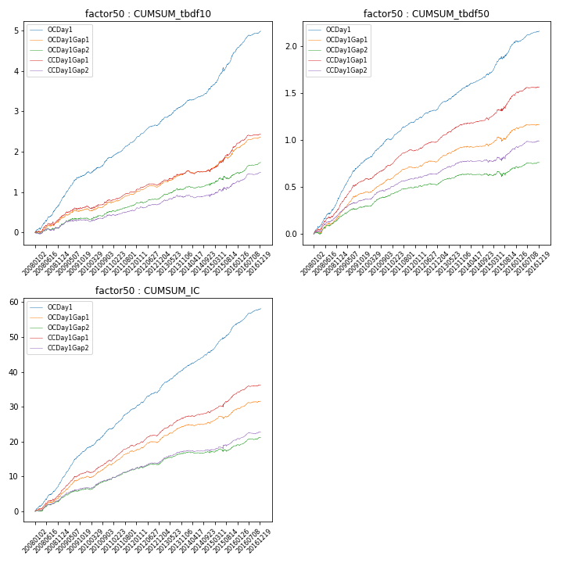

**因子换手率:** 57.89%

**截面指标_OCDay1:**

|  |  |  |  |  |  |  |  |  |
| --- | --- | --- | --- | --- | --- | --- | --- | --- |
| year | annret_tbdf10 | sharpe_tbdf10 | maxdd_tbdf10 | annret_tbdf50 | sharpe_tbdf50 | maxdd_tbdf50 | mean_IC | tstat_IC |
| 2008 | 0.74 | 7.71 | -0.04 | 0.38 | 8.74 | -0.01 | 0.03 | 9.37 |
| 2009 | 0.69 | 8.6 | -0.02 | 0.4 | 12.05 | -0.01 | 0.04 | 12.55 |
| 2010 | 0.42 | 5.26 | -0.03 | 0.23 | 7.59 | -0.01 | 0.02 | 7.73 |
| 2011 | 0.46 | 8.67 | -0.01 | 0.18 | 7.5 | -0.01 | 0.02 | 9.32 |
| 2012 | 0.44 | 8.02 | -0.02 | 0.17 | 7.06 | -0.01 | 0.02 | 8.32 |
| 2013 | 0.46 | 6.81 | -0.01 | 0.2 | 7.55 | -0.01 | 0.02 | 8.79 |
| 2014 | 0.4 | 6.56 | -0.01 | 0.15 | 5.71 | -0.01 | 0.02 | 7.6 |
| 2015 | 0.89 | 7.44 | -0.08 | 0.33 | 6.89 | -0.03 | 0.03 | 9.78 |
| 2016 | 0.51 | 7.64 | -0.01 | 0.13 | 4.37 | -0.01 | 0.02 | 7.34 |

**截面指标_CCDay1Gap1:**

|  |  |  |  |  |  |  |  |  |
| --- | --- | --- | --- | --- | --- | --- | --- | --- |
| year | annret_tbdf10 | sharpe_tbdf10 | maxdd_tbdf10 | annret_tbdf50 | sharpe_tbdf50 | maxdd_tbdf50 | mean_IC | tstat_IC |
| 2008 | 0.36 | 2.95 | -0.09 | 0.27 | 6.29 | -0.02 | 0.02 | 5.75 |
| 2009 | 0.27 | 3.29 | -0.04 | 0.3 | 8.55 | -0.01 | 0.02 | 8.08 |
| 2010 | 0.16 | 1.94 | -0.07 | 0.16 | 5.3 | -0.01 | 0.01 | 4.97 |
| 2011 | 0.24 | 4.82 | -0.02 | 0.16 | 7.12 | -0.01 | 0.02 | 7.93 |
| 2012 | 0.2 | 3.93 | -0.04 | 0.13 | 5.62 | -0.01 | 0.02 | 6.29 |
| 2013 | 0.26 | 3.51 | -0.03 | 0.17 | 6.47 | -0.01 | 0.02 | 6.71 |
| 2014 | 0.07 | 0.96 | -0.07 | 0.06 | 2.26 | -0.02 | 0.01 | 2.55 |
| 2015 | 0.6 | 5.08 | -0.05 | 0.25 | 4.61 | -0.03 | 0.02 | 5.06 |
| 2016 | 0.29 | 4.66 | -0.02 | 0.08 | 3.11 | -0.01 | 0.01 | 4.31 |

**风格暴露:**

|  |  |  |  |  |
| --- | --- | --- | --- | --- |
|  | long | short | corr_OCDay1 | corr_CCDay1Gap1 |
| liquidity10 | 0.08 | -0.08 | 0.07 | 0.07 |
| liquidity20 | 0.07 | -0.06 | 0.1 | 0.1 |
| liquidity5 | 0.12 | -0.11 | 0.05 | 0.03 |
| logmktcap | 0.04 | -0.03 | -0.16 | -0.21 |
| momentum15 | 0.32 | -0.31 | -0.2 | -0.26 |
| momentum30 | 0.23 | -0.23 | -0.21 | -0.24 |
| momentum5 | 0.55 | -0.55 | -0.28 | -0.29 |
| retvolatility30 | 0.09 | -0.08 | 0.1 | 0.16 |