Factors Report 20080102-20161230

**1. factor7**

**截面指标累计曲线:**

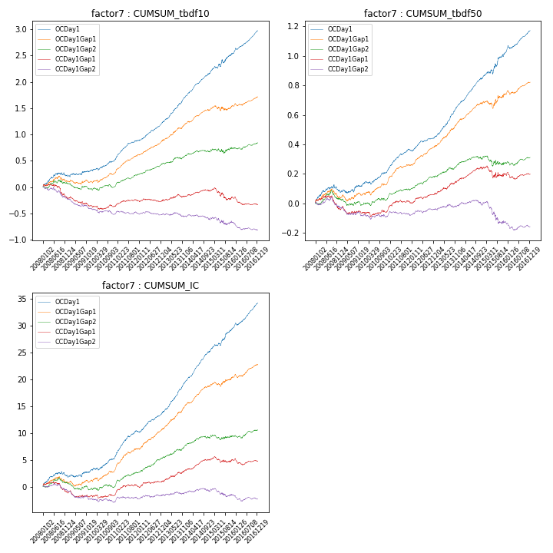

**因子换手率:** 54.38%

**截面指标_OCDay1:**

|  |  |  |  |  |  |  |  |  |
| --- | --- | --- | --- | --- | --- | --- | --- | --- |
| year | annret_tbdf10 | sharpe_tbdf10 | maxdd_tbdf10 | annret_tbdf50 | sharpe_tbdf50 | maxdd_tbdf50 | mean_IC | tstat_IC |
| 2008 | 0.23 | 2.29 | -0.06 | 0.09 | 2.06 | -0.04 | 0.01 | 2.37 |
| 2009 | 0.09 | 1.19 | -0.03 | 0.05 | 1.26 | -0.02 | 0.0 | 1.12 |
| 2010 | 0.2 | 2.95 | -0.03 | 0.08 | 2.7 | -0.02 | 0.01 | 3.07 |
| 2011 | 0.37 | 6.32 | -0.01 | 0.14 | 5.77 | -0.01 | 0.02 | 6.41 |
| 2012 | 0.35 | 6.37 | -0.02 | 0.09 | 4.16 | -0.01 | 0.02 | 5.47 |
| 2013 | 0.52 | 7.02 | -0.02 | 0.22 | 7.25 | -0.01 | 0.02 | 7.88 |
| 2014 | 0.43 | 7.22 | -0.02 | 0.18 | 7.02 | -0.01 | 0.02 | 8.66 |
| 2015 | 0.39 | 3.36 | -0.07 | 0.18 | 3.3 | -0.03 | 0.02 | 4.89 |
| 2016 | 0.43 | 7.39 | -0.03 | 0.14 | 5.58 | -0.02 | 0.02 | 6.79 |

**截面指标_CCDay1Gap1:**

|  |  |  |  |  |  |  |  |  |
| --- | --- | --- | --- | --- | --- | --- | --- | --- |
| year | annret_tbdf10 | sharpe_tbdf10 | maxdd_tbdf10 | annret_tbdf50 | sharpe_tbdf50 | maxdd_tbdf50 | mean_IC | tstat_IC |
| 2008 | -0.2 | -1.81 | -0.23 | -0.03 | -0.77 | -0.09 | -0.0 | -1.14 |
| 2009 | -0.16 | -2.12 | -0.17 | -0.03 | -0.81 | -0.05 | -0.0 | -1.07 |
| 2010 | -0.01 | -0.13 | -0.07 | 0.01 | 0.18 | -0.03 | 0.0 | 0.22 |
| 2011 | 0.1 | 1.81 | -0.03 | 0.06 | 2.34 | -0.02 | 0.01 | 2.33 |
| 2012 | 0.01 | 0.13 | -0.05 | 0.06 | 2.65 | -0.01 | 0.0 | 1.59 |
| 2013 | 0.09 | 1.16 | -0.06 | 0.09 | 3.04 | -0.01 | 0.01 | 2.81 |
| 2014 | 0.09 | 1.59 | -0.04 | 0.08 | 3.03 | -0.02 | 0.01 | 3.13 |
| 2015 | -0.13 | -1.18 | -0.21 | -0.04 | -0.69 | -0.08 | -0.0 | -0.05 |
| 2016 | -0.12 | -1.96 | -0.14 | 0.01 | 0.31 | -0.05 | -0.0 | -0.18 |

**风格暴露:**

|  |  |  |  |  |
| --- | --- | --- | --- | --- |
|  | long | short | corr_OCDay1 | corr_CCDay1Gap1 |
| liquidity10 | 0.08 | -0.07 | 0.13 | 0.17 |
| liquidity20 | 0.08 | -0.08 | 0.1 | 0.15 |
| liquidity5 | 0.08 | -0.07 | 0.17 | 0.18 |
| logmktcap | 0.01 | -0.0 | 0.0 | -0.11 |
| momentum15 | 0.01 | -0.0 | 0.2 | 0.15 |
| momentum30 | -0.01 | 0.01 | 0.15 | 0.07 |
| momentum5 | 0.01 | -0.0 | 0.24 | 0.17 |
| retvolatility30 | 0.05 | -0.04 | 0.17 | 0.23 |