Factors Report 20080102-20161230

**1. factor8**

**截面指标累计曲线:**

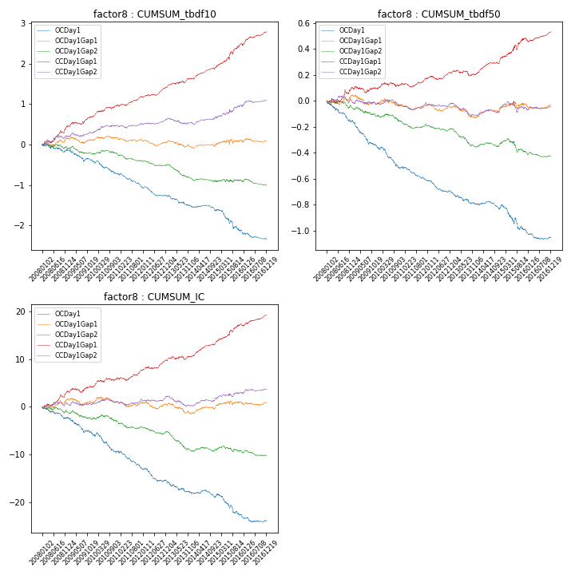

**因子换手率:** 70.96%

**截面指标_OCDay1:**

|  |  |  |  |  |  |  |  |  |
| --- | --- | --- | --- | --- | --- | --- | --- | --- |
| year | annret_tbdf10 | sharpe_tbdf10 | maxdd_tbdf10 | annret_tbdf50 | sharpe_tbdf50 | maxdd_tbdf50 | mean_IC | tstat_IC |
| 2008 | -0.14 | -1.1 | -0.21 | -0.16 | -3.37 | -0.16 | -0.01 | -2.31 |
| 2009 | -0.25 | -2.16 | -0.27 | -0.19 | -4.44 | -0.18 | -0.01 | -3.02 |
| 2010 | -0.33 | -3.1 | -0.29 | -0.17 | -3.84 | -0.16 | -0.02 | -3.45 |
| 2011 | -0.34 | -4.21 | -0.3 | -0.1 | -3.48 | -0.1 | -0.01 | -3.99 |
| 2012 | -0.21 | -2.87 | -0.21 | -0.09 | -3.52 | -0.09 | -0.01 | -3.29 |
| 2013 | -0.26 | -2.74 | -0.25 | -0.09 | -2.58 | -0.09 | -0.01 | -2.42 |
| 2014 | -0.11 | -1.41 | -0.14 | -0.02 | -0.54 | -0.06 | -0.0 | -0.69 |
| 2015 | -0.5 | -3.23 | -0.42 | -0.2 | -3.17 | -0.19 | -0.02 | -3.57 |
| 2016 | -0.21 | -2.43 | -0.2 | -0.05 | -1.66 | -0.06 | -0.0 | -1.42 |

**截面指标_CCDay1Gap1:**

|  |  |  |  |  |  |  |  |  |
| --- | --- | --- | --- | --- | --- | --- | --- | --- |
| year | annret_tbdf10 | sharpe_tbdf10 | maxdd_tbdf10 | annret_tbdf50 | sharpe_tbdf50 | maxdd_tbdf50 | mean_IC | tstat_IC |
| 2008 | 0.45 | 3.14 | -0.08 | 0.1 | 1.67 | -0.04 | 0.01 | 2.73 |
| 2009 | 0.23 | 2.2 | -0.06 | -0.01 | -0.21 | -0.05 | 0.0 | 0.94 |
| 2010 | 0.3 | 3.07 | -0.05 | 0.05 | 1.07 | -0.03 | 0.01 | 2.07 |
| 2011 | 0.18 | 2.36 | -0.04 | 0.04 | 1.3 | -0.03 | 0.01 | 1.92 |
| 2012 | 0.25 | 3.48 | -0.04 | 0.04 | 1.29 | -0.03 | 0.01 | 2.45 |
| 2013 | 0.22 | 2.27 | -0.05 | -0.01 | -0.18 | -0.04 | 0.0 | 0.99 |
| 2014 | 0.3 | 3.93 | -0.04 | 0.13 | 4.01 | -0.01 | 0.01 | 4.59 |
| 2015 | 0.56 | 3.61 | -0.07 | 0.15 | 2.43 | -0.04 | 0.01 | 3.28 |
| 2016 | 0.29 | 3.13 | -0.05 | 0.05 | 1.68 | -0.03 | 0.01 | 2.82 |

**风格暴露:**

|  |  |  |  |  |
| --- | --- | --- | --- | --- |
|  | long | short | corr_OCDay1 | corr_CCDay1Gap1 |
| liquidity10 | -0.12 | 0.12 | 0.11 | 0.05 |
| liquidity20 | -0.09 | 0.1 | 0.13 | 0.05 |
| liquidity5 | -0.14 | 0.14 | 0.09 | 0.03 |
| logmktcap | -0.08 | 0.08 | -0.06 | 0.0 |
| momentum15 | -0.33 | 0.34 | -0.06 | -0.04 |
| momentum30 | -0.29 | 0.29 | -0.02 | -0.01 |
| momentum5 | -0.32 | 0.33 | -0.08 | -0.09 |
| retvolatility30 | -0.11 | 0.11 | 0.13 | 0.06 |