Factors Report 20080102-20161230

**1. factor9**

**截面指标累计曲线:**

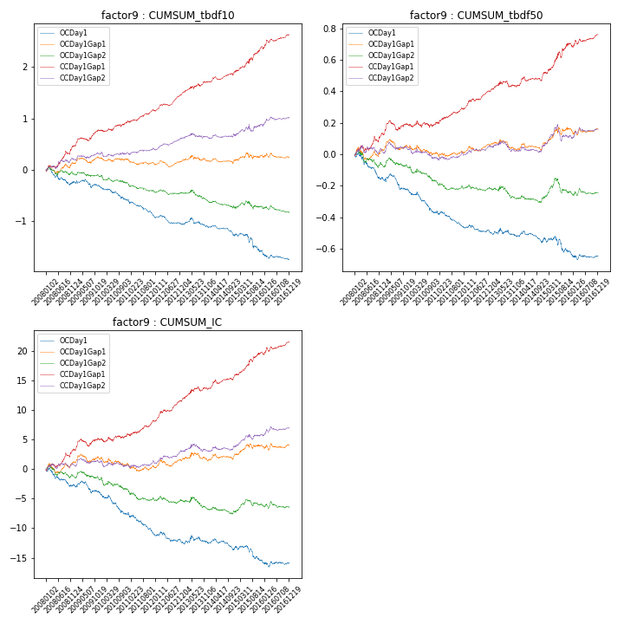

**因子换手率:** 64.35%

**截面指标_OCDay1:**

|  |  |  |  |  |  |  |  |  |
| --- | --- | --- | --- | --- | --- | --- | --- | --- |
| year | annret_tbdf10 | sharpe_tbdf10 | maxdd_tbdf10 | annret_tbdf50 | sharpe_tbdf50 | maxdd_tbdf50 | mean_IC | tstat_IC |
| 2008 | -0.24 | -2.05 | -0.3 | -0.15 | -2.86 | -0.16 | -0.01 | -2.47 |
| 2009 | -0.08 | -0.78 | -0.16 | -0.08 | -1.81 | -0.11 | -0.01 | -1.27 |
| 2010 | -0.27 | -2.72 | -0.24 | -0.14 | -3.05 | -0.13 | -0.01 | -3.18 |
| 2011 | -0.33 | -3.88 | -0.29 | -0.09 | -2.73 | -0.1 | -0.01 | -3.45 |
| 2012 | -0.14 | -2.07 | -0.17 | -0.04 | -1.22 | -0.05 | -0.01 | -1.35 |
| 2013 | -0.05 | -0.43 | -0.18 | -0.02 | -0.53 | -0.05 | -0.0 | -0.12 |
| 2014 | -0.17 | -2.25 | -0.19 | -0.02 | -0.65 | -0.08 | -0.0 | -1.08 |
| 2015 | -0.31 | -1.99 | -0.31 | -0.09 | -1.58 | -0.1 | -0.01 | -2.01 |
| 2016 | -0.17 | -1.9 | -0.16 | -0.02 | -0.45 | -0.04 | -0.0 | -0.38 |

**截面指标_CCDay1Gap1:**

|  |  |  |  |  |  |  |  |  |
| --- | --- | --- | --- | --- | --- | --- | --- | --- |
| year | annret_tbdf10 | sharpe_tbdf10 | maxdd_tbdf10 | annret_tbdf50 | sharpe_tbdf50 | maxdd_tbdf50 | mean_IC | tstat_IC |
| 2008 | 0.46 | 3.27 | -0.07 | 0.13 | 2.14 | -0.04 | 0.01 | 2.69 |
| 2009 | 0.3 | 3.08 | -0.06 | 0.05 | 1.14 | -0.06 | 0.01 | 1.7 |
| 2010 | 0.19 | 2.03 | -0.05 | 0.02 | 0.5 | -0.04 | 0.0 | 1.02 |
| 2011 | 0.2 | 2.48 | -0.03 | 0.09 | 2.55 | -0.01 | 0.01 | 2.42 |
| 2012 | 0.32 | 4.69 | -0.04 | 0.11 | 3.51 | -0.01 | 0.01 | 4.03 |
| 2013 | 0.26 | 2.5 | -0.05 | 0.03 | 0.75 | -0.04 | 0.01 | 1.88 |
| 2014 | 0.21 | 2.63 | -0.06 | 0.09 | 2.4 | -0.03 | 0.01 | 2.99 |
| 2015 | 0.48 | 3.12 | -0.06 | 0.18 | 2.79 | -0.04 | 0.02 | 3.39 |
| 2016 | 0.24 | 2.45 | -0.05 | 0.06 | 1.59 | -0.03 | 0.01 | 2.19 |

**风格暴露:**

|  |  |  |  |  |
| --- | --- | --- | --- | --- |
|  | long | short | corr_OCDay1 | corr_CCDay1Gap1 |
| liquidity10 | 0.02 | -0.06 | 0.03 | 0.0 |
| liquidity20 | 0.01 | -0.06 | 0.04 | 0.0 |
| liquidity5 | 0.01 | -0.05 | 0.02 | -0.02 |
| logmktcap | 0.23 | -0.05 | -0.11 | -0.07 |
| momentum15 | -0.25 | 0.25 | 0.01 | 0.03 |
| momentum30 | -0.15 | 0.15 | 0.01 | 0.01 |
| momentum5 | -0.32 | 0.33 | -0.0 | 0.0 |
| retvolatility30 | 0.04 | -0.12 | 0.02 | -0.02 |