Factors Report 20080102-20161230

**1. factor10**

**截面指标累计曲线:**

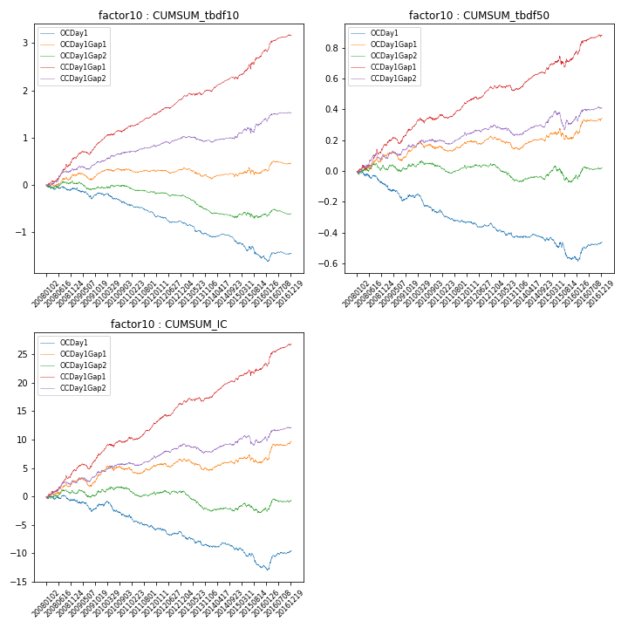

**因子换手率:** 64.04%

**截面指标_OCDay1:**

|  |  |  |  |  |  |  |  |  |
| --- | --- | --- | --- | --- | --- | --- | --- | --- |
| year | annret_tbdf10 | sharpe_tbdf10 | maxdd_tbdf10 | annret_tbdf50 | sharpe_tbdf50 | maxdd_tbdf50 | mean_IC | tstat_IC |
| 2008 | -0.08 | -0.7 | -0.13 | -0.09 | -1.77 | -0.09 | -0.0 | -0.67 |
| 2009 | -0.1 | -0.88 | -0.22 | -0.07 | -1.54 | -0.11 | -0.0 | -0.63 |
| 2010 | -0.25 | -2.54 | -0.23 | -0.11 | -2.64 | -0.12 | -0.01 | -2.1 |
| 2011 | -0.24 | -3.29 | -0.23 | -0.07 | -2.34 | -0.08 | -0.01 | -2.61 |
| 2012 | -0.14 | -2.06 | -0.15 | -0.03 | -0.92 | -0.04 | -0.0 | -1.14 |
| 2013 | -0.27 | -3.05 | -0.25 | -0.07 | -1.98 | -0.07 | -0.01 | -2.09 |
| 2014 | -0.15 | -2.07 | -0.17 | -0.01 | -0.47 | -0.05 | -0.0 | -0.65 |
| 2015 | -0.28 | -1.98 | -0.3 | -0.11 | -1.94 | -0.14 | -0.01 | -2.65 |
| 2016 | 0.05 | 0.49 | -0.11 | 0.1 | 2.18 | -0.03 | 0.01 | 2.25 |

**截面指标_CCDay1Gap1:**

|  |  |  |  |  |  |  |  |  |
| --- | --- | --- | --- | --- | --- | --- | --- | --- |
| year | annret_tbdf10 | sharpe_tbdf10 | maxdd_tbdf10 | annret_tbdf50 | sharpe_tbdf50 | maxdd_tbdf50 | mean_IC | tstat_IC |
| 2008 | 0.55 | 3.8 | -0.06 | 0.17 | 2.81 | -0.03 | 0.02 | 3.87 |
| 2009 | 0.37 | 3.85 | -0.08 | 0.11 | 2.53 | -0.04 | 0.01 | 3.27 |
| 2010 | 0.3 | 3.38 | -0.04 | 0.08 | 2.0 | -0.03 | 0.01 | 2.69 |
| 2011 | 0.26 | 3.73 | -0.03 | 0.09 | 3.11 | -0.03 | 0.01 | 3.46 |
| 2012 | 0.35 | 5.19 | -0.03 | 0.09 | 3.21 | -0.02 | 0.01 | 4.27 |
| 2013 | 0.17 | 2.06 | -0.05 | 0.0 | 0.09 | -0.04 | 0.0 | 1.35 |
| 2014 | 0.26 | 3.66 | -0.05 | 0.12 | 4.14 | -0.01 | 0.01 | 4.92 |
| 2015 | 0.59 | 3.91 | -0.1 | 0.1 | 1.53 | -0.07 | 0.01 | 2.13 |
| 2016 | 0.32 | 3.6 | -0.05 | 0.12 | 2.87 | -0.02 | 0.02 | 3.72 |

**风格暴露:**

|  |  |  |  |  |
| --- | --- | --- | --- | --- |
|  | long | short | corr_OCDay1 | corr_CCDay1Gap1 |
| liquidity10 | -0.15 | 0.16 | 0.13 | 0.08 |
| liquidity20 | -0.12 | 0.13 | 0.14 | 0.08 |
| liquidity5 | -0.16 | 0.17 | 0.12 | 0.07 |
| logmktcap | 0.22 | -0.21 | -0.13 | -0.12 |
| momentum15 | -0.31 | 0.31 | -0.03 | 0.02 |
| momentum30 | -0.21 | 0.22 | -0.02 | 0.0 |
| momentum5 | -0.29 | 0.3 | -0.04 | -0.03 |
| retvolatility30 | -0.0 | 0.01 | 0.09 | 0.04 |