Factors Report 20080102-20161230

**1. factor8**

**截面指标累计曲线:**

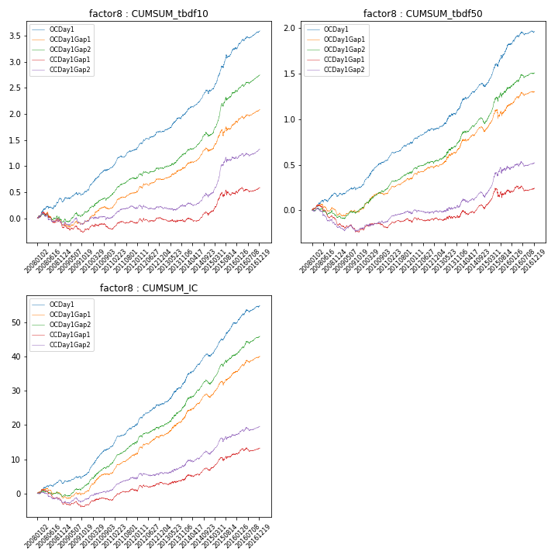

**因子换手率:** 58.46%

**截面指标_OCDay1:**

|  |  |  |  |  |  |  |  |  |
| --- | --- | --- | --- | --- | --- | --- | --- | --- |
| year | annret_tbdf10 | sharpe_tbdf10 | maxdd_tbdf10 | annret_tbdf50 | sharpe_tbdf50 | maxdd_tbdf50 | mean_IC | tstat_IC |
| 2008 | 0.31 | 2.94 | -0.07 | 0.16 | 2.54 | -0.04 | 0.01 | 2.54 |
| 2009 | 0.21 | 2.57 | -0.06 | 0.11 | 2.55 | -0.03 | 0.01 | 2.79 |
| 2010 | 0.45 | 5.02 | -0.03 | 0.28 | 5.18 | -0.02 | 0.03 | 6.43 |
| 2011 | 0.35 | 5.03 | -0.03 | 0.19 | 4.93 | -0.02 | 0.03 | 5.85 |
| 2012 | 0.33 | 4.21 | -0.03 | 0.16 | 3.49 | -0.02 | 0.02 | 4.84 |
| 2013 | 0.37 | 4.06 | -0.03 | 0.25 | 3.66 | -0.02 | 0.03 | 4.53 |
| 2014 | 0.43 | 4.71 | -0.07 | 0.22 | 3.59 | -0.04 | 0.03 | 5.16 |
| 2015 | 0.81 | 5.47 | -0.07 | 0.46 | 4.79 | -0.04 | 0.04 | 6.23 |
| 2016 | 0.35 | 4.1 | -0.04 | 0.14 | 2.53 | -0.04 | 0.02 | 3.9 |

**截面指标_CCDay1Gap1:**

|  |  |  |  |  |  |  |  |  |
| --- | --- | --- | --- | --- | --- | --- | --- | --- |
| year | annret_tbdf10 | sharpe_tbdf10 | maxdd_tbdf10 | annret_tbdf50 | sharpe_tbdf50 | maxdd_tbdf50 | mean_IC | tstat_IC |
| 2008 | -0.16 | -1.4 | -0.25 | -0.15 | -2.5 | -0.19 | -0.01 | -2.69 |
| 2009 | -0.05 | -0.53 | -0.14 | -0.06 | -1.24 | -0.09 | -0.0 | -0.53 |
| 2010 | 0.0 | 0.02 | -0.11 | 0.02 | 0.42 | -0.05 | 0.01 | 1.33 |
| 2011 | 0.1 | 1.45 | -0.05 | 0.06 | 1.44 | -0.04 | 0.01 | 2.47 |
| 2012 | 0.1 | 1.21 | -0.07 | 0.04 | 0.92 | -0.04 | 0.01 | 2.06 |
| 2013 | -0.05 | -0.52 | -0.07 | 0.03 | 0.44 | -0.03 | 0.01 | 0.86 |
| 2014 | 0.16 | 1.77 | -0.07 | 0.08 | 1.31 | -0.05 | 0.01 | 1.9 |
| 2015 | 0.35 | 2.26 | -0.1 | 0.17 | 1.52 | -0.1 | 0.02 | 2.7 |
| 2016 | 0.13 | 1.39 | -0.09 | 0.05 | 0.79 | -0.06 | 0.01 | 1.6 |

**风格暴露:**

|  |  |  |  |  |
| --- | --- | --- | --- | --- |
|  | long | short | corr_OCDay1 | corr_CCDay1Gap1 |
| liquidity10 | -0.75 | 0.76 | 0.6 | 0.63 |
| liquidity20 | -0.79 | 0.8 | 0.6 | 0.64 |
| liquidity5 | -0.7 | 0.7 | 0.59 | 0.62 |
| logmktcap | 0.56 | -0.55 | -0.45 | -0.51 |
| momentum15 | -0.05 | 0.05 | 0.14 | 0.08 |
| momentum30 | -0.18 | 0.19 | 0.19 | 0.14 |
| momentum5 | 0.13 | -0.12 | 0.05 | 0.0 |
| retvolatility30 | -0.87 | 0.88 | 0.65 | 0.68 |