Factors Report 20080102-20161230

**1. factor12**

**截面指标累计曲线:**

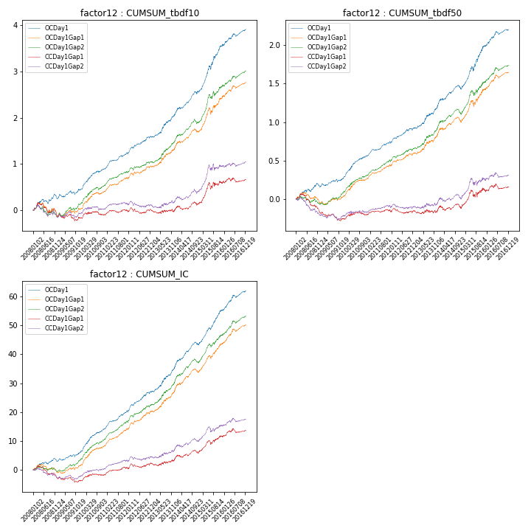

**因子换手率:** 36.82%

**截面指标_OCDay1:**

|  |  |  |  |  |  |  |  |  |
| --- | --- | --- | --- | --- | --- | --- | --- | --- |
| year | annret_tbdf10 | sharpe_tbdf10 | maxdd_tbdf10 | annret_tbdf50 | sharpe_tbdf50 | maxdd_tbdf50 | mean_IC | tstat_IC |
| 2008 | 0.25 | 2.19 | -0.1 | 0.16 | 2.38 | -0.05 | 0.01 | 2.27 |
| 2009 | 0.2 | 2.13 | -0.08 | 0.11 | 2.34 | -0.04 | 0.01 | 2.9 |
| 2010 | 0.45 | 4.7 | -0.04 | 0.29 | 4.98 | -0.02 | 0.03 | 5.66 |
| 2011 | 0.34 | 4.82 | -0.03 | 0.17 | 4.04 | -0.02 | 0.02 | 5.29 |
| 2012 | 0.36 | 3.94 | -0.03 | 0.19 | 3.7 | -0.02 | 0.03 | 4.66 |
| 2013 | 0.5 | 3.92 | -0.03 | 0.29 | 3.65 | -0.02 | 0.04 | 4.52 |
| 2014 | 0.48 | 4.37 | -0.06 | 0.22 | 3.3 | -0.05 | 0.03 | 4.85 |
| 2015 | 1.0 | 5.55 | -0.08 | 0.56 | 4.81 | -0.06 | 0.05 | 6.34 |
| 2016 | 0.36 | 3.54 | -0.06 | 0.22 | 3.36 | -0.04 | 0.03 | 4.41 |

**截面指标_CCDay1Gap1:**

|  |  |  |  |  |  |  |  |  |
| --- | --- | --- | --- | --- | --- | --- | --- | --- |
| year | annret_tbdf10 | sharpe_tbdf10 | maxdd_tbdf10 | annret_tbdf50 | sharpe_tbdf50 | maxdd_tbdf50 | mean_IC | tstat_IC |
| 2008 | -0.12 | -0.95 | -0.26 | -0.17 | -2.44 | -0.22 | -0.01 | -2.21 |
| 2009 | -0.05 | -0.48 | -0.14 | -0.08 | -1.6 | -0.11 | -0.0 | -0.84 |
| 2010 | 0.08 | 0.78 | -0.08 | 0.06 | 0.98 | -0.04 | 0.01 | 1.64 |
| 2011 | 0.05 | 0.71 | -0.06 | 0.03 | 0.7 | -0.03 | 0.01 | 1.76 |
| 2012 | 0.04 | 0.4 | -0.13 | 0.01 | 0.26 | -0.07 | 0.01 | 1.39 |
| 2013 | 0.01 | 0.08 | -0.07 | 0.01 | 0.09 | -0.05 | 0.01 | 0.84 |
| 2014 | 0.13 | 1.17 | -0.08 | 0.03 | 0.47 | -0.07 | 0.01 | 1.42 |
| 2015 | 0.44 | 2.37 | -0.14 | 0.22 | 1.83 | -0.09 | 0.02 | 2.87 |
| 2016 | 0.08 | 0.78 | -0.1 | 0.05 | 0.74 | -0.07 | 0.01 | 1.53 |

**风格暴露:**

|  |  |  |  |  |
| --- | --- | --- | --- | --- |
|  | long | short | corr_OCDay1 | corr_CCDay1Gap1 |
| liquidity10 | -0.97 | 0.98 | 0.69 | 0.7 |
| liquidity20 | -0.99 | 1.0 | 0.68 | 0.7 |
| liquidity5 | -0.95 | 0.95 | 0.69 | 0.71 |
| logmktcap | 0.73 | -0.72 | -0.51 | -0.53 |
| momentum15 | -0.23 | 0.23 | 0.19 | 0.18 |
| momentum30 | -0.35 | 0.35 | 0.22 | 0.21 |
| momentum5 | -0.08 | 0.08 | 0.08 | 0.06 |
| retvolatility30 | -1.13 | 1.13 | 0.73 | 0.73 |