Factors Report 20080102-20161230

**1. factor16**

**截面指标累计曲线:**

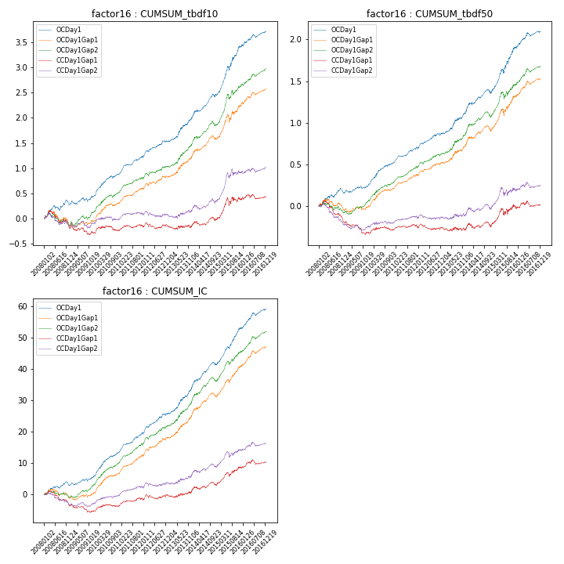

**因子换手率:** 38.86%

**截面指标_OCDay1:**

|  |  |  |  |  |  |  |  |  |
| --- | --- | --- | --- | --- | --- | --- | --- | --- |
| year | annret_tbdf10 | sharpe_tbdf10 | maxdd_tbdf10 | annret_tbdf50 | sharpe_tbdf50 | maxdd_tbdf50 | mean_IC | tstat_IC |
| 2008 | 0.27 | 2.34 | -0.1 | 0.16 | 2.31 | -0.06 | 0.01 | 2.24 |
| 2009 | 0.17 | 1.82 | -0.08 | 0.09 | 1.87 | -0.04 | 0.01 | 2.58 |
| 2010 | 0.44 | 4.61 | -0.05 | 0.27 | 4.73 | -0.02 | 0.03 | 5.57 |
| 2011 | 0.34 | 4.99 | -0.03 | 0.18 | 4.32 | -0.02 | 0.02 | 5.41 |
| 2012 | 0.31 | 3.57 | -0.03 | 0.18 | 3.54 | -0.02 | 0.03 | 4.42 |
| 2013 | 0.48 | 3.79 | -0.03 | 0.28 | 3.56 | -0.02 | 0.03 | 4.42 |
| 2014 | 0.45 | 4.17 | -0.06 | 0.21 | 3.09 | -0.05 | 0.03 | 4.62 |
| 2015 | 0.97 | 5.39 | -0.09 | 0.55 | 4.82 | -0.05 | 0.05 | 6.25 |
| 2016 | 0.31 | 3.04 | -0.07 | 0.2 | 3.06 | -0.05 | 0.03 | 4.08 |

**截面指标_CCDay1Gap1:**

|  |  |  |  |  |  |  |  |  |
| --- | --- | --- | --- | --- | --- | --- | --- | --- |
| year | annret_tbdf10 | sharpe_tbdf10 | maxdd_tbdf10 | annret_tbdf50 | sharpe_tbdf50 | maxdd_tbdf50 | mean_IC | tstat_IC |
| 2008 | -0.17 | -1.36 | -0.29 | -0.19 | -2.79 | -0.23 | -0.01 | -2.71 |
| 2009 | -0.12 | -1.2 | -0.17 | -0.13 | -2.51 | -0.15 | -0.01 | -1.75 |
| 2010 | 0.06 | 0.54 | -0.1 | 0.04 | 0.67 | -0.05 | 0.01 | 1.37 |
| 2011 | 0.06 | 0.77 | -0.06 | 0.02 | 0.55 | -0.04 | 0.01 | 1.65 |
| 2012 | 0.02 | 0.26 | -0.13 | -0.0 | -0.04 | -0.07 | 0.01 | 1.12 |
| 2013 | 0.01 | 0.05 | -0.07 | -0.0 | -0.04 | -0.05 | 0.01 | 0.77 |
| 2014 | 0.12 | 1.12 | -0.08 | 0.02 | 0.25 | -0.07 | 0.01 | 1.22 |
| 2015 | 0.38 | 2.02 | -0.15 | 0.22 | 1.81 | -0.08 | 0.02 | 2.84 |
| 2016 | 0.07 | 0.64 | -0.1 | 0.04 | 0.61 | -0.07 | 0.01 | 1.38 |

**风格暴露:**

|  |  |  |  |  |
| --- | --- | --- | --- | --- |
|  | long | short | corr_OCDay1 | corr_CCDay1Gap1 |
| liquidity10 | -0.96 | 0.96 | 0.68 | 0.68 |
| liquidity20 | -0.98 | 0.98 | 0.67 | 0.68 |
| liquidity5 | -0.93 | 0.94 | 0.68 | 0.68 |
| logmktcap | 0.71 | -0.71 | -0.49 | -0.5 |
| momentum15 | -0.22 | 0.23 | 0.18 | 0.2 |
| momentum30 | -0.34 | 0.35 | 0.22 | 0.22 |
| momentum5 | -0.07 | 0.08 | 0.07 | 0.06 |
| retvolatility30 | -1.11 | 1.11 | 0.73 | 0.7 |