Factors Report 20080102-20161230

**1. factor5**

**截面指标累计曲线:**

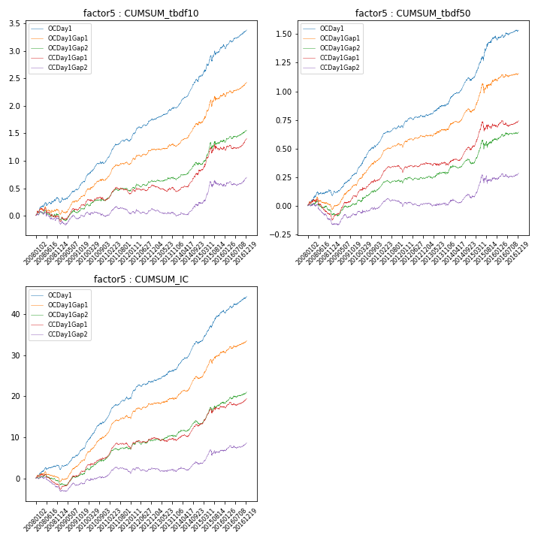

**因子换手率:** 43.98%

**截面指标_OCDay1:**

|  |  |  |  |  |  |  |  |  |
| --- | --- | --- | --- | --- | --- | --- | --- | --- |
| year | annret_tbdf10 | sharpe_tbdf10 | maxdd_tbdf10 | annret_tbdf50 | sharpe_tbdf50 | maxdd_tbdf50 | mean_IC | tstat_IC |
| 2008 | 0.24 | 2.31 | -0.09 | 0.1 | 2.0 | -0.04 | 0.01 | 2.52 |
| 2009 | 0.37 | 5.07 | -0.04 | 0.18 | 4.82 | -0.02 | 0.02 | 5.62 |
| 2010 | 0.4 | 5.13 | -0.04 | 0.27 | 6.62 | -0.01 | 0.03 | 7.35 |
| 2011 | 0.36 | 5.69 | -0.04 | 0.15 | 5.24 | -0.02 | 0.02 | 6.2 |
| 2012 | 0.38 | 5.47 | -0.03 | 0.08 | 2.6 | -0.02 | 0.02 | 4.23 |
| 2013 | 0.22 | 3.4 | -0.02 | 0.11 | 2.8 | -0.01 | 0.01 | 3.22 |
| 2014 | 0.59 | 7.44 | -0.05 | 0.21 | 5.43 | -0.03 | 0.03 | 7.21 |
| 2015 | 0.54 | 3.72 | -0.1 | 0.37 | 4.71 | -0.04 | 0.03 | 6.05 |
| 2016 | 0.3 | 3.65 | -0.08 | 0.06 | 1.41 | -0.04 | 0.01 | 3.51 |

**截面指标_CCDay1Gap1:**

|  |  |  |  |  |  |  |  |  |
| --- | --- | --- | --- | --- | --- | --- | --- | --- |
| year | annret_tbdf10 | sharpe_tbdf10 | maxdd_tbdf10 | annret_tbdf50 | sharpe_tbdf50 | maxdd_tbdf50 | mean_IC | tstat_IC |
| 2008 | -0.08 | -0.72 | -0.2 | -0.1 | -2.0 | -0.15 | -0.01 | -2.4 |
| 2009 | 0.28 | 3.65 | -0.04 | 0.19 | 4.55 | -0.02 | 0.02 | 4.54 |
| 2010 | 0.09 | 1.13 | -0.07 | 0.15 | 3.4 | -0.02 | 0.01 | 3.89 |
| 2011 | 0.1 | 1.51 | -0.12 | 0.09 | 3.12 | -0.03 | 0.01 | 3.02 |
| 2012 | 0.16 | 2.29 | -0.06 | 0.05 | 1.55 | -0.03 | 0.01 | 2.44 |
| 2013 | -0.11 | -1.66 | -0.11 | -0.01 | -0.19 | -0.03 | -0.0 | -0.5 |
| 2014 | 0.39 | 4.51 | -0.03 | 0.14 | 3.64 | -0.03 | 0.02 | 4.44 |
| 2015 | 0.38 | 2.51 | -0.1 | 0.2 | 2.23 | -0.08 | 0.02 | 3.07 |
| 2016 | 0.19 | 2.23 | -0.07 | 0.05 | 1.1 | -0.05 | 0.01 | 2.31 |

**风格暴露:**

|  |  |  |  |  |
| --- | --- | --- | --- | --- |
|  | long | short | corr_OCDay1 | corr_CCDay1Gap1 |
| liquidity10 | -0.14 | 0.15 | 0.24 | 0.27 |
| liquidity20 | -0.24 | 0.24 | 0.27 | 0.29 |
| liquidity5 | -0.03 | 0.04 | 0.22 | 0.25 |
| logmktcap | 0.23 | -0.22 | -0.34 | -0.38 |
| momentum15 | 0.22 | -0.22 | -0.1 | -0.12 |
| momentum30 | 0.11 | -0.1 | -0.06 | -0.06 |
| momentum5 | 0.32 | -0.31 | -0.15 | -0.16 |
| retvolatility30 | -0.23 | 0.24 | 0.34 | 0.35 |