Factors Report 20080102-20161230

**1. factor9**

**截面指标累计曲线:**

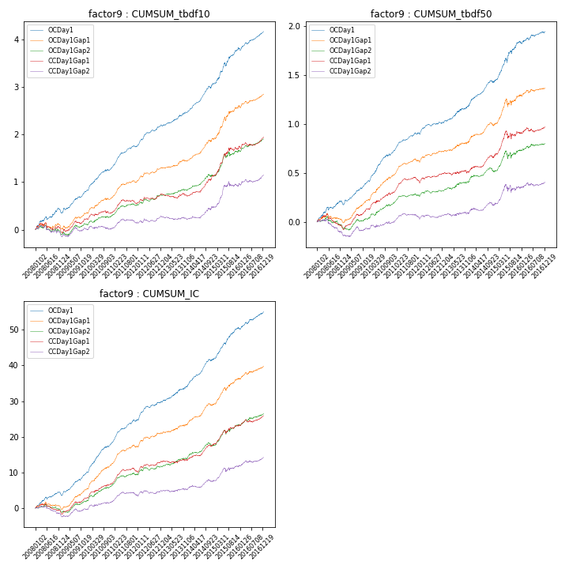

**因子换手率:** 44.18%

**截面指标_OCDay1:**

|  |  |  |  |  |  |  |  |  |
| --- | --- | --- | --- | --- | --- | --- | --- | --- |
| year | annret_tbdf10 | sharpe_tbdf10 | maxdd_tbdf10 | annret_tbdf50 | sharpe_tbdf50 | maxdd_tbdf50 | mean_IC | tstat_IC |
| 2008 | 0.35 | 3.23 | -0.09 | 0.18 | 3.28 | -0.03 | 0.02 | 3.54 |
| 2009 | 0.46 | 6.06 | -0.03 | 0.23 | 6.41 | -0.01 | 0.03 | 7.19 |
| 2010 | 0.49 | 6.13 | -0.03 | 0.3 | 6.92 | -0.01 | 0.03 | 7.88 |
| 2011 | 0.46 | 7.25 | -0.03 | 0.19 | 6.06 | -0.02 | 0.03 | 7.25 |
| 2012 | 0.43 | 6.24 | -0.02 | 0.11 | 3.35 | -0.02 | 0.02 | 5.22 |
| 2013 | 0.29 | 4.22 | -0.02 | 0.17 | 3.74 | -0.01 | 0.02 | 4.24 |
| 2014 | 0.6 | 7.72 | -0.05 | 0.24 | 5.88 | -0.02 | 0.03 | 7.68 |
| 2015 | 0.72 | 5.3 | -0.06 | 0.41 | 5.03 | -0.05 | 0.04 | 6.98 |
| 2016 | 0.38 | 4.57 | -0.06 | 0.11 | 2.42 | -0.03 | 0.02 | 4.29 |

**截面指标_CCDay1Gap1:**

|  |  |  |  |  |  |  |  |  |
| --- | --- | --- | --- | --- | --- | --- | --- | --- |
| year | annret_tbdf10 | sharpe_tbdf10 | maxdd_tbdf10 | annret_tbdf50 | sharpe_tbdf50 | maxdd_tbdf50 | mean_IC | tstat_IC |
| 2008 | -0.03 | -0.3 | -0.17 | -0.06 | -1.21 | -0.14 | -0.01 | -1.33 |
| 2009 | 0.26 | 3.16 | -0.06 | 0.2 | 4.73 | -0.02 | 0.02 | 4.66 |
| 2010 | 0.13 | 1.57 | -0.06 | 0.18 | 3.78 | -0.02 | 0.02 | 4.23 |
| 2011 | 0.19 | 2.79 | -0.08 | 0.11 | 3.51 | -0.04 | 0.01 | 3.85 |
| 2012 | 0.19 | 2.77 | -0.05 | 0.08 | 2.34 | -0.03 | 0.01 | 3.1 |
| 2013 | -0.04 | -0.53 | -0.08 | 0.01 | 0.3 | -0.03 | 0.0 | 0.44 |
| 2014 | 0.43 | 5.1 | -0.03 | 0.16 | 3.85 | -0.03 | 0.02 | 4.75 |
| 2015 | 0.55 | 3.71 | -0.07 | 0.23 | 2.45 | -0.08 | 0.02 | 3.71 |
| 2016 | 0.25 | 2.82 | -0.06 | 0.07 | 1.46 | -0.05 | 0.01 | 3.04 |

**风格暴露:**

|  |  |  |  |  |
| --- | --- | --- | --- | --- |
|  | long | short | corr_OCDay1 | corr_CCDay1Gap1 |
| liquidity10 | -0.26 | 0.26 | 0.31 | 0.37 |
| liquidity20 | -0.35 | 0.36 | 0.33 | 0.39 |
| liquidity5 | -0.14 | 0.15 | 0.28 | 0.34 |
| logmktcap | 0.26 | -0.25 | -0.35 | -0.42 |
| momentum15 | 0.22 | -0.22 | -0.12 | -0.1 |
| momentum30 | 0.09 | -0.09 | -0.07 | -0.05 |
| momentum5 | 0.38 | -0.37 | -0.18 | -0.18 |
| retvolatility30 | -0.35 | 0.35 | 0.41 | 0.45 |