Factors Report 20080102-20161230

**1. factor13**

**截面指标累计曲线:**

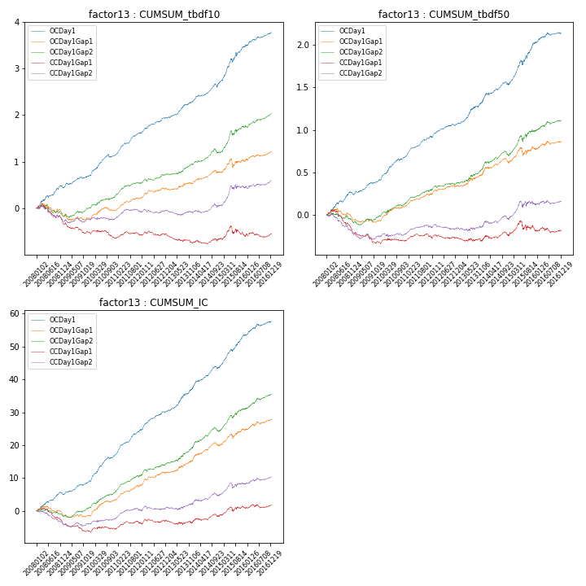

**因子换手率:** 67.77%

**截面指标_OCDay1:**

|  |  |  |  |  |  |  |  |  |
| --- | --- | --- | --- | --- | --- | --- | --- | --- |
| year | annret_tbdf10 | sharpe_tbdf10 | maxdd_tbdf10 | annret_tbdf50 | sharpe_tbdf50 | maxdd_tbdf50 | mean_IC | tstat_IC |
| 2008 | 0.44 | 4.16 | -0.05 | 0.24 | 4.11 | -0.03 | 0.02 | 4.45 |
| 2009 | 0.25 | 3.39 | -0.04 | 0.17 | 4.26 | -0.02 | 0.02 | 4.39 |
| 2010 | 0.45 | 5.36 | -0.06 | 0.28 | 5.47 | -0.02 | 0.03 | 6.84 |
| 2011 | 0.48 | 7.4 | -0.02 | 0.23 | 6.41 | -0.02 | 0.03 | 7.77 |
| 2012 | 0.32 | 4.51 | -0.03 | 0.15 | 3.78 | -0.02 | 0.02 | 5.22 |
| 2013 | 0.36 | 4.71 | -0.02 | 0.28 | 4.6 | -0.02 | 0.03 | 5.4 |
| 2014 | 0.4 | 4.74 | -0.07 | 0.2 | 3.55 | -0.04 | 0.03 | 5.02 |
| 2015 | 0.77 | 5.12 | -0.08 | 0.49 | 5.04 | -0.05 | 0.04 | 6.54 |
| 2016 | 0.31 | 3.93 | -0.03 | 0.12 | 2.43 | -0.03 | 0.02 | 3.77 |

**截面指标_CCDay1Gap1:**

|  |  |  |  |  |  |  |  |  |
| --- | --- | --- | --- | --- | --- | --- | --- | --- |
| year | annret_tbdf10 | sharpe_tbdf10 | maxdd_tbdf10 | annret_tbdf50 | sharpe_tbdf50 | maxdd_tbdf50 | mean_IC | tstat_IC |
| 2008 | -0.3 | -2.77 | -0.33 | -0.2 | -3.2 | -0.23 | -0.02 | -3.38 |
| 2009 | -0.21 | -2.72 | -0.21 | -0.12 | -2.85 | -0.13 | -0.01 | -2.64 |
| 2010 | -0.12 | -1.42 | -0.16 | 0.02 | 0.51 | -0.04 | 0.0 | 0.77 |
| 2011 | 0.06 | 0.83 | -0.08 | 0.03 | 0.88 | -0.04 | 0.01 | 1.44 |
| 2012 | -0.0 | -0.01 | -0.11 | -0.0 | -0.07 | -0.05 | 0.0 | 0.79 |
| 2013 | -0.17 | -1.96 | -0.16 | -0.02 | -0.39 | -0.04 | -0.0 | -0.23 |
| 2014 | 0.08 | 0.92 | -0.08 | 0.05 | 0.95 | -0.05 | 0.01 | 1.5 |
| 2015 | 0.06 | 0.36 | -0.21 | 0.05 | 0.49 | -0.12 | 0.01 | 1.5 |
| 2016 | 0.06 | 0.67 | -0.11 | 0.0 | 0.07 | -0.06 | 0.0 | 0.89 |

**风格暴露:**

|  |  |  |  |  |
| --- | --- | --- | --- | --- |
|  | long | short | corr_OCDay1 | corr_CCDay1Gap1 |
| liquidity10 | -0.59 | 0.6 | 0.5 | 0.56 |
| liquidity20 | -0.64 | 0.65 | 0.51 | 0.57 |
| liquidity5 | -0.54 | 0.54 | 0.5 | 0.56 |
| logmktcap | 0.42 | -0.41 | -0.38 | -0.49 |
| momentum15 | 0.04 | -0.03 | 0.07 | 0.03 |
| momentum30 | -0.09 | 0.1 | 0.11 | 0.09 |
| momentum5 | 0.22 | -0.21 | -0.01 | -0.06 |
| retvolatility30 | -0.69 | 0.69 | 0.57 | 0.63 |