Factors Report 20080102-20161230

**1. factor4**

**截面指标累计曲线:**

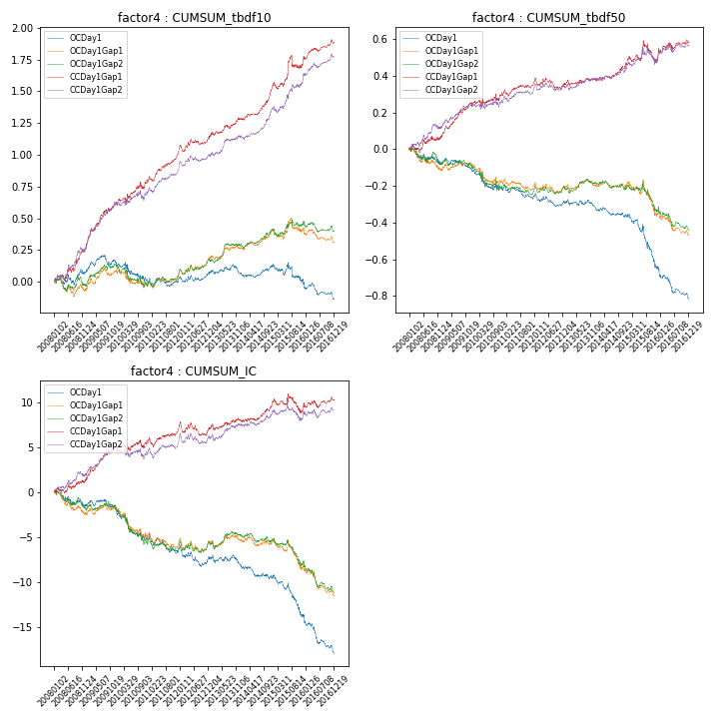

**因子换手率:** 43.2%

**截面指标_OCDay1:**

|  |  |  |  |  |  |  |  |  |
| --- | --- | --- | --- | --- | --- | --- | --- | --- |
| year | annret_tbdf10 | sharpe_tbdf10 | maxdd_tbdf10 | annret_tbdf50 | sharpe_tbdf50 | maxdd_tbdf50 | mean_IC | tstat_IC |
| 2008 | 0.07 | 0.77 | -0.08 | -0.08 | -1.33 | -0.1 | -0.01 | -1.28 |
| 2009 | 0.06 | 0.84 | -0.08 | -0.04 | -0.87 | -0.07 | -0.0 | -0.88 |
| 2010 | -0.14 | -1.37 | -0.15 | -0.11 | -1.63 | -0.11 | -0.01 | -2.03 |
| 2011 | 0.03 | 0.47 | -0.07 | -0.04 | -1.05 | -0.07 | -0.0 | -1.11 |
| 2012 | 0.05 | 0.81 | -0.04 | -0.03 | -0.73 | -0.07 | -0.0 | -0.85 |
| 2013 | -0.01 | -0.14 | -0.07 | -0.03 | -0.7 | -0.04 | -0.0 | -0.78 |
| 2014 | 0.06 | 1.25 | -0.03 | -0.05 | -1.3 | -0.06 | -0.01 | -1.61 |
| 2015 | -0.11 | -0.92 | -0.15 | -0.27 | -3.16 | -0.26 | -0.02 | -3.07 |
| 2016 | -0.16 | -2.13 | -0.15 | -0.18 | -3.12 | -0.17 | -0.02 | -3.65 |

**截面指标_CCDay1Gap1:**

|  |  |  |  |  |  |  |  |  |
| --- | --- | --- | --- | --- | --- | --- | --- | --- |
| year | annret_tbdf10 | sharpe_tbdf10 | maxdd_tbdf10 | annret_tbdf50 | sharpe_tbdf50 | maxdd_tbdf50 | mean_IC | tstat_IC |
| 2008 | 0.27 | 2.97 | -0.04 | 0.07 | 1.14 | -0.04 | 0.01 | 1.39 |
| 2009 | 0.34 | 4.41 | -0.03 | 0.18 | 3.96 | -0.02 | 0.01 | 3.75 |
| 2010 | 0.18 | 1.76 | -0.06 | 0.05 | 0.77 | -0.04 | 0.0 | 0.34 |
| 2011 | 0.26 | 4.47 | -0.04 | 0.07 | 2.04 | -0.04 | 0.01 | 2.08 |
| 2012 | 0.11 | 1.64 | -0.05 | -0.01 | -0.25 | -0.06 | -0.0 | -0.1 |
| 2013 | 0.14 | 2.22 | -0.03 | 0.03 | 0.64 | -0.03 | 0.0 | 1.0 |
| 2014 | 0.24 | 4.09 | -0.02 | 0.09 | 2.13 | -0.02 | 0.01 | 1.85 |
| 2015 | 0.22 | 1.62 | -0.11 | 0.05 | 0.55 | -0.12 | -0.0 | -0.16 |
| 2016 | 0.15 | 2.54 | -0.03 | 0.07 | 1.25 | -0.04 | 0.0 | 0.88 |

**风格暴露:**

|  |  |  |  |  |
| --- | --- | --- | --- | --- |
|  | long | short | corr_OCDay1 | corr_CCDay1Gap1 |
| liquidity10 | 0.74 | -0.74 | -0.57 | -0.56 |
| liquidity20 | 0.75 | -0.74 | -0.57 | -0.56 |
| liquidity5 | 0.74 | -0.73 | -0.57 | -0.58 |
| logmktcap | -0.7 | 0.71 | 0.5 | 0.49 |
| momentum15 | 0.23 | -0.23 | -0.16 | -0.15 |
| momentum30 | 0.26 | -0.26 | -0.2 | -0.2 |
| momentum5 | 0.17 | -0.17 | -0.1 | -0.13 |
| retvolatility30 | 0.39 | -0.39 | -0.54 | -0.51 |