Factors Report 20080102-20161230

**1. factor12**

**截面指标累计曲线:**

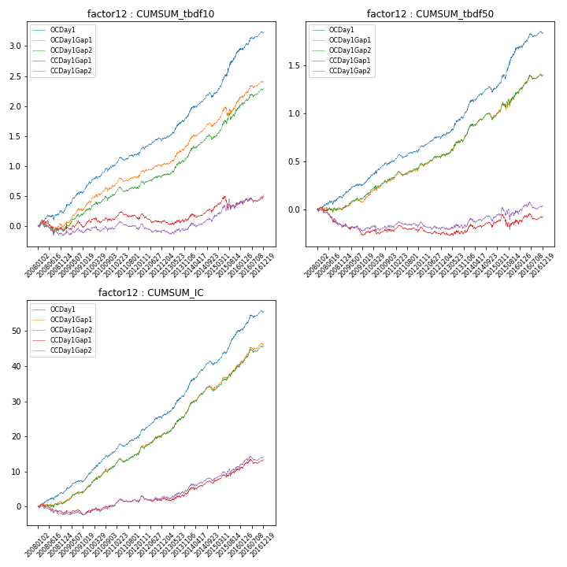

**因子换手率:** 25.1%

**截面指标_OCDay1:**

|  |  |  |  |  |  |  |  |  |
| --- | --- | --- | --- | --- | --- | --- | --- | --- |
| year | annret_tbdf10 | sharpe_tbdf10 | maxdd_tbdf10 | annret_tbdf50 | sharpe_tbdf50 | maxdd_tbdf50 | mean_IC | tstat_IC |
| 2008 | 0.22 | 1.91 | -0.08 | 0.13 | 1.94 | -0.04 | 0.02 | 2.8 |
| 2009 | 0.49 | 4.51 | -0.04 | 0.19 | 3.34 | -0.02 | 0.02 | 4.28 |
| 2010 | 0.3 | 2.97 | -0.06 | 0.19 | 2.9 | -0.04 | 0.03 | 4.13 |
| 2011 | 0.18 | 2.53 | -0.05 | 0.09 | 2.2 | -0.04 | 0.02 | 3.41 |
| 2012 | 0.27 | 3.03 | -0.06 | 0.17 | 3.33 | -0.03 | 0.03 | 4.42 |
| 2013 | 0.41 | 3.65 | -0.03 | 0.29 | 3.73 | -0.02 | 0.03 | 4.42 |
| 2014 | 0.33 | 3.26 | -0.08 | 0.18 | 2.69 | -0.06 | 0.03 | 4.12 |
| 2015 | 0.73 | 4.24 | -0.06 | 0.45 | 3.89 | -0.05 | 0.04 | 5.01 |
| 2016 | 0.33 | 2.93 | -0.04 | 0.16 | 2.35 | -0.04 | 0.02 | 3.49 |

**截面指标_CCDay1Gap1:**

|  |  |  |  |  |  |  |  |  |
| --- | --- | --- | --- | --- | --- | --- | --- | --- |
| year | annret_tbdf10 | sharpe_tbdf10 | maxdd_tbdf10 | annret_tbdf50 | sharpe_tbdf50 | maxdd_tbdf50 | mean_IC | tstat_IC |
| 2008 | -0.08 | -0.65 | -0.21 | -0.18 | -2.55 | -0.19 | -0.01 | -1.47 |
| 2009 | 0.16 | 1.44 | -0.1 | -0.05 | -0.83 | -0.11 | 0.0 | 0.6 |
| 2010 | 0.03 | 0.3 | -0.09 | 0.02 | 0.26 | -0.05 | 0.01 | 1.13 |
| 2011 | -0.01 | -0.18 | -0.13 | -0.02 | -0.49 | -0.07 | 0.0 | 0.69 |
| 2012 | -0.02 | -0.22 | -0.15 | -0.01 | -0.18 | -0.08 | 0.0 | 0.8 |
| 2013 | 0.04 | 0.38 | -0.08 | 0.03 | 0.41 | -0.04 | 0.01 | 1.12 |
| 2014 | 0.17 | 1.63 | -0.07 | 0.05 | 0.69 | -0.06 | 0.01 | 1.79 |
| 2015 | 0.06 | 0.34 | -0.21 | 0.02 | 0.16 | -0.16 | 0.01 | 1.96 |
| 2016 | 0.14 | 1.21 | -0.07 | 0.08 | 1.08 | -0.07 | 0.01 | 2.05 |

**风格暴露:**

|  |  |  |  |  |
| --- | --- | --- | --- | --- |
|  | long | short | corr_OCDay1 | corr_CCDay1Gap1 |
| liquidity10 | -0.95 | 0.96 | 0.72 | 0.75 |
| liquidity20 | -0.98 | 0.99 | 0.73 | 0.75 |
| liquidity5 | -0.92 | 0.93 | 0.72 | 0.75 |
| logmktcap | 0.87 | -0.87 | -0.57 | -0.58 |
| momentum15 | -0.26 | 0.27 | 0.19 | 0.19 |
| momentum30 | -0.37 | 0.38 | 0.25 | 0.24 |
| momentum5 | -0.14 | 0.15 | 0.06 | 0.1 |
| retvolatility30 | -1.13 | 1.14 | 0.78 | 0.77 |